Arif Ilham Perdana  DevOps Engineer  Address Kampung Melayu, East Jakarta, 13320  Phone 0813-8739-5875  e-Mail arifilhamperdana88@gmail.com  Website https://yuichizx.github.io/template-cv-online/  LinkedIn www.linkedin.com/in/arif-ilham-perdana | 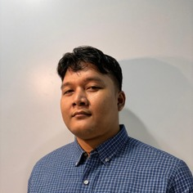

Summary
I'm a DevOps Engineer with over 5 years of experience building, automating, and managing application infrastructure in fast-paced and dynamic environments.
Focused on improving reliability, deployment efficiency, and system scalability through CI/CD pipelines, scripting, containerization, Kubernetes, serverless architecture, and cloud infrastructure management using Google Cloud and Google Kubernetes Engine.

Professional Experience
 | PT AVOWS Technologies  DevOps Engineer | Jul 2024 - Present  Project Engagement at PT Bank Raya Indonesia Tbk - Jakarta | 
• Managed CI/CD pipelines for frontend and backend build, testing, and deployment processes
• Developed DevOps tools for code scanning, diff checking, and confidential file protection
• Implemented Docker and Kubernetes to standardize application deployment
• Developed serverless solutions on Google Cloud to support automatic scalability
• Resolved production issues related to system configuration and deployment
• Collaborated across teams to implement features according to target timelines

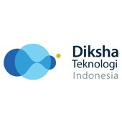 | PT Diksha Teknologi Indonesia  DevOps Engineer | Dec 2023 - Jun 2024  Project Engagement at PT Bank Rakyat Indonesia - Jakarta | 

 | Insource PT Satkomindo  DevOps Engineer | Dec 2020 - Dec 2023  Project Engagement at PT Bank Rakyat Indonesia - Jakarta | 
• Developed automated CI/CD pipelines for web applications and backend services
• Implemented containerization technologies such as Docker and Kubernetes
• Established code quality standards through unit testing and continuous integration
• Configured serverless architecture using Google Cloud Platform
• Handled troubleshooting for production issues

 | PT Multidaya Dinamika  Junior DevOps Engineer | Sep 2019 - Dec 2020  Jakarta
• Built and prepared new development tools and infrastructure
• Worked with developers and IT teams to oversee code releases
• Identified technical issues and developed CI/CD solutions
• Monitored networks and servers, including VPN, firewall, routing, and Mikrotik
• Created container-based servers in Proxmox

Education
 | Universitas Terbuka  Bachelor Program - 4th Semester  Currently pursuing an online degree | 2024 - Present

 | SMK Negeri 7  Computer and Network Engineering  Graduated from Computer and Network Engineering major | Latest Graduated Education

Skills
Operating Systems | Ubuntu, CentOS, Debian, Windows Server
Cloud Platform | DigitalOcean, Google Cloud Platform, Google Kubernetes Engine
Deployment & CI/CD | Docker, Docker Compose, Ansible, Jenkins, Kubernetes, Nginx
Security & Networking | Proxy, Firewall, Nmap, Snort, SSL, SCP, SFTP, Cloud Armor
Monitoring | Prometheus, Grafana, Kibana, Elasticsearch, Heartbeat

Projects
DevOps Tools Hub
A comprehensive platform for DevOps tools integration, CI/CD pipeline management, and infrastructure automation. Built to streamline development workflows and improve deployment efficiency.
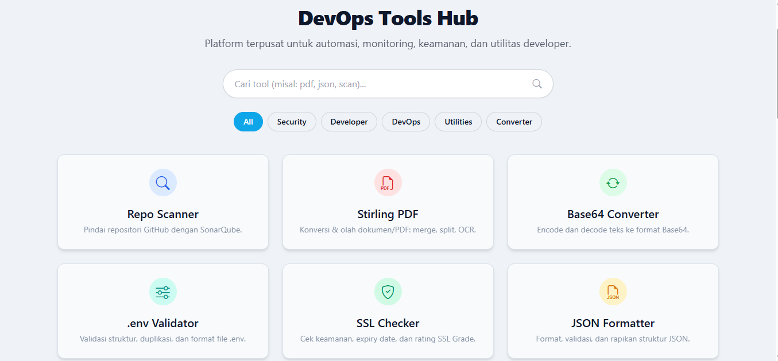 | 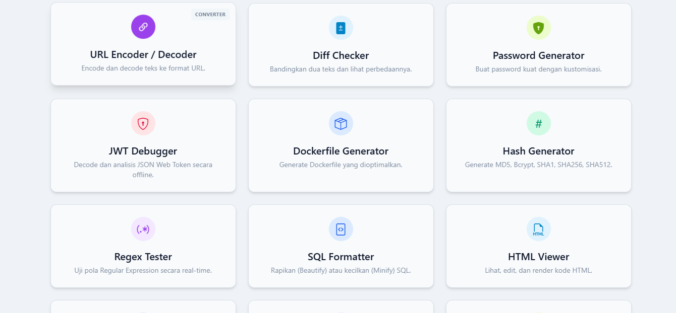
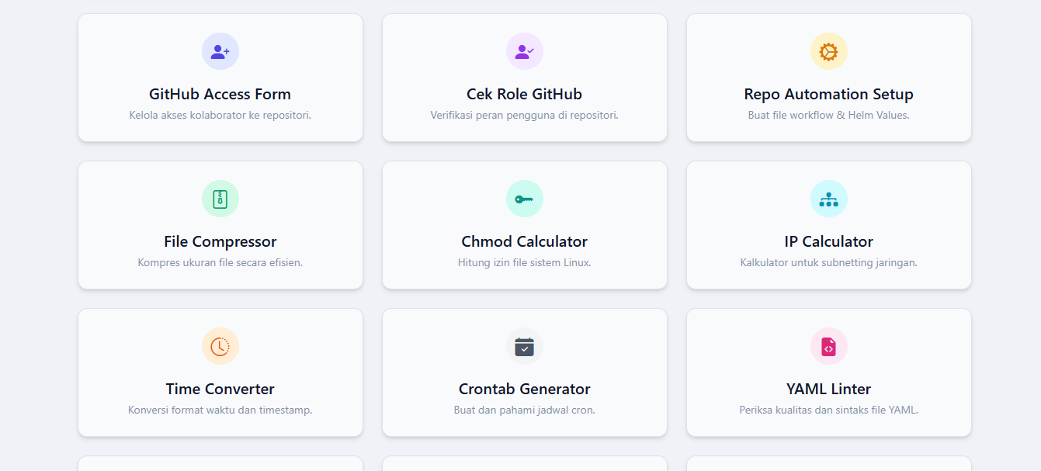 | 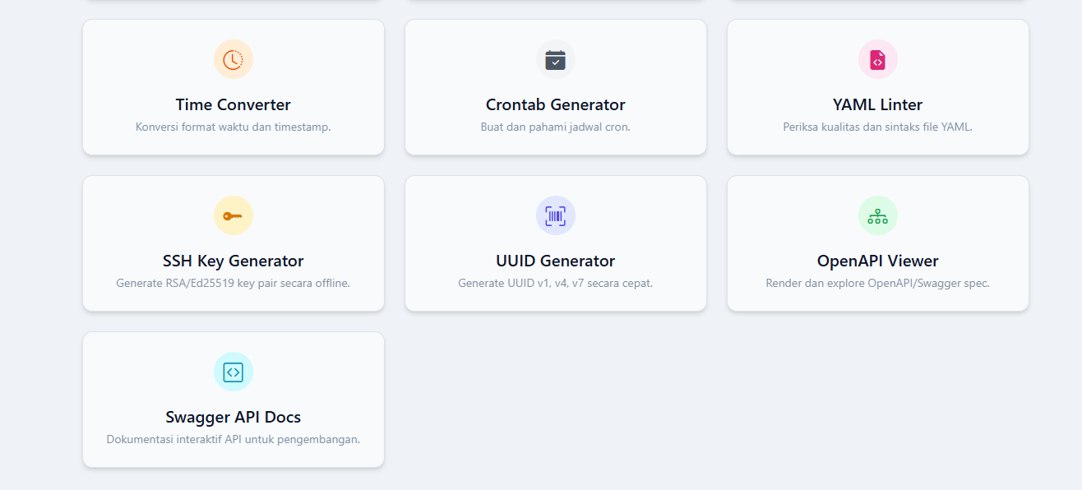

Certification & Course
BSDP IT Specialist DevSecOps - Agile Technical Excellence Module

