UI/UX Design Analysis
Coffee Meets Bagel
&
Drops Language Learning
Screen-by-Screen Breakdown · April 2026

Table of Contents
A — Coffee Meets Bagel
1. Overview & Design Philosophy ... 3
2. Onboarding & Login ... 4
3. Discover — Daily Bagels ... 5
4. Profile Detail View ... 6
5. Likes You ... 6
6. Matches & Chat ... 7
7. Beans — In-App Currency ... 8
8. Profile & Settings ... 8
9. Navigation & Visual Design ... 9
10. CMB vs Competitors ... 9
B — Drops Language Learning
11. Overview & Design Philosophy ... 10
12. Onboarding & Login ... 11
13. Home / Dashboard Screen ... 12
14. Explore Screen ... 12
15. Challenges Screen ... 13
16. Lesson & Game Screens ... 13
17. Profile & Progress ... 14
18. Premium & Monetisation ... 14
19. Navigation & Visual Design ... 15
20. Drops vs Competitors ... 15

PART A — Coffee Meets Bagel

1. Overview & Design Philosophy
Coffee Meets Bagel (CMB) is a dating app founded in 2012. Its UI/UX is built around a single thesis: quality over quantity. Every screen — the daily match limit, rich profile format, chat expiry timer — reinforces this philosophy.

Core UX Principles
Intentionality | Limited, curated profiles daily — never an endless feed
Text-first | Bios and Q&A prompts take visual precedence over photos
Anti-ghosting | Chat expiry timers push both parties to actually converse
Warm tone | Coffee/café metaphors make the experience feel casual
Soft monetisation | Beans currency gives spending agency without hard paywalls
Social proof | Mutual Facebook connections shown to build trust

2. Onboarding & Login Screen

Login Methods
Facebook | Primary auth — enables mutual-friends feature; one-tap sign-in
Phone / SMS | 6-digit OTP code; auto-read on iOS and Android
Email | Email + password fallback option
Apple Sign In | iOS only; privacy-preserving masked email option

Onboarding Steps
Step 1: Auth method selection — large, thumb-friendly buttons
Step 2: Basic info: name, birthdate, gender, orientation
Step 3: Photos: 2–6 uploads, drag-to-reorder, primary photo crops to square
Step 4: Prompts: choose 3 from 20+ icebreaker questions, 150-char answers
Step 5: Preferences: gender, age range, max distance sliders
Step 6: Attributes: height, religion, ethnicity chips — all optional
Step 7: Push notification permission — framed as 'never miss a Bagel'
Step 8: Location permission — friendly copy explaining the why
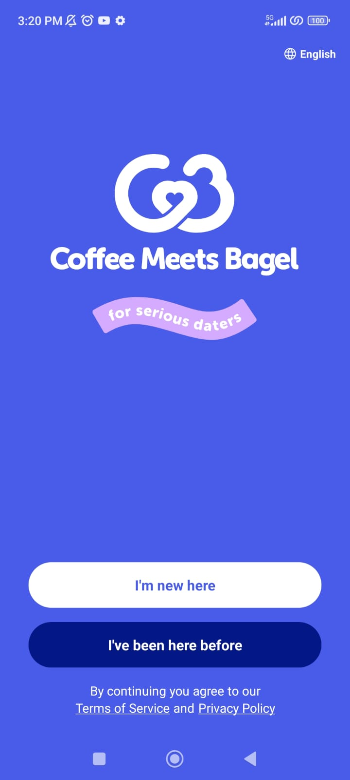

3. Discover — Daily Bagels
The Discover screen replaces the infinite swipe deck with a curated queue of up to 21 profiles per day — each called a 'Bagel'.

Screen Anatomy
Photo card | Full-bleed image, 16:9 ratio; pinch to zoom; name/age/distance overlaid at bottom
Headline prompt | One-line ice-breaker answer shown below photo
Like / Pass CTAs | Large coral 'Like' (heart) and gray 'Pass' (X) — side by side, thumb-reach height
Bagel counter | 'X Bagels left today' — reinforces daily scarcity
Empty state | Countdown timer to next day's queue when all Bagels are used

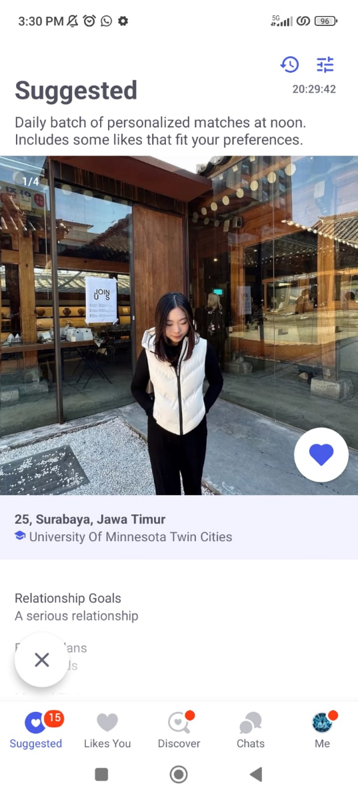

4. Profile Detail View
Tapped from the Discover card — the richest screen in the app. Designed to be read, not skimmed.

Screen Sections (top to bottom)
Photo carousel | Multi-photo strip; tap to advance; dot indicator; no auto-play
Name block | First name, age, distance, verified badge
Bio | Up to 500 characters, displayed in full — no truncation
Prompt cards | 3 Q&A cards — question in gray italic, answer in primary black
Attribute chips | Height · Religion · Politics · Drinking · Smoking
Mutual friends | Small avatar row if Facebook-linked
Sticky action bar | Fixed 'Like' and 'Pass' bar persists while scrolling the profile

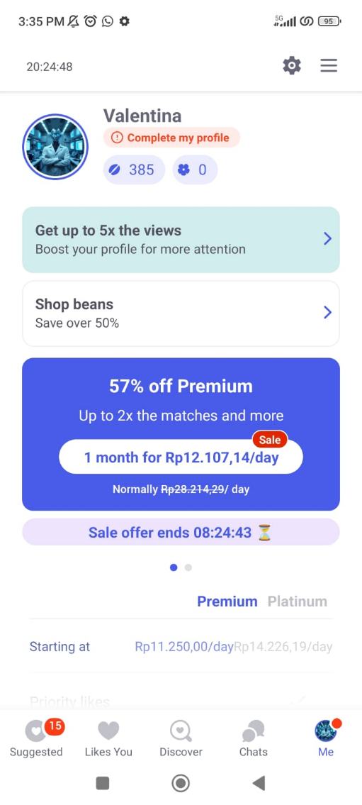

5. Likes You
Free tier | 3-column grid with blurred/mosaic faces — count visible, identities hidden
Premium tier | Fully unblurred grid; tap to view full profile and act
Sort order | Most recent likes first — freshness creates urgency
Upgrade hook | Soft inline CTA banner above the blurred grid — no intrusive modal

6. Matches & Chat

Inbox (Match List)
Row layout | Avatar + name + last message preview + timestamp
Expiry chip | Countdown shown on each match — turns red under 24 hours
Unread badge | Red dot on avatar for unread messages
New match chip | Coral 'New match!' tag until first message is sent

Chat Thread
Expiry bar | Slim countdown progress bar directly below the header
Message bubbles | Sender = coral right-aligned; receiver = gray left-aligned
Icebreaker tray | Horizontal scroll of suggested openers from partner's prompts
Composer | Text input + emoji picker + GIF search (Tenor); no voice messages

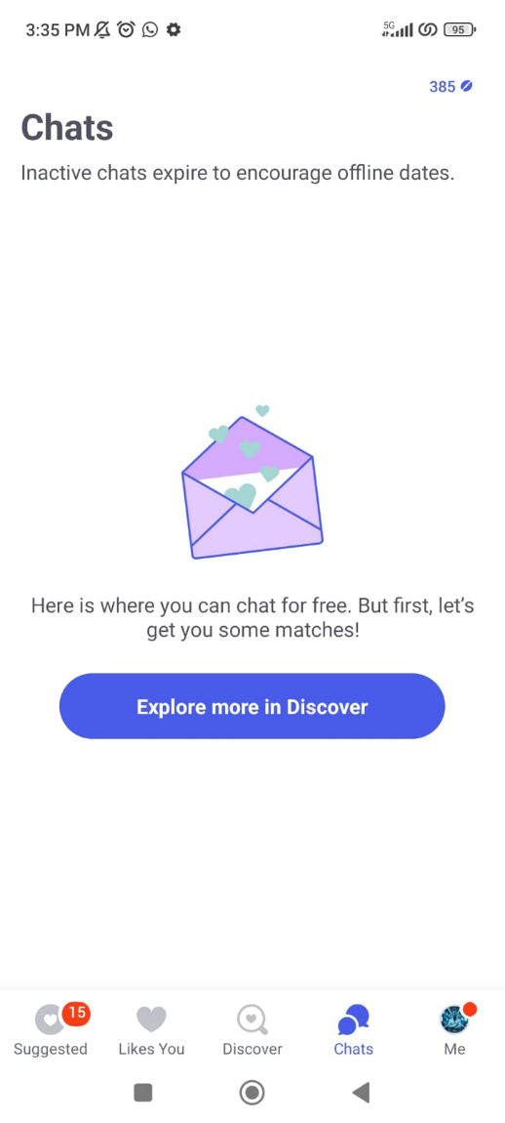

7. Beans — In-App Currency

Earn (Free)
Daily login | +1 Bean per day
Profile complete | +10–50 Beans per section filled
Invite friends | +20 Beans per successful referral

Spend
Extend a match | 50 Beans — adds 24h to an expiring chat
Woo | 150 Beans — highlighted Like with a personal note
Streak repair | 30 Beans — re-earn Activity Badge

8. Profile & Settings
Photo manager | Drag-to-reorder grid; tap to replace; star marks primary photo
Bio editor | Tappable text area with 500-char counter; auto-saves on exit
Prompts editor | Tap any prompt to change question or edit answer
Preview button | Shows exact view that Bagels would see before going live
Discovery prefs | Gender, age range slider, distance slider
Notifications | Granular toggles per event type
Snooze mode | Temporarily hides profile without deleting — high-retention feature
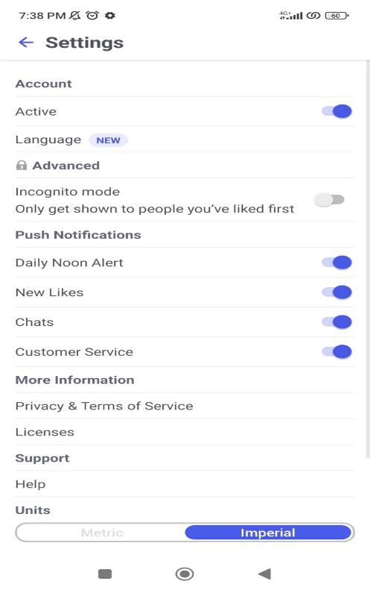

9. Navigation & Visual Design

Bottom Navigation (4 tabs)
Discover | Coffee cup icon — daily Bagels queue; badge shows remaining count
Liked You | Heart icon — who liked your profile; badge shows unseen count
Matches | Chat bubble icon — inbox; badge shows unread count
Profile | Person icon — your profile + all settings

Color & Typography
Primary brand | #B84C2E — warm coral/rust; CTAs, active nav, accents
Background | Off-white — warmer than pure white, less clinical feel
Font | Circular (SF Pro / Roboto fallback) — rounded, friendly
Heading | 24–28px bold; Body 15–16px; Labels 12–13px
Motion | Horizontal slide transitions; confetti on match; no parallax or physics

10. CMB vs Competitors
Key UI/UX dimensions compared against the three most similar dating apps.

Feature | Coffee Meets Bagel | Tinder | Hinge | Bumble
Daily limit | 21 Bagels | Unlimited | ~8 (free) | Unlimited
Interaction | Tap Like / Pass | Swipe L/R | Like / X | Swipe L/R
Chat expiry | 8 days | None | None | 24h (women)
Profile depth | High (prompts) | Low (photos) | Very high | High
In-app currency | Beans | Gold/Platinum | Roses | Coins
Free gate | Blurred Likes | No rewind | Full Likes | No SuperSwipe

Key Differentiators
- Only major dating app with a hard daily profile cap (21 Bagels)
- 8-day chat expiry is unique among the four compared apps
- Profile depth (bio + 3 prompts + attribute chips) matches Hinge and exceeds Tinder and Bumble
- Beans is the most nuanced soft-currency system — more earn opportunities, more granular spend

PART B — Drops Language Learning

11. Overview & Design Philosophy
Drops is a language learning app covering 55+ languages, built around one constraint: 5 minutes per day. Every design decision — visual vocabulary games, drag-and-match mechanics, streak system — is engineered to make learning feel fast, fun, and habit-forming.

Core UX Principles
5-min session cap | Free users get exactly 5 minutes — creates urgency and daily habit
Visual-first learning | Every word is paired with a custom illustration, not text translation
Game mechanics | Drag-and-match games replace traditional flashcard repetition
Spaced repetition | Words reappear based on memory science — harder for forgotten words
Micro-commitment | Short sessions lower the barrier to 'just one more' return visit
Illustration system | 3,000+ custom-illustrated vocabulary words — consistent, inclusive style

12. Onboarding & Login

Login Methods
Google | One-tap OAuth — primary on Android
Apple Sign In | Primary on iOS; privacy-preserving
Facebook | Available but less prominent
Email | Traditional email + password; least prominent
Guest mode | Full lesson without account — sign-up prompted after completion

Onboarding Steps
Step 1: Language selection — grid of 55+ illustrated flag cards; searchable
Step 2: Reason for learning — Travel, Culture, Career, Brain Training, etc.
Step 3: Experience level — Beginner / Some words / Conversational
Step 4: Topic interests — multi-select chip grid (Food, Travel, People…)
Step 5: Daily goal — 5 / 10 / 15 min options
Step 6: Notification permission — framed as streak protection
Step 7: Tutorial lesson — full 5-min guided lesson before account creation
Step 8: Account creation — 'Save your progress' framing post-lesson.

13. Home / Dashboard Screen
The Home screen balances session entry (primary action), progress visibility, and content discovery without overwhelming the user.

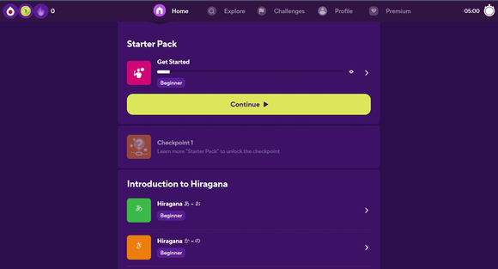
Fig 1. Drops Home Screen — Starter Pack, topic navigation, and session entry

Screen Anatomy
5:00 timer | Top-right countdown clock — shows exactly how much free time remains
Starter Pack | Featured lesson pack with progress bar — primary learning path
Continue CTA | Large yellow 'Continue' button — single unmissable primary action
Checkpoint | Locked milestone card — motivates completing the current pack
Script sections | Hiragana/Katakana topic rows — color-coded cards with native characters
Top nav | Home · Explore · Challenges · Profile · Premium — 5-tab horizontal nav

UX Note: The session timer is the most important element — it frames learning as a finite ritual. Seeing '5:00' remaining before it begins makes the session feel manageable, not daunting.

14. Explore Screen
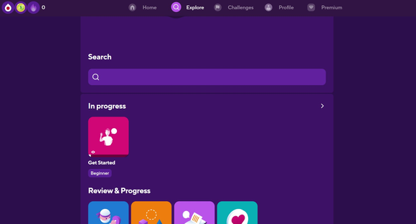
Fig 2. Explore Screen — Search, In Progress packs, and Review & Progress tools

Search bar | Full-width search field — find any word pack or topic by name
In progress | Cards for currently active learning packs — quick resume access
Review & Progress | Grid of review mode cards: flashcard review, accuracy test, conversation mode, favorites
Card design | Each pack shown as a colored rounded square with illustration + title + level badge

15. Challenges Screen
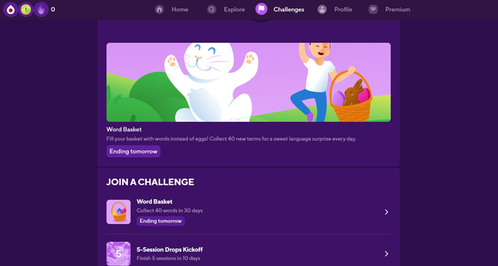
Fig 3. Challenges Screen — Seasonal challenge hero and joinable challenge list

Hero banner | Full-width seasonal illustration with challenge name and description
Urgency tag | 'Ending tomorrow' chip — FOMO mechanic identical in spirit to CMB's expiry timer
Challenge list | Scrollable list of joinable challenges — icon + name + goal + deadline
Challenge types | Word count goals (collect 40 words), session goals (5 sessions in 10 days)
Illustration style | Custom seasonal artwork — Easter, New Year, etc. — maintains brand warmth

16. Lesson & Game Screens
Drops' flagship UX — the game-based learning engine that defines the app's identity. Two lesson screens are shown below, captured during active sessions.

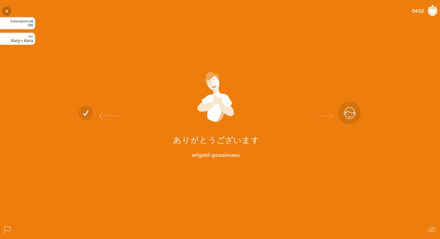 | 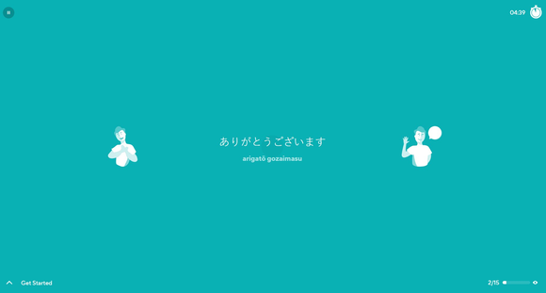
Fig 4. Orange lesson screen — vocabulary introduction with illustration + romanization | Fig 5. Teal lesson screen — drag-to-match game with two character choices

What These Screenshots Show
Full-bleed color | Each game type uses a distinct background color — orange for intro, teal for matching
Word illustration | Custom character illustration centered — visual-to-word association core mechanic
Target script | Word displayed in target script (ありがとうございます) — large, legible, center-screen
Romanization | Romaji shown below — 'arigatō gozaimasu' — toggleable via Transcription Aid switch
Script toggle | Top-left: Kana / Kanji+Kana toggle — adapts display to learner level
Swipe mechanic | Left arrow (checkmark = already knew it) / Right arrow (speaker = hear pronunciation)
Session counter | Bottom-right '2/15' progress indicator — shows position in current word set
Timer | Top-right countdown '04:52' — consistent across all game screens
Pause button | Top-left pause icon — accessible at any point in a session

All Game Types
- Drag to match — drag a word to its matching illustration
- Drag to image — reverse; drag an illustration to its word
- Word drop — tap correct falling letters to spell the word
- Swipe to sort — swipe cards left/right based on recognition
- Quiz mode — 4-option multiple choice from a shown illustration
- Grammar tips — short contextual grammar tip cards (new feature: EN/ES/DE/PT)

17. Profile & Progress
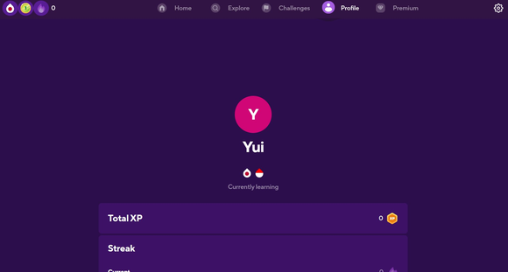
Fig 6. Profile Screen — avatar, language badges, Total XP counter, and Streak tracking

Avatar | Large circular avatar with initial — pink/magenta on dark purple background
Language badges | Drops icon + flag icon showing currently active learning languages
Total XP | Running XP total with gold XP badge — tangible progress metric
Streak counter | Flame icon + current streak count below — always visible on profile
Stats sections | Scrollable stat rows: words learned, sessions completed, accuracy rate
Settings gear | Top-right gear icon — account settings, notification prefs, subscription

18. Premium & Monetisation
Free limit | 5 minutes per session — timer ends the lesson; one language; ads between sessions
Unlimited | No session time limit; multiple languages; offline mode; no ads
Streak shield | Premium-only — one weekly shield prevents streak loss on missed days
Paywall trigger | Shown at end of 5-min session — 'Continue learning' CTA at peak motivation
Paywall design | Full-screen feature checklist + pricing tiers; annual plan highlighted as 'best value'
Free trial | Offered on first paywall view — lowers conversion barrier significantly
Gems | Secondary soft currency for streak repair and minor boosts — IAP packs

UX Note: The 5-minute cap is a freemium masterclass — long enough to deliver genuine value and build habit, short enough to leave users wanting more. The paywall appears exactly when motivation is highest: right after a satisfying lesson.

19. Navigation & Visual Design

Top Navigation (5 tabs — Web version)
Home | Raindrop icon — main lesson dashboard and Starter Pack
Explore | Search icon — browse all word packs by topic; review tools
Challenges | Flag icon — seasonal and ongoing challenges
Profile | Person icon — XP, streaks, stats, account settings
Premium | Diamond icon — upgrade prompt; visible to free users always

Color System
Background | Deep purple (#2C1D5B) — dark, immersive; makes illustrations pop
Primary action | Yellow-green (#C8E832) — high-contrast CTA; 'Continue' button
Lesson: orange | Full-bleed orange (#F5821F) — vocabulary introduction screens
Lesson: teal | Full-bleed teal (#3CBFB4) — drag-to-match game screens
Accent: magenta | Profile avatar, badge chips, active elements
Text | White and light purple on dark backgrounds throughout

Typography & Illustration
- Primary font: rounded sans-serif — friendly, highly legible at small sizes
- Heading: 22–28px medium; Body: 15–16px regular; Labels: 12px
- 3,000+ custom illustrated vocabulary words — warm, inclusive, professional style
- Full-bleed colored lesson backgrounds — each game type has a distinct hue
- Micro-animations: correct answer scale-up, incorrect shake, streak milestone confetti

20. Drops vs Competitors
Key UI/UX dimensions compared against the three most similar language learning apps.

Feature | Drops | Duolingo | Babbel | Memrise
Focus | Visual vocabulary | Gamified grammar | Structured courses | Vocab + native video
Lesson length | 5 min daily | 5–20 min | 15–30 min | 3–5 min
Languages | 55+ | 40+ | 14 | ~22
Game mechanics | Drag & match | XP + leagues | Linear paths | Mnemonics
Free tier | 5 min/day cap | Full (with ads) | First lesson only | Partial
Visual design | Illustrated, vibrant | Flat cartoon | Clean, corporate | Dark, native-video

Key Differentiators
- Only major language app with a hard daily time gate on the free tier (5 minutes)
- Custom illustration library (3,000+ words) is a visual moat no competitor matches
- 55+ languages is the broadest coverage — 40%+ more than Babbel
- Guest-first onboarding (value before account) is rare among edtech apps — and highly effective
- Full-bleed colored lesson canvases make each game type instantly identifiable — no UI chrome needed

Coffee Meets Bagel + Drops · UI/UX Analysis · April 2026

