**Computer Organization 2019**

**HOMEWORK 6**

系級: 資訊110 學號: F74061111 姓名: 周郁婕

**問題(Question)**

Q1. How do you know the number of block from input file?

Number of block=cache size*1024/block size

Q2. How do you know how many set in this cache?

Directed-mapped: number of block

Four-way set associative: number of block/4

Fully associative:1

通式:number of block/ n (way set associative)

Q3. How do you know the bits of the width of the Tag ?

Directed-mapped:32-lg(block size)-lg(number of block)

Four-way set associative:32-lg(block size)-lg(number of set)

Fully associative:32-lg(block size)

Q4. Briefly describe your data structure of your cache.

Directed-mapped:設兩個vector存index跟tag

Four-way set associative:設一個2D vector存第幾個set跟tag

Fully associative:設一個vector存tag

Q5. Briefly describe your algorithm of LRU.

最久未被使用的，因此每次遇到Hit時，我就會把那個tag erase並重新

push_back，最後再直接print出vector index為0的tag(也就是最早放進去且最久未被使用的tag)。

Q6. Briefly describe your algorithm of your policy.

我是結合LRU跟隨機選取下去做我的policy，首先按照LRU排序好，再在所有排序好的block中，拿前一半的block去做隨機選取，最後replace掉隨機選到的block。

Q7. Run trace2.txt, trace3.txt and then makefile to get the miss rate and put it in your report.

trace2:Miss rate=0.000597

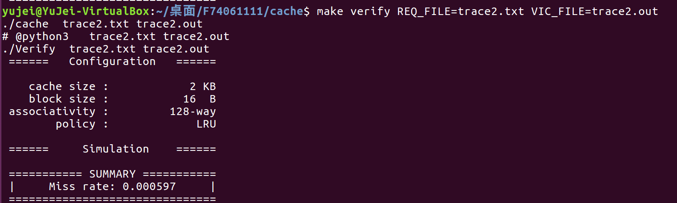

trace2:Miss rate=0.000076

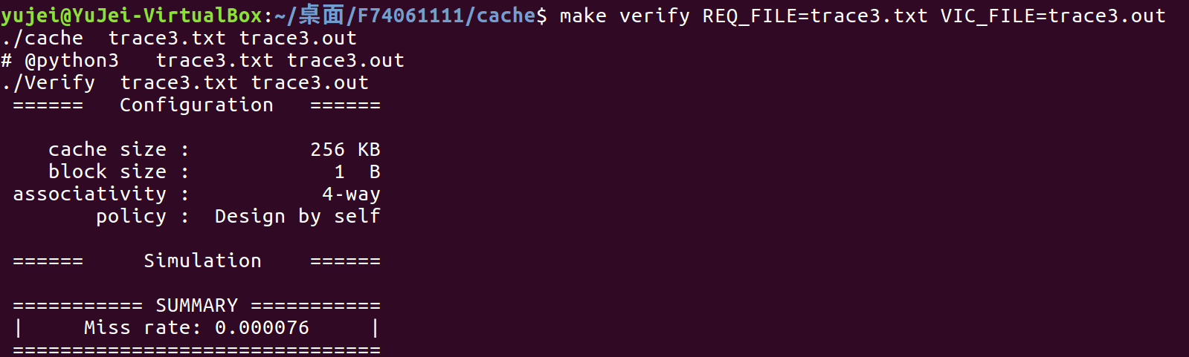

**心得(Report)**

困難的點在於要對整個cache運作很熟悉，以及必須知道各種情況的tag width是多長，像在做four-way set associative跟fully associative時，就因為沒有搞清楚這兩個的tag width該取多長，而debug了好久。