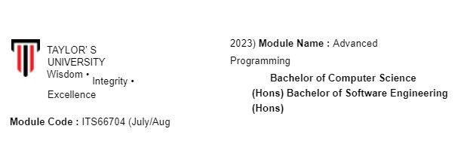

|  |  |
| --- | --- |
| **Assignment No./Title** | **Assignment Task 2 & Task 3 (Group Project)20% (PART A - ANALYSIS AND DESIGN)**  **30% (PART B - DEVELOPMENT)** **10% (PRESENTATION)** |
| **Course**  **Tutor/Lecturer** | Mr. Biju Maharjan/ Mr.Subit Timalsina |
| **Submission Date** | 09/11/2023 (PART A - ANALYSIS AND DESIGN)  23/11/2023 (PART B - DEVELOPMENT)  23/11/2023 (PRESENTATION) |
| **Student Name, ID and Signature**   1. Dev Mani Maharjan, 0355610 2. Aadarsh Shrestha, 0355711 3. Yujen Maharjan, 0355776 4. Aslin Karmacharya, 0355447 5. Sagun Karki, 0355487 | |

**Declaration** (need to be signed by students. Otherwise, the assessment will not be evaluated)

Certify that this assignment is entirely my own work, except where I have given fully documented references to the work of others, and that the material contained in this assignment has not previously been submitted for assessment in any other formal course of study.

|  |  |
| --- | --- |
| **Marks/Grade:** | **Evaluated by:** |
| **Evaluator's Comments:** |  |

# Contents

**Works Responsibilities and Delegation** ....................................................................................................... 4

**Brief documentation of the related 20 questions** ....................................................................................... 5

For Malaysia .............................................................................................................................................. 5

For Singapore ............................................................................................................................................ 9

For Thailand ............................................................................................................................................ 13

Over all question ..................................................................................................................................... 17

**Countries selected** ...................................................................................................................................... 20

Introduction ............................................................................................................................................ 20

Malaysia .................................................................................................................................................. 20

Singapore ................................................................................................................................................ 20

Thailand ................................................................................................................................................... 21

**UML use case diagram** ............................................................................................................................... 22

**UML class diagram** ..................................................................................................................................... 23

**User Interface static prototype** .................................................................................................................. 24

Login Page ............................................................................................................................................... 24

Signup Page: ............................................................................................................................................ 25

User Additional Information Page .......................................................................................................... 26

User Additional Page ............................................................................................................................... 27

Take the Test Page .................................................................................................................................. 28

Test Interface .......................................................................................................................................... 29

Display Result .......................................................................................................................................... 30

# Works Responsibilities and Delegation

1. Yujen Maharjan (Project Manager):

Responsibilities: Oversee the entire project to make sure that tasks are being accomplished within their specified deadlines, and be the main contact point in regard to supervision, coordination and communication.

Specific Tasks: Planning of a project, setting timelines to guide each activity through to completion while at the same time monitoring adherence to project objectives to ensure that good quality in products is maintained.

1. Aslin Karmacharya (User Interface Designer):

Responsibilities: Create a good looking and friendly user interface for the system design.

Specific Tasks: Build statically prototype of the screen for the candidate registration, exams, analyses and results presenting purposes. Make sure that the user interface is in line with both the aesthetic and usability goals of the project.

1. Dev Mani Maharjan (Question Database Manager):

Responsibilities: Provide a question database for the citizenship test in terms of selecting questions, formatting them, and saving them.

Specific Tasks: Develop a 20 structured questions survey comprising of several options, touching on diverse issues that define the selected people groups and countries in history and culture.

1. Sagun Karki (UML and Class Diagram Designer): Responsibilities: Use UML diagrams for illustrating the system’s use cases, as well as its class structures.

Specific Tasks: Design a UML use case diagram that depicts how actors will interact with their system use cases. Develop a UML class diagram which describes the main classes and how they relate to the system.

1. Aadarsh Shrestha (Documentation and Report Writer):

Responsibilities: Summarize all of the documentation, including the analysis and design documentation related to the project at this point.

Specific Tasks: Document the project with the brief on the selected states, the twenty possible questionnaire, and overall explanation of UML diagrams. Ensure that the document is appropriately formatted to include a cover page which shall contain all group members’ names and students’ IDs.

# Brief documentation of the related 20 questions

## For Malaysia

1. What is the official religion of Malaysia?

1. Buddhism
2. Hinduism
3. Islam
4. Christianity Answer: c) Islam

2. Which two regions make up East Malaysia?

1. Penang and Selangor
2. Sabah and Sarawak
3. Johor and Perak
4. Pahang and Kelantan Answer: b) Sabah and Sarawak

3. What is the currency of Malaysia?

1. Baht
2. Ringgit
3. Rupiah
4. Yen Answer: b) Ringgit

4. Which Malaysian state is known as the "Land of the Hornbills"?

1. Penang
2. Sarawak
3. Perlis
4. Pahang Answer: b) Sarawak

5. What is the capital city of Malaysia?

1. Kuala Lumpur
2. Bangkok
3. Singapore
4. Jakarta

Answer: a) Kuala Lumpur

6. What is the national flower of Malaysia?

1. Hibiscus
2. Orchid
3. Rose
4. Sunflower Answer: a) Hibiscus

7. Malaysia is known for its diverse cuisine. What is the popular Malaysian dish made with stir-fried rice noodles?

1. Dim Sum
2. Pho
3. Sushi
4. Char Kway Teow Answer: d) Char Kway Teow

8. Which famous twin towers are located in Kuala Lumpur?

1. Petronas Twin Towers
2. Taipei 101
3. Burj Khalifa
4. Willis Tower

Answer: a) Petronas Twin Towers

9. What is the largest ethnic group in Malaysia?

1. Malays
2. Chinese
3. Indians
4. Orang Asli Answer: a) Malaysia

10. Malaysia has a famous island known for its crystal-clear waters and coral reefs. What is it called? a) Bali

1. Phuket
2. Langkawi
3. Tioman Answer: d) Tioman

11. What is the name of the traditional Malay dress for women?

1. Kimono
2. Sari
3. Baju Melayu
4. Baju Kurung Answer: d) Baju Kurung

12. Which historical city in Malaysia is known for its well-preserved Dutch colonial architecture? a) George Town

1. Kuala Lumpur
2. Malacca
3. Kuching Answer: c) Malacca

13. Malaysia's national car brand is known as:

1. Proton
2. Perodua
3. Toyota
4. Honda Answer: a) Proton

14. What is the name of the traditional Malay martial art?

1. Taekwondo
2. Silat
3. Kung Fu
4. Judo Answer: b) Silat

15. The highest mountain in Southeast Asia, Mount Kinabalu, is located in which Malaysian state? a) Selangor

1. Pahang
2. Sabah
3. Johor Answer: c) Sabah

16. Which river is the longest in Malaysia?

1. Sungai Kelantan
2. Sungai Perak
3. Sungai Pahang
4. Sungai Rajang Answer: c) Sungai Pahang

17. What is the official language of Malaysia?

1. English
2. Malay
3. Chinese
4. Tamil Answer: b) Malay

18. What is the name of the Malaysian dish consisting of rice cooked in coconut milk and served with various accompaniments? a) Pho

1. Nasi Lemak
2. Pad Thai
3. Biryani

Answer: b) Nasi Lemak

19. Malaysia has a famous festival celebrating the victory of good over evil. What is it called? a) Chinese New Year

1. Hari Raya Aidilfitri
2. Deepavali
3. Diwali

Answer: c) Deepavali

20. In which year did Malaysia gain its independence from British colonial rule? a) 1945

1. 1957
2. 1963
3. 1957 Answer: c) 1963

These numerous multiple- choice questions can form a very interesting means through which to gauge understanding of Malaysia’s complex picture. These are not just queries but windows to Malaysia’s cultural, historical and geographic tapestry. Addressing these issues means exploring the mystery of “Malaysianess.” For every answer, people get a chance to prove their knowledge and even uncover interesting facts of India. These serve as the stepping-stones to intellectual questions that feed into one’s curiosity and knowledge about cultural heritage, traditions, and remarkable monuments that make up the Nation. These, however, represent keys to some hidden treasures of Malaysia which one explores with great pleasure and amazement.

## For Singapore

1. What is the official language of Singapore?

1. Malay
2. English
3. Mandarin
4. Tamil Answer: b) English

2. Which iconic building is often referred to as the "Lion City"?

1. Merlion
2. Marina Bay Sands
3. Sentosa Island
4. Orchard Road Answer: a) Merlion

3. In what year did Singapore gain independence from Malaysia?

1. 1957
2. 1965
3. 1971
4. 1980 Answer: b) 1965

4. What is the currency of Singapore?

1. Ringgit
2. Baht
3. Dollar
4. Rupiah Answer: c) Dollar

5. Which island is known for its thriving nightlife and entertainment in Singapore?

1. Pulau Ubin
2. Sentosa
3. Pulau Tekong
4. Orchard Road Answer: d) Orchard Road

6. What is the name of the airport in Singapore, one of the busiest in the world?

1. Changi Airport
2. Jurong Airport
3. Sentosa Airport
4. Merlion Airport Answer: a) Changi Airport

7. Which strait separates Singapore from Indonesia?

1. Malacca Strait
2. Singapore Strait
3. Lombok Strait
4. Bering Strait

Answer: b) Singapore Strait

8. What is the traditional Singaporean dish made of rice and chicken, often served with chili sauce? a) Mee Goreng

1. Hainanese Chicken Rice
2. Laksa
3. Char Kway Teow

Answer: b) Hainanese Chicken Rice

9. What is the national flower of Singapore?

1. Orchid
2. Jasmine
3. Hibiscus
4. Lotus

Answer: a) Orchid

1. Which event in Singapore is celebrated with the lighting of lanterns, making offerings, and boat races? a) Deepavali
   1. Chinese New Year
   2. Vesak Day
   3. Mid-Autumn Festival Answer: d) Mid-Autumn Festival

1. What is the name of the lion-headed fish statue that symbolizes Singapore? a) Merlion
   1. Dragonfish
   2. Koi
   3. Naga

Answer: a) Merlion

1. The Singapore River flows into which body of water?
   1. Andaman Sea
   2. South China Sea
   3. Java Sea
   4. Bay of Bengal

Answer: b) South China Sea

1. Which district in Singapore is known for its arts and heritage precinct? a) Orchard
   1. Bugis
   2. Chinatown
   3. Kampong Glam Answer: d) Kampong Glam

1. What is the name of the island resort known for its Universal Studios theme park in Singapore? a) Sentosa Island
   1. Pulau Ubin
   2. Lazarus Island
   3. Kusu Island

Answer: a) Sentosa Island

1. The Singapore Flyer is a giant observation wheel located near which iconic area of Singapore? a) Chinatown
   1. Little India
   2. Marina Bay
   3. Raffles Place

Answer: c) Marina Bay

1. What is the name of the famous shopping street in Singapore that is home to luxury brands and department stores? a) Arab Street
   1. Orchard Road
   2. Haji Lane
   3. Bugis Street

Answer: b) Orchard Road

1. What is the name of the housing development board responsible for public housing in Singapore? a) HDB
   1. HUDC
   2. BTO
   3. CPF

Answer: a) HDB

1. The iconic Raffles Hotel is named after Sir Stamford Raffles, who is known for:
   1. Inventing the Singapore Sling cocktail
   2. Founding modern Singapore
   3. Building the Esplanade
   4. Establishing the Sentosa Resort Answer: b) Founding modern Singapore
2. Which annual race is held on the Marina Bay Street Circuit in Singapore?
   1. Singapore Grand Prix
   2. Singapore Marathon
   3. Dragon Boat Race
   4. F1 Night Race

Answer: a) Singapore Grand Prix

1. What is the name of the popular island that's a short ferry ride away from Singapore, known for its beaches and resorts? a) Langkawi
   1. Tioman
   2. Pulau Ubin
   3. Bintan Answer: d) Bintan

Multiple-choice questions are gateways into Singapore’s magical land, revealing the rich fabric of culture, natural landscapes and history of the state. Each question unlocks a world of wisdom on the Lion City; the preeminence of the English language, down to the significance of the Merlion logo. Through revisiting the year 1965, when Singapore gained its independence, the following questions offer possible indications of the country’s road towards sovereignty. Its strength in both regional and international economies is demonstrated by this currency. Orchard road, which glitters at night with all its pulsating life presents itself almost like urban life brush stroke. As well, the questions further highlight the world fame of Changi Airport and the geopolitical importance of the Singapore Strait. However, the delicious Hainanese Chicken Rice, an art of food cuisine, as well as the national orchid express the Singaporeans love for tasty cuisine and beautiful nature. Questions for Singapore’s ‘Lion City’ are intriguing journeys to the essence of the Lion City and its vibrant cultures such as the Mid-Autumn Festival and iconic Merlion.

## For Thailand

1. Which river is considered the "Mother of Water" in Thailand?

1. Chao Phraya
2. Mekong
3. Ping
4. Kwai

Answer: a) Chao Phraya

2. What is the traditional Thai greeting where the palms are placed together in a prayer-like gesture? a) Sawadee Krub/Ka

1. Wai
2. Namaste
3. Konnichiwa Answer: b) Wai

3. Which famous festival in Thailand features water fights in April?

1. Songkran
2. Loi Krathong
3. Loy Krathong
4. Yi Peng Answer: a) Songkran

4. What is the capital of Thailand?

1. Chiang Mai
2. Phuket
3. Bangkok
4. Pattaya

Answer: c) Bangkok

5. Which mountain range runs along Thailand's western border?

1. Himalayas
2. Alps
3. Andes
4. Western Ghats Answer: a) Himalayas

6. What is the currency of Thailand?

1. Baht
2. Ringgit
3. Rupiah
4. Kyat Answer: a) Baht

7. Which animal is revered and considered a sacred symbol in Thailand? a) Elephant

1. Tiger
2. Cobra
3. Monkey Answer: a) Elephant

8. What is the famous Thai dish made from rice noodles stir-fried with eggs, tofu, shrimp, and various seasonings?

1. Green Curry
2. Pad Thai
3. Tom Yum
4. Som Tum Answer: b) Pad Thai

9. Which ancient capital city of Thailand is known for its historical ruins and temples? a) Chiang Mai

1. Ayutthaya
2. Sukhothai
3. Pattaya

Answer: b) Ayutthaya

1. What is the name of the Thai New Year celebration that involves building and floating small boats made of banana leaves and flowers on water? a) Songkran
   1. Loy Krathong
   2. Loi Krathong
   3. Yi Peng

Answer: b) Loy Krathong

1. Which island in Thailand is famous for its full moon parties?
   1. Koh Samui
   2. Koh Phi Phi
   3. Koh Tao
   4. Koh Phangan Answer: d) Koh Phangan

1. The famous Bridge on the River Kwai is located in which Thai province? a) Chiang Mai
   1. Kanchanaburi
   2. Krabi
   3. Phang Nga

Answer: b) Kanchanaburi

1. What is the name of the Thai kickboxing martial art that is a national sport of Thailand? a) Taekwondo
   1. Karate
   2. Muay Thai
   3. Capoeira

Answer: c) Muay Thai

1. Which ancient script is used for writing the Thai language? a) Sanskrit
   1. Khmer
   2. Lao
   3. Devanagari Answer: b) Khmer

1. What is the main religion of Thailand?
   1. Islam
   2. Buddhism
   3. Christianity
   4. Hinduism Answer: b) Buddhism

1. The Emerald Buddha, considered the most sacred statue in Thailand, is located in which temple?
   1. Wat Phra Kaew (Temple of the Emerald Buddha)
   2. Wat Pho (Temple of the Reclining Buddha)
   3. Wat Arun (Temple of Dawn)
   4. Wat Rong Khun (White Temple)

Answer: a) Wat Phra Kaew (Temple of the Emerald Buddha)

1. What is the name of the famous Thai street food made of skewered and grilled meat or seafood? a) Tom Yum
   1. Som Tum
   2. Satay
   3. Massaman Curry

Answer: c) Satay

1. Thailand is known for its annual lantern festival, especially in the city of Chiang Mai. What is this festival called? a) Songkran
   1. Loi Krathong
   2. Loy Krathong
   3. Yi Peng Answer: d) Yi Peng
2. The ancient city of Sukhothai, a UNESCO World Heritage Site, was the first capital of which Thai kingdom?
   1. Ayutthaya
   2. Lan Na
   3. Sukhothai
   4. Rattanakosin Answer: c) Sukhothai

1. What is the largest national park in Thailand, known for its diverse wildlife and lush rainforests? a) Erawan National Park
   1. Khao Yai National Park
   2. Doi Inthanon National Park
   3. Mu Ko Ang Thong National Park

Answer: b) Khao Yai National Park

These questions give intriguing insights into Thailand’s culture, geography and traditions. They open up in the mother of waters, Chao Phraya River, and say the traditional Thai greetings (wai). The tour will encompass Songkran celebration, getting wet in April and an introduction to vibrant Bangkok. Bordering it to the west is the majestic Himalayas. The Baht is also its local currency. In the context of national identity, the respected elephant represents heritage. It becomes possible to experience such culinary delights as pad Thai, Ayutthaya and so on. These questions lead one through Koh Phangan’s famous full moon parties and the Bridge on the River Kwai. It also incorporates Muay Thai, the country’s national sport, as well as the Khmer script. The principal religion is Buddhism with a sacred Buddha image of emerald in Wat Phra Kaew. The alluring Yi Peng lantern festival lights up Chiang Mai while street food is a delight in its own way – Satay. This trip will explore diverse Thai heritage which can also be seen in Sukhothai, a

UNESCO World Heritage site and one of Khao Yai’s national parks.

## Over all question

(If question are same for all countries)

1. What is the capital of Malaysia, and what is its historical significance?

1. Kuala Lumpur (Correct Answer)
2. Jakarta
3. Bangkok
4. Singapore

2. Name one traditional Malaysian festival and briefly describe its customs and traditions.

1. Hari Raya Aidilfitri (Correct Answer)
2. Diwali
3. Chinese New Year
4. Songkran

3. Which famous Malaysian landmark is known for its iconic twin towers, and where is it located?

1. Petronas Twin Towers, Kuala Lumpur (Correct Answer)
2. Burj Khalifa, Dubai
3. Eiffel Tower, Paris
4. Big Ben, London

4. In Singapore, what is the official language, and how does this reflect the country's cultural diversity? a) English (Correct Answer)

1. Malay
2. Mandarin
3. Tamil

5. Name a significant historical event in Singapore's journey to independence from Malaysia.

1. Separation from Malaysia in 1965 (Correct Answer)
2. Arrival of the British
3. Japanese Occupation
4. Founding of Singapore as a trading port

6. Thailand is known for its unique cuisine. Name a popular Thai dish and describe its main ingredients. a) Pad Thai (Correct Answer)

1. Sushi
2. Kimchi
3. Peking Duck

7. What is Songkran, and how is it celebrated in Thailand?

1. Thai New Year, water festival (Correct Answer)
2. Buddhist pilgrimage
3. Royal coronation
4. Thai Independence Day

8. Identify a famous Thai temple and explain its cultural and religious importance.

1. Wat Pho (Temple of the Reclining Buddha) (Correct Answer)
2. Angkor Wat
3. Borobudur
4. Shwedagon Pagoda

9. In what year did Malaysia gain its independence from British colonial rule, and what is the significance of Merdeka Day? a) 1957

1. 1963
2. 1957 (Correct Answer)
3. 1965

10. Describe the national flag of Singapore, including its elements and their meanings.

1. Red and white with a lion (Correct Answer)
2. Green with a crescent moon and star
3. Blue and white with a sun
4. Yellow with an elephant

11. Explain the importance of the Malaysian "Rukunegara" (National Principles) in the country's history and culture.

1. Five principles for national unity (Correct Answer)
2. Five major cities in Malaysia
3. Five principles of Buddhism
4. Five famous landmarks in Malaysia

12. What is the primary religion in Thailand, and how does it influence daily life and customs? a) Buddhism (Correct Answer)

1. Islam
2. Hinduism
3. Christianity

13. Name a prominent figure from Singapore's history who played a significant role in the nation's development.

1. Lee Kuan Yew (Correct Answer)
2. Mahathir Mohamad
3. King Rama IX
4. Sultan of Brunei

14. What is the meaning of "Bhumibol Adulyadej," the name of a beloved Thai monarch?

1. "Father of the Nation" (Correct Answer)
2. "Eternal Sunshine"
3. "Golden Land"
4. "Land of Smiles"

15. In Malaysia, what is the "Hari Raya" festival, and how is it celebrated?

1. Eid al-Fitr, celebrating the end of Ramadan (Correct Answer)
2. Christmas
3. Deepavali
4. Chinese New Year

16. Describe the importance of the Malacca Sultanate in the history of Malaysia.

1. Established early trade routes (Correct Answer)
2. Built the Petronas Towers
3. Led the fight for independence
4. Invented the Malay language

17. Explain the significance of the Merlion statue in Singapore's cultural landscape.

1. Symbol of Singapore's history as a fishing village (Correct Answer)
2. Guardian of the city
3. Ancient deity
4. Protector of the arts

18. Thailand is known for its festivals. Name one major festival and its associated traditions.

1. Loy Krathong, floating lanterns (Correct Answer)
2. Oktoberfest
3. Diwali
4. Carnival

19. What is the role of the "Asean Way" in regional cooperation among Southeast Asian nations, including Malaysia, Singapore, and Thailand?

1. Informal consensus and non-interference (Correct Answer)
2. Strong military alliance
3. Economic competition
4. Colonial rule

20. In Malaysia, what is the meaning of "Bunga Raya," and why is it an important national symbol?

1. National flower, symbol of unity (Correct Answer)
2. Traditional dance
3. Royal palace
4. Historical treaty

We are using these questions in the citizenship process of our new country because it has some key advantages. First, these questions help ensure that individuals seeking citizenship have a good grasp of the diverse mix of cultures, the historical background, and the varied geography inherited from Malaysia, Singapore, and Thailand. This understanding is vital as it fosters respect for the blend of traditions and enhances unity among our citizens, reinforcing our collective identity. Second, they check if applicants can speak the official languages and have some general knowledge about our region and the world. This is crucial for enabling effective communication and integration within the nation. These questions are like a bridge, connecting our people through a shared sense of belonging and a deep appreciation for our common heritage, ultimately contributing to a strong, united, and culturally rich nation.

# Countries selected

## Introduction

The development of an automated Citizenship Assessment System for Masathai represents a pivotal step in the unification of three distinguished nations: Malaysia, Singapore, and Thailand. The primary focus of the initiative is that all citizens of Masathai should be united under a single identity. Such an identity should be accompanied by knowledge regarding these countries’ history as well as culture. Developed for the principal to provide objective statistics on citizen’s performance using the basis of object oriented programming but a user-friendly interface. The citizenship assessment system for Masathai has been built upon three different countries – Malaysia, Singapore, and Thailand. The citizenship test will cover the history and culture of each of these countries.

## Malaysia

* Over the years, some of the colonizers were the Portuguese, Dutch, and the British in case of Malaysia. In 1957, they achieved their independence and later formed Malaysia in 1963.
* Malaysia is very culturally diverse, comprising Malaysia, Chinese, Indians and aboriginal societies peacefully coexisting. Its customs, traditions and festivals also reflect this diversity.
* Significantly, the country’s modernization and economic growth are well represented by the famous Petronas Twin Towers of Kuala Lumpur.

## Singapore

* That year of 1965, it was Singapore that underwent a separation from Malaysia in its quest for independence. From being a tiny fishing community, it grew into a prosperous urban area.
* Its multiculturalism is evidenced by the fact that the official language of Singapore is English. The country’s unique multiculturalism is also due to Malay, Mandarin, and Tamil languages.
* The Merlion statue representing a legendary creature with a lion's head and fish’s tail is one of Singapore’s symbols.

## Thailand

* Thailand has been in existence for many centuries where critical occurrences took place such as the Ayutthaya Kingdom, which was an important trading center and culture. It has never been taken by western powers.
* This involves some aspects of Thai culture which are well known across the word like their unique cuisine, intricate art forms and Buddhist religion whose practice forms an important part of people’s day to day lives.
* Wat Pho depicts some of Thailand’s most exquisite architecture and sculpture of Buddhism.

# UML use case diagram

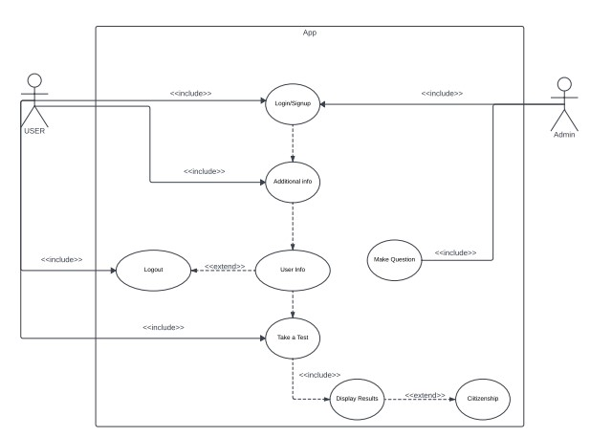

# UML class diagram

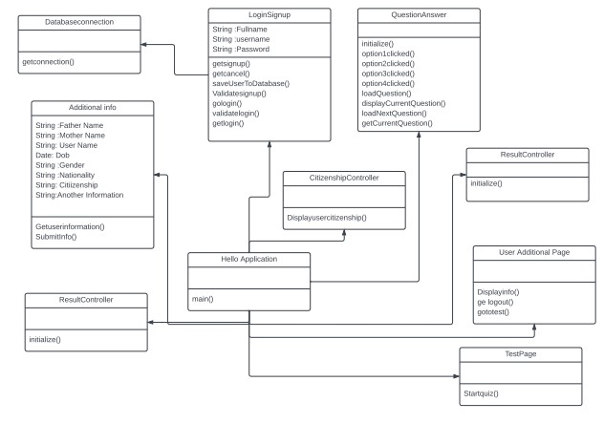

# User Interface static prototype

Creating a static prototype for an Automated Citizenship Assessment System for Masathai involves designing the user interface and its key components. Here's a simple static prototype for such a system:

Login Page

* Login form with fields for email, password.
* Option for users to log in.
* Option for users to register for a new account.

Design Prototype Screenshot:

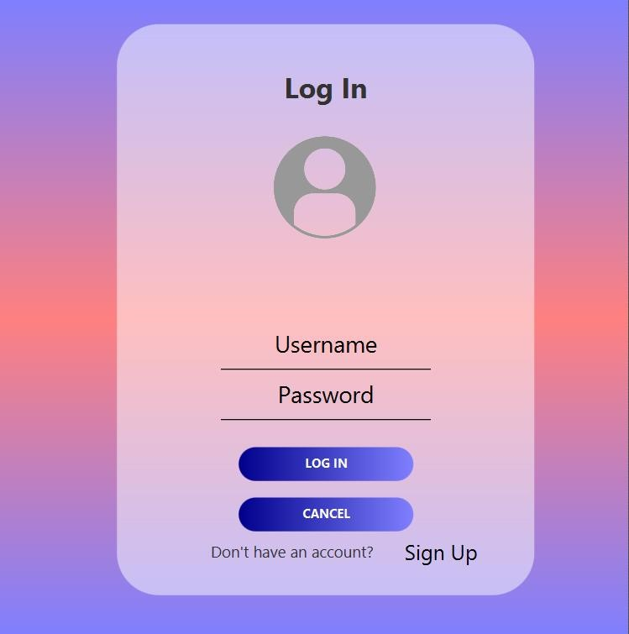

Signup Page:

* Registration form with name, email, password, mobile number.
* Option for users to create new accounts.
* Option for users to go to the Login Page.

Design Prototype Screenshot:

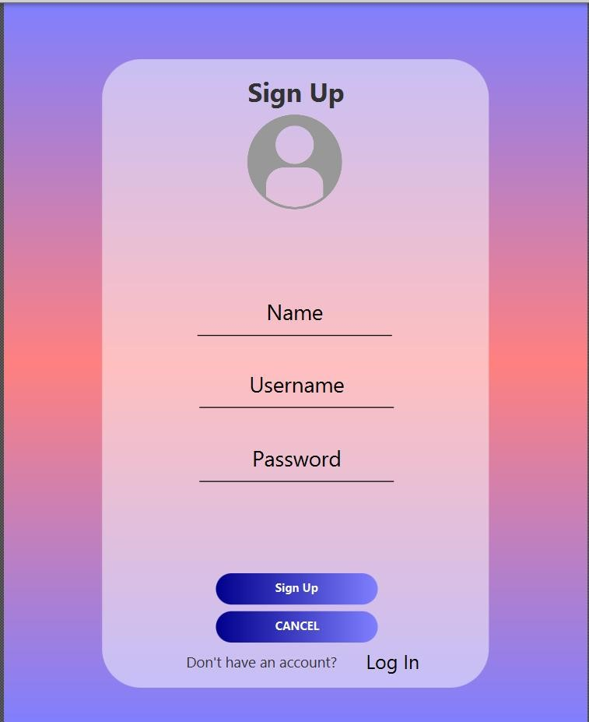

## User Additional Information Page

* Information form with gender, date of birth, nationality, father’s name, mother’s name, previous country citizenship ID.
* Option for users to add new information.
* Option for users to submit their information.

Design Prototype Screenshot:

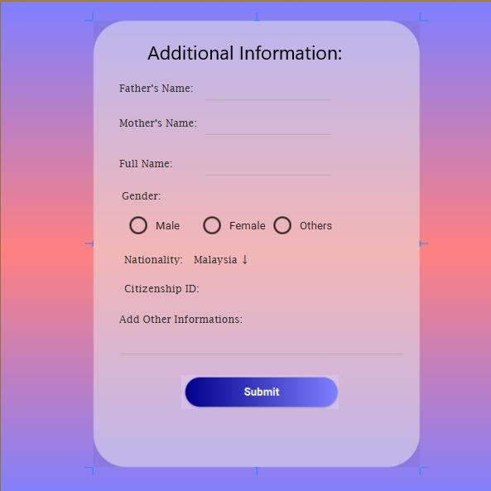

## User Additional Page

* Display Users: gender, date of birth, nationality, father’s name, mother’s name, previous country citizenship ID.
* Option for users to Logout

Design Prototype Screenshot:

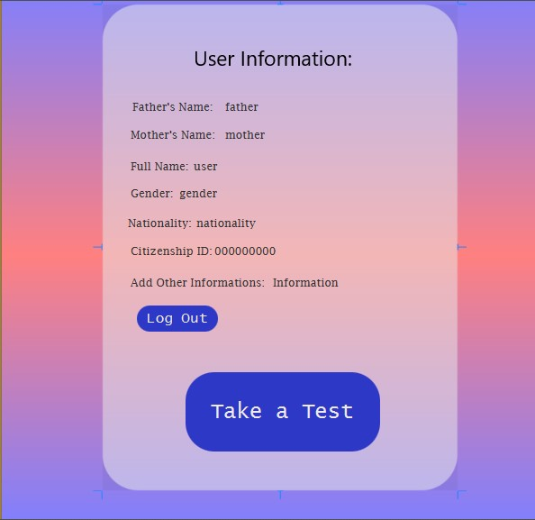

## Take the Test Page

* Title: "Masathai Citizenship Test."
* Brief description of the purpose and importance of the test. • Button to start the test.

Design Prototype Screenshot:

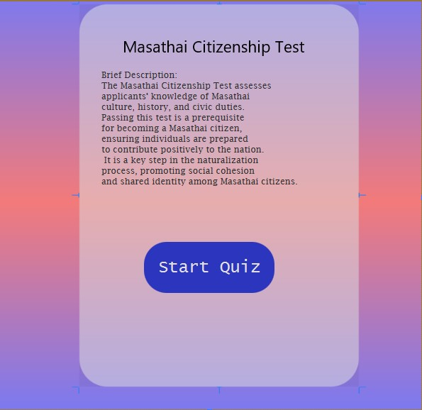

## Test Interface

* Welcome message with the user's name.
* Timer to indicate the time remaining for the test.
* Display of the current question number out of the total. • Question text.
* Multiple-choice options (typically 4) for each question. • A "Submit" button to finish the test.

Design Prototype Screenshot:

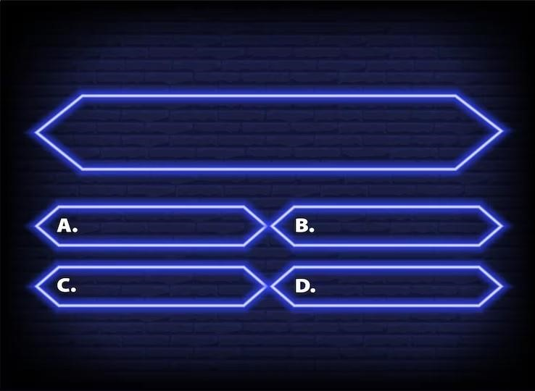

## Display Result

* Title: "Test Results."
* Display of the user's name and nationality.
* Overall score or percentage achieved in the Masathai Citizenship Test.
* Display correct marks obtained, incorrect marks obtained.
* A congratulatory message for successfully completing the test.
* Button to return to the home page

Design Prototype Screenshot:

