

|  |  |
| --- | --- |
| **Assignment No./Title** | **Assignment Task 2 & Task 3 (Group Project)20% (PART A - ANALYSIS AND DESIGN)**  **30% (PART B - DEVELOPMENT)** **10% (PRESENTATION)** |
| **Course**  **Tutor/Lecturer** | Mr. Biju Maharjan/ Mr.Subit Timalsina |
| **Submission Date** | 09/11/2023 (PART A - ANALYSIS AND DESIGN)  23/11/2023 (PART B - DEVELOPMENT)  23/11/2023 (PRESENTATION) |
| **Student Name, ID and Signature**   1. Dev Mani Maharjan, 0355610 2. Aadarsh Shrestha, 0355711 3. Yujen Maharjan, 0355776 4. Aslin Karmacharya, 0355447 5. Sagun Karki, 0355487 | |

**Declaration** (need to be signed by students. Otherwise, the assessment will not be evaluated)

Certify that this assignment is entirely my own work, except where I have given fully documented references to the work of others, and that the material contained in this assignment has not previously been submitted for assessment in any other formal course of study.

|  |  |
| --- | --- |
| **Marks/Grade:** | **Evaluated by:** |
| **Evaluator's Comments:** |  |

**Table of Contents**

**Resourses 4**

**Testing 4**

**Sign Up 5**

**Login page 6**

**Additional Information 7**

**User Information 8**

**Description 9**

**Quiz 10**

**Result 11**

**Admin Signup: 12**

**Development 13**

**Question and Answer in CSV 15**

**Result csv 16**

**Java Controller 17**

**Additional Controller 17**

**Admin Controller 18**

**Database Connection 21**

**Hello Application 21**

**Login Signup 22**

**Quiz Page Controller 25**

**Result 27**

**Test Description Page Controller 28**

**User Additional Page 30**

**Designing (css) 30**

**Login signup 31**

**Test 32**

**OOP concepts 32**

**Inheritance 33**

**Encapsulation 34**

**Polymorphisms 35**

**Abstraction 37**

**Conclusion 38**

# Resourses

# Testing

## Sign Up

* A new user can register by providing their name, username, and password in the form. Then it is registered in sql database.

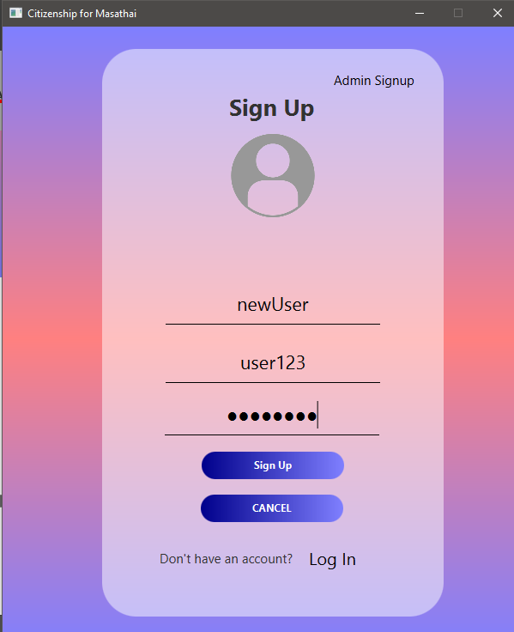

* If anything is missed, “Fill the form” is displayed

## Login page

* 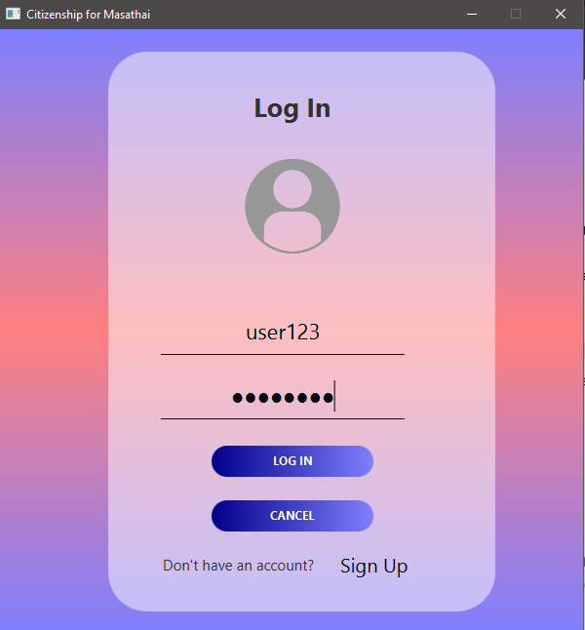By entering our username and password, we can access the log-in page.
* The message "Enter your user name and password" appears if something is missed.



## Additional Information

* Data about new users, including full name, DOB, nationality, citizenship ID, father's and mother's names, and gender, should be entered into the additional information page and stored in a sql database.

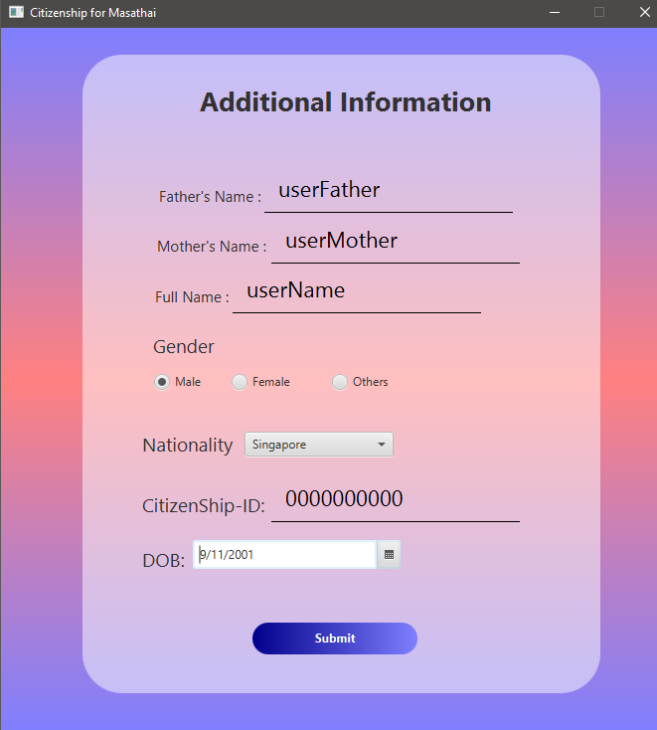

## User Information

* The user's added additional details are visible

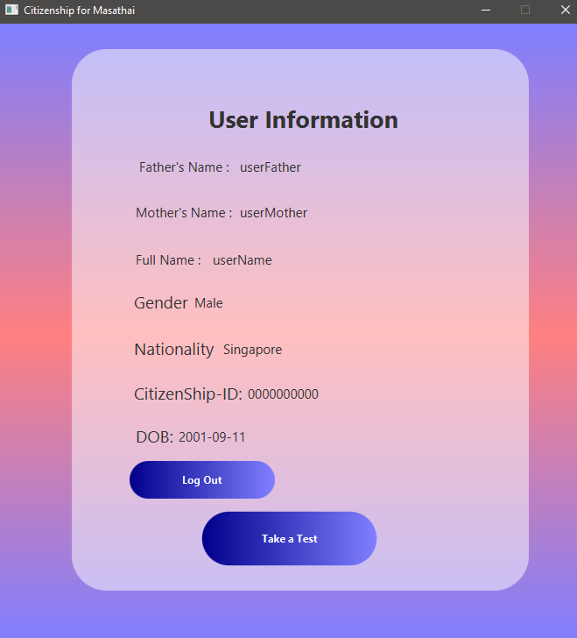

## Description

* An explanation of the Masathai Citizenship Test is shown, along with a button to initiate the test.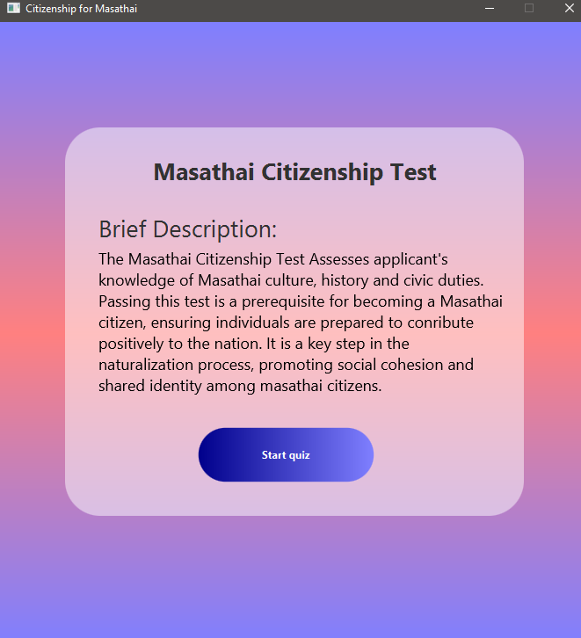

## Quiz

* The questions are displayed when the user begins the quiz based on their country.
* The buttons for previous and next questions are functional.
* When 20 questions are submitted, “Submit” button should be
* The quiz time is for 5 minutes. If 5 minutes is crossed, then it is directly submitted

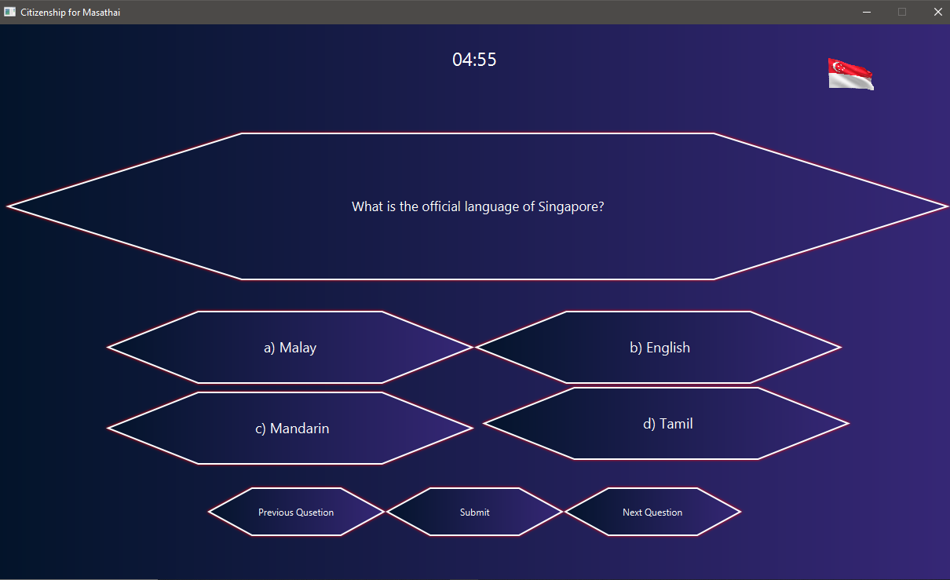

## Result

* The username is shown along with their nationality.
* Their passing or failing grade is indicated, and a progress bar showing right and wrong is shown.
* If user has passed, “Congratulations, You are eligible for citizenship for Masathai” is shown.
* If user has wrong, “You have failed the citizenship test for Masathai” is shown.
* A button asking the user to log out or return to the home page is displayed.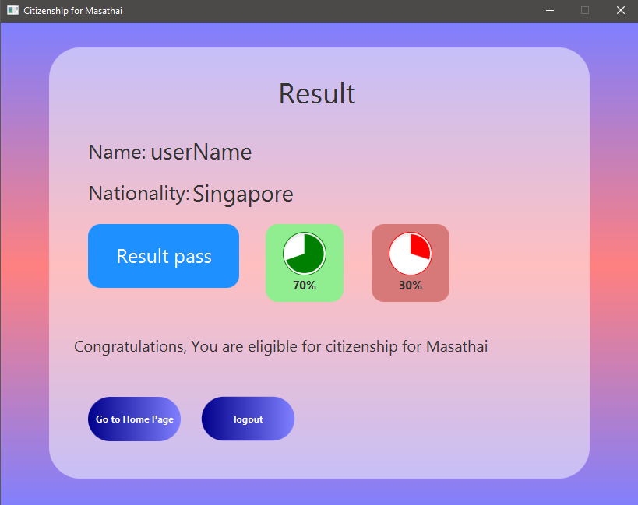

## Admin Signup:

* Click on Admin Signup to register and provide your username and password.

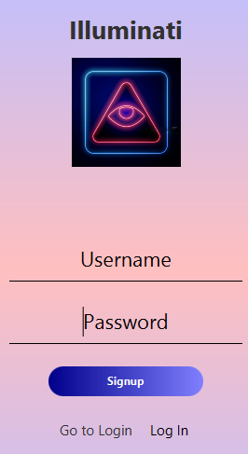

* For security purposes, a pin verification is necessary because it is for registration of administrator.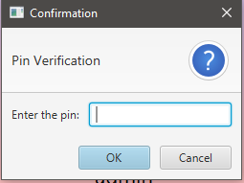**Admin POV**
* The admin page displays the following metrics: mean, median, mode, standard deviation, minimum and maximum marks.
* According to the user selected, result of being pass or fail, progress indicator of their correct answers and wrong answers

# Development

**Sql for login and signup page**

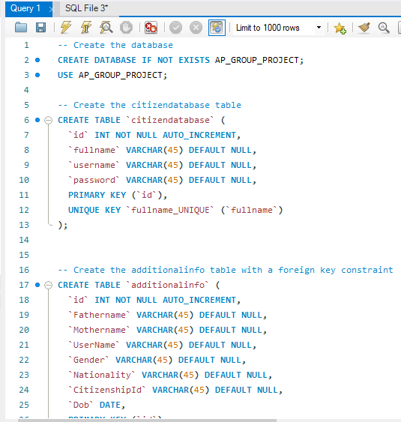

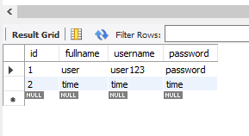

# Question and Answer in CSV

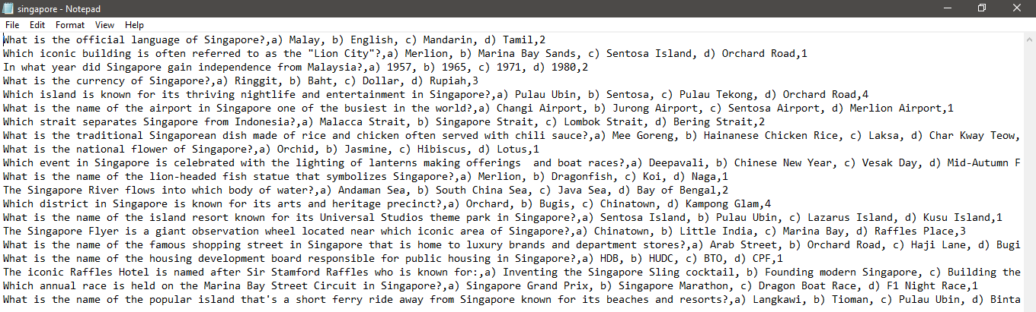

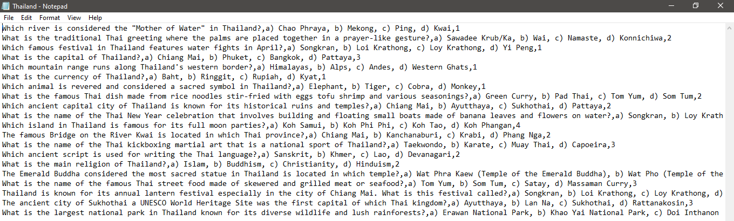

## Result csv

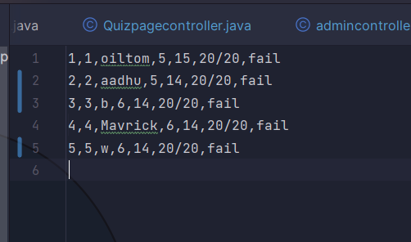

# Java Controller

## Additional Controller

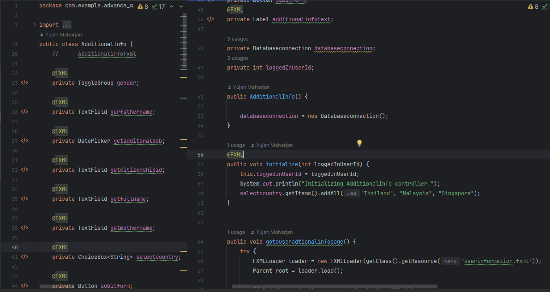

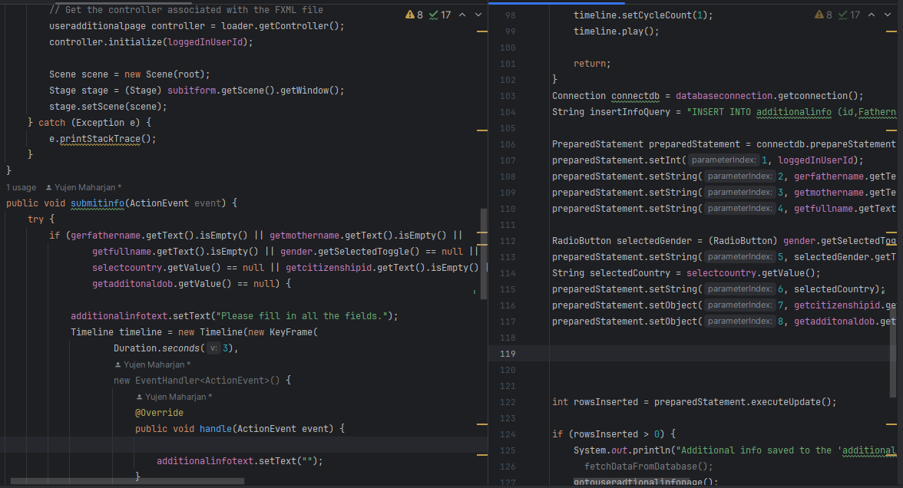

## Admin Controller

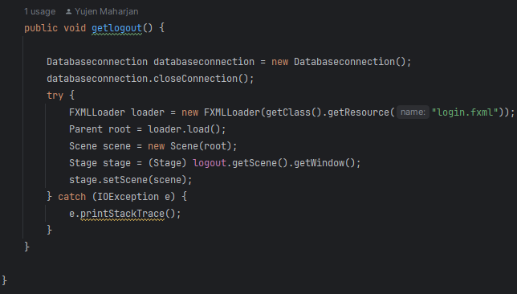

## Database Connection

## Hello Application

## Login Signup

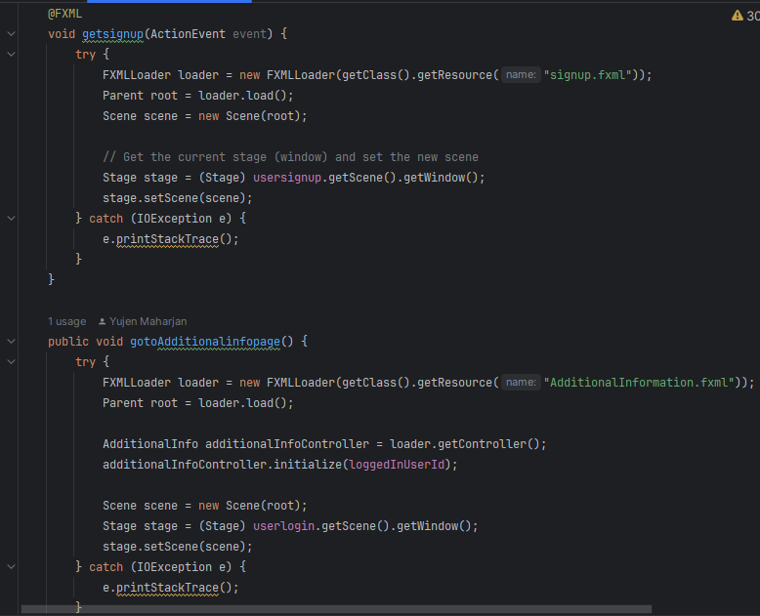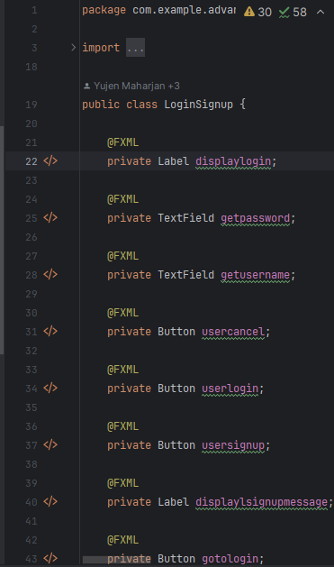

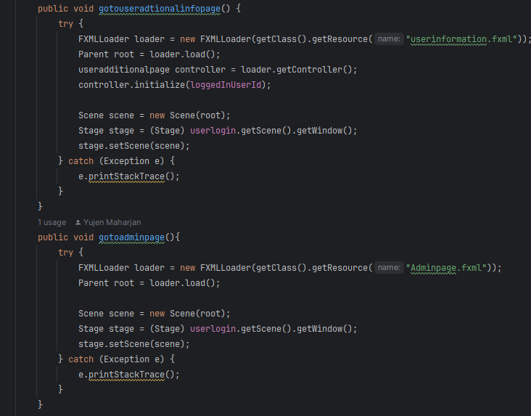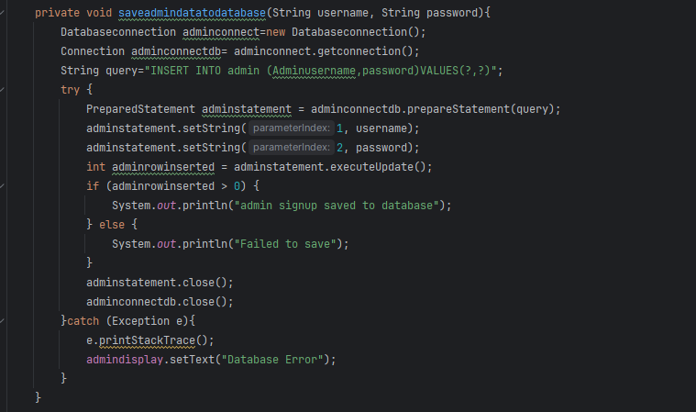

## Quiz Page Controller

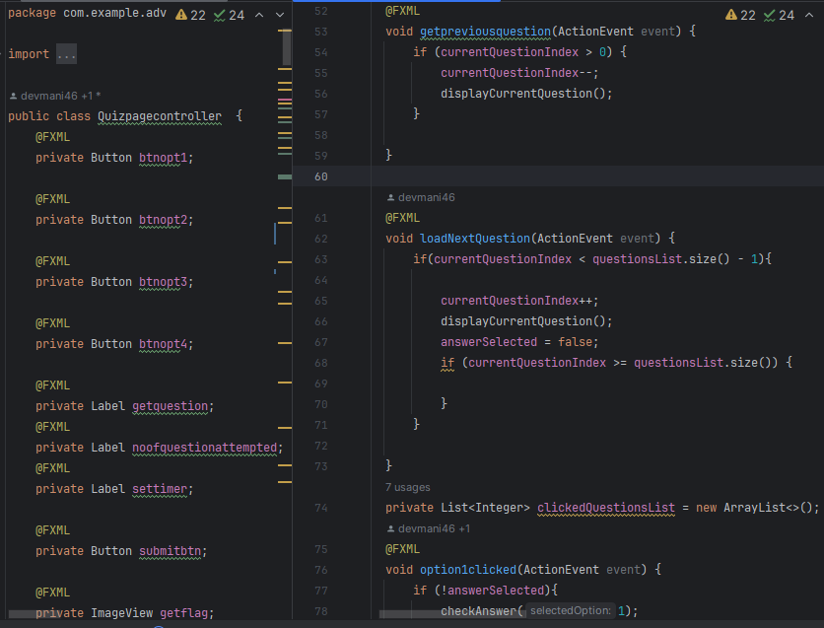

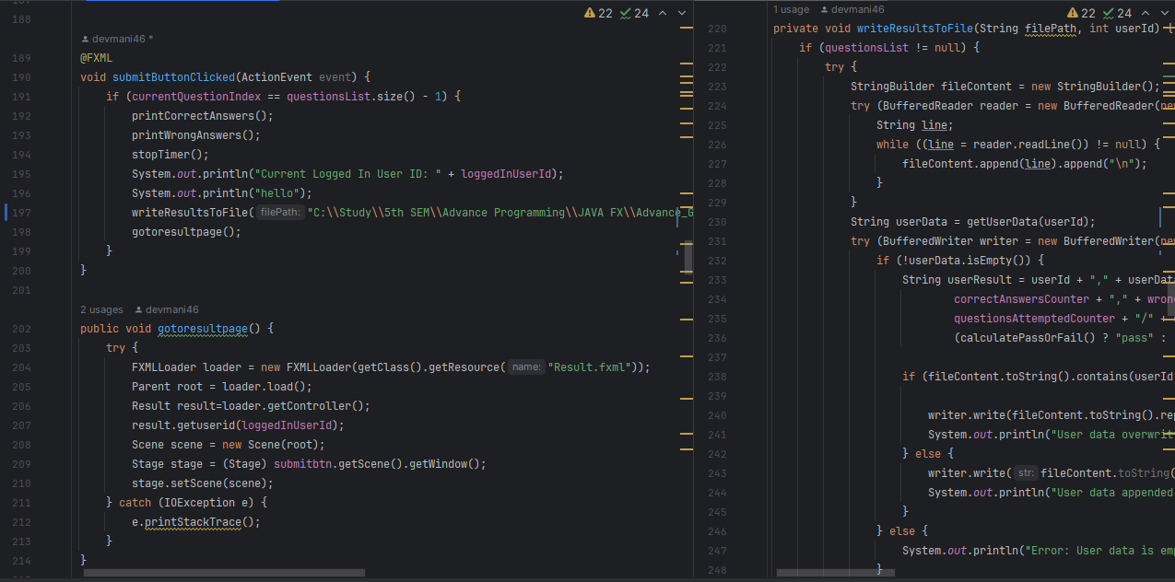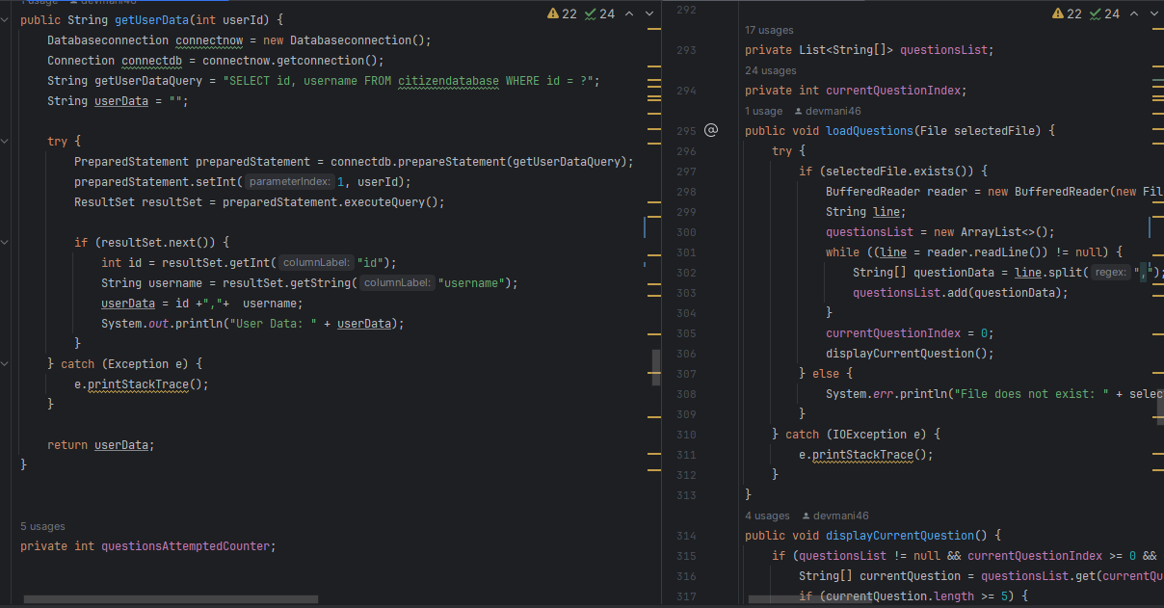

## Result

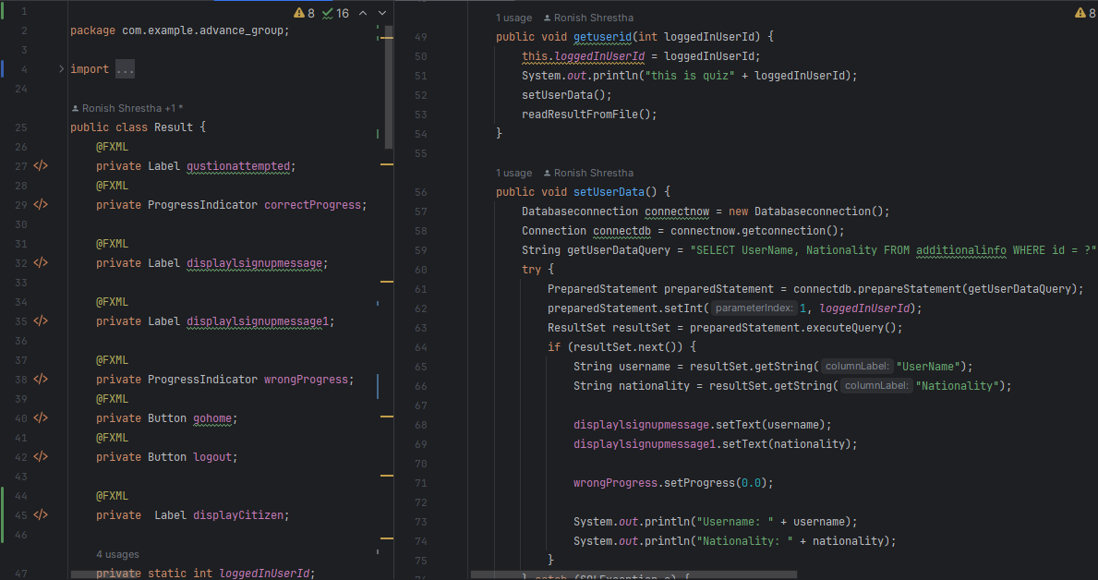

## Test Description Page Controller

## User Additional Page

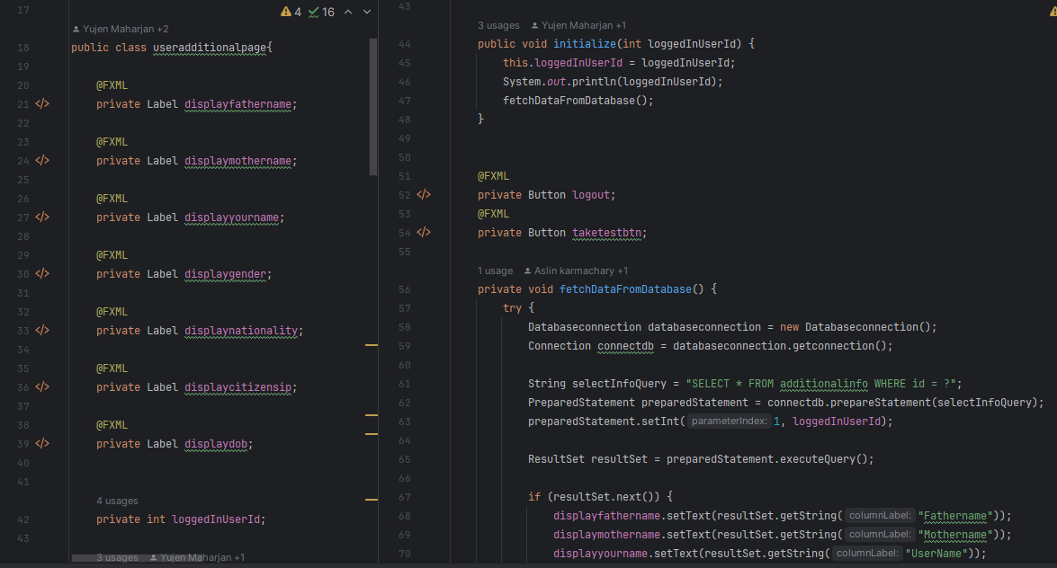

# Designing (css)

## Login signup

## Test

# OOP concepts

## Inheritance

* The JavaFX library contains the Application class, which is extended by the HelloApplication class. In order to utilize the functionality of the Application class, HelloApplication inherits from it. This is an example of inheritance.

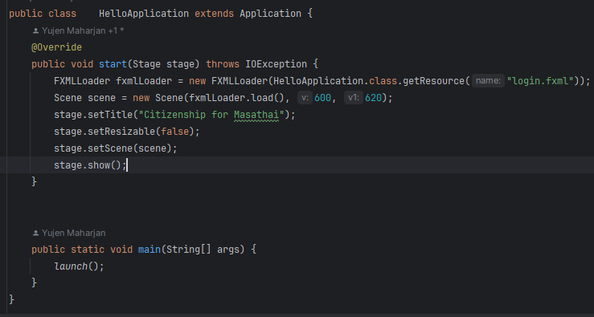

## Encapsulation

* The methods and fields (such as getlogin, getusername, getpassword, and validatelogin) are grouped together. Additionally, the method getlogin serves as an event handler, which is a common pattern in GUI programming, demonstrating the concept of event-driven programming.

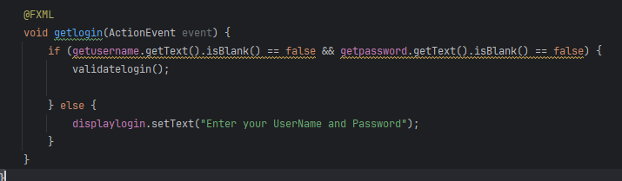

## Polymorphisms

Polymorphism through method overriding, method overloading, and dynamic method dispatch:

**Method Overriding:**

* In the **AdminSignup** class, the **validatelogin** method is overridden to provide a specialized implementation for admin login validation.

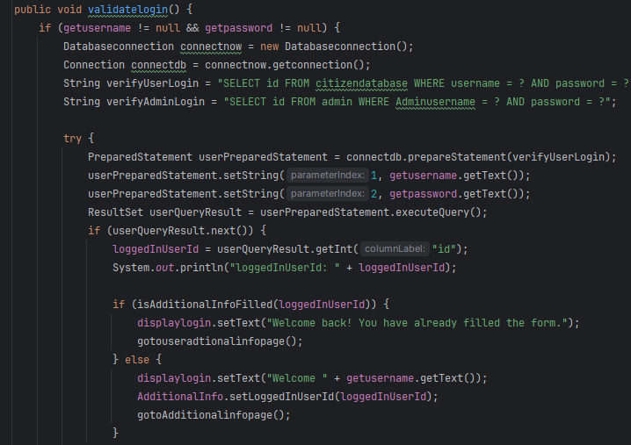

**Method Overloading**:

* Multiple versions of **saveUserToDatabase** and **saveadmindatatodatabase** exist, each accepting different parameter lists.

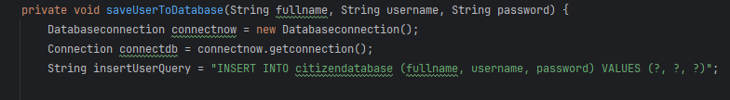

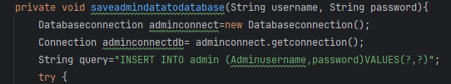

**Dynamic Method Dispatch**:

* The concept is illustrated when calling **validatelogin** on an instance of **AdminSignup** through a reference of the parent type (**LoginSignup**). The overridden method in **AdminSignup** is dynamically invoked at runtime based on the actual object type.

## Abstraction

Abstraction is an object-oriented programming (OOP) concept that involves simplifying complex systems by modeling classes based on the essential features they share. In Java, abstraction is achieved through abstract classes and interfaces.

**Abstract Class**:

* The **LoginSignup** class is not marked as abstract, but it contains abstract methods, such as **Validatesignup** and **getLoggedInUserId**. Abstract methods are declared without implementation in the abstract class and must be implemented by concrete subclasses.

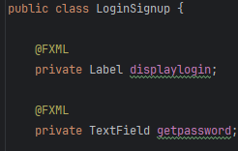

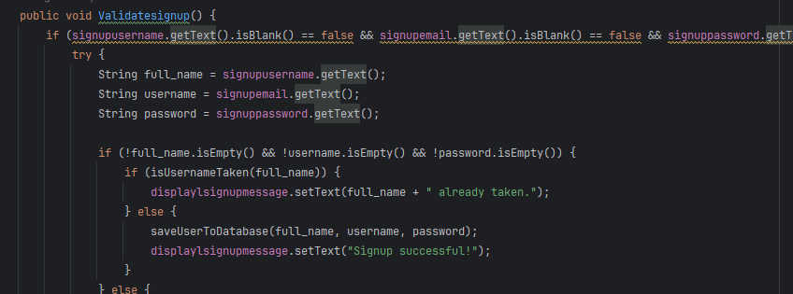

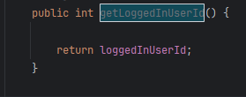

# Conclusion

In conclusion, the completion of our work on Automated Citizen Assessment System for Masathai is a monumental step toward integrating the Malaysian, Singaporean, and Thai countries. This proposal has very carefully delineated the history of such a system, and the importance of using an automated system to distribute knowledge and determine the level of citizen’s understanding. The system which has its foundation on the vision and mission is aimed at realizing an enlightened and networked Masathai citizens through a well-defined and easily accessible citizenship test.

We have documented the peculiarities of each country’s culture to provide a base that takes into account the multicultural dimension of our global community.

As a team, we have different skills and roles that we are going to put in place to ensure that our automated citizenship assessment system is functional and user-friendly. This involves delineation of duties between the two entities which aims to create a system that is efficient and effective in consideration of the end user’s experience.

This indicates that there was thorough planning regarding the entire system requirement, UML diagrams, and technical implementations demonstrated in this proposal. We anticipate that the Automated Citizenship Assessment System will become a symbol of its educational worth, greatly aiding the development of a common Masathai identity and culture.

**Turnitin Report**

