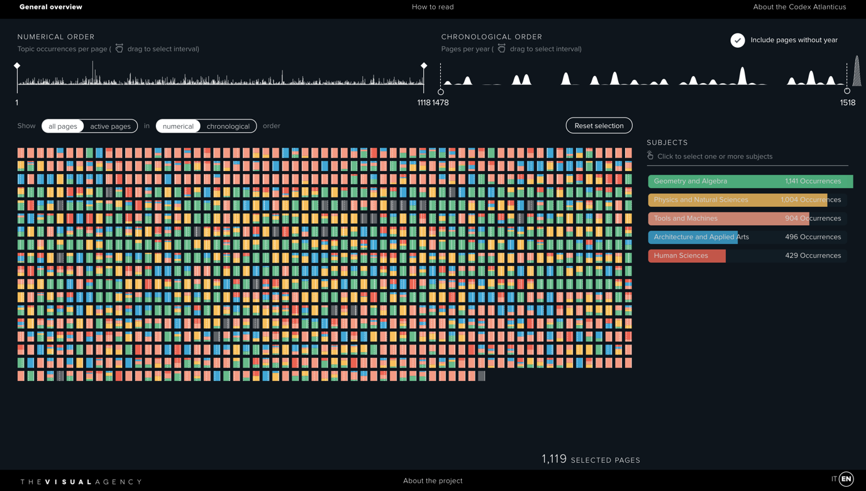

<https://codex-atlanticus.it/#/Overview>

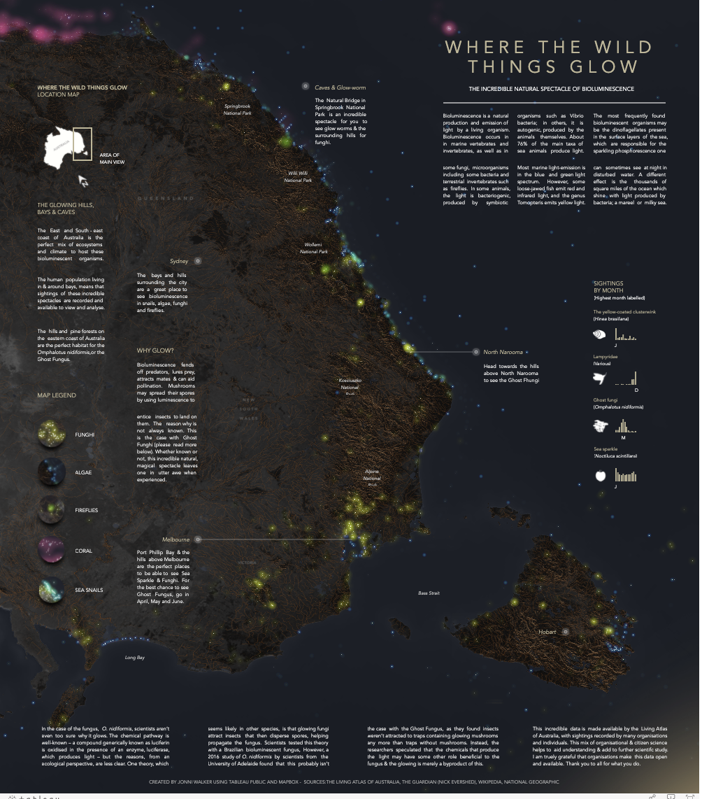

<https://public.tableau.com/views/WhereTheWildThingsGlow/Tester?:embed=y&:display_count=yes&publish=yes&:toolbar=no&:origin=viz_share_link&:showVizHome=no>

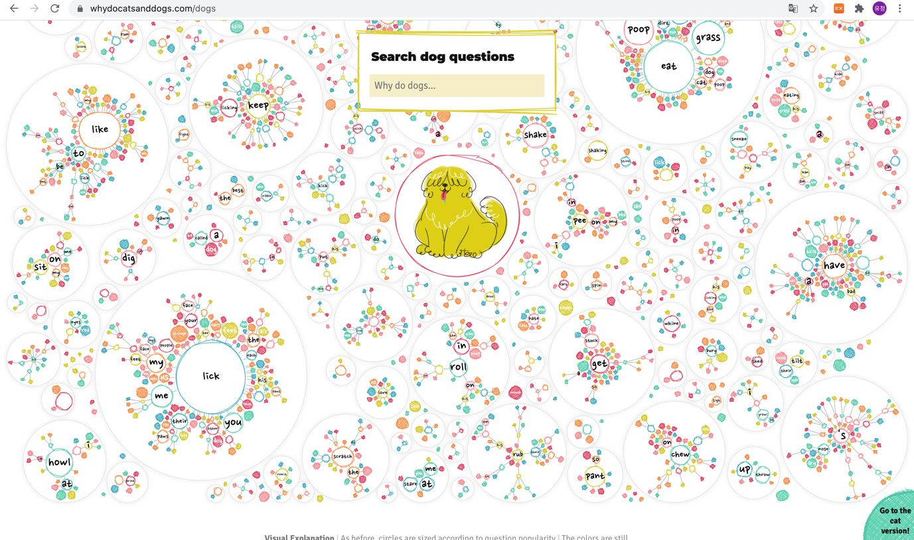

<https://whydocatsanddogs.com/dogs>

These visualisations are all simple but beautiful and catch people's attention. There's a combination of colours used in data visualisations, the shapes used to make it easier for people to see, and the order that looks complicated but actually is simple and I can find easily the information I want. Especially, Da Vinci's visualisation of codex looks complicated, but it's very simple and neat. It was very impressive that we could express a variety of information in this way. I think it'll help a lot with colour combinations and how to distinguish data later on when visualising data.