Smart City Traffic Intelligence
  - Part 3 | Machine Learning and AI | Yujin Cho | 11 October 2026

Purpose and connection to Parts 1 and 2
This project supports traffic analysis on the westbound I-94 corridor near Minneapolis–St Paul. It extends the SQL and Power BI exploration in Part 1 and the Python cleaning and feature-engineering workflow in Part 2. Part 3 rebuilds learned preprocessing from the raw CSV using training data only, avoiding leakage from full-dataset imputation or scaling. The solution estimates hourly traffic volume, demonstrates proxy classification, identifies traffic patterns and recommends travel timing.
No real accident dataset was sourced. The classification target is a rule-based proxy and must not be interpreted as accident probability. Likewise, traffic volume is not a direct measurement of travel time, speed or road capacity.

Data preparation and evaluation design
The raw file contains 48,204 records and nine columns. Removing 17 exact duplicates leaves 48,187 records across 40,575 unique timestamps. Different weather records sharing a timestamp remain. A chronological 70/15/15 split is applied to unique timestamps so that the same hour cannot cross partitions; row proportions therefore differ slightly.
Partition | Records / unique hours | Time coverage
Train | 33,497 / 28,402 | 2012-10-02 09:00 to 2017-05-10 04:00
Validation | 7,274 / 6,086 | 2017-05-10 05:00 to 2018-01-19 14:00
Test | 7,416 / 6,087 | 2018-01-19 15:00 to 2018-09-30 23:00

Temperature at or below 0 K, rainfall below zero or above 9,000 mm, negative snowfall and cloud cover outside 0–100 are treated as invalid. Ten temperature values and one rainfall value in training are imputed using training monthly medians, with training-wide medians as fallback. Validation and test weather values require no imputation. This is a basic plausibility screen, not comprehensive sensor validation.
Seventeen common inputs cover hour, weekday, month, weekend and holiday indicators, sine/cosine encodings of hour and weekday, Celsius temperature, precipitation, cloud cover, rain/snow indicators, a low-visibility proxy and weather category. Holiday markers are propagated to their recorded date within each partition. Numeric scaling and weather one-hot encoding are fitted only on training data.

Task 1 | Supervised prediction
Training quartiles are Q1=1,160, Q2=3,331 and Q3=4,924. Categories are Low (volume ≤ Q1), Medium (Q1 < volume ≤ Q2), High (Q2 < volume ≤ Q3) and Severe (volume > Q3). A positive proxy label requires High/Severe volume together with snow, thunderstorm or squall, or a low-visibility category (mist, fog, haze or smoke). These project-defined weather rules are not calibrated severity measurements. The traffic target and its derived labels are excluded from model inputs.
Ridge (alpha=1) and Random Forest regression were compared. Classification compares balanced Logistic Regression (max_iter=2,000) with a balanced Random Forest. Both forests use 100 trees, maximum depth 16, minimum leaf size 3 and random_state=42. Classification uses a fixed score threshold of 0.5; selection uses validation F1, with ROC AUC as a tie-breaker. Regression selection uses validation MAE.
Regressor | Validation MAE | Validation R² | Fit seconds
Ridge | 813.41 | 0.7242 | 0.18
Random Forest | 249.84 | 0.9587 | 2.83
Neural network | 279.05 | 0.9527 | 41.71

Validation classifier | Accuracy | Precision | Recall | F1 | ROC AUC
Logistic regression | 0.9698 | 0.8124 | 0.9834 | 0.8898 | 0.9965
Random Forest | 0.9900 | 0.9531 | 0.9668 | 0.9599 | 0.9986

Random Forest is selected for both tasks. Held-out regression MAE is 246.60 vehicles and R² is 0.9510. Held-out classification accuracy is 0.9784, precision 0.8621, recall 0.9777, F1 0.9162 and ROC AUC 0.9954. The test partition contains 895 positive proxy labels. No threshold or model retuning is performed on the reported test results.
High classification scores partly reflect the deterministic weather rule reused in the inputs. They measure agreement with an engineered label, not accident prediction. Repeated timestamps retained within partitions also weight some hours more heavily. These are record-level metrics, not independent-hour confidence estimates. Observed weather is used, so this is conditional traffic estimation rather than a validated advance weather-forecast service.

Task 2 | Clusters and association rules
K-means uses training traffic volume, cyclical hour features, weekend indicator, temperature and cloud cover, standardized on training data. Values k=2–6 were compared using a fixed 3,000-record silhouette sample. k=3 gives the highest silhouette score, 0.2645. Separation is modest; the clusters summarize overlapping patterns rather than definitive traffic states.
Cluster | Records | Mean volume | Interpretation
0 | 12,820 | 5,229.06 | Almost entirely weekday daytime
1 | 9,505 | 2,532.90 | Weekend observations
2 | 11,172 | 1,550.61 | Weekday evening/night observations

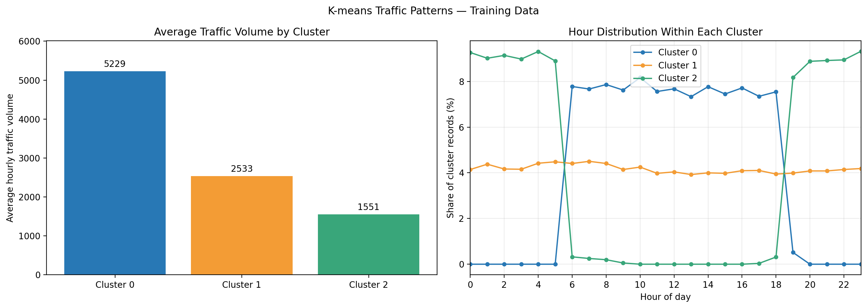
Figure 1. Cluster means and the distribution of record hours within each cluster. A common observation hour is not necessarily a traffic-volume peak.
Association rules enumerate combinations of time band, day type and weather, with congestion category as the consequent. Rules require support ≥1%, confidence ≥60% and lift >1. The highest-lift rule is Weekend + 00–05 → Low: support 6.48%, confidence 88.72%, lift 3.5485. The highest-lift High/Severe rule is Weekday + 06–09 + Clear → Severe: support 2.37%, confidence 86.12%, lift 3.4464. The next is Weekday + 06–09 + Rain → Severe: support 1.16%, confidence 86.06%, lift 3.4442.
Thus weekday mornings frequently coincide with high volume even in clear weather. Lift compares conditional frequency with the overall category frequency; it does not demonstrate causation. Rules were discovered on training records and have not been independently validated as interventions.

Tasks 3 and 4 | Neural network, explainability and tracking
A feed-forward MLP was chosen for tabular demand estimation: two hidden layers (64, 32), ReLU, Adam, alpha=0.001, batch size 256, learning rate 0.001 and up to 300 iterations. Inputs and target are scaled on training data. Training stopped after 132 iterations under the training-loss tolerance criterion; early_stopping=False avoids an internal random validation split. Test MAE is 281.63 and R² is 0.9433. The lower training loss does not establish better generalization; Random Forest remains the stronger validation model.
SHAP TreeExplainer is applied to the comparable Random Forest on the same regression task. This explains the selected deployable model directly and avoids conflating its explanations with the MLP. Two hundred validation records were sampled with random_state=42. Mean absolute SHAP is largest for hour_cos (1,414.76), hour (420.69) and hour_sin (195.03), showing strong reliance on time-of-day patterns. Correlated encodings share attribution; these values are not causal effects.
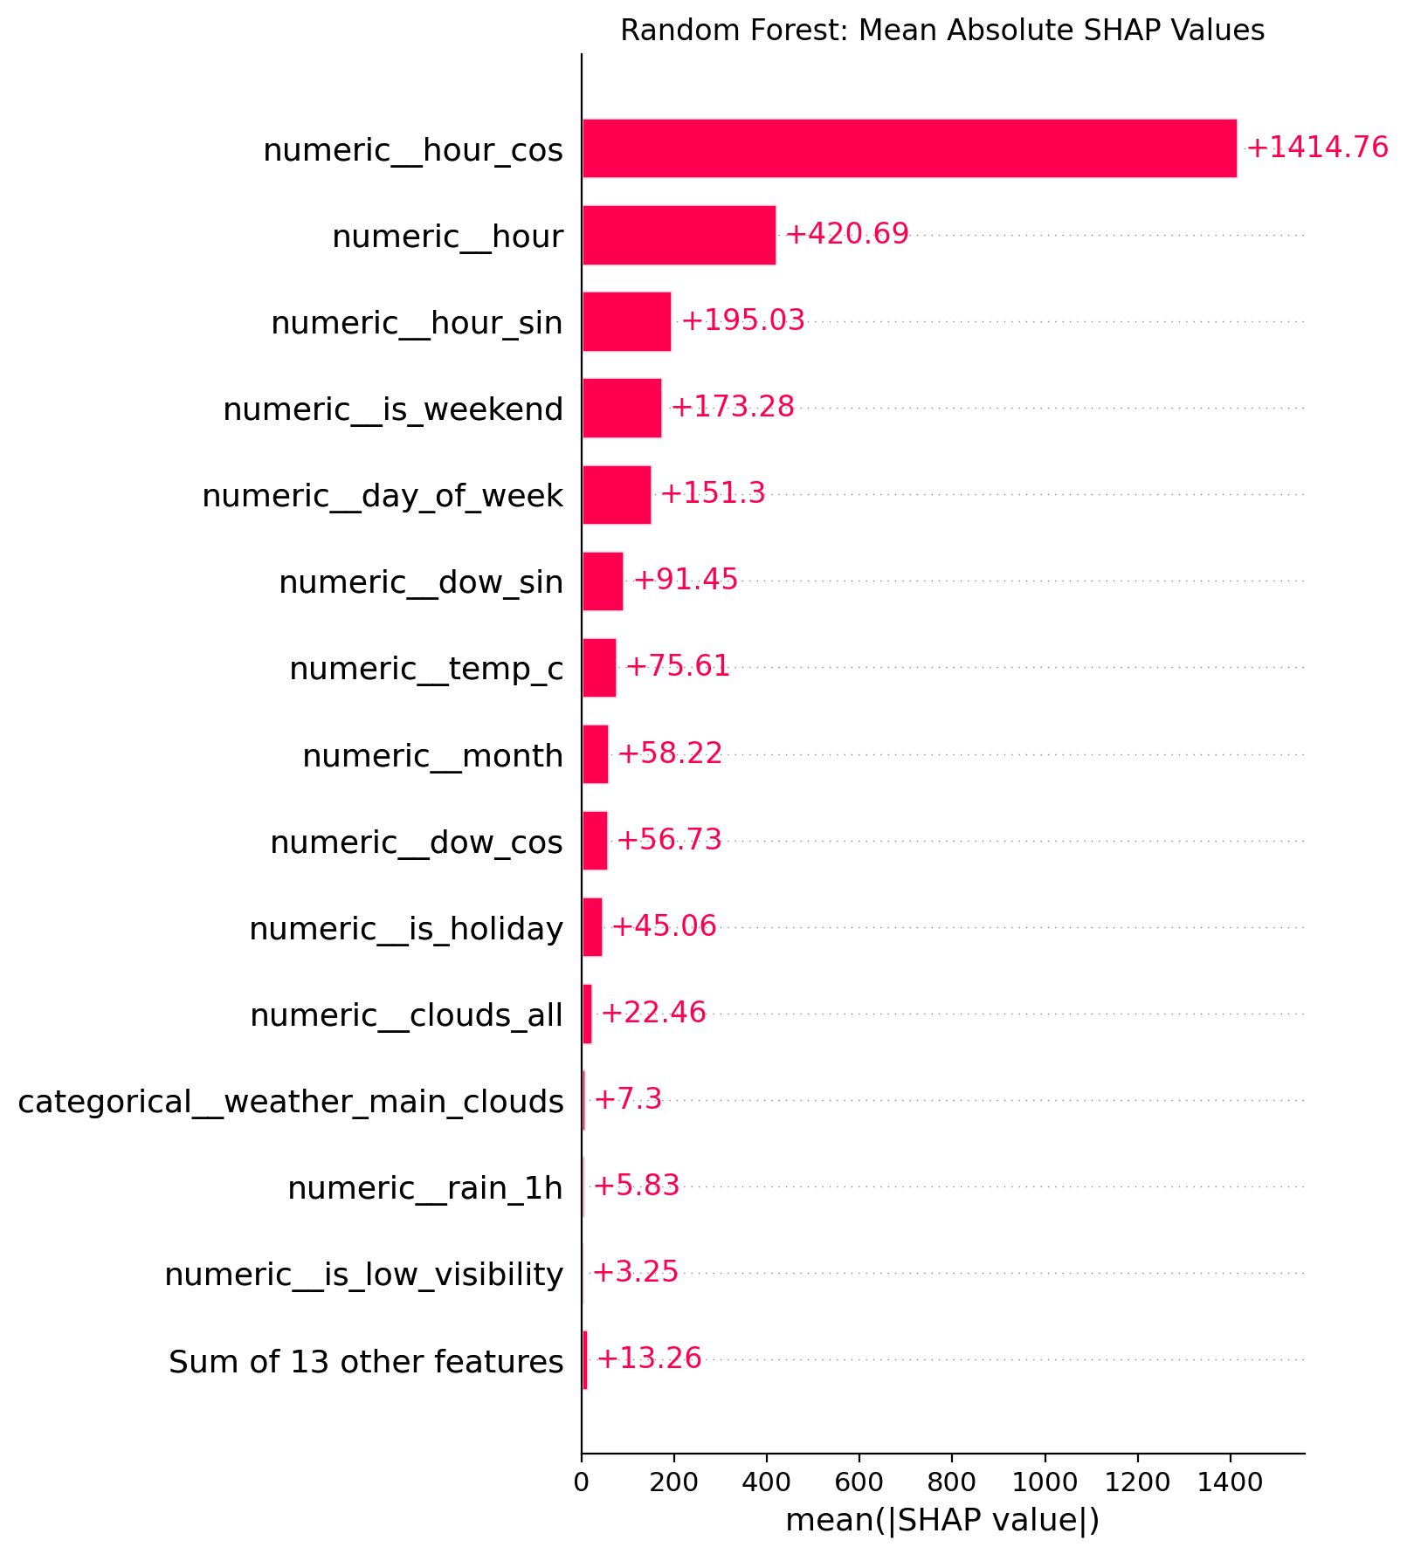
Figure 2. Global SHAP importance on 200 validation records. A separate local waterfall explains one prediction; displayed numeric inputs there are standardized values.
MLflow was selected as the advanced technique because it links experiments, parameters, metrics and saved artifacts. Five post-training runs are stored in Smart_City_Traffic using SQLite and a local artifact directory. Each has a unique run ID and v1 tag; fitted joblib pipelines and preparation settings are attached. This improves auditability, but v1 is a custom tag, not a registered-model version. These are five algorithm/task configurations, not a demonstrated v1-to-v2 promotion history. UI run duration measures logging time; training_seconds records actual fitting time.

Tasks 5 and 6 | Recommendations and deployment simulation
The recommendation engine ranks historical mean traffic within a requested day type, weather and inclusive hour range. Training observations are averaged by timestamp and weather before profiling. Candidates need at least 10 observed hours. Empty candidate sets return no recommendation with a warning. This engine uses data-driven historical patterns, not model predictions or alternate-route data.
Example: weekday / clear / 06–10 | Mean volume | Observed hours
1. 10:00 | 4,472.42 | 241
2. 09:00 | 4,971.31 | 232
3. 06:00 | 5,502.19 | 263

Plain-language recommendation: For a weekday journey in clear weather, consider the 10:00 hourly period within your requested 06:00–10:00 range. Its historical mean is approximately 4,472 vehicles, lower than the other eligible hours. This is a corridor-specific historical suggestion, not a promise of shorter travel time or safer travel.
The Flask mock-up serves the saved Random Forest regression pipeline. GET /health returns status; POST /predict accepts one JSON object containing all 17 engineered features and returns predicted_traffic_volume plus a version tag. The saved pipeline performs scaling and encoding. Raw timestamps, raw Kelvin temperatures and holiday-calendar lookup are not processed by this endpoint; callers must use the same feature logic as the notebook. Only basic missing-field, text and finite-number checks are implemented.
API check | HTTP status | Outcome
Health endpoint | 200 | PASS
Prediction matches notebook model | 200 | PASS; example 5,841.33
Missing features rejected | 400 | PASS

These checks use Flask’s in-process test client and demonstrate the API contract, not a public or production deployment. The script can start a local server on 127.0.0.1:5001.
Error monitoring compares MAE with 1.25 × validation MAE: 312.30. Actual test MAE 246.60 returns PASS. Adding 1,000 to predictions produces MAE 1,031.64 and ALERT. The 25% margin is a project-defined demonstration threshold. The alert is synthetic; this is not evidence of live concept drift. Monitoring requires subsequently observed traffic labels and does not include a feature-distribution drift detector.

Task 7 | Responsible use, sustainability and delivery
The condition audit finds larger errors on weekends (MAE 343.16 versus 207.00 on weekdays), in fog (616.61) and snow (558.56), and during 16–19 (351.59). In 20–23, all six positive proxy records are missed. Smoke has only two records. Missing recall/FPR values indicate absent denominator classes, not zero error. Full evidence and proposed controls appear in the accompanying Bias, Fairness and Responsible AI Report.
One corridor, historical coverage gaps, recurring weather records and incomplete holiday markers limit representativeness. There are no protected-group attributes for demographic fairness testing. Operators should review group-level performance, validate on later independent observations and real outcomes, document model changes and retain human authority. These models should not autonomously control safety-critical traffic decisions.
Random Forest fitting took 2.83 seconds versus 41.71 seconds for the MLP on this run and also achieved better validation accuracy. Fit time is a resource proxy only: energy, carbon emissions and inference power were not measured. Reusing fitted models, limiting SHAP to 200 samples and avoiding unnecessary searches reduce computation. Future monitoring-driven retraining should balance resource costs with meaningful performance gains.

Reproducibility and artifact map
Requirement | Evidence / location
Supervised and neural models | Notebook; models/; regression and classification CSVs
Clustering and rules | K-means summaries; association_rules.csv; figures/
Explanations | shap_feature_importance.csv; shap_values.csv; two SHAP figures
Tracking/version identifiers | mlflow.db; mlflow_artifacts/; mlflow_run_summary.csv
Recommendation | Notebook recommend_travel(); travel_timing_profiles.csv
Deployment and monitoring | app.py; sample_request.json; API test and monitoring CSVs
Governance and reproducibility | Bias/fairness report; README.md; requirements.txt; logs

All numerical results above refer to the original recorded run. The submission notebook retains those model outputs while making setup paths portable and using named loggers for status reporting. Its setup changes require a local rerun before claiming an end-to-end reproduction. The trained binaries, MLflow database/artifact directory, dependency files and logs must be included in the repository from the local project; a screenshot or CSV does not replace them.

Sources
NUSSOC_AMLDS_Capstone Project Instructions.docx, Part 3 Tasks 1–7; Metro_Interstate_Traffic_Volume.csv; Capstone_Part3 notebook and exported reports/ and figures/ outputs. Values are rounded for presentation. Part 1 and Part 2 reports remain separate portfolio deliverables.

