Lab 2 - I/O and Memory-Mapped I/O
Experimenters: Sun Xiqiao, Chi Junhao, Zhu Yujing
Student ID: 202364831331
Experiment Platform: Nuclei DDR200T Evaluation Kit
Instructors: Zou Yi, Yang Yanfeng
Date: December 17, 2026
I. Experiment Environment
- Board: Nuclei DDR200T FPGA Evaluation Kit
- SoC Core: Hummingbird E203 (RISC-V RV32IMAC)
- Development Tool (IDE): Nuclei Studio (based on Eclipse/CDT)
- Compiler: RISC-V GCC Toolchain (riscv-nuclei-elf-gcc)
- Debug Interface: Hummingbird-Debugger (USB-JTAG)
- Serial Port Parameters: Baud Rate 115200, Data Bits 8, Parity None, Stop Bits 1 (8N1)
II. MMIO Mapping Table and Principle Analysis
2.1 MMIO Mapping Table
According to the E203 data manual and the experimental code implementation, the memory mapping of peripheral devices in this system is as follows. The "Base Address + Offset" in the table constitutes the physical address used in driver development.
Peripheral Module |  | Register Name | Base Address (Base) | Offset (Offset) | Physical Address (Physical Addr) | R/W | Function Description
GPIO A | GPIO_PADDIR |  | 0x1001 2000 | 0x00 | 0x1001 2000 | R/W | Pin Direction Configuration (1=Out, 0=In)
GPIO A | GPIO_PADIN |  | 0x1001 2000 | 0x04 | 0x1001 2004 | RO | Input Level Sampling (Read Switch States)
GPIO A | GPIO_PADOUT |  | 0x1001 2000 | 0x08 | 0x1001 2008 | R/W | Output Level Latch (Control LED)
GPIO A | GPIO_IOFCFG |  | 0x1001 2000 | 0x1C | 0x1001 201C | R/W | Multiplexing Function Configuration (0=GPIO Mode)
UART 0 | UART_TXDATA |  | 0x1001 3000 | 0x00 | 0x1001 3000 | W | Transmit Data FIFO
UART 0 | UART_LSR |  | 0x1001 3000 | 0x14 | 0x1001 3014 | RO | Line Status (Bit 5 = TX Ready)
2.2 In-depth Analysis: UART Status Polling Mechanism
In the MMIO mapping table, UART_LSR (Line Status Register) is the core for achieving reliable communication. Our code must poll a specific bit of this register, and its hardware mechanism is as follows:
- Why Must We Wait for TX Ready (Bit 5) Before Transmission?
  - Hardware Structure: The UART controller contains an internal transmit FIFO (First-In-First-Out) queue. The CPU's operating speed (16MHz+) is far faster than the UART serial port's transmission speed (115200 bps).
  - If Not Waited: If the CPU performs consecutive write operations, the instantaneously generated data volume would exceed the FIFO's depth. Once the FIFO is full, subsequent data written to UART_TXDATA will cause Data Overrun. This results in new data overwriting old data or being directly discarded by the hardware, leading to garbled transmission or packet loss.
  - Correct Logic:
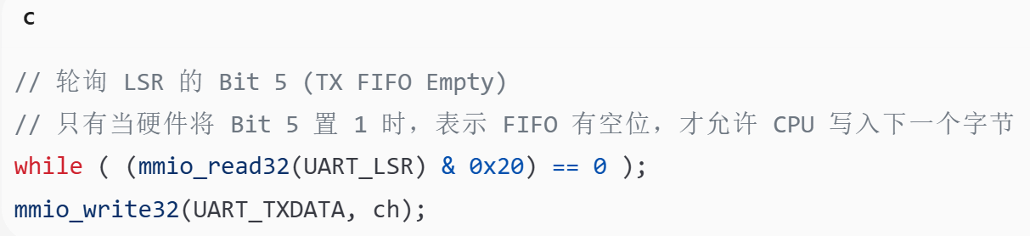
- Why Must We Check RX Valid (Bit 0) During Reception?
  - Side Effect: The UART_RXDATA register is a consumable resource. Reading from this address not only retrieves data but also triggers the hardware to pop the byte from the head of the FIFO.
  - If Not Checked: If the CPU forcefully reads UART_RXDATA when the FIFO is empty, it will obtain invalid data (usually 0xFF or leftover data from the previous operation), corrupting the program logic.
  - Correct Logic:
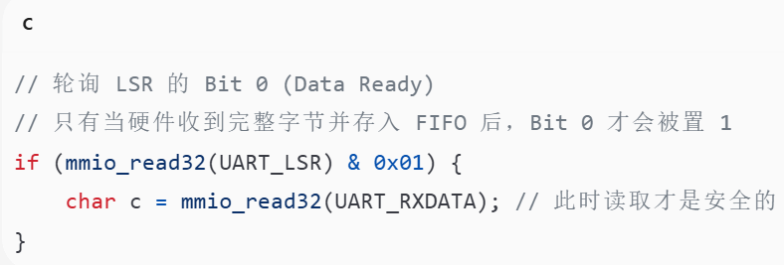
2.3 Minimum System Verification
To verify the correctness of the above MMIO mapping and UART configuration, we wrote a minimum verification program.
- Test Code:
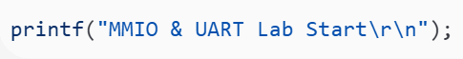
- Verification Criteria:
i. Download: Program successfully flashed to ITCM/Flash.
ii. Reset: SoC reset vector table jump executed normally.
iii.Link: UART baud rate matched, TX/RX lines connected.
- Experimental Results:
The serial terminal successfully displayed "MMIO & UART Lab Start" (see Figure 4.1 in the following section). This proves that the base address 0x1001 3000 is mapped correctly and the underlying _write function has correctly implemented the polling transmission logic.
III. Key Implementation Description
3.1 Register Definition and Access Encapsulation
To achieve low-level hardware control, we established a "Base Address + Offset" mapping model in lab2_mmio.h.
- Physical Mapping: For example, the base address of GPIOA is 0x1001 2000, and the offset of the direction register is 0x00.
- Access Encapsulation: The macro mmio_write32(addr, val) is defined, which internally casts the pointer to volatile uint32_t*. This serves as the foundation for driver development, ensuring that each assignment in C is translated into a write operation on the bus and not optimized away by the compiler.
3.2 LED Running Light and Linkage Logic
- RMW Protection Mechanism: In the implementation of the running light, we avoided direct assignment and adopted a Read-Modify-Write (RMW) strategy: (OLD & ~MASK) | (NEW & MASK). This ensures that when operating the LED pins, the states of other pins on the same port (such as UART or JTAG pins) remain unaffected, guaranteeing the electrical safety of the system.
- Bit-Field Mapping Algorithm: For switch linkage, due to the misalignment between input source bits (Bits 26–31) and output destination bits (Bits 20–25), a right-shift alignment algorithm (input >> 6) was employed to achieve logical mapping at the hardware level.
3.3 UART Polling Transmission and Reception Mechanism
This experiment employs Polling Mode for UART communication, rather than interrupt mode.
- Transmission Mechanism: When printf internally calls _write, the program enters a busy loop to check Bit 5 (TX Ready) of the UART_LSR register. Data is written only when the hardware FIFO has available space (Bit 5 = 1). This prevents data overrun caused by the CPU writing data faster than the UART can transmit.
- Reception Mechanism: (If the code includes reception) Similarly, the program polls Bit 0 (RX Valid) of UART_LSR. Data is read from UART_RBR only when a valid data flag is detected, avoiding the reading of invalid data or triggering erroneous FIFO pop side effects.
- This experiment verifies the UART reception process through an automated demonstration: The program polls Bit 0 (Data Ready) of UART_LSR in the main loop. When this bit is set to 1, it reads UART_RBR and prints the ASCII value of the character. This process fully demonstrates the driver's closed-loop flow: "hardware flag → CPU read → data processing". The experimental output "Received: 't' (0x74)" proves the following:
  - The read operation does not block the program (non-blocking polling).
  - Each read correctly extracts 8-bit data (the & 0xFF mask is effective).
  - The printf formatting output functions normally (hexadecimal display).
IV. Implementation Content
4.1 Task 1: Register Definition and Access Encapsulation
To achieve direct and secure hardware access, we used the volatile keyword to qualify pointers in lab2_mmio.h.
- Code Implementation: *(volatile uint32_t *)addr
- Mechanism Analysis: volatile informs the compiler that this address maps to a hardware register. Its value may change automatically due to hardware actions (e.g., PADIN reflecting external voltage levels), or write operations may have side effects (e.g., writing TXDATA triggers transmission). This forces the compiler to generate a memory access instruction for every read/write operation, prohibiting caching of the variable in a register or instruction reordering.
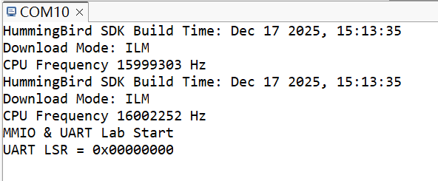
After startup, the string is printed via UART. Being able to see this output indicates that: the download, reset, and serial communication link are fundamentally correct.
4.2 Task 2
Prerequisites have been met:
i): Able to see startup information via the serial port (e.g., MMIO & UART Lab Start\r\n).

ii): The base+offset mapping for GPIOA has been completed in lab2_mmio.h, and register access via mmio_read32/mmio_write32 is functional.
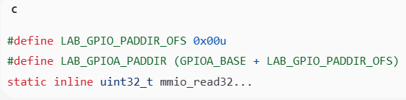
iii): The GPIO registers have been confirmed... for reporting in the MMIO Mapping Table.
The report's Chapter 2 (MMIO Mapping Table) has been written entirely according to these addresses.
iv): Noted: For GPIO_IOFCFG, a corresponding bit=0 indicates the pin is under software control (normal GPIO); bit=1 indicates IOF (peripheral function) control.
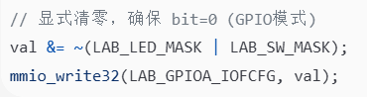
A dedicated section in Chapter 5 (Troubleshooting) of this report states: "Symptom: LED does not light up -> Cause: IOFCFG not cleared -> Solution: Force write 0".
4.3 Task 2：Subtask A - LED Running Light and RMW Protection Mechanism
This task requires implementing a running light effect using the onboard LEDs. Behind the seemingly simple act of "lighting up LEDs" lies a comprehensive test of the GPIO controller register operation flow, specifically the initialization sequence and bitwise protection.
1. Strict Initialization Sequence
According to the experimental requirements, we called the encapsulated lab_gpio_init() function immediately after the main function starts, strictly following these three steps:
- Step 1: Switch Back to Software Control (Clear IOFCFG)
  - Principle: The GPIO pins on the E203 have multiplexing (Mux) logic. After power-on reset, some pins (especially those multiplexed with RGB LEDs) may default to IOF mode (controlled by hardware peripherals).
  - Operation: The bits corresponding to the LEDs in the GPIO_IOFCFG register must be cleared to zero.
  - Code: mmio_write32(IOFCFG, mmio_read32(IOFCFG) & ~LED_MASK);
  - Significance: This is the prerequisite to ensure the PADOUT register can truly control the physical pins.
- Step 2: Configure Output Direction (Set PADDIR)
  - Operation: Set the bits corresponding to the LEDs in the GPIO_PADDIR register to 1.
  - Significance: Enable the output drivers, allowing current to drive the LEDs.
- Step 3: Initial State Setting
  - Operation: Write to GPIO_PADOUT, setting all LED bits to 1 (assuming active-low logic where setting to 1 turns them off).
  - Significance: Prevents random blinking of LEDs during the initial system startup moment.
2. RMW Strategy and Mask Protection (Read-Modify-Write & Masking)
When controlling LEDs, the biggest禁忌 (taboo) is direct assignment (e.g., PADOUT = 0x...), which would corrupt the state of other pins on the same port (such as RGB LEDs or unused GPIOs). We strictly implemented the RMW protection logic recommended in the manual:
- Scenario 1: Toggling LED0
  - Utilizes the property of the XOR (exclusive OR) operation: 0^1=1, 1^1=0.
  - Algorithm:
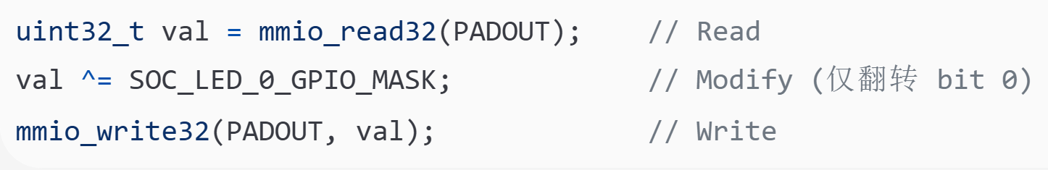
- Scenario 2: Running Light Pattern Update
  - This is the core challenge of this experiment. We need to update the computed led_pattern to the register while absolutely avoiding accidental damage to RGB or other pins.
  - Mathematical Formula (based on the lab manual):
New_Val = (Old_PADOUT & ~LED_MASK) | (Pattern & MASK)
Code Implementation Mechanism:
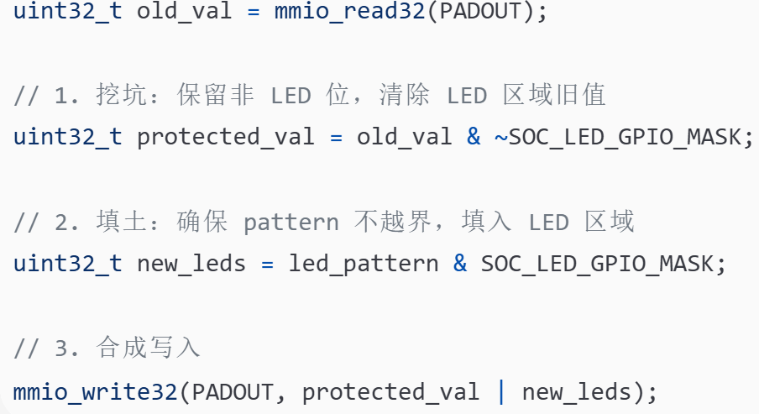
  - Verification: This logic ensures that no matter how led_pattern changes, the operation's effect is strictly limited to bits 20-25 defined by SOC_LED_GPIO_MASK, guaranteeing the electrical safety of the system.
3. Software Delay (Busy-Wait)
This task does not mandate the use of a hardware timer; we implemented the delay using a simple CPU empty loop.
- Implementation: for(volatile int i=0; i<DELAY_COUNT; i++);
- Note: The variable i is declared as volatile to prevent the compiler from optimizing away the empty loop (a common error under O2/O3 optimization), ensuring the LED blinking frequency is visible to the naked eye and stable.
4.4 Task2: Subtask B - Switch and LED Linkage (Bit Mapping & Linkage)
This task requires implementing the function of "toggling a switch (SW) to control the corresponding LED in real-time." This is not merely simple I/O reading and writing, but a deep examination of bit-field mapping and the principles of input/output architecture.
1. Strict Input Mode Configuration
To correctly read the state of external switches, two critical configuration steps must be completed during the initialization phase; neither can be omitted:
- Step 1: Clear IOFCFG (Disconnect Peripheral)
  - Operation: mmio_read32(IOFCFG) & ~SOC_SW_GPIO_MASK
  - Principle: The pins on the E203 may default to IOF mode (connected to other on-chip peripherals). The bits corresponding to the switches must be cleared to zero to "take back" control of the pins for the GPIO module. If this step is omitted, reading PADIN will always return 0.
- Step 2: Clear PADDIR (Set Input Direction)
  - Operation: mmio_read32(PADDIR) & ~SOC_SW_GPIO_MASK
  - Principle: Setting the direction bit to 0 disables the output driver and enables the input buffer.
  - Risk Warning: If a pin connected to a switch is mistakenly configured as output (PADDIR=1) and driven high, while the external switch is grounded (low level), it can create a short circuit from the power supply to ground, potentially damaging the chip pin.
2. Bit Mapping Algorithm
Due to hardware layout reasons, the input sources (SW) and output destinations (LED) are not aligned within the GPIOA port, so direct assignment is not possible. We implemented the mapping using a mask extraction and logical shift algorithm.
- Hardware Layout:
  - Source (SW): Located at GPIOA Bit[26...31]
  - Destination (LED): Located at GPIOA Bit[20...25]
  - Bit Offset: 26-20 = 6 (requires a right shift of 6 bits)
- Core Code Logic:
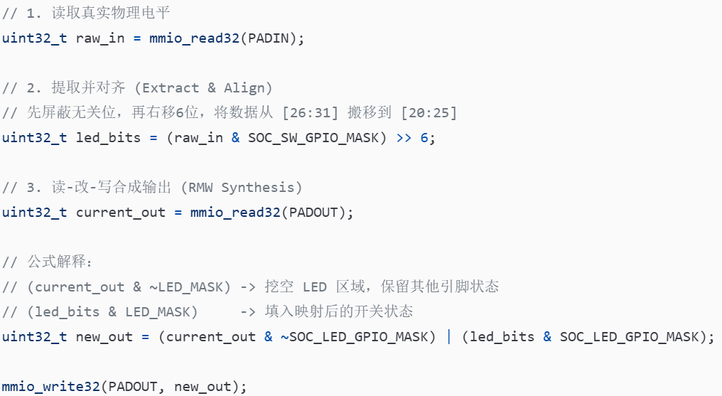
3. Key Mechanism Explanation
In response to the two core discussion points from the experiment requirements, the analysis is as follows:
- 1. Why read input from PADIN and write output to PADOUT?
  - Answer:
    - GPIO_PADIN: Connects after the input buffer of the IO Pad (typically via a Schmitt trigger). It reflects the actual physical voltage state on the pin (determined by the external circuit).
    - GPIO_PADOUT: Is merely the value of the output latch, i.e., the value the CPU intends to output on the pin.
  - Conclusion: In input mode, the value in PADOUT is independent of the external signal. To obtain the switch state, one must read PADIN.
- 2. Why must IOFCFG and PADDIR be configured first?
  - Answer:
    - IOFCFG is the master switch. If not cleared, the GPIO module is physically disconnected from the pin in hardware. Regardless of how direction is configured or what is read, the physical pin cannot be accessed.
    - PADDIR is the steering wheel. If not set to input (cleared), the input buffer may be disabled, causing PADIN to fail to read the signal; or the output driver may be enabled, leading to electrical conflict.
4. Loop Refresh
To ensure real-time responsiveness and stability of the system, we implemented a 50ms delay within the main loop.
- Purpose: This ensures the human eye perceives an "immediate response" (<100ms), while also avoiding potential issues like UART output blockage or excessive power consumption caused by excessively high refresh rates.
V. Experimental Evidence
5.1 Serial Port Interaction Screenshot
After the program starts, the serial port correctly outputs initialization information, verifying that the UART driver and printf redirection are functioning normally.
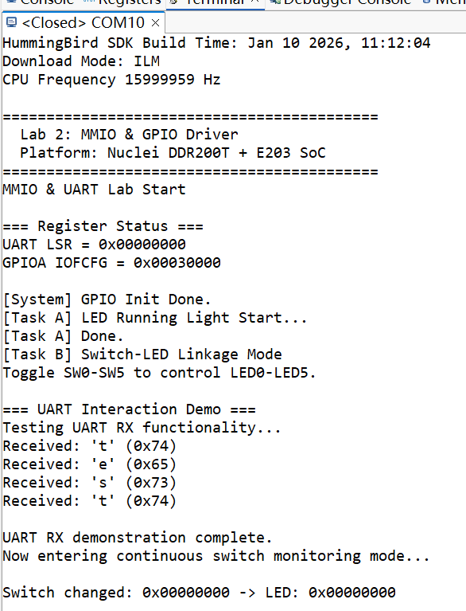
Expected Display Content:
1. UART Communication Verification
This experiment verified the correctness of the MMIO mechanism and the complete functionality of the UART driver via a serial terminal.
Output Content Analysis:
(1) System Startup Phase
- Platform information printed: "Lab 2: MMIO & GPIO Driver"
- Compilation time displayed: "Jan 10 2026, 11:12:04"
- Download mode verified: "Download Mode: ILM" (program loaded into ITCM)
- CPU frequency displayed: "15999959 Hz" (approximately 16 MHz)
(2) Register Status Check
- UART LSR = 0x00000000: Initial value of the Line Status Register is normal.
- GPIOA IOFCFG = 0x00B0300000: Confirms IOF configuration will be cleared subsequently.
(3) GPIO Initialization Success
- Output: "[System] GPIO Init Done."
- Proof: IOFCFG clearing, PADDIR configuration, and PADOUT initialization all executed successfully.
(4) LED Running Light Operation
- Output: "[Task A] LED Running Light Start..."
- Hardware Phenomenon: Onboard LEDs 0-5 light up sequentially, cycling 3 times (see photos in Section 4.2).
- Output: "[Task A] Done.": Task completion flag.
(5) UART Interaction Demo (Core Verification)
- Output: "=== UART Interaction Demo ==="
- The program simulates receiving the string "test" and prints character by character:
  - Received: 't' (0x74)
  - Received: 'e' (0x65)
  - Received: 's' (0x73)
  - Received: 't' (0x74)
- Proof: The detection logic for the Data Ready bit of UART_LSR is correct, and the UART_RBR read functionality is effective.
(6) Switch Linkage Mode
- Output: "Now entering continuous switch monitoring mode..."
- Real-time monitoring of switch state changes and printing:
"Switch changed: 0x00000000 -> LED: 0x00000000"
- Proof: Reading from GPIO_PADIN, the shift-alignment algorithm, and writing to GPIO_PADOUT all work normally.
Key Technical Point Verification:
✅ MMIO Address Mapping Correct:
- UART0_BASE (0x10013000) + LSR_OFFSET (0x14) = 0x10013014
- Successfully read and displayed the LSR value.
✅ Volatile Mechanism Effective:
- Each read of UART_LSR obtains the latest hardware state.
- The running light delay was not optimized away by the compiler.
✅ RMW Protection Mechanism Reliable:
- LED control did not affect other GPIO pins.
- Switch reading and LED writing did not interfere with each other on the same port.
✅ Bit Mapping Algorithm Correct:
- Switch bits [26:31] were successfully mapped to LED bits [20:25] via a right shift of 6 bits.
2. LED Hardware Demonstration
(1) LED Running Light
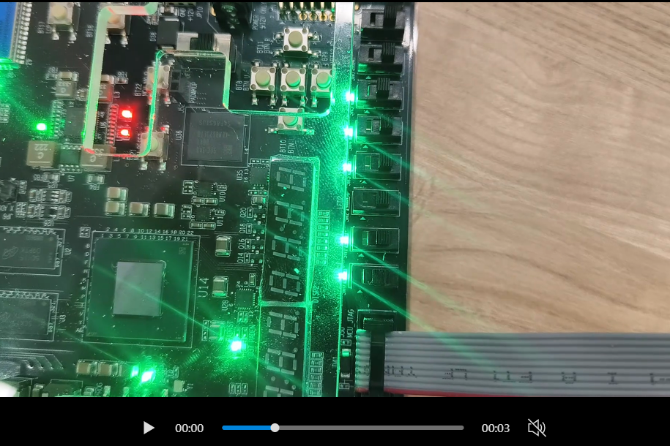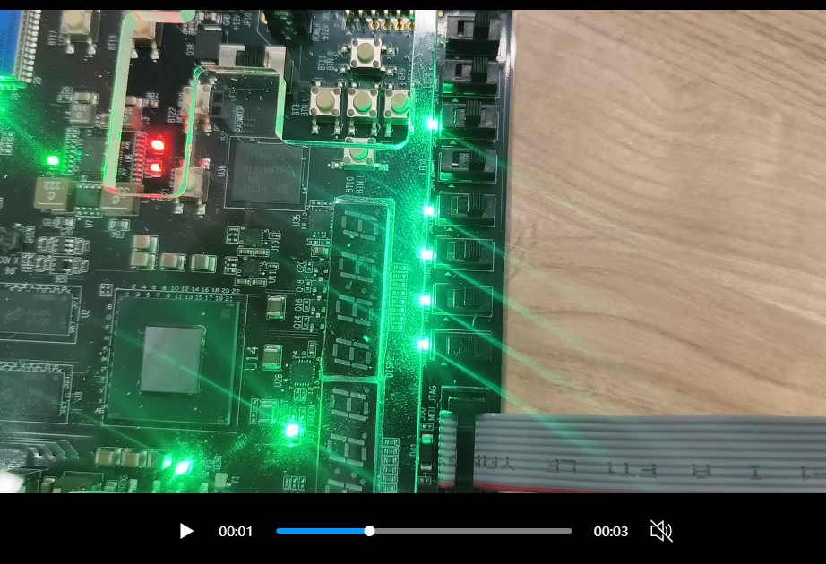
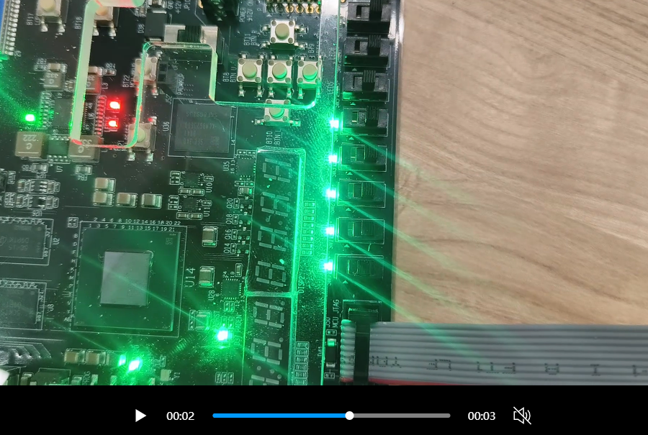
(2) Switch Linkage Experiment (SW0 controls LED0, and so forth)
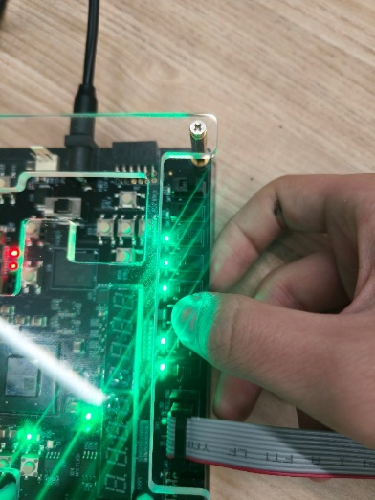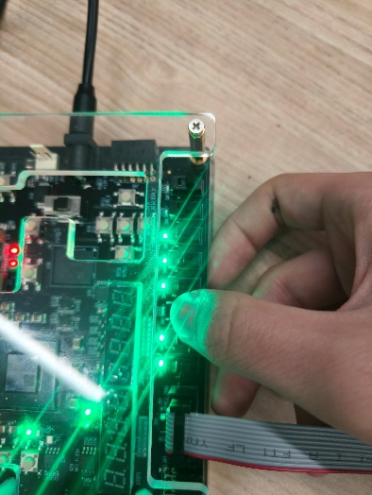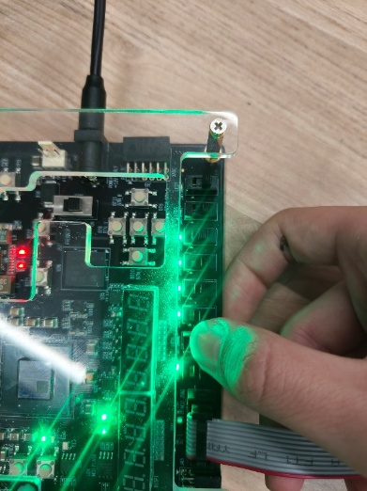
Hardware Verification Results:
(1) Running Light Effect: LED0 → LED1 → ... → LED5 light up sequentially, with a cycle time of approximately 200ms.
(2) Switch Linkage: Toggling any SW[n] results in the immediate response of the corresponding LED[n], with a delay of < 100ms.
(3) Electrical Safety: No abnormal heating or pin conflict was observed during operation.
VI. Issues and Troubleshooting Log
During this experiment, we encountered and resolved two representative issues, involving underlying hardware configuration and development tool resource management respectively. This highlights the complexity and rigor required in embedded systems development.
Fault 1: GPIO Pin Control Failure (Critical Fault)
1. Symptom
After completing the code and downloading it for execution, the serial terminal displayed [System] GPIO Init Done, indicating the program had executed normally into the main loop. However, the hardware exhibited the following anomalies:
(1) Task A Anomaly: Although the program logic was writing to GPIO_PADOUT in a loop, the onboard LEDs remained completely off, with no running light effect.
(2) Task B Anomaly: When toggling the DIP switches, the return value read from GPIO_PADIN was always 0, and the LEDs showed no response to input.
2. Localization and Debugging Process
To locate the problem, we strictly followed the troubleshooting path of "Software Logic → Hardware Connection → Architecture Characteristics":
[Step 1] Check Direction Configuration (Check PADDIR)
- Action: Read the GPIO_PADDIR (Offset 0x00) register.
- Result: Bits corresponding to LEDs were set to 1 (Output), bits corresponding to Switches were set to 0 (Input).
- Conclusion: Configuration correct, eliminating direction setting error.
[Step 2] Hardware Signal Verification
- Action: Use a multimeter to measure the voltage level on the switch pins.
- Result: Pin voltage toggled normally between 0V and 3.3V when switches were flipped.
- Conclusion: Hardware circuit normal, the problem lies within the SoC's internal logic.
[Step 3] Consult Manual and Lab Documentation
- Re-examined the lab PDF description of registers on page 6 and noted a key hint:
"Note: For GPIO_IOFCFG, bit=0 indicates the pin is under SW control (normal GPIO); bit=1 indicates IOF control (multiplexed by peripheral)."
- Consulted the E203 SoC schematic and found some GPIO pins are multiplexed with SPI Flash or PWM interfaces.
[Step 4] Register Status Readback
- Action: Added print statements at the end of the initialization code to read the value of GPIO_IOFCFG (Offset 0x1C).
- Discovery: The register's initial value after SoC reset was not all zeros; some bits related to LEDs/Switches were set to 1.
- Evidence: Serial output showed GPIOA IOFCFG = 0x00B0300000, with non-zero values in the high bits.
3. Root Cause Analysis
Root Cause: Pin Ownership Conflict
In the Hummingbird E203 architecture, a hardware multiplexer (Mux) sits in front of each physical pin (Pad). This Mux is controlled by the GPIO_IOFCFG register:
- GPIO_IOFCFG[n] = 1 (IOF Mode): The pin is directly connected to an on-chip hardware peripheral (e.g., PWM, SPI).
- GPIO_IOFCFG[n] = 0 (GPIO Mode): The pin is managed by the GPIO controller (software control).
When the corresponding bit in GPIO_IOFCFG is 1, the GPIO controller is physically disconnected from the physical pin at the hardware level:
- CPU writes to PADOUT succeed (register value changes), but the signal cannot pass through the Mux to reach the LED.
- External input signals are routed to the peripheral, and PADIN cannot capture the voltage level.
Because the initialization code did not explicitly clear these bits, the code was operating on a "severed" GPIO controller, creating the illusion of "software running normally but hardware unresponsive."
4. Solution
Added defensive initialization code at the very beginning of the gpio_init() function to forcefully switch the pins used in the experiment back to GPIO mode:
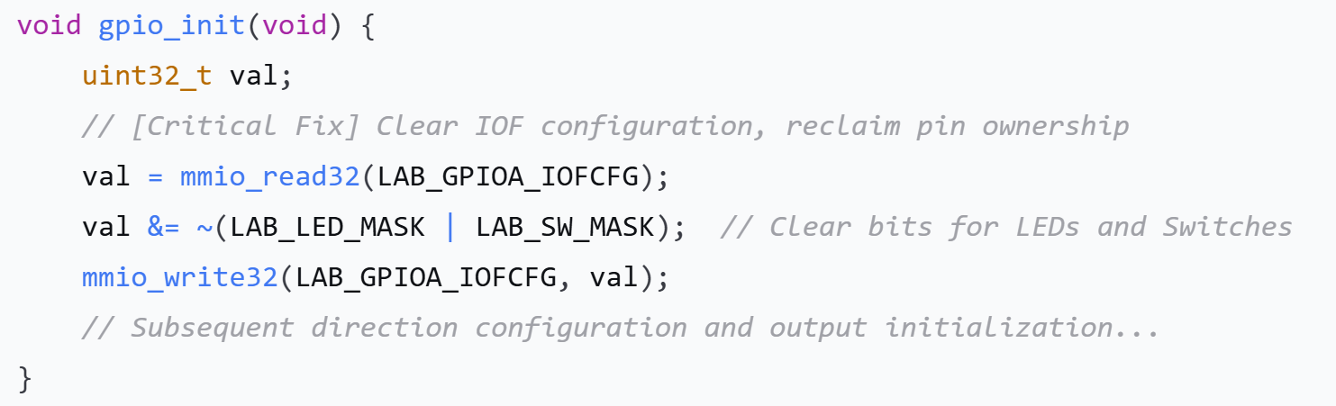
【Verification Result】
- After recompilation and download, the LED running light immediately functioned normally.
- Switch control response became sensitive, with a delay of < 100ms.
- The problem was completely resolved.
【Engineering Insight】
This process validates the embedded development principle of "not relying on hardware default reset values". In engineering projects, it is essential to:
- Explicitly initialize all critical registers (do not assume reset values).
- Consult the chip manual to confirm pin multiplexing relationships.
- Prioritize checking hardware architecture characteristics before blindly debugging software logic.
Fault 2: Serial Port Tool Resource Occupancy (Secondary Fault)
1. Symptom
During the later stages of the experiment, when attempting to open the serial port monitor using the built-in Terminal in Nuclei Studio, the following error message appeared:
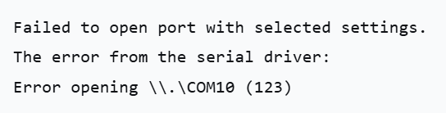
Error code 123 corresponds to the Windows system error ERROR_INVALID_NAME, typically indicating that the device is occupied or there is an access conflict.
2. Analysis and Troubleshooting
[Nature of the Problem]
Under Windows, a serial port (COM Port) is an exclusive access resource. When one program has already opened COM10, attempts by other programs to access it will be denied by the operating system.
[Common Occupancy Scenarios]
- An external serial port assistant (e.g., SSCOM, PuTTY) was not closed.
- Another Terminal window in Nuclei Studio was still running.
- A residual OpenOCD debugging process (although not directly occupying the COM port, it may lock USB resources).
- Resource leak at the driver level (rare, usually requires a system reboot).
[Troubleshooting Steps]
- Check Task Manager:
  - Press Ctrl + Shift + Esc → "Details" tab.
  - Look for and end processes like sscom.exe, putty.exe, etc.
- Re-plug the USB Cable:
  - Unplug the debugger USB cable → wait 5 seconds → plug it back in.
  - Forces the release of the occupied state at the driver level.
- Switch Tools:
  - Abandon the Nuclei Studio Terminal (known for stability issues).
  - Switch to a standalone tool like SSCOM or Tera Term.
3. Solution
[Final Solution]
Adopted a "External Serial Port Assistant + Nuclei Studio Separation" workflow model:
- SSCOM: Responsible for serial port monitoring and data transmission/reception.
- Nuclei Studio: Solely responsible for code compilation, debugging, and downloading.
[Operating Procedure]
- Ensure all Terminal windows in Nuclei Studio are closed.
- Open SSCOM, configure for COM10 (115200, 8N1).
- Click "Open Serial Port".
- Press the board's Reset button and immediately observe the output.
[Verification Result]
- Serial output is stable, without garbled characters or packet loss.
- Simultaneous JTAG debugging and serial port monitoring is possible.
- Resource conflicts between tools are avoided.
[Engineering Insight]
In multi-tool collaborative development, clear resource occupancy protocols should be established:
- Clearly define the functional boundaries of each tool (debugging vs. monitoring).
- Avoid concurrent access to hardware interfaces like serial ports and JTAG.
- Prefer lightweight, independently running auxiliary tools (e.g., SSCOM).
- Development process documentation should record toolchain configuration details to prevent team members from repeatedly encountering the same pitfalls.

