Technical Report: Book Metadata and Recommendation Analytics API
Module: XJCO3011 Web Services and Web Data
Assessment: Coursework 1 (Individual API Development Project)
Student Repository: https://github.com/Yuk11119/Web_Services_cw1
API Documentation (PDF): docs/api_documentation.pdf
Presentation / Visuals Link: TBD_SLIDES_LINK
1. Project Overview
This project implements a data-driven RESTful API for managing book metadata, authors, and reviews, with additional analytics endpoints for genre trends, rating distributions, and recommendation candidates. The work was designed to meet coursework requirements for CRUD functionality, SQL-backed persistence, endpoint documentation, and oral demonstration readiness.
The implemented system supports practical API workflows: user registration and login, protected resource operations, filtered list retrieval, and summary analytics. The API is structured so that each deliverable required by the brief (code repository, API documentation, technical reflection, and oral presentation material) can be traced to concrete project artifacts.
2. Stack Justification
The implementation uses FastAPI + SQLAlchemy + Alembic + JWT authentication + Pytest. FastAPI was adopted as the backend framework to support rapid development, request validation, and automatic OpenAPI documentation generation. SQLAlchemy was used to define clear ORM mappings for core entities while ensuring relational integrity, with Alembic enabling schema versioning and reproducible database migrations. JWT-based authentication was implemented to secure non-public endpoints in line with standard API security practices. System functionality was validated using Pytest and the FastAPI TestClient, allowing integration-level testing across authentication, CRUD operations, and analytics workflows. This stack balances delivery speed and engineering rigor, while remaining easy to justify in oral Q&A.
3. Architecture and Design Decisions
The project uses a layered backend design:
- Router layer (app/api) for HTTP contracts and query/route binding.
- Service layer (app/services) for business logic and validation decisions.
- Repository layer (app/repositories) for database access concerns.
- Model/schema layers (app/models, app/schemas) for persistence and input/output definitions.
The data model comprises users, authors, books, and reviews, structured with relational constraints to ensure integrity and efficiency. Specifically, the books table enforces a unique ISBN constraint, review ratings are restricted to the range of 1 to 5 through database-level checks, and foreign key relationships maintain referential consistency across entities. Additionally, indexes are applied to common filtering fields to improve query performance.
This decomposition improves maintainability, enables focused testing, and provides clear explainability during the oral exam.
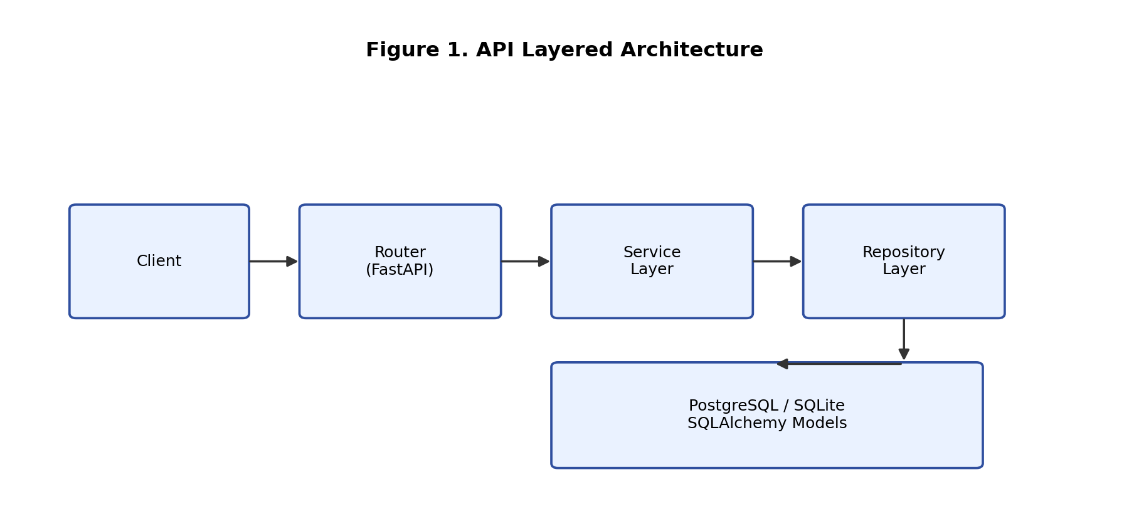
Figure 1. Layered architecture used in the implementation.
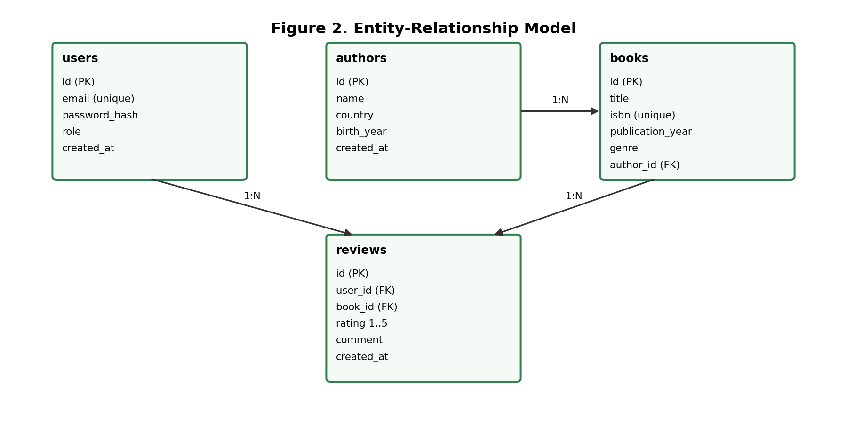
Figure 2. Relational model for users, authors, books, and reviews.
4. Implementation Highlights
4.1 Core API Capability
Implemented endpoint groups:
- Authentication: /auth/register, /auth/login
- Authors CRUD: /authors
- Books CRUD + filters (genre, year, author_id): /books
- Reviews CRUD + filters (book_id, user_id, rating): /reviews
- Analytics:
  - /analytics/genre-trends
  - /analytics/rating-distribution
  - /analytics/recommendations/{user_id}
4.2 API Contract and Error Handling
Responses use consistent envelopes:
- success: { "data": ..., "meta": ... }
- error: { "error_code": ..., "message": ..., "details": ... }
Custom application exceptions are mapped to appropriate status codes (e.g., 400, 401, 404, 409, 422), improving API clarity and client integration behavior.
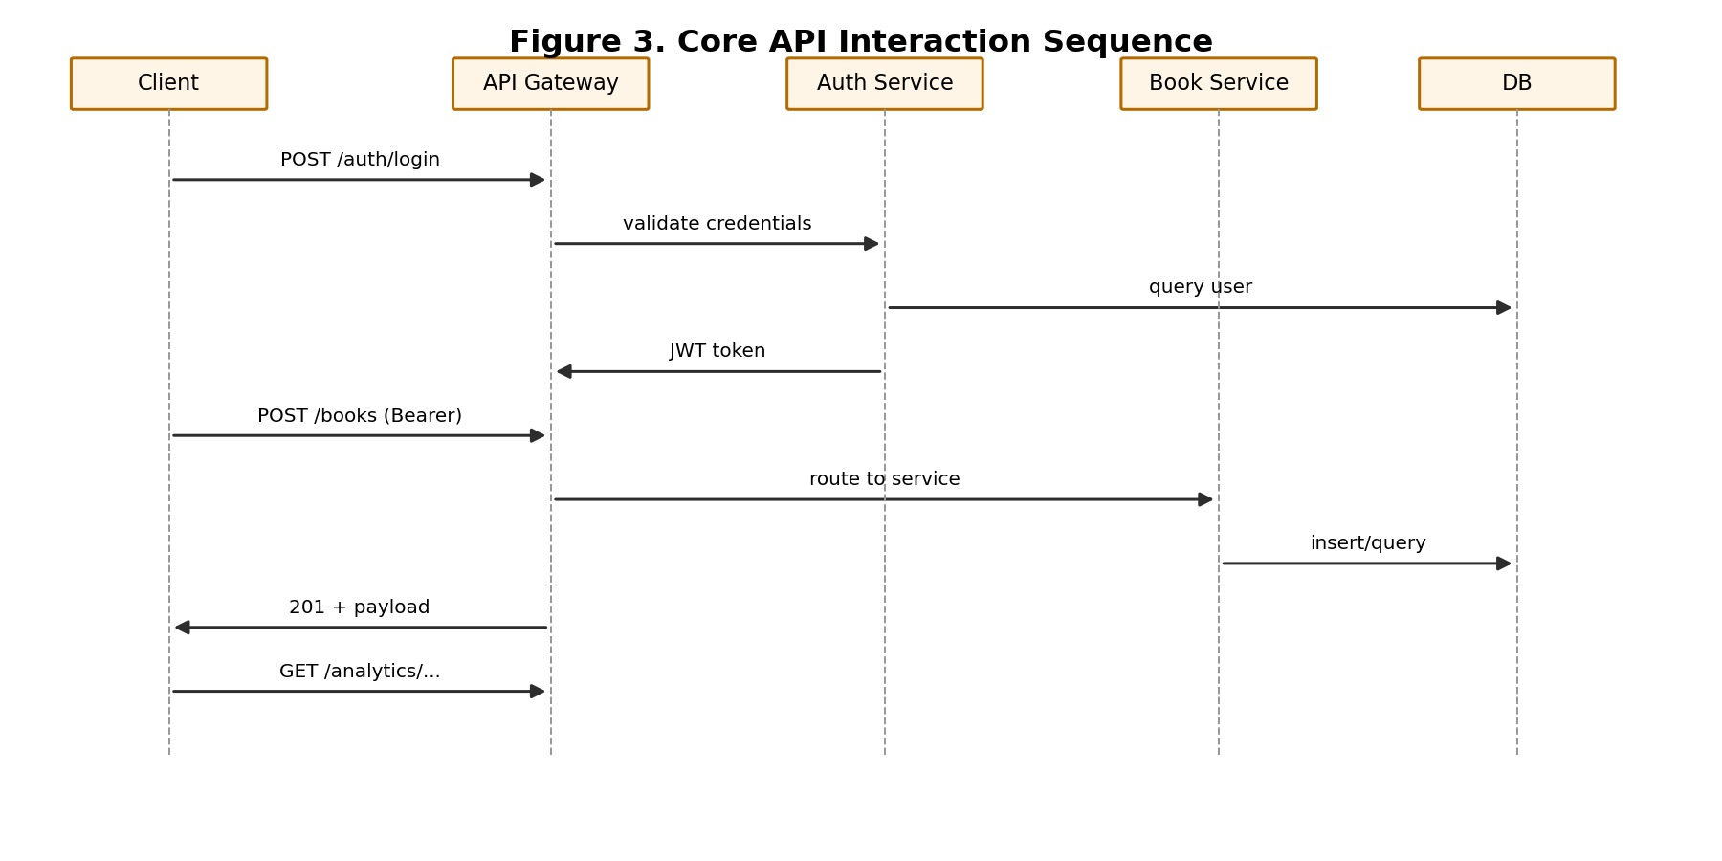
Figure 3. Typical request flow from login to protected CRUD/analytics usage.
4.3 Deployment Readiness
README.md provides local run instructions and production-oriented deployment notes (Render-style setup with environment variables and migration command before startup).
5. Testing Strategy and Evidence
Testing focuses on integration-level behaviors in line with coursework marking priorities, including authentication success and failure cases, access control for protected routes, end-to-end CRUD workflows, handling of duplicate ISBN conflicts, validation failure scenarios, and the correctness of analytics endpoint responses.
This verifies implemented features are functional and consistent with documented behavior.
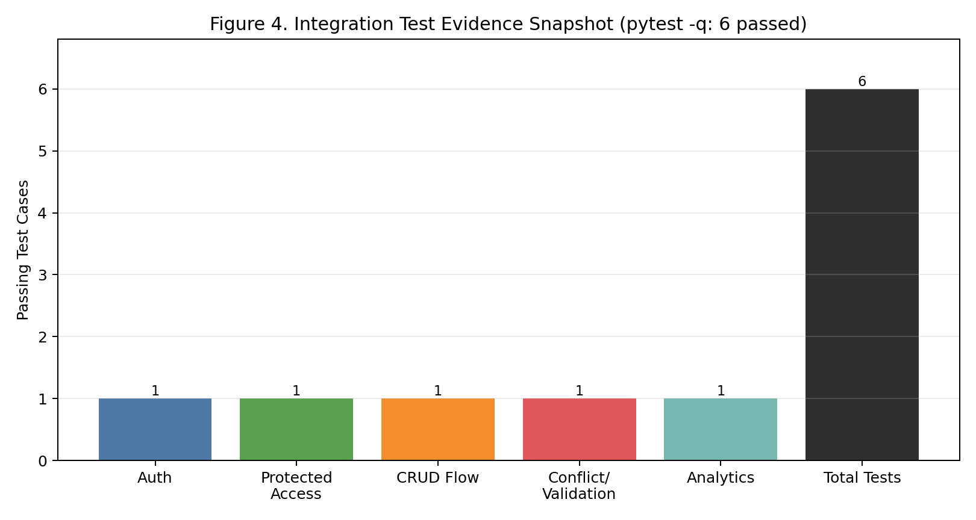
Figure 4. High-level integration test evidence summary.
6. Challenges and Lessons Learned
The main implementation challenges included maintaining consistent response and error contracts across multiple routers, ensuring SQL compatibility for aggregation and recommendation queries, and balancing practical testability with a modular system architecture. From this process, several key lessons were derived: enforcing a clear separation between service and repository layers can significantly reduce debugging complexity; introducing integration tests at an early stage helps prevent contract inconsistencies; and adopting concise error-code conventions greatly enhances overall API usability.
7. Limitations and Future Work
Current limitations:
- recommendation logic is heuristic and not personalized by collaborative filtering,
- no external production dataset pipeline is integrated yet,
- baseline security is implemented, but advanced controls (rate limiting, audit logging, refresh-token rotation) are not fully developed.
Planned improvements:
- add dataset ingestion jobs (scheduled ETL),
- expand test coverage (service-level unit tests and negative analytics cases),
- strengthen production hardening (observability, security policies, and load/performance profiling).
8. Dataset and Licensing
Current implementation includes a small seeded dataset for demonstration (scripts/seed_data.py) and does not redistribute any proprietary dataset bundle.
For coursework-scale extension, suitable academic-use sources include:
- Open Library datasets/APIs,
- Google Books API metadata,
- Kaggle book metadata collections (license-dependent).
Before final production use, each selected dataset must be recorded with exact source URL and license terms in the final submission appendix.
9. GenAI Declaration and Reflection
GenAI was used as an assistive engineering tool in a declared manner.
Tool | Primary Purpose | Human Verification Method | Outcome
ChatGPT/Codex assistant | Project planning, architecture shaping, endpoint/test scaffolding | Manual code review, local execution, endpoint-by-endpoint checks | Faster iteration with preserved author control
ChatGPT | Technical report language refinement | Cross-check against actual repository files and test output | Clearer academic writing without changing factual claims
Integrity statement:
- AI-assisted output was treated as a draft proposal, not an unquestioned final artifact.
- Final decisions, implementation adjustments, test execution, and submission responsibility remained with the student.
- Claims in this report are constrained to implemented behavior observable in the repository.
GenAI evidence references are provided in:
- docs/genai_declaration_appendix.md
- docs/genai_logs/ (summary logs, test evidence, and exported conversation examples)

