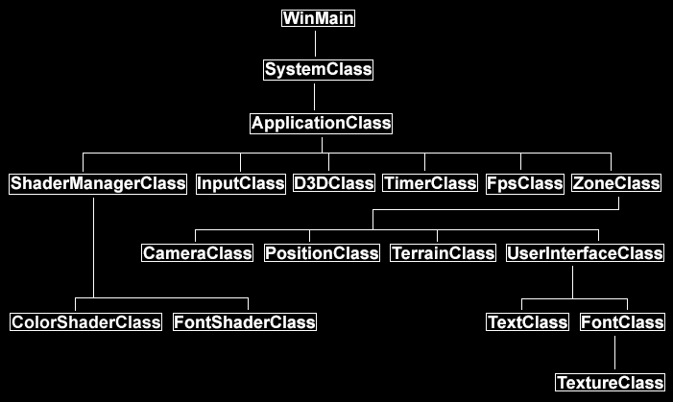

|  |
| --- |
| YOKAI  24.06.2017 |

Main

SystemClass

ApplicationClass

Not initiated in the project.

ZoneClass

TextureArrayClass

ModelListClass

ModelClass

Frustumclass

Bitmapclass

LightClass

SoundClass

CameraClass

PositionClass

D3DClass

InputClass

ShaderManagerClass

ColorsHaderClass

FontShaderClass

LightsHaderClass

TexturesHaderClass

MultiTextureShaderClass

TerrainClass

TextClass

FontClass

TextureClass

UserInterfaceClass

CPUclass

TimerClass

FPSclass

WinMain

SystemClass

ApplicationClass

Not initiated in the project.

CPUclass

TimerClass

FPSclass

ZoneClass

UserInterfaceClass

TextureArrayClass

ModelListClass

ModelClass

Frustumclass

Bitmapclass

LightClass

SoundClass

TextureClass

FontClass

TextClass

CameraClass

TerrainClass

PositionClass

D3DClass

InputClass

ShaderManagerClass

ColorsHaderClass

FontShaderClass

LightsHaderClass

TexturesHaderClass

MultiTextureShaderClass