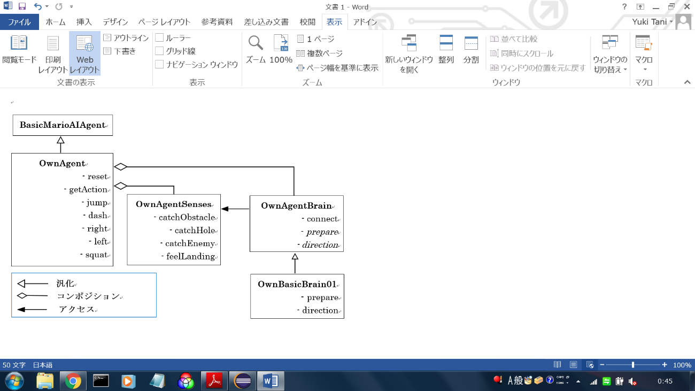

**BasicMarioAIAgent**

**OwnAgent**

- reset

- getAction

- jump

- dash

- right

- left

- squat

**OwnAgentSenses**

- catchObstacle

- catchHole

- catchEnemy

- feelLanding

**OwnAgentBrain**

- connect

- *prepare*

*- direction*

**OwnBasicBrain01**

**-** prepare

- direction

**汎化**

**コンポジション**

** アクセス**