Multi-Field Packet Classification at Edge Routers

Advisor : Dr. Ren-Hung Hwang
Student : Chug-Jung Chen

Department of Computer Science and Information Engineering
National Chung Cheng University
Chia-Yi, Taiwan, R.O.C

Abstract

Due to new network services, such as firewall, VPN, and Quality of Service support. Packet classification becomes one of the major tasks of an Internet router. In this thesis, we propose a new packet classification algorithm for edge routers. The algorithm classifies packets according to five fields of packet headers: source / destination IP address, source / destination ports and TOS of the packet header. By analyzing the characteristics of these five fields, the algorithm uses B-tree to classify IP address and hash function to classify the rest of three fields. The results of each field are merged to yield the matched policies. The goal of the proposed algorithm is to output all the policies that match the packet. Time and space complexity of the proposed algorithms are evaluated and compared with existing schemes.

邊際路由器中之多維度封包區分法

指導教授： 黃仁竑博士
學生：陳重融

國立中正大學
資訊工程研究所

論文摘要
封包區分（Packet Classification）為網際網路（Internet）上路由器的主要工作之一，由於網路軟硬體設備的普及與進步，傳統的封包區分法已經無法滿足如防火牆（firewall）、虛擬私人網路（VPN）及服務品質保證（QoS）等新興的的技術。在此篇論文中，我們提出了一個新的封包區分演算法以滿足這些新興技術的需求。此封包區分演算法針對來源/目的地之IP位置、port位置及TOS等五個欄位做封包區分。演算法包含了幾個針對各欄位特性的B-tree模組、雜湊（hash）模組及整合模組。此外，此封包區分演算法還能輸出封包符合的所有規則，以避免因為搜尋規則的先後次序造成的矛盾。

TABLE OF CONTENTS

Chapter 1 Introduction……………………………………………….1

Chapter 2 Over View of Packet Classification……………………….3
2.1 Design Goals…………………………………………………...3
2.2 Characters of each field in packet classification…………….4

Chapter 3 Multi-field Packet Classification………………………….7
3.1 Over view………………………………………………………7
3.2 Source/ Destination IP field…………….………………….8
3.3 Local IP field…………………………………………………13
3.4 Port field……………………………………………………….16
3.5 TOS field………………………………………………………17
3.6 Merging of the fields………………………………………….17
3.7 Result generating ……………………………………….…….20

Chapter 4 Complexity analysis………………………………..21
4.1 Time and Space complexity………………………………..…21
4.2 Comparison of the algorithms………………………………..22

Chapter 5 Conclusions and Future Works…………………………..24

References…………………………………………………….……….25
LIST OF FIGURES

Figure 3.1 Overview of the packet classifier………………………………………..7
Figure 3.2 Six regions with three policies…………………………………………...8
Figure 3.3 the relationship of three components in destination IP classification.9
Figure 3.4 a basic entry of a policy table…………………………………………..9
Figure 3.5 the data structures of a B-tree element………………………………..10
Figure 3.6 a basic entry of a region table……………………………..…………..11
Figure 3.7 the status of three main component before add a new policy………..12
Figure 3.8 the status of three main component after add a new policy………….12
Figure 3.9 the over view of source IP classification………………………………14
Figure 3.10 data structures of the port number classification…………………...16
Figure 3.11 data structure of classifier in TOS field……………………………...17
Figure 3.12 overview of a merging module………………………………………..18
Figure 3.13 building of a merge table……………………………………………...19
Figure 3.14 building of a merge table with a wildcard c in one region table…..19
Figure 3.15 the data structure of result module………………………………….20
Figure 4.1 there are only 3 regions in 12 segments……………………………….22
Figure 4.2 the time and space comparison of several classification methods…22

Chapter 1
Introduction

With the advancements of communication and technology, the Internet is becoming prevalence worldwide. In particular, after the advent of World Wide Web, the number of Internet users has growing up in an amazing speed. On the other hand, many emerging services in Internet have posted many challenges to routers, such as classify packets to security policy enhancement.
Packet classification has become one of the major tasks for Internet routers, especially for edge routers. The task of packet classification is to classify incoming packets according to their headers such that appropriate actions can be taken. The most critical issues for packet classification are high speed and low memory usage. In particular, growing network bandwidth poses a high demand on the speed of packet classification. When packets have been classified into different classes, appropriate actions, such as accept, drop, redirect, QoS setup, …, can be taken.
Unfortunately, traditional routers which only lookup the destination address of an incoming packet and then forward the packet to an outgoing link cannot meet the requirement of various services on Internet. Multiple field packet classification with source/destination IP address, source/destination ports and TOS fields is required for the new services such as firewall, VPN, rate-limiting applications. To keep up with the growing complexity and flexibility of Internet, faster routers that can deal with multiple field classification is needed. To look up a packet in the multiple fields, the ordinary linear search mechanism is not practical.
For fast packet classification in multiple fields, many kinds of solutions were provided. However, each of the solutions still has some restrictions. For example, in [1], the author shows a trie based algorithm, which is only suitable for classification based on IP address and difficult to add new polices after LC-trie is constructed. The other algorithm proposed in [1] is cross-producting algorithm. It finds the corresponding entry of particular field and then index to the cross-producting table, it can easily handle with arbitrary field. However, the cross-product table will be huge size that the algorithm is impractical. In [2], the author proposed a hardware based parallel algorithm, in which each field has a processor to compute the matching prefix. But the memory requirement scales quadratically with the size of classifier. In [3], a Tuple-Sapce Search algorithm is proposed. The authors divided the rules into different tuple categories by the number of bits in the rules, and use hashing within each category. Recently, in [4], the authors proposed the HiCuts algorithm that classifies a packet by traversed a decision tree, then performs a linear search in the leaf node.
Hence, to fulfill the requirement of multiple field classification and to speed up looking up process at edge devices like edge routers, firewall and secure gateway. A new lookup algorithm is needed. Classification is not only based on destination address but also source address, source port, destination port, and TOS.
In addition to the problem that is mentioned above, we observe that there are many policies overlapped in some field, which cause ambiguous situation in the lookup progress. We can use the segmentation and merging technique to rebuild the new rules that is not overlap. The packet classifier will find out all the policies that an arriving packet matched.
The remainder of this thesis is organized as follows. We describe the characteristics of each field in chapter 2. We discuss the data structure and algorithms of packet classification in chapter 3. In chapter 4, we present and analyze the emulation result. Finally, the conclusion and future works are given in chapter 5.
Chapter 2
Overview of Packet Classification

The task of packet classification can be decomposed into two components. First, the packet classifier converts the received forwarding data into specific data structures that provides fast querying speed and good properties for maintenance. Second, the packet classifier has to searching all of policies that the incoming packets matched.

2.1 Design goals

For developing a good packet classifier, the converting component and searching component of a classifier require some good attributes [5]. We can take following properties into consideration.
- Query speed:
The searching algorithm must be fast. A packet classifier has to deal with over 300,000 packets per second on an OC-3 link if the size of packets is all 64 bytes. When the query speed of a classifier cannot keep up with the bandwidth, it will case a server packet loss problem under heavy traffic load.
- Memory usage
For a practical packet classifier, the memory usage has to be reasonable for 500~2,000 policies.
- Updating ability and speed
Reconstructing a new data structure for searching a packet just because a few new policies is costly. A packet classifier should be able to update incrementally.
- Flexibility
The packet classifier must have some flexibility to find the rules might be fixed-length, prefixed or wildcard. Besides, the packet classification algorithms should be able to adapt to with new protocols, such as IPv6.

2.2 Characters of each field in packet classification

We assume that packets will be classified base on following five fields in their header, source and destination IP address, source and destination port numbers and protocol identifier. In the following, we examine the particular characteristic of each field when performing searching.
2.2.1 Source and Destination IP address
Because the characteristics of IP address and CIDR environment, the forwarding engine have to perform longest prefix matching. Many algorithms solves the longest prefix matching have been proposed recently. We can classify these algorithms into four categories as follows:
Linear Search: The primitive solution for IP address lookup. If there are N policies, it only takes 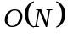 entries in memory space. Unfortunately, it takes of time complexity to find the matching rule. Therefore, it is not an efficient method for large number of rules.
Trie-base lookup: There are some algorithms [6-10] employing tries as their main data structures. The major problems of trie base lookup algorithms are the worse case complexity for classification. It takes 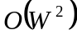 of time complexity for finding a rule in the worst case with back tracking, where W is the address length. This approach cannot be used in IPv6 networks without appropriate modification. Although a new algorithm of tries has been proposed recently which only takes 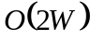 of time complexity, but it is still not suitable for IPv6 networks. Furthermore, it needs some pre-computation when building the data structures, and its refined algorithm is hard to maintain for updating rules.
Hash-base Lookup: In these algorithms [11-12], hash functions usually get the result in only two or three memory accesses. However, the memory requirement for hash tables is more than linear search and the time that spent in finding a matched rule in the entry of hash table is the bottleneck of the searching process.
Comparison base lookup: Comparison based lookup algorithm bring to the less times of memory access with m-way searching, it takes 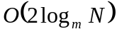 times of memory access in the worst case [13-14]. Because the times of memory access depends on the numbers of policies, not the address length, it can easily adopt the IPv6 packet classification.

The packets passing by the edge routers has two directions, one leaves the local networks to Internet, the other goes from Internet to the local networks. The local networks are usually much smaller than the Internet. We decide to use the comparison based algorithm in the Destination filed for packet matching of IP on Internet, and a hashing function combined with trie based lookup algorithm for IP on local networks.

2.2.2 Source ports, destination ports and TOS
The fields in source and destination port are not as complex as IP. In this paper, a two level hashing algorithm is adopted to find a matching port by linear search. TOS field has only several bits; An easy matching algorithm can finds the matching rule.
Chapter 3

Multi-field packet classification

3.1 Over view
In this thesis, we use some algorithms for classification in different field that has various attributes itself. With two rounds of merging, the packet gets some policies it matches, as shown in Figure 3.1. The packet classifier consists two levels, one is classification level, and the other is merging level. When an incoming packet arrives, the classifier use different kinds of classification algorithm in each field. Then the classifier merges the result of each field and get the policy sets belongs to the packet. We use two-level merge tables in order to avoid wasting too much memory when expansion.

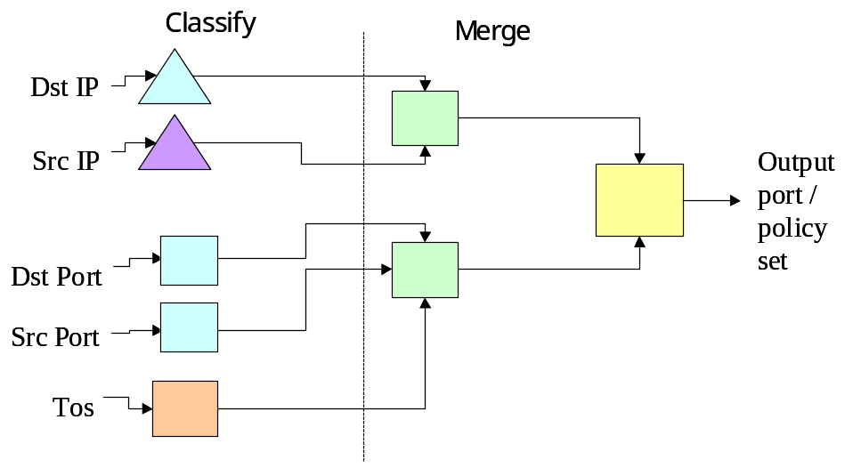

Figure 3.1 Overview of the packet classifier

3.2 Field of source/destination IP
Each policy on fields of IP address can be considered as some regions. Let us view the space of the IP address as a linear region form 0 (0.0.0.0) to 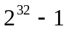 (255.255.255.255). The IP field (source or destination) of a policy maybe specified as an address prefix, e.g. 140.123.0.0/16, which is corresponding a region in the IP space. The intersection of more than two policies may result in splitting the IP space into several regions, each region corresponding to a single or the intersection of several policies. Fro example, consider policies A, B, C with IP address prefix 140.123.0.0/16, 140.123.101.0/24, 140.123.101.128/25, respectively. The intersection of these policies results in 6 regions, as shown in Figure 3.2. In region (1,6) the packet matches no policies. In region (2,5) the packet matches policy A. In region (3) the packet matches policies A, B. In region (4) the packet matches A, B and C.

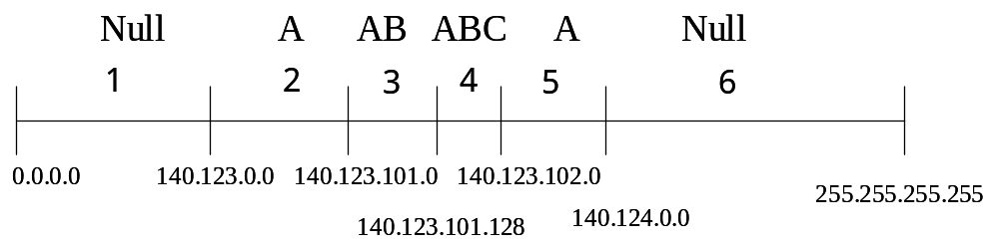

Figure 3.2. Six regions with three policies.

With the features of IP field, we propose a B-tree based algorithm in fields of destination IP address. We can put IP values of edge of regions that divide the destination IP fields into a B-tree structure. The B-tree structure has many advantages in the region searching in comparison with tries. The worst case of search time is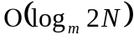, where is the number of the policies with-way B-tree structures.

3.2.1 Data Structure
The data structure of our IP classification algorithm consist of contains four components: a B-tree structure for fast querying, a policy table for adding and deleting policies, a wildcard list for avoiding intensive modification to modify in the region table, and a region table for getting the merged ID. Figure 3.3 shows the relationship of these four components.
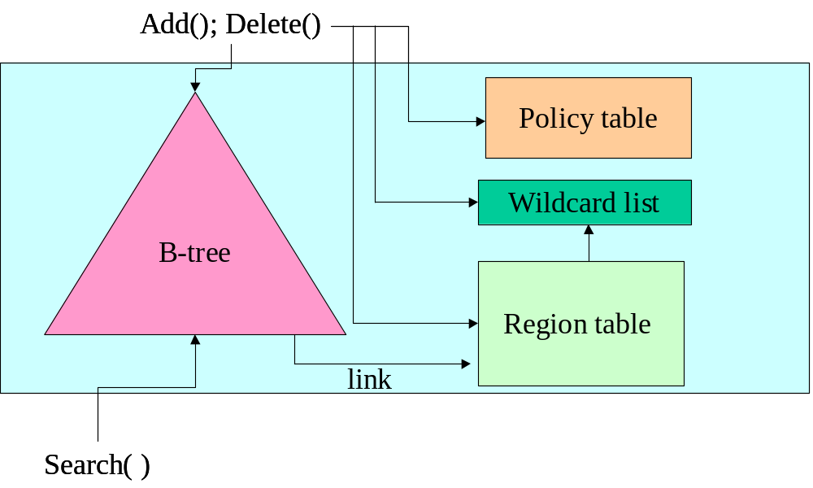
Figure 3.3 the relationship of three components in destination IP classification.

The policy table is used to maintain the policies, each entry of the table contains following fields: a number of the policy ID, a destination of policy, the start point and end point of the IP address of policy, as shown in the Figure 3.4.

Figure 3.4 a basic entry of a policy table

When a policy is added, the IP classifier analyzes the IP field (source or destination) of the policy and then fills the start point and end point of the given address prefix into the policy table. For example, if the address prefix of a policy is (140.123.0.0/16), the start point and end point of the policy are (140.123.0.0) and (140.123.255.255), respectively. Incoming packets with destination or source IP address in this region matches the policy.
The B-tree element is the most important data structure of IP classification. A B-tree element has -1 entries and links, every entry has an IP address and two region ID is separated by the IP address. A entry has two IDs avoiding to backtrack if the entry is at left end or right end of a leaf node. Structures of B-tree are shown in Figure 3.5. A two level B–tree structure has three nodes and six entries. Each of the entries has value of an edge IP address and two pointers to region IDs. The relationship of these IP address are IP1<IP2 …<IP6.

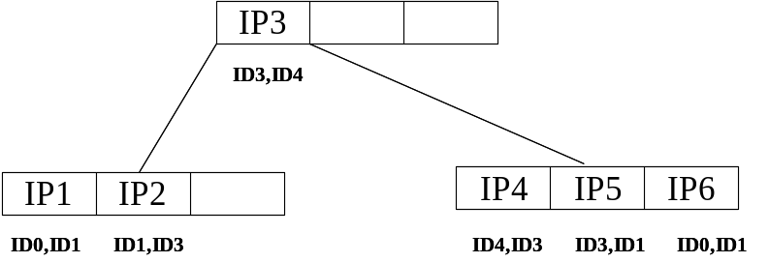
Figure 3.5 the data structures of a B-tree element

The region table maintains the region ID. Each entry consists of the number of policies matched, the set of matched policies, a new flag, its ID, and a reference count (RC), as shown in Figure 3.6. The number of policies field is the hash key for searching the policy set quickly. Policy set field contains a policy list of matched policies. The new flag field indicates the status of the policy set. The use of this flag will be discussed in next section. ID field gives the hash key for merging in next level. Reference count keeps the information of how many entries of B-tree link to this entry of region table.

Figure 3.6 a basic entry of a region table.

The wildcard list contains policies that has wildcard in its IP address. It does not change the ID of the policy set, but add the wildcard list to the policy set for merging in next level.

3.2.2 Insertion of source/destination IP
There are three major functions in the field of source/destination IP address, a policy adder, a policy remover and policy query module.
When a new policy is added, the policy adder extracts destination IP prefix and mask, gets the start point and end point of the region, and then inserts the start point and end point into the b-tree structure. It updates the relative entries of the region table and maintains the policy set in the region of the new policy. For example, assume that we have 8 bit addresses and two policies the IP address prefix (10*) and (1001*). The content of these three components are shown in Figure 3.7

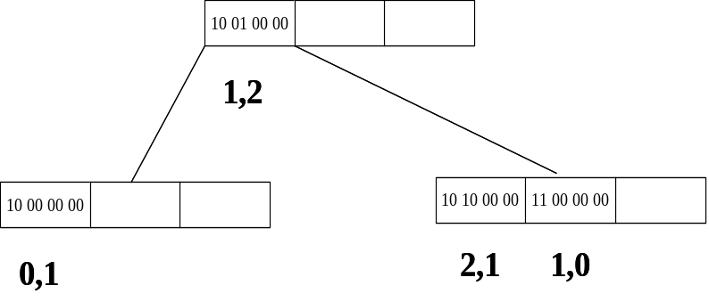
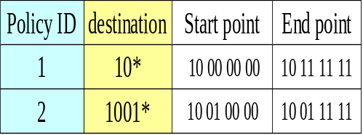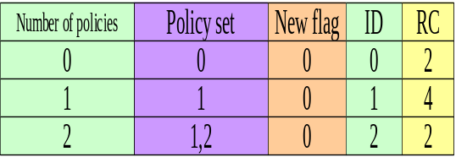
Figure 3.7 the status of three main components before adding a new policy

After adding the new policy (100110*), the policy table increases one entry and so does region table, the B-tree has two more entry, as shown in Figure 3.8

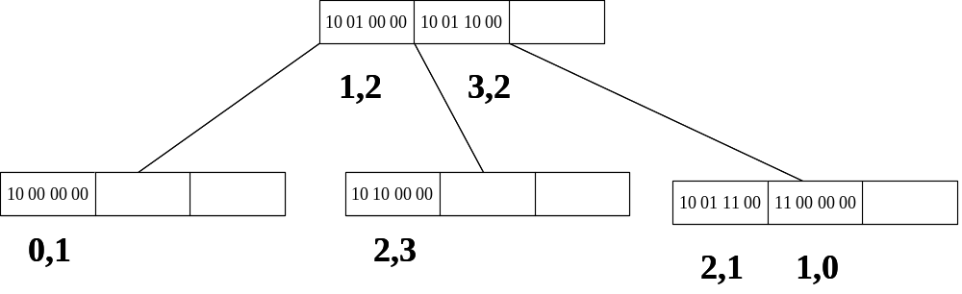
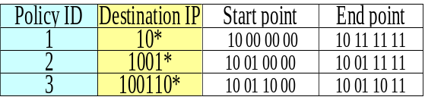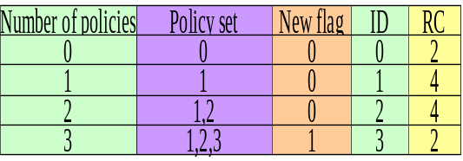
Figure 3.8 the status of three main component after add a new policy

3.2.3 Deletion of source/destination IP
When a policy is to be deleted, the policy remover modifies the data structures in the B-tree element. And then get the policy set by searching in the B-Tree structure and removing the entry if RC is equal to 0. And then the remover transverses the B-tree from start point entry to end point entry, and maintain the links to the region table at each entry. Finally the remover deletes the policy in the policy table.

3.2.4 Query of source/destination field
Querying ID for merging of an incoming packet is simpler than adding or deleting a policy. When a packet comes, the source/destination IP classifier finds the corresponding ID and policy set to the packet; then checks if there is any policy in the wildcard list. If there are some policies in the wildcard list, the classifier adds polices in wild card list to the policy sets. If there is no any policy in the wildcard list, the ID and policies are directly passed to the next level for merging.

3.3 field of Local IP
The packets passing by the edge routers have two directions, from the local networks to Internet or from Internet to the local network. For each direction of packets, one side of an edge router is Internet and the other is a local subnet. Accordingly, we assume that the subnet is scaled in class B or class C IP address. The local IP classification deals with the local IP address only for last 16 bits or 8 bits.
We use two index tables for performing 16-bit local IP classification; the source classifier also contains a policy table, a region table and a wildcard list, as shown in Figure 3.9
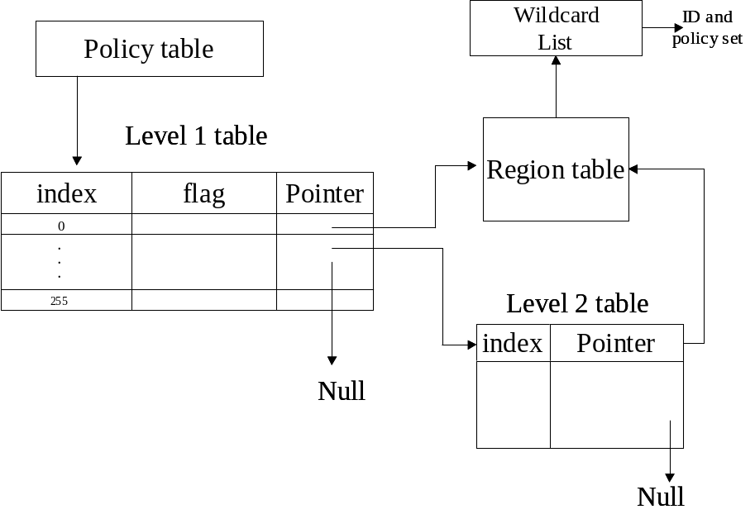
Figure 3.9 the over view of source IP classification
3.3.1 Data structure
The policy table is the same as the one in field of source/destination; it is used to maintain policies in the local IP classifier and give a number to each policy.
Level-1 table and level-2 table are the main structures in local IP classification. Level-1 table has 256 entries, each entry in level-1 table has three fields, the index field takes the first 8 bits of local IP address as the index, the flag shows the status of pointer field, the pointer field may be null, point to level-2 table or point to region table directly. Each level-2 table has 256 entries, an entry has two fields, one is index the other is a pointer to region table or null.
The region table and wildcard list are the same as the field of source/destination IP. An entry in the region table gives policy set and an ID for merging in the next level. The wildcard list is used to modify the policy set if there are some wildcard policies in the local IP field.

3.3.2 Insertion of local IP
When a new policy is inserted, a new policy entry in the policy table will be created. Suppose the prefix of the new policy length is more than 8 and there is no prefix in the same region, a new level-2 table is created and the flag is set to 1. Every level-2 entry fits the policy is link to the suitable entry in the region table. If there is no corresponding entry in the region table, a new entry in the region table will be created.
If the prefix length is less than 8, every entry in level-1 table fits the policy will links to the corresponding entry in the region table when the entry has no policy that prefix length is more then 8. If the flag of the entry is equal to 1, means that there are some policies in the region of the level-1 entry; each entry in the level-2 table is pointed by the level-1 entry which links to the corresponding entry in the region table.

3.3.3 Deletion of local IP
If a policy is deleted, the entries in level-1 and level-2 fits the policy is modified, they links to the new entry in the region table. If a policy with more than 8 bit prefix length is deleted, and there has no more policy in the level-2 table; this table is removed and the flag of the entry point in level-1 table will be set to 0.

3.3.4 Query of local IP
When a packet comes, the first 8 bits of address indexes level-1 entry fits the packet. If the flag of the entry is 0, the packet gets ID and policy set in the region table by the pointer. Otherwise, the packet has to look up the entry in the level-2 table point by the level-1 table. In level-2 table, the last 8 bits of address indexes the entry that fits the packet. It links to an entry of the region table, the packet gets ID and policy set in the region table. After getting the ID and policy, the classifier modifies the policy set by the wildcard list if needed.

3.4 Field of port
3.4.1 Data structure
We use the two level hash tables for port field classification similar to local IP classification with some modification. Because the ports that policies define are not uniform distributed. The port numbers under 256 is used more frequently than others. Figure 3.10 shows data structures of the port number classification. The first 256 entries reserved to port number with value 0 to 255 for getting the ID and policy set in two times of memory access.

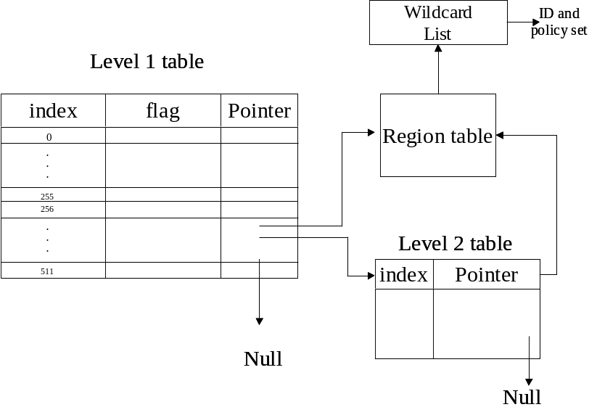
Figure 3.10 data structures of the port number classification.

3.4.2 Insertion, deletion and query of port field classification
The difference between classification in ports and classification in local IP is the hash function, the hash function of index: 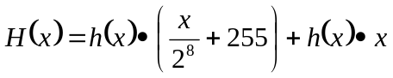 where is the port number of the incoming packet. Other maintenance is similar to the local IP classification.

3.5 Field of TOS
TOS field only has two bits we can use in the packet classification. We use a table with four entries in classification. Each entry contains an ID and the policy set. Adding or deleting the policy just modifies the policy set in the matching entry. The data structure of classifier in TOS field is shown on Figure 3.11

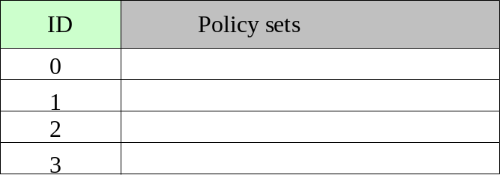
Figure 3.11 data structure of classifier in TOS field

3.6 Merging of the fields
Merge module is the second level of the packet classification engine; it takes the ID from each field as input, and consists a key of the final table. There are two main structures in the merging module, one is a merging table and the other is a new policy list. The entry of a merging table contains an index, a new policy set and a key to next level. The new policy list is used when a new policy id added between two updates of the merging table. Structures of merging module are shown in Figure 3.12.

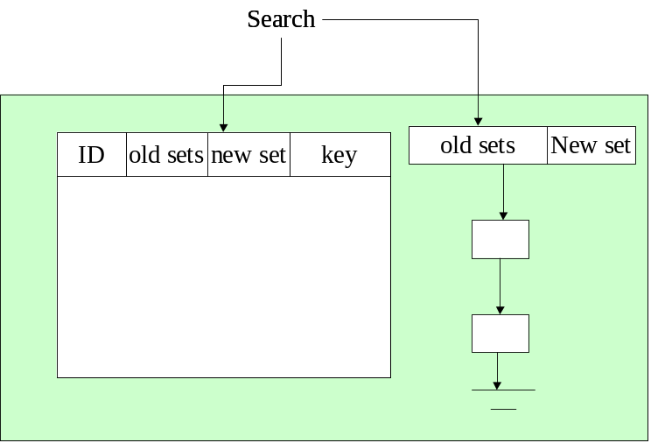
Figure 3.12 overview of a merging module.

3.6.1 Building of the merging table
Merging table is rebuilt periodically or the new policy list is large than a threshold. In our design, the packet classifier is capable of incremental updating, but has to rebuild the merging table periodically or when size of the new policy list is larger than a threshold. We expanse two or three fields of IDs, then the new set is the intersection of the matching policies in origin fields. After that gives the new key for final table. For example, if there are two IDs in the region table of field of destination IP address with policy sets (A, AB) and two sets (A, ABC) on field source IP address. The merging table will be built as Figure 3.13

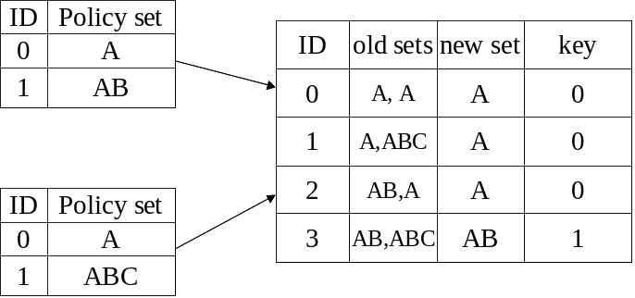
Figure 3.13 building of a merge table

The ID of merge table can be compute as 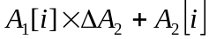 where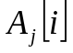 is the th ID in the th region table,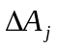is the amount of entry in theth region table. If the origin field has the wildcard list, the algorithm adds the policies to each first old sets when expansion, as show in Figure 3.14.

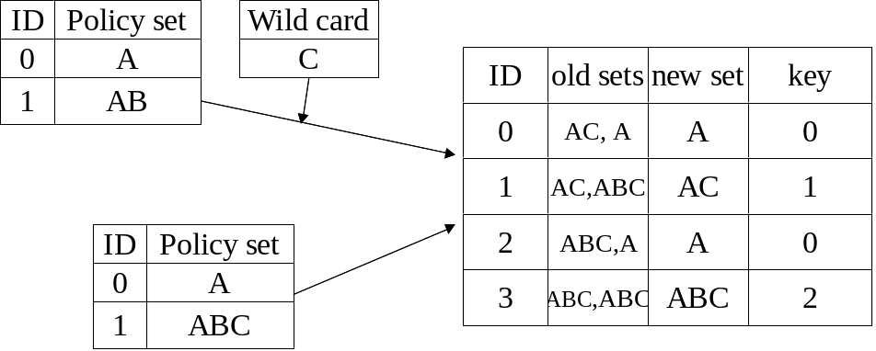
Figure 3.14 building of a merge table with a wildcard c in one region table

3.6.2 Usage of the new policy list
When a packet matches one of the entry in region table with a new flag, it cannot find the keys of final table by the computation of IDs form the merging table. It has to search if there is a result after intersection by the new entry with another field in the link list. If there is the one, get the new policy set, else doing intersection and leave the result on the link list. The new policy list plays a cache role for new policy that was just added.

3.7 Result generating
Result module takes two keys form merge table to find the packet matches with which policies and then takes the proper actions. Figure 3.15 shows the data structure of result module. It has a result table and a new policy list like the merging module, but does not have the wildcard problem.

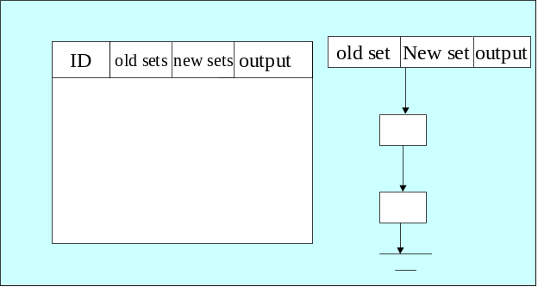
Figure 3.15 the data structure of output module

Building and searching process is the same as the merging module; finally the packet classifier gets the policy set which incoming packet matches. We call the final policy set as rule that does not overlap with other ones.
Chapter 4

Complexity Analysis

In this chapter, we first descript the time and space complexity of our algorithms. After that, we compare the time and space complexity with other existing algorithms.

4.1 Time and Space complexity
The worst cast of time complexity in memory access when querying a packet in our algorithm is 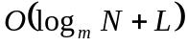 whereis the number of policies with -way search trees in destination IP field, L is the number of policy sets in new policy list of merge table. The other parts of our algorithm only take one or two times of memory access.
According to the computer geometry [14], it can be considered as a point location problem when finding a packet for a set of policies. The space requirement is 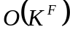 if we want to find a space divided in K segment without overlapping in dimensions when the algorithm is optimized for querying time. In our observation, in practice the space requirement does not need so much. For example, there are only 3 kinds of regions in policy B with 12 segments that does not aggregate, as shown in Figure 4.1. From this point of view, we use two merging tables and a final table to aggregate the policy sets. It saves much memory for expending the entire segment in 5 dimensions.

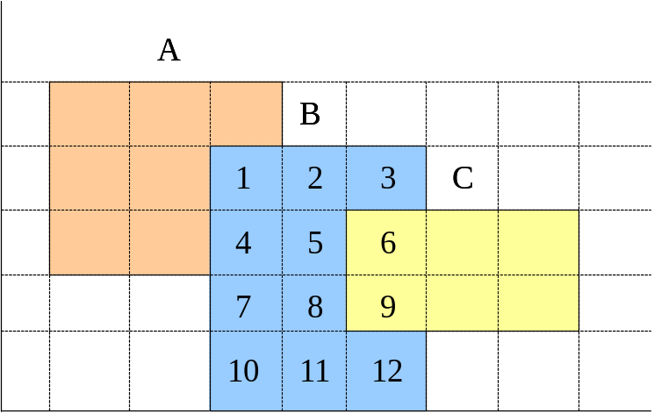
Figure 4.1 there are only 3 regions in 12 segments

4.2 Comparison of the Algorithms

There are four multi-field classification algorithms that list on the Figure 4.2. N denotes the numbers of policies, F denotes the numbers of field that we searched, W denotes the maximum bit length of any destination or source prefix, and m denotes there are the number of entries in a B-tree element.

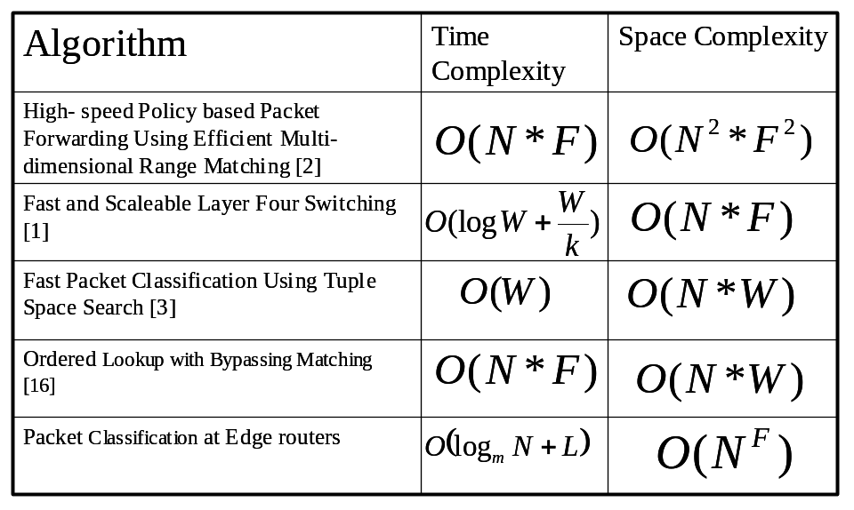
Figure 4.2 the time and space comparison of several classification methods

We can observe that the time complexity of our algorithm can less than the other algorithms, but the space requirement is higher than that of other schemes. However, as we described in 4.1, the space requirement is much less than the worst-case because the clustering polices and two-level merging data structures.

Chapter 5
Conclusion and feature works

In this thesis, we proposed a new algorithm for multi-field packet classification. We consider the attribute of each field and develop an efficient classification scheme for each of them. For the destination IP address field, we propose a B-tree algorithm. For source IP address and port fields, the hash-based algorithms are used. We merge the ID that we get in each field by the merge table to get the final policy set and rule ID by the final table in the same way. The algorithm has the flexibility for on-line adding or deleting a policy without too much overheads.
The algorithms can pick up all the policies that a packet matches, not only just one of the matched policies. To support QoS routing, this is a significant property that a packet classifier has to provide. On the other hand, it has good properties for searching a packet with IPv6 address.
For future study, we will try to equip the multi-field packet-forwarding algorithm in the Linux kernel to realize the classifier with new routing daemon that we designed. And a precise policy analyzer has to be accomplished to distinguish the actions to take when there are conflicts among matched policies.
Reference

- V. Srinivasan, G. Varghese, S. Suri and M. Waldvogel. “Fast and Scalable Layer Four Switching,” ACM SIGCOMM’97.
- .T.V Lakshman and D.Stiliadis. “High-Speed Policy-based Forwarding Using Efficient Multi-dimensional Rang Matching,” ACM SIGCOMM’98.
- V. Srinivasan, G. Varghese and S. Suri. “Packet Classification using Tuple Space Search”. ACM SIGCOMM’99.
- Pankaj Gupta and Nick McKeown,“Packet Classification using Hierarchical Intelligent Cuttings,” Hot Interconnects VII, vol. (August), 1999.
- Anja Feldmann and S. Muthukrishnan, “Tradeoffs for Packet Classification,” (in Proceedings of )Nineteenth Annual Joint Conference of the IEEE Computer and Communications Societies. Volume: 3 , 2000 Page(s): 1193 -1202 vol.3
- Tzeng, H.H.-Y. and Przygienda, T. “On Fast Address-Lookup Algorithms.”, IEEE Journal on Selected Areas in Communications , Volume: 17 Issue: 6 , June 1999 Page(s): 1067 -1082
- Pinar Altin Yilmaz, Andrey Belenkly and Necdet Uzun, “A Trie-based Algorithm for IP Lookup Problem,” IEEE GLOBECOM 2000
- Chen W.E, and Tsai, C.J" A Fast and Scalable IP Lookup Scheme for High-speed Networks," International Conference on Networks , 1999: 211 -218.
- W. Doeringer, G. Karjoth, and M. Nassehi, "Routing on Longest-Matching Prefixes," IEEE/ACM Trans. on Networking, Vol. 4, No. 1, Feb. 1996, Page(s). 86 - 97.
- Mikael Degermark, Andrej Brodink, Svante Carlsson and Stephen Pink.Small “Forwarding Table for Fast Routing Lookups”. ACM SIGCOMM’97.
- Daxiao Yu, Smith B.C, and Wei B. “Forwarding Engine for Fast Routing Lookups and Updates”. GLOBECOM '99 , Volume: 2 , 1999 Page(s): 1556 -1564 vol.2
- Nen-Fu Huang, Shi-Ming Zhao, Jen-Yi Pan, and Chi-An Su. “A Fast IP Routing Lookup Scheme for Gigabit Switching Routers,” ( in Proceedings of) Eighteenth Annual Joint Conference of the IEEE Computer and Communications Societies, Volume: 3 , 1999 Page(s): 1429 -1436 vol.3
- Yazdani N, and Min P.S. “Fast and scalable schemes for the IP address lookup problem”. ( in Proceedings of) the IEEE Conference on High Performance Switching and routing, 2000.Page(s): 83 –92
- Lampson B.; Srinivasan V, and Varghese G. “IP lookups using multiway and multicolumn search Networking”, Transactions on IEEE/ACM, Volume: 7 Issue: 3 , June 1999 Page(s): 324 –334
- Pankaj Gupta and Nick McKeown, “Packet Classification on Multiple Fields”, ACM SIGCOMM 99.
- Kuo-Jui Wu and Ying-Dar Lin, “Ordered Lookup with Bypass Matching for Fast Classification in Layer 4 Routers.” ICS2000, Chia-Yi, Taiwan Nov 2000.

