This program is coded by Hongyun Du

NetId: hxd171530

Data file: data.txt

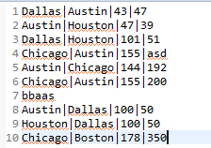

Query file: query.txt

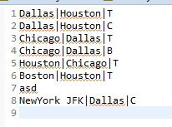

Result: result.txt

