CS 3345 PROJECT 5

HONGYUN DU

HXD171530

THIS PROGRAM USES THE ECLIPSE

Based on these samples, generally when we selected the first element as the pivot, we will have the slowest speed to sort (on the average)

This program will create two files which are sorted.txt and unsorted.txt

The sorted.txt will store all these 4 results.

The unsorted.txt will store the raw-array.

Size = 100

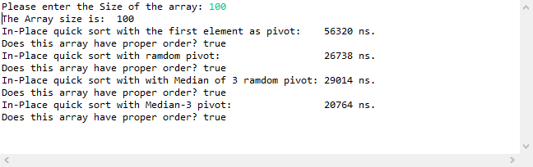

Size = 1000

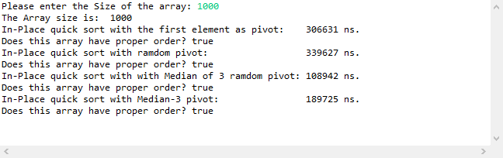

Size = 5000

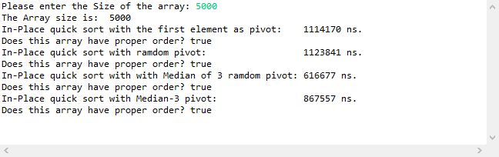

Size = 10000

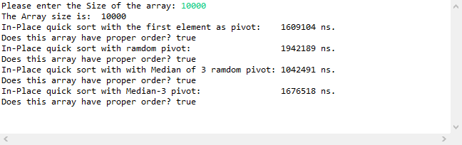

Size = 50000

