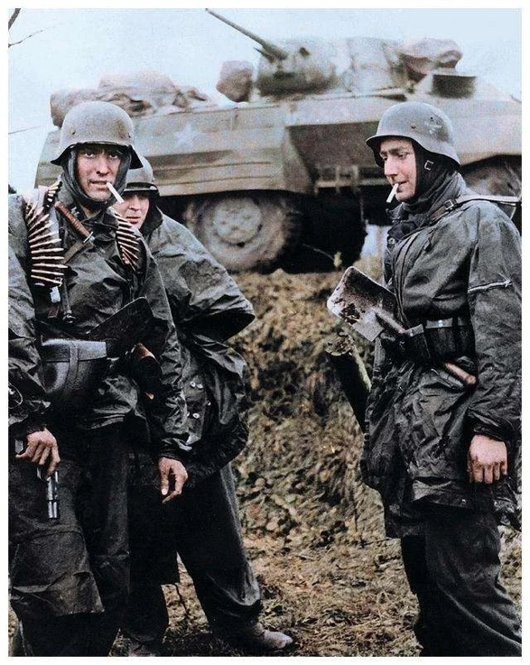
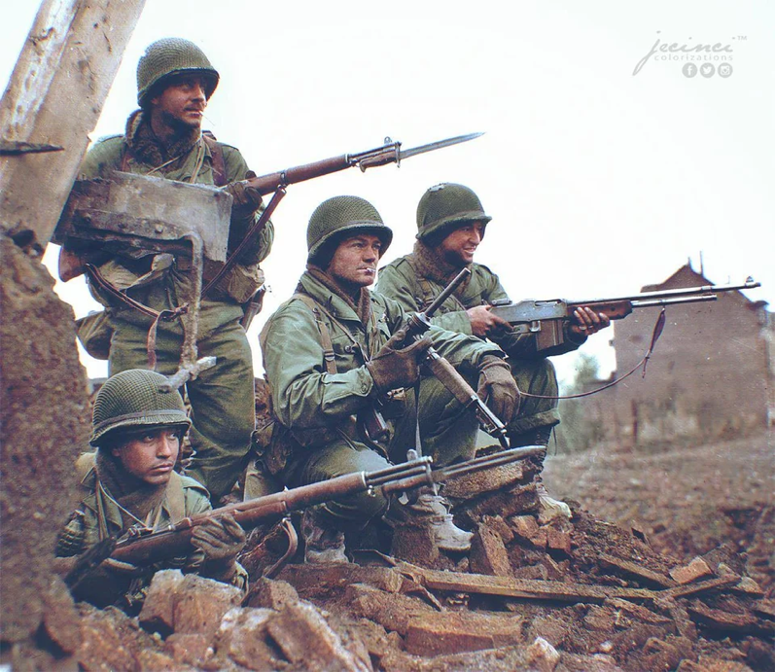
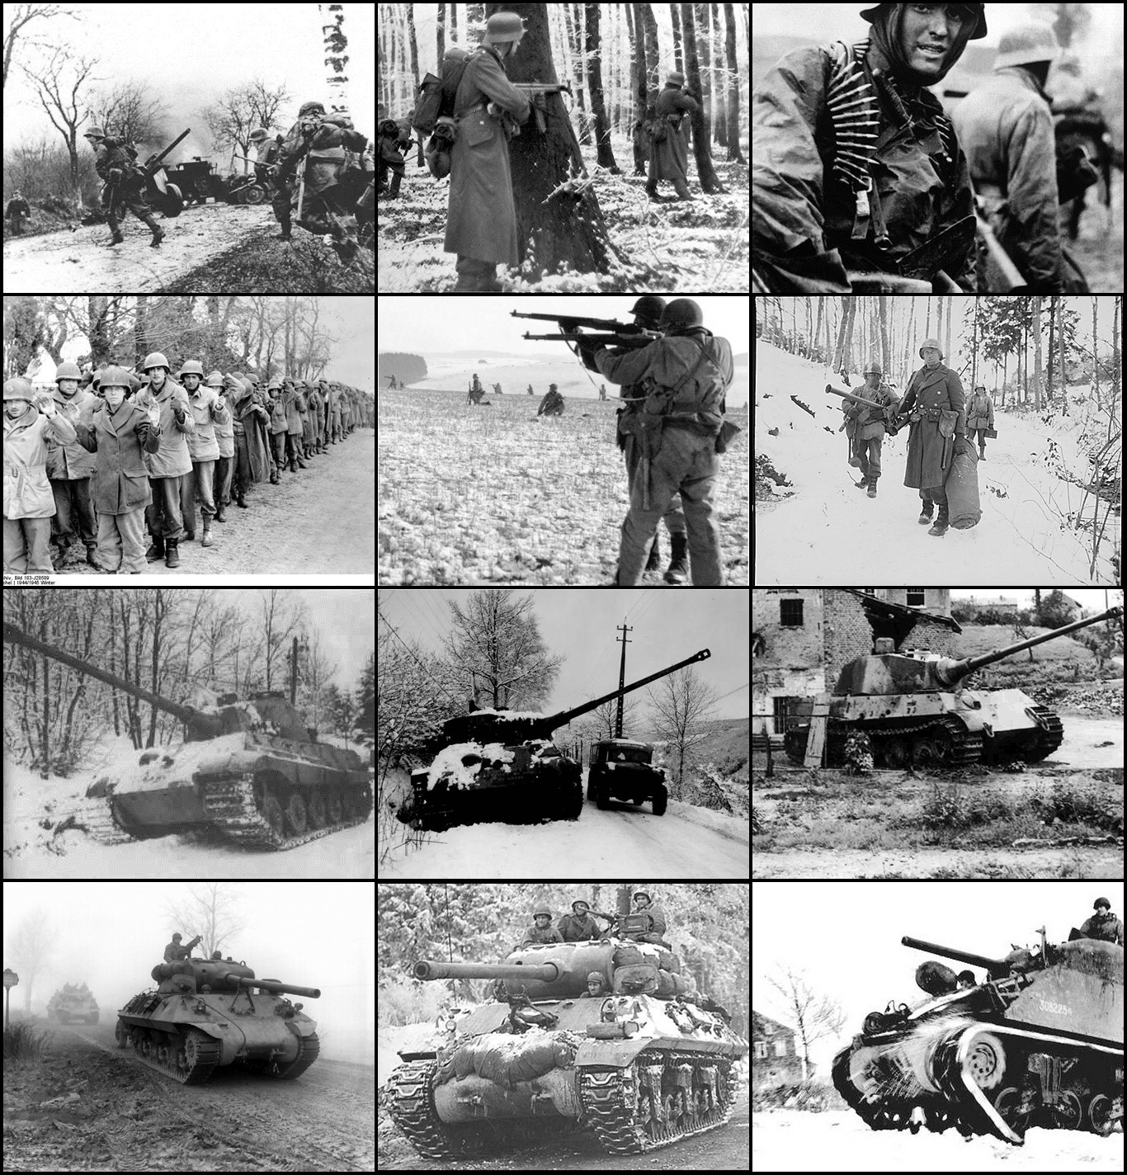
Author：YukiKana
Email: yukikana0108@gmail.com

Spearhead of the Bulge: Ardennes 1944
Historical Wargame Simulation: Spearhead of the Bulge: Ardennes 1944 Rulebook
Type: Operational-level wargame
Design background: This game is designed to recreate, through tabletop operational simulation, the German assault and the US defensive decision-making during the WWII Ardennes Offensive.
1. General Information
• Players: 2 (German player vs US player)
• Playing time: approx. 60-90 minutes
• Map scale: hex grid; each hex represents approx. 2-3 km
• Unit scale: regiment/battalion level
• Time scale: 1 turn represents approx. 12-24 hours (half a day to one day)
2. Components
- Hex map: includes terrain such as forests, roads, rivers, towns, and hills.
- Unit counters: represent US units (olive green) and German units (black SS / gray Wehrmacht).
Front side: undamaged state
Reverse side: damaged state
- Markers:
Turn marker
Fatigue/ammunition-shortage marker
Control marker
Weather marker (blizzard/clear)
- Dice: two six-sided dice (D6).
3. Unit Counter Explanation
Each combat unit counter contains the following values:
- A (Attack): attack strength
- D (Defense): defense strength
- MP (Movement Points): movement allowance
- R (Range/Resilience): range
- Icon: NATO military symbols (infantry, armor, airborne, artillery, etc.)
- Special units (HQ) contain:
CMP (Command Points): command points shown in parentheses; they may be allocated as bonuses to the A or D of friendly units within range R.
MP (Movement Points): movement allowance
R (Range/Resilience): command range (only within
Damage mechanism:
- All units have a default hit-point value (HP) of 2.
- First hit: flip to the damaged side (values are reduced).
- Second hit: remove the unit from the map (destroyed).
- Special exception: units with the "Tenacious" rule, such as the 101st Airborne Division, require additional damage before being destroyed.

4. Terrain & Movement
Movement expends movement points (MP). When a unit runs out of MP, it must stop moving.
Terrain | Movement Cost (MP) | Defense Modifier (DEF MOD) | Attack Modifier (ATK MOD) | Notes
Clear | 1 | 0 | 0 | Favorable terrain for armored units
Road | 0.5 (road movement only) | 0 | 0 | Ignore terrain MP penalties
Forest | 2/3 | +1 (infantry/engineers only) | 0 | Armored units spend 3 MP
Hill | 3 | +1 | +1 (attacking lower ground) | Provides line of sight
Town | 1 | +2 | 0 | Key defensive point
River | Impassable | +1 | -1 (attack across river) | Must cross via bridge/ford
Bridge/Ford | 2 | 0 | 0 | May be destroyed/repaired by engineers

Zone of Control (ZOC): when a unit enters a hex adjacent to an enemy unit, it must immediately stop moving unless it has the "Blitzkrieg" or "Infiltration" special ability.
Supply-line mechanism: if a unit can trace a road path from its own hex or any of the six adjacent hexes directly to a friendly supply marker, it is considered supplied. Supply lines may not pass through an EZOC (enemy zone of control).
5. Sequence of Play
The game lasts 8 turns. Each turn is played in the following order:
Phase 1: Preparation Phase
- Refit: each side chooses one damaged unit and restores it to undamaged status (flip it back to the front side).
- Remove status markers: remove all fatigue markers from the map.
- German fuel check: the German player rolls 1D6. On a result of 1, all armored units have their MP halved for this turn.
- Weather determination:
  - Turns 1-3: fixed as "dense fog and blizzard" (no air support).
  - Turns 4-8: roll 1D6. A result of 1-4 is "clear" (US Army Air Forces may operate).
- Supply status check: check the supply status of all units on both sides. Any unit without supply receives an "out of supply" marker.
Phase 2: Air & Support Phase
- US player action:
  - If the weather is "clear," the US player may conduct P-47 air interdiction. Choose one German unit and roll 1D6: 1-3 suppresses it (no movement/attack); 4-6 inflicts 1 damage.
Phase 3: US Player Turn
*Note: on Turn 1, the US player may not move or initiate attacks.
- Movement: move all unsuppressed US units.
- Combat: adjacent units may initiate attacks.
- Engineer action: build fieldworks or demolish bridges.
Phase 4: German Player Turn
- Special operation: Skorzeny commandos conduct disguise/infiltration checks.
- Movement: move all German units.
- Combat: initiate attacks.
- Engineer action: build pontoon bridges or repair demolished bridges.
Phase 5: Artillery / Indirect Fire Phase
- Howitzer and rocket artillery units on both sides conduct attacks.
- Rule: the target must be within 5 hexes and line of sight of any friendly unit.
Phase 6: End Phase
- Check victory conditions.
- Advance the turn marker.
6. Combat Rules
Procedure:
- Declare combat: the attacker designates the attacking unit(s) and target.
- Calculate modifiers:
  - Attack value (Atk Total) = unit A value + terrain attack modifier (e.g., hill +1) + status modifier (e.g., fatigue -1).
  - Defense value (Def Total) = unit D value + terrain defense modifier (e.g., town +2) + status modifier.
- Opposed die roll:
  - Attacker rolls D6 + Atk Total
  - Defender rolls D6 + Def Total
Combat Results Table (CRT)
This table resolves damage and tactical effects after a successful hit. Players calculate the post-roll advantage difference (attacker total minus defender total), then consult the table.
$$Advantage Difference =(Attacker A + D6 + attack modifier)-(Defender D + D6 + defense modifier)$$
CRT result definitions:
Result | Meaning | Detailed effect (on defender)
D1 / D2 | Damage | The target unit suffers 1 / 2 damage (flip or remove).
R1 / R2 | Retreat | The target unit must retreat 1 / 2 hexes into a direction not adjacent to the attacker. It must prioritize non-EZOC hexes. If all six surrounding hexes are EZOC, it suffers 1 damage and retreats, if possible, into a hex farther from the enemy. If surrounded and unable to retreat, it suffers 2 damage in place.
F | Fatigue | The target unit immediately enters a "fatigued/suppressed" state (A-1, D-1) until the next Preparation Phase.

Combat Results Table
Advantage Difference | Result | Notes
0 (tie) | None | The attacker fails to gain a numerical advantage, but still forces the defender to expend ammunition (the defender gains fatigue).
+1 | F | Minor advantage; mainly causes suppression.
+2 | R1 | Push the target back 1 hex. This is the most common basic hit result.
+3 | D1 + R1 | Push the target back 1 hex and inflict 1 damage. Common in infantry-on-infantry attacks.
+4 | D1 + R2 | Inflict 1 damage and push the target back 2 hexes. Common in armored breakthroughs.
+5 | D2 | Inflict 2 damage. Enough to destroy a standard unit immediately or flip an elite unit.
+6 or higher | D2 + R1 | Devastating blow; the target unit may be destroyed immediately and the defensive line may be forced back.
Attacker rolls a 6 (critical hit) | +1 additional advantage difference | The critical-hit point is added to the advantage difference. If this raises the advantage difference to +4 or higher, inflict 1 additional damage.
Critical-hit details:
If the attacker rolls a natural 6:
- First calculate the advantage difference normally.
- If the advantage difference is 2 or more (a hit), upgrade the final table result by one step, to a maximum of D2+R2.$≥$
- Alternative rule (simpler): if the attacker rolls a 6 and scores a hit, the result is at least D1 + R1 regardless of the advantage difference.
Note: unless a special rule states otherwise, the attacker becomes fatigued after resolving the attack result.
Example Calculation:
Assume:
- Attacker (Ger KG Peiper): A=7
- Defender (US 101st PIR): D=5 (D+1 in forest, total D=6)
- Die results: attacker D6=4, defender D6=2
- Totals: attacker 7+4 = 11, defender 6+2 = 8
Advantage difference = 11 - 8 = +3
- Table result: +3 corresponds to D1 + R1.
- Outcome: the 101st suffers 1 damage (flips to damaged status) and retreats 1 hex.
Artillery effects:
$Artillery Advantage Difference = (Firing unitA + D6）-(Target unitD6result + modifier)$
Artillery Results Table:
Result Code | Meaning | Detailed effect (on target unit)
D1 | Damage | The target unit suffers 1 damage (flip or remove).
P1 / P2 | Pin/Suppression | The target unit enters a "fatigued/suppressed" state for 1 / 2 turns (A-1, D-1), removed after the corresponding number of turns.
X | Shaken | The target unit must immediately retreat 1 hex in a direction not adjacent to the attacker and enters fatigue.
A | Area Effect | The target unit and all adjacent units, friendly or enemy, enter fatigue simultaneously.

Advantage Difference | Result | Typical effects and notes
0 (tie) | None | Fire falls off target.
+1 | P1 | Minor suppression. The target has limited movement or attack capability during the enemy action phase.
+2 | P1 + X | Suppression succeeds and forces the target to retreat 1 hex. This is a common effective howitzer result.
+3 | D1 + P1 | Hit! Inflicts 1 physical damage and 1 turn of suppression.
+4 | P2 + X | The target is heavily suppressed (lasting 2 turns) and pushed back 1 hex.
+5 | D1 + X | Severe hit! Inflicts 1 damage and forces a shaken retreat.
+6 or higher | D1 + A | Barrage saturation! Inflicts 1 damage, and the target plus all adjacent units enter fatigue (an ideal rocket-artillery result).
Rocket Artillery / Heavy Artillery Special Rule: | +1 additional advantage difference | When heavy artillery/rocket artillery (US M2 155mm / German multiple rocket launcher battalion) attacks, the base advantage difference receives an additional +1 regardless of the die roll, representing area-saturation firepower.
Critical Check (attacker rolls a 6): | Upgrade result | If the attacker rolls a 6 and the advantage difference is 2 or more, upgrade the final table result by one step, to a maximum of D1+A.$≥$

2. Ammunition Shortage / Fatigue / Supply Mechanism
A fatigue marker represents ammunition shortage, reduced morale, organizational disruption, or short-term supply interruption.
Conditions that trigger fatigue
- Active attack: any unit that initiates an attack must immediately receive a fatigue marker afterward.
- Artillery suppression: when enemy artillery hits a target with a suppression result, the target unit enters fatigue (see the artillery results table).
- Special rules: some unit special rules trigger fatigue, such as the US 422nd Regiment's "Inexperienced" rule.
- Out of supply:
  - If a unit, at game start or upon entering the map, cannot trace a supply line from a friendly map edge or friendly divisional HQ along a continuous road path not blocked by enemy ZOC, it enters fatigue at the end of that turn.
Effects of fatigue
- Reduced attack/defense: a fatigued unit treats both A (attack) and D (defense) as -1 in its next combat.
- Movement restriction: a fatigued unit has MP -1 on the next turn (minimum 1).
- No further active attack: a fatigued unit cannot initiate another attack until its fatigue marker is removed.
Removing fatigue
- Automatic removal in the Preparation Phase: during each turn's Preparation Phase, all fatigue markers are removed automatically.
- Special rules: some unit special rules may accelerate or delay removal of fatigue.
Design intent: this mechanism simulates the ammunition, fuel, and manpower fatigue caused by sustained attacks during the Ardennes campaign, especially for the Germans, as well as the condition of US units under suppression during defense. It encourages players to rotate units tactically and advance deliberately instead of overextending their forces.

Initial Scenario 1: The Ghost Front Awakes
Time: 16 December 1944, 05:30 AM
Weather: dense fog and blizzard (special rules apply: Allied air strikes are unavailable for the first 3 turns; visibility is limited).
Map area: northern and central Ardennes front (Monschau - St. Vith - Bastogne sector).
Turn limit: 8 turns (representing the first 4-5 days of the campaign).
1. Scenario Context
The Ardennes was known as the "Ghost Front," the quietest sector of the Allied line. Exhausted US units rested here, while inexperienced recruits acclimated to the front. At this moment, Hitler committed Germany's last strategic reserves--the 6th Panzer Army and the 5th Panzer Army--and sought to exploit bad weather that grounded Allied air power. The resulting blitz offensive, code-named "Watch on the Rhine," aimed to tear open the Allied line and drive straight toward Antwerp.
2. German Player Briefing
Commander: Josef "Peiper" Dietrich (6th Panzer Army)
Current situation: this is the Reich's final gamble. The Führer has given you elite Waffen-SS panzer divisions and several Volksgrenadier divisions. Your armored spearhead, Kampfgruppe Peiper, is a powerful ground assault force, but your Achilles heel is fuel and time. Before the Allies can react, you must pierce their line like a blade.

Strategic Objectives:
- Breakthrough: by the end of Turn 2, destroy or force back the first-line US infantry units.
- Seize the Roads: control the key road hubs of St. Vith and Malmedy.
- Cross the River: at least one armored unit must exit from the western map edge before game end, simulating an advance from the Meuse toward Antwerp.
Tactical advantages:
- Surprise: on Turn 1, all German attack rolls receive +1, and US defending units receive no terrain bonuses, representing the US forces being caught off guard by the sudden German offensive.
- Assault engineers: use your engineers to rapidly repair bridges demolished by the US or build temporary pontoon bridges that allow units other than heavy armor to cross rivers.
Tactical disadvantages:
- Congestion: you have many units, but the roads are narrow. If you cannot quickly clear the US forces ahead, following armored units will jam the roads and be unable to enter battle.
- Fuel crisis: at the start of each turn, Kampfgruppe Peiper must make a fuel check.

3. American Player Briefing
Commanders: Troy Middleton (VIII Corps) / Leonard Gerow (V Corps)
Current situation: this should have been a quiet morning. Your troops are spread along an extended line, the foxholes are shallow, and many soldiers are still in their sleeping bags. Suddenly, thousands of guns tear through the silence, followed by the roar of tracks. Communications are cut, and the front is in chaos. You face an enemy several times your strength--and possibly King Tiger tanks.
Strategic Objectives:
- Survive: do not allow your troops to be encircled and destroyed. Use forests and towns to conduct a fighting withdrawal.
- Delay: every turn you hold is a victory. Prevent German armored forces from passing through St. Vith and Bastogne.
- Wait for Patton: hold until Turn 4, when the 101st Airborne Division and armored reinforcements arrive from the map edge. Hold until the weather clears (Turn 4-5), and let the P-47 Thunderbolts bomb the Germans back to the Stone Age.
Tactical advantages:
- Stubborn defense: your units begin in confusion, but once they entrench in towns or forests, their defense becomes extremely strong (using the "Nuts!" rule).
- Artillery support: despite the chaos at the front, your rear artillery on call (105mm/155mm) remains deadly.

Tactical disadvantages:
- Intelligence vacuum: on Turn 1, most of your units are in a "suppressed/shocked" state.
(cannot move; all units have defense -1)
- Lack of heavy weapons: early on, you have almost no weapons capable of fighting King Tiger tanks; you must rely on terrain and anti-tank gun ambushes.
Initial Setup
German deployment area (eastern map edge):
• 12th, 277th, and 326th Infantry Divisions (Volksgrenadier), 3rd Panzergrenadier Division, Kampfgruppe Peiper (KG Peiper), 12th SS Panzer Division, and 150th Panzer Brigade (Skorzeny special operations unit).
• "Fallschirmjaeger Kampfgruppe von der Heydte": choose one hex on the map and roll D6. Starting from the 12 o'clock direction and proceeding clockwise, use the die result to determine the direction from the chosen hex in which the parachute regiment is dropped. Roll D6 again; subtract 1 from the result to determine the distance from the chosen hex to the deployment hex (e.g., a 1 deploys directly in the chosen hex; a 5 deploys 4 hexes away in that direction). Roll D6 once more: on 1-4, the Fallschirmjaeger regiment deploys flipped; on 5-6, it deploys front side up.
The German player may instead use Kampfgruppe von der Heydte as a normal grenadier regiment. In that case, it follows the deployment rules for other German infantry units and deploys front side up.
US deployment area (central map and eastern defensive line):
• Forward line: the 99th Infantry Division (393rd Regiment), 106th Infantry Division (422nd Regiment), 2nd Infantry Division (9th Regiment), and M10 Tank Destroyer Battalion deploy in the forward forests. The 28th Infantry Division (110th Regiment), 1104th Engineer Battalion, 82nd Airborne Division (504th PIR), 4th Armored Division (37th Tank Battalion), and 552nd Field Artillery Battalion deploy in key towns such as Clervaux.
From Turn 4 onward, the following reinforcements enter from the US start area or map edge:
3rd Armored Division (32nd Armored Regiment), 4th Armored Division (8th Cavalry Reconnaissance Squadron), 101st Airborne Division (501st PIR), 82nd Airborne Division (508th PIR), 9th Armored Division (27th Tank Battalion), US 11th Armored Division (41st Armored Infantry Regiment), US 4th Heavy Artillery Group, 1st Armored Division (Combat Command B, 32nd Armored Regiment), and US First Army Headquarters (enters stacked with the 32nd Armored Regiment Combat Command).
4. Victory Conditions
The game ends at the end of Turn 8. Both players score victory points according to the campaign situation. At game end, the side with the higher score wins.
German Victory Point Awards (German Victory Points - GVP)
- Breakthrough Points:
  - For each armored or mechanized infantry unit that exits from the western map edge by game end, simulating arrival at the Meuse and an advance toward Antwerp: gain 3 GVP.
- Strategic Objective Control:
  - Control Bastogne (at least one German unit in the town and no US units): gain 3 GVP.
  - Control St. Vith (at least one German unit in the town and no US units): gain 2 GVP.
  - Control Malmedy (at least one German unit in the town and no US units): gain 1 GVP.
- American Losses:
  - For each US armored or airborne unit destroyed: gain 1 GVP.
  - For each US infantry or engineer unit destroyed: gain 0.5 GVP.
American Victory Point Awards (American Victory Points - AVP)
- Defense Points:
  - If, at game end, no German armored or mechanized infantry unit has exited from the western map edge: gain 3 AVP.
- Strategic Objective Defense:
  - Hold Bastogne (at least one US unit in the town and no German units): gain 3 AVP.
  - Hold St. Vith (at least one US unit in the town and no German units): gain 2 AVP.
  - Hold Malmedy (at least one US unit in the town and no German units): gain 1 AVP.
- German Losses:
  - For each German armored or SS unit destroyed: gain 1 GVP.
  - For each German Wehrmacht unit destroyed: gain 0.5 GVP.
- Weather Advantage:
  - If, on Turn 5 or later, the Germans still control neither St. Vith nor Bastogne: gain 1 AVP, representing successful delay until Allied air support can intervene.
Game result determination
- Major US Victory: AVP exceeds GVP by 5 or more.
- Minor US Victory: AVP exceeds GVP by 1-4.
- Draw: AVP and GVP differ by 0 points.
- Minor German Victory: GVP exceeds AVP by 1-4.
- Major German Victory: GVP exceeds AVP by 5 or more.

Unit Counters

II
2-2-3-4
US 552nd Field Artillery Bn.
M2 105
III
28th
2-4-2-1
US 110th Infantry Reg.
III
28th
US 110th Infantry Reg.
3-5-3-1
US 110th Infantry Reg. (28th Inf. Div.)

US Units
II
US 552nd Field Artillery Bn.
0-0-2-4
CBT
II
US 1104th Engineer Bn.

1-2-2-1
US 99th Infantry Div. (393rd Inf. Reg.)

III
99th

US 393rd Infantry Reg.

2-3-2-1
US M10 Tank Destroyer Bn.

US 4th Armored Div. (37th Tank Bn.)

4th

II
4th

5-4-4-2
US 37th Tank bn.
II
1-3-3-1
US 1104th Engineer Bn.
CBT
II

US 705th Tank Destroyer Bn.
2-5-2-3
M5 AT GUN
III
106th
2-3-2-1
US 422nd Infantry Reg.
III
106th
US 422nd Infantry Reg.

3-4-3-1
US 422nd Infantry Reg. (106th Inf. Div.)

II
82nd
US 504th PIR.
3-3-2-1
II
82nd

US 504th PIR.
4-4-3-1
US 82nd Airborne Div. (504th PIR)

III
2nd

US 9th Infantry Reg.
4-4-3-1
III
2nd
US 9th Infantry Reg.

3-3-2-1
US 2nd Infantry Div. (9th Inf. Reg.)
III
99th
US 393rd Infantry Reg.
3-4-3-1
II
US 37th Tank bn.

4-3-3-2
4th

US 552nd Field Artillery Bn. (M2 105mm Howitzer)

US 1104th Engineer Bn. (Combat Engineers)

M2 105
1st
1st
P-47 Thunderbolt
A
Air Support
P-47 Thunderbolt (Air Support)

M5 AT GUN
II
US 705th Tank Destroyer Bn.

1-4-1-3
At the start of Game Turn 4, enter from the U.S. start area or the map edge.
3rd
II
82nd
Nd
US 508th PIR.
4-5-3-1
II
82nd
US 508th PIR.
3-4-2-1
II
101st

US 501st PIR.
3-4-2-1
II
101st

US 501st PIR.
4-5-3-1
US 101st Airborne Div. (501st PIR)

III
6-5-4-2
US CCB 32nd Armor Reg.
III
US CCB 32nd Armor Reg.

5-4-3-2
US 1st Armored Div. (32nd Armored Reg.)

xxxx
(2)-5-2
Ger 1. SS-Pz. Div.
HQ
KG Peiper
US 1st Army Headquarter

H
H
155mm
155mm
US 4th Artillery Group (155mm Howitzer Bn.)

II
US 552nd Field Artillery Bn.
0-0-1-4
II
3-2-2-4
US 552nd Field Artillery Bn.
US 11th Armored Div. (41st Arm. Inf. Reg.)

III
US 41st Arm. Inf. Reg.

3-3-3-2
11th
III
11th
4-4-4-2
US 41st Arm. Inf. Reg.
US 9th Armored Div. (27th Tank Bn.)

II
US 27th Tank Bn.

4-3-3-2
9th
II
9th
5-4-4-2
US 27th Tank Bn.
III
US 32nd Tank Reg.

5-4-3-2
3rd
III
3rd
6-5-4-2
US 32nd Tank Reg.
US 82nd Airborne Div. (508th PIR)

II
US 8th Cav. Rcn. Sq.

2-3-4-2
4th
II
4th
3-4-5-2
US 8th Cav. Rcn. Sq.
US 4th Armored Div. (8th Cav. Rcn. Sq.)

US 3rd Armored Div. (32nd Arm. Reg.)

GermanGerman1st SS Panzer Division - Kampfgruppe Peiper
German 1st SS Panzer Division "Leibstandarte Adolf Hitler" - Kampfgruppe Peiper
III
5-4-4-1
Ger 2. SS-Pzgd. Reg.

KG Peiper
III
6-5-4-1
Ger 2. SS-Pzgd. Reg.
KG Peiper
Ger 12. SS-Division „Hitlerjugend“-25. Panzergrenadier-Regiment
12th SS Panzer Division "Hitlerjugend" - 25th SS Panzergrenadier Regiment
III
5-4-5-1
Ger 25. SS-Pzgd. Reg.
12. SS-Pz.
III
5-4-5-1
Ger 25. SS-Pzgd. Reg.
12. SS-Pz.
Ger 12. SS-Division „Hitlerjugend“-25. Panzergrenadier-Regiment
12th SS Panzer Division "Hitlerjugend" - 25th SS Panzergrenadier Regiment
III
5-4-5-1
Ger 25. SS-Pzgd. Reg.
12. SS-Pz.
III
5-4-5-1
Ger 25. SS-Pzgd. Reg.
12. SS-Pz.
German 12th SS Division "Hitlerjugend"
III
6-5-4-1
Ger 1. SS-Pzgd. Reg.
KG Peiper
II
(2)-5-2
Ger 1. SS-Pz. Div.
HQ
KG Peiper
Ger 1. SS-Panzer-Division LSSAH
1st SS Panzer Division "Leibstandarte Adolf Hitler" - Divisional HQ
III
2-1-3-3
Ger 1. SS-Artillery Reg.
12. SS-Pz.

III
1-0-2-3
Ger 1. SS-Artillery Reg.

12. SS-Pz.

Ger 12. SS-Division „Hitlerjugend“-12. SS-Panzer Artillerie Regiment
12th SS Division "Hitlerjugend" - Divisional 12th Panzer Artillery Regiment

III
3-2-3-3
Ger 1. SS-Artillery Reg.
KG Peiper

III
2-2-2-3
Ger 1. SS-Artillery Reg.

KG Peiper

Ger 1. SS-Panzer-Division LSSAH - 1. SS-Panzer Artillerie Regiment
1st SS Panzer Division "Leibstandarte Adolf Hitler" - Kampfgruppe Peiper - Divisional 1st Panzer Artillery Regiment
III
6-5-4-2
Ger 12. SS-Pz. Reg.
12. SS-Pz.
III
5-4-3-2
Ger 12. SS-Pz. Reg.
12. SS-Pz.
II
(1)-4-2
Ger 12. SS-Pz. Div.
HQ
12. SS-Pz.

Ger 12. SS-Division „Hitlerjugend“
12th SS Division "Hitlerjugend" - Divisional HQ
Ger 1. SS-Panzer-Division LSSAH - SS-1. & 2. Panzergrenadier-Regiment
1st SS Panzer Division "Leibstandarte Adolf Hitler" - Kampfgruppe Peiper - 1st and 2nd SS Panzergrenadier Regiments
III
5-4-4-1
Ger 26. SS-Pzgd. Reg.
12. SS-Pz.
III
4-4-4-1
Ger 26. SS-Pzgd. Reg.
12. SS-Pz.
Ger 12. SS-Division „Hitlerjugend“-26. Panzergrenadier-Regiment
12th SS Division "Hitlerjugend" - 26th SS Panzergrenadier Regiment
III
4-4-4-1
Ger 25. SS-Pzgd. Reg.
12. SS-Pz.
Ger 12. SS-Division „Hitlerjugend“-25. Panzergrenadier-Regiment
12th SS Division "Hitlerjugend" - 25th SS Panzergrenadier Regiment
III
5-4-4-1
Ger 25. SS-Pzgd. Reg.
12. SS-Pz.
Ger 12. SS-Division „Hitlerjugend“-12. Panzer Regiment
12th SS Division "Hitlerjugend" - 12th SS Panzer Regiment
Ger 1. SS-Panzer-Division LSSAH - SS-1. Panzer Regiment
1st SS Panzer Division "Leibstandarte Adolf Hitler" - Kampfgruppe Peiper - 1st SS Heavy Panzer Regiment
III
6-5-3-2
Ger 1. SS-Pz. Reg.

H
12. SS-Pz.
III
5-4-4-1
Ger 1. SS-Pzgd. Reg.

KG Peiper
III
7-5-4-2
Ger 1. SS-Pz. Reg.
H
KG Peiper

German Wehrmacht units under the 6th Panzer Army
Ger 326. Volksgrenadier-division (Gren. Reg. 751)
German Wehrmacht 326th Volksgrenadier Division (751st Grenadier Regiment)
III
3-4-3-1
Ger Gren. Reg. 751
326. VGD
III
2-3-2-1
Ger Gren. Reg. 751
326. VGD
II
3-3-3-1
Ger Fsch. Reg. 5
Der Heydte
II
1-2-2-1
Ger Fsch. Reg. 5
Der Heydte

Fallschirmjäger-Kampfgruppe von der Heydte(Fsch.Jg.Rgt. 5)
Kampfgruppe von der Heydte (5th Fallschirmjaeger Regiment)
Ger 12. Volksgrenadier-division (Pz.Jg.Abt 12)
German Wehrmacht 12th Volksgrenadier Division (12th Tank Destroyer Battalion)
II
3-3-2-2
Ger Gren. Reg. 27
12. VGD
II
2-2-1-2
Ger Gren. Reg. 27
27
12. VGD
Ger 277. Volksgrenadier-division 277. (Pionier-Btl 277)
German Wehrmacht 277th Volksgrenadier Division (277th Engineer Battalion)
II
3-4-3-1
Ger Pionier-Btl 277
277. VGD
II
2-3-2-1
Ger Pionier-Btl 277

277. VGD
Ger 12. Volksgrenadier-division (Gren. Reg. 48)
German Wehrmacht 12th Volksgrenadier Division (48th Grenadier Regiment)
III
3-4-3-1
Ger Gren. Reg. 48
12. VGD
III
2-3-2-1
Ger Gren. Reg. 48

12. VGD
Ger 3. Panzergrenadier Div. (8. Panzergrenadier-Reg.)
German Wehrmacht 3rd Panzergrenadier Division (8th Panzergrenadier Regiment)
III
4-4-4-1
Ger Fsch. Reg. 8
12. VGD
III
3-3-3-1
Ger Fsch. Reg. 8

12. VGD
Ger 12. Volksgrenadier-division (Gren. Reg. 27)
German Wehrmacht 12th Volksgrenadier Division (27th Grenadier Regiment)
III
3-4-3-1
Ger Gren. Reg. 27
12. VGD
III
2-3-2-1
Ger Gren. Reg. 27
27
12. VGD
II
3-3-3-1
Ger Fsch. Reg. 9
Der Heydte
II
1-2-2-1
Ger Fsch. Reg. 9
Der Heydte

Fallschirmjäger-Kampfgruppe von der Heydte(Fsch.Jg.Rgt. 9)
Kampfgruppe von der Heydte (9th Fallschirmjaeger Regiment)
Ger 150. Panzer-Brigade (Einheit Stielau)
150th Panzer Brigade (Skorzeny Commando)
x
3-3-4-1
Ger Fsch. Reg. 8
150. Pz.
x
2-2-3-1
Ger Fsch. Reg. 8

150. Pz.

SOF
SOF
Ger 277. Volksgrenadier-division (Gren. Reg. 989)
German Wehrmacht 277th Volksgrenadier Division (989th Grenadier Regiment)
III
3-4-3-1
Ger Gren. Reg. 989
277. VGD
III
2-3-2-1
Ger Gren. Reg. 989
277. VGD
III
1-2-3-4
Ger 1. SS-Artillery Reg.
KG Peiper

III
0-1-2-4
Ger 1. SS-Artillery Reg.

KG Peiper

Ger 12. SS-Division „Hitlerjugend“-12. SS-Panzer Artillerie Regiment
12th SS Division "Hitlerjugend" - Divisional 12th Panzer Artillery Regiment

III
3-3-2-2
Ger 1. SS-Flak-Abt
LSSAH

III
2-2-2-2
Ger 1. SS-Flak-Abt

LSSAH

Ger 1. SS-Panzer-Division LSSAH - 1. SS-Flak-Abt
1st SS Panzer Division "Leibstandarte Adolf Hitler" - 1st SS Self-propelled Flak Battalion
III
5-1-3-3
Ger SS-Werfer-Abt 12

12. SS-Pz.

III
3-0-2-3
Ger SS-Werfer-Abt 12

12. SS-Pz.

Ger 12. SS-Division „Hitlerjugend“-12. SS-Werfer-Abt 12
12th SS Division "Hitlerjugend" - 12th SS Multiple Rocket Launcher Battalion
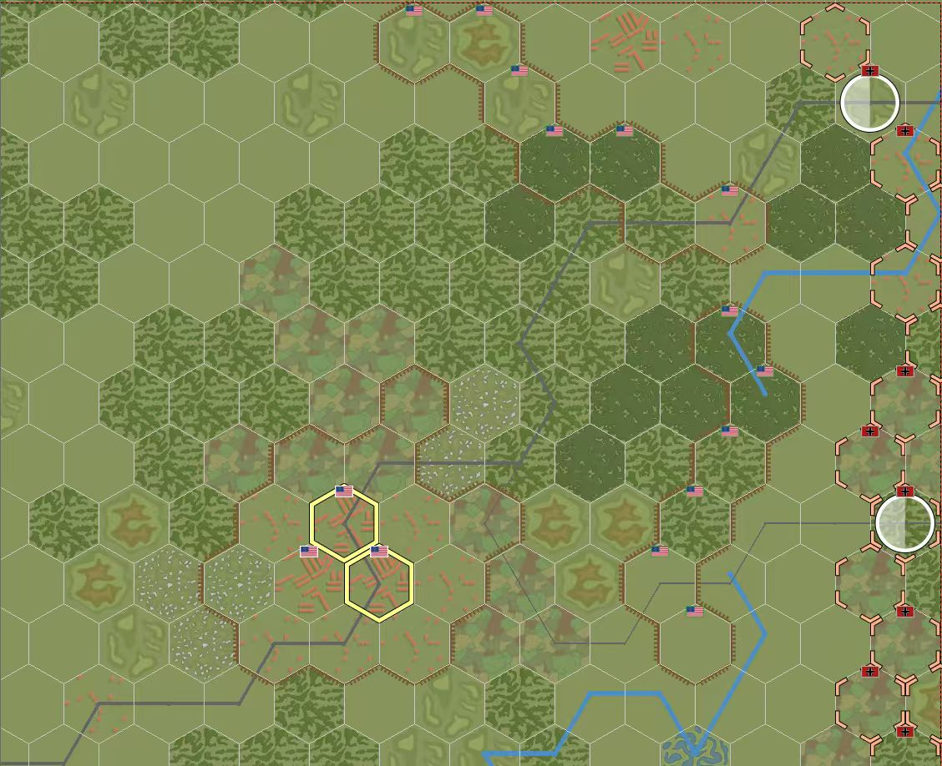
Map(excerpt)
Partial map display(near St. Vith)
SS 1 Div.
SS 12 Div.
Saint-Vith

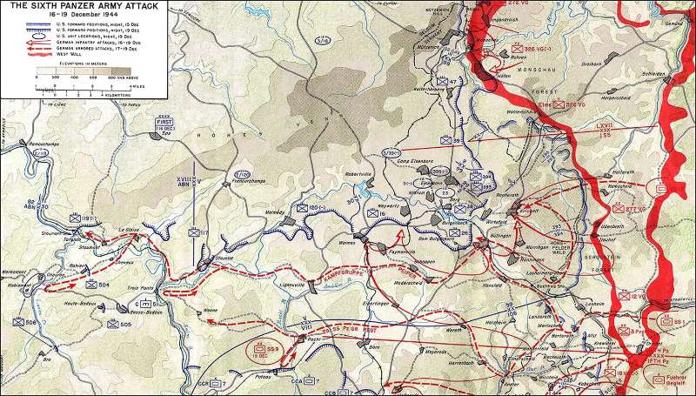
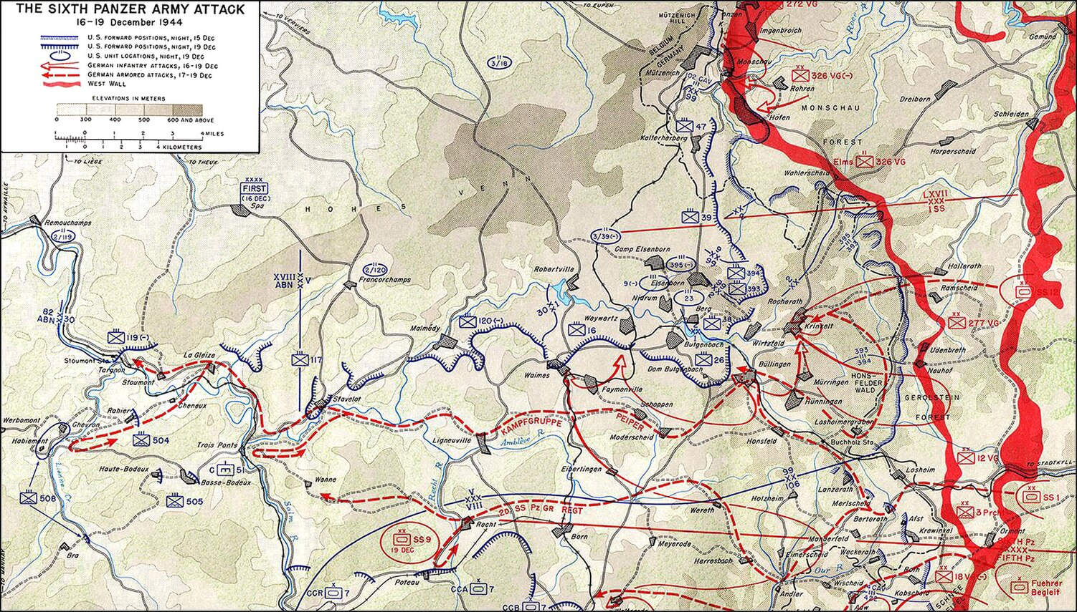
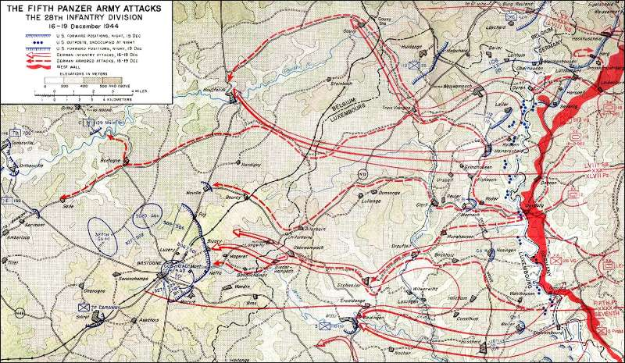
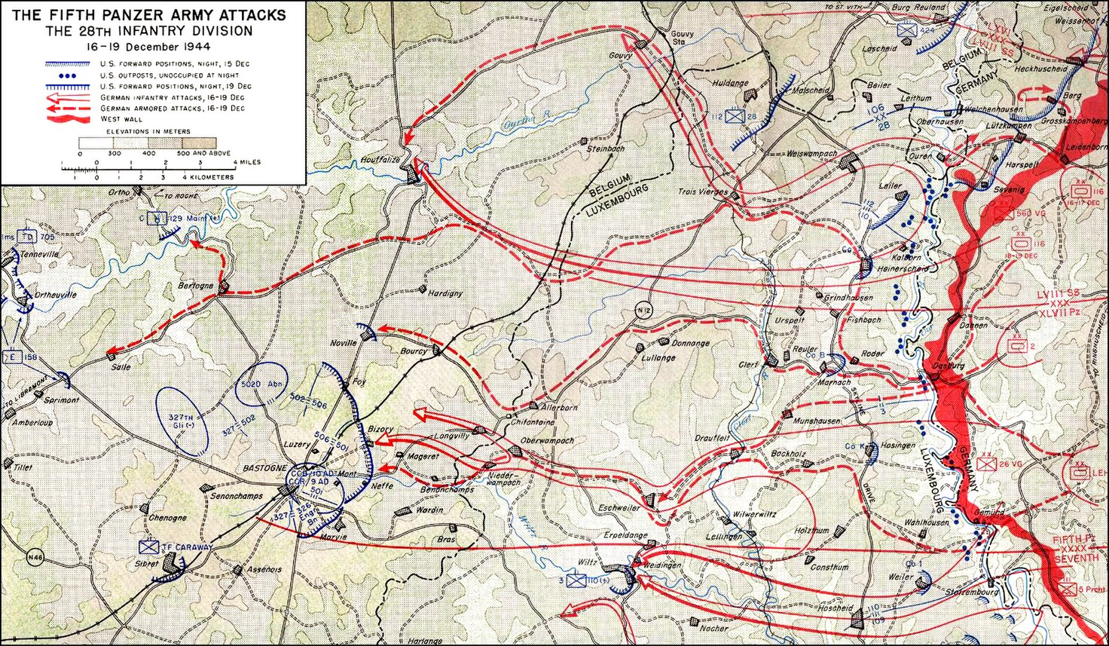
Historical campaign map (central front)
Historical campaign map (northern front)
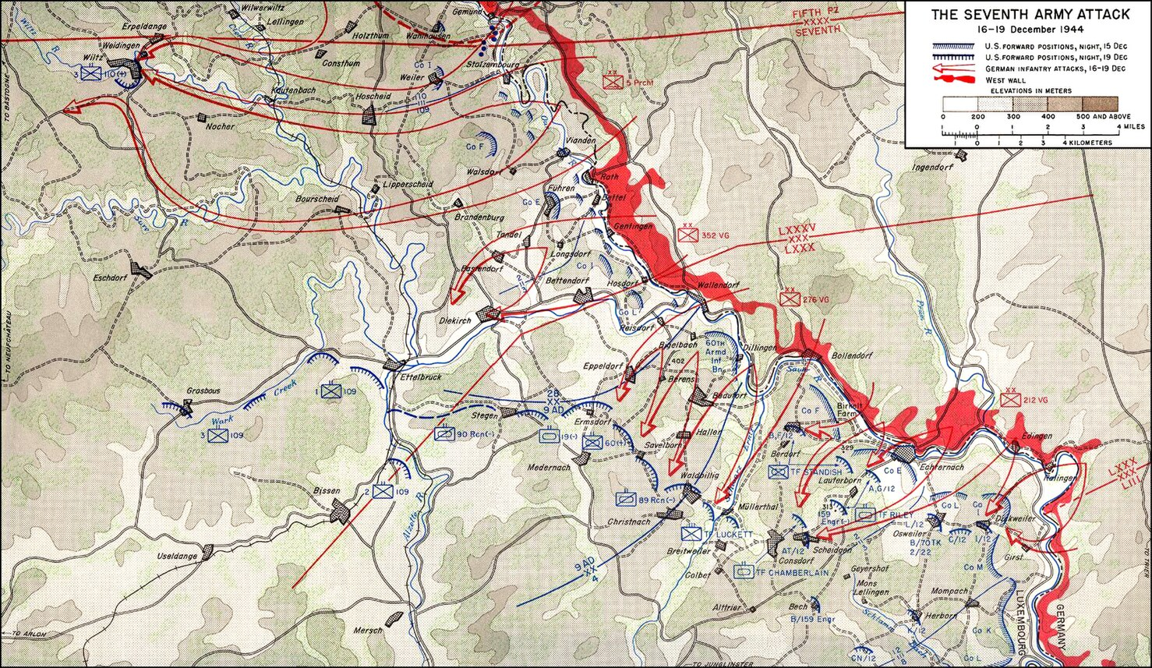
Historical campaign map (southern front)

Notes on Counters with Special Rules on Both Sides
US units:
• US 110th Infantry Regiment (28th Infantry Division) (basic infantry unit).
• US 422nd Infantry Regiment (106th Infantry Division)
- Special rule: Inexperienced. If fatigued (F), defense suffers an additional -1.
• US 4th Armored Division (37th Tank Battalion) (standard armored unit).
• US 705th Tank Destroyer Battalion (M10 Tank Destroyer Battalion)
- Special rule: Ambush. D+1 when defending against armored units. If deployed in forest or hill terrain, it may not be targeted by active artillery fire before its first shot. D+1 when defending against armored units.
• US 99th Infantry Division (393rd Infantry Regiment)
- Special rule: First Contact. If hit by the Germans on Turn 1, the unit automatically enters fatigue.
• US 552nd Field Artillery Battalion (M2 105mm Howitzer Battalion)
- Special rule: Indirect Fire. May attack only when within an observing unit's spotting conditions (R 4, with a friendly unit within 2 hexes of the target acting as an observer; if the observing unit is adjacent to the enemy, add +1 to the roll).$≤$
• US 1104th Engineer Battalion (Combat Engineers)
- Special rule: Build/Repair. Spend 3 MP to repair a ford or build temporary fieldworks (+1 defense).
• US 2nd Infantry Division (9th Infantry Regiment)
- Special rule: Veteran Tenacity. After taking damage, this unit may hold its position and ignore retreat results R1/R2.
• US 82nd Airborne Division (504th PIR)
- Special rule: Rapid Deployment. At game start, this unit may deploy in any strongpoint or hill behind the front line.
• US Army Air Forces P-47 Thunderbolt (Air Support)
- Special rule: Air Support. Available only in clear weather after Turn 4. Conduct air interdiction: roll D6; 1-3 causes suppression, 4-6 causes 1 damage.

The following US units enter after Turn 4:
• US 3rd Armored Division (32nd Armored Regiment)
- Special rule: "Thunderbolt Vanguard." When first entering the map, this unit may ignore 1 MP of cost to enter any clear or road hex.
• US 4th Armored Division (8th Cavalry Reconnaissance Squadron)
- Special rule: Rapid Penetration / Observer Unit. This unit has MP 5; movement cost on clear terrain is halved. At turn end, it may act as an R=3 observing unit to spot targets for artillery.
• US 101st Airborne Division (501st PIR)
- Special rule: "Nuts!" (Hold Fast). When defending, the US player may reroll one defense die. Tenacious: the unit must suffer 2 damage before being destroyed, so its reverse side can still absorb 1 additional damage.
• US 82nd Airborne Division (508th PIR)
- Special rule: Veteran Experience. When attacking German Volksgrenadier units, attack rolls receive +1.
• US 9th Armored Division (27th Tank Battalion) (standard armored reinforcement unit).
• US 11th Armored Division (41st Armored Infantry Regiment)
- Special rule: Mechanized Firepower. When attacking or defending against a target on clear terrain or a road, choose either A+1 or D+1.
• US 4th Heavy Artillery Group (155mm Heavy Howitzer)
- Special rule: Counter-battery Fire / Indirect Fire. When a German indirect-fire unit attacks a US unit, this unit may spend 1 AP in the artillery phase to conduct a counter-battery attack against it (counter-battery attack roll -1).
• US First Army Headquarters (HQ)
- Special rule: Theater Command. This unit moves with friendly forces; it may only stack with friendly units, cannot enter EZOC, and cannot attack. When an adjacent US unit initiates combat, that combat unit receives the modifier shown in parentheses to A or D; the points in parentheses may be allocated freely between A and D.
• US 1st Armored Division (32nd Armored Regiment Combat Command B / CCB)
- Special rule: Experienced. When attacking, this unit may choose to ignore counterfire from up to two enemy units with R=1; those enemy D values are not counted when calculating advantage difference. Command Center: adjacent friendly units receive MP +1.

German units:
I. 1st SS Panzer Division "Leibstandarte Adolf Hitler" (LSSAH)
- 1st SS Panzer Division - Kampfgruppe Peiper (1st SS Heavy Panzer Regiment)
  - Special rule: Armored Assault / "Blitzkrieg." Attack rolls receive +2. After successfully destroying an enemy unit, this unit may immediately move an additional 2 hexes, representing rapid armored-column penetration. Weakness: each turn, there is a 1/6 chance its MP is halved (fuel crisis); it cannot cross pontoon bridges.
- 1st SS Panzer Division - Kampfgruppe Peiper (1st/2nd SS Panzergrenadier Regiments)
  - Special rule: Infantry-Tank Coordinated Assault. If attacking the same target as Kampfgruppe Peiper - 1st SS Heavy Panzer Regiment, this unit receives A+1.
- 1st SS Panzer Division - Divisional 1st Panzer Artillery Regiment
  - Special rule: Mobile Firepower. This self-propelled artillery unit may still conduct indirect fire after moving. Indirect fire: R 4 and a friendly unit within 2 hexes of the target must act as an observer; if the observing unit is adjacent to the enemy, add +1 to the roll.$≤$
- 1st SS Panzer Division - Divisional HQ
  - Special rule: this unit moves stacked with the 1st SS Heavy Panzer Regiment and may enter EZOC, but cannot attack.
- 1st SS Panzer Division - 1st SS Self-propelled Flak Battalion
  - Special rule: Wirbelwind self-propelled AA. May offset US air strikes against itself or units in the six surrounding hexes. On a roll of 1-2, subtract the corresponding number from the air-strike roll before determining the air-strike result. It may also attack ground targets, but only infantry not in cover (R=2).

II. 12th SS Panzer Division "Hitlerjugend"
- 12th SS Panzer Division - 12th SS Panzer Regiment
  - Special rule: Fanatical Defense. When defending, if this unit takes damage but is not destroyed, it ignores all retreat (R) results.
- 12th SS Panzer Division - 25th SS Panzergrenadier Regiment
  - Special rule: Flank Cover. When attacking a fatigued unit, this unit receives A+1.
- 12th SS Panzer Division - 26th SS Panzergrenadier Regiment
  - Special rule: Motorized March. MP cost is halved when moving along roads.
- 12th SS Panzer Division - Divisional 12th Panzer Artillery Regiment
  - Special rule: Indirect Fire. R$≤$4; a friendly unit within 2 hexes of the target must act as an observer. If the observing unit is adjacent to the enemy, add +1 to the roll.
- 12th SS Panzer Division - Divisional HQ
  - Special rule: Divisional Command. This unit may move stacked with any unit of the 12th SS Panzer Division and cannot attack. CMP may only be allocated to D. When a same-hex or adjacent 12th SS Panzer Regiment unit fights, it may reroll one defense die.
- 12th SS Panzer Division - 12th SS Multiple Rocket Launcher Battalion
  - Special rule: Screaming Death. Attacks cause area suppression. If a hit (D1) is scored, the target unit and all adjacent units, friendly or enemy, enter fatigue.

II. German Wehrmacht units under the 6th Panzer Army
- German Wehrmacht 12th Volksgrenadier Division (48th Grenadier Regiment)
  - Special rule: Snow March. During the first movement action, if the unit enters only forest hexes, reduce MP cost by 1.
- German Wehrmacht 12th Volksgrenadier Division (27th Grenadier Regiment) (standard Volksgrenadier unit).
- German Wehrmacht 3rd Panzergrenadier Division (8th Panzergrenadier Regiment)
  - Special rule: Rapid Reaction. During the US action phase, this unit may spend 1 MP at any time to move 1 hex.
- Kampfgruppe von der Heydte (5th Fallschirmjaeger Regiment)
  - Special rule: Forest Hunters. In forest terrain, when facing pure infantry units, this unit receives an additional +1 modifier to both attack A and defense D.
- Kampfgruppe von der Heydte (9th Fallschirmjaeger Regiment)
  - Special rule: Anti-artillery. When receiving artillery fire, apply a -2 die-roll modifier.
- 150th Panzer Brigade (Skorzeny Commando)
  - Special rule: Disguise Operation. At game start, this unit may deploy behind the US defensive line, no more than 6 hexes from the German front line. It may not stack with US units. During Turns 1-2, before it initiates an attack, it is treated as a US unit and may not be actively attacked by US units.
- German Wehrmacht 326th Volksgrenadier Division (751st Grenadier Regiment)
  - Special rule: Human Wave Tactics. If adjacent to a friendly unit, this unit receives A+1.
- German Wehrmacht 277th Volksgrenadier Division (989th Grenadier Regiment)
  - Special rule: Prepared Defense. Sacrifice mobility for defense. If this unit did not move this turn, its defense roll receives +1.
- German Wehrmacht 277th Volksgrenadier Division (277th Engineer Battalion)
  - Special rule: Obstacle Clearance / Demolition. When attacking enemy units in forest or hill terrain, ignore the +1 terrain defense bonus. May spend one turn action to repair a bridge or build a pontoon bridge.
- German Wehrmacht 12th Volksgrenadier Division (12th Tank Destroyer Battalion)
  - Special rule: "Hetzer" Counterattack. When defending in forest or hill terrain, D+1.

