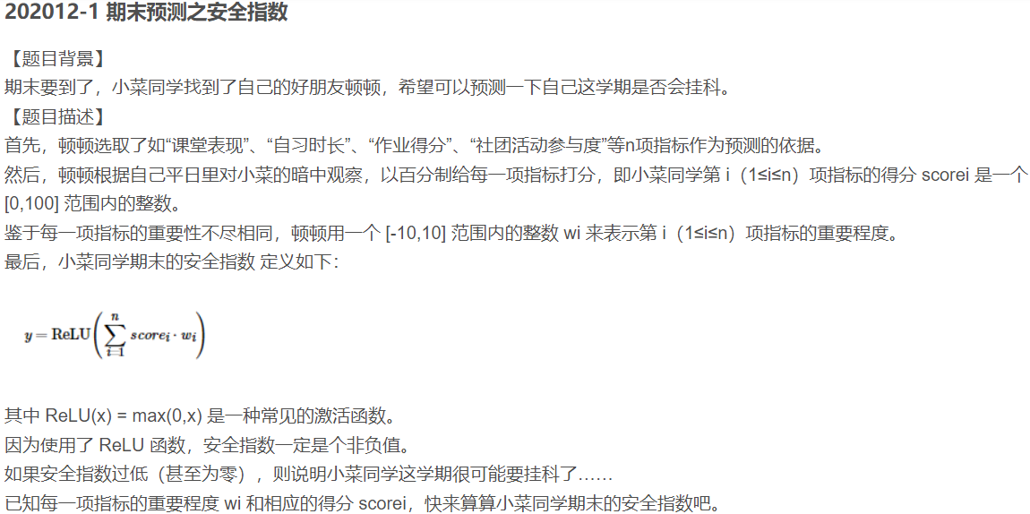

- //期末预测之安全指数
- #include <iostream>
- using namespace std;
- #include <vector>
- int main()
- {
- //vector<int> v;
- int n,sum = 0;
- cin >> n;

- for (int i = 0; i < n; i++)
- {
- int w = 0, score = 0;
- cin >> w >> score;
- sum += w * score;
- }
- /*for (auto h : v)
- {
- sum += h;
- }*/
- if (sum > 0)
- {
- cout << sum << endl;
- }
- else
- {
- cout << 0 << endl;
- }
- system("pause");
- return 0;
- }

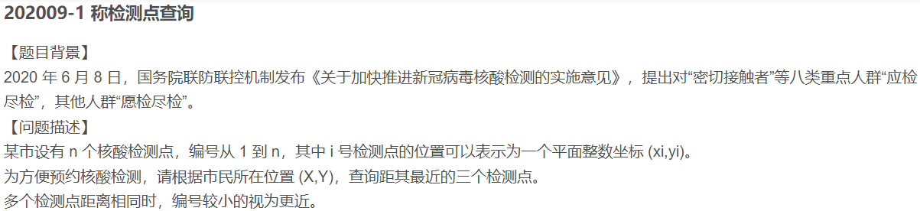
- #include <iostream>
- using namespace std;
- #include <map>
- #include <math.h>
- int main()
- {
- int n, X, Y;
- cin >> n >> X >> Y;
- multimap<double ,int> m;//根据key自动排序，升序

- for (int i = 0; i < n; i++)
- {
- int x, y;
- cin >> x >> y;
- double distance = sqrt(pow((X - x), 2) + pow((Y - y), 2));
- m.insert(pair<double , int>(distance,i+1));
- }
- int count = 0;
- for (auto a : m)
- {
- if (count < 3)
- {
- cout << a.second << endl;
- count++;
- }
- else
- {
- break;
- }
- }
- system("pause");
- return 0;
- }

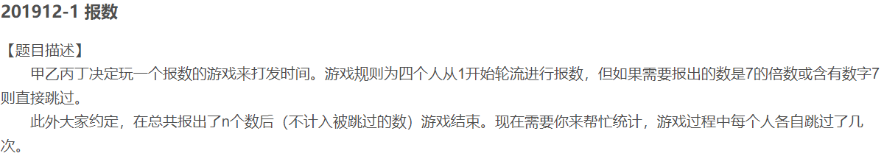
- #include <iostream>
- using namespace std;

- int main08()
- {
- int n;
- int asum = 0, bsum = 0, csum = 0, dsum = 0;
- cin >> n;

- for (int i = 1; i <= n; i++)
- {
- if (i % 4 == 1 && (i % 7 == 0 || i % 10 == 7 || i / 10 % 10 == 7 || i / 100 == 7))
- {
- asum++;
- n++;
- }
- else if (i % 4 == 2 && (i % 7 == 0 || i % 10 == 7 || i / 10 % 10 == 7 || i / 100 == 7))
- {
- bsum++;
- n++;
- }
- else if (i % 4 == 3 && (i % 7 == 0 || i % 10 == 7 || i / 10 % 10 == 7 || i / 100 == 7))
- {
- csum++;
- n++;
- }
- else if(i % 4 == 0 && (i % 7 == 0 || i % 10 == 7 || i / 10 % 10 == 7 || i / 100 == 7))
- {
- dsum++;
- n++;
- }
- }
- cout << asum << endl << bsum << endl << csum << endl << dsum << endl;
- return 0;
- }

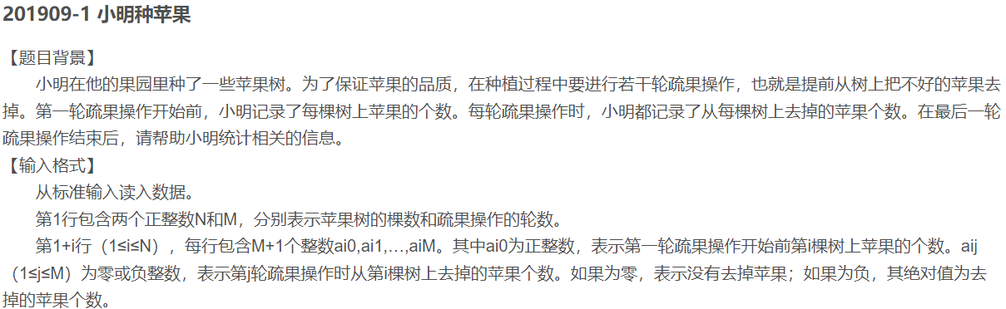

- #include <iostream>
- using namespace std;
- #include <map>
- #include <math.h>
- class Mycompare
- {
- public:
- bool operator()(int v1, int v2)
- {
- return v1 > v2;
- }
- };
- int main()
- {
- int N, M, T = 0;
- cin >> N >> M;
- multimap<int,int,Mycompare> m;
- for (int i = 1; i <= N; i++)
- {
- int temp;
- cin >> temp;
- int a ,b = 0;
- for (int j = 0; j < M; j++)
- {
- cin >> a;
- temp += a;
- b += a;
- }
- T += temp;
- b = fabs(b);
- m.insert(make_pair(b, i));
- }
- cout << T << " " << m.begin()->second << " " << m.begin()->first << endl;
- system("pause");
- return 0;
- }
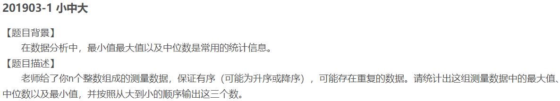

- #include <iostream>
- using namespace std;
- #include <cstdio>
- #include <vector>
- int main()
- {
- int n;
- cin >> n;
- vector<int> v;
- for (int i = 0; i < n; i++)
- {
- int temp;
- cin >> temp;
- v.push_back(temp);
- }
- int max, min;
- if (v.front() > v.back())
- {
- max = v.front();
- min = v.back();
- }
- else
- {
- max = v.back();
- min = v.front();
- }
- double medium = 0;
- if (n % 2 == 0)
- {
- medium = (v[n / 2] + v[n / 2 - 1]) / 2.0;//vector中【】也是从0开始
- }
- else
- {
- medium = v[n / 2];
- }
- if ((int)medium == medium)
- {
- printf("%d %d %d", max, (int)medium, min);
- }
- else
- {
- printf("%d %0.1f %d", max, medium, min);
- }
- system("pause");
- return 0;
- }

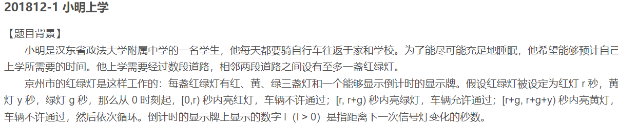

- #include <iostream>
- using namespace std;
- int main()
- { int r, g, y, n;
- int T = 0;
- cin >> r >> g >> y;
- cin >> n;
- for (int i = 0; i < n; i++)
- {
- int k, t = 0,temp;
- cin >> k >> temp;
- switch (k)
- {
- case 0:
- {
- t = temp; break;
- }
- case 1:
- {
- t = temp; break;
- }
- case 2:
- {
- t = temp;
- t += r; break;
- } }
- T += t;
- }
- cout << T << endl;
- return 0; }
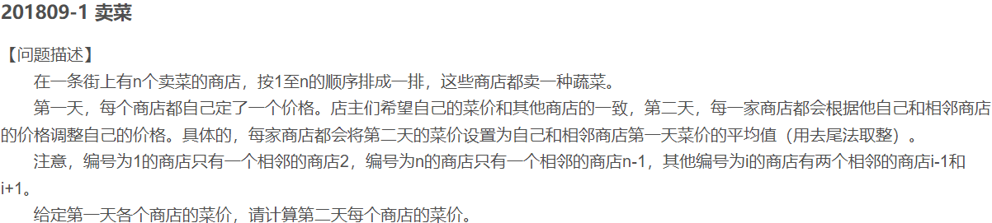
- #include <iostream>
- using namespace std;
- #include <vector>

- int main12()
- {
- int n ,a;
- cin >> n;
- vector<int> v1;
- vector<int> v2;//一定要设置两个容器，一个不能满足要求。防止篡改存放第一天菜价的数据。
- for (int i = 0; i < n; i++)
- {
- cin >> a;
- v1.push_back(a);
- }

- for (int i = 0; i < n; i++)
- {
- if (i == 0)
- {
- v2.push_back((v1[i + 1] + v1[i]) / 2);
- }
- else if(i == n-1)
- {
- v2.push_back((v1[n - 2]+ v1[n-1]) /2);
- }
- else
- {
- v2.push_back((v1[i - 1] + v1[i + 1] + v1[i]) / 3);
- }
- }
- for (auto k : v2)
- { cout << k << " "; }
- cout << endl;
- system("pause");
- return 0;
- }
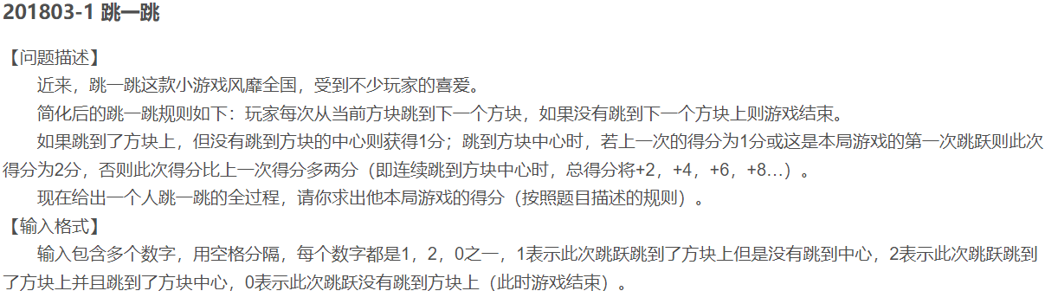

- #include <iostream>
- using namespace std;
- #include <vector>
- //#include <algorithm>
- /*int k = 0;
- void sumfunc(int val)
- {
- k += val;
- }*/

- int main()
- {
- vector<int> v;
- int sum = 0;
- for(int i = 0;;i++)
- {
- int a,score = 0;
- cin >> a;
- if (a == 0)
- {
- score = 0;
- break;
- }
- else if (a == 1)
- {
- score = 1;
- v.push_back(score);
- }
- else if (a == 2)
- {
- if (i == 0 || v[i - 1] == 1)
- {
- score = 2;
- v.push_back(score);
- }
- else
- {
- score = v[i - 1] + 2;
- v.push_back(score);
- }
- }
- }
- //for_each(v.begin(), v.end(), sumfunc);
- for (auto k : v)
- {
- sum += k;
- }
- cout << sum << endl;
- system("pause");
- return 0;
- }

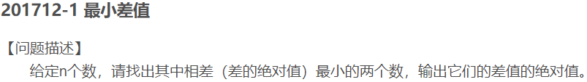

- #include <iostream>
- using namespace std;
- #include <set>
- #include <vector>
- #include <math.h>
- #include <algorithm>

- int main()
- {
- multiset<int> s;
- vector<int> v;
- int n;
- cin >> n;
- for (int i = 0; i < n; i++)
- {
- int temp = 0;
- cin >> temp;
- v.push_back(temp);
- }

- sort(v.begin(), v.end());
- for (int j = 0; j < n-1; j++)
- {
- int temp02 = 0;
- temp02 = v[j + 1] - v[j];
- temp02 = fabs(temp02);
- s.insert(temp02);
- }
- cout << (*s.begin()) << endl;
- system("pause");
- return 0;
- }

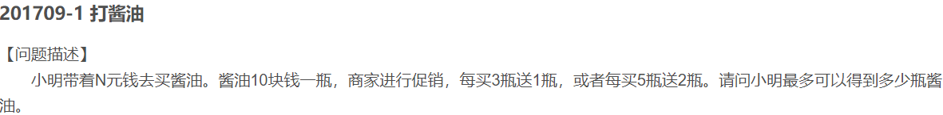

- #include <iostream>
- using namespace std;

- int main15()
- {
- int n;
- cin >> n;
- int sum = 0;
- sum += n / 50 * 7;
- n = n % 50;
- sum += n / 30 * 4;
- n = n % 30;
- sum += n / 10;
- cout << sum;

- system("pause");
- return 0;
- }

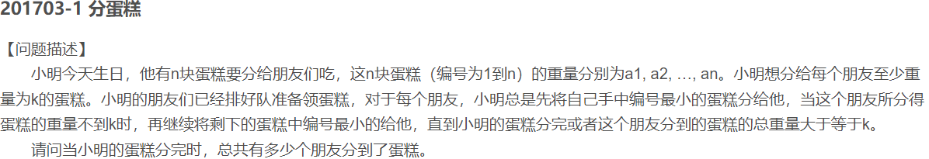
- #include <iostream>
- using namespace std;
- #include <vector>
- int main()
- {
- vector<int> v;
- int n, k,sum = 0;
- cin >> n >> k;

- for (int i = 1; i <= n; i++)
- {
- int a = 0;
- cin >> a;
- v.push_back(a);
- }
- for (int j = 0;j < n; j++)
- {
- int temp = 0;
- if (v[j] >= k)
- {
- sum++;
- }
- else
- {
- temp = v[j] + v[j+1];
- j++;
- for (; temp < k; ++j, temp += v[j] );
- sum++;
- }
- }
- cout << sum << endl;
- system("pause");
- return 0;
- }
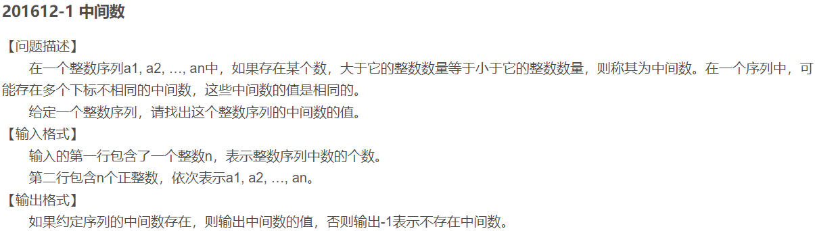
- #include <iostream>
- using namespace std;
- #include <vector>
- #include <algorithm>
- //注意vector跟数组一样，是从0开始
- int main()
- {
- vector<int> v;
- int sum1 = 0, sum2 = 0;
- int n;
- cin >> n;
- for (int i = 0; i < n; i++)
- {
- int k = 0;
- cin >> k;
- v.push_back(k);
- }
- sort(v.begin(), v.end());
- if (n % 2 == 1)
- {
- int temp = v[(n - 1) / 2];
- for (auto h : v)
- {
- if (h < temp)
- {
- sum1++;
- }
- else if (h > temp)
- {
- sum2++;
- }
- }
- if (sum1 == sum2)
- {
- cout << temp << endl;
- }
- else
- {
- cout << -1 << endl;
- }
- }
- else if (n % 2 == 0)
- {
- if (v[(n-2) / 2] == v[n / 2 ])
- {
- int temp = v[(n-2) / 2];
- for (auto h : v)
- {
- if (h < temp)
- {
- sum1++;
- }
- else if (h > temp)
- {
- sum2++;
- }
- }
- if (sum1 == sum2)
- {
- cout << temp << endl;
- }
- else
- {
- cout << -1 << endl;
- }
- }
- else
- {
- cout << -1 << endl;
- }
- }
- system("pause");
- return 0;
- }

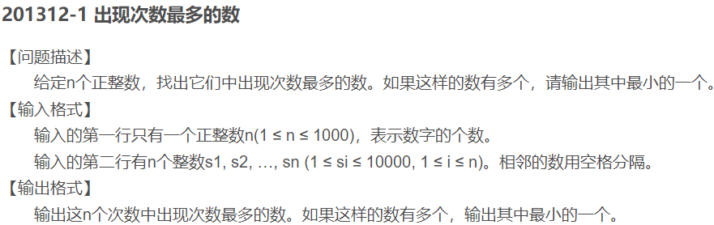

- #include <iostream>
- using namespace std;
- #include <map>

- int main()
- {
- int n,times = 0;
- cin >> n;
- int num;
- map<int, int> m;

- for (int i = 0; i < n; i++)
- {
- int n;
- cin >> n;
- m[n]++;
- }
- for (auto k: m)
- {
- if (k.second > times)
- {
- times = k.second;
- num = k.first;
- }
- }
- cout << num << endl;
- system("pause");
- return 0;
- }
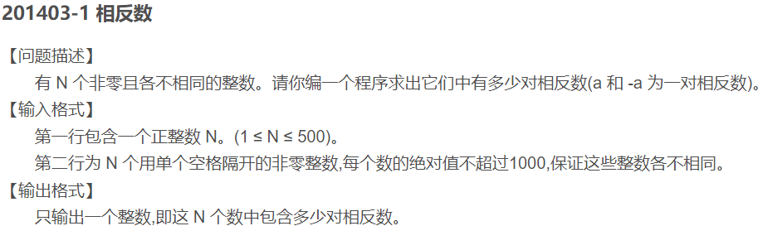
- #include <iostream>
- using namespace std;
- #include <vector>
- #include <cmath>
- #include <algorithm>
- int main()
- {
- int n,sum = 0;
- cin >> n;
- vector<int> v;
- for (int i = 0; i < n; i++)
- {
- int temp = 0;
- cin >> temp;
- temp = abs(temp);
- v.push_back(temp);
- }

- for (int i = 0; i < n; i++)
- {
- if (count(v.begin(), v.end(), v[i]) == 2)
- {
- sum++;
- }
- }
- cout << sum/2 << endl;//vector中有两个相同数时，sum多记一次
- system("pause");
- return 0;
- }
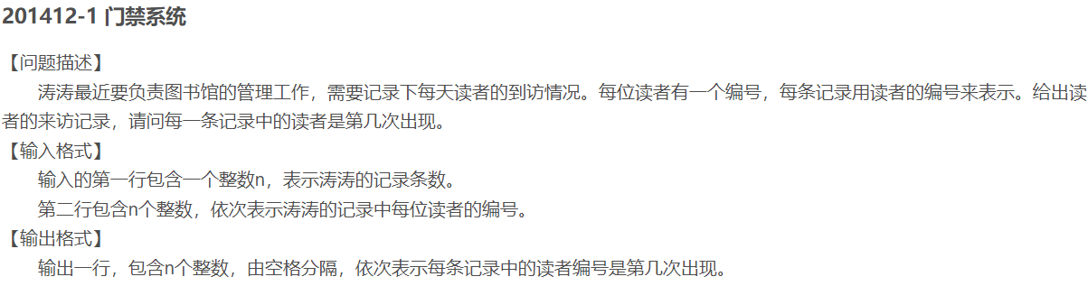
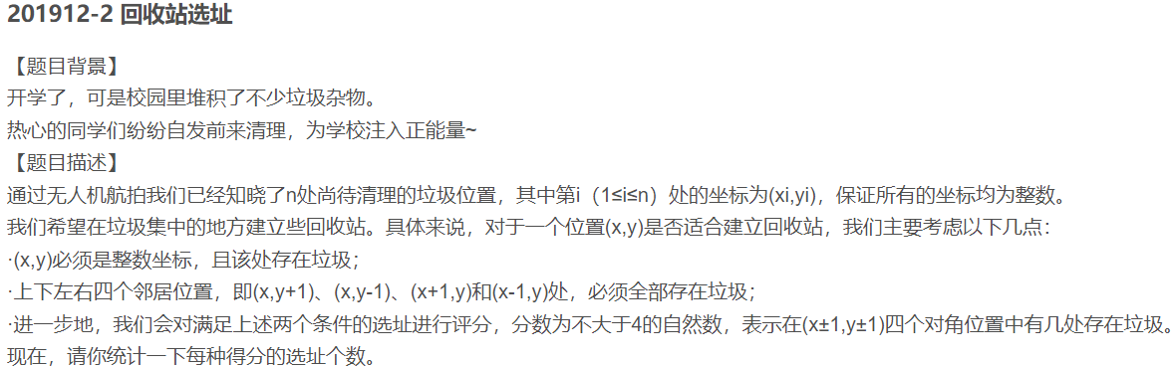
- #include <iostream>
- using namespace std;

- int main()
- {
- int number;
- cin >> number;
- int p[1001];
- int i;
- for (i = 0; i < 1001; i++)
- p[i] = 0;
- int n;
- for (i = 0; i < number; i++)
- {
- cin >> n;
- p[n]++;
- cout << p[n] << " ";
- }
- return 0;
- }

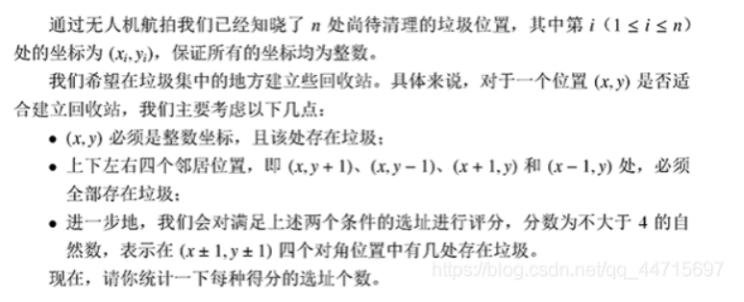
- #include<iostream>
- using namespace std;
- #include <vector>

- class Point
- {
- public:
- int x, y;
- int flag = 0;
- };
- void isgarbageprint(vector<Point>& v, int n)
- {
- for (int i = 0; i < n; i++)
- {
- int sum = 0;
- for (int j = 0; j < n; j++)
- {
- if ((v[i].x - 1 == v[j].x && v[i].y == v[j].y) ||
- (v[i].x + 1 == v[j].x && v[i].y == v[j].y) ||
- (v[i].x == v[j].x && v[i].y - 1 == v[j].y) ||
- (v[i].x == v[j].x && v[i].y + 1 == v[j].y))
- sum++;
- }
- if (sum == 4)
- v[i].flag = 1;
- }
- }
- void getPrint(vector<Point> v, int n, vector<int> &score)
- {
- for (int i = 0; i < n; i++)
- {
- if (v[i].flag == 1)
- {
- int sum = 0;
- for (int j = 0; j < n; j++)
- {
- if ((v[i].x - 1 == v[j].x && v[i].y - 1 == v[j].y) ||
- (v[i].x + 1 == v[j].x && v[i].y - 1 == v[j].y) ||
- (v[i].x - 1 == v[j].x && v[i].y + 1 == v[j].y) ||
- (v[i].x + 1 == v[j].x && v[i].y + 1 == v[j].y))
- sum++;
- }
- if (sum == 0)
- {
- score[0]++;
- }
- else if (sum == 1)
- {
- score[1]++;
- }
- else if (sum == 2)
- {
- score[2]++;
- }
- else if (sum == 3)
- {
- score[3]++;
- }
- else if (sum == 4)
- {
- score[4]++;
- }
- }
- }
- }
- int main()
- {
- vector<Point> v;
- vector<int> score;
- v.resize(1005);
- score.resize(5);
- int n;
- cin >> n;
- for (int i = 0; i < n; i++)
- {
- cin >> v[i].x >> v[i].y;
- }
- isgarbageprint(v, n);
- getPrint(v, n,score);
- for (auto d : score)
- {
- cout << d << endl;
- }
- system("pause");
- return 0；}
1. #include <iostream>
- #include <stack>
- using namespace std;
- //定义一个取相反数的函数
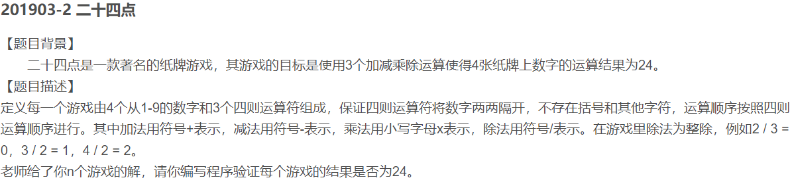
- int reverse(int m)
- {
- return (0-m);
- }
- int main()
- {
- stack<int> num; //声明一个int型的栈变量
- string s;
- int n;
- cin>>n;
- while(n--)
- {
- cin>>s;
- for(int i=0;i<7;i++)
- {
- //当字符是数字时直接进栈
- if(s[i]>='0'&&s[i]<='9')
- {
- num.push(s[i]-'0');
- }
- //当字符是x或者/时，定义栈顶元素出栈后完成乘除操作
- else if(s[i]=='x'||s[i]=='/')
- {
- int temp=num.top();
- num.pop();
- if(s[i]=='x')
- {
- temp *= (s[++i]-'0');
- //这里使用++i而不是i++，因为i++在这条语句执行前没有完成+1操作，而这里需要的是完成了+1操作的数据，因此就是++i
- }
- else if(s[i]=='/')
- {
- temp /= (s[++i]-'0');
- }
- num.push(temp); //将得出的结果进栈
- }
- else if(s[i]=='+'||s[i]=='-')
- {
- //如果是+或者-则直接进行进栈操作
- if(s[i]=='+')
- {
- num.push(s[++i]-'0');
- }
- else if(s[i]=='-')
- {
- //注意：减号直接将数字的相反数进栈即可
- num.push(reverse(s[++i]-'0'));
- }
- }
- }
- int res=0;
- //当栈不为空时，一直进行计算，知道最后出栈
- while(!num.empty())
- {
- int temp=num.top();
- res +=temp;
- num.pop();
- }
- if(res==24)
- {
- cout<<"Yes"<<endl;
- }
- else if(res!=24)
- {
- cout<<"No"<<endl;
- }
- }
- return 0;
- }

201703-2
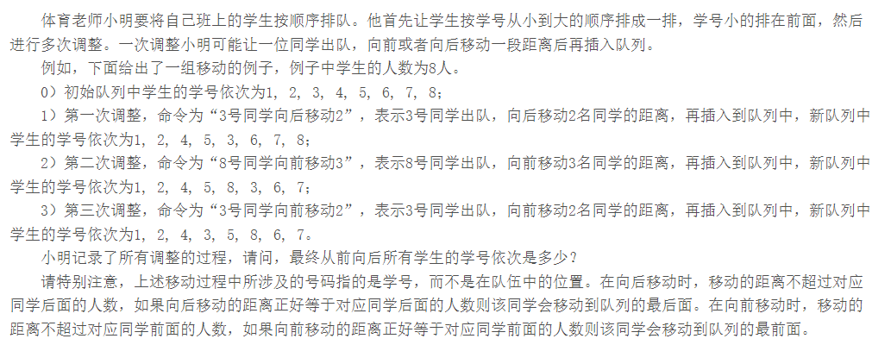

- #include <iostream>
- using namespace std;
- #include <list>
- #include <algorithm>

- void Print(int val) {
- cout << val << " "; }
- class Print01
- {
- public:
- void operator()(int val) {
- cout << val << " "; }
- };
- int main()
- {
- int n, m, p, q;
- list<int>stu;
- cin >> n;
- for (int i = 1; i <= n; i++)
- {
- stu.push_back(i);
- }
- cin >> m;
- for (int i = 0; i < m; i++)
- {
- cin >> p >> q;
- auto it = find(stu.begin(), stu.end(), p);
- it = stu.erase(it);
- advance(it ,q);
- stu.insert(it, p);
- }
- for_each(stu.begin(),stu.end(),Print);//如果是函数则写函数名
- cout << endl;
- for_each(stu.begin(),stu.end(),Print01());//如果是函数对象则还要加括号
- cout << endl;
- system("pause");
- return 0;
- }

