Bias Voltage DAC Progress Tracker
  - Purdue SoCET AMS Senior Design | Sprint 4 | Progress through October 25, 2026
Henan Wang | Experimental work: October 17 and October 22, 2026
I implemented a physical NMOS reset in the 3-bit CDAC, compared reset widths, tested discharge from a charged output, and ran three TT temperature points. I also characterized a transmission gate through an ON–OFF–ON sequence. Reset release error and OFF-current numerical accuracy remain unresolved; a thermometer-coded comparison is the next implementation task.

1 Tagged GitHub Issues and Project Cards
Continuing project task recorded in Sprint 3: AMS Tracking Issue #48
Work item | Sprint 4 status
Physical reset and width comparison | Implemented; nominal comparisons complete
Charged-output reset and TT temperature scan | Simulated; release error remains
TG ON/OFF behavior | Transient markers recorded; OFF validation open
Thermometer CDAC comparison | Planned; implementation not yet confirmed

2 Evidence of Progress

Physical reset and width comparison — October 17
The recovered six-TG baseline uses an ideal relay reset with 1 kΩ closed resistance. In cdac_3b_n65_tg_mosrst_oct17, I replaced this reset with tsmcN65 nch: D=Vout, G=rst, S=Vl, B=VSS; L=60 nm and nf=m=1. Reset width changed from 1 to 0.5 µm in the same variant. A mistakenly MOS-bound reference run was excluded; the corrected reference binding and relay were verified before comparison.
Conditions: tt_lib, 27 °C, 1 V supply/reference span, no added output load, and 400 ns transient. The binary array retains eight 110.659 fF units and six MOS reference TGs. Reference sources and behavioral control remain ideal.
Code | ΔV, W=1 µm  (µV) | ΔV, W=0.5 µm  (µV) | Reduction in |ΔV|
000 | −330.0194 | −184.2289 | 44.2%
100 | −732.3 | −395.6 | 46.0%
111 | −1016.9 | −546.0 | 46.3%

ΔV is MOS-reset output minus the verified ideal-reset reference. Readouts are rounded and taken at slightly unequal times near 59, 223 and 344 ns. The smaller reset reduced all three sampled error magnitudes, but these points do not establish INL/DNL or an optimum width. Charge injection, feedthrough and parasitic loading remain possible contributors rather than isolated mechanisms.

2 Evidence of Progress (continued)

Charged-output discharge and reset release
With W=0.5 µm, a second reset pulse was applied from 350 to 370 ns with 1 ns edges while the bottom-plate code remained 111. This directly tested discharge from a high output; it did not restore the prior bias or demonstrate refresh operation.
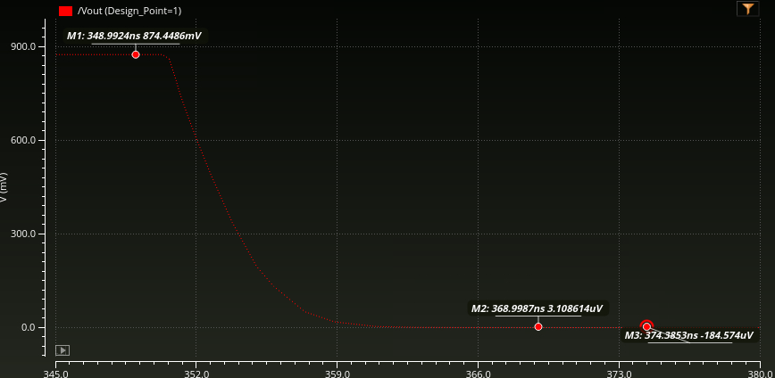
Figure 1. October 17 charged-output reset. Vout is 874.4486 mV at 348.9924 ns, +3.108614 µV at 368.9987 ns, and −184.574 µV at 374.3853 ns.
The output discharged near zero while reset was ON, then retained about −185 µV offset after release. A separate marker at 365.542 ns measured +61.27946 µV, about 15.54 ns after assertion. It is slightly outside the provisional +61 µV boundary, so this is a near-threshold estimate, not a verified settling time. The near-zero zigzag and numerical convergence remain unchecked.

Temperature-only TT scan
I ran tt_lib at −40, 27 and 85 °C with the same W=0.5 µm reset, references, driver and no-added-load setup. All three runs completed with the staircase and second reset visible. Code-111 values were compared near 343 ns.
Temperature | Code-111 Vout (mV) | Difference from 27 °C (µV)
−40 °C | 874.4884 | +31.4
27 °C | 874.4570 | 0
85 °C | 874.3085 | −148.5

The sampled maximum-to-minimum spread is 179.9 µV. The 27 and 85 °C markers occur at 343.0198 and 343.0218 ns. The −40 °C value was confirmed near 343 ns, but its exact marker time was obscured. This is one-code, finite-delay temperature sensitivity; full-code temperature INL/DNL, temperature-dependent reset timing, full PVT and cryogenic operation are not established.
Reset release error and temperature sensitivity therefore need separate error budgets. The provisional ±61 µV comparison band is not an approved reset requirement, and these results do not demonstrate the future 12-bit accuracy target.

2 Evidence of Progress (continued)

Transmission-gate ON–OFF–ON test — October 22
Following mentor feedback to examine both switch states, I tested complementary EN/ENB transitions with vtest=0.52 V and an intended 1 mV A-to-B bias. The unchanged TG uses NMOS W/L=1 µm/60 nm and PMOS W/L=2 µm/60 nm. The traces show ON initially, OFF around 21–60 ns, and ON again after about 61 ns.
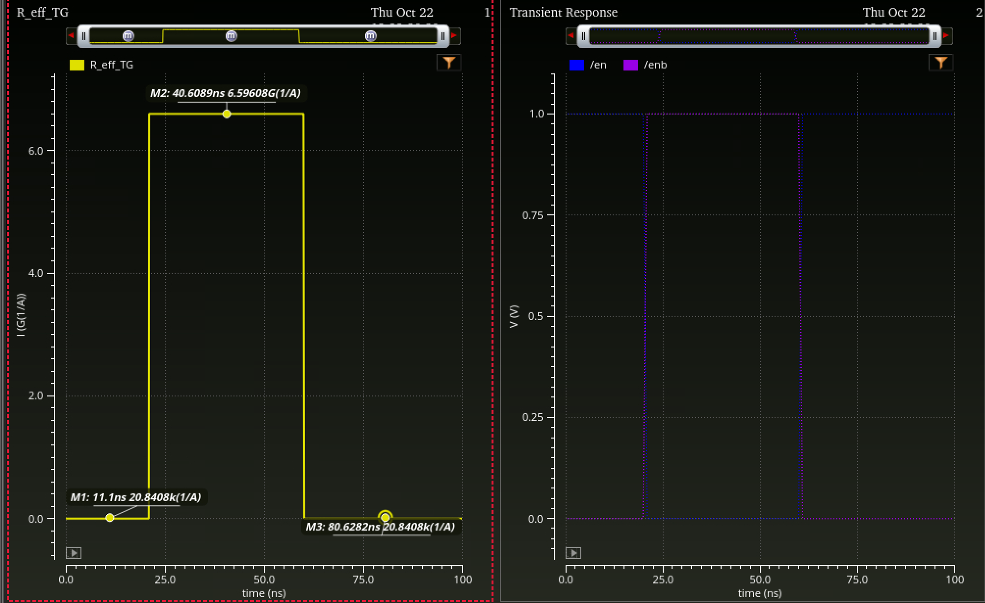
Figure 2. Effective-resistance expression and EN/ENB waveforms. The plotted 1/A units arise from a unitless 0.001 numerator; resistance values below use the intended 1 mV bias.
State | Marker time (ns) | (1 mV)/|I(V2/PLUS)|
ON, before | 11.1000 | 20.8408 kΩ
OFF | 40.6089 | 6.59608 GΩ (provisional)
ON, after | 80.6282 | 20.8408 kΩ

The two ON readings match to displayed precision and agree with the earlier enabled DC result near 0.52 V. The OFF/ON ratio is approximately 3.16 × 10⁵ at this bias; this does not establish a channel isolation specification.
Raw I(V2/PLUS) is +151.605 fA at 34.6089 ns, whereas the ON current is visually negative. With unchanged terminal bias, this sign reversal prevents treating the magnitude ratio as a demonstrated passive A-to-B channel resistance. The raw current and resistance expression use the same signal, so their agreement is not independent validation. Signed current at the other terminal and tolerance/gmin sensitivity remain unresolved.

2 Evidence of Progress (additional waveforms)

Reset width and discharge detail — October 17
These waveforms supplement the reset comparison table and charged-output test. The first shows the W=0.5 µm ascending scan; the second resolves the discharge near the provisional precision band.
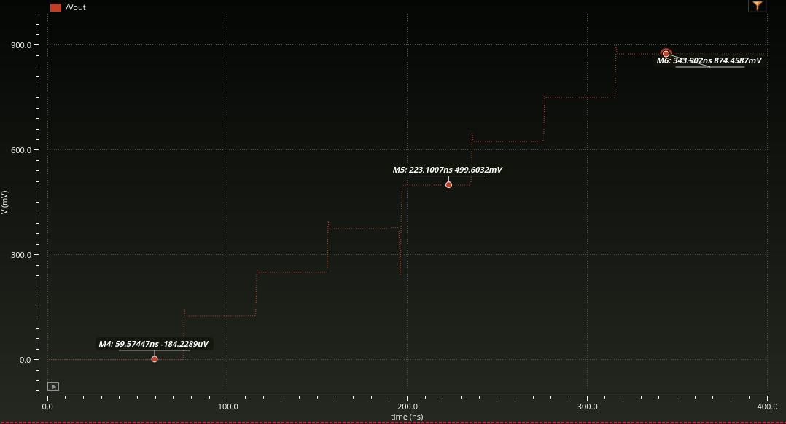
Figure 3. W=0.5 µm reset: code-000 output is −184.2289 µV at 59.57447 ns; code 100 is 499.6032 mV at 223.1007 ns; code 111 is 874.4587 mV at 343.902 ns. Compare with the ideal-reset and W=1 µm values in the reset table. The switching dip remains visible.
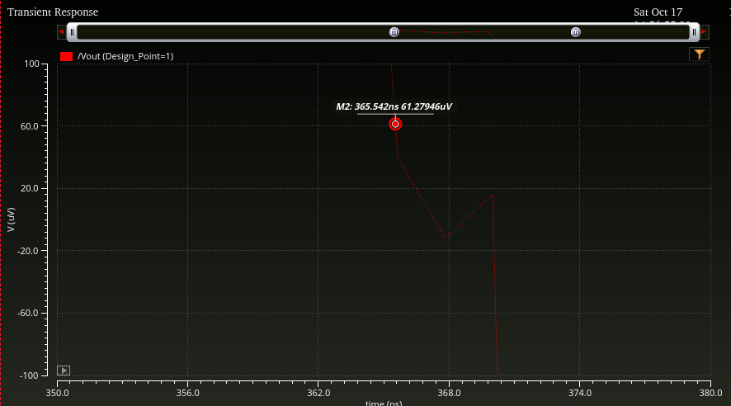
Figure 4. Charged-output reset near zero: +61.27946 µV at 365.542 ns, about 15.54 ns after the 350 ns assertion command. This is slightly outside +61 µV. The trace leaves the comparison band after release near 370 ns; the zigzag around zero has not been resolved by a numerical-convergence check.

2 Evidence of Progress (additional waveforms)
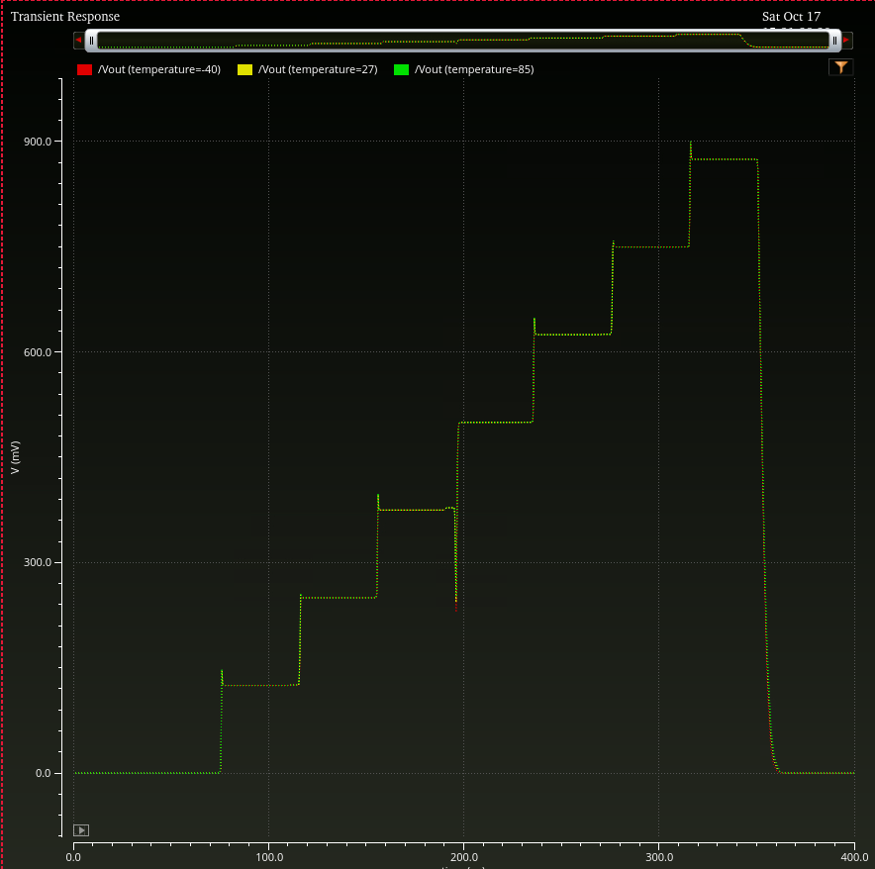
Figure 5. TT temperature overlays at −40 °C (red), 27 °C (yellow) and 85 °C (green), using W=0.5 µm reset. All runs show the staircase and second reset. The full-scale overlap does not resolve precision; the temperature table reports the 179.9 µV sampled code-111 spread.
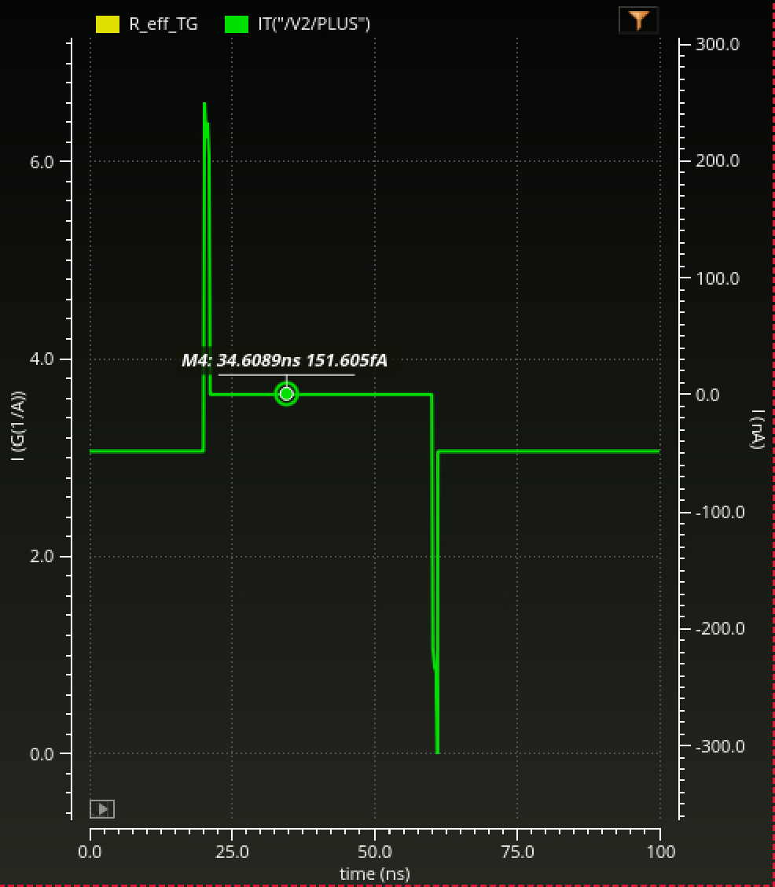
Figure 6. October 22 raw I(V2/PLUS), green, read on the right-hand current axis. The OFF marker is +151.605 fA at 34.6089 ns; the ON current is visually negative. The OFF marker label provides the small current value that is not resolved on the nA-scale axis. Edge-current peaks and OFF-current numerical accuracy remain unverified.

3 Blockers and Open Decisions

Numerical confidence and physical interpretation
OFF-current verification was paused before a tolerance or gmin rerun. A simulator-options screen displayed gmin=10⁻¹² and disabled tolerance fields, but the effective solver settings were not verified. The current femtoampere result must remain provisional until the active simulator mode, signed terminal currents and numerical sensitivity are checked.
Reset comparisons also require matched-time sampling and a smaller-step/tighter-tolerance check. The approximate discharge threshold time does not establish post-release accuracy, and width dependence alone does not separate charge injection, feedthrough and capacitive loading.

Architecture and measurement coverage
Mentor feedback reported on October 22 requested TG ON/OFF characterization and suggested thermometer coding or another approach if the output drop is switching-related. The historical binary 011→100 disturbance remains the comparison motivation; its magnitude was not remeasured for a thermometer implementation this sprint.
The current design remains a 3-bit schematic test vehicle. Loaded settling, 1 ms retention, power, noise, mismatch, PEX and validated cryogenic performance are still open. Reset error/timing budgets, acceptable load and area, and cold-model availability require agreement before system-level accuracy claims.

4 Proposed Goals for the Next Sprint
1. Build a separate thermometer CDAC while preserving the six-TG MOS-reset baseline. Use seven switched unit capacitors plus one dummy, with the same total capacitance, references and reset. Schematic copying, rewiring, symbol expansion and driver/testbench updates are not yet confirmed complete.
2. Compare binary and thermometer transitions under matched load, timing and numerical settings. Measure overshoot/undershoot and settling in a common error band, including reverse transitions. Adjacent thermometer codes change one unit; arbitrary code jumps may change several. Fourteen reference TGs are required instead of six, so switch area, parasitic capacitance and drive distribution must be included in the comparison.
3. Resume TG OFF-current verification. Identify effective solver settings, record signed currents at both terminals at the same OFF time, and test tolerance/gmin sensitivity before interpreting leakage. Extend terminal-bias coverage after the existing 1 mV test is understood.
4. Verify reset and DAC accuracy before extending claims. Recheck discharge/release with controlled numerical settings, sample all codes at matched delays, and then prioritize loaded settling and hold drift. Extend the architecture comparison to the three existing temperatures only after the nominal comparison works.

Supporting project records
October 17 and October 22 experiment logs; final Week 8 Word/PDF report; Sprint 3 baseline report; working specifications v0 revision 2. Figures reproduce the recorded simulation evidence. Measurements above are simulation readouts, not silicon characterization.

