Bias Voltage DAC Sprint 5 Report
Henan Wang | Purdue SoCET AMS Senior Design | November 8, 2026
I built and simulated a 3-bit thermometer-coded capacitor DAC to investigate the output dip previously observed when the binary DAC switched from code 3 to code 4. The thermometer output rose from approximately 375 to 500 mV with no visible dip at the recorded scale. This week I prepared the driver for a 2+1 segmented array to test whether eight reference switches can deliver similar transition behavior.

1 Project tracking
Earlier mentor task for this project · AMS Tracking Issue #48
Work item | Status through November 8
Thermometer array and testbench | Built and simulated at TT and 27 °C
Static output and code 3 to 4 | Seven plateau readings and a transition detail recorded
Segmented array and comparison | Local driver prepared. Schematic and simulations pending.

2 Thermometer CDAC implementation
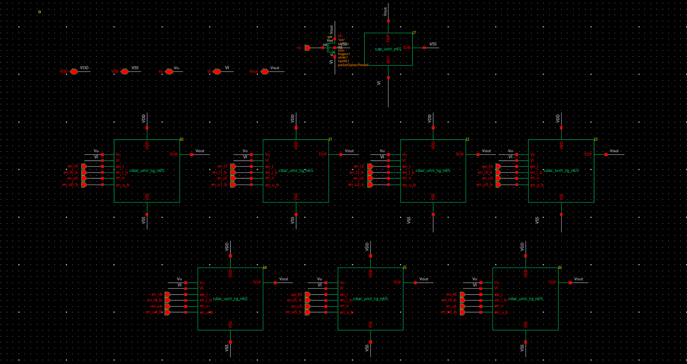
Figure 1. Seven independently switched unit capacitors share Vout with one fixed dummy capacitor and the NMOS reset. Moving up one code connects one more unit to the upper reference.

Reference selection and testbench
Each unit connects its bottom plate to either Vu or Vl through a pair of transmission gates (TGs). Seven identical units give 14 reference TGs. The binary array has six. Both use eight unit capacitors including the dummy.
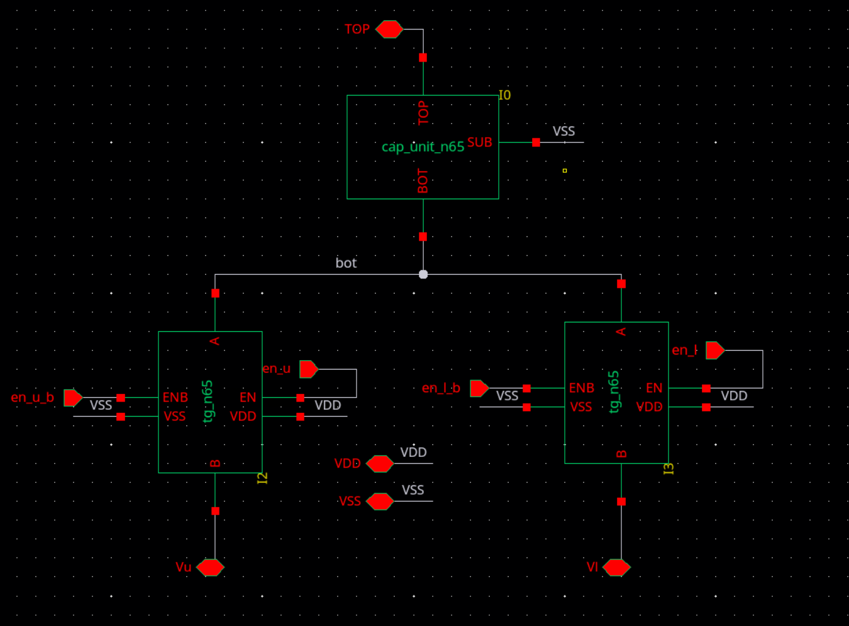
Figure 2. The reusable unit contains one cap_unit_n65 and two tg_n65 devices. TOP connects to Vout, and both switches meet at the capacitor bottom plate.
The behavioral driver supplies 28 gate controls. At each code change it disconnects the changing unit for 5 ns before connecting the opposite reference. Synchronizing the 30-terminal driver symbol with its Verilog-A view cleared the reported port mismatch.
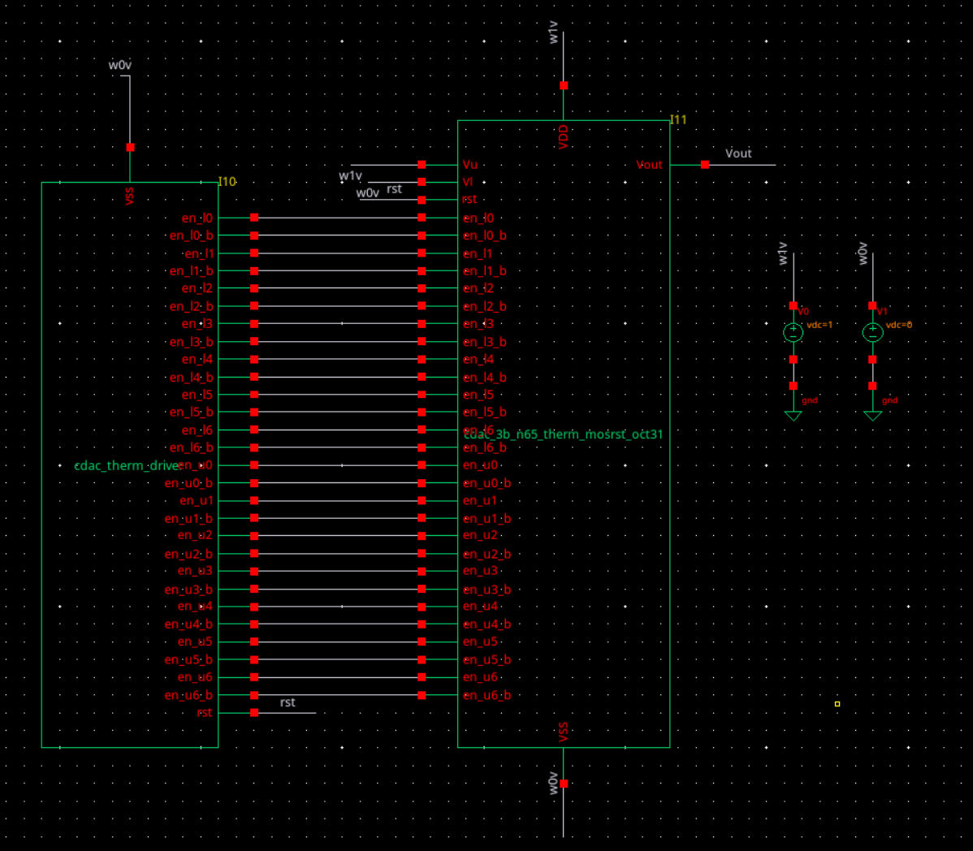
Figure 3. The testbench connects the driver to the 34-pin thermometer array. It applies a 1 V reference span and controls the physical reset at the output.

Nominal output across the code range
I ran a 400 ns transient using tt_lib at 27 °C with Vu = VDD = 1 V, Vl = VSS = 0 V and a 0.5 µm / 60 nm NMOS reset. The seven nonzero plateau readings all fall below their nominal targets. The table records the sample time because it affects the voltage comparison.
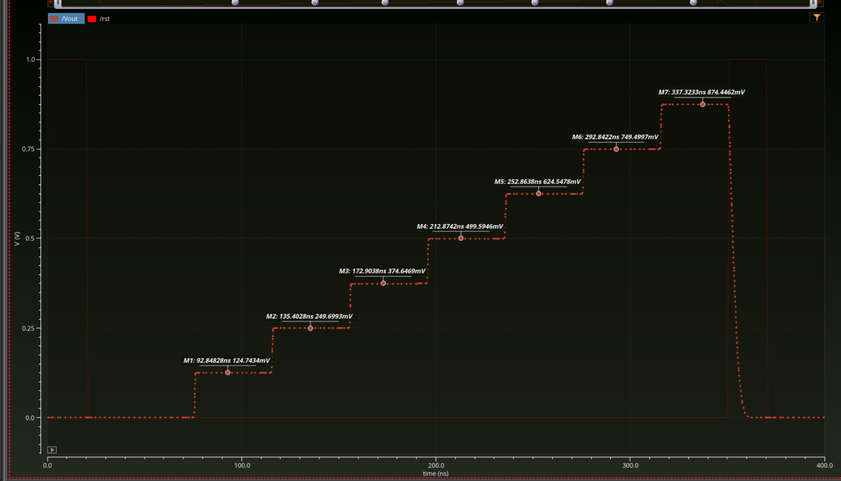
Figure 4. The nominal output climbs through eight levels before the second reset at 350–370 ns. The seven marked plateaus supply the values below.
Code | Time (ns) | Ideal (mV) | Vout (mV) | Error (µV)
1 | 92.84828 | 125 | 124.7434 | −256.6
2 | 135.4028 | 250 | 249.6993 | −300.7
3 | 172.9038 | 375 | 374.6469 | −353.1
4 | 212.8742 | 500 | 499.5946 | −405.4
5 | 252.8638 | 625 | 624.5478 | −452.2
6 | 292.8422 | 750 | 749.4997 | −500.3
7 | 337.3233 | 875 | 874.4462 | −553.8
Error is sampled Vout minus the ideal code voltage, using 125 mV per code. A code-zero marker and a common sampling delay are still needed to separate offset, span and endpoint linearity.

The code 3 to 4 transition
At the binary boundary 011 → 100, all three weighted branches change reference. In the thermometer array, the first three units stay connected to Vu and only the fourth unit switches. This transition tests whether reducing the number of simultaneous changes reduces the carry dip.
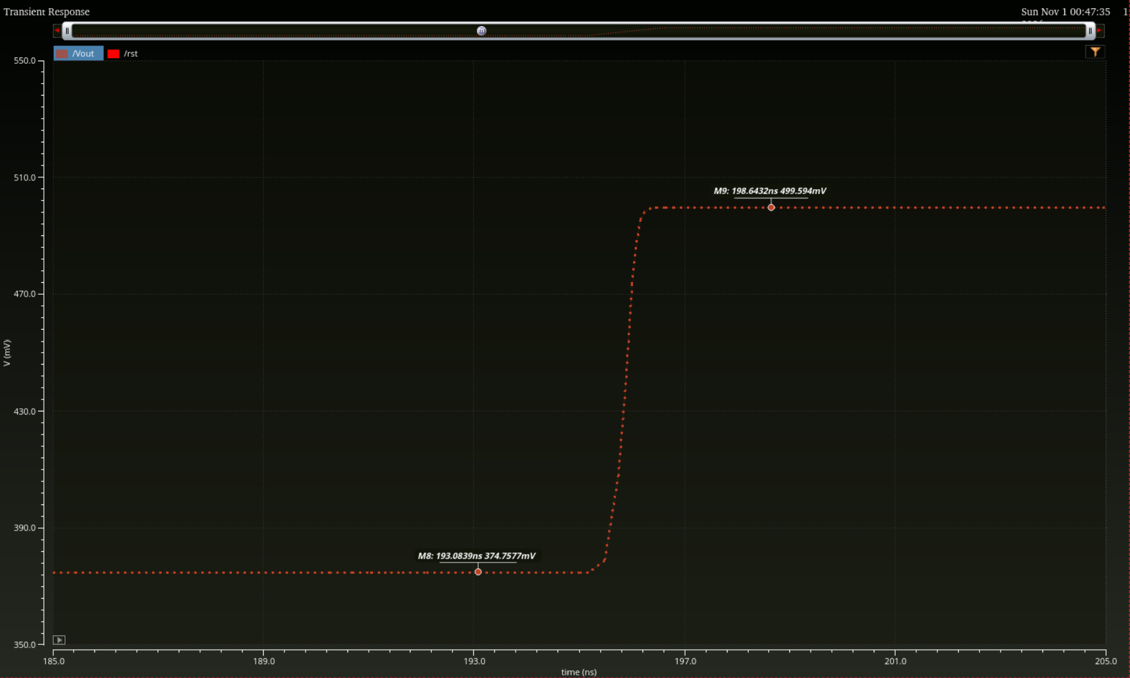
Figure 5. The 185–205 ns view spans 350–550 mV. The markers read 374.7577 mV at 193.0839 ns and 499.5940 mV at 198.6432 ns. The rise shows no resolved overshoot or undershoot at this scale.

3 Limits of the binary comparison
The earlier binary run used the same reset dimensions. At the two codes with readings from both physical-reset designs, the thermometer output was slightly lower.
Code | Thermometer (mV) | Binary MOS (mV) | Therm. − binary (µV)
4 | 499.5946 | 499.6032 | −8.6
7 | 874.4462 | 874.4587 | −12.5
The two architectures were sampled at different delays. Even within the thermometer run, the later code-3 marker is 110.8 µV above its earlier reading. A common sampling delay and a finer timestep are needed to rank static accuracy and quantify any residual glitch or settling difference.

4 Work in progress and next measurements

Build the 2+1 segmented array
On November 8 I prepared cdac_seg21_driver.va and checked its code masks and break-before-make logic locally. The next Cadence step is to copy the one-unit switch cell and wire a second capacitor in parallel on the same switch pair. Three of these 2Cu groups supply the coarse codes. One 1Cu group supplies the fine bit, and a fixed dummy brings the total to eight units.
Architecture | Switched groups | Reference TGs | Groups changing at 3 → 4
Binary | 4Cu, 2Cu, 1Cu | 6 | 3
Thermometer | 7 × 1Cu | 14 | 1
Segmented 2+1 | 3 × 2Cu and 1 × 1Cu | 8 | 2
The group counts follow from the schematics and proposed encoding. For the segmented 3 → 4 step, the fine 1Cu returns to Vl while another 2Cu group switches to Vu. The output transient for that exchange is the first segmented result to measure.

Run a matched three way comparison
I will verify the generated netlists, driver bindings and reset connections, then run all three arrays at TT, 27 °C, a 1 V span and zero added load with the same physical reset and timing. For code k = 0…7, I will sample Vout at 60 + 40k ns, 25 ns after each make event, and calculate code error, offset, span and endpoint INL/DNL.
For 3 → 4, I will inspect Vout, switch controls and bottom plates over 185–215 ns. I will measure undershoot and overshoot relative to the transition endpoints, then measure settling to a stated band. Repeating the run at maximum timesteps of 100 and 50 ps will test sensitivity to simulation resolution. The reverse 4 → 3 transition is the next check.

Application work for the following week
I selected quantum-dot gate biasing as the application and outlined a two-gate experiment. After the segmented comparison I will return to the question of whether a smaller DAC transient reduces the voltage disturbance on a held gate when its neighbor updates. A quiet-hold trace provides the control. Gate loading, allowable error and the readout window still need input from the device partner.

