Bias Voltage DAC Progress Tracker
Purdue SoCET AMS Senior Design | Sprint 3 | September 28 to October 11, 2026
I integrated all six MOS reference switches into the 3-bit CDAC, automated code sequencing, and investigated the midrange Ron peak and major-carry disturbance. Fixed-delay nominal INL/DNL and a first 12-bit area estimate are now available. Reset and reference sources remain ideal; cold, mismatch and post-layout performance are not yet established.

1 Tagged GitHub Issues and Project Cards
Work item | Status | Mentor task link
Six-TG CDAC and code sequencer | Implemented and tested | Issue #48
Ron and switching diagnosis | Initial findings recorded | Issue #48
Linearity and specifications | Nominal extraction; targets provisional | Issue #48
Cryogenic blocks and area | Screened; implementation deferred | Issue #48
Sprint task: https://github.itap.purdue.edu/SoCETOrganization/AMS_Tracking_Fall2026/issues/48

2 Evidence of Progress
October 4: six tg_n65 reference switches, shared supplies and cdac_code_driver replaced manual control setup. Tests demonstrated 001→100 (124.9975 and 499.9959 mV) and an ascending 000→111 scan. Reset remains ideal. October 11: the driver source was checked; only changed bits enter the break phase.
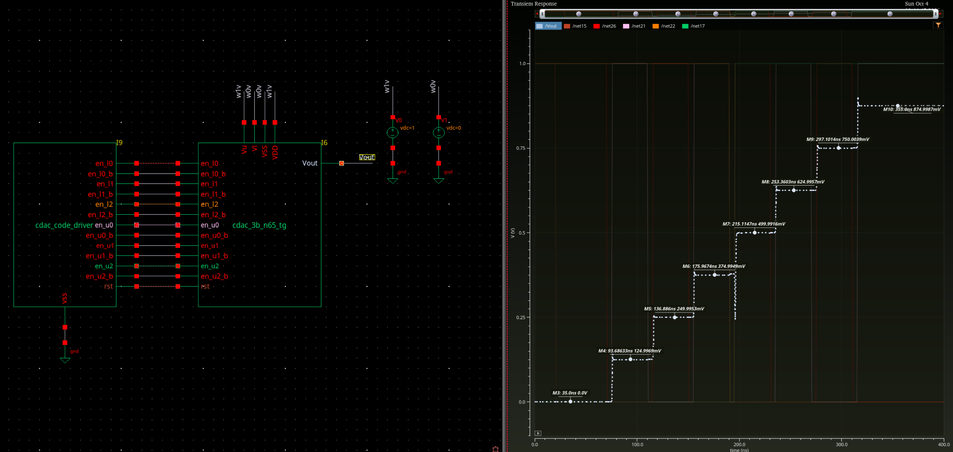
October 4 integration and full-code scan. Historical plateau markers use unequal delays; October 11 fixed-delay measurements on the following pages are the current linearity dataset.

Enabled TG resistance investigation
October 11, tt_lib at 27 C: the peak occurs with EN = VDD = 1 V and ENB = VSS = 0 V held constant. A = vtest and B = vtest + 1 mV; DC sweep 0 to 0.999 V in 0.01 V steps. Ron = 0.001 / abs(I(V2/PLUS)). NMOS W/L = 1 um/60 nm; PMOS = 2 um/60 nm; each has one finger and multiplicity one.
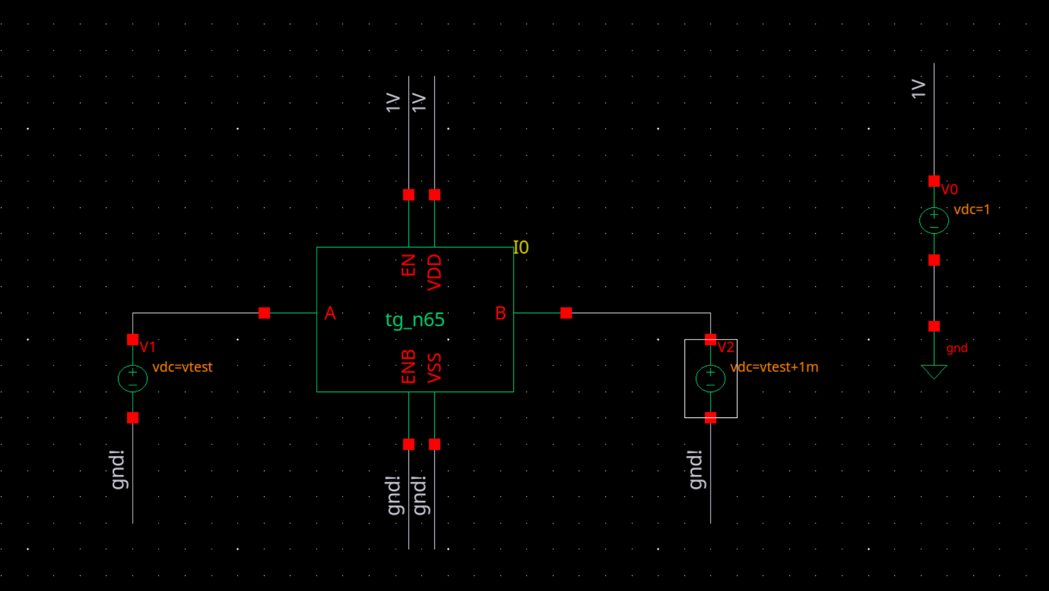
Ron testbench: EN and VDD are held at 1 V; ENB and VSS are grounded. V1 sets A to vtest, and V2 sets B to vtest + 1 mV. The TG remains enabled throughout the DC sweep.

Enabled TG resistance results
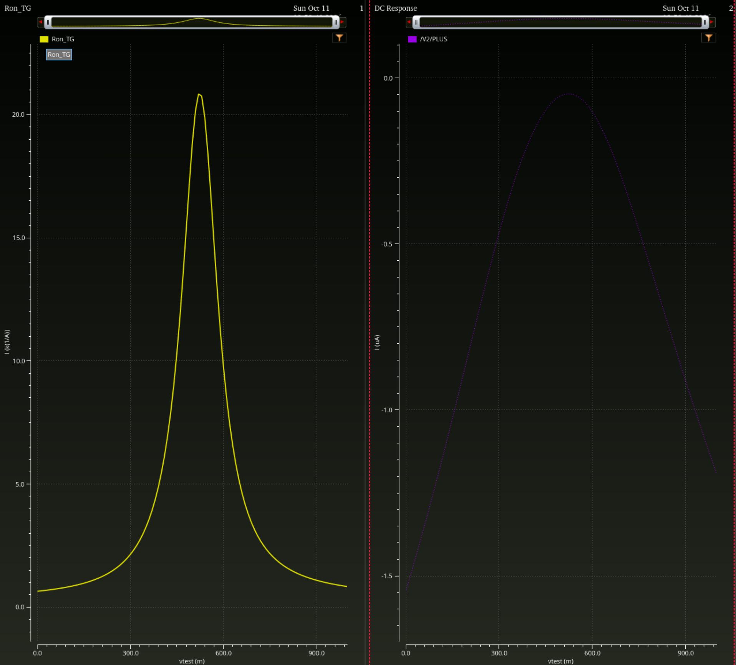
Enabled DC sweep. The peak near 0.52 V is approximately 20–21 kOhm; it is not a control turn-off event. The current plot uses microamperes.
Device at vtest = 0.52 V | Vgs (mV) | Vth (mV) | Vbs (mV) | Id (nA)
NMOS | 480 | 654.5 | −520 | 25.65
PMOS | −521 | −644.6 | 479 | −22.33
Both devices are below their reported thresholds. Summing current magnitudes gives 47.98 nA, corresponding to 20.84 kOhm. At the rail comparisons, NMOS Vth = 601.4 mV and |Id| = 1.546 uA; PMOS |Vth| = 575.4 mV and |Id| = 1.19 uA. Reduced gate overdrive dominates the midrange concern; reverse body bias adds a threshold increase.
Decision pending: retain the baseline and review device family, gate drive and sizing with the mentor. These data do not by themselves establish failure of the DAC settling specification. The displayed PMOS endpoint current is +1.19 uA; its sign convention remains to be checked.

Switching disturbance and sampled linearity
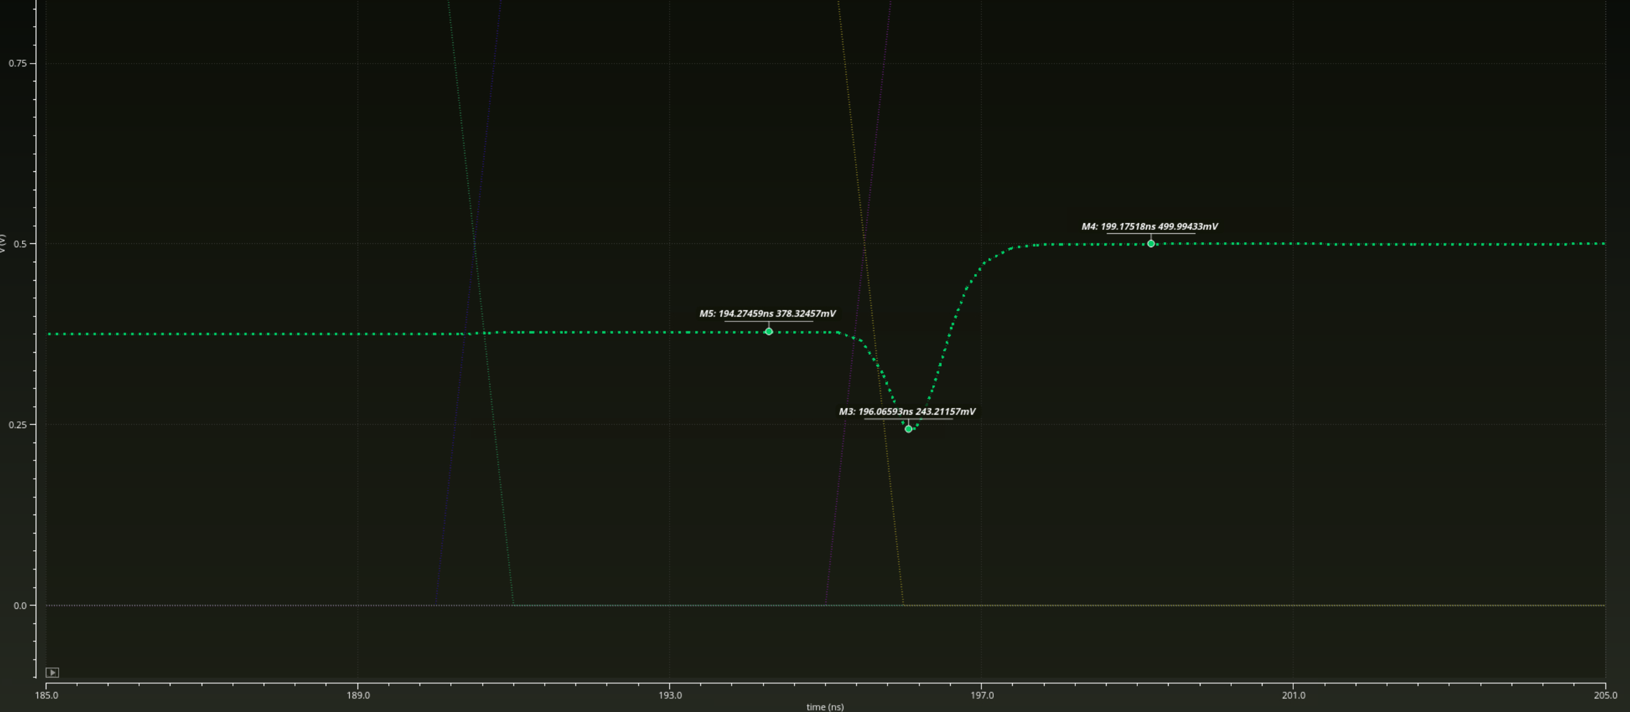
October 11, 011 to 100: break at 190 ns, make at 195 ns. Near-minimum marker: 243.21157 mV at 196.06593 ns, approximately 131.79 mV below ideal code 011. This is a sampled local minimum, not a converged peak search.
At 196.0659 ns, bottom plates b0/b1/b2 are 173.7483/436.5179/224.7282 mV. Their weighted sum (b0 + 2b1 + 4b2)/8 = 243.2121125 mV agrees with Vout = 243.2116 mV to about 0.51 uV at displayed precision. The whole-window residual is visually about −4.9 to −0.5 uV. Unequal bottom-plate trajectories account for the dip; their physical cause is not yet isolated.
Code | t (ns) | Vout (mV) | Error (uV) | INL (LSB) | DNL (LSB)
000 | 60 | ~0 | ~0 | 0.00e+00 | —
001 | 100 | 124.995486 | -4.514 | -3.27e-05 | -3.27e-05
010 | 140 | 249.995979 | -4.021 | -2.53e-05 | 7.39e-06
011 | 180 | 375.006612 | +6.612 | 6.32e-05 | 8.85e-05
100 | 220 | 499.995980 | -4.020 | -1.84e-05 | -8.16e-05
101 | 260 | 624.995510 | -4.490 | -1.87e-05 | -3.10e-07
110 | 300 | 749.997581 | -2.419 | 1.35e-06 | 2.00e-05
111 | 340 | 874.996981 | -3.019 | 0.00e+00 | -1.35e-06
Driver: reset release 20 ns, first break 30 ns, 40 ns code interval, 5 ns dead time, 1 ns edges; stop 400 ns. Samples: t = 60 + 40k ns, 25 ns after each scheduled make. Error is relative to k × 125 mV. Endpoint step L = (V7−V0)/7 = 124.999568714 mV; INL(k) = (Vk−V0−kL)/L; DNL(k) = (Vk−V(k−1))/L−1. Both use the same endpoint normalization.
Maximum |INL| = 6.32e−5 LSB (011); maximum |DNL| = 8.85e−5 LSB (010 to 011). All sampled steps are positive. These are finite-delay nominal results; hold-window stability, timestep/tolerance convergence, mismatch, PEX and cryogenic operation remain unverified.

Specifications and area outlook
Specs v0 revision 2 was updated against the mentor guide and three full-text papers. Targets remain provisional: 12-bit resolution over 1 V, 5 uW/channel at 1 kupdate/s including allocated support power, <=10 us room-temperature settling to a 61 uV band, and <=61 uV hold drift over 1 ms. These are design goals, not measured achievements.
Resolution | Unit count | Total C (pF) | Sum W×L (mm²)
3 bit | 8 | 0.885272 | 0.0008
8 bit | 256 | 28.328704 | 0.0256
12 bit | 4096 | 453.259264 | 0.4096
Area assumes binary weighting plus one dummy and unchanged 10 um × 10 um, 110.659 fF MIM units. It excludes layout enclosure/spacing, routing, edge dummies, switches and support blocks. It is not post-layout core area. The inspected unit has With Mismatch Effect unchecked; this alone does not audit every instance or Monte Carlo setup.

3 Blockers
Design decisions: confirm switch device/drive options, actual load and voltage range, allowable area and validated cryogenic models. High midrange Ron is a concern to evaluate against settling, not proof of specification failure. The bottom-plate response explains the output dip, but the origin of unequal trajectories and a verified remedy remain open.
Confirmed October 11 conditions: tt_lib, 27 C, 1 V supply/reference span, and no added CDAC output load. The array uses eight 110.659 fF units and six MOS TG reference switches; reset and references remain ideal, with Verilog-A control.
Numerical evidence still needed: exported current waveforms, maxstep/tolerance settings, and convergence checks. No power, 1 ms retention, Monte Carlo, PEX or cryogenic qualification is claimed.

4 Proposed Goals for the Next Sprint
Agree with the mentor on TG device/drive direction and the area/load budget; retain the original regression.
Verify disturbance and sampled linearity convergence; complete isolated-bit/reverse tests and one controlled drive-strength comparison.
Implement and compare a physical reset; select one approved functional submodule. The two-channel hold bank remains a concept and requires a suitable DAC drive interface.
Measure loaded settling and hold drift against the working specifications, and check a real MIM layout footprint before choosing higher-resolution architecture.
Application reference: van Staveren et al., Cryo-CMOS Bias-Voltage Generation and Demultiplexing at mK Temperatures for Large-Scale Arrays of Quantum Devices, IEEE TQE, 2025, DOI 10.1109/TQE.2025.3580377. Its sample-and-hold distribution motivates a candidate system block; it does not validate this design.

Complete CDAC schematic
cdac_3b_n65_tg | Completed reference-switch integration | Screenshot supplied October 11, 2026
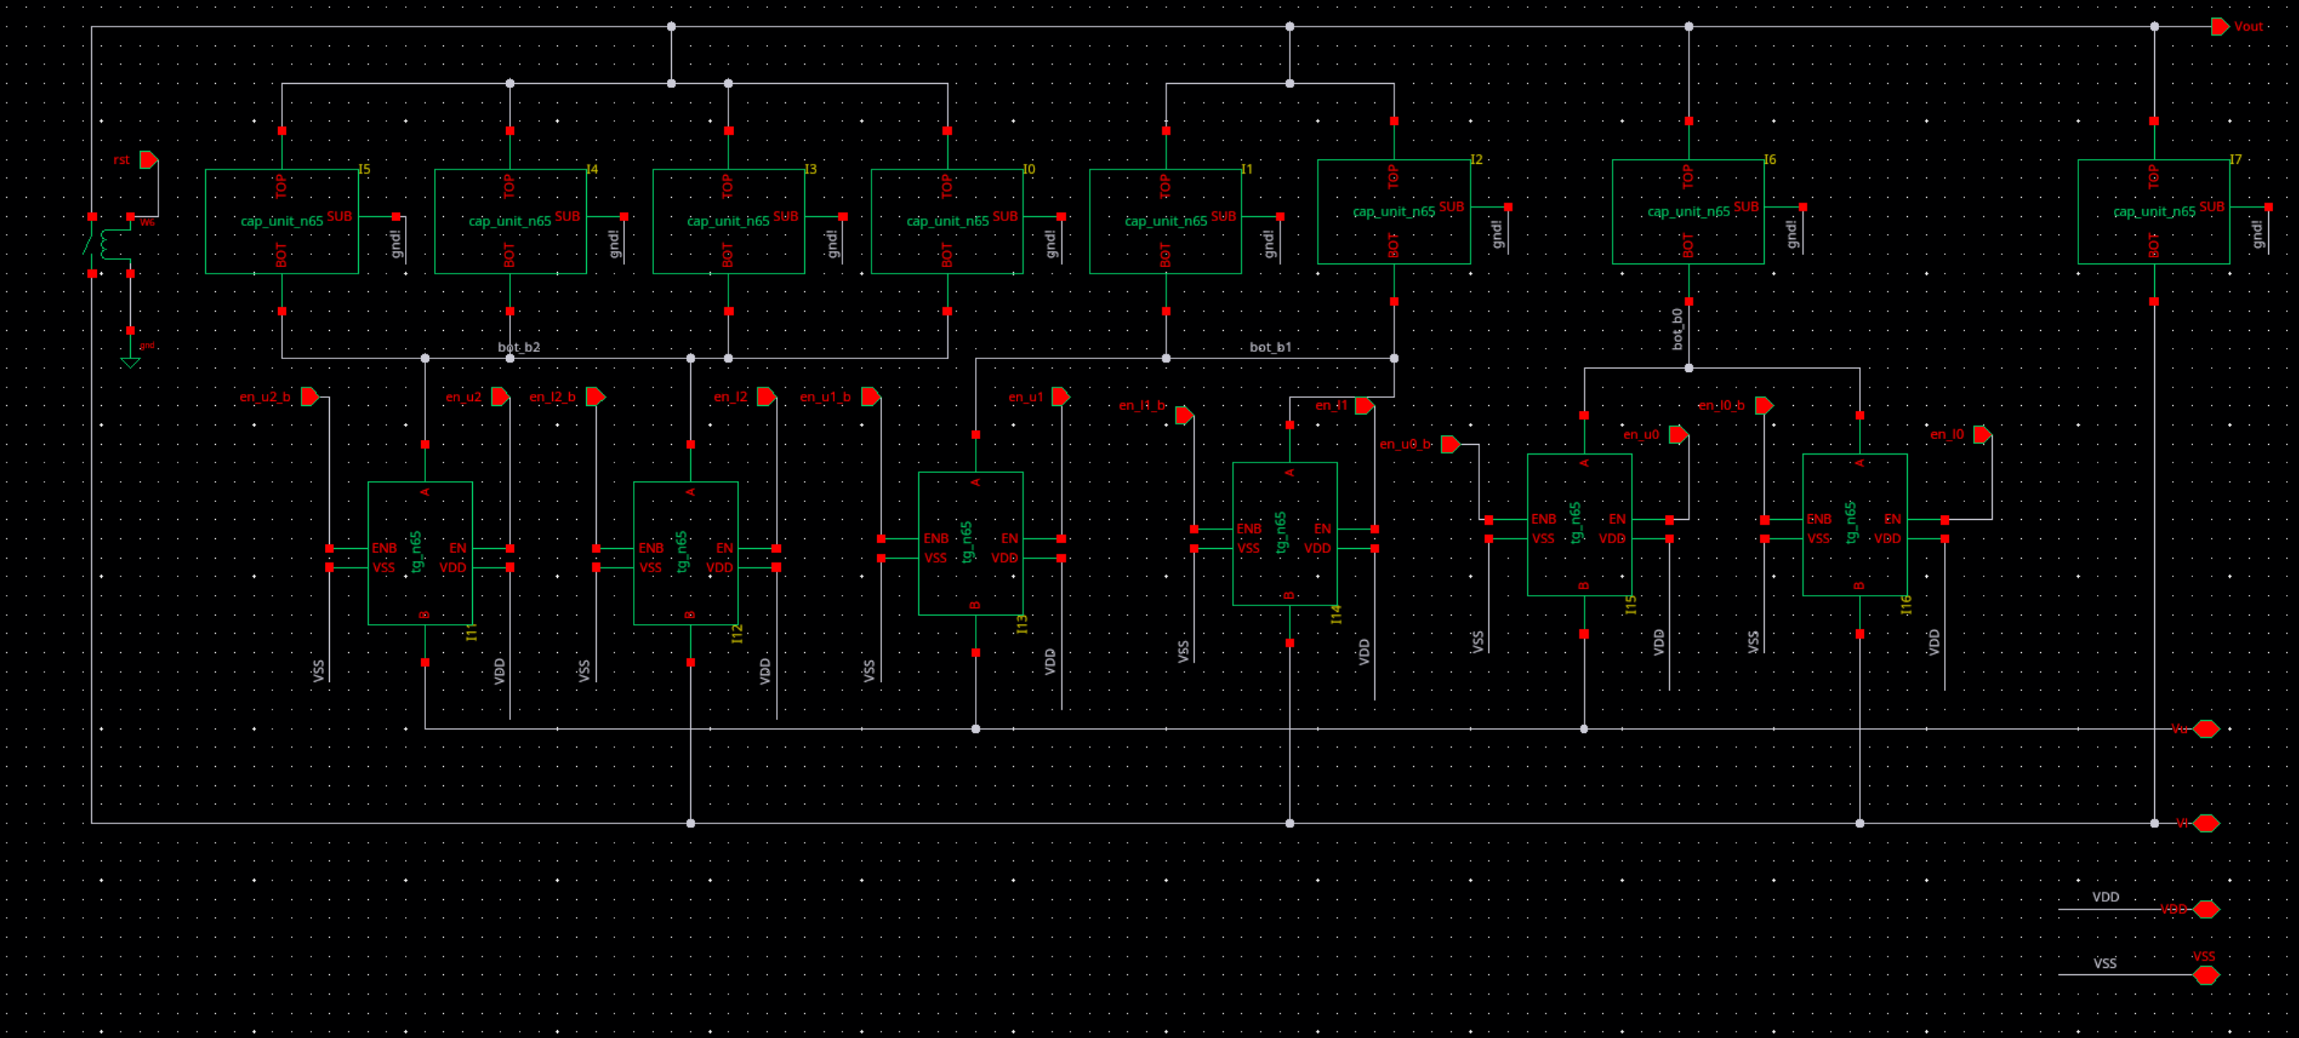
Full internal schematic: four unit capacitors form b2, two form b1, one forms b0, and one is the dummy. All top plates share Vout; each bit bottom plate selects Vu or Vl through a pair of tg_n65 switches. VDD/VSS are shared, and capacitor substrate pins are grounded.
Implementation boundary: all six reference switches are MOS transmission gates. The top-plate reset at the left remains an ideal switch; the reference sources and Verilog-A stimulus are in the testbench. This is schematic evidence, not a layout or PEX result.

