Bias Voltage DAC Progress Tracker
  - Purdue SoCET AMS Senior Design | Sprint 2 | September 27, 2026
I verified the ideal 3-bit DAC, replaced its capacitors with TSMC65 MIM devices, and tested a standalone CMOS transmission gate (TG). The PDK-capacitor DAC reaches 499.996 mV for code 100. The TG passes both reference levels and shows an approximately +3.2 mV turn-off step on a held capacitor. Integration of TG switches into the DAC is next.

1 Tagged GitHub Issues and Project Cards
Mentor task links are TBD and must refer to the mentor's task-tracking repository.
Work item | Task link | Status
Cadence and TSMC65 environment setup | ALL PROJECTS-Follow my last email and build YOUR OWN MODEL and do the required simulations-V2 · Issue #44 · SoCETOrganization/AMS_Tracking_Fall2026 | Working
3-bit ideal DAC and transient test | TBD | Code 100 verified
PDK capacitor DAC and standalone TG | TBD | Baseline tested
TG DAC integration and code staircase | TBD | Next sprint

2 Evidence of Progress
Environment and ideal baseline: I established the ASICFab Virtuoso/Spectre setup, resolved the OA_HOME and model-path issues, and verified an ideal 3-bit charge-redistribution DAC. Eight equal capacitors form C, 2C, 4C, and a C dummy. Code 100 produces approximately 0.5 V with 1 V and 0 V references.
PDK capacitor implementation: I created cap_unit_n65 and cdac_3b_n65 while retaining the ideal switches. Each unit uses mimcap_3t_9m_1p0, with 10 um x 10 um geometry, nominal capacitance of 110.659 fF, and its substrate terminal grounded. At tt_lib and 27 C, Vout is 499.996 mV at 79.581 ns, approximately 4 uV below the ideal code-100 value. Netlist inspection confirms the mimcap_sin_3t model and mismatch disabled; this single-code result does not establish INL/DNL.
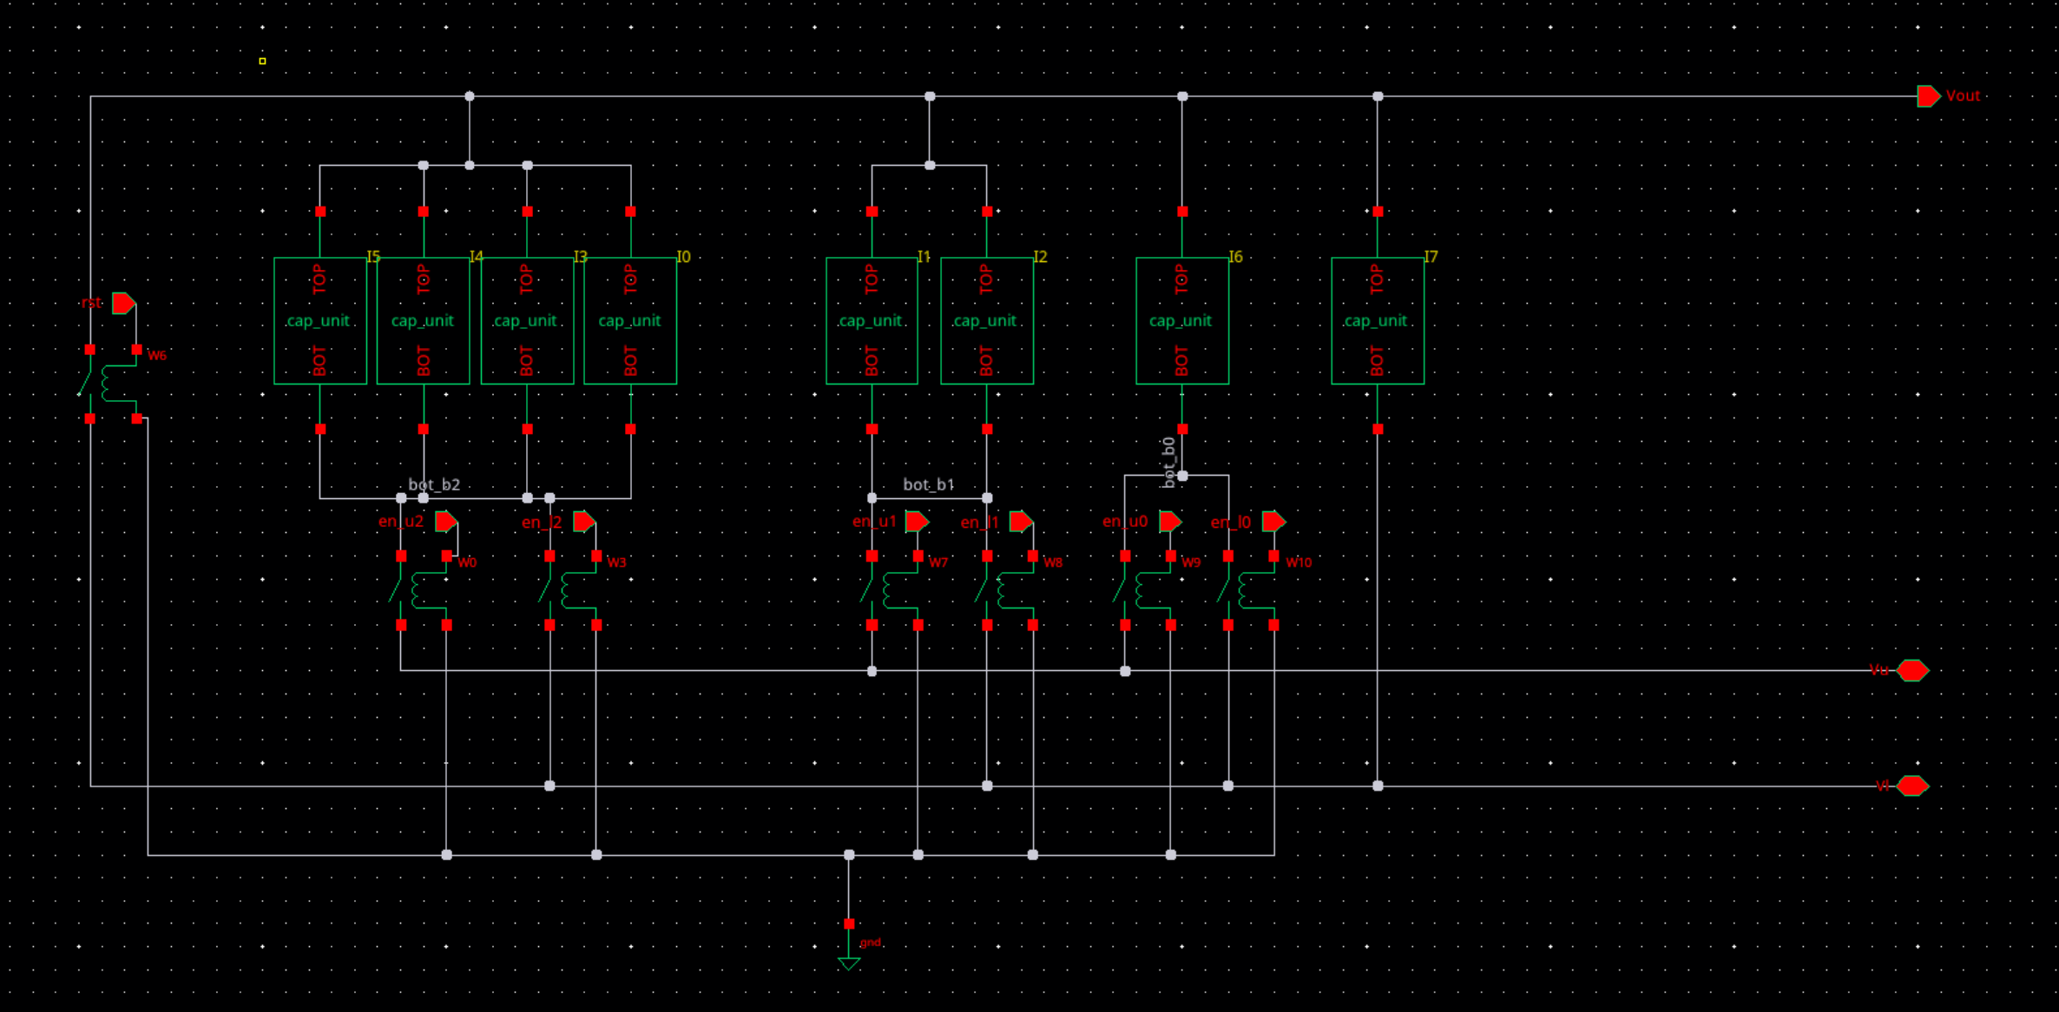
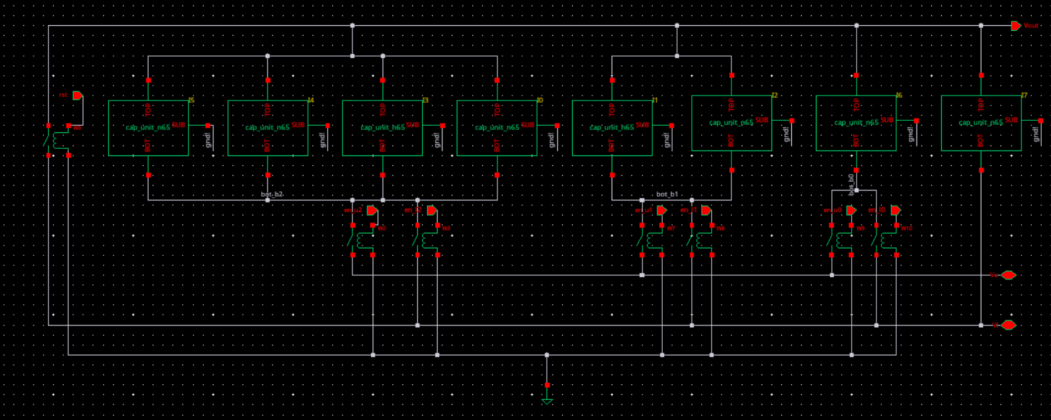
Figure 1. Compare the preserved ideal baseline with the PDK capacitor array.
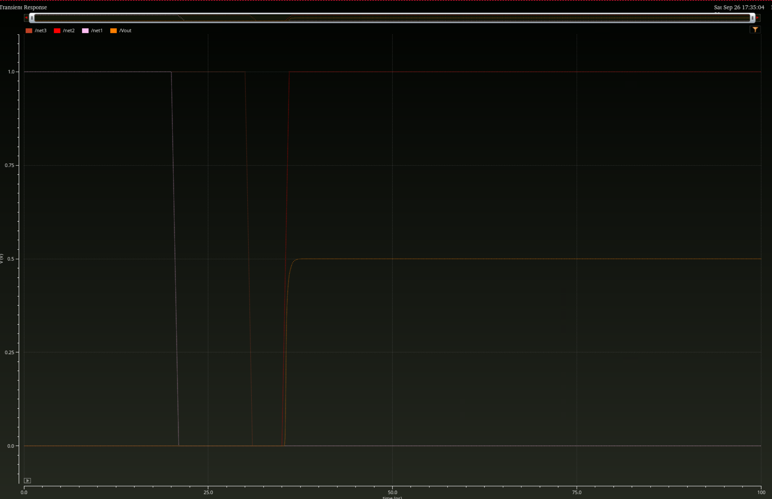

Figure 2. Show the 499.996 mV marker and the transient settling near 35 ns.
Transmission gate tests: I built tg_n65 using core nch/pch devices with bulks tied to VSS/VDD. With 1 V supplies and a single PDK capacitor load, increasing NMOS/PMOS widths from 0.2/0.2 um to 1/2 um, at L = 60 nm, visibly improved tracking of the 1 ns input edges. This comparison changes both absolute size and width ratio; it does not isolate the benefit of a 2:1 ratio.
Hold behavior: Complementary controls turn the TG off at 20-21 ns. Vhold rises from about 1.0000 V to 1.0032 V, a net turn-off step of about +3.2 mV consistent with combined charge injection and clock feedthrough. When the input falls at 31-32 ns, Vhold remains near 1.0032 V; additional coupling is not resolved at the displayed scale. The 45 ns test does not establish long-term retention.
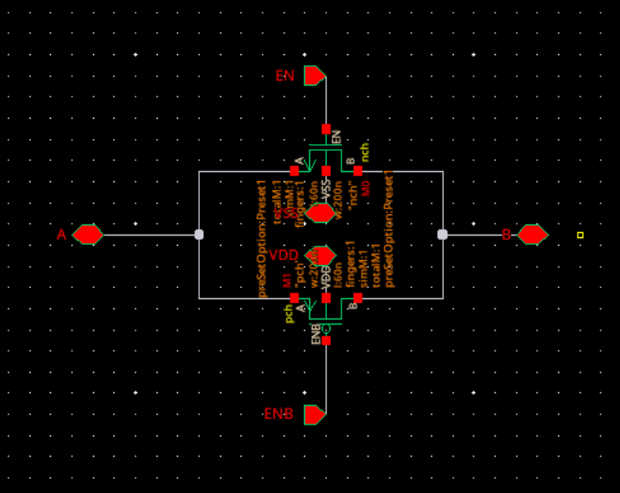
Figure 3. Show the TG connections and tracking before and after widening both MOS devices.
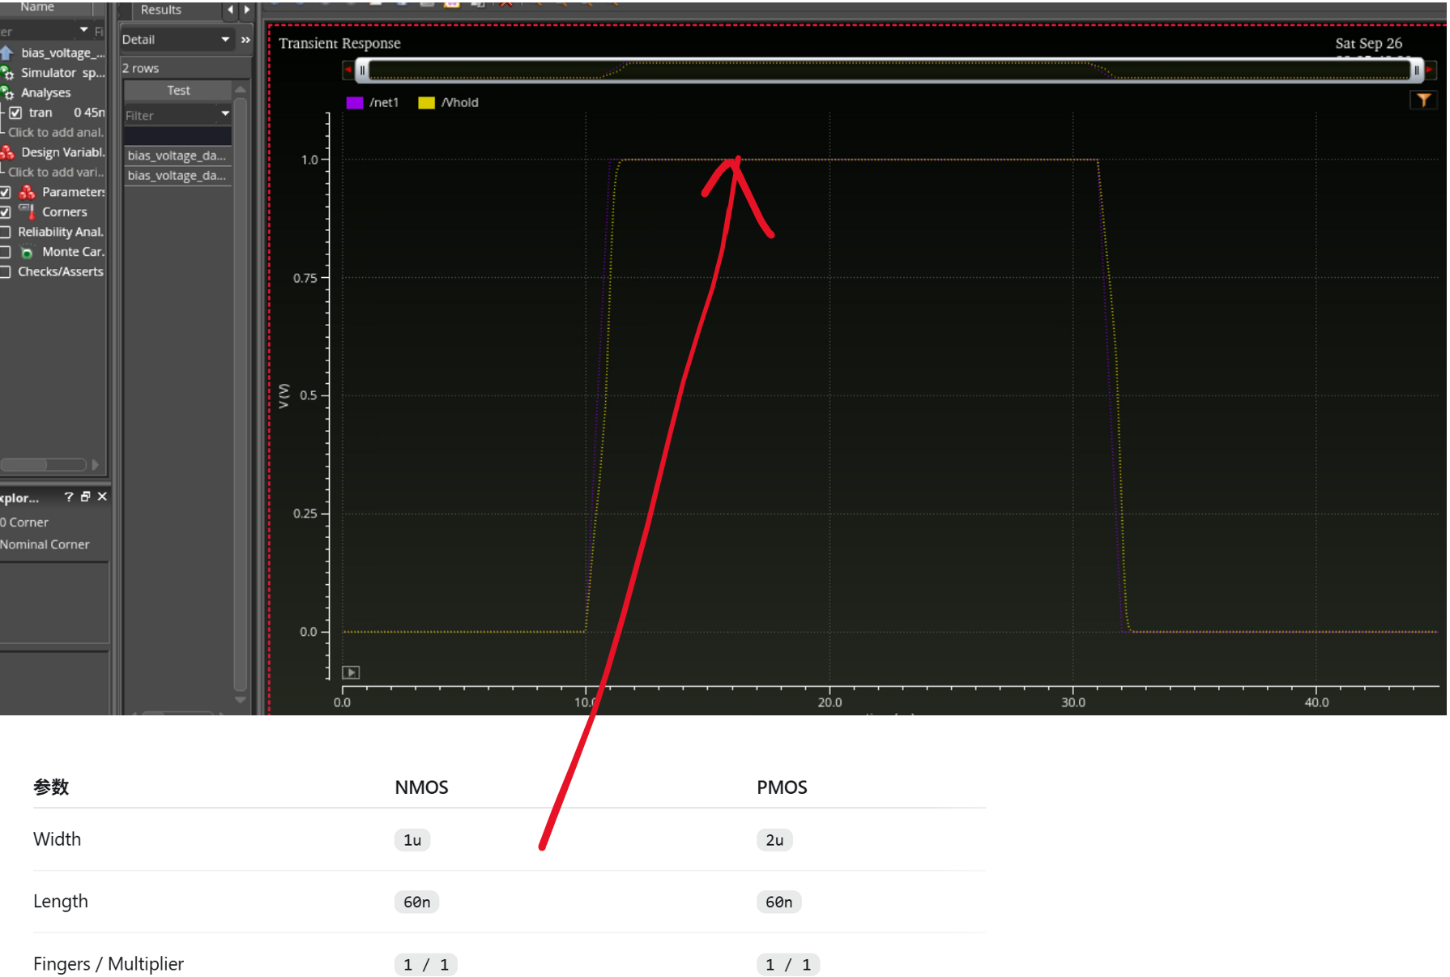Figure 4. Show held voltage after input falls and the approximately +3.2 mV turn-off step.
Validation boundary: The DAC still uses ideal switches; the MOS TG has only been tested separately. Full-code staircase, INL/DNL, power, corner/mismatch, and cryogenic validation remain outstanding. The standalone TG voltage step is not a measured DAC output error.

3 Blockers
No active technical blocker. Mentor issue links are pending. Cryogenic application targets and validated low-temperature models remain TBD. Final switch device family, gate-drive voltage, and sizing also require mentor review; core devices are the current room-temperature baseline.

4 Proposed Goals for the Next Sprint
- Integrate TG reference/reset switches into a separate DAC version. Generate complementary controls, preserve break-before-make timing, and repeat code 100.
- Run codes 000 through 111; record the staircase waveform and settled output versus code. Calculate initial INL/DNL with a stated LSB and reference-line convention.
- Compare switch sizing, settling, switching error, and longer hold intervals. Confirm device-family and drive-voltage choices with the mentor.
- Draft cryogenic application specifications from the reference paper and mentor input. Keep temperature, final resolution/range, load, update/refresh rate, noise, power, and accuracy targets TBD until agreed.
Application reference: P. Vliex et al., Bias Voltage DAC Operating at Cryogenic Temperatures for Solid-State Qubit Applications (2020). doi:10.1109/LSSC.2020.3011576
Before submission: Add mentor task links and evidence images, review before or during the mentor meeting, and export to PDF for GradeScope. Literature results are not adopted project specifications.

