Yukon Snow Survey Bulletin & Water Supply Forecast

2023-09-18

## PREFACE

The Department of Environment’s Water Resources Branch issues the Yukon Snow Survey Bulletin and Water Supply Forecast three times annually – early March, April and May. The bulletin provides a summary of winter meteorological and streamflow conditions for the Yukon, as well as current snow depth and snow water equivalent observations for 57 locations. This information is used to evaluate the potential for spring flooding caused by both breakup ice jams and large spring snowmelt (freshet) flows. It is important to note that other processes such as summer rain and glacier melt can significantly influence maximum annual water levels in specific Yukon basins. March weather conditions for the Yukon are presented in two maps, one showing temperature anomalies (deviation from climate normals), and another showing precipitation anomalies. Territory-wide snowpack data are presented in a third map showing snow water equivalent (SWE) as a percent of historical median for each station, as well as the basinaveraged estimated SWE for 11 watersheds (or river basins). Complementary meteorological and hydrological data are presented for each basin through a series of five graphs, depending on data availability:

* **Figure A:** Daily Snow Water Equivalent (SWE) data starting in September at one specific location in the watershed, showing an overview of winter snowpack evolution.
* **Figure B:** Current, basin-averaged, estimated Snow Water Equivalent (SWE) from snow survey data, compared with historical data, serving as an indicator of potential runoff volumes in the spring (acknowledging that snow sublimation, evapotranspiration, rain and glacier melt also significantly affect runoff).
* **Figure C:** Monthly winter precipitation (rain and/or snow) compared with historical data (1980-2022 period of record), complementing the information presented in Figure B.
* **Figure D:** Cumulated degree-days of freezing (CDDF, sum of negative daily temperatures) compared with historical data, functioning as an indicator of winter coldness and overall river ice thickness; variables that influence river ice breakup scenarios in the spring.
* **Figure E:** Current, estimated daily discharge or measured water level, compared with historical data, representing an overview of the watershed hydrological conditions.

## All basins

## Upper Yukon river basin (Southern lakes / Whitehorse)

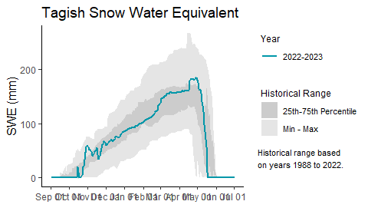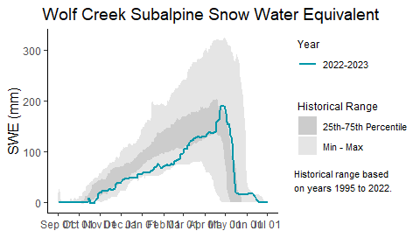

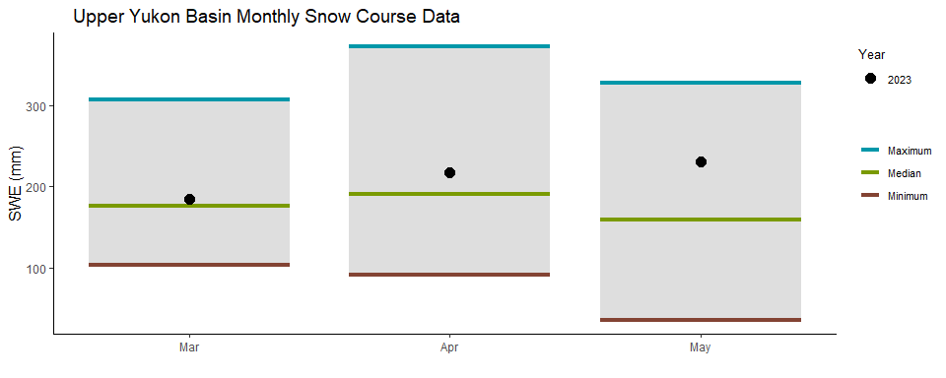

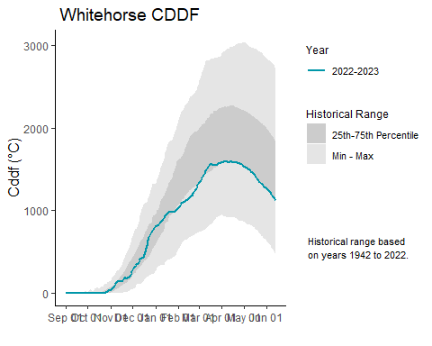

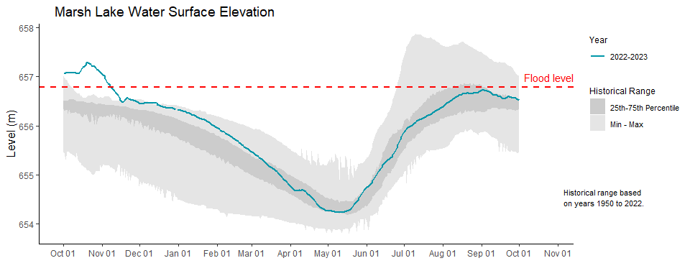

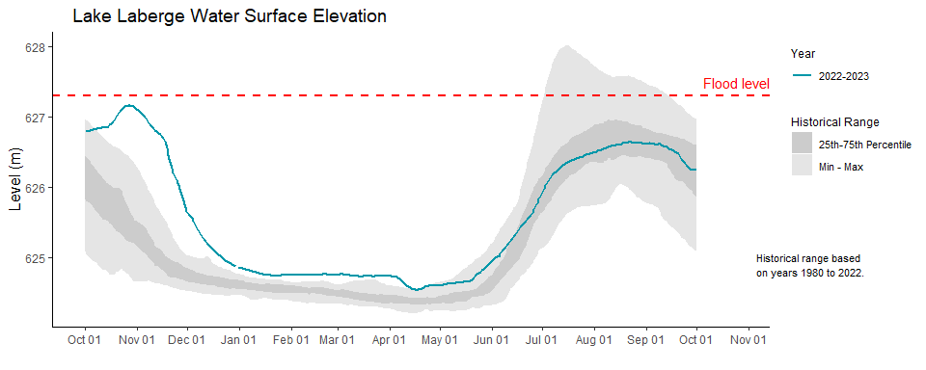

## Teslin river basin

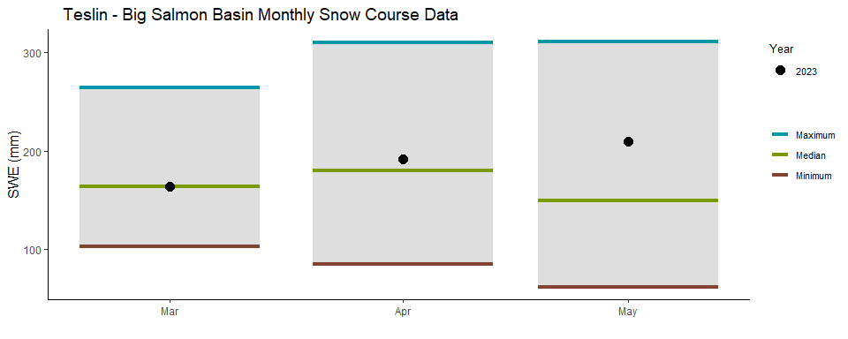

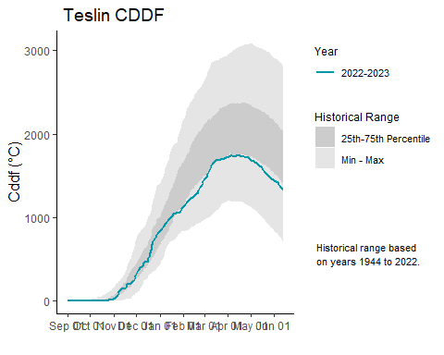

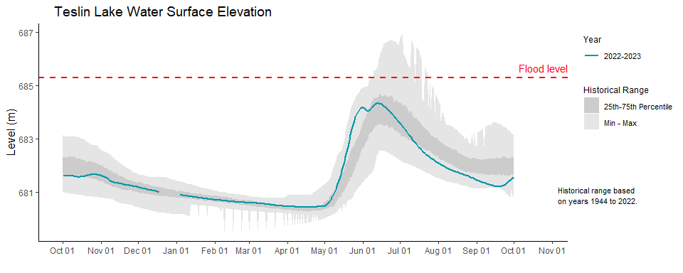

## Central Yukon river basin (Carmacks area)

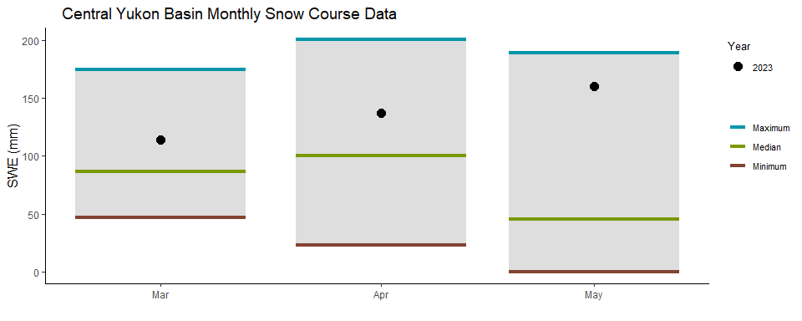

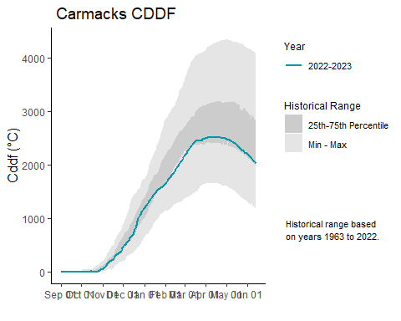

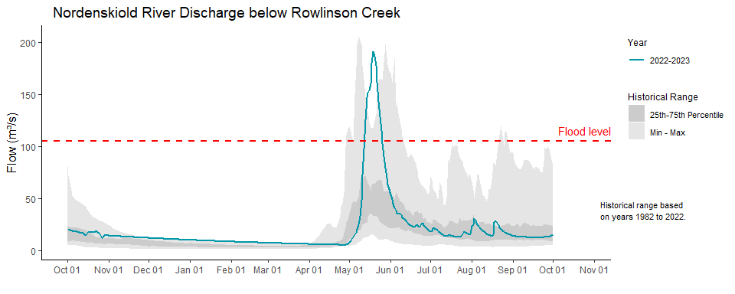

## Pelly river basin

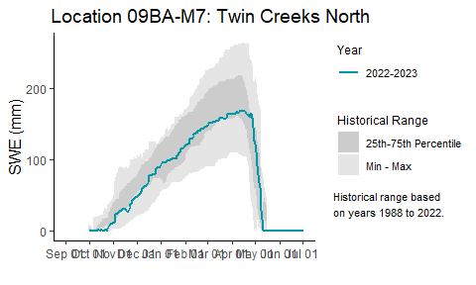

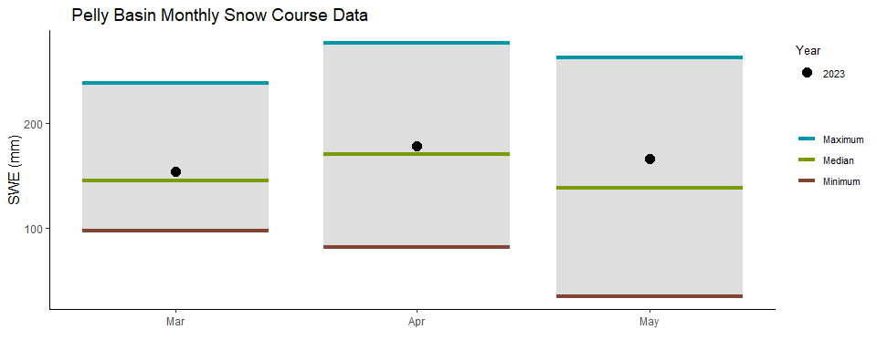

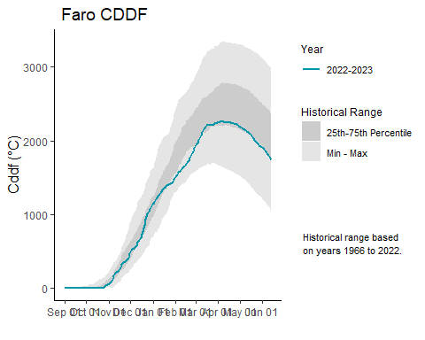

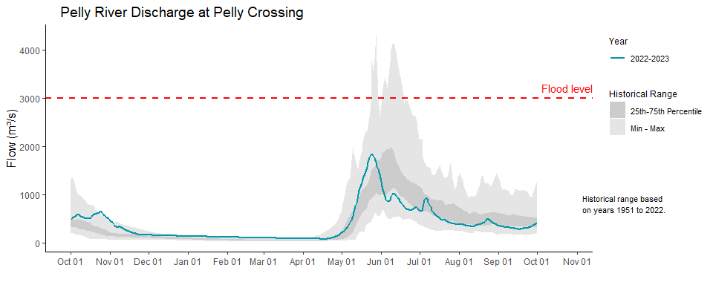

## Stewart river basin

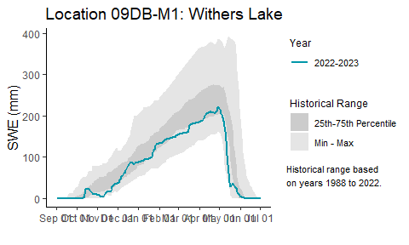

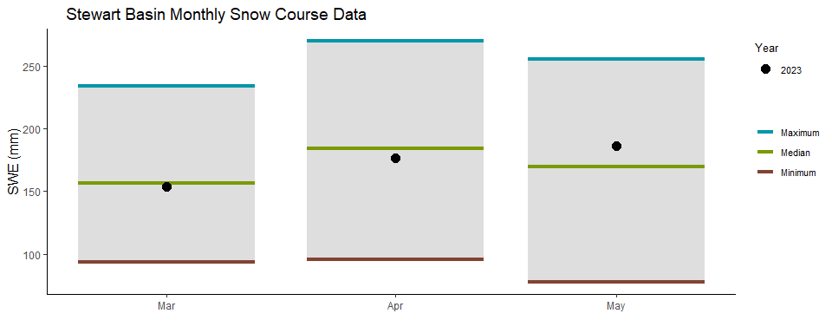

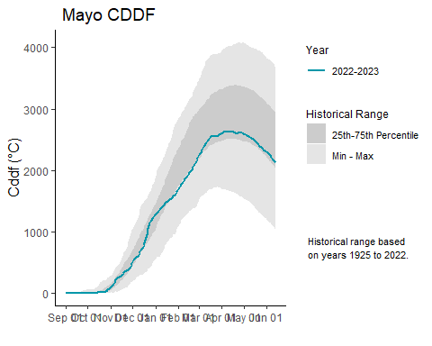

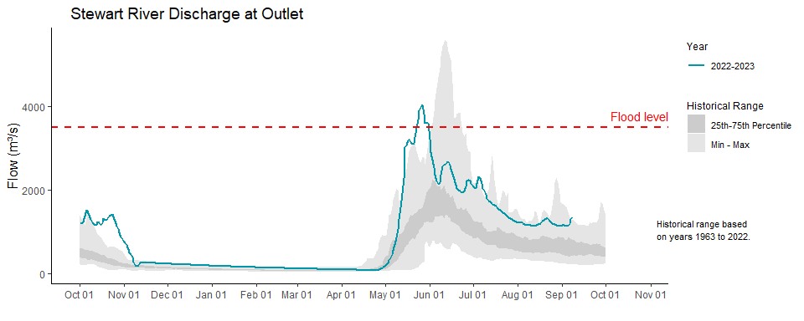

## White river basin

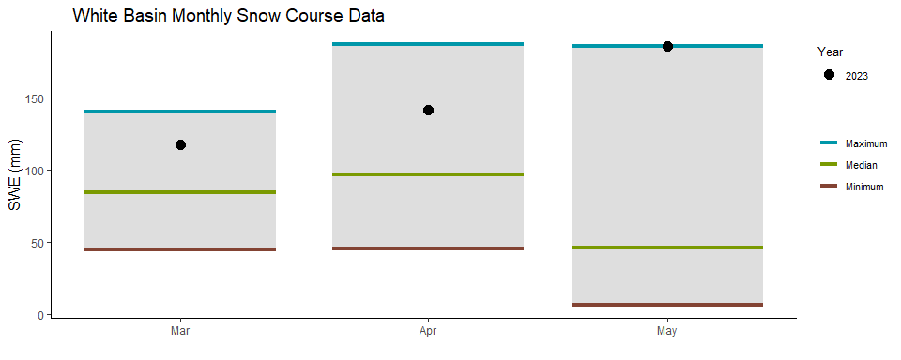

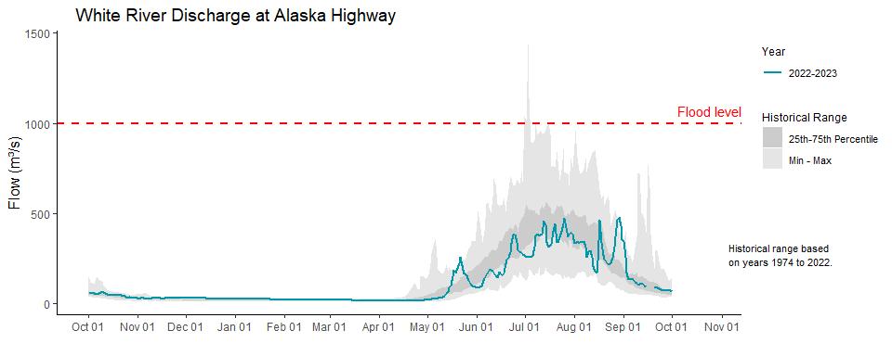

## Lower Yukon River basin (Dawson area)

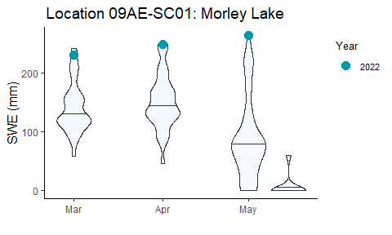

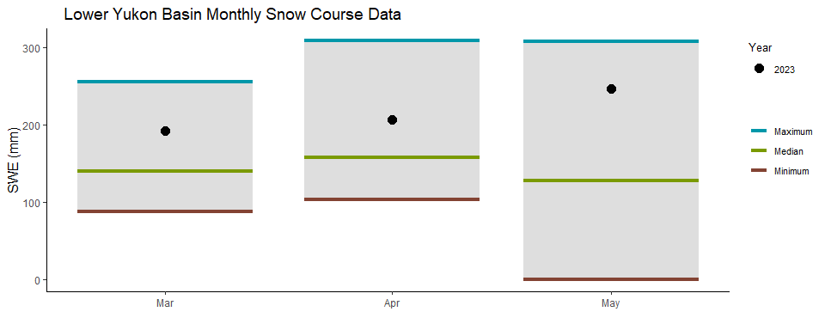

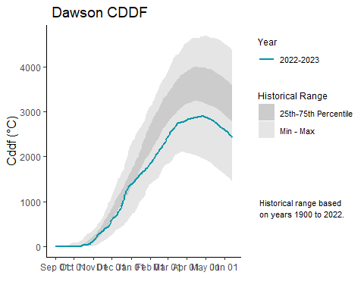

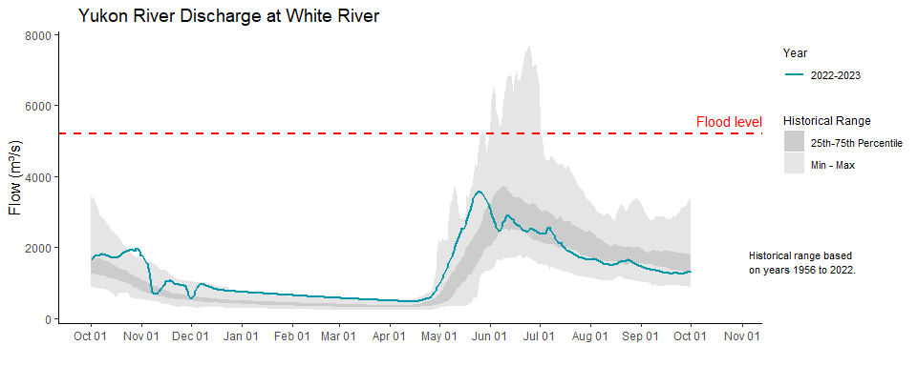

## Porcupine River basin

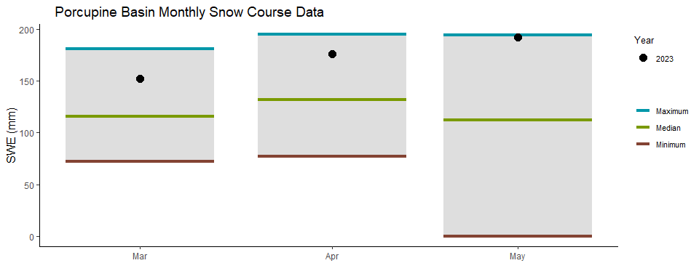

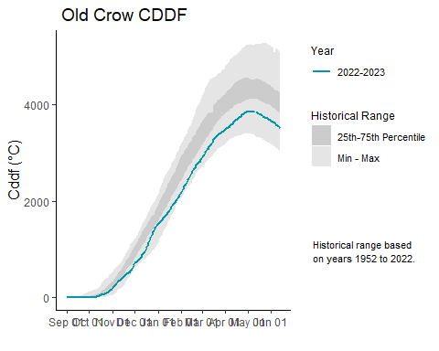

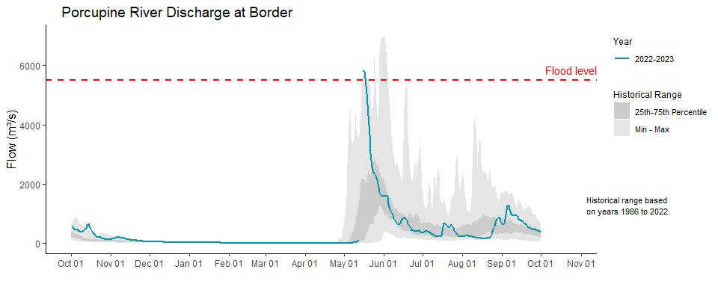

## Peel River basin

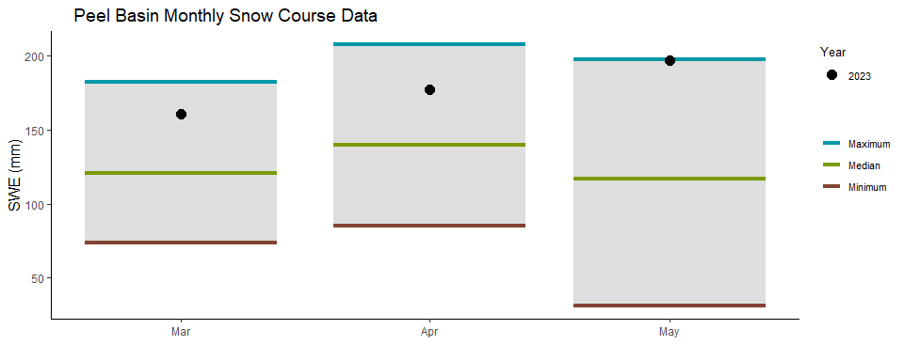

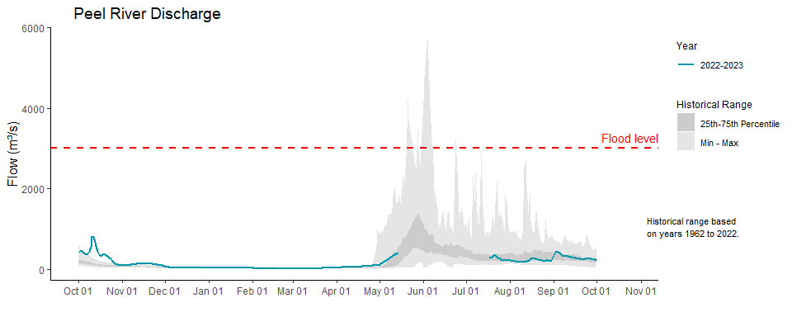

## Liard River basin

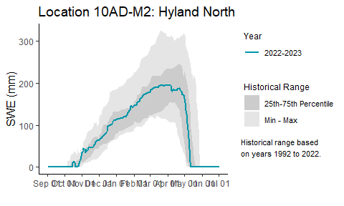

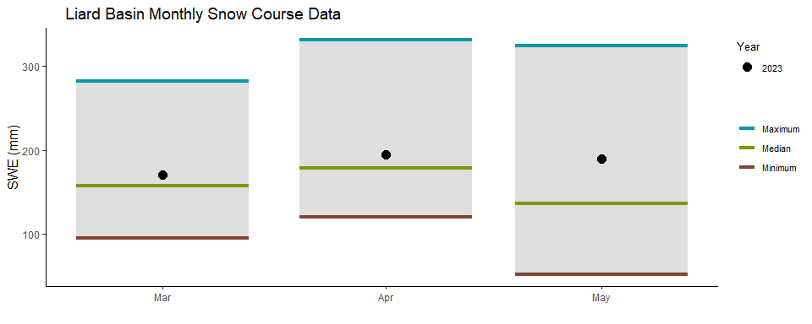

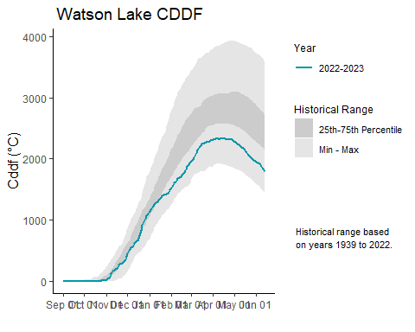

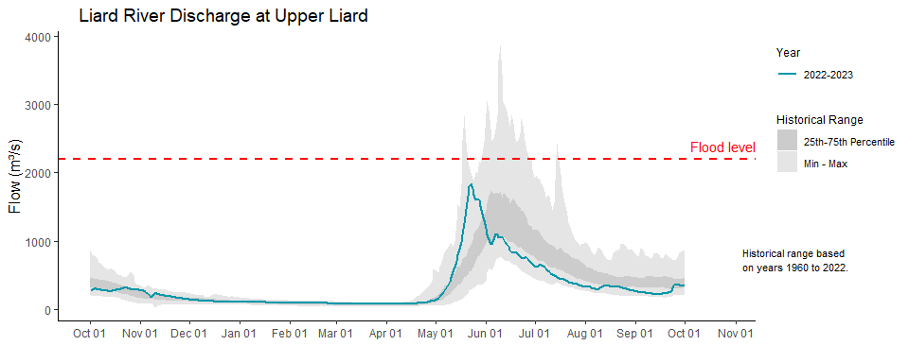

## Alsek River basin

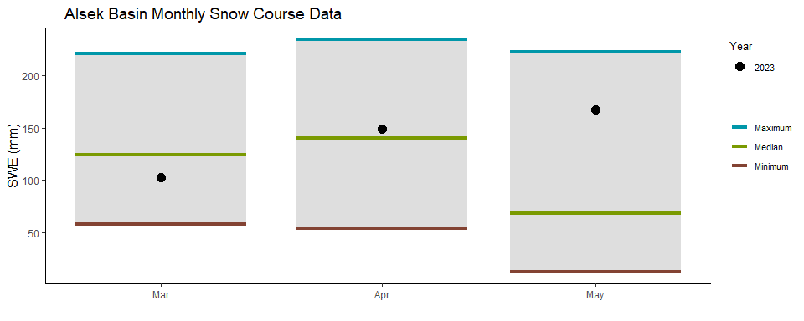

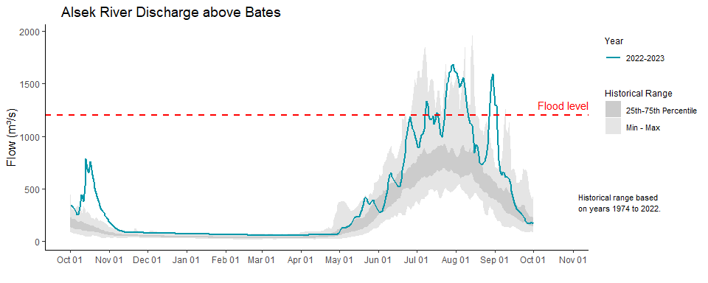

## Drainage Basin and Snow Course

## Remember to disconnect using DBI::dbDisconnect() when finished.

## Remember to disconnect using DBI::dbDisconnect() when finished.

| location_id | location_name | sample_date | depth | swe | swe_prevyear | swe_med | swe_rat | years | sub_basin |
| --- | --- | --- | --- | --- | --- | --- | --- | --- | --- |
| 08AA-SC01 | Canyon Lake | 2023-02-23 | 45 | 74 | 137 | 80 | 0.92 | 46 | Alsek |
| 08AA-SC02 | Alder Creek | 2023-03-01 | 66 | 114 | 172 | 136 | 0.84 | 43 | Alsek |
| 08AA-SC03 | Aishihik Lake | 2023-02-23 | 31 | 50 | 114 | 69 | 0.72 | 30 | Alsek |
| 08AA-SC04 | Haines Junction Farm | 2023-02-28 | 41 | 64 | 87 | 87 | 0.74 | 24 | Alsek |
| 08AB-SC01 | Felsite Creek | NA | NA | NA | NA | 212 | NA | 8 | Alsek |
| 08AB-SC02 | Clay Creek | NA | NA | NA | NA | 556 | NA | 29 | Alsek |
| 08AB-SC03 | Summit | 2023-02-28 | 93 | 193 | 280 | 230 | 0.84 | 44 | Alsek |
| 08AB-SC04 | Profile Mountain | NA | NA | NA | NA | 282 | NA | 24 | Alsek |
| 08AC-SC01 | Stanley Creek | NA | NA | NA | NA | 234 | NA | 8 | Alsek |
| 08AC-SC02 | Takhanne | NA | NA | NA | NA | 160 | NA | 5 | Alsek |
| 08AK-SC01 | Eaglecrest | 2023-03-02 | 196 | 493 | 668 | 439 | 1.12 | 41 | Alaska |
| 08AK-SC02 | Moore Creek Bridge | 2023-02-28 | 147 | 439 | 561 | 472 | 0.93 | 31 | Alaska |
| 09AA-SC01 | Tagish | 2023-02-28 | 70 | 151 | 191 | 128 | 1.18 | 48 | Upper_Yukon |
| 09AA-SC02 | Montana Mountain | 2023-03-01 | 64 | 135 | 174 | 132 | 1.02 | 48 | Upper_Yukon |
| 09AA-SC03 | Log Cabin (B.C.) | 2023-02-23 | 115 | 328 | 419 | 327 | 1.00 | 62 | Upper_Yukon |
| 09AA-SC04 | Atlin (B.C) | 2023-02-27 | 39 | 75 | 129 | 99 | 0.76 | 58 | Upper_Yukon |
| 09AB-SC01A | Mt McIntyre A | NA | NA | NA | NA | 97 | NA | 9 | Upper_Yukon |
| 09AB-SC01B | Mt McIntyre B | 2023-03-01 | 74 | 132 | 228 | 135 | 0.98 | 48 | Upper_Yukon |
| 09AB-SC01C | Mt McIntyre C | NA | NA | NA | NA | 126 | NA | 8 | Upper_Yukon |
| 09AB-SC01D | Mt McIntyre D | NA | NA | NA | NA | 196 | NA | 5 | Upper_Yukon |
| 09AB-SC02 | Whitehorse Airport | 2023-02-28 | 57 | 117 | 168 | 92 | 1.27 | 59 | Upper_Yukon |
| 09AB-SC03 | McClintock | NA | NA | NA | NA | 104 | NA | 6 | Upper_Yukon |
| 09AB-SC04 | Chadburn Lake | NA | NA | NA | NA | 86 | NA | 2 | Upper_Yukon |
| 09AB-SC05 | Long Lake | NA | NA | NA | NA | 85 | NA | 2 | Upper_Yukon |
| 09AD-SC01 | Meadow Creek | 2023-02-28 | 103 | 236 | 396 | 248 | 0.95 | 47 | Teslin_Big_Salmon |
| 09AD-SC02 | Jordan Lake | 2023-02-28 | 76 | 150 | 183 | 122 | 1.22 | 33 | Teslin_Big_Salmon |
| 09AE-SC01 | Morley Lake | 2023-02-23 | 58 | 118 | 230 | 128 | 0.92 | 35 | Teslin_Big_Salmon |
| 09AG-SC01 | Mt Peters | NA | NA | NA | NA | 173 | NA | 1 | Teslin_Big_Salmon |
| 09AG-SC02 | Northern Lake | NA | NA | NA | NA | 201 | NA | 3 | Teslin_Big_Salmon |
| 09AH-SC01 | Mount Berdoe | NA | NA | NA | 217 | 97 | NA | 47 | Central_Yukon |
| 09AH-SC03 | Satasha Lake | NA | NA | NA | 166 | 82 | NA | 35 | Central_Yukon |
| 09AH-SC04 | Williams Creek | 2023-02-27 | 68 | 122 | 174 | 80 | 1.52 | 27 | Central_Yukon |
| 09BA-SC01 | Ross River Hill | NA | NA | NA | NA | 65 | NA | 11 | Pelly |
| 09BA-SC02B | Twin Creeks B | 2023-03-01 | 81 | 162 | 243 | 132 | 1.23 | 45 | Pelly |
| 09BA-SC03 | Hoole River | 2023-02-28 | 77 | 145 | 188 | 117 | 1.24 | 45 | Pelly |
| 09BA-SC04 | Burns Lake | 2023-02-28 | 98 | 220 | 318 | 194 | 1.13 | 35 | Pelly |
| 09BA-SC05 | Finlayson Airstrip | 2023-02-28 | 67 | 122 | 170 | 92 | 1.33 | 37 | Pelly |
| 09BB-SC01 | Clearwater Creek | NA | NA | NA | NA | 235 | NA | 1 | Pelly |
| 09BB-SC02 | MacMillan Pass | NA | NA | NA | NA | 236 | NA | 2 | Pelly |
| 09BB-SC03 | Fuller Lake | 2023-03-01 | 76 | 144 | 223 | 171 | 0.84 | 34 | Pelly |
| 09BB-SC04 | Russell Lake | 2023-03-01 | 92 | 191 | 355 | 195 | 0.98 | 36 | Pelly |
| 09BC-SC01 | Rose Creek | 2023-02-27 | 67 | 122 | 195 | 98 | 1.25 | 29 | Pelly |
| 09CA-SC01 | Mount Nansen | 2023-02-27 | 58 | 97 | 136 | 68 | 1.44 | 47 | White |
| 09CA-SC02 | MacIntosh | 2023-02-27 | 69 | 117 | 185 | 80 | 1.47 | 47 | White |
| 09CA-SC03 | Burwash Airstrip | 2023-02-23 | 36 | 49 | 70 | 40 | 1.23 | 47 | White |
| 09CA-SC04 | Duke River A | NA | NA | NA | NA | 120 | NA | 5 | White |
| 09CA-SC05 | Duke River | NA | NA | NA | NA | 88 | NA | 24 | White |
| 09CA-SC06 | Burwash Uplands | NA | NA | NA | NA | 70 | NA | 4 | White |
| 09CB-SC01 | Beaver Creek | 2023-03-01 | 73 | 136 | 165 | 64 | 2.12 | 48 | White |
| 09CB-SC02 | Chair Mountain | 2023-03-01 | 74 | 133 | 131 | 77 | 1.73 | 30 | White |
| 09CB-SC03 | White River | NA | NA | NA | NA | 68 | NA | 5 | White |
| 09CD-SC01 | Casino Creek | 2023-02-27 | 84 | 155 | NA | 108 | 1.44 | 44 | White |
| 09CD-SC02 | Fort Selkirk | NA | NA | NA | NA | 79 | NA | 3 | Pelly |
| 09CD-SC03 | Pelly Farm | 2023-02-27 | 59 | 121 | 176 | 76 | 1.59 | 37 | Pelly |
| 09DA-SC01 | Plata Airstrip | 2023-03-01 | 76 | 163 | 265 | 165 | 0.99 | 42 | Stewart |
| 09DA-SC02 | Arrowhead Lake | NA | NA | NA | NA | 151 | NA | 15 | Stewart |
| 09DB-SC01 | Withers Lake | 2023-03-01 | 81 | 174 | 236 | 188 | 0.93 | 36 | Stewart |
| 09DB-SC02 | Rackla Lake | 2023-03-01 | 88 | 184 | 202 | 159 | 1.16 | 33 | Stewart |
| 09DC-SC01A | Mayo Airport A | 2023-03-01 | 65 | 112 | 172 | 92 | 1.22 | 53 | Stewart |
| 09DC-SC01B | Mayo Airport B | 2023-03-03 | 63 | 104 | 160 | 96 | 1.08 | 35 | Stewart |
| 09DC-SC02 | Edwards Lake | 2023-03-01 | 74 | 130 | 218 | 137 | 0.95 | 34 | Stewart |
| 09DD-SC01 | Calumet | 2023-03-01 | 92 | 150 | 246 | 172 | 0.87 | 46 | Stewart |
| 09DD-SC02 | Keno Hill | NA | NA | NA | NA | 130 | NA | 6 | Stewart |
| 09DD-SC03 | Stewart Crossing A | NA | NA | NA | NA | 88 | NA | 3 | Stewart |
| 09EA-SC01 | King Solomon Dome | 2023-02-28 | 92 | 202 | 316 | 148 | 1.36 | 49 | Lower_Yukon |
| 09EA-SC02 | Grizzly Creek | 2023-02-27 | 90 | 199 | 204 | 150 | 1.33 | 48 | Lower_Yukon |
| 09EB-SC01 | Midnight Dome | 2023-02-23 | 90 | 201 | 281 | 135 | 1.49 | 48 | Lower_Yukon |
| 09EC-SC02 | Boundary (Alaska) | 2023-03-02 | 81 | 170 | 185 | 114 | 1.49 | 45 | Lower_Yukon |
| 09EC-SC04 | Clinton Creek | NA | NA | NA | NA | 109 | NA | 7 | Lower_Yukon |
| 09FA-SC01 | Riffs Ridge | 2023-02-27 | 91 | 197 | 191 | 132 | 1.50 | 37 | Porcupine |
| 09FB-SC01 | Eagle Plains | 2023-02-27 | 88 | 179 | 213 | 144 | 1.24 | 41 | Porcupine |
| 09FB-SC02 | Eagle River | 2023-02-27 | 72 | 128 | 203 | 110 | 1.16 | 40 | Porcupine |
| 09FD-SC01 | Old Crow | 2023-02-27 | 81 | 137 | 147 | 108 | 1.27 | 29 | Porcupine |
| 10AA-SC01 | Watson Lake Airport | 2023-02-28 | 62 | 98 | 258 | 118 | 0.83 | 59 | Liard |
| 10AA-SC02 | Tintina Airstrip | 2023-02-28 | 99 | 227 | 301 | 186 | 1.22 | 43 | Liard |
| 10AA-SC03 | Pine Lake Airstrip | 2023-02-23 | 83 | 160 | 344 | 188 | 0.85 | 47 | Liard |
| 10AA-SC04 | Ford Lake | 2023-02-28 | 89 | 177 | 261 | 162 | 1.09 | 34 | Liard |
| 10AB-SC01 | Frances River | 2023-02-28 | 82 | 156 | 237 | 142 | 1.10 | 48 | Liard |
| 10AD-SC01B | Hyland River B | 2023-02-23 | 84 | 167 | 263 | 173 | 0.97 | 48 | Liard |
| 10EA-SC01 | Tungsten | NA | NA | NA | NA | 225 | NA | 10 | Liard |
| 10HA-SC01 | Tsichu River | NA | NA | NA | NA | 202 | NA | 6 | Liard |
| 10MA-SC01 | Blackstone River | 2023-02-27 | 73 | 126 | 171 | 85 | 1.48 | 48 | Peel |
| 10MA-SC02 | Ogilvie River | 2023-02-27 | 72 | 136 | 151 | 90 | 1.51 | 48 | Peel |
| 10MB-SC01 | Bonnet Plume Lake | 2023-03-01 | 82 | 159 | 154 | 146 | 1.09 | 33 | Peel |