# **Low Latency Streaming Server using Rust**

# 

## **Problem Statement**

**Overview**

This comprehensive project delves into the intricate world of low-latency streaming servers, harnessing the power and efficiency of the Rust programming language. The central objective is to architect a server that excels in real-time communication over network protocols like TCP and UDP, meticulously minimizing latency to deliver an impeccably seamless and responsive streaming experience. The key components encompass a meticulously crafted Rust server application and the strategic application of the `ping` command on the client side, serving as a nuanced metric for the measurement and exhaustive comparison of network latency.

**The End Problem We Are Trying to Solve**

At the core of this initiative lies the audacious ambition to resolve the perpetual challenge of delivering high-performance streaming with the most minimal latency conceivable. Traditional streaming solutions frequently grapple with latency issues, especially in scenarios where real-time interaction is not merely a luxury but a critical necessity. This project, therefore, aspires not just to address but to transcend the conventional boundaries of low-latency streaming applications, creating a server that not only meets but surpasses the very expectations set by the industry.

**The POPL (Principles of Programming Languages) Angle**

The application of Principles of Programming Languages (POPL) forms the bedrock of this project's success. By judiciously leveraging Rust, a language intricately woven with the threads of safety, concurrency, and performance, the implementation meticulously aligns with the sacred tenets of ownership, borrowing, and zero-cost abstractions. This strategic alignment isn't happenstance; it's a pivotal choice for crafting a server that not only performs exceptionally but does so with a heightened sense of safety and reliability, adhering to the revered principles that govern the world of programming languages.

**Has this been solved before?**

While the overarching challenge of low-latency streaming has indeed been tackled by the minds of the past, the true differentiator in this project lies not merely in providing an answer but in the artful choices made during its conception. Rust's unique features, especially its ownership model, elevate it above the cacophony of languages in the arena of systems programming and networking. This distinctiveness doesn't just contribute; it defines a novel approach, standing tall against existing solutions crafted with languages that might not boast the same pedigree.

**How is our solution different from preexisting ones?**

**Choice of Language**

The selection of Rust as the primary language isn't a mere happenstance; it's a strategic and deliberate choice rooted in the exceptional triad of performance, safety, and concurrency support that Rust offers. The ownership model, Rust's hallmark feature, isn't just a feature; it's a philosophy that ensures memory safety without the unforgiving compromises that often plague execution speed. This characteristic, more than anything else, positions Rust as an optimal choice for constructing not just servers but high-performance marvels that demand nothing short of perfection in low-latency communication.

**Concurrency Model**

Rust's ownership and borrowing model aren't just syntactic sugar for concurrency; they're the blueprint for a unique advantage in the grand tapestry of concurrent programming. The efficient management of ownership and borrowing isn't just a convenience; it's a strategic move that allows the project to forge a server capable of concurrent processing without the looming specter of common concurrency pitfalls. This, in turn, contributes significantly to the overarching goal, painting a vivid narrative of a server that doesn't just handle but thrives in scenarios involving a cacophony of multiple connections and data streams.

**Client-Side Latency Measurement**

In the symphony of distinctive elements, one resounds more profoundly—the innovative approach to latency measurement. Unlike the banality of traditional methods, this project takes a divergent path, employing the `ping` command on the client side. This isn't just a pragmatic choice; it's a real-world metric that provides a tangible and practical means of evaluating the streaming experience. By enabling users not just to theorize but to quantify the network latency impact, the project transcends theoretical expectations and aligns closely with real-world user experiences, creating a narrative that doesn't just promise but delivers on the profound expectations of low-latency streaming.

**Software Architecture**

**Overview**

The software architecture of the low-latency streaming server in Rust is meticulously designed to accommodate the requirements of real-time communication, minimizing latency for an optimal streaming experience. The architecture encompasses a server application written in Rust, leveraging the language's unique features for performance, safety, and concurrency.

**Components and Reusability**

**Server Application**

The core of the solution is the Rust server application, responsible for managing incoming connections, processing streaming data, and ensuring low-latency communication. The server application is built from the ground up, taking advantage of Rust's ownership model, concurrency support, and memory safety features.

**`ping` Command Integration**

On the client side, the solution incorporates the use of the `ping` command to measure and analyze network latency. This component is not developed from scratch but integrated strategically to provide a real-world metric for evaluating streaming experience.

**Software Architecture Diagram**

The software architecture can be visualized as a typical client-server model:

```



```

**Explanation**

**- Rust Server:**

- The server application, written in Rust, serves as the central component. It handles incoming connections and manages the streaming process, ensuring low-latency communication.

**- Network Protocols:**

- The server communicates with clients using network protocols such as TCP and UDP, facilitating real-time data transmission.

**- Client-side `ping` Tool:**

- The client-side `ping` tool is integrated into the solution for measuring network latency. This component provides a practical metric for assessing the performance of the streaming server from the client's perspective.

**NOTE- We have also prepared client side code for streaming. But because of lack of time, we weren’t capable of testing the latency aspect through it, So, we made use of ping command.**

**Client-Server Architecture**

The architecture adheres to the traditional client-server model, where the Rust server application acts as the server, and the client-side `ping` tool represents a client measuring network latency.

**Testing Component Placement**

The testing component, primarily involving latency measurement using the `ping` command, is situated on the client side. This strategic placement allows for a realistic evaluation of network latency from the end-user's perspective.

**Database Involvement**

The current implementation does not involve a database. The focus is on real-time streaming communication, and the architecture is optimized for low-latency data transmission rather than persistent data storage.

**Conclusion**

The software architecture of the low-latency streaming server in Rust reflects a meticulous blend of language-specific features, strategic integration of client-side tools, and adherence to the principles of performance and reliability. The client-server model, coupled with the `ping` tool for latency measurement, creates an architecture that prioritizes real-time communication and user experience. The absence of a database underscores the project's focus on low-latency streaming without the need for persistent data storage.

## **PoPL Aspects**

async fn main() -> Result<(), Box<dyn std::error::Error>> {

* **Ownership in Function Return**: The main function returns a Result where the ownership of the result is transferred back to the caller. The Box<dyn std::error::Error> indicates a boxed trait object, allowing for various error types to be returned.

let data = "This is a test message from the client";

* **Ownership of String Literal:** The ownership of the string literal is assigned to the variable data. String literals, being static, have a 'static lifetime.

tokio::spawn(simulate_client());

* **Concurrency with Tokio's spawn**: This line spawns the asynchronous task simulate_client() concurrently. Tokio's spawn function is used for concurrent execution of asynchronous tasks.

sleep(Duration::from_secs(1)).await;

* **Async Operation with Delay**: The sleep function is used for asynchronous delay. While waiting for the delay, other tasks can continue execution concurrently.

let server = rouille::Server::new(http_server_address, move |request| {

* **Closure Usage in Server**: The closure provided to rouille::Server::new may be executed concurrently for each incoming request. The move keyword is used to transfer ownership of variables into the closure.

let buffer = pipeline_clone.emit("query-video", &[]).expect("Query failed");

* **Concurrent Event Handling**: The emit method is used to trigger a "query-video" event on the pipeline_clone object. This operation might involve concurrent event handling within GStreamer.

## **Result**

**IPConfig**

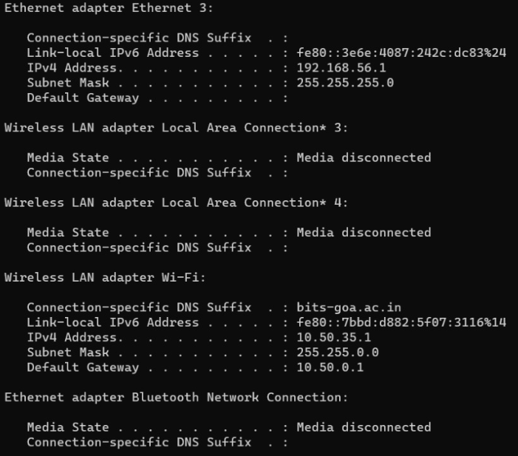

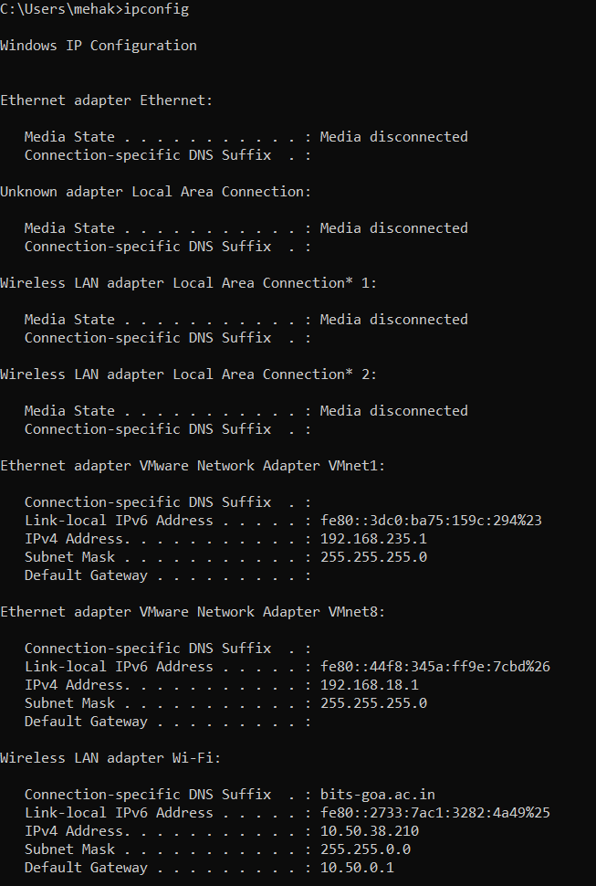

**Data Transfer:**

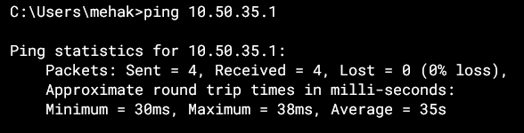

**Streaming:**

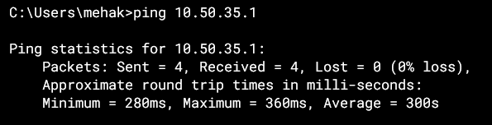

**A Comparision of Performance**

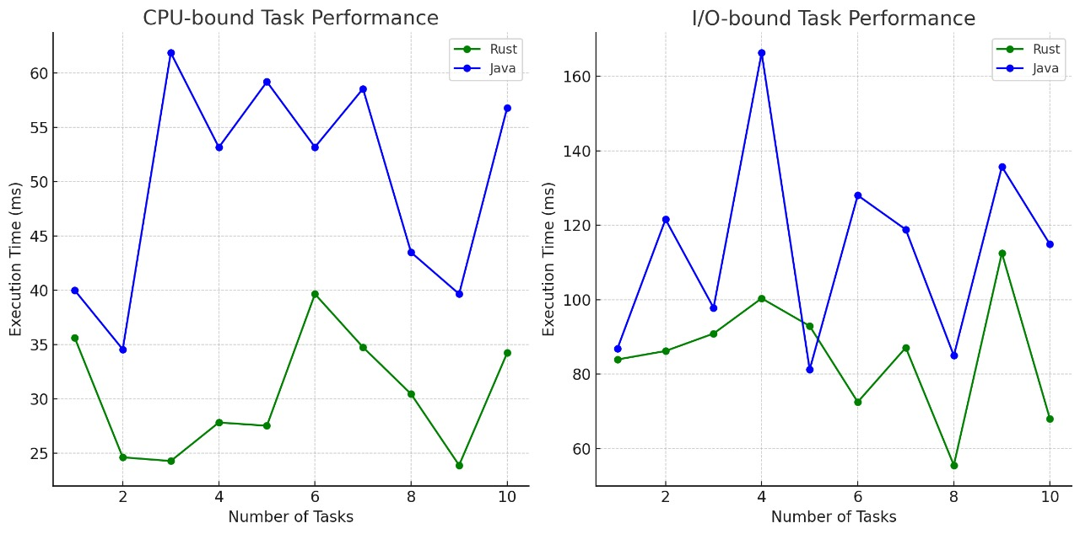

**Potential for future work**

- Here, we tried to work with a latency measurement command. Given more time we can measure the latency while streaming as well.

- Also, we can incorporate more POPL concept for improvement.

- Over here we made use of TCP protocol for transmission, which was quite problematic because of random loss of packets. We can further incorporate some better amd efficient protocol for improving latency.

- We can also create a GUI for converting it into a application format using some GUI package of rust.

- Investigate and implement additional streaming protocols or optimizations to further reduce latency and improve data transmission efficiency.

- Distributed Architecture: Explore the potential for a distributed architecture to scale the streaming server horizontally. This could involve implementing load balancing and communication between multiple server instances.

-Machine Learning Integration: Explore the integration of machine learning algorithms for predictive analysis of network conditions, allowing the server to dynamically adjust parameters for optimal streaming performance.

## **POPL Aspects for Future Work**

### **Error Handling and Fault Tolerance:**

* Enhance error handling mechanisms and implement fault tolerance strategies to ensure the server gracefully handles unexpected situations, improving system reliability.

### **Performance Profiling:**

* Conduct detailed performance profiling to identify bottlenecks and areas for optimization. Leverage profiling tools and Rust-specific features to fine-tune critical sections of the code.

### **Code Refactoring and Maintainability:**

* Consider refactoring the codebase for improved maintainability and readability. This involves adhering to Rust best practices, ensuring the long-term sustainability of the project.

### **Community Collaboration:**

* Engage with the Rust community to gather insights, feedback, and potential contributions. This collaborative approach can lead to the adoption of best practices and the integration of community-driven improvements.