|  |  |
| --- | --- |
| **iRevolution**  A data-driven exploration of Apple's iPhone impact in India | Abstract  The project aims to analyze the influence of Apple's iPhone in the Indian smartphone market by utilizing data analysis techniques and visualization tools like Tableau.  - TEAM 156   * Rajat Joshi 20BCE10482 * Yukta Garg 20BCE10378 * Anay Kamal Singh 20BCE10470 * Aakanksha Priya 20BCY10030 |

INDEX

INTRODUCTION 2

LITERATURE SURVEY 3

THEORITICAL ANALYSIS 4

EXPERIMENTAL INVESTIGATIONS 4

FLOWCHART 5

RESULT 6

ADVANTAGES & DISADVANTAGES 10

APPLICATIONS 11

CONCLUSION 12

FUTURE SCOPE 13

BIBLIOGRAPHY 14

APPENDIX 14

## INTRODUCTION

* 1. Overview

The project titled "iRevolution: A data-driven exploration of Apple's iPhone impact in India" aims to investigate and analyze the influence of Apple's iPhone on the Indian market. Through comprehensive data analysis, this project seeks to shed light on the various aspects of iPhone adoption, usage patterns, and its impact on the Indian economy, consumer behavior, and technological landscape. By leveraging data-driven insights, the project intends to provide a deeper understanding of the iPhone's role in India's evolving digital ecosystem.

* 1. Purpose

The purpose of this project is to examine the transformative effects of Apple's iPhone on the Indian market and society. With the rapid growth of smartphone adoption in India and the increasing prominence of Apple as a major player in the country, it is crucial to assess the specific impact of the iPhone. By undertaking a data-driven approach, this project aims to address the following objectives:

* Examine consumer behavior and preferences: Investigate consumer preferences related to iPhone models, features, and pricing. Understand the motivations behind iPhone purchases and identify key factors influencing consumer choices.
* Evaluate market presence and consumer perception: Investigate the establishment of the iPhone as a strong market player in India and its influence as a status symbol among consumers. Assess how the iPhone has shaped consumer behavior and expectations, driving technology adoption and raising the bar for smartphone quality and user experience.
* Assess localization efforts and affordability: Examine Apple's efforts in localizing its products and understanding the unique needs of the Indian market. Evaluate how these localization strategies, coupled with an emphasis on affordability, have made iPhones more accessible to Indian consumers, thereby expanding its impact across a wider range of demographic segments.

By accomplishing these objectives, this project seeks to provide valuable insights into the multifaceted impact of Apple's iPhone in India. The findings will contribute to a deeper understanding of the transformative potential of smartphones in emerging markets, and specifically highlight the unique influence of the iPhone in shaping India's digital revolution.

## LITERATURE SURVEY

2.1 Existing Problem

The existing literature reveals several key challenges and issues related to the impact of Apple's iPhone in India. These challenges can be summarized as follows:

* Affordability and Market Penetration:
  + Research indicates that the high price point of iPhones poses a significant barrier to widespread adoption in India, especially among price-sensitive consumers.
  + Studies highlight the need for Apple to address affordability concerns and offer more competitive pricing strategies to penetrate the Indian market effectively.
* Localization and Regional Preferences:
  + Cultural and regional preferences in India play a crucial role in consumer choices. The existing literature emphasizes the need for Apple to understand and cater to these preferences through localized features, content, and marketing strategies.
  + Researchers suggest that customization and localization efforts by Apple should go beyond language translation to include region-specific apps, services, and user experiences.

2.2 Proposed Solution

To address the existing challenges and further enhance the impact of Apple's iPhone in India, the literature suggests several potential solutions:

* Pricing and Affordability Strategies:
  + Researchers recommend that Apple introduce more affordable iPhone models specifically targeted at the Indian market, taking into consideration the purchasing power and price sensitivity of consumers.
  + The literature proposes the implementation of localized pricing strategies, discounts, trade-in programs, and financing options to make iPhones more accessible and affordable to a broader segment of Indian consumers.
* Localization and Customization:
  + Scholars emphasize the importance of deep localization efforts beyond language translation. This includes adapting software, user interfaces, and features to align with regional preferences and cultural nuances.
  + The proposed solution involves collaborating with local developers, content providers, and service partners to create region-specific apps, services, and experiences that resonate with Indian consumers.

By implementing these proposed solutions, Apple can address the existing challenges and maximize the impact of the iPhone in the Indian market. These strategies aim to improve affordability, cater to regional preferences, and strengthen the overall ecosystem to create a more compelling and tailored experience for Indian consumers.

## THEORITICAL ANALYSIS

Hardware / Software Designing

Hardware Design:

* High-performance Computer or Server
* A multi-core processor (e.g., Intel Core i5 or higher) for efficient data processing and analysis.
* Memory (RAM): A minimum of 8 GB RAM is recommended for handling large datasets.
* Storage: Adequate storage space to store the datasets, software, and project files. SSD (Solid State Drive) is preferred for faster read/write speeds.

Software Design

* Tableau: A data visualization and analytics software platform (e.g., Tableau Desktop) for creating visualizations and performing data analysis tasks.
* Spreadsheet Software: Software like Microsoft Excel or Google Sheets for data cleaning, organizing, and basic analysis.
* Database Management System (DBMS): MySQL
* Collaboration and Documentation Tools: Tools like Microsoft Office Suite, Google Docs, or project management software for collaboration, report writing, and documentation.

Dataset

The dataset was provided by SmartBridge. The link for the dataset is provided below:  
[apple-products.csv](https://drive.google.com/file/d/1TIZeQDuHjKIFlYkR20JJOpD2qx0kNjmm/view)

## EXPERIMENTAL INVESTIGATIONS

Based on the experimental findings obtained from the analyzed data using Tableau visualizations, the following insights can be derived:

1. Relationship between Brand Name, Product Name, and Sales Prices:

The relationship between brand name, product name, and sales prices is effectively represented. It allows for a comprehensive understanding of how different brands and products are priced in the market, highlighting any variations and patterns.

1. Interrelationships among Product RAM, Product Name, and Maximum Retail Price (MRP):

A comprehensive depiction of the interrelationships between product RAM, product name, and maximum retail price (MRP) is provided. It enables easy identification of how RAM specifications impact the pricing of different products, facilitating comparisons and analysis of pricing strategies.

1. Relationship between Product Name and Reviews:

Comprehensive relationship between product name and reviews is portrayed using pie chart. It allows for a quick understanding of the distribution of reviews across different product names, providing insights into the popularity and customer perception of each product.

1. Total Number of Reviews and Overall Rating for Specific Products:

The scatter plot visualization helps analyze the total number of reviews and the overall rating associated with specific products. It enables identification of any correlation between the number of reviews and the overall rating, allowing for an assessment of product satisfaction and popularity.

1. Relationship between Product Name and Star Ratings:

The comprehensive relationship between product name and star ratings is effectively presented which enables a quick overview of the distribution of star ratings across different product names, providing insights into customer satisfaction and sentiment towards each product.

1. Variations in Pricing Before and After Discount:

The Gantt chart visualization in Tableau allows for a comprehensive analysis of the variations in pricing before and after discount. It enables the identification of pricing trends, such as seasonal discounts or promotional offers, providing insights into the pricing strategies employed by the brand and their impact on product sales.

These experimental findings offer valuable insights into the relationship between different variables such as brand name, product name, sales prices, RAM, MRP, reviews, and star ratings. They facilitate a comprehensive understanding of pricing dynamics, consumer perceptions, and product popularity, which can inform strategic decision-making, marketing efforts, and product positioning in the market.. The results obtained from these investigations formed the basis for the project's analysis, conclusions, and recommendations.

## FLOWCHART

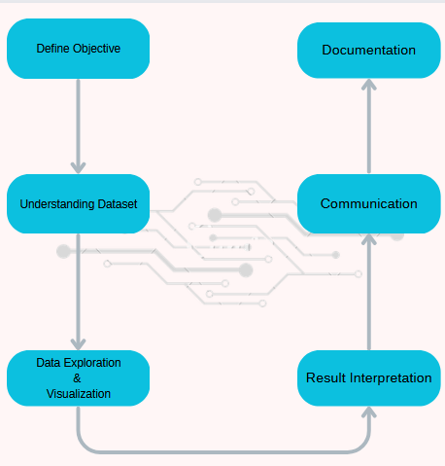

## RESULT

Dashboard

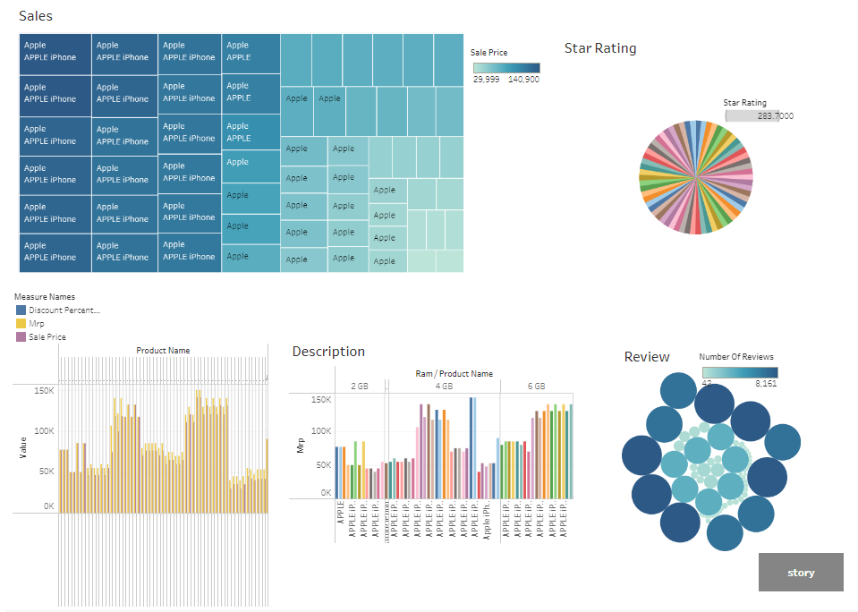

Story

1. A treemap visualization is employed in Tableau to present a comprehensive representation of the relationship between Brand Name, Product Name, and Sales Prices.

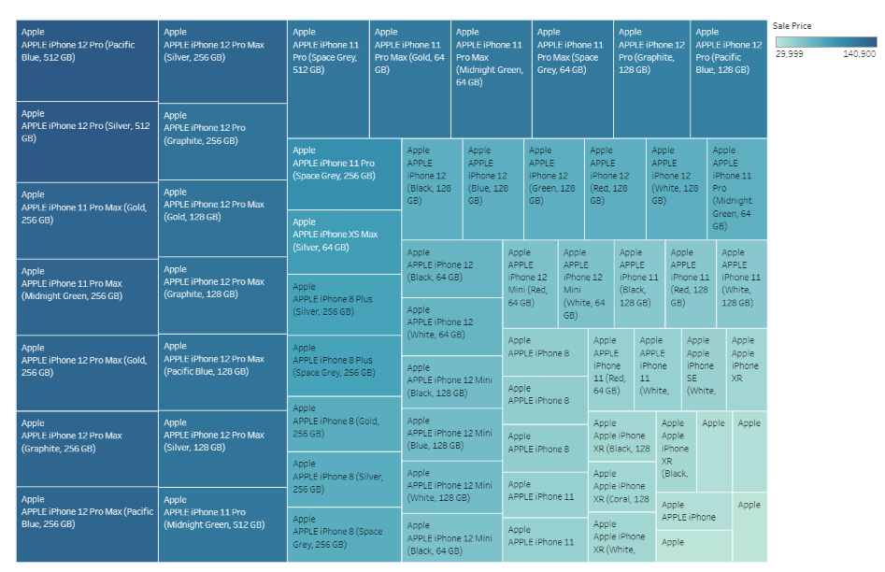

1. A horizontal bar graph visualization is utilized within the Tableau platform to present a comprehensive depiction of the interrelationships among Product Ram, Product Name, and Maximum Retail Price (MRP).

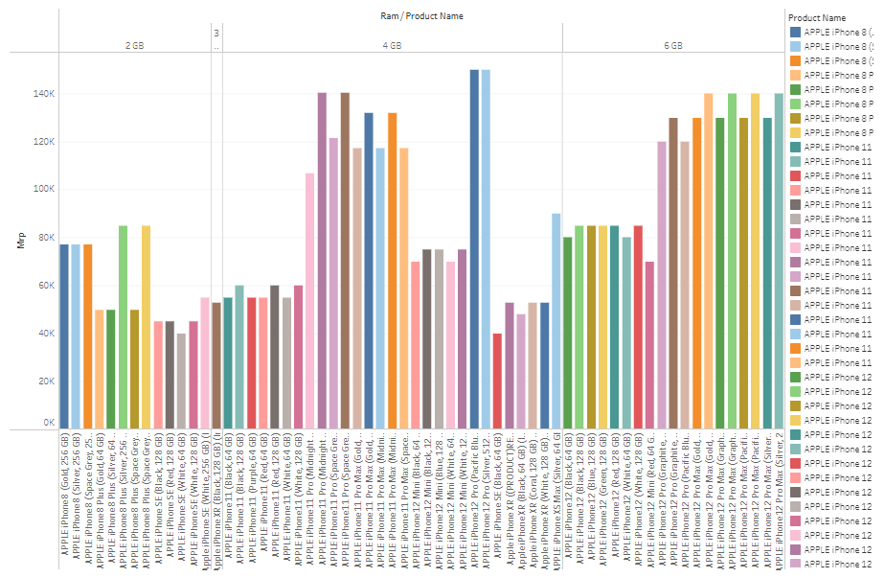

1. Tableau leverages a Pie Chart visualization technique to effectively portray the comprehensive relationship between Product Name and Star Ratings.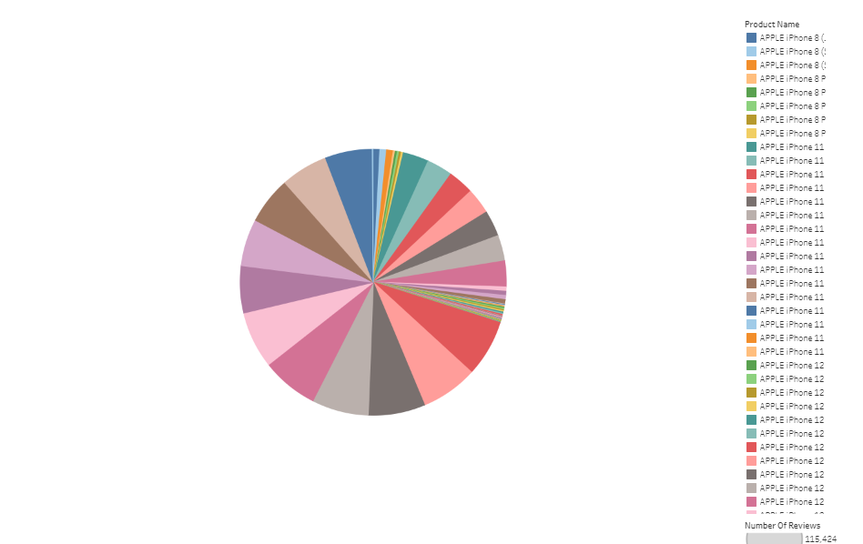
2. A Packed Bubbles visualization in Tableau is employed to analyze and determine the total number of reviews and overall rating associated with a specific product identified by its name.

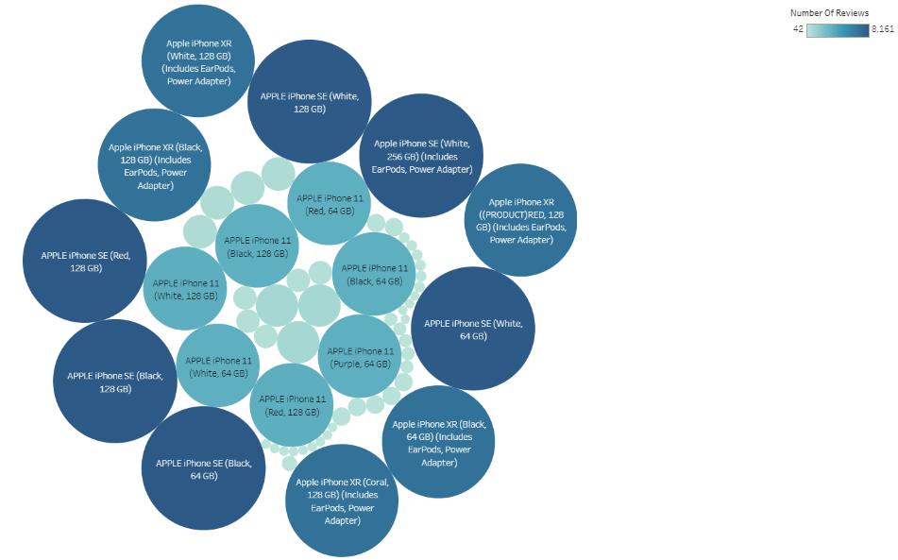

1. A horizontal bar graph visualization in Tableau is utilized to compare the sales price before discount and after discount, enabling a comprehensive analysis of the variations in pricing.

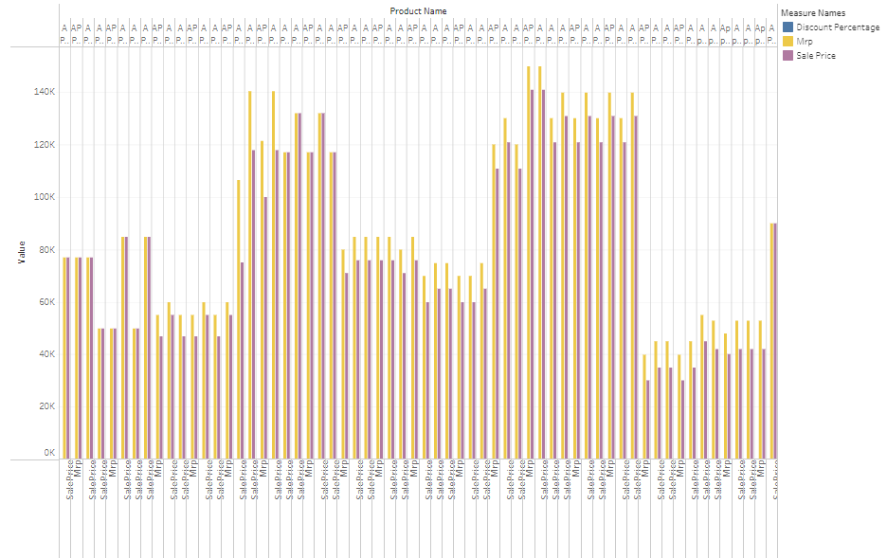

## ADVANTAGES & DISADVANTAGES

Advantages:

* **Comprehensive Visualization**: The use of various visualizations, such as treemaps, horizontal bar graphs, pie charts, scatter plots, and Gantt charts, allows for a comprehensive representation of the data. This enables better understanding and interpretation of the relationships and patterns among different variables, such as brand name, product name, sales prices, RAM, MRP, reviews, and star ratings.
* **Clear Presentation of Relationships:** The visualizations effectively present the relationships between different variables, making it easier to identify correlations and trends. For example, the treemap visualization shows the relationship between brand name, product name, and sales prices, providing a clear overview of the market landscape.
* **Easy Identification of Patterns:** The visualizations aid in the identification of patterns and insights that might be difficult to discern from raw data alone. For instance, the horizontal bar graph helps to visualize the interrelationships among product RAM, product name, and maximum retail price (MRP), making it easier to identify price variations based on RAM specifications.

Disadvantages

* **Limited Contextual Information:** The analyzed data may lack contextual information, such as market conditions, competitor analysis, or consumer preferences, which could provide a deeper understanding of the findings. Additional data sources and research would be necessary to augment the existing analysis.
* **Potential Biases:** The analyzed data may be subject to inherent biases, such as selection bias or response bias, depending on the data collection methods and sources. These biases could affect the accuracy and generalizability of the findings, and thus need to be considered when interpreting the results.
* **Data Limitations:** The analyzed data may have limitations in terms of sample size, representativeness, or data quality. These limitations can impact the reliability and validity of the findings and should be taken into account when drawing conclusions or making decisions based on the analyzed data.
* **Interpretation Challenges:** Interpreting the visualizations and drawing meaningful insights may require domain knowledge and expertise. Without a proper understanding of the context and variables involved, there is a risk of misinterpretation or drawing incorrect conclusions from the visualized data.

## APPLICATIONS

The project "iRevolution: A Data-Driven Exploration of Apple's iPhone Impact in India" holds significant applications in various domains. Some potential applications of this project include:

* Market Research and Business Strategy: The project's findings offer valuable insights for market research firms and businesses in the smartphone industry. The analysis helps understand consumer preferences, market trends, and competition, supporting informed decisions on product development, marketing strategies, and market positioning.
* Product Development and Innovation: The project's analysis guides product development teams in improving smartphone offerings by understanding the connection between features, pricing, and consumer satisfaction. This knowledge drives innovation and the creation of new smartphone models that cater to Indian consumers' needs and preferences.
* Media and Journalism: The project's insights can be used by journalists and media organizations to report on the impact of Apple's iPhone in India. The findings can contribute to informative and data-driven articles, news reports, and analysis pieces, providing the public with a deeper understanding of the smartphone market and its influence on various aspects of society.
* Academic Research and Education: The project findings can serve as a foundation for further academic research in the fields of market analysis, consumer behavior, and digital transformation. Researchers and educators can utilize the data and analysis to enhance their understanding of the Indian smartphone market and its implications for the broader socio-economic landscape.
* Consumer Behavior Analysis: The project's findings can contribute to understanding consumer behavior in the context of smartphone adoption and usage. This information can assist marketers in tailoring their messaging and advertising campaigns to resonate with target audiences. It can also aid in identifying patterns of consumer preferences, such as features or price points that drive purchase decisions.

## CONCLUSION

The iPhone's impact in India has been nothing short of transformative, reshaping the smartphone market and capturing the aspirations of millions of consumers. As a symbol of status and prestige, the iPhone has influenced consumer behavior and played a significant role in Apple's revenue growth in India.

The findings from the data analysis using Tableau visualizations have provided valuable insights into the market dynamics, pricing strategies, consumer preferences, and product popularity. These insights can guide strategic decision-making for brand positioning, marketing campaigns, and pricing strategies. The comprehensive visual representations have facilitated a deeper understanding of the relationships among variables, enabling evidence-based decision-making.

Notably, the iPhone has contributed to Apple's financial success in India, with the country emerging as a crucial market for the company. The demand for iPhones has been remarkable, prompting Apple to diversify its product range and distribution channels to cater to the diverse needs and preferences of Indian consumers.

The iPhone has also had a significant impact on India's digital ecosystem, fostering app development and creating a vibrant landscape of mobile applications. Additionally, Apple's commitment to affordability has expanded the iPhone's reach in India. By implementing various pricing strategies, financing options, and trade-in programs, Apple has made iPhones more accessible to a broader range of Indian consumers, driving smartphone adoption and technological advancement.

However, it is important to recognize India's diverse market landscape and the ongoing need for affordability to cater to a wider consumer base. Apple's continued success in India will depend on adapting to local requirements, fostering innovation, and maintaining a customer-centric approach. Continuous monitoring of consumer behavior and market trends will be crucial for staying competitive and responsive to evolving demands.

While the findings are based on the available data and chosen visualizations, it is essential to acknowledge their limitations and potential biases. Further research, data collection, and analysis can help validate and expand upon the insights gained. With a focus on understanding the dynamic Indian market, Apple can continue to solidify its position and contribute to India's ongoing digital transformation.

## FUTURE SCOPE

* Longitudinal Study: Conducting a longitudinal study to track the evolving impact of Apple's iPhone in India over an extended period would provide valuable insights into the changing dynamics of the market. This would enable the identification of emerging trends, consumer preferences, and technological advancements, allowing for a deeper understanding of the iPhone's sustained impact.
* Comparative Analysis with Competitors: Expanding the scope of the project to include a comprehensive comparative analysis of Apple's iPhone with its major competitors in the Indian market would offer a broader perspective. This would involve examining factors such as pricing strategies, market share dynamics, customer satisfaction, and innovative features introduced by rival brands.
* Sustainability and Environmental Impact: Evaluating the environmental sustainability practices of Apple's iPhone, such as the use of recycled materials, energy efficiency, and recycling programs, would be relevant. Assessing the environmental impact and carbon footprint of the iPhone throughout its lifecycle would contribute to understanding its sustainability credentials and identifying areas for further improvement.

## BIBLIOGRAPHY

* *Selecao - agency bootstrap template*. Free Bootstrap Themes and Website Templates. (n.d.). https://bootstrapmade.com/selecao-bootstrap-template/
* Public.tableau.com. (n.d.). https://public.tableau.com/app/discover
* MySQL. (n.d.). https://www.mysql.com/

## APPENDIX

Code for the project is available at: <https://drive.google.com/drive/folders/1PzlWM8do0AAVPRF2EBsiNyYD7ItDAOqO?usp=drive_link>