Software Requirements Specification
for
FixMate — Home Service Management System
Version 1.0
Prepared by: [Yukta Karwa]
[Institution / Organization: Vivekanand Education Society’s Institute of Technology]
[Date- August 2026]

Table of Contents
Table of Contents 1
Document Information 1
1. Introduction 1
1.1 Purpose 1
1.2 Document Conventions 1
1.3 Intended Audience and Reading Suggestions 1
1.4 Product Scope 1
1.5 References 1
2. Overall Description 1
2.1 Product Perspective 1
2.2 Product Functions 1
2.3 User Classes and Characteristics 1
2.4 Operating Environment 1
2.5 Design and Implementation Constraints 1
2.6 User Documentation 1
2.7 Assumptions and Dependencies 1
3. External Interface Requirements 1
3.1 User Interfaces 1
3.2 Hardware Interfaces 1
3.3 Software Interfaces 1
3.4 Communications Interfaces 1
4. System Features 1
4.1 User Registration and Authentication 1
4.1.1 Description and Priority 1
4.1.2 Stimulus/Response Sequences 1
4.1.3 Functional Requirements 1
4.2 Service Provider Verification and Profile Management 1
4.2.1 Description and Priority 1
4.2.2 Stimulus/Response Sequences 1
4.2.3 Functional Requirements 1
4.3 Service Search and Browsing 1
4.3.1 Description and Priority 1
4.3.2 Stimulus/Response Sequences 1
4.3.3 Functional Requirements 1
4.4 Booking and Scheduling 1
4.4.1 Description and Priority 1
4.4.2 Stimulus/Response Sequences 1
4.4.3 Functional Requirements 1
4.5 Real-Time Tracking 1
4.5.1 Description and Priority 1
4.5.2 Stimulus/Response Sequences 1
4.5.3 Functional Requirements 1
4.6 In-App Payments and Invoicing 1
4.6.1 Description and Priority 1
4.6.2 Stimulus/Response Sequences 1
4.6.3 Functional Requirements 1
4.7 Ratings, Reviews, and Complaints 1
4.7.1 Description and Priority 1
4.7.2 Stimulus/Response Sequences 1
4.7.3 Functional Requirements 1
4.8 Admin Management Dashboard 1
4.8.1 Description and Priority 1
4.8.2 Stimulus/Response Sequences 1
4.8.3 Functional Requirements 1
4.9 Notifications and Alerts 1
4.9.1 Description and Priority 1
4.9.2 Stimulus/Response Sequences 1
4.9.3 Functional Requirements 1
4.10 Booking History and Rebooking 1
4.10.1 Description and Priority 1
4.10.2 Stimulus/Response Sequences 1
4.10.3 Functional Requirements 1
5. Other Nonfunctional Requirements 1
5.1 Performance Requirements 1
5.2 Safety Requirements 1
5.3 Security Requirements 1
5.4 Software Quality Attributes 1
5.5 Business Rules 1
6. Other Requirements 1
Appendix A: Glossary 1
Appendix B: Analysis Models 1
Appendix C: To Be Determined List 1

Revision History
Name | Date | Reason For Changes | Version
Yukta Karwa | August 2026 |  | 1.0

1. Introduction

1.1 Purpose
This document explains what the FixMate system must do. FixMate is a home service platform that connects homeowners with trusted service providers — such as plumbers, electricians, carpenters, painters, cleaners, and appliance repair technicians. This document describes the complete FixMate system: the Customer app, the Service Provider app, and the Admin dashboard. It is meant to guide the people who design, build, and test the system, so that everyone shares the same understanding of what needs to be built.

1.2 Document Conventions
Every requirement in this document is marked as High, Medium, or Low priority. The word “shall” means the feature is required. The word “should” means the feature is recommended but not compulsory.

1.3 Intended Audience and Reading Suggestions
This document is written for the following readers:
- Project supervisors and evaluators, who want to check that the project is complete and well planned.
- Developers, who will build the features described here.
- UI/UX designers, who will design the app screens.
- Testers, who will write test cases based on the requirements.
- Project managers, who will plan the schedule and resources.
New readers should first read Section 2 for a general overview, and then read Section 4 for the detailed feature-by-feature requirements.

1.4 Product Scope
Finding a reliable and reasonably priced person to fix something at home is often slow and frustrating. People usually depend on word-of-mouth recommendations, and there is no easy way to check if a worker is trustworthy or available. FixMate solves this problem with one simple app. A homeowner can open FixMate, choose the type of service they need, pick a verified provider, and book an appointment in a few taps. They can track the provider's arrival on a map, pay safely through the app, and rate the service afterwards. For service providers, FixMate offers a steady stream of job requests, an easy way to manage bookings and earnings, and a fair rating system that rewards good work. The long-term goal of FixMate is to become the most trusted platform for home services in the region.

1.5 References
- IEEE Std 830-1998, IEEE Recommended Practice for Software Requirements Specifications.
- Wiegers, K. E., Software Requirements Specification Template, 1999.
- Google Maps Platform Documentation — https://developers.google.com/maps
- Razorpay / Stripe Payment Gateway API Documentation.
- Firebase Cloud Messaging (FCM) Documentation — https://firebase.google.com/docs/cloud-messaging

2. Overall Description

2.1 Product Perspective
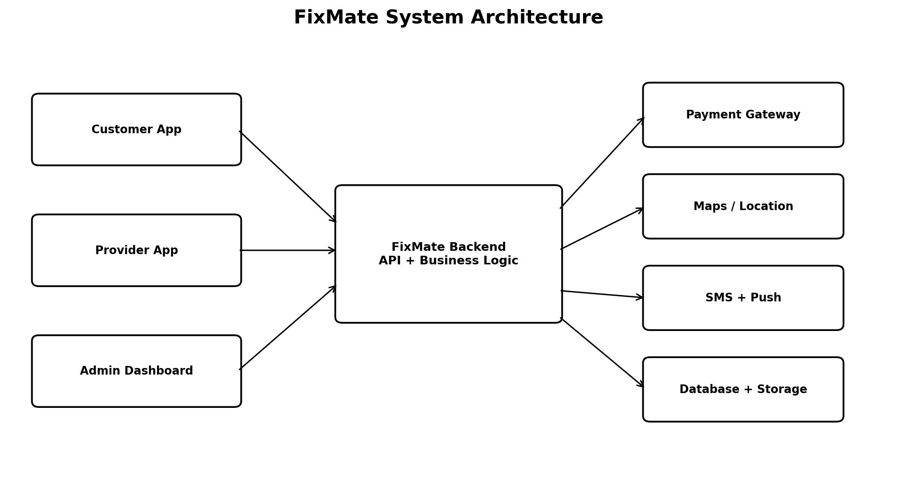
Figure 1. High-level FixMate system architecture.
FixMate is a brand-new product, not an upgrade of an existing system. It has three connected parts that all talk to one shared backend server:
- Customer App (Android, iOS, and Web) — used by homeowners to find, book, and pay for services.
- Service Provider App (Android and iOS) — used by workers to receive and manage job requests.
- Admin Web Dashboard — used by FixMate staff to approve providers, monitor bookings, and resolve issues.
These three apps connect to a central server and database, and also rely on outside services such as a payment gateway, a maps service, and a notification service. A simple diagram of how these pieces connect is described in Appendix B.

2.2 Product Functions
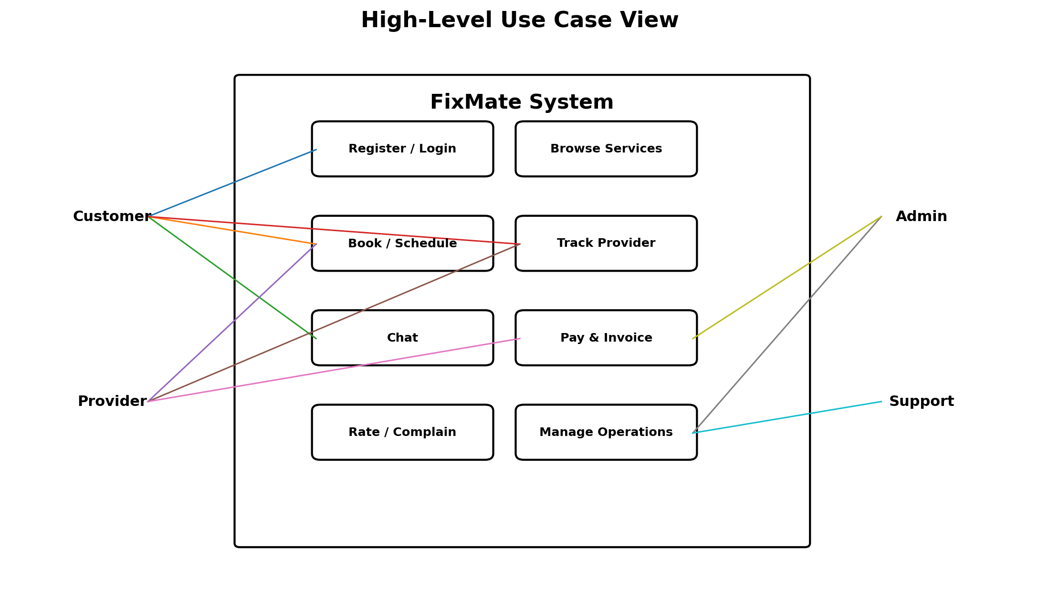
Figure 2. High-level use case view of the FixMate platform.
The main things FixMate must do are listed below. Full detail is provided in Section 4.
- Let customers and providers register and log in.
- Verify each provider's identity and skills before they can accept jobs.
- Let customers browse and search for services near them.
- Let customers book a service instantly or schedule it for later.
- Show the provider's live location and arrival time on a map.
- Let customers and providers chat inside the app.
- Handle payments and generate receipts inside the app.
- Let customers rate providers and report problems.
- Give admins tools to manage users, providers, and complaints.
- Send notifications for booking updates, arrival, and payments.
- Keep a booking history and allow quick rebooking.

2.3 User Classes and Characteristics
User Class | Characteristics | Importance
Customer | Homeowners or tenants with everyday smartphone skills. Most will use the app occasionally, when something needs fixing. | Primary — the core user group.
Service Provider | Skilled workers who use the app daily to manage jobs and track earnings. | Primary — provides the services customers book.
Admin | FixMate staff who approve providers, monitor activity, and settle disputes. | Secondary — runs day-to-day operations.
Support Staff | Customer-care agents who handle complaints and refunds. | Secondary — helps resolve issues.

2.4 Operating Environment
- Customer and Provider apps: Android 8.0 and above, or iOS 13 and above, with internet and GPS turned on.
- Web pages (Customer website and Admin dashboard): the latest two versions of Chrome, Firefox, Edge, and Safari.
- Backend: hosted on a cloud server (such as AWS or Azure) so it can be scaled up as more users join.
- Database: a standard relational database (such as PostgreSQL or MySQL) for storing all app data.

2.5 Design and Implementation Constraints
- The system must follow local data-protection and privacy laws when storing personal and location information.
- Payment handling must follow standard card-security rules; FixMate itself will never store raw card numbers — this is handled by the payment provider.
- The system must use a maps service to show addresses and live tracking.
- The app must support at least two languages from launch: English and one regional language.
- The backend should be built in independent modules so that each part (bookings, payments, notifications) can be updated or scaled without affecting the others.

2.6 User Documentation
- A short in-app tutorial and help section (FAQ) for customers and providers.
- A Service Provider Handbook explaining sign-up, verification, and how to handle jobs.
- An Admin Dashboard guide for FixMate staff.
- Terms of Service and a Privacy Policy, available inside every app.

2.7 Assumptions and Dependencies
- Users have a mobile number that can receive SMS, for OTP verification.
- Service providers own a smartphone with GPS and an internet connection.
- A stable internet connection is available when the app is used.
- Outside services — the payment gateway, maps service, SMS service, and notification service — stay available and work as expected.
- The first launch will cover one city or region before expanding to others.

3. External Interface Requirements

3.1 User Interfaces
The Customer App includes screens for signing up and logging in, browsing services, booking and scheduling, tracking a provider on a map, chatting, paying, and leaving a rating. The Service Provider App includes screens for accepting or declining jobs, navigating to the customer, updating job status, and viewing earnings. The Admin Dashboard includes screens for approving providers, managing users and bookings, and resolving complaints. All screens will follow one consistent visual style, support both light and dark mode, and be easy to use for people with different levels of technical comfort. Detailed screen designs will be documented separately.

3.2 Hardware Interfaces
- Smartphone GPS — needed to track a provider's location and to detect addresses automatically.
- Smartphone camera — needed to upload verification documents and job-completion photos.
- Server hardware — cloud computing and storage hardware, managed by the hosting provider.

3.3 Software Interfaces
Interface | Purpose
Payment Gateway (e.g., Razorpay/Stripe) | Handles payments, refunds, and receipts.
Maps Service (e.g., Google Maps) | Finds addresses and shows live tracking on a map.
SMS/OTP Service (e.g., Twilio) | Sends the one-time password used to verify sign-up and login.
Push Notification Service | Sends alerts for bookings, arrival, and payments.
Database | Stores users, bookings, payments, and reviews.
Cloud Storage | Stores profile photos, verification documents, and job photos.

3.4 Communications Interfaces
- All data sent between the apps and the server will be encrypted for security.
- Live features, such as chat and map tracking, will update instantly without needing to refresh the screen.
- Receipts and account emails will be sent through an automated email service.
- Notifications will be delivered as push alerts on both Android and iOS.

Accounts & Verification | Service Discovery | Booking & Tracking | Payments & Support
Secure customer/provider access | Verified providers and filters | Scheduling and live arrival | Invoices, ratings and complaints

4. System Features
The requirements below are grouped by feature. Each feature is given a priority of High, Medium, or Low.

4.1 User Registration and Authentication

4.1.1 Description and Priority
Lets customers and providers create an account, verify their phone number, and log in securely.
Priority: High

4.1.2 Stimulus/Response Sequences
- The user enters their mobile number and receives an OTP by SMS; once entered correctly, their account is created or opened.
- A returning user can log in with a saved password or their fingerprint/face unlock, if the phone supports it.

4.1.3 Functional Requirements
The system shall let a new user sign up using a mobile number verified by OTP.
The system shall also allow sign-up using an email address and password.
The system shall let users reset a forgotten password using OTP or an email link.
The system shall lock an account for 15 minutes after 5 failed login attempts in a row.
The system shall require providers to finish the verification steps in Section 4.2 before they can accept bookings.

4.2 Service Provider Verification and Profile Management

4.2.1 Description and Priority
Lets providers submit their ID and skill documents for approval, and manage their public profile — services offered, working area, and pricing.
Priority: High

4.2.2 Stimulus/Response Sequences
- The provider uploads their ID and any relevant certificates; the request is sent to the Admin for review.
- The Admin checks the documents and approves or rejects the application; the provider is notified either way.

4.2.3 Functional Requirements
The system shall require providers to upload a government-issued ID and one proof of address.
The system shall not let a provider accept bookings until an admin approves their documents.
The system shall let providers choose their service categories, working area, and prices, within limits set by the admin.
The system shall notify a provider of approval or rejection, with a reason, within 48 hours.
The system shall let providers mark themselves as Available, Busy, or Offline at any time.

4.3 Service Search and Browsing

4.3.1 Description and Priority
Lets customers browse service categories and see a list of nearby, verified providers along with their ratings and prices.
Priority: High

4.3.2 Stimulus/Response Sequences
- The customer taps a service category; the system shows nearby available providers, sorted by distance, rating, or price.
- The customer can apply filters, such as price range or minimum rating, to narrow the list.

4.3.3 Functional Requirements
The system shall show service categories in an easy-to-browse list on the home screen.
The system shall list providers within the customer's search area, sorted by distance by default.
The system shall let customers filter and sort results by price, rating, and distance.
The system shall show each provider's average rating, number of completed jobs, and starting price.

4.4 Booking and Scheduling
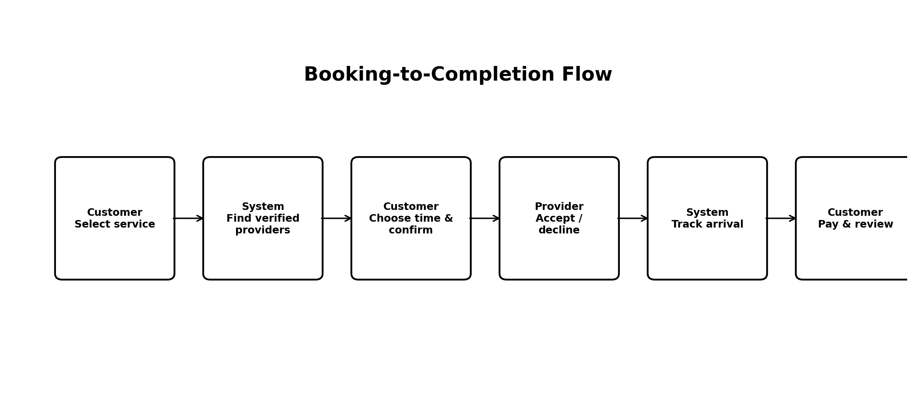
Figure 3. Booking-to-completion flow.

4.4.1 Description and Priority
Lets a customer book a service right away or schedule it for later, and lets a provider accept, decline, or reschedule the request.
Priority: High

4.4.2 Stimulus/Response Sequences
- The customer picks a provider and time, then confirms the booking; the provider is notified of the new request.
- The provider accepts or declines within a short time window; if there is no response, the system offers the job to the next available provider.

4.4.3 Functional Requirements
The system shall let customers book a service instantly or schedule it up to 30 days ahead.
The system shall notify the chosen provider of a new request and give them 5 minutes to respond.
If the provider does not respond in time, the system shall automatically offer the job to the next best-matched available provider.
The system shall let customers cancel a booking, following the cancellation policy in Section 5.5.
The system shall let both customer and provider reschedule a confirmed booking, with both sides agreeing to the new time.

4.5 Real-Time Tracking

4.5.1 Description and Priority
Shows the customer the provider's live location and expected arrival time once a booking is confirmed.
Priority: Medium

4.5.2 Stimulus/Response Sequences
- Once a booking is accepted, the provider's location is shared and shown on a map in the customer's app, along with an updating arrival estimate.

4.5.3 Functional Requirements
The system shall show the provider's live location on a map, from booking acceptance until the job starts.
The system shall show an estimated arrival time, updated at least every 30 seconds.
The system shall notify the customer when the provider is close to arriving (for example, within 500 metres).

4.6 In-App Payments and Invoicing

4.6.1 Description and Priority
Lets customers pay for a finished job using a card, UPI, wallet, or net banking, and creates a digital receipt.
Priority: High

4.6.2 Stimulus/Response Sequences
- When the job is done, the provider marks it complete and confirms the final amount; the customer reviews and pays through the app.
- The system creates a digital invoice and emails it to the customer once payment succeeds.

4.6.3 Functional Requirements
The system shall accept payment by card, UPI, net banking, and in-app wallet.
The system shall hold the provider's payment until the customer confirms the job is complete, or for 24 hours if there is no dispute.
The system shall create a digital invoice for every completed job, viewable in the booking history.
The system shall let an admin issue a full or partial refund if a dispute is raised.

4.7 Ratings, Reviews, and Complaints

4.7.1 Description and Priority
Lets customers rate and review a provider after a job, and report a problem if something goes wrong.
Priority: Medium

4.7.2 Stimulus/Response Sequences
- After payment, the customer is asked to give a star rating and an optional comment, or to raise a complaint instead.

4.7.3 Functional Requirements
The system shall ask the customer to rate the provider within 24 hours of job completion.
The system shall calculate and display a provider's average rating from all reviews received.
The system shall let a customer file a complaint, with photos if needed, within 7 days of the job.
The system shall notify Support Staff of new complaints and track their progress until resolved.

4.8 Admin Management Dashboard

4.8.1 Description and Priority
Gives FixMate staff the tools to approve providers, watch over active bookings, manage users, and resolve complaints.
Priority: High

4.8.2 Stimulus/Response Sequences
- The admin logs into the dashboard to review pending provider applications, active bookings, and open complaints.

4.8.3 Functional Requirements
The system shall show admins a list of pending provider applications with their uploaded documents.
The system shall let an admin suspend or deactivate a customer or provider account.
The system shall show a summary of daily, weekly, and monthly bookings, revenue, and active users.
The system shall record every admin action, along with who made it and when, for accountability.

4.9 Notifications and Alerts

4.9.1 Description and Priority
Sends timely alerts for important events, such as a confirmed booking, a provider's arrival, or a completed payment.
Priority: Medium

4.9.2 Stimulus/Response Sequences
- The system sends an alert whenever something important happens — a booking is confirmed, the provider starts travelling, or payment is completed.

4.9.3 Functional Requirements
The system shall notify the customer when a booking is confirmed, when the provider starts travelling, and when payment is completed.
The system shall send an SMS if a push notification for an important event is not delivered within 60 seconds.
The system shall let users turn off promotional messages while still receiving essential booking alerts.

4.10 Booking History and Rebooking

4.10.1 Description and Priority
Keeps a record of a customer's past bookings and lets them rebook the same provider with one tap.
Priority: Low

4.10.2 Stimulus/Response Sequences
- The customer opens “My Bookings” to see past and upcoming appointments, and taps “Book Again” on a past one.

4.10.3 Functional Requirements
The system shall keep a record of all of a customer's past bookings, in order.
The system shall let a customer rebook the same provider and service with one tap.
The system shall let customers view or download invoices from their past bookings.

5. Other Nonfunctional Requirements

5.1 Performance Requirements
- Search results shall appear within 3 seconds under normal network conditions.
- The system shall support at least 10,000 people using the app at the same time, and be able to grow beyond that as needed.
- A provider shall be notified of a new booking within 5 seconds of the customer submitting it.
- The provider's live location on the map shall update with no more than a 5-second delay.

5.2 Safety Requirements
- Every service provider shall be identity-checked before they are allowed to accept bookings, to help keep customers safe.
- The app shall include an emergency (SOS) button during an active job that alerts FixMate support and shares the user's live location.
- Job-completion photos and records shall be kept in case a safety issue needs to be looked into later.

5.3 Security Requirements
- All data sent between the app and server shall be encrypted; sensitive stored data, such as documents, shall also be encrypted.
- Logins shall use OTP or a securely stored (never plain-text) password.
- The system shall give each type of user — Customer, Provider, Admin, Support — access only to the features meant for their role.
- Card details shall never be stored on FixMate's own servers; all card handling shall be done by the certified payment provider.
- The system shall keep a log of admin actions and payment activity for security review.

5.4 Software Quality Attributes
- Availability: the system shall be up and running at least 99.5% of the time each month, not counting planned maintenance.
- Usability: a first-time customer shall be able to complete a booking within 5 taps from opening the app.
- Scalability: the backend shall be able to grow to support more cities without a full redesign.
- Maintainability: the code shall be organised so that individual features can be updated without affecting the whole system.
- Reliability: if an outside service (such as the payment gateway) goes down briefly, the system shall retry the action instead of losing the customer's data.

5.5 Business Rules
- A provider must be approved by an admin before customers can see or book them.
- FixMate shall keep a set percentage of each payment as a commission before paying the provider.
- A customer who cancels a confirmed booking within 15 minutes of the scheduled time shall be charged a cancellation fee, as set by the admin-defined policy.
- A provider whose average rating drops below a set level (for example, 3.0) shall be automatically flagged for admin review.
- Only Admin users may approve, reject, or suspend a provider's account.

6. Other Requirements
- Language support: new languages shall be easy to add later without changing the app's code.
- Legal: the app shall show Terms of Service and a Privacy Policy for users to accept when they sign up, and shall follow relevant consumer-protection and data-privacy laws.
- Taxes: invoices shall show the correct local taxes, such as GST, where applicable.
- Backups: the system shall automatically back up its database every day and keep backups for a set period.

Appendix A: Glossary
Term | Meaning
FixMate | The home service platform described in this document.
Customer | A registered user who books home services through FixMate.
Provider | A verified worker who completes bookings on FixMate.
Admin | A FixMate staff member who manages the platform.
KYC | “Know Your Customer” — the process of checking a provider's identity.
OTP | A one-time password sent by SMS to verify a phone number.
ETA | Estimated time of arrival of a service provider.
SOS | The in-app emergency alert feature.
SLA | Service Level Agreement — an agreed standard for how fast or well a service is delivered.

Appendix B: Analysis Models
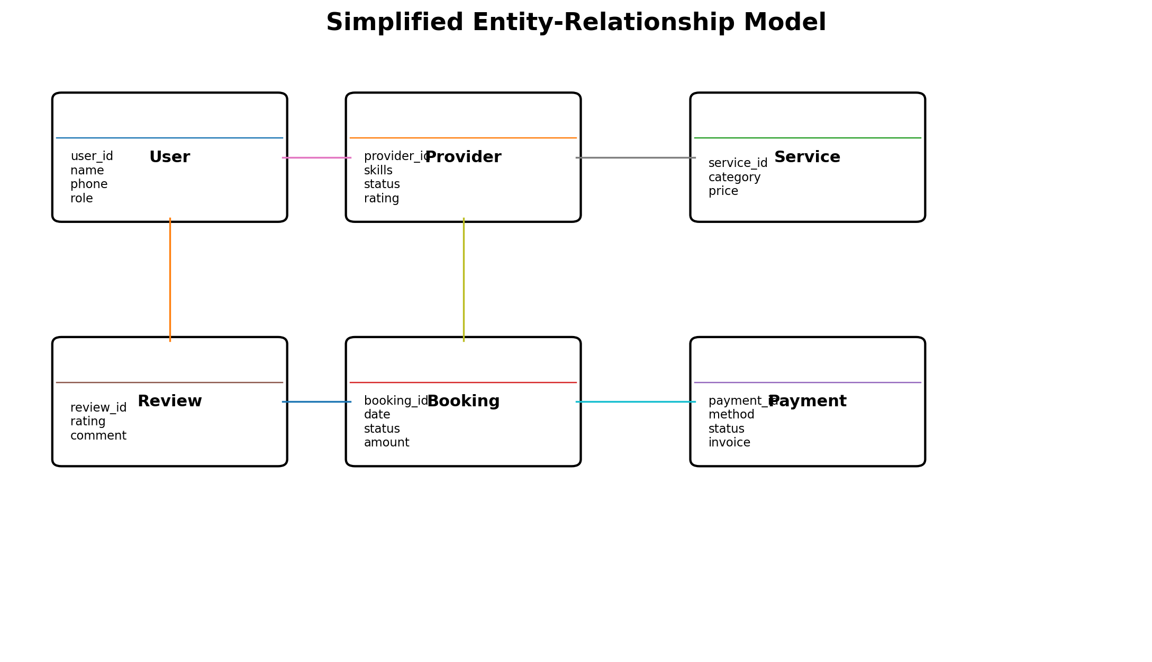
Figure 4. Simplified entity-relationship model.
The following analysis models are included to clarify the system structure, major interactions, booking flow, and core data relationships.
- Use Case Diagram — showing how the Customer, Provider, and Admin interact with the main features listed in Section 2.2.
- System Architecture Diagram — showing how the Customer App, Provider App, Admin Dashboard, server, database, and outside services (payment, maps, SMS, notifications) connect, as described in Section 3.3.
- Entity-Relationship (ER) Diagram — showing the main data items, such as User, Provider, Service Category, Booking, Payment, and Review, and how they relate.
- Booking Sequence Diagram — showing the step-by-step flow between Customer, Server, and Provider, from booking through payment and rating (Sections 4.4 and 4.6).
These models can be refined further during detailed design and implementation.

Appendix C: To Be Determined List
TBD # | Item
TBD-1 | Which payment gateway(s) will be used at launch.
TBD-2 | The exact commission percentage charged to providers.
TBD-3 | The full list of service categories offered at launch.
TBD-4 | The exact cancellation fee amounts and time windows.
TBD-5 | Which city or region will launch first, and the order of expansion after that.
TBD-6 | The exact response-time targets for customer support and complaint handling.

A. Open-Ended Questionnaire
Purpose: To collect detailed opinions, problems, expectations, and suggestions from users regarding the FixMate – Home Service Management System.
- What problems do you currently face while finding reliable home-service providers?
- What features would you like to have in a home-service management application?
- What difficulties do you face while booking home services such as plumbing, electrical work, cleaning, or appliance repair?
- What information would you like to see about a service provider before booking a service?
- How can the service-booking process be made easier and more convenient?
- What problems have you experienced with service pricing or payment?
- What type of notifications would you expect from a home-service application?
- What factors would make you trust a service provider?
- What improvements would you suggest for managing cancelled or rescheduled bookings?
- What additional features would you suggest for FixMate?

B. Closed-Ended Questionnaire
Purpose: To collect specific and measurable responses from potential FixMate users.
Q1. Have you ever used a home-service provider?
- Yes
- No
Q2. Which home service do you require most frequently?
- Plumbing
- Electrical
- Cleaning
- Appliance Repair
- Carpentry
- Painting
Q3. Do you face difficulty finding reliable service providers?
- Yes
- No
- Sometimes
Q4. Would you prefer booking home services through an online application?
- Yes
- No
Q5. Which factor is most important when selecting a service provider?
- Price
- Rating and Reviews
- Experience
- Availability
- Location
Q6. Which payment method would you prefer?
- Cash
- UPI
- Debit/Credit Card
- Net Banking
Q7. How important is service-provider rating and review information?
- Very Important
- Important
- Neutral
- Not Important
Q8. Would you like to track the status of your service booking?
- Yes
- No
Q9. Would you like to receive notifications about your booking?
- Yes
- No
Q10. Would you like the option to cancel or reschedule a booking?
- Yes
- No
Q11. Would you like to rate and review the service after completion?
- Yes
- No
Q12. Overall, how useful would you find an application like FixMate?
- Very Useful
- Useful
- Neutral
- Not Useful

Conclusion: The experiment provided an understanding of Software Requirements Specification (SRS) and its importance in the software development process. It explained how requirements are collected, documented, analyzed, and validated before system development begins. Open-ended and closed-ended questionnaires were studied as effective techniques for gathering user requirements. Different types of requirements, including functional, non-functional, user, and system requirements, were also identified. Overall, proper requirement analysis and documentation help reduce ambiguity, improve communication among stakeholders, and ensure the successful development of a software system.

