System Design (Nikhil Lohia)

Scaling
Let’s say I want to open a bookstore, I have a small bookstore and some customers starts to come in,

now as more and more customers starts to come in, so my bookstore start to get smaller, so I want to accommodate more customers, so I will try to expand my shop and I’ll open a big store, now more and more customers come in and store is able to accommodate everyone, so we are increasing our store capacity, now if more customers starts to come in maybe I can increase my store once again.

But the problem with this approach is if more and more customers come in, we can’t just expand the bookstore, by doing this we will have parking problems, and resources problems as well and we cannot manage all the customers, right now we are scaling the bookstore vertically (Vertical Scaling)
So, the solutions that all the big companies come up with is, they do not open a store at only one place, they open different stores at different places, and each of the store they are made on the basis of consumption, this is Horizontal scaling, so we can use our same store format and open it up in a lot of different places.
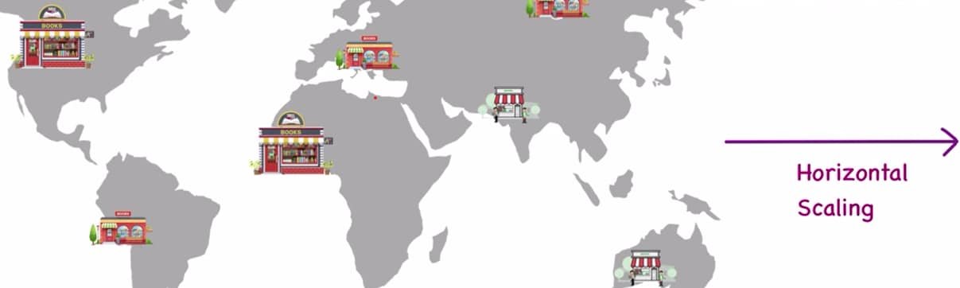
With that we can distribute all of our customers at different places, and if we had our store open only in one region then we are only targeting our customers from this particular region we cannot expect our customer to fly all the way to come to our store, but if we have opened our store at all of these different places then a customer can go to any of the store that is nearest to them, so this is how we are solving a problem and this is Horizontal Scaling
We cannot expect vertical scaling infinitely but with horizontal scaling we have a lot more scope

Creating a basic application
Let’s say we’re developing an application and this application will be having a db, some disk usage and CPU as well, we made our app on a computer, now I want this app available to someone so we run our own server and we deploy this app, so people will start coming in and they want to use our app
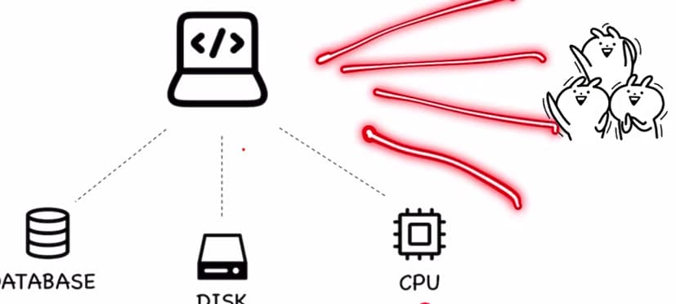
But, the more and more people will try to use our app, so we will need more disk, more cpu and moe db as well, so we can increase our disk size (from 2TB to 4TB of RAM) and we can even use faster cpu (from 2.2 GHz to 3 GHz)
But if we had to deal with a millions of user like Facebook, so we cannot expect that we will keep on increasing our disk, db and CPU quantity as we have limitation. And when we are dealing with such large memories then the cost of things also starts to grow
Eg, 2 RAMs of 4TB each they will cost you less then a single piece of 8TB RAM, so we cannot keep on increasing our RAM continuously and we’ll never make a profit, as we increase the memory the cost keeps on going up, and whenever we deal with applications we need more RAM and more fast memory.
So that is when horizontal scaling comes in, so we take up our app and deploy it to 2 different regions of the world, so now our customers is divided so we partitioned our users and we are able to give them the same service.
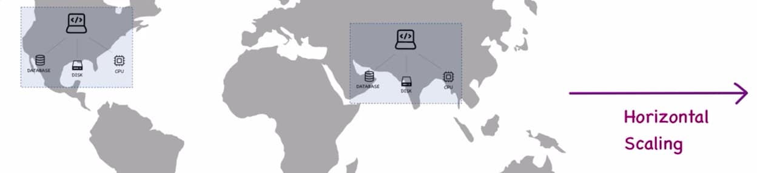

Client-Server Architecture
A client is someone who requests some piece of information and server is something that sits on the other end and gives you that information back.
A Client Server Model
We’ve a bookstore and a person decides to come to our book store, this person is client who is good to our bookstore. Now there should be someone present over there in the bookstore that can answer your queries. They can tell you where the book is located, where can you find it, and how do you pay for it. So, this bookstore will have some kind of cashier/clerk that can help you with all the information. So, we are the client and the cashier is the server, this is how we are making our interactions and that is how we are getting our job done.
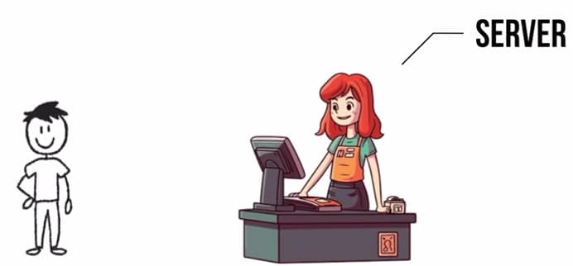
When we talk about computer app, so I have an app running that has a db, some disk and some CPU. And we can assume that it is located somewhere centrally, we are building this app somewhere and wherever we deploy this app, this entire thing is called a server or we can say cloud. So, this app is uploaded somewhere and clients wants to interact with it, now our clients can be anyone we could have a person who is accessing our app from a laptop, or a person who is accessing our app from a mobile phone and similarly we can have all different clients as well. So we are establishing a client server communication
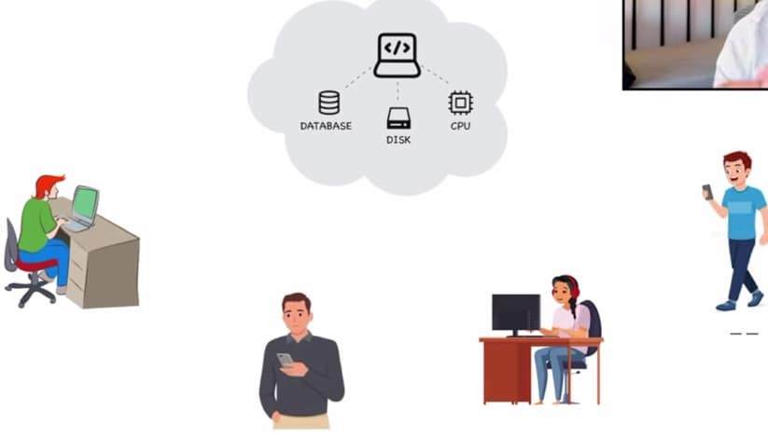
So, either we or our web browser that is the client and this app is being hosted on a server which is giving you back all the responses
Now, this client server architecture can be made in a lot of different ways. It is not just an application, we can also have a gaming server, that is we can have a game that is available on a lot of different platforms, so this game is hosted somewhere on the cloud and then we have different devices that are connecting to the same server for information, so now all of these devices become our client.
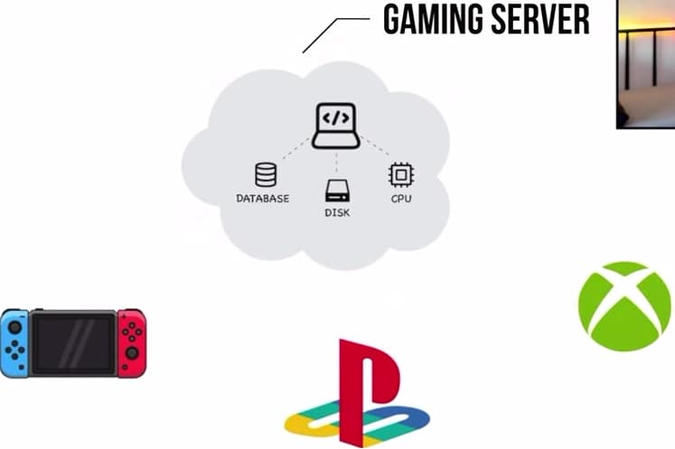
Similarly, there is example of mailbox account as well, if I purchase a mailbox account then we have all these different clients that can access our email, so this is our email server from this email server I have all of these apps that are fetching my information for me.
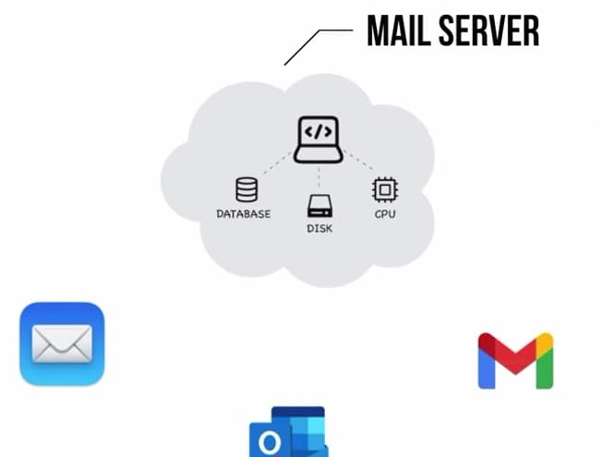
For the gaming server only the gaming clients can connect to it. For an email server, only the email clients can connect to it. But if we have a web browser then all of these different type of devices, they have a web browser too, so they become our client.
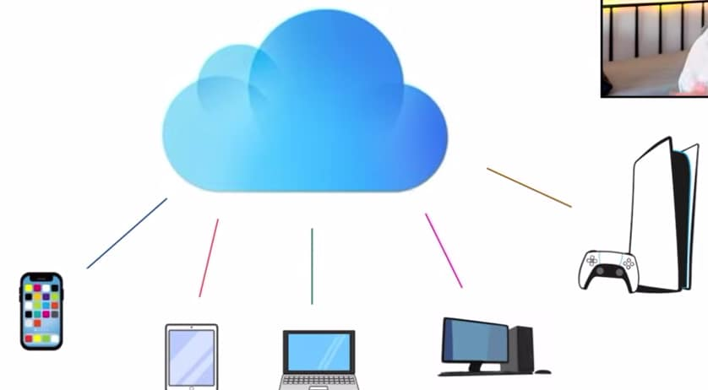
In a bookstore, we can have all different type of customers they are the clients and this store clerk is serving all of them
Client-Server Architecture Advantages:
In the bookstore we hired a clerk/salesperson. This person is a kind of central resource. They have all the information about all the books that are available, all the sales that have been made, how many customers came in, how many bought a book, what are the profits. This person knows everything, so they can tell you everything.
Similarly for computer app, we are having a server where our app is deployed and all the clients are connected. So, this server has all the information. It knows what type of people are coming to our app, from what geographies are people connecting, what is the total hit count, total visitor count, I have all of this information and we can store all of this information in our db.
So, by this client server architecture we’re able to manage everything centrally, if I want to block a user we can do right over here and then that particular user will not be able to access our app
Or we made a small change to our app, it gets reflected to every client that is connected. So it makes managing things very easy.
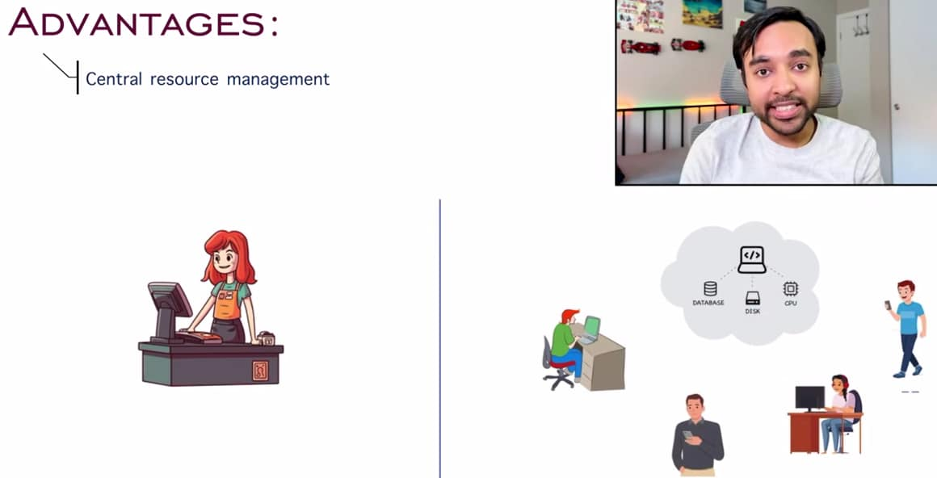
Next advantage is scalability
Let’s say in my bookstore I have clerk and customers which are my clients. Now this salesperson is able to handle all the customers coming in. Suddenly our store gets popular and a lot more customers starts to come in, so it could be possible that this particular salesperson is not able to handle all the traffic that means some of the customers may return and they are not happy. So one option we can have is we can hire a new person who is more qualified, more effective and more efficient, so we just scaled up our app, now this person can handle all the traffic
Similarly, when it comes to computer app and I was only serving a couple of customers. Suddenly our app get popular and we have a whole bunch of new customers coming in. Everyone will try to load up our app and our app will slow down and customers gets unhappy. So we will start scaling up, and we can scale up by increasing CPU, by using more faster disks and we can scale up our db sizes, so we can scale up at a server and handle all the new traffic coming in
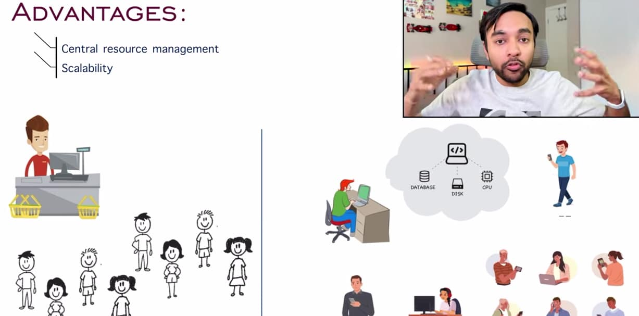

Next advantage is Flexibility of reach
We can just deploy our app at one place in the world and through internet everyone from the world is able to access


Client-Server Architecture Disadvantages:
We have a cashier available at the bookstore and now for some reason this person feels sick and isn’t available to come to job that date, so all of the customers are unhappy b/s the store is closed and there is no one to serve them. So we only had a single point of failure. If this person is not present then there is no one available to serve, so this is one disadvantage.
Equating it to computer app, let’s say our app is running on one server, currently everyone is connected, what if the service goes down what if disk gets corrupted or if we have any bad entries in our db so once again our app will go down and nobody will be able to connect. So once again we have single point of failure
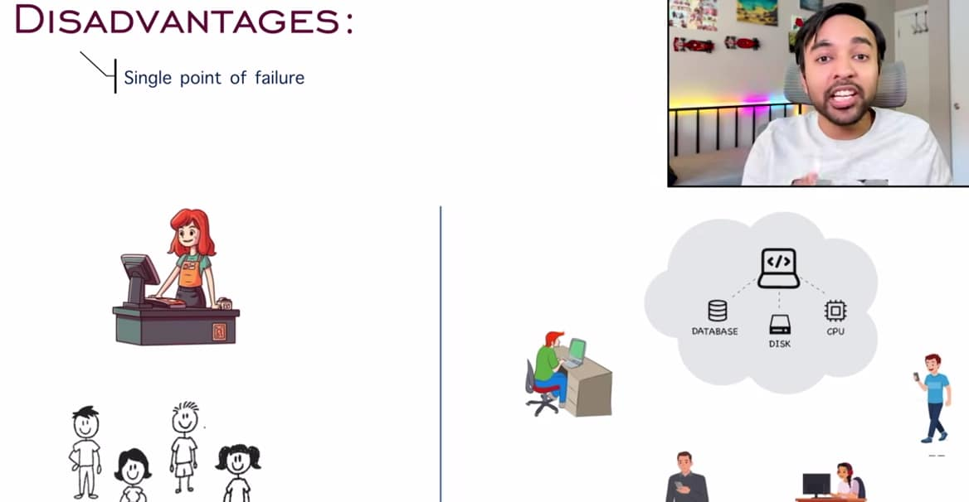
There are ways that you can mitigate it. In a store we can hire an additional part time worker and they can serve you. Similarly in case of app we can have a backup db and a backup disk and then we can restore our app.
Next challenge we can face is network congestion.
In a bookstore we can have only one salesperson and they handling current traffic that we have, suddenly more customers coming in, so every customer, they’ll have to wait a little more to be served, this is what causes slowness in our service.
Similarly in computer app, if there are no users connected or only a handful users are connected, so our service is very fast, but as more and more starts to connect to our app, so our app response time can slow down a lot. We will start to experience some congestion and our speeds will go down.
So, in case of bookstore, I can hire 2 person at the same time and then some of the people will go to the first person and some of the people will go to the second person, that is how these stores are handling the traffic
In case of computer app, instead of deploying app at only one place in the world, we can deploy our computer app 2 places in the world, so some bunch of people will be connected to server1 and the other bunch of people will be connected to server2, and both these servers can be managed by a central db system
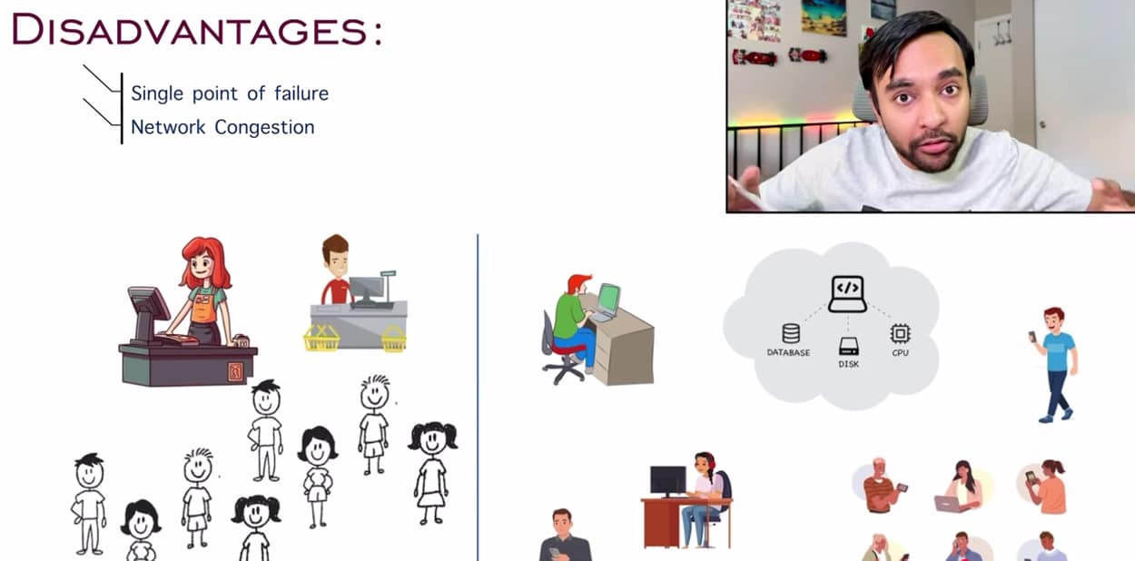

last challenge we can face is security risks.
In a bookstore, if this salesperson gets compromised, it means thief can steal all of the resources this person had, they can access all of the information about the bookstore and all the money.
And for a computer app, our app gets compromised just by hacking the server, so we have a hacker who can directly attack our server, if you do not have security protocols in place and then this hacker can exploit your server
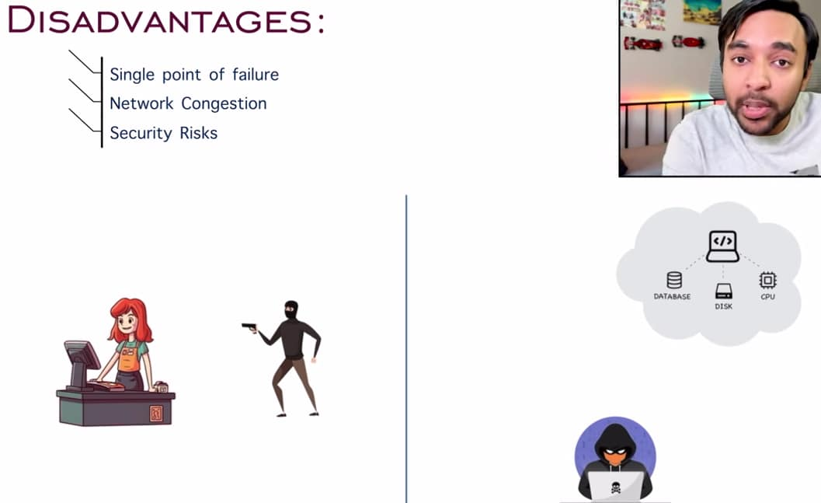
We can mitigate this, in a bookstore we can have security guards outside our bookstore who can take care of particular thief. And when it comes to client server architecture we can have some protocols like we can enable encryption, we can enable two-factor authentication, we can enable passwords, passkeys.

Load Balancing:
We are creating a model where we’ve all of these clients and they are interacting with the servers, now we want all of these clients to be happy only then our app will be successful, so we’ve to make sure that all of these clients are balanced and they get the service that they need.
We have a big bookstore, it has music library, digital books, physical books and it also has a café, so I will be expecting a lot of traffic in there, I had a server available and all of my clients are coming to get them serviced, since my bookstore is big I will have a lot of customers coming in and when I have so many customers a single server gets overwhelmed so it may be possible that this server is unable to process all of these customers in time and eventually some of the customers will be unhappy and they will just leave the store.
So either we can change the server we can have an efficient person who is doing it or instead of having a single lane we can have multiple lanes as well, like in a supermarket we will have multiple counters, in such a case some of the customers will go to a separate lane and some of the people will go to a separate lane this way we’re able to reduce the stress of each of the server and all of the clients are happy and store is successful again.
Now, when a new customer comes in, so that customer goes to the shortest line. It is very unlikely that the customer goes to the huge line this usually does not happen
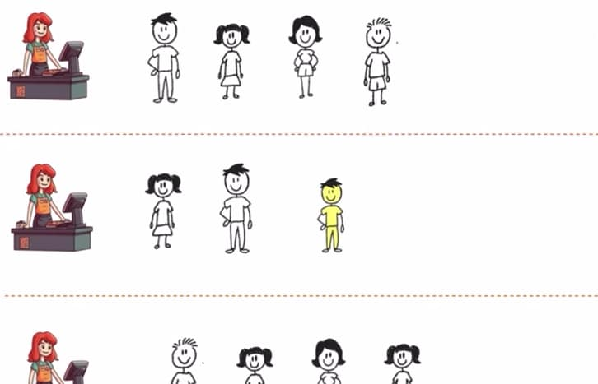
So, we are trying to balance the load at each of the server, this is called load balancing
In a computer app, it has its own db, disk and cpu.
I have my server and it is serving all the clients, suppose there is a sale going on then suddenly we will have a lot more clients who wants to connect to the same server, this server now get overwhelmed and the response time will slow down, so some of the customers might get unhappy and they can just leave the website
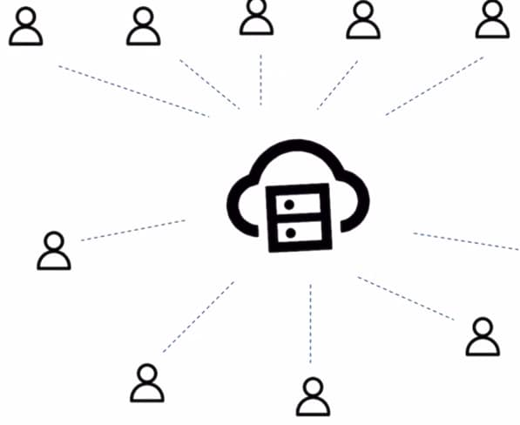
So, instead of having our app deployed only on one server, we can deploy our app on multiple servers, now these multiple servers are like multiple lanes and our clients could just connect to any of them, this way we are able to reduce the load on each of the server and all of our clients are happy.
Now, when a new client comes in, in case of supermarket we’re able to see the shortest line and we could just join the line, but when we are on internet we cannot see the servers and clients also we don’t even know how many servers are available, so how do we decide which server to connect to?
This is where load balancer comes in, this load balancer could be a hardware/software or it could simply be a piece of code that decides that if a client comes where should they go, so they go to the first/ second/ third server and there are multiple ways by which we can allot the client to any of these server
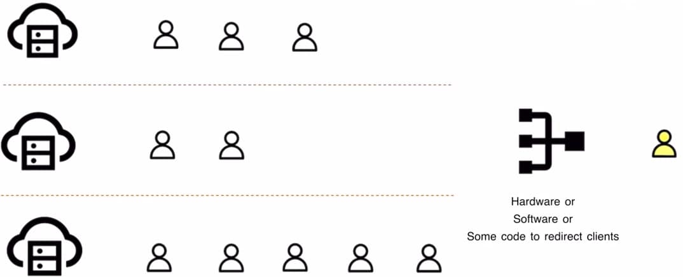
Our end goal is that each of these servers should be balanced, so when new client comes in so we start of with the server that has the least no. of requests, so load balancer knows all of the information about each of the server and how many clients are connected, so when I have a client connected, this load balancer will take it and allot it to the server that had the least no. of requests, and when another client comes in, then this client can go to any of the server which has the least no. of requests, so randomly it is possible that this client went to the first server
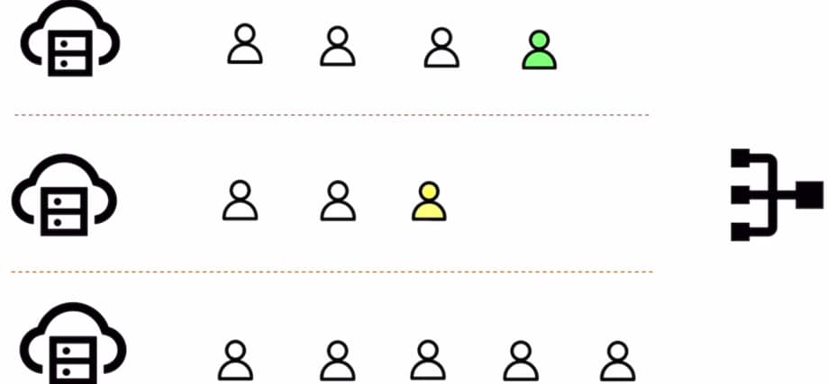
Now it could be possible that server 3 was able to finish all three clients
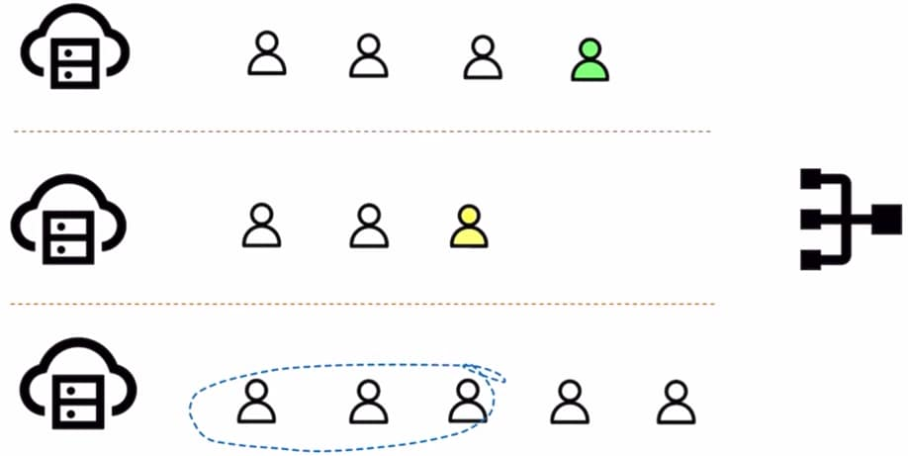
Now these clients have been served, and since new clients coming in so load balancer will check that I have a new server where I can allot the load and these new clients will get to server3, similarly this process will go on and we could keep on allotting clients, so load balancer is making sure that all of the servers have balanced loads and this kind of scenario is usually efficient when each of the server is configured in the exact same way
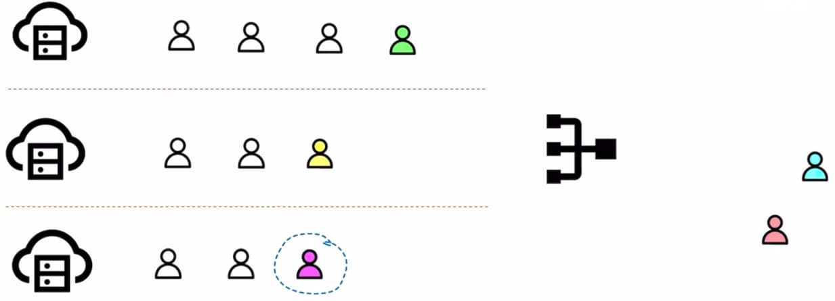
The other way we can do load balancing is round robin scheduling, let’s say we have lot of candies available and we want to distribute it to lot of kids so we keep giving one candy to each student at a time we will keep on repeating this process until we’re out of candies, this ensures that all of the kids have equal no of candies, so now we have all of these servers and clients, so by round robin scheduling we can keep on allotting all of these clients one by one, so in this way we are trying to keep the load balanced b/w each of the server
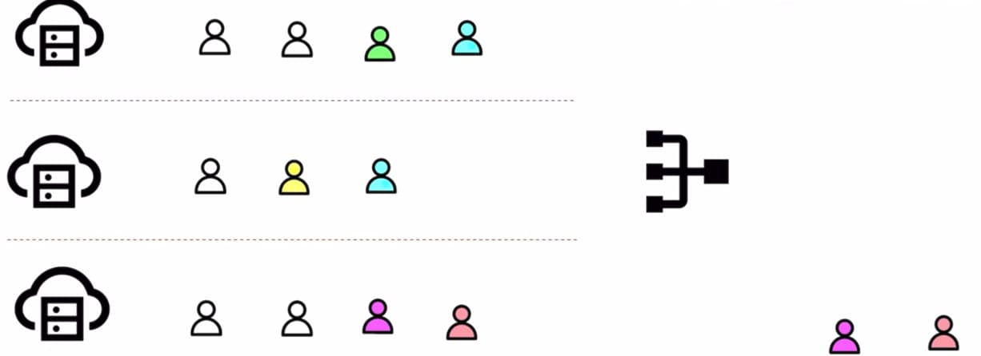

There can be only small problem with this approach, these 2 users they had very tiny requests they wanted to download an image they did it and they’re done
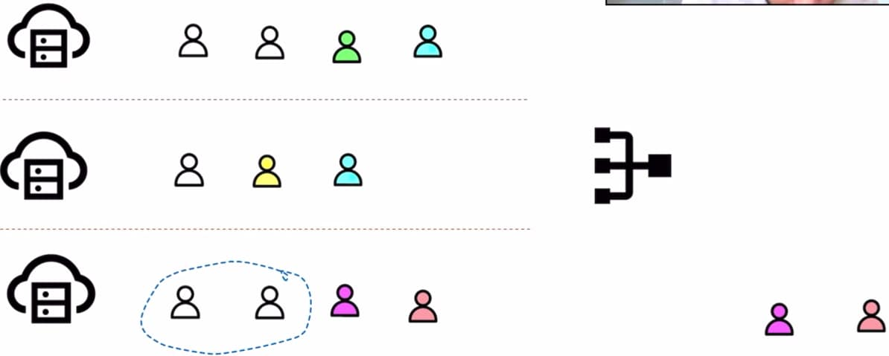
Now according to round robin scheduling method next client goes to server1 and next client goes to server2 and it is possible that this particular user is blocking the server b/s he is downloading a huge movie and all of the other clients of server1 are waiting
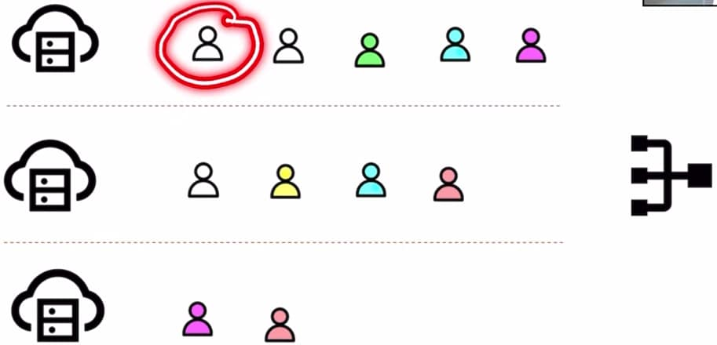
So sometimes to round robin scheduling method is not desirable and to address this issue we can also do weighted round robin scheduling in which we allot all of the clients based upon the servers capacity, let’s say in this scenario server3 is more efficient than rest of the servers
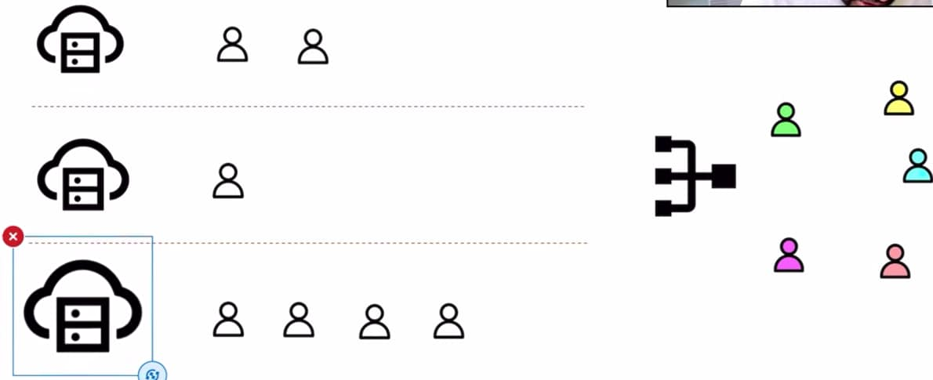
This server is huge and process more requests, so instead of allotting all of the clients one by one, when it comes to efficient server we can allot them 2 clients and all of the other servers one client at a time
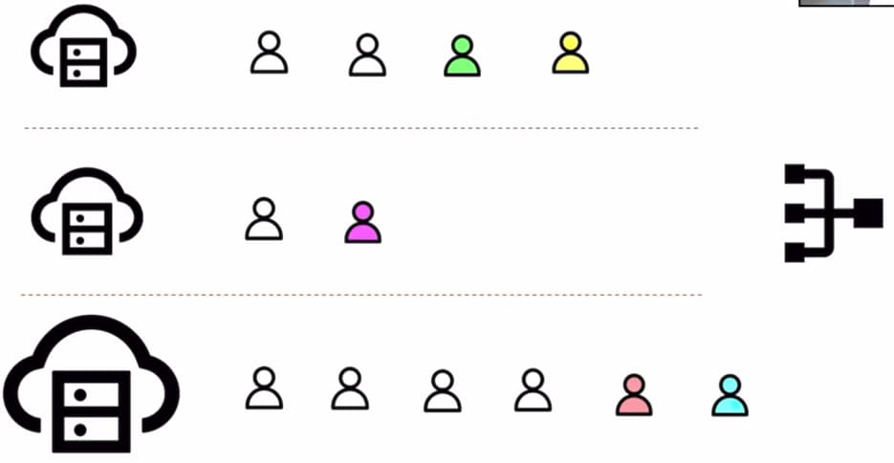
So we are relying on the server’s capacity and based upon that we are doing all of our load balancing b/s it is possible that server3 is able to serve all the customers quickly, we are doing weighted scheduling to maintain balance b/w all of these servers
One more method is IP Hashing, it means that there could be some particular clients that are always connected to only one particular server, let’s say we’ve a server in North America and then all of the users in yellow they’re in North America region so they’ll get the best service when they are connected to the server in North America, so when we’re scheduling all clients, so we will schedule one client to server1 other client to server3 and whenever we see yellow client we will allot them to server2, so this way again we’re making sure that all of our load is balanced

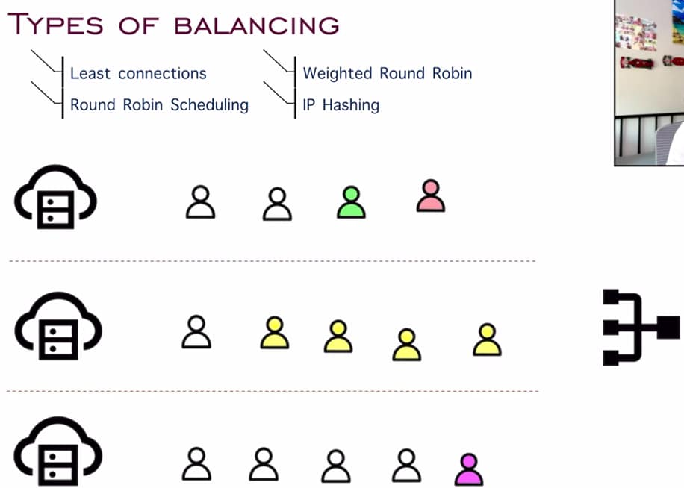
If we go to supermarket where it says 10 items or less, so we are fixing certain type of clients to certain type of servers, so only clients with 10 items or less can go to this particular counter, this is exactly how IP hashing works
We have also seen concept of free and premium version, and if we have taken a premium version then we will be served faster, so they apply the concept of load balancing, so premium users in yellow they have a dedicated server, so if we’ve any other user so they will get randomly assigned to any the other servers that are available but for premium users they’ll have a dedicated line and they will only allot them to that premium server
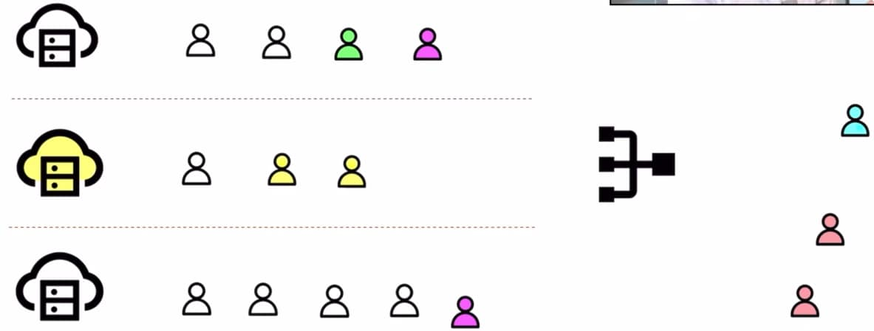
Advantages of Load balancing
We had a system where everyone is connecting to the same server to a system where we’ve multiple servers and all of our traffic is distributed, the advantage is that all of our traffic is now working in parallel and our load got distributed
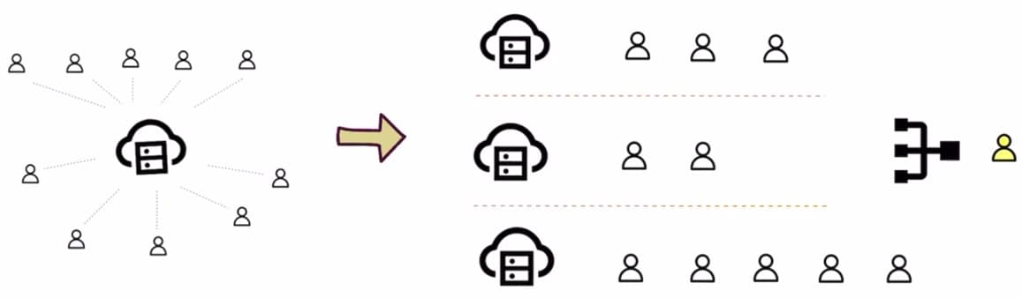
Let’s say we’ve a system set up like this, now suddenly a lot more customers start to come in, so this particular model allows us to scale up system as well, if many users coming in so we can deploy our app to one more server as well and now we can start allotting all of my users to balance my load effectively
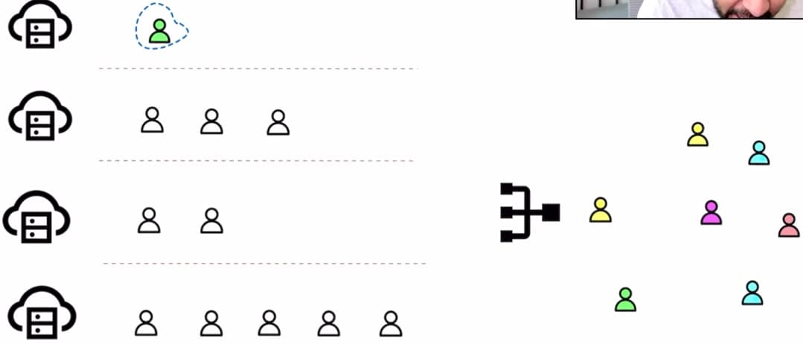
Load balancer allows high availability as well, lets say one of our server goes down but we still wants the service to be accessible, so the load balancer takes all the clients that were connected to this faulty server and it will allot them to these different servers, so our service time might go down but our service did not end and our clients can still connect and they will get served
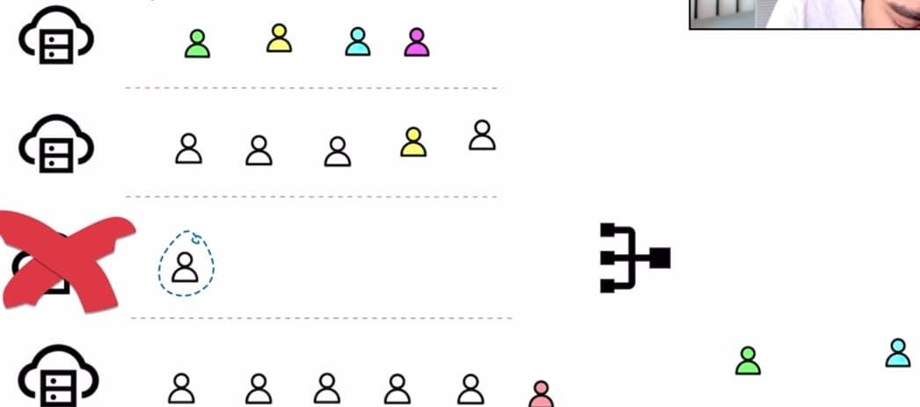

Disadvantages of Load balancing
Entire system of load balancing is not easy to design, it becomes very complex and we have to handle all of these scenarios as well, what if server goes down, what if there is a lot of traffic what if client is taking so much time and what if client is unresponsive, so this load balancer has to manage all of it, so writing a code and managing all of these servers in parallel is not easy
Another disadvantage is load balancer itself become a single point of failure , b/s if load balancer goes down then these clients cannot even connect to the servers, let alone having a distributed system, so load balancer becomes single bottleneck and our entire system could crash
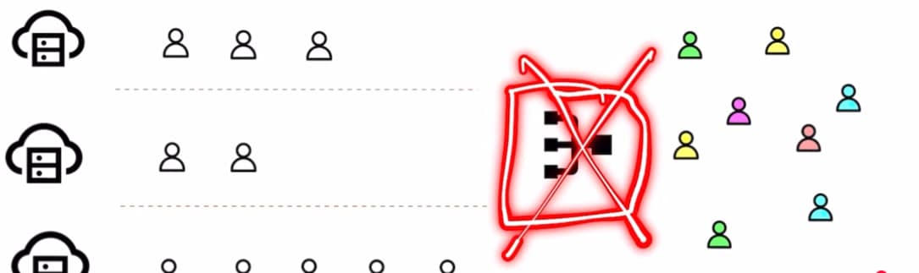
Another disadvantage is security, we want to make sure that we have all security protocols in place when we’re implementing a load balancer b/s if this load balancer gets compromised then we can divert all of our traffic to just one server and then that server gets overwhelmed and it can go down, so naturally all of our server goes down so our entire system once again crashed
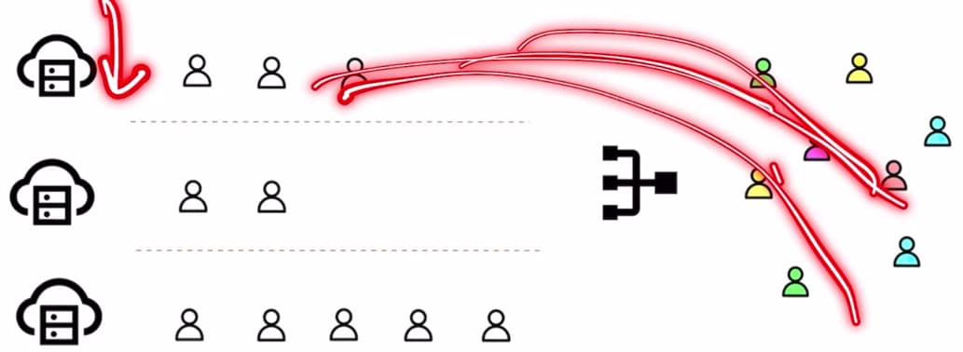

Caching:
Our end goal is to serve a lot of customers and we have to do it in fastest possible way, we can increase the speed of serving those customers if we somehow already know what the customer is coming in for.
Eg We have a bookstore and even before the customer walks in we already know that this customer wants this item, this way the customer will be very happy.
I have a large bookstore and some customers coming in, suppose there are 4 bookstores, in all of these 4 bookstores one thing is common there is a huge collection of books but in front of all of these bookstores there is a counter/shelf where some of the popular books are already available

So when a customer walks in and because these books are popular there is a very high chance that the customer came in looking for these books and this speeds up the process so much b/s if the shelf wouldn’t have been there then our customer will have to look at all the other books and it could be a chance that the customer becomes unhappy and they just leave or they don’t even find the book just b/s of shortage of time or our book storage is so huge, so we keep one section of the book store as best sellers and this best sellers is caching which pre determines that the customer can come in and wanted. It saves our time, customers time and it increases speed of transaction as well

When it comes to computer app, we used caching everywhere, for system design we represent caching as:

It is a kind of memory or small database which has a very high speed, suppose we have our hard drive and we also have RAM, RAM is a kind of cache memory that’s why we say if we increase RAM then the speed will go up b/s we are loading all of our content that we need frequently and if our RAM size is huge then we’re able to load a lot of content so that we can process the items quickly
But RAM is expensive than the main memory that’s why we can’t replace hard disk with RAM, and RAM cannot also be so huge that we are dumping all of the data on it, so if we increase RAM then performance will improve up to a certain limit but we cannot say that if we install 4 Tb of RAM and then my computer will be very fast like in a bookstore if we increase the size of best sellers and let’s say that rack is very huge then it defeats the entire purpose, so cache is usually small in capacity
Cache memory is relatively very less compared to main memory and it has to be fast
We have a server and when users query data so we went to our database and then db returns some info and then give it back to the clients Eg Server is a news website and then all of the clients are requesting for specific articles, let’s say there is some breaking news so client1 is asking article1 client2 is asking article2 and all the other clients they are asking for article1, for each of the request, this server is going to make 5 requests to the db and then get all the articles again and again.
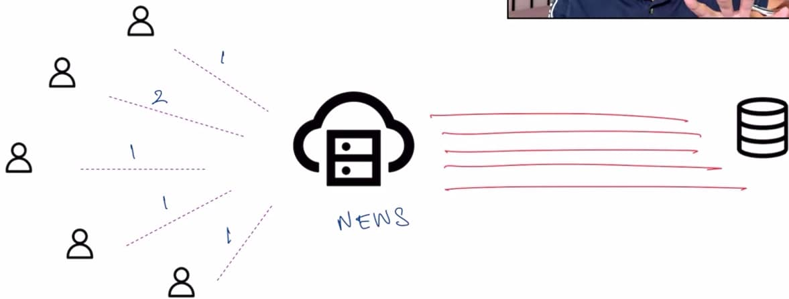
This is where we introduce caching and now this server will try to first look into the cache, in the cache if it finds article1 then it doesn’t need to go and look into our db and it simply returns article1 from the cache and client1 will be very happy, then user2 is requesting for article2, the server will again look into the cache it cannot find the article there so now it will go into the db and then get the result and go on to the client2, and for other clients they are looking for article1 so server1 will just query the cache and it can serve all these 3 clients very fast.
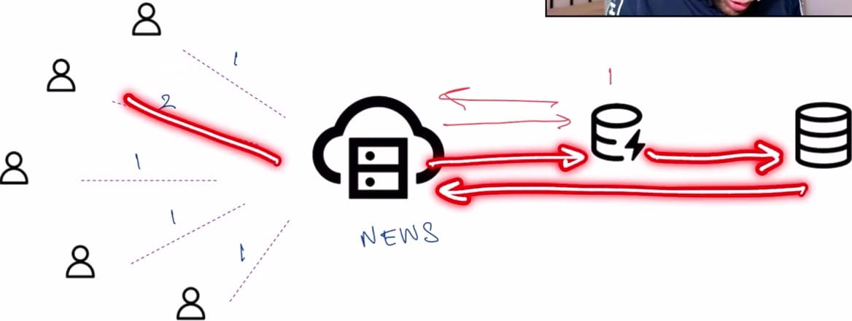
We are reducing how many times we have to look up in the main memory and this is saving a lot of time.
Let’s say our system has a server available and in my cache all of these articles are available and then my main db that has all the articles and there are bunch of users that are requesting some of the articles so user1 is asking for article1, and we will look into the cache and we found it and we will simply return it, if we are able to find anything in our cache this is called as cache hit, similarly user2 is asking for article9 we are able to find it in our cache and we simply return it (cache hit), user3 is asking for article1 so once again it is cache hit, user4 is looking for article10 we look it into our cache we cannot find it and now we will try to look it into our main memory this concept is known as cache miss, user5 is looking for article5 (cache hit) , user6 is looking for article12 (cache miss) , user7 is looking for article7 (cache hit)
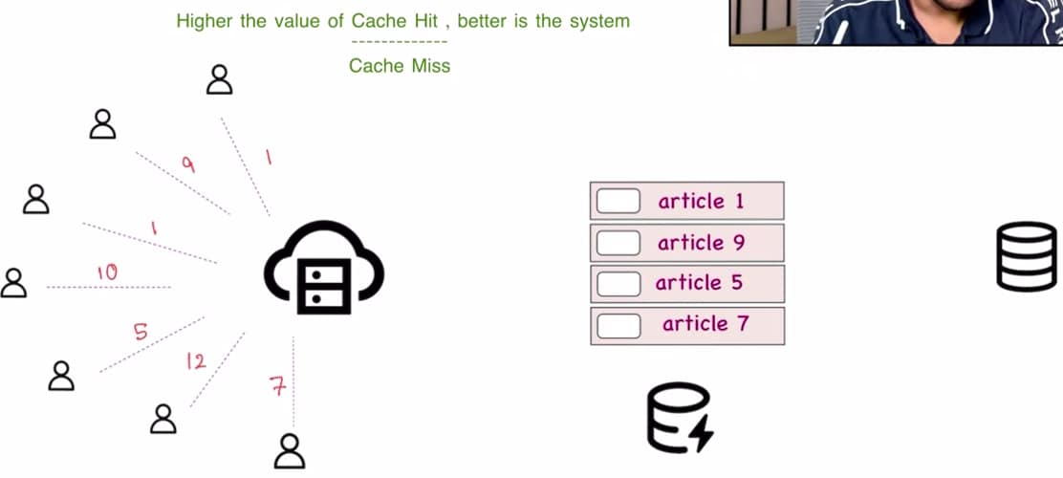
A system is supposed to be good if it has a good cache hit to cache miss ratio that means we’re able to look up a lot of our requests in the cache.
How we are determining what articles do we want to keep in the cache?
It could be possible that we have to change the cache.
If suddenly there is some breaking news and then all of the users they want to know about the breaking news so all of them they try to look into the cache they won’t find it and they try to look into the db, so cache miss count is increasing so our ratio is decreasing
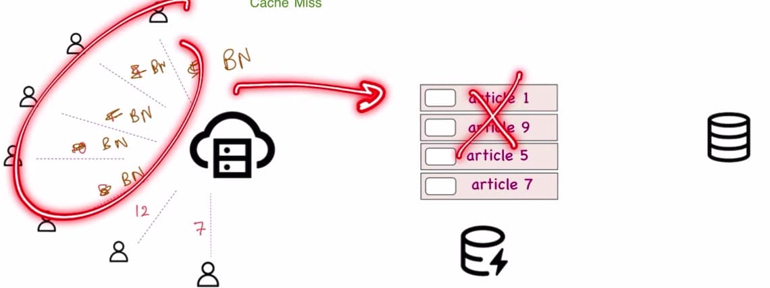
We will now have to add a new element to our cache, but our cache has a very small memory and it is limited that means we will have to remove any one element from this cache it could be any element so let’s say we remove article5 so this will be gone and new element will be inserted in cache
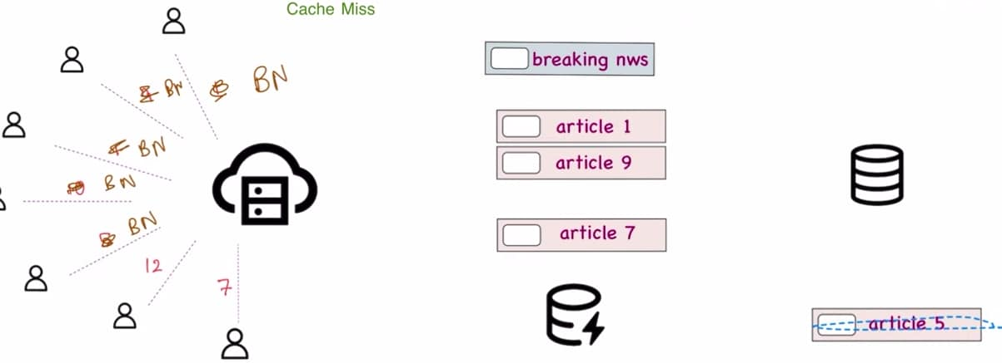
But how do we decide which article do we have to remove, we have to remove this article in such a way that out cache hit: cache miss ratio this remains good only then our system will be fast, so there are multiple strategies by which we can determine which element do we have to evict from our cache
Let’s say I have these articles in my cache and there is new article coming up.
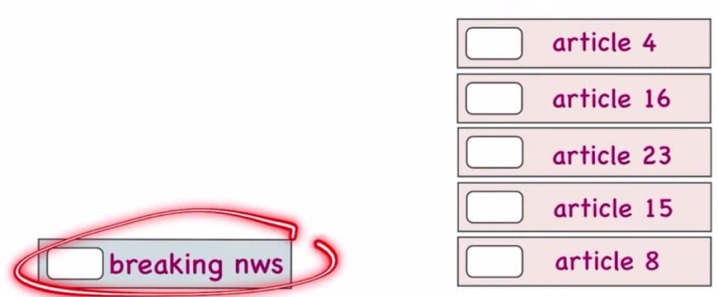
So, we have to get rid of any one of these articles, so first strategy is: random eviction, so we can randomly remove any of the article like article16 and then we will put new element in cache, sometimes it could just work b/s it could have a website which has a lot of random articles and it is not necessary that one of the article (like article16) has a very high viewership, in that scenario random eviction is very helpful
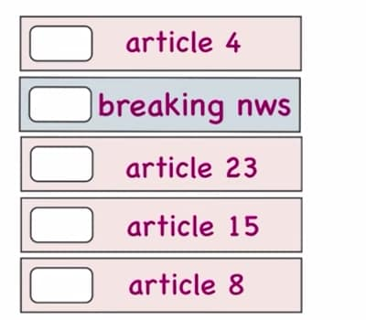
Next technique is First in First Out, let’s say this is our initial cache, someone opened article 4 then 16 then 23 then 15 then 8 so these got added in my cache one after the other
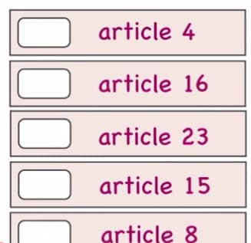
Now when next member comes in, we remove the element that was added in the 1st place that is article4 replace it with breaking #1, now if we have to add another member to our cache so article16 go away and breaking #2 gets added to our cache
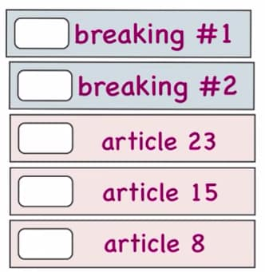
This is just a queue and we’ll keep on adding elements to our cache one by one and keep on removing the old ones, so the elements that got added to our cache previously they are now old and we want space for new articles, but it could be possible that the article is old but it is still very popular, in that scenario we use Least Frequently Used (LFU) technique, in this we will try to evict the element from the cache that has the least hit count, so let’s say we’ve all of these elements in our cache and we’re also storing how many times we’ve actually done cache hit on these elements
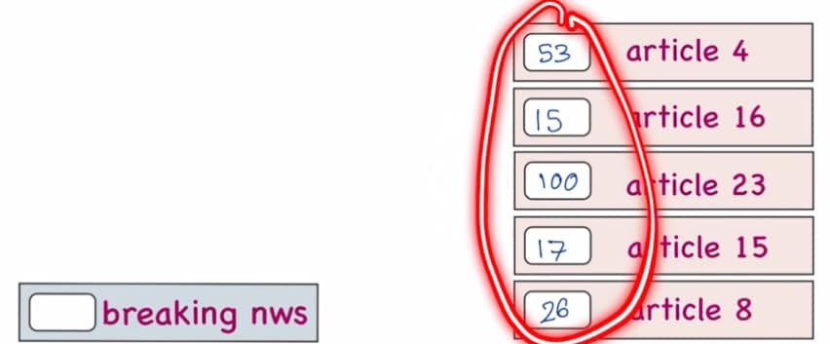

If it was a FIFO method, so article4 would have gone away but article4 has 53 hit counts, but article16 was only accessed 16 times, so if we had to remove an element from our cache, we will get rid of article16 and we’ll take new element which gets added to our cache
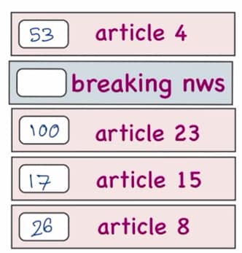
Another method is Least Recently Used (LRU) which keeps a track of least recently used so this is keeping a track of when was the cache item accessed for the last time, we’ve all of these elements to our cache, along with these elements we are also storing when there was cache hit on these elements
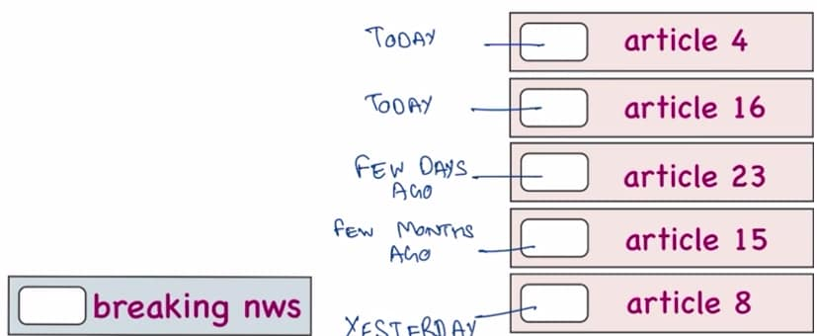
When new article comes in we have to evict one element, so article15 is least recently used other than this all of the other elements are recent, so according to this LRU algorithm article15 will go away, article15 was really popular some days ago and now the trend just went away and now some new viral trends coming up like Instagram, we want to see only the latest trends, so we get rid of the trend that was in the past
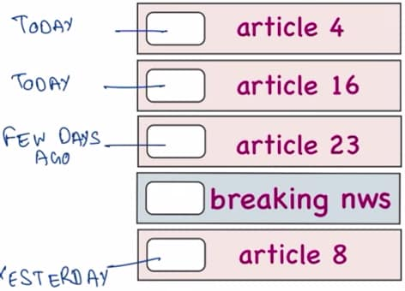
Eviction technique is based on something which we’re implementing according to our use case, and there is no best method
For a book store, which book do we remove from the shelf , do we remove the book that is from the past, do we just remove the book randomly, do we remove the book that we placed first or do we remove the book based upon frequency of people buying it, so it depends.
Things to be careful about:
Let’s say these are the users and my cache has some articles, lets say both of these users want article16, so cache returned the article16 to these users
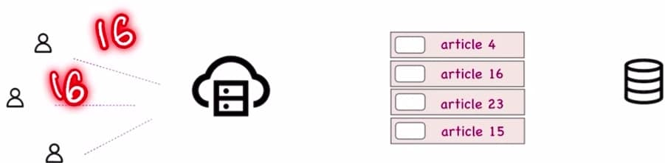
But what if someone updates article16 on our db, then this article is no longer consistent with the cache, it could be possible that article16 of cache is an older version and on the db we might have newer version, in the web pages as well until and unless we keep on refreshing every time we won’t get any new content loaded, so we have to keep a track that if an article gets updated on our db then we have to update our cache as well, so we have to keep cache updated all the time.
Other issue is coherence that means our server is deployed at multiple places in the world then each of the servers will have a different cache, so we have to decide should all of our cache be exactly the same or should all of our caches be according to the users who are accessing them
And last is Security, just like all of these articles sometimes we might have to cache login credentials also, we check on stay signed in and then whenever we open our account it just opens without asking for a login that is b/s caching is involved in it, so we always have to be mindful how much time we’ve to keep these login creds in our cache we cannot have them permanently b/s there can be some malicious activity on our account, we’ve to remove these creds as determined by our policy
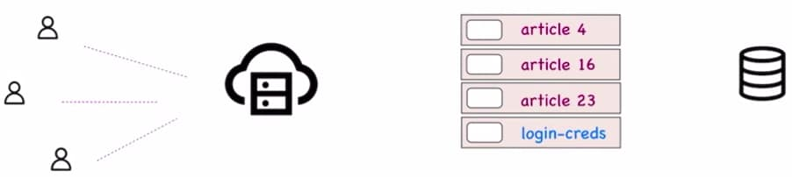
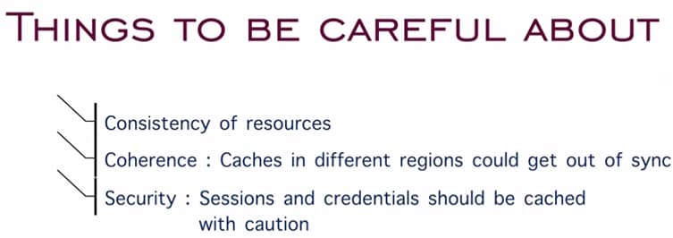
Databases
When we enter in a bookstore, there are so many operations going on, we have people buying books, people returning books, customers having previous issues and we could also have new inventory coming in.
Suppose I am a store manager and I’ve to take care of all of these operations and we cannot just take a piece of paper for this and at the end of the day I want to find out how much sale did I make, what is my operating profit, what is monthly revenue, it is simply not possible to find if we’re not organizing all of our data, for that we can use a ledger to maintain some kind of data and where I write down all of the transaction that take place during the day (we will write down date then transaction then sale), we would keep on filling this ledger throughout our entire day, and then at the end of the day we can use these column to find out my sale and item that was returned and we can also use ledger to maintain inventory, we can maintain a list of books that I have and list of books that are out of stock (this was the time when there was no computer), this ledger is maintaining all of the records which makes things simpler.


In computer app we use a db, and in system design we represent db using this symbol:

Db creates a layer on top of all the storage data that we’ve, if I want to ask on this particular day what was my profit then we can ask this db and it will return the result to us and that is managed by all of the tables and all of the rows and columns that are created in it.
Advantages of databases
Efficient data retrieval: If we’re maintaining a ledger then it is so easy to find out like in the month of April this happened, in the month of June this happened similarly in db we’ll maintain tables for each of the month or we could have rows for each of the month and then we can quickly look up all of the data, like we’ve sql queries like select * from table where month is June, so that makes data retrieval superfast.
Data Integrity and Consistency: when we’ve ledger so this is my source of truth and adding up all of the values will help us to audit that everything is going right, let’s say I put x amount of money in my bookstore, now ledger keeps track of all of the expenses so we can make sure about all of the money that was spent similarly in a db we keep a track of all of the entries that we’ve added like there are users who are signing up on our platform, this db keep a list of all of those users, so we know all info about active users, logged out users, and users which are currently doing something.
Handle complex queries: In a bookstore when we’ve ledger so I can ask questions like what was my profit for the month of April, what was my profit for the month of June, how is the profit trending if it increasing/decreasing, what was the profit compared to ledger.
Similarly, with a db we are doing all of it in computer programs and then we can answers so many questions very quickly like how is app performing, how are users feeling are they happy, what are all the comments, what is the sentiment etc so these are some complex queries & db’s make them possible.
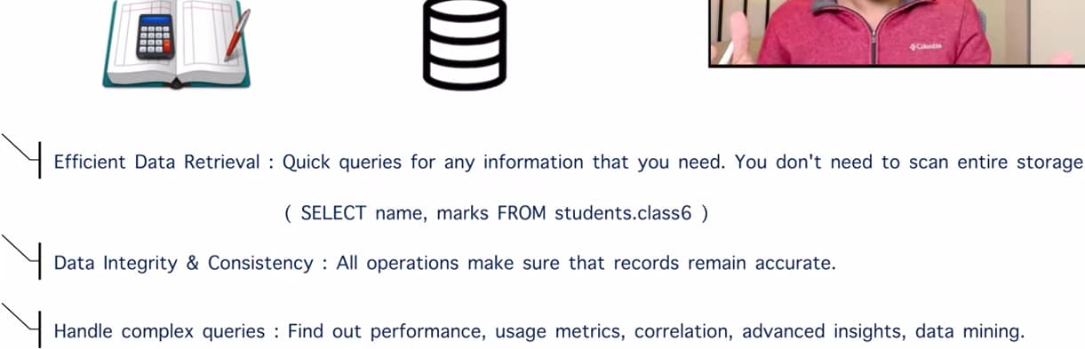
Challenges of database:
Scalability: I have a ledger & let’s say there is some sale coming in and we would see that there are a lot of customers coming and at that moment we are maintaining all these entries in a single ledger can get difficult, so in that case we can split up our ledger in 2 different books, in one book we can maintain all the sales and in the other book we can maintain all of our inventory, so this way 2 separate people can work upon it and we are maintaining all of our info
For computer app, let’s say we’ve a db and we’re developing a ride sharing app like uber and when there is a lot of traffic and a lot of customers are trying to access the app, some people are trying to make payments and some people are trying to sign up, all of that can happen at once, and at that moment using a single db it can become slow, our service will go down and customers are unhappy
In that case instead of maintaining a single db we can split up our db’s into 3 parts, new rides, ongoing rides and then payments, we scale up our db and we’re maintaining all of these 3 modules in 3 different db’s
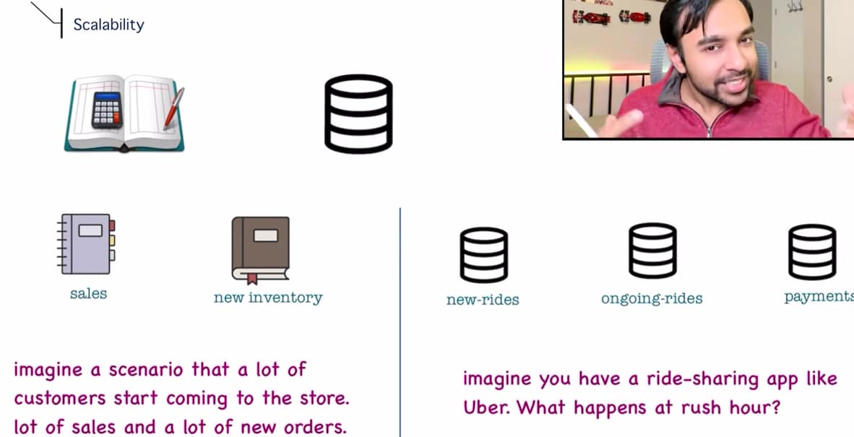
Consistency: In a distributed system where our app is deployed all over the world, Eg A bookstore that is available only in 1 region right now and then we’re opening another location, so for 2 diff locations we’ll have 2 diff ledgers, so we gave 1 ledger to one person and 2nd ledger to another person in another city, so the challenge is that we’ve to maintain that both of these ledgers they are in same format, both should not be in other formats b/s if that happens then this person has to do diff calculations and another person has to do diff calculations, so this is a challenge, we have to make sure that our ledgers are consistent
In computer app, if we’re deploying our app in 3 diff regions, we could have db’s in 3 diff regions as well and it is our responsibility that all of these 3 db’s they are consistent so that whenever we’re doing queries, if we’re able to do query on one of the db, the same query should work on all of the 3 diff regions only then our system is efficient, we cannot expect to write a query that works on region1 and fails on region2.
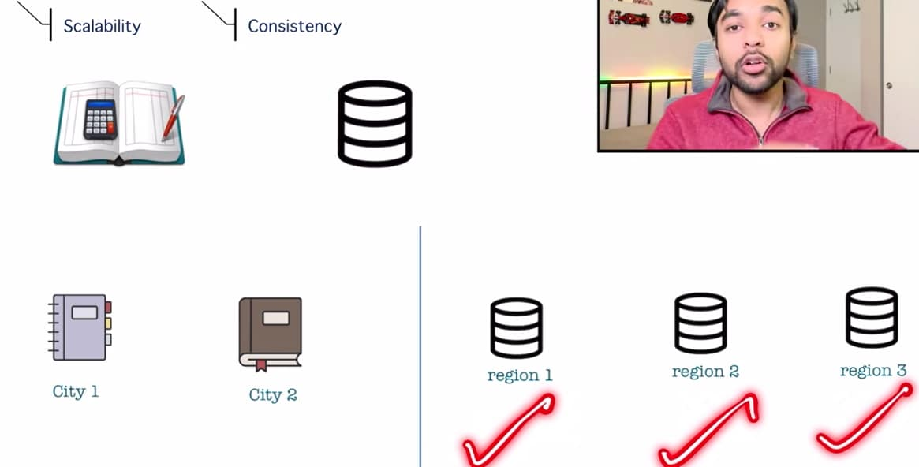
Availability: what happens in case of failure?
Lets say my bookstore has a particular ledger and what if this ledger suddenly gets lost, so all of our data and work is simply gone, so in that case we maintain a duplicate copy and we maintain all of our records in the first ledger during day time and when I came back home I simply copy all of our records in duplicate copy, next day also we do the same process, so even if first ledger gets lost we have a duplicate copy available and it may be possible that some work is lost but a major chunk of copy is available, so our business is not impacted.
In a computer app, if we just have one db and it gets corrupted/compromised, then all our work is lost, so we can make several copies of our db and periodically on a cron schedule we can just copy all of our transactions to both of the db’s, so if our main db gets out of service then our 1st backup can take up the place of the primary db and meanwhile we can start to restore this faulty db and while restoring we can use backup2 to copy all of our data again, so our performance is not degraded, b/s service is available most of the time so that the customers can access it. There can be still the times where we need to have a downtime to upgrade versions of our db’s .
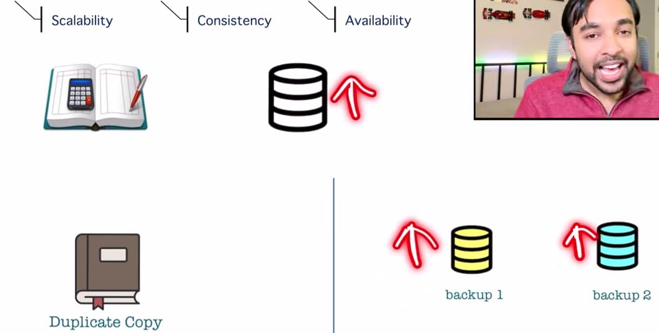
SQL v/s NoSQL
Some db’s follows SQL terminology and some are based upon NoSQL concept, if our data is very defined Eg A bank statement no matter which bank we’re using our statement looks like this:
We would have date, transaction, credit, debit and balance so this schema is common and this structure will help us throughout all of our customers and this is very much defined.
If there is social networking websites like IG comment section, so they are evolved over time, earlier we could just comment but now we can like and reply to a comment and we can also add images to a comment, so this comment is evolving.
Whenever we have a structure that is not following a certain schema and that can be expanded, in that scenarios we would want to use NoSQL db b/s it works on documents rather than individual rows as compared to SQL format.
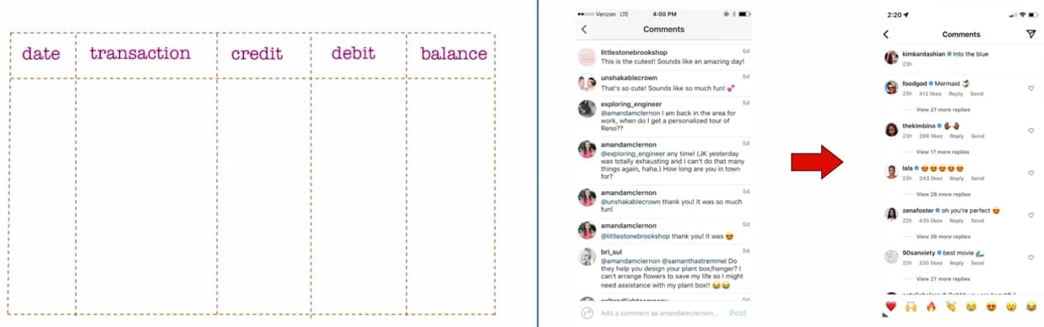
Examples of db’s that uses SQL format and NoSQL format
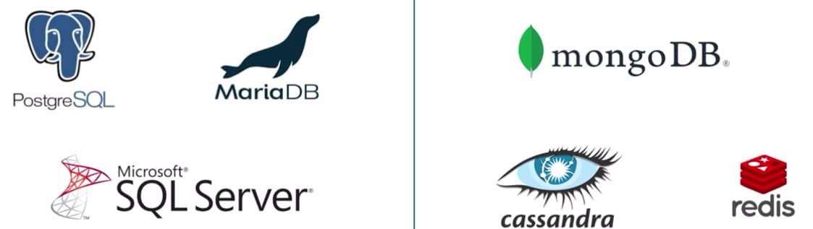

Creating Diagrams
Let’s say we write a computer app on laptop, but I want this app should be accessible to a lot of users, so we cannot go to every laptop and install our app.

So, we implemented client server model, where we upload our computer app to some server and then all of our diff clients they’ll be connecting to server and all of the clients can access app.
So it could be possible that one of our client is asking to open a site and another client is making certain api call that is how we make requests in a client server model
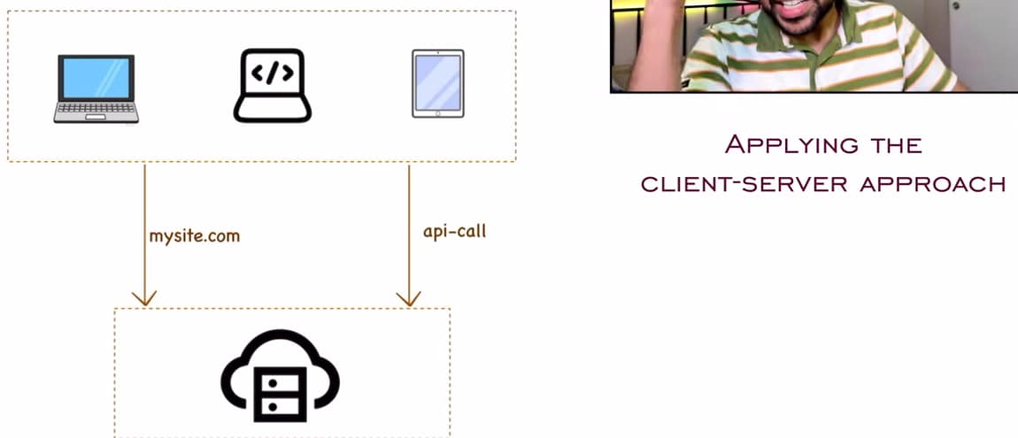
Now, we want to store all of our info, we have a lot of clients and they might come back to use our app, so in that case we need some kind of storage, so that we can serve the users whenever they come. So, we introduce a db and in this db our server can connect, and it can write data and read the data whenever required. So, we added db to our diagram and we’re writing data to our db and we’re reading data from our db.
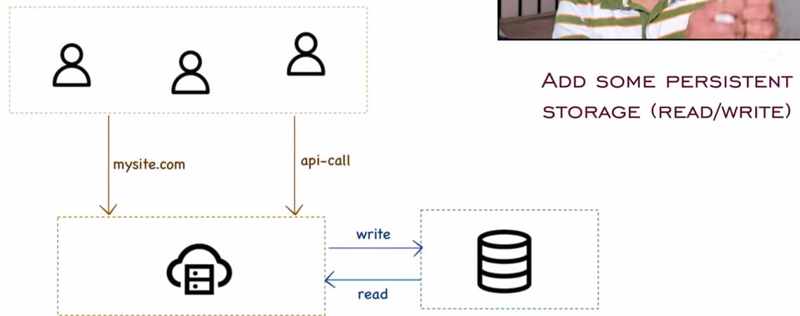
Now, I want to scale up my app I want a lot of users should be able to access it and these users can be from any part of the world, so we can increase the no. of servers, b/s more the no. of servers more the availability to serve all of our clients, so we took a server and then we added it to our server list, so now we’ve multiple servers who are serving my clients.
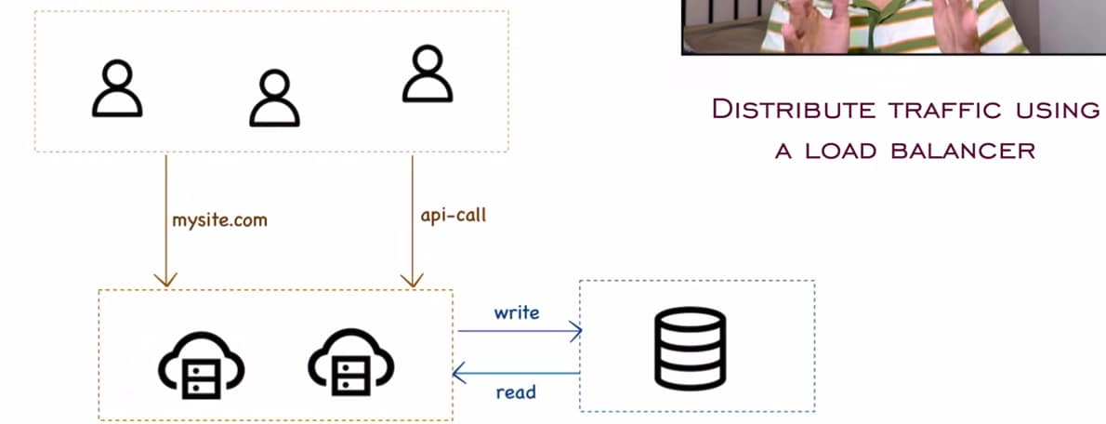
But by introducing multiple servers a new problem starts to come up, how do we manage that both of these servers are equally used, I do not want that one of the server is being hit constantly with requests, while the other server is sitting ideally to make sure that it does not happen, so we introduce a load balancer in between, so now any of these requests that come to they get distributed to my servers that are available.
First, we had a single client and now we have multiple clients to handle, first we had a single server and now we have multiple servers, so we’re addressing this issue with a load balancer, but I only have a single db and this become a single point of failure
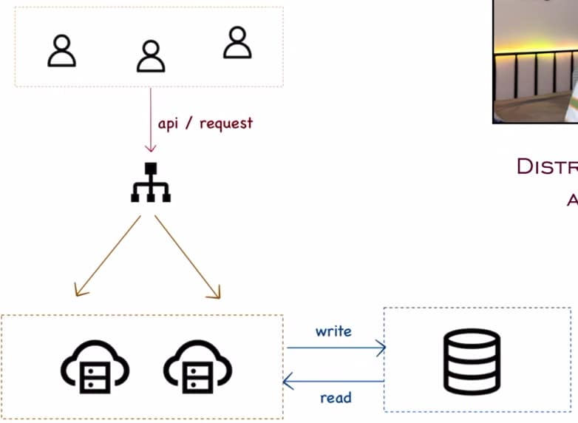
Whenever we create diagrams in system design we need to address these problems.
Currently we only have a single db and we’re writing to it and we’re also reading from it, if this db goes down then our entire service goes down b/s we cannot write and read data, so we can make this db as master db and along with that we can also have slave db, slave db is acting as a backup for primary db
With a periodic schedule we can replicate all of our data from the primary db to slave/secondary db, it could be hourly job or minute job or daily job, so I was always sure that whatever data I have in master db I have backup of all of this data in my secondary db as well, and we can have multiple slave db’s as well and when we add backup db’s we get other advantages as well, right now all read and write operations were on only a single db so this can get slow and there can be performance issues as well, so whenever our app is writing we can write all of our data to master db and whenever we are just reading data we can make use of slave db, so we still have all of our data available and load is splitted b/w both the db’s so this will give us performance improvement.
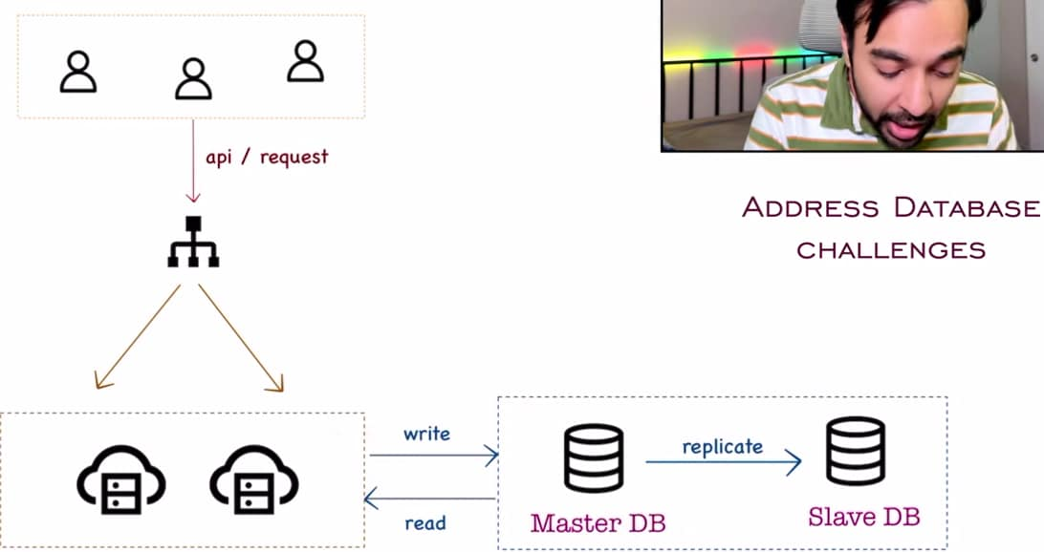
For all the write operations I can put them onto master db and for all the read operations I can read from slave db, and even if slave db goes down then we can keep on reading from master db and our service does not go down.
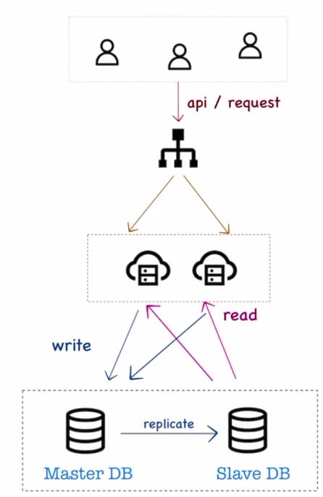
We can introduce caching as well, so whenever our servers are looking for information, so instead of directly going to the db, we can first querying the cache, if the data is available in cache then return it quickly and that speeds up our process, if we do not find in the cache we always have an option to look into our db, so we’ve also added cache layer to our design, and based upon cache hit : cache miss ratio we can also update our cache, this will get updated periodically.
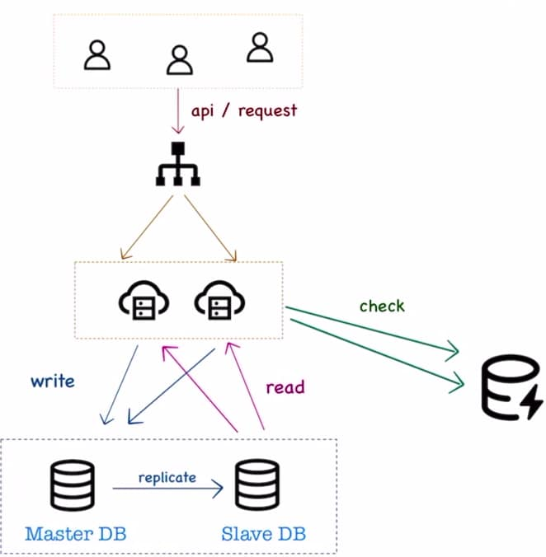
Right now we have a persistent storage I know all of the data that I want to store with me and we can also have some sharable data as well Eg I log in to my account and I want session to be saved, now this session info is not persistent and we do not want to save it in our db that is where NoSQL db come in.
In my design, along with all of my persistent data storage I can store some of the info in my shared storage as well
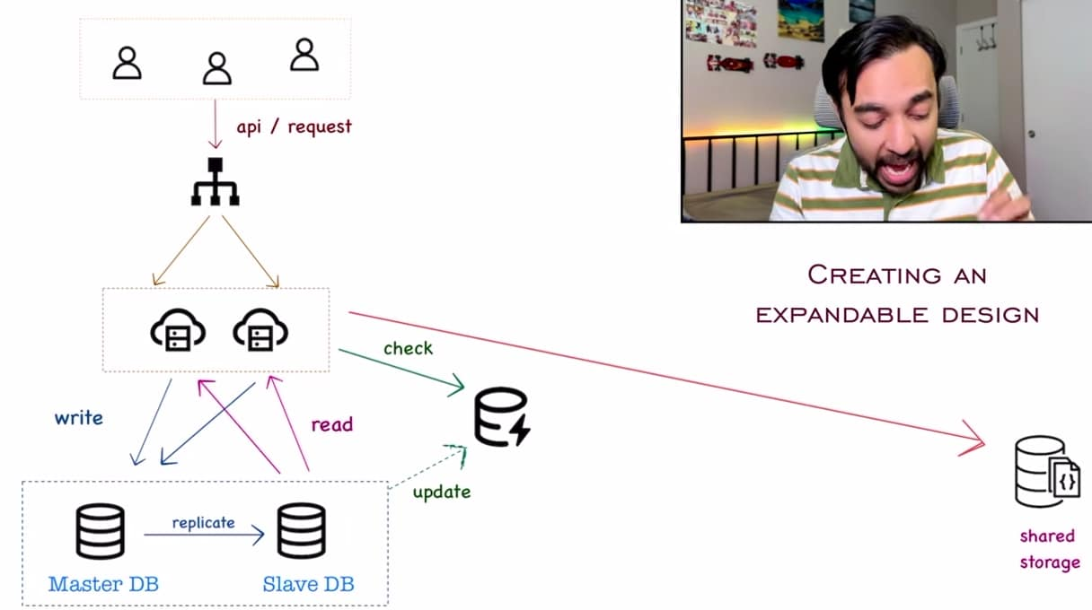
We always wanted to create a design in which we can scale to more and more users. With a load balancer we are distributing our requests to 2 diff servers, but we can also have a load balancer at a data center level and it means this entire block, this exists in one data center.
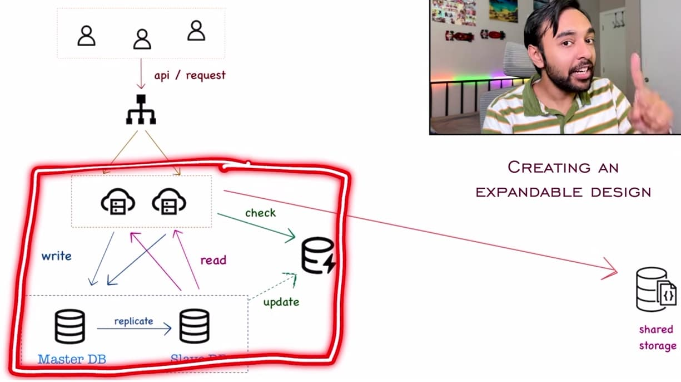
Suppose this entire data center is for North America, and we can create a similar block which is from diff data center like Asia , so we need some kind of shared storage space to manage both the data centers Eg. Instagram comments, we can access those comments from different regions of the world
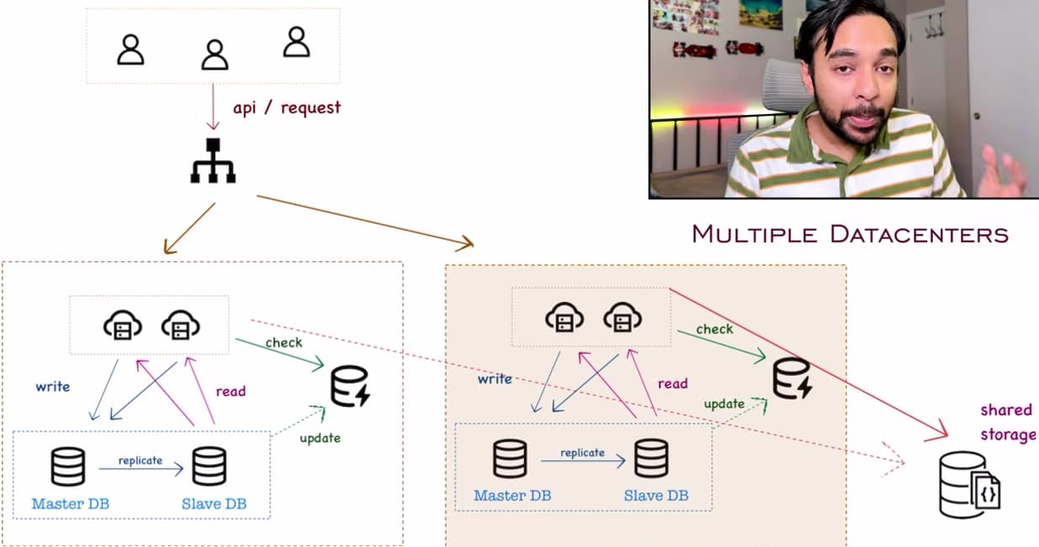
With such a design we can scale to a lot of users and when we’re defining data centers, it also helps us with high availability, it simply means that we’ve to prepare for worst scenario and in a worst scenario entire data center goes down
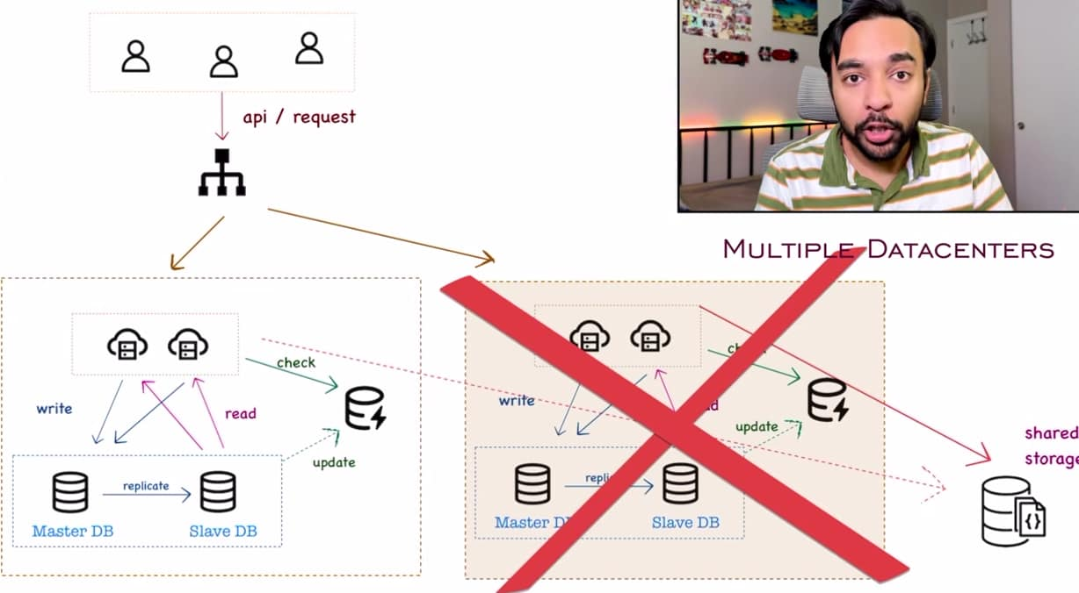
So we can redirect all of our traffic to the other data center, it is still better to have a slow service available rather than having no service available at all, and in that case shared storage is very helpful.
Suppose we are trying to log in to some website, now the session is stored to shared storage, if data center goes down we can be rooted to diff data center and then these servers they can get all of the data required from shared storage.
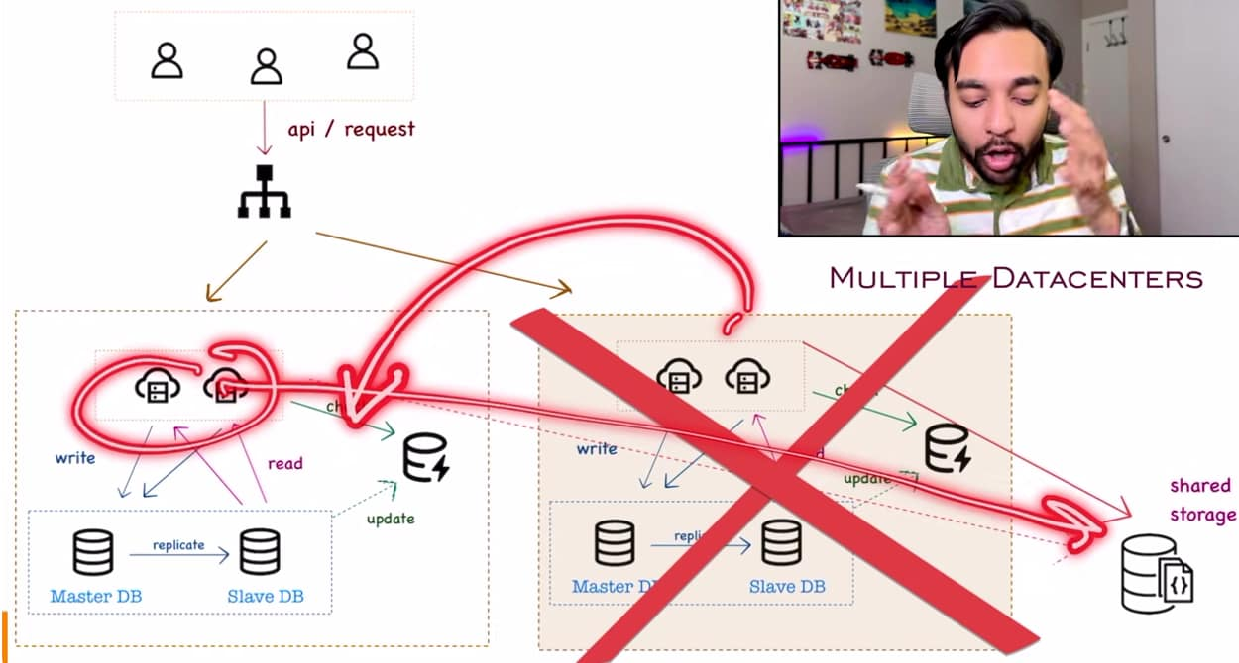
It is not necessary that we create all of these diagrams in such a detail, for eg this particular diagram can be simplified and it covers everything, when we say client it means all the clients, and then we’re looking for load balancer and this load balancer is targeting us to a data center, and when we talk about data center it is implied that there can be multiple data centers. In that data center we have a server that will have a db and that will have a cache and then we’re having the shared storage.
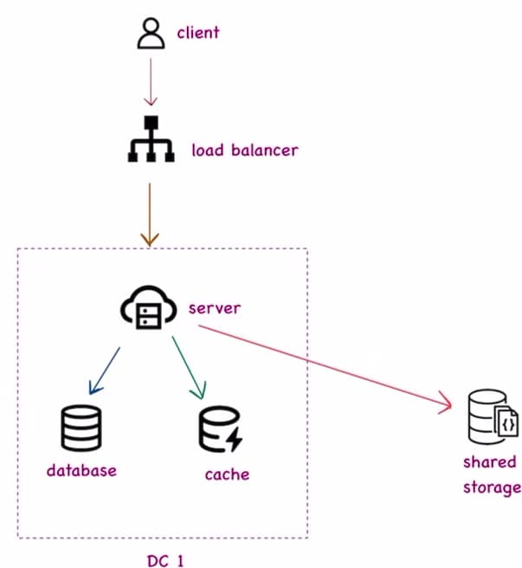
Based upon the requirement we keep on expanding each of the component.

Indexing in Databases
Till now we want to scale to a million users which means that data was simply keep on growing and I want that we’re able to retrieve the data fast whenever I need it, so handling data at such a large scale is really a challenge, so we’ve to implement algo and techniques by which we can retrieve data in faster way even if we’ve limited resources.
Bookstore without an index
Our bookstore looks like this, it is right now in a mess. If I arrive at this bookstore and I am looking for a certain book but I do not know where to look and we cannot go through entire books one by one.

If it is a small bookstore then we can ask the cashier or we can locate the book ourself, but if this bookstore is huge then how do we look up that book, so to solve this problem we use the concept of Indexing . Indexing is nothing but marking/categorizing all of our data, we could have seen it in a bookstore or a library, we would have all of these racks and all of these books are categorized with these indexes. If we’ve to look at a book that starts with A so we can go according to that line, in this way we are not looking for entire bookstore. We could also have indexes based on horror section, comedy section and fiction section.
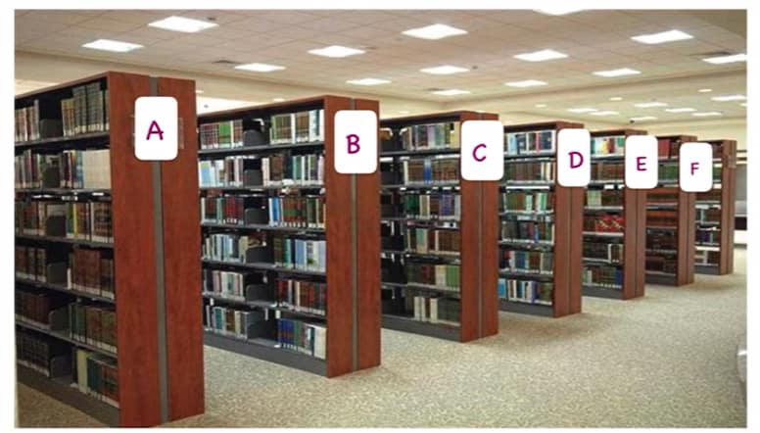
Another example is a book and if we’ve to search something, so every book will have some kind of index or a marking that will tell you if you’ve to look at this particular topic then go into this page, so we are indexing all of the topics or data that are available to us, so according to page no. we go directly and then we get our data, that is exactly what is happening in a db as well.
When it comes to system design we’ve a db available and it has a lot of data stored. If there is no concept of indexing and we have all of this data stored in table and if a user makes any query so we’ll go over each of the row and then we’ll determine the result, so we’re traversing through each of the row in our db and that is taking a lot of time, this looks like Brute Force Approach which is generally not scalable, we cannot expect a lot of users and then we are doing the scan of our db again and again.
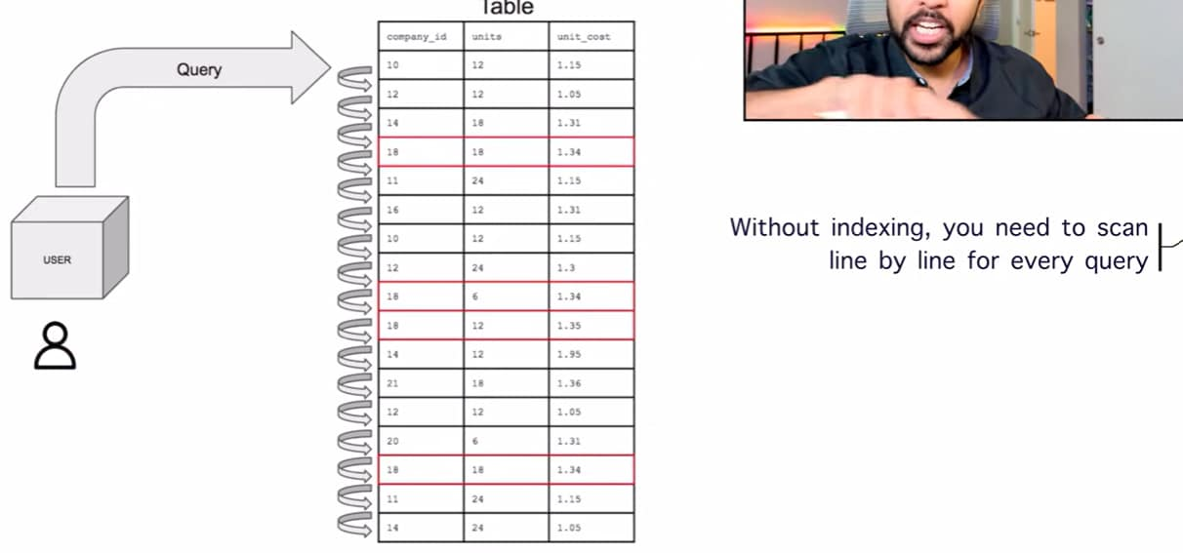
We have a table and each of the row they are somewhere in my memory, so if we try to map all of these memory locations with my index somewhere i.e. I create a separate table of index that is maintaining all of the memory locations corresponding to each of the index, now if a user makes a query, so now we’ve to scan only one column instead of all the rows and this one column redirects me to the exact memory location that I want
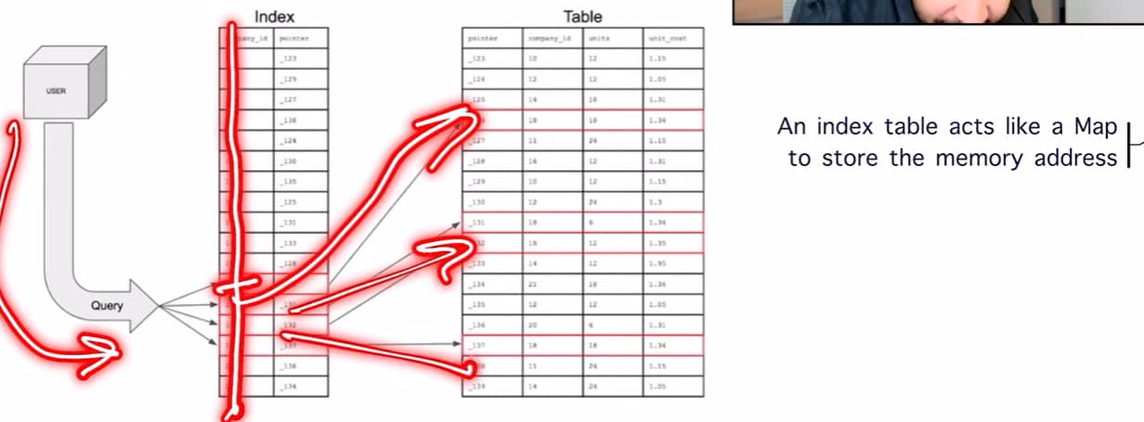
So just by adding indexing to our db, I do not have to scan my entire db and this is saving a lot of time, query become faster and the disk load also reduces a lot and indexing a db improves performance.

How indexing implemented internally?
With a b tree we can specify that all of the values smaller than a particular node can reside in my left child and all the values larger can reside in my right child.
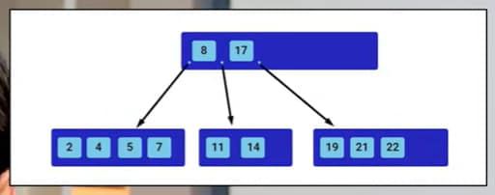
In SQL queries, where my certain field is b/w these 2 values, so internally we are navigating through our binary tree and then determine that I’ll find my required data only in this block, in this way we’re looking only at small section of data.

There are lot of ways where we can index all of our data. If we’re in a bookstore then we’ve to index all of our books either we can do in alphabetical order or we can do them in a order of all the genres or we can categorize in form of all the authors, all of these are diff ways and we’ve to pick a way by which the customers are able to easily find our data and it all depends on the type of book we’re operating.
When it comes to computer science, the first type of indexing we can do is primary index, it is most commonly used for scenarios where we’ve only one key as identifier Eg We have bank records and our db looks like this where date can be a primary key, whenever we’re looking up transactions, then the most common query is tell me all the transactions that happened on a particular date, so instead of scanning through our entire table, we can just scan the date column which we’ve already indexed and then we can return that for this particular date all of these were our particular transactions. This speeds up our query.
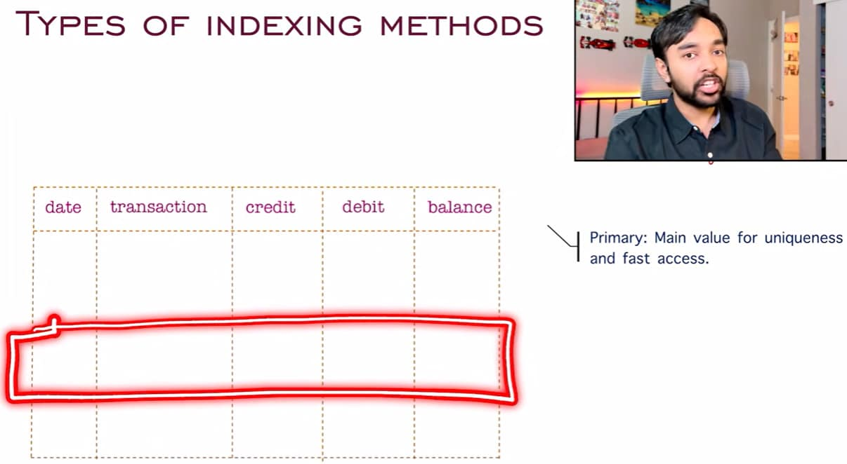
Next type of indexing is secondary index, it means that along with the primary index we also take the help of one more column, it means we take the help of 2 columns to arrive at our answer and when we extend this concept it becomes composite indexing. Composite indexing means that we take the help of multiple columns to arrive at our answer
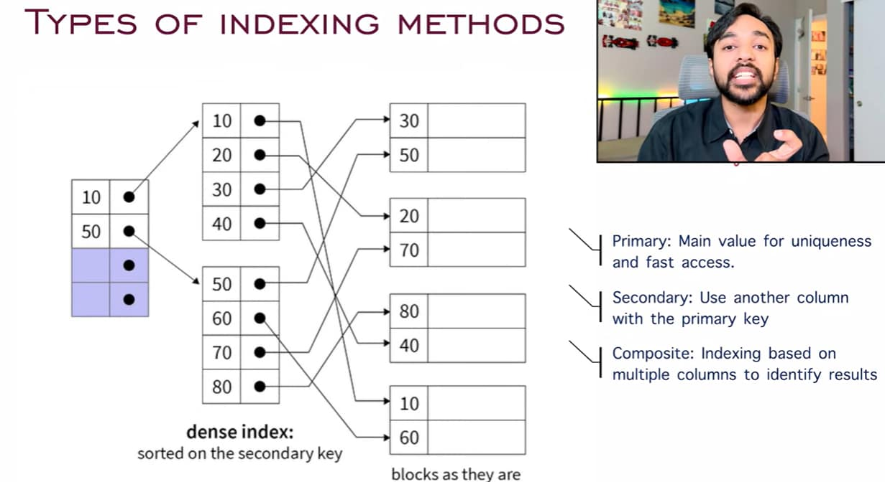
Suppose we’ve Amazon where we’ve all these filters available, we can choose by price or by brand or by fabric type or by size, we just cannot rely on primary index, I cannot say that I will have an index just for the price by that way our db will keep on running all of these queries, but with a composite index we’re indexing on all of these fields as well and when customer selects like a size 5 of this fabric of this brand then we get all of our results so quickly
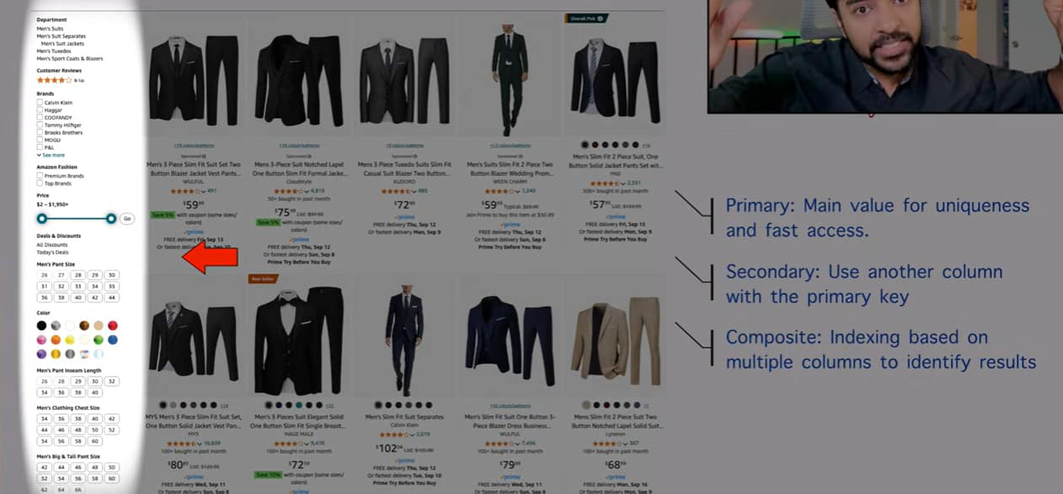
We cannot have a specific way that I will index my data in this way, it is all dependent upon the use case. Eg we design a system that captures all of these access logs that appear when someone visits a website, all of these logs are homogeneous, so if we’ve to index all of these we could use a hashing based index technique.
It will take up access logs use a hash function and then generate a sample bucket where we can put our data, when we’ve to query again use the hash function and then we can look up that particular bucket, depending upon the scenario we’ve to choose which indexing technique to use b/s choosing a wrong indexing technique can slow down our system and performance will go down.
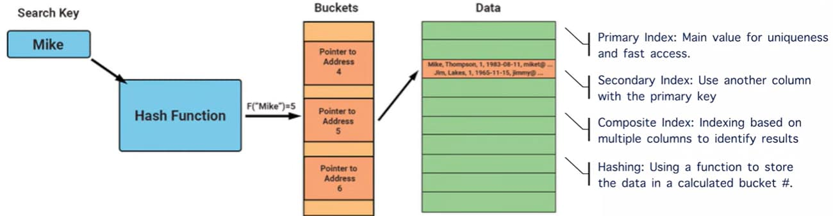
So we’ve to understand the data and what does our input look like and then we decide to use that particular concept of indexing our data. And there is no defined methods we can index our data in any way that we like, our main goal is retrieval should be fast and we’re able to scale up.
Challenges of indexing:
I am doing a query and I have index table with me and now my retrieval speed has increased to quickly look up the data, but when this index table is not there and when we’re writing new data so we simply add a row, but when we have index, so we’ve to perform 2 write operations we have to write in our main table and then we’ve to check our index once again and then update the info accordingly, so we’re writing 2 times and the complex our indexing is, more the no. of write operations we’ll need Eg we are using a secondary/composite index then we’ve to perform more write operations and more write operations means more load on our db.
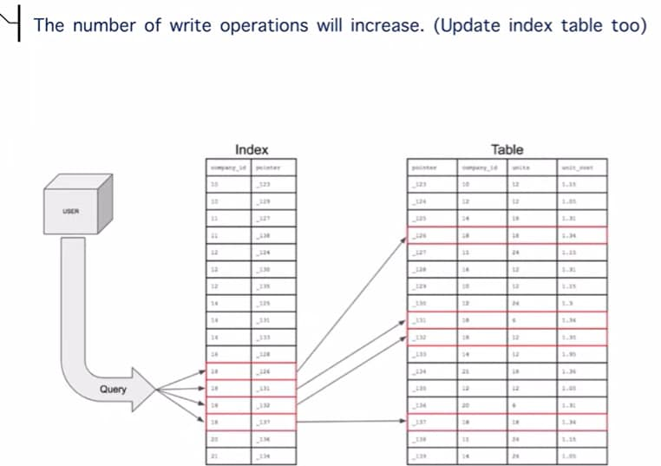
Next challenge is earlier we only had main table but now we’ve one more table to deal with it. This index table is not free as it is taking extra space and more complex our indexing is, more space we need and this space comes at a cost so we’ve to decide that by adding this index and taking on more costs are we giving that much output, so these are the calculations we need.
Another challenge is when we’re writing more data in our db we could also have to delete entries in our db, so when there was no index present we could simply get rid of the data, but when we’ve index then we’ve to make sure that we’re cleaning up some of the unused indexes as well, so whenever we do write or delete operation we have to scan our index table again and we’ve to make sure that our index table is also updated
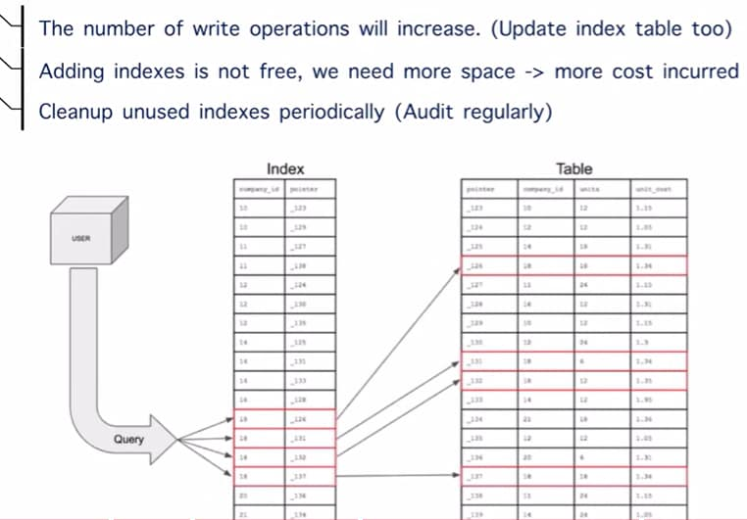
Eg we are creating a design that is collecting data for all the students and faculty in some kind of an institute, now students can be so many so that is where indexing can be helpful, index based upon each of the class, but we don’t need indexing for the faculty b/s faculty is limited (so we don’t need to waste space for faculty)
Forward and reverse proxy
At school, colleges, work places there are certain websites that are blocked like social networking websites b/s of security and the reverse is also true let’s say there is a network that is only accessible within a certain organization then it is not possible that anyone in the world can connect to those servers. We have to configure a certain vpn/proxy to get to that network.
A proxy is an intermediate that fits b/w client and server which is responsible for handling all of the requests and responses, we need proxy b/s when we are designing a system that is huge and we’ve to handle millions of users then we want a good control on what requests are coming to our system and who are we giving responses to b/s we do not want that we’ll send out info that is not intended for a certain user and we do not want to take up a lot of info that was not even needed.
Proxy at a bookstore
I come to this bookstore and now I want to look up for the book, I go into the bookstore but I don’t find it, so I go up to the cashier and ask that is this book available, so this cashier check up the book in their inventory and it is possible that this book is just not present on the shelves, so in that case the cashier will ask one of their staff members to go and look into the warehouse or at the back of the bookstore and then they are going to fetch that book for me.

So, this cashier acted kind of intermediate, they do not want that I go into this warehouse and fetch the book b/s there can be problems like I can see what’s going on I can see the organization and I can see what is there in the inventory, so this cashier acted as a proxy and they asked a certain staff member to go and search the book for me, this way we’re able to take care of the request that came in and we’re able to control the response as well, it is more secure and we’re able to handle the request in efficient manner as well.
That means we are delegating a request to someone else and then the task is being performed by someone else.
In computer app, we’ve all of these clients and they’re connected to the internet and they can access any of these resources that are publicly available. These resources could be anything it could be malicious sites or dark web or social networking sites it can be anything. So, we want some kind of control that all of these users are accessing based upon what rules and parameters that we’ve set.
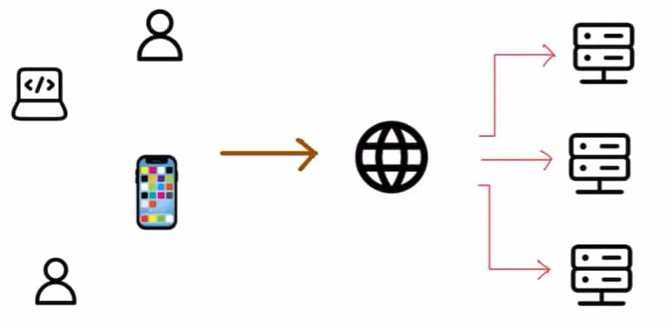
This is where concept of forward proxy come in. We have all of our clients and we can assume that all these clients are in some sort of private network i.e. they all accessing internet from a school or any workplace, now in case of forward proxy instead of directly connecting to the internet all of these clients will connect to a proxy server, and this proxy server is connected to the internet and they take care of all of the requests that are coming in and based upon the rules that we specified we can allow that if it is a work based thing we will allow the connection but if it is something like a social network website or a gaming website then we can simply decline it and then we won’t be able to access these resources.
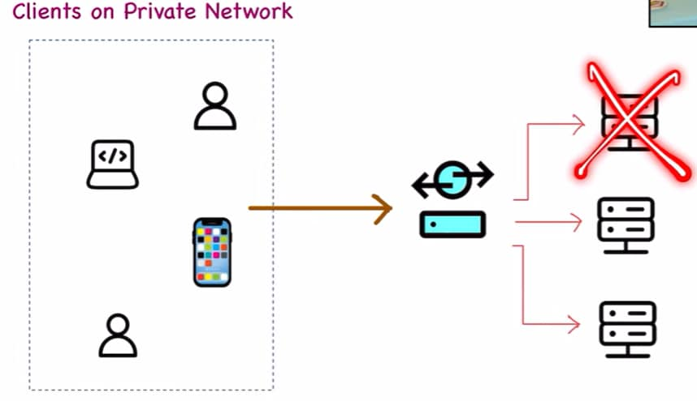
We are able to manage all of our content just by using forward proxy, forward proxy gives us a lot of benefits other than just blocking all of our content.
All these clients are making request to proxy server, so now we can log all of these requests and this becomes very helpful when we have to audit that what person is trying to access what content, so logging is very good aspect when it comes to forward proxy
Another benefit is traffic control, we’re serving all of these clients so we’ve a very good idea that what is the influx of requests and based upon our capacity we can decide if the request has to go through or do we want to block it, that’s how all organizations try to manage bandwidth and they can ensure that all of the clients are getting equally served b/s it should not be possible that one person is using all of the bandwidth while other people are experiencing the internet to be very slow.
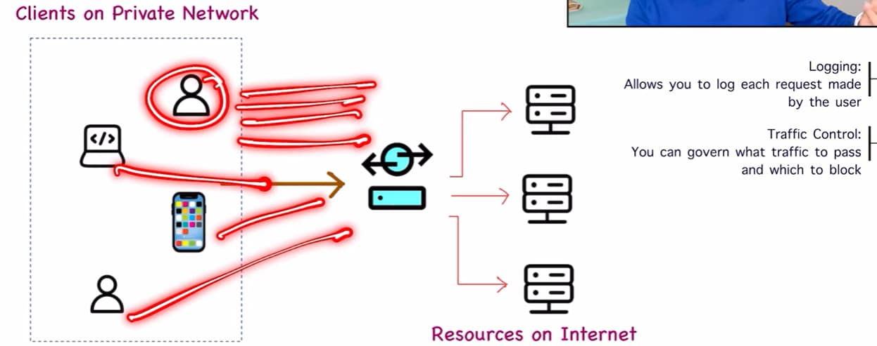
3rd advantage is encryption, we can make sure that whatever request we forward to all of the resources of the internet, we can encrypt the incoming request and then forward it, so this gives us security benefit b/s it is not necessary that all of these clients they are accessing resources in a secure manner, but by defining a proxy server we can take care of it.
And since proxy server is responsible for all of the requests that are going to public internet it can control what info is being sent to all of these servers as all of these resources/servers they don’t have any knowledge like who are all my clients, all they know is there requests are coming from proxy server, so it is kind of giving us anonymity to all of these clients.
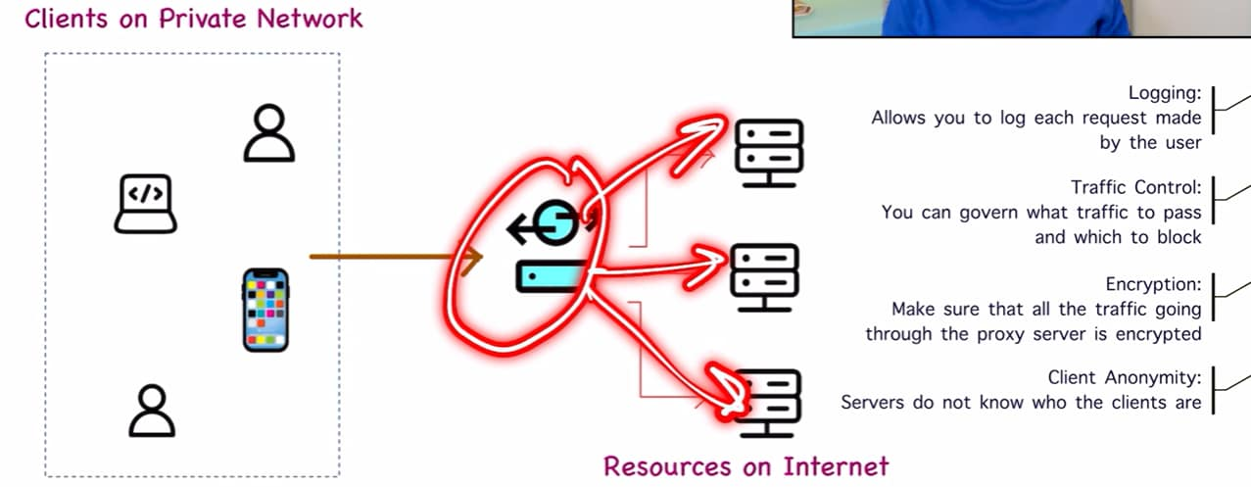
We have seen some of the vpn networks as well we might have seen some softwares like install the software and then we can access certain service that is available in a diff country, so here we are the client and instead of connecting resource directly which is in a diff country, we connect to vpn and then we could connect to proxy server, now this proxy server is going to capture request and then it is going to transform to send it to resource, and now the resource will think that my request is coming from one particular country and then resource will respond and then proxy server send the info back to client, so this resource has no idea where we are coming from, that is what vpn’s are doing and that’s why we remain anonymous and we can protect all browser history as resource has no knowledge about it and only the proxy server have all of the knowledge, this is how proxy server works.
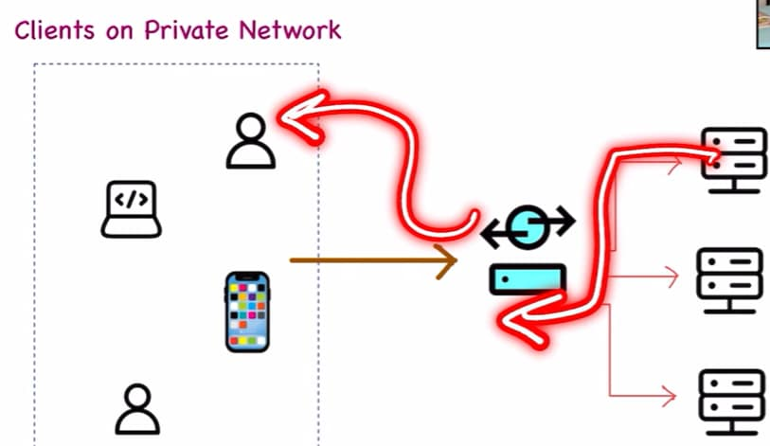
A forward proxy is something that works on behalf of all the clients.
But there should be something for the servers as well, so a proxy that works on behalf of the servers that is known as reverse proxy, we have all of the clients available and we want to access a certain resource, this time the situation has reversed, all of my clients are on internet whereas all of my resources are on some private network Eg I am working from home and all of these resources that belong to my company they’re on a private network, if I’m not an employee of the company then I can’t connect to any of these resources, so I generally connect to a certain service and then I am able to access these resources and this proxy is known as reverse proxy
Advantage of reverse proxy is when we’ve reverse proxy in place we can define the list of all of the users that only these users are allowed to access the resources on my private network and these resources are close to the public we cannot access them from the public internet, so we can make sure that only our employees only they can get access b/s if a random user tries to connect to this particular server then they can get explicit deny b/s this particular user is not allowed to access the service. So basically, we’re getting server anonymity that means these clients they have no info about the server they are connecting to.
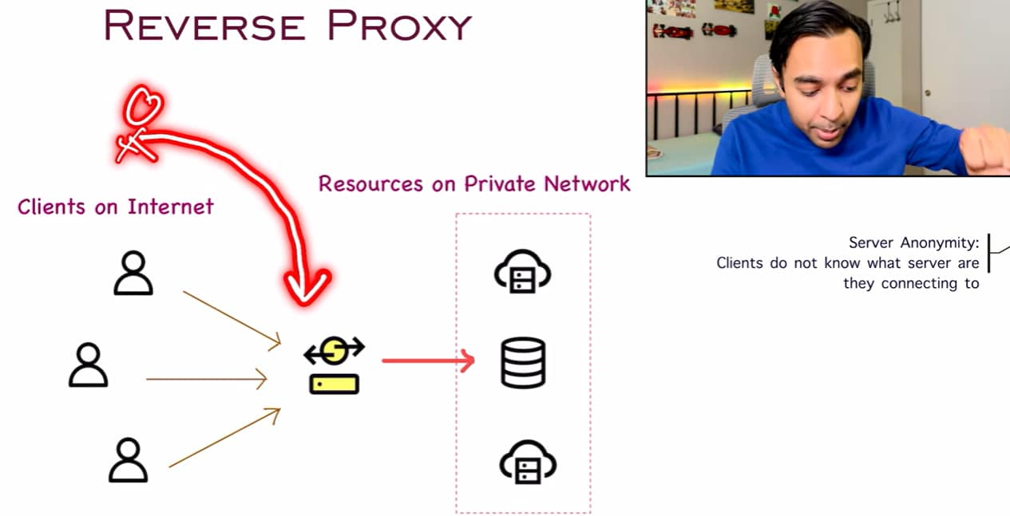
Just like we got client anonymity in a forward proxy, we get server anonymity in a reverse proxy and since we do not have any info about these servers we don’t know the IP address so we protect our system from a lot of attacks and a DDos attack is one of them. A DDos attack means that we constantly try to bombard a server with a lot of request and expect that it will fail, if we’ve no knowledge about the server then how we make that attack, so this reverse proxy is helping us with DDos attack.
Reverse proxy can give us some optimizations as well, b/s we know that all of these clients they will connect this reverse proxy server, so we can implement some sort of caching and then we can serve this clients faster and reverse proxy can also act as a load balancer so based upon the request it can determine that which server the request should go to.
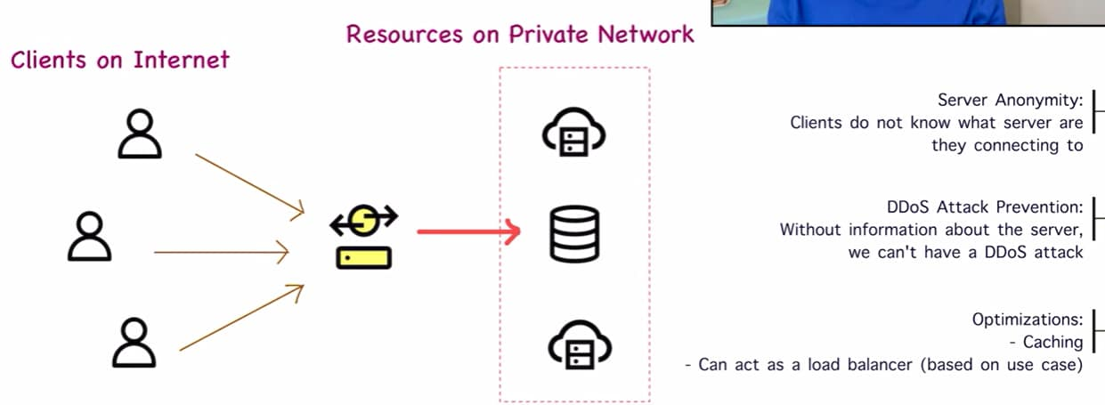
If we have a lot more advantages then the disadvantages then we implement that system then we add component to our design.

Message Queue and CDN
Message Queue (MQ) helps us to make our system more scalable and more fault tolerant whereas a Content Delivery Network it helps us to reduce the latency in our system.
In a book store, we have a server (cashier) and there are a lot of customers so it is possible that this server can get overwhelmed with all of the requests coming in from all of these customers, so in such a scenario MQ comes in, so what happens in a MQ is all the customers will come in and they will take a token this token is defining the order in which they will be served, we would have seen this in a lot of stores also, although there are a lot of cashiers then we take up a token and then we are served according to the number that’s being called out, so this is reducing load on a system and also reducing load on all the cashiers/servers, we do not have to keep on standing on the queue we can just stand anywhere and then we just go whenever our token number is called out so this also solves the problem that one of the queue is moving faster and one of the queue is moving slower, this is what MQ is doing.

In computer app, MQ looks something like this, this is a standard queue and there are a lot of implementations like Rabbit MQ, Apache Kafka, Amazon SQS, so in this queue we send messages one by one and these queues they maintain an order in which all of these msg’s are coming so when we have this queue we also have 2 more components the producers and the consumers , the role of the producers is that they will keep on queuing up the msg’s in the queue and based upon the availability all of these consumers will start taking up the msg’s one by one
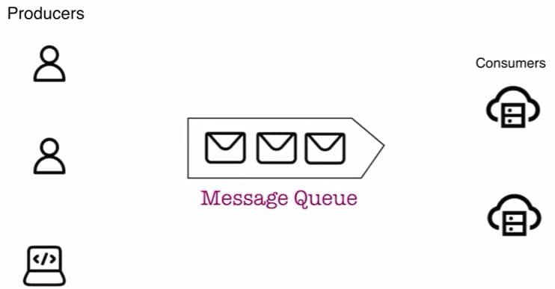
But why did we’ve to introduce a separate component MQ in our design, what was the problem when we’re directly communicating with my server, I had these load balancers and all of these things?
We are getting a lot more advantages when we have MQ in place, first advantage is we’re able to decouple the system decoupling means that we can just allot our request and then done with it, we do not need to have a constant connection Eg we are placing an online order so we placed an order and then we forget about it, it is now role and responsibility of the entire system to process our message and then place our order and then send us a confirmation on the email, so as a client we don’t have to keep on waiting, so we are detached from entire system, decoupling allows more freedom and then this system is also under some stress b/s it can start processing each of these messages according to its capacity and it also takes its time to analyze that is this a security threat or is this is a safe msg.
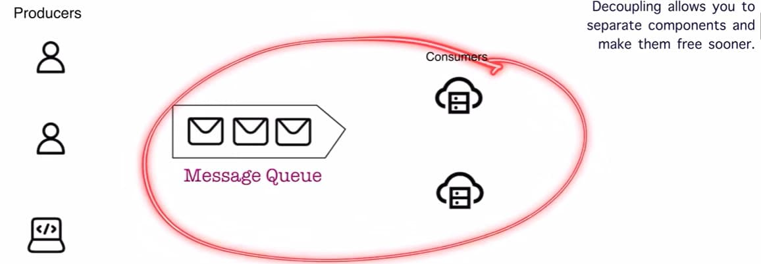
Since these 2 components are now separated, one additional benefit is scalability , we don’t have to serve all of these clients/producers at the same time, we can serve them one by one when we have resources, so it allows us to scale our system very much, and we can have a lot of users and we’re not worried that we’ve to serve all of them immediately. We have to just put all of our requests in the MQ and whenever servers/consumers are free they will process our msg’s and then revert the producer with answer
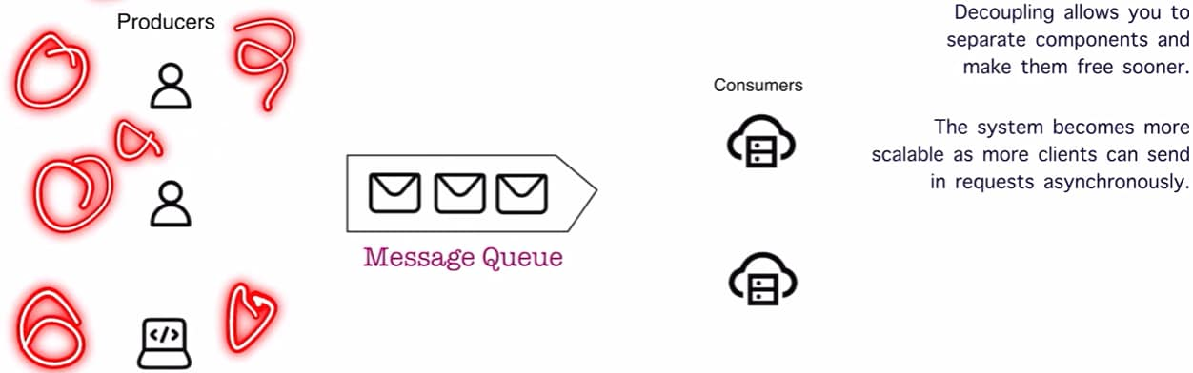
This model it is on a case-by-case basis, we cannot expect that it is a chatbot and it will respond whenever it wants. In that place a MQ may not be helpful, so based on scenario like online merchant (Amazon) or cart or posting videos on you tube or publishing a post these are all the places where MQ is very handy.
Consumers have to process the msg one by one, now we’re allowed a certain time window in which we can process the msg, this is allowing fault tolerance as well, it could be possible that this server picked up a msg, it is processing and may be there is some error and the server went down
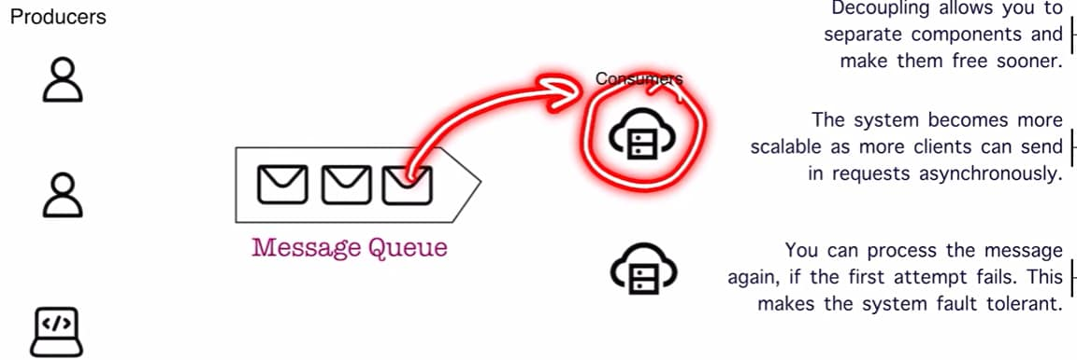

In such a case, we can ask other server to pick up the same msg and process it, so our system became more fault tolerant. We can handle all of the failures.
Challenges of a MQ
Ordering of msg’s: We need to make sure that this queue is processing all of the messages in the order in which it was received or we want to implement a custom order there could be a priority client where we have to process their msg’s first
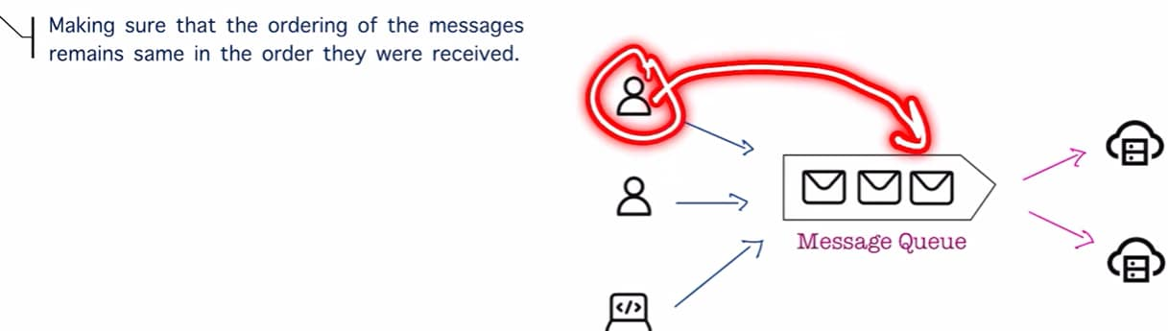
Msg in queue gets duplicated: It is our responsibility to make sure that we’re handling all of these duplicates.
Latency: we have introduced one more component i.e. MQ so response time will go down b/s earlier we’re directly connecting with the server so we got a response now we’ve a middleman, so it will take additional time for the msg to first reach the queue and then reach the server and then we’ll get back our response, and it may be possible that there will be a MQ in the response as well.
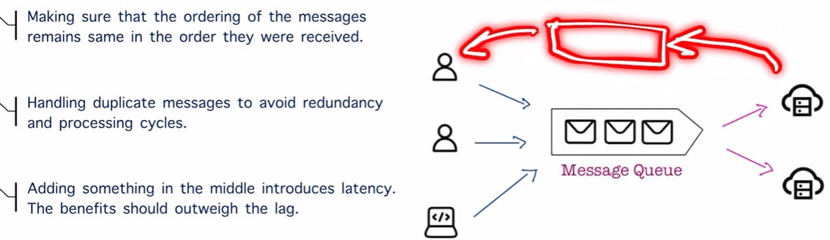
According to the use case we’ve to use MQ.
We can find app of MQ at a lot of places, in social networks there is notification system so whenever any activity happens it gets pushed to our notification queue and that is where we see all of them one by one.
MQ is also used in email systems as well, it is possible that we’ve a lot of msg’s in our outbox, and as soon as we connect to the internet we’ve to send all of these msg’s so we store all of these msg’s in a MQ and then we start sending them one by one.
Content Delivery Network:
Let’s say we’ve a lot of bookstores in the city, each are in diff locations now if we’ve to maintain a warehouse of all of these bookstores, so we’ll just have a warehouse somewhere in b/w and then all of the inventory of all of the stores that is managed through this particular warehouse.
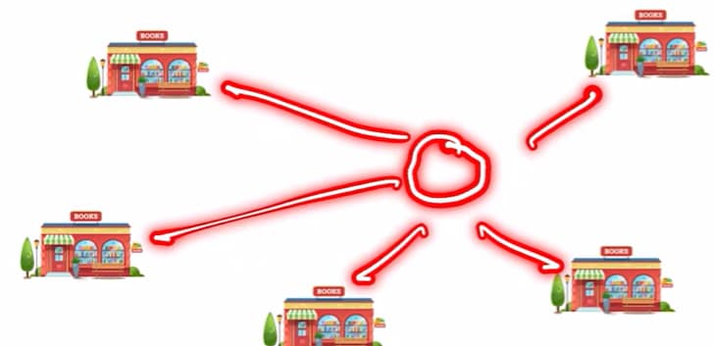
Or if I maintain a warehouse based upon the cluster of all of the bookstores that I have, so this particular warehouse it can serve all of these bookstores whereas this particular warehouse can serve these 2 bookstores, so I am maintaining a warehouse that has all of my content, so I am able to reduce the time that it takes to go and fetch a resource from my warehouse.
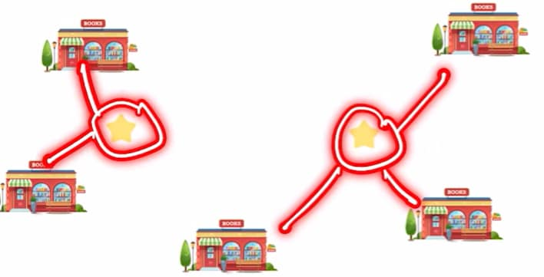
Basically, we want to make an app that is scaling up to a million users, so our users can be in any part of the world so we deploy our app only in one part of the world, so all of these users their response time will be very low, but what about other users
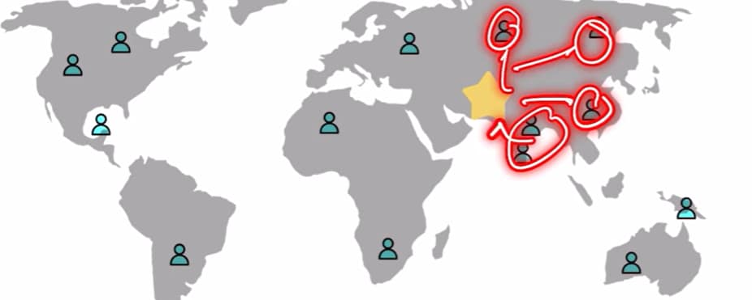
All of the other users for any request that they make, it has to travel halfway around the world and then get a response back. So this is taking up a lot of time, it may see that it’s just a fraction of sec but making multiple requests it can really slow down the experience. Nobody likes slow site.
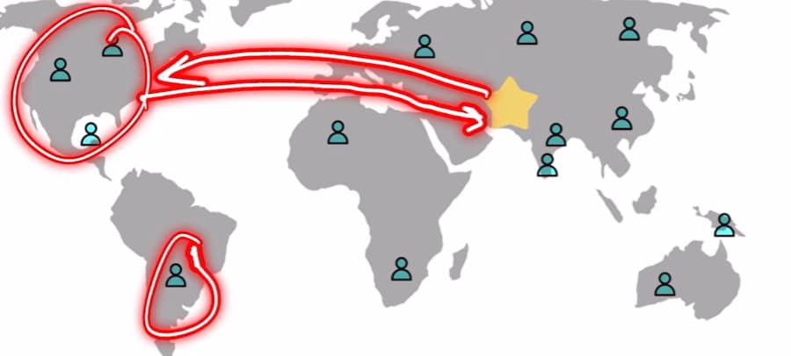
So, this is where CDN comes in, we can have main part of our app deployed somewhere centrally and for all of our audience around the world, we can establish a CDN for all of the diff regions
CDN is storing or caching all of the content that we need for our app, so whenever all of these clients make a request, first they try to query the CDN and there is a chance that they’ll get all of the data that they need. If there is some data that was not available then we query our central location.
Similarly all of the users they can just query the CDN closest to them, so it is helping us to maintain all of our resources.
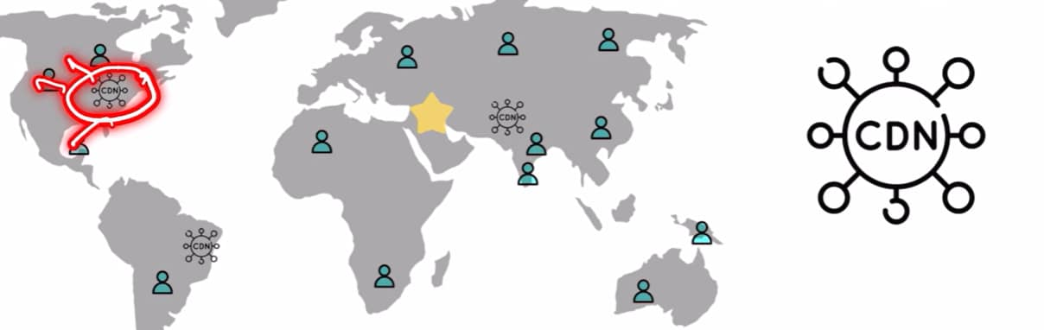
Eg We want to develop something like Netflix, so it is not feasible that we store all of our data in just a single location b/s the audience in this country will have diff preference, and the audience in other country will have diff preference, so we can have region specific CDN so all of the content that pertains to this particular region we will store that in that particular CDN
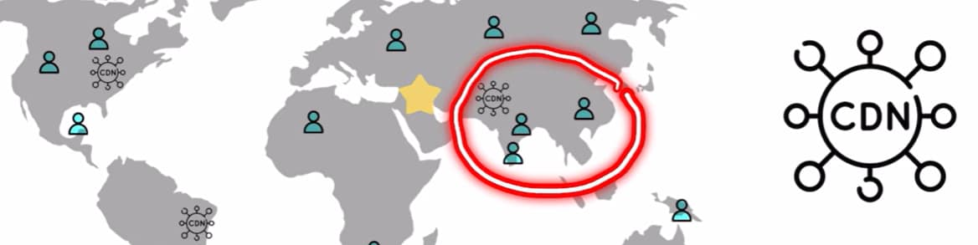
So, we’ve a system where everything is available, it is very much possible that this particular audience want to view the content of this region and it is also fine, first it will look into the closest CDN, if we don’t find then we can look into a diff region, so we’re still getting a very good response time for a majority of our users, for a few % of users the response time can be higher.
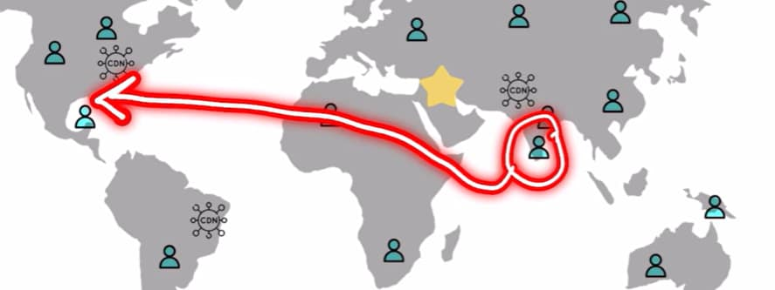
PROS & CONS (CDN)
Loading time goes down and responses become very fast b/s all these users they can just query the local CDN and the content will be served to them, this is possible b/s we’ve localized our content and this is reducing latency to fetch all of it and served to all of the clients.
Along with local content, we can cache all of the static content too, Eg when we open a website we can see all of the images, banners etc, so I don’t want to fetch of these info again and again from central location, so we can simply duplicate all of the info and have it available in all of the CDNs, so getting these images this becomes very fast and our site loads up very quickly, this is how static caching is helping us to reduce the latency.
Challenges are: we want to make sure that our data is always fresh, so it means that we’ve to refresh our CDN periodically, we don’t want to serve our clients old info, it should not be possible that we update our site in one location and all of the other users are seeing the older version of site b/s the CDN has not been updated.
And when we set up all of these components it comes at a cost, so we always have to make sure that the benefit is more than the cost we’re incurring
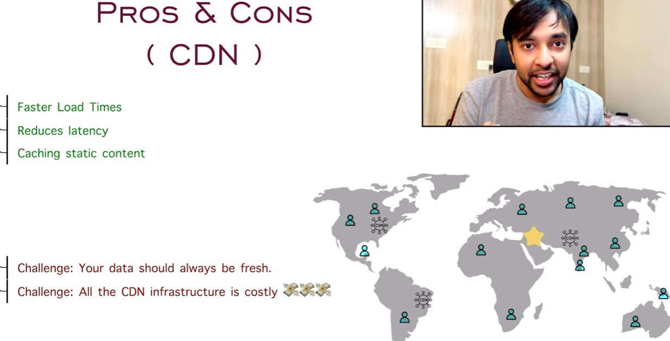
CAP Theorem and use cases
Consistency, availability, and partition tolerance these are the 3 parameters that helps us judge how good our design is and we can never achieve all 3.
Let’s say our system is distributed, we’re designing a system that has to scale to a million users so it will have components all throughout the world, all of these are systems that are connected to each other b/s in the end it will work as one system Eg Netflix, Fb so they have data centers all throughout the world but they are behaving only as one system, now when we have such a big system we have certain parameters, first parameter is consistency (C) it means that whenever we query the system it should return us a consistent result i.e. if I do my query in North America or if I do my query in India then both of these results they should be the same. Eg we have a banking system it does not matter where we’re making the query it will always gives you the exact balance that is available in our account and that needs consistency we cannot have diff results from diff regions of the world.
Next metric is availability (A) it means that whenever we query the system we should get back some result, it should not be a case that we send a request and we don’t get back any response. Eg we’ve some bad performing websites where we keep on clicking and nothing happens that means that the system is compromised on availability and that is not a good design. Systems like IG, Whatsapp, Twitter they are always available and that gives us a better experience.
Last metric is partition tolerance (P), so this distributed system it has components all throughout the world they are connected, partition tolerance means if one of these connections goes down in that case is our system available or is our system offline at that moment, this also defines how good our system and it greatly defines how better our system design is, so we can have a system that can completely go offline if one of the node fails or we can also have a system that still remains functional even if one of the node fails, it depends upon the use case and what kind of system we’re designing
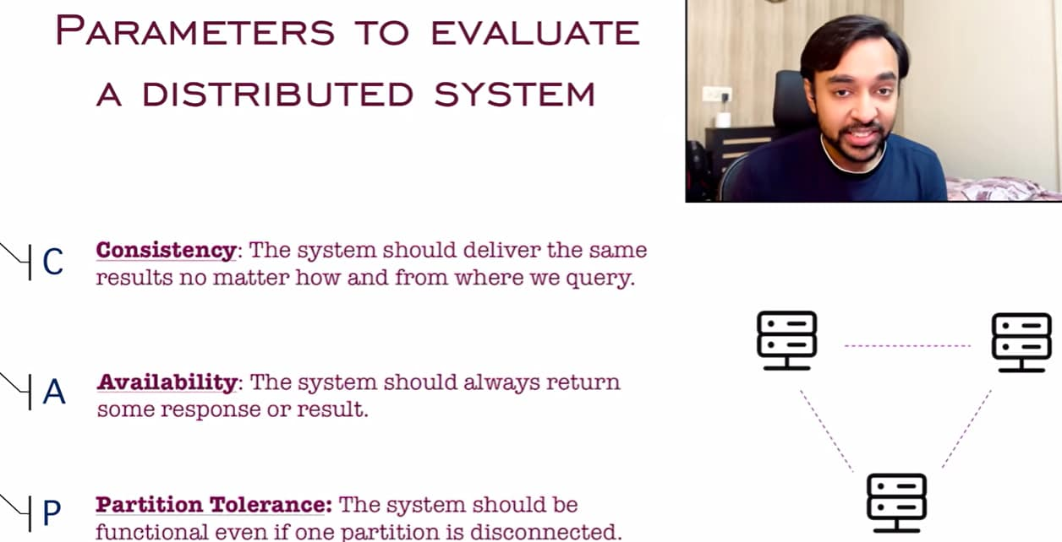
CAP Theorem states that in a distributed system you can never have consistency, availability, and partition tolerance simultaneously you’ll have to compromise on one of them
In this Venn diagram, I have all the systems where I have consistency as my priority, in all these systems I have availability as my priority and in all of these systems where I have partition tolerance as my priority, so according to CAP theorem we can have systems in these regions:
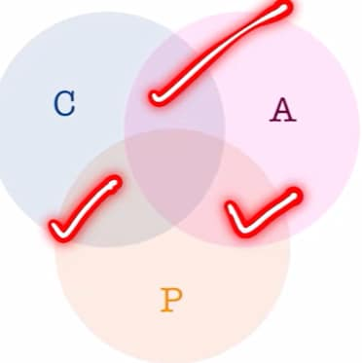

But we can never have a design that satisfies all of these 3 conditions simultaneously, we can never achieve all of these 3
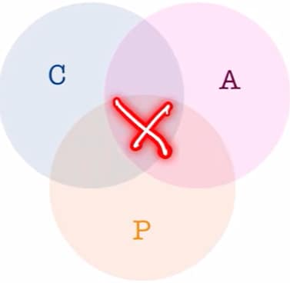
Let’s look at a system where I want consistency and partition tolerance but I can sacrifice my availability, one such system is banking system, whenever we try to query bank balance, no matter which part of the world we are in, our account balance should always be the same, that’s why consistency is very imp in case of bank, similarly in case of banks we must have partition tolerance as well it means all of our components all throughout the world they should remain connected it should not happen that one of the system goes offline that can affect what our bank balance is and we’ve to always account that case, so in that case we sacrifice our availability, when the system goes down then the bank will simply says that I am available the transaction cannot proceed, so it means that the system isn’t available b/s there has been some error b/s consistency and partition tolerance are my priority, I can be a little relaxed on the availability b/s I want that my transaction should either succeed completely or it should fail, we can say that my servers are busy or the service is not available but we cannot have wrong transaction showing up.
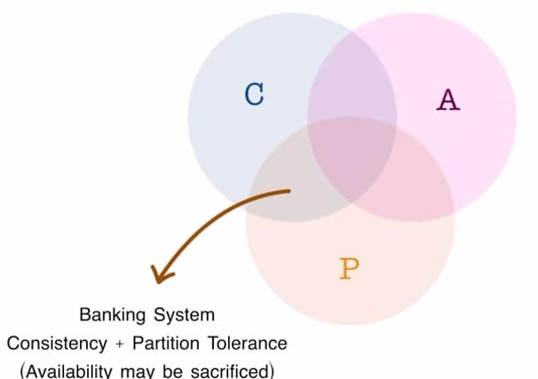

Let’s look at a system where we’re prioritizing consistency and availability but we can be lenient on the partition tolerance Eg Ticket booking System, we could have ticket bookings for airlines or concerts, in this kind of system we want it to be consistent that means if I’ve booked a ticket it should show me available if my ticket is cancelled it should be cancelled no matter where in the world I’m looking it for and I want to my system to be available as well, we should always allow ticket bookings it could be for concert A or concert B and in such a kind of system we can sacrifice partition tolerance, let’s say one component of our system goes down lets say we’ve 3 concerts, concert A, B & C if concertC is blocking or there is some problem in the part of the network, so we can block off ticket bookings for concert C, but concert A and B will still be available, so our system is available to book all of the tickets, and in case of air tickets as well we can block bookings of certain airline but all of the other airlines they’re still available, so we need to understand use case when we’re designing the system
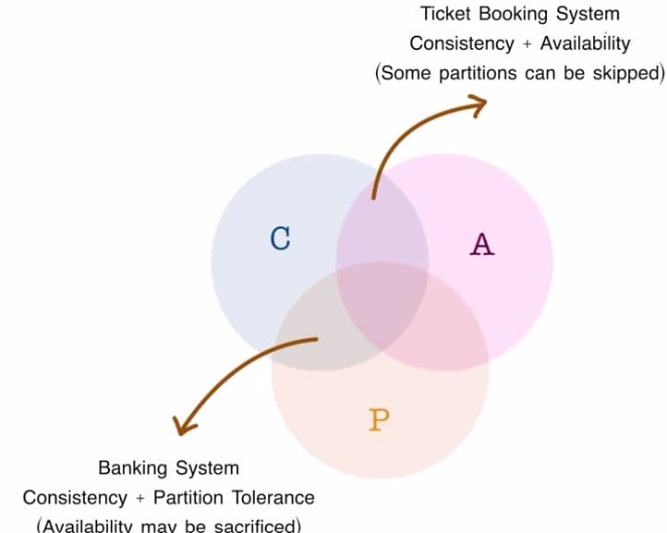
Now, there is 3rd system where I want availability and partition tolerance but we can sacrifice consistency, these are social networking systems whenever we open IG or FB it is always available whenever we open we have content and of these systems are partition tolerant as well, even if one of the systems goes down they’ve db backups all throughout the world and then they can get content from those diff networks, but what about consistency, we have seen that it is not necessary that as soon as we post a comment and immediately it will start to show up on friend’s profile or it can happen that I post a comment and eventually after some time the comment will show up or there could be a popular post that has millions of comments, so it is not necessary that any comment I post it should be immediately visible to everyone, so we can sacrifice consistency, we can give them eventual consistency, let’s say a post has million comments then if I post a comment then after 1 hour or 2 hours that comment will be visible, that’s why we’re sacrificing on consistency
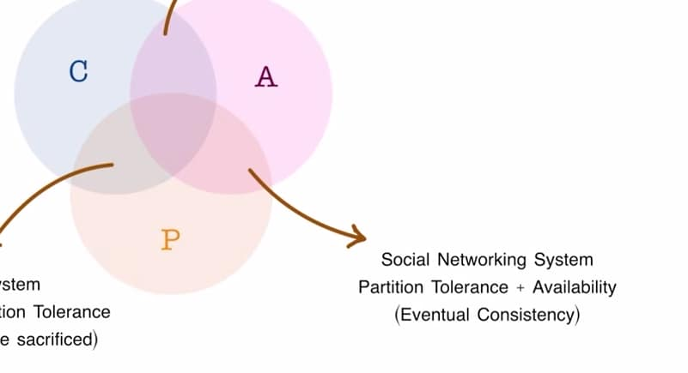
We can never have all of these 3 components simultaneously in any available distributed system, but why can’t we achieve all of the 3 simultaneously?
B/s in case of distributed system it can become a paradox, a distributed system is connected throughout the world whenever everything is functional it is a happy case and we’ll be serving clients every time, the problem arises when there is network problem b/w any of the 2 components
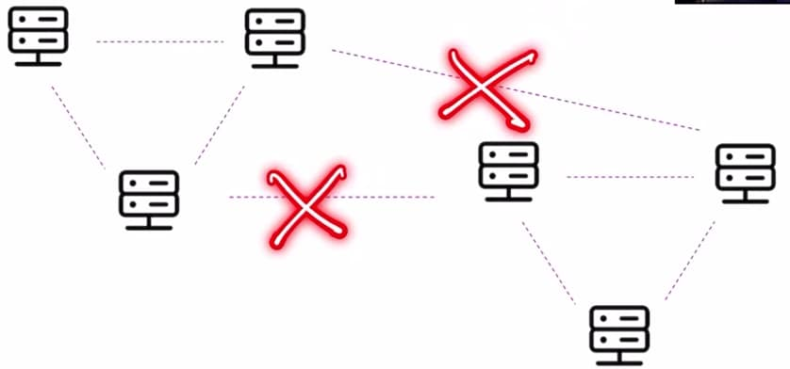
This was a huge system, but let us look at only 2 servers so both of these servers are currently connected, suppose network goes down, in that case both servers A and B they cannot communicate with each other, so if I want consistency both these servers should agree, Eg if it is a banking system and I ask that tell me the balance then both servers A and B they should give same response but since network is broken then they cannot give exact result so availability is compromised, and if network goes down and if I want availability then we can query both of these servers and they should give us some response, but since they can’t communicate with each other they can give us inconsistent result, so we’ve compromised consistency, so this is a paradox either I was getting consistency and partition tolerance or I was getting availability and partition tolerance, we cannot have all 3
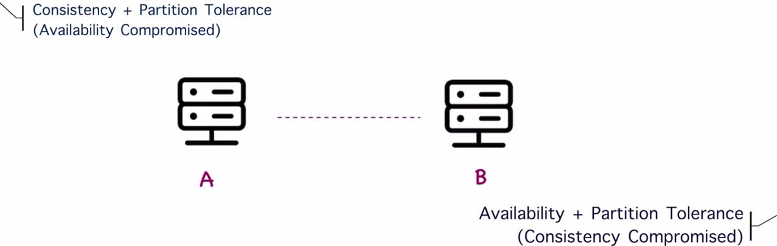
Design a Rate Limiter
We have seen limitations like we cannot post more than 2 msg’s per sec, we cannot create more than 10 accounts per day or we cannot watch Netflix on more than 2 devices at once, in all of these scenarios the concept of rate limiter comes in.
Suppose we have designed a huge system now we want to protect it otherwise people just giving you requests and our system get overwhelmed due to which our site can go down or simply unavailable, there can also be security/maintenance issues, quality of service issues and DDos attacks as well, so a rate limiter is very helpful as it gives more control on how many people are able to reach us. This allows us to manage the load on our server and we can make sure that system is running smoothly.
While creating diagram of system design, do not just start creating diagram b/s we must be aware of all of the requirements before we can start designing things.
Requirement Gathering: we can start with basic questions like Is this rate limiter going to be a client side or server side, then interviewer will say that this is going to be a server side implementation. Then our next question could be how am I to determine how to throttle the requests, is it only one condition or there can be multiple conditions to which interviewer can say that you have to design a system which can throttle based upon multiple conditions, so we need to be able to handle that, similarly we can ask more questions, now these questions can be to the interviewer and they can be to ourselves as well. Eg Do you want to inform users that their requests have been throttled, this is a question that is more client specific, so we can expect the ans from an interviewer that yes, we should inform all of our clients and there can be another question as well do you want to design a system that is distributed or it is only a single machine system?, that is how we design a system based on the requirements
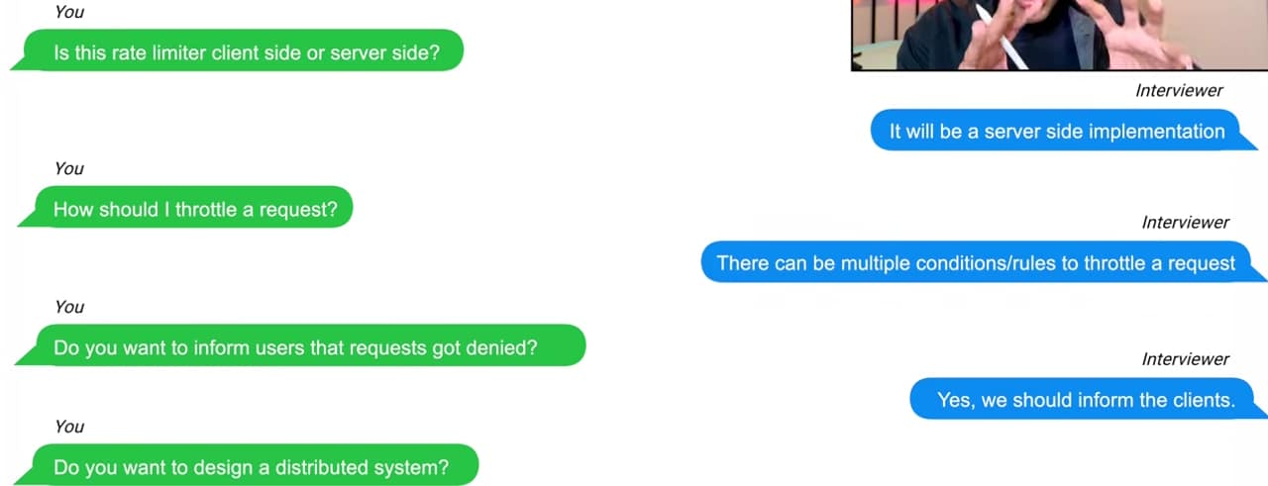
Implementation of rate limiter:
We have several options for rate limiter:
- I will design a rate limiter that is on the client side, which is usually not a good idea b/s clients are not under our control b/s a client can install any software and they can manipulate the requests.
We have the control of all of the servers, so that is where we can put all of our logic and that is where we control things, a client can come from anywhere and we cannot account for all the cases.
- Next option is, I will design a rate limiter that is on the server side, in that case we have our client and we’ve API servers, and we are implementing a rate limiter on the servers, in this we’ll make requests to API servers and if the servers are available they will process our request and if the servers are not available then the request goes and rate limiter will deny the request, this design looks feasible but in this scenario we’re hitting all of our API servers for every request and that takes up load on our API servers, so even better approach to design a rate limiter is an API Gateway which is some kind of middleware b/w the client and the server, so we’ve a client and API servers and this is a gate which is implementing rate limiter middleware in such scenario we’ll make all of our requests to API gateway, if the rate limiter allows these requests, then these requests will go through and these will hit the API server, but in a case when we make one more request and the rate limiter denies it then this request is not processed and it goes back to the client. So by this we’re able to save one of the request even to reach the API servers, that is very essential & it is saving some of the load on our servers, using the API Gateway will be the best option to proceed.

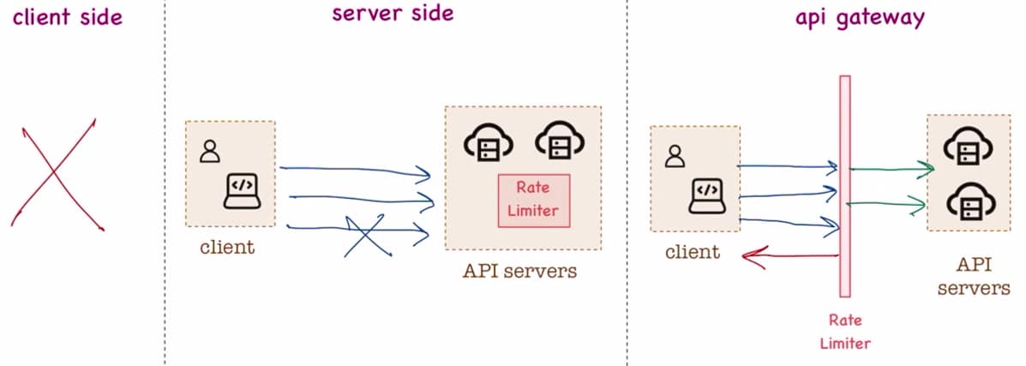
We have finalized a basic high level design, this will lay up the foundation. When we’re designing a rate limiter what about the algorithm and how I am performing all these rate limiting operations, so we need to decide which algo we need to pick.
3 different algorithms by which we can implement rate limiter
Token Bucket Algorithm imagine there is a kind of bucket and this bucket is storing all of the tokens that are allowed to process each of the request. Eg we’ve a refiller, this refiller keep on adding tokens to our bucket, let’s say I only want to process 3 requests per sec, so this refiller it will add 3 tokens every sec to this bucket, and now let’s say I have all of these incoming requests, so in 1 sec I am getting 5 requests so all of these requests get forwarded to my bucket, now in this bucket I only have 3 tokens available, so for 3 requests they’ll go on to my API servers, and 2 of the requests will get denied and then these requests are dropped, when we’ve these dropped requests we can do anything with them we can inform them to the client or we can put these requests in a retry queue as well, so that whenever this refiller fills the bucket again we can retry if we want, it is up to the requirement if the interviewer wants that we’ve to retry then go for it otherwise you can drop it or just inform the client that 3 requests got processed but 2 of them were dropped. This approach is very easy to implement, memory efficient and it allows bursts of traffic as well. In this we’ve 2 parameters to tune one of them is the refiller rate, how many requests per sec we want to refill and other parameter is bucket size let’s say for 5 sec we’re not getting any request, so will the refiller keep on adding tokens to this bucket, Eg we’re having 3 tokens per sec, for 5 sec there are no requests, so will this bucket have 15 tokens available now or it will have a max cap, i.e. my bucket will only hold a max of 10 tokens, these are all the parameters that we’ve to tune when we’re implementing this algorithm.
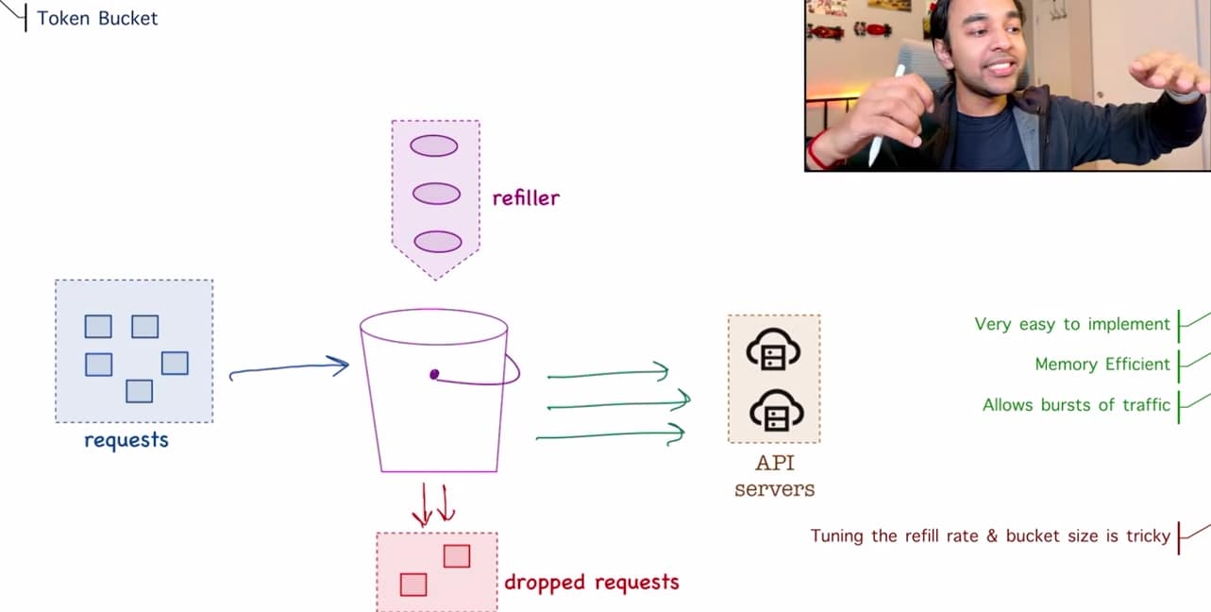
Next algo is Fixed Window Counter Algorithm, in this we define how many requests we want to process every sec, in this scenario in the first sec I am getting 3 requests, in the 2nd sec I am getting 6, then 4 then 3 and then 5 If I have defined that I want to process only 3 requests per sec, so in this algo after 3 requests will cut off any more requests that are coming in, and rest of these requests will get dropped. This algo is memory efficient and it allows us to manage quota dynamically, if we’ve more resources available we can move up this margin or we can move down this margin
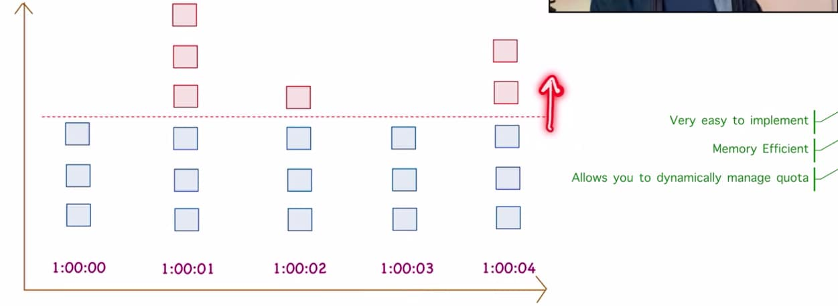
There is one problem with this algo, suppose I’ve requests coming in every min, in 1 min I am getting 5 requests and in this other min I’m once again getting 5 requests, let’s say I am allowing 5 requests per min, so this algo will see that in 1 min I got 5 requests, so it will allow all of these requests, for the other min once again we got 5 requests so this algo will allow all of these requests to pass through it may seem correct but all of these requests they came in a period of half minute of 1 min and half min of the other half so in 1 min our algo allowed 10 requests, the problem is although we had limited 5 requests per min and our algo was doing 5 requests per min but the way this algo works it cannot handle bursts of traffic.
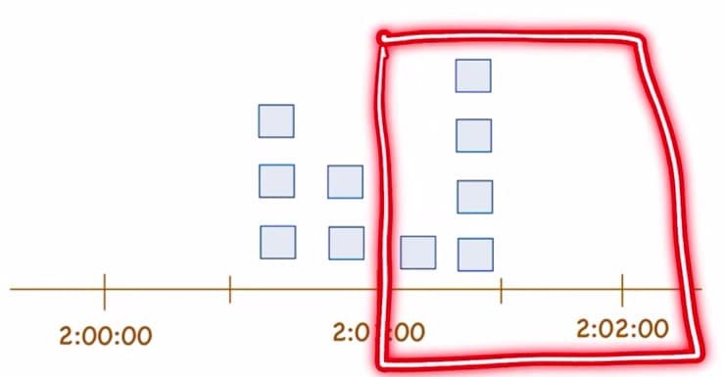
With a burst of traffic it was able to pass on all of these requests which overwhelm our server. So, we have to watch out this particular condition when using this algo.
Next algo is Sliding Window Log Algorithm, in this we log all of the requests that are coming in. Let’s say in this scenario my limit is 2 requests per min, for the 1st case a request comes in at 02 sec so I will log this entry and since I do not have any other request I will allow it to pass through, for the next case I get another request at 30th sec, we checked in our log that we have only 2 requests for the particular min so we’ll allow this request.
Now I get the 3rd entry this request comes in at the 50th sec, in the logs in 1 min log we’ve the request at 2 sec then at 30th sec and now at 50th sec, so we got a 3rd request and this is not allowed, so this request will get denied it won’t pass through and since it is sliding window log algo as the min keeps on passing we’ll keep on deleting the previous log entries from our record, let’s say a new request comes in at 1 min and 30th sec, at this moment the 1st request has been deleted, 2nd request has been deleted and 3rd request stays there b/s we denied it and now we’ve a new request coming in we are allowed 2 msg’s per sec, so this request is valid and it will once again pass.
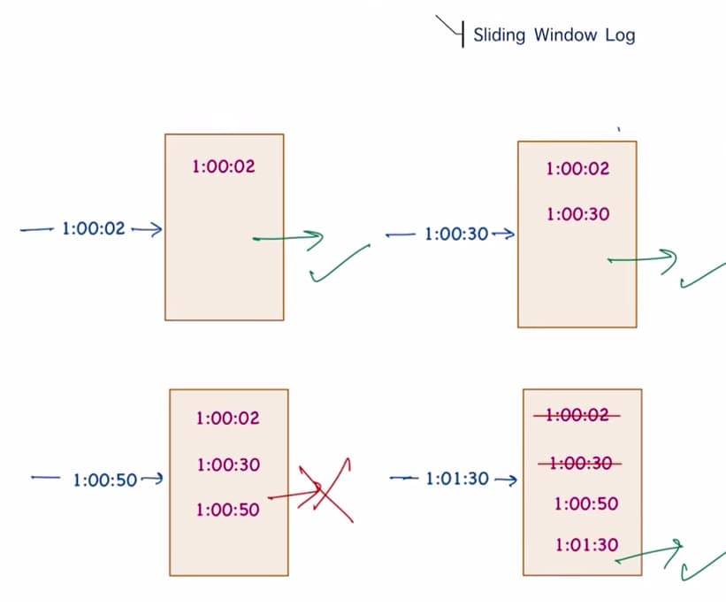
So we’ve sliding window of all requests and we keep a log entry, good thing about this algo is it is very accurate and it will never allow requests to pass through in a rolling window but there is one caviat that this algo is not memory efficient, we’ve to store a log of all of the requests that are coming in and we also have to maintain a record of all of the requests that we denied, we’re basically sacrificing some memory for greater accuracy.
There is no particular fixed method that can be said to be the best one, based upon the requirement & input data and the type of the system that we’re designing we’ve to pick an algo, there can be multiple algo as well but the basic idea remains same we’ll have to maintain a counter that we’ll increment and then we’ll decrement and this will determine if the request has to pass through or we’ve to deny it, when it comes to incrementing and decrementing, redis is very popular. It is an inmemory store that only supports 2 operation increment and decrement
Basic high-level design
We had client, API servers and rate limiter implementation in middle we can choose what implementation we want and we can add redis component to our design, but we had to make a design such that we can throttle on all of the diff rules possible there can be multiple rules based on which we have to implement our algo so where are all of these rules stored and how we are notifying client that your request failed, so these components needs to be added.
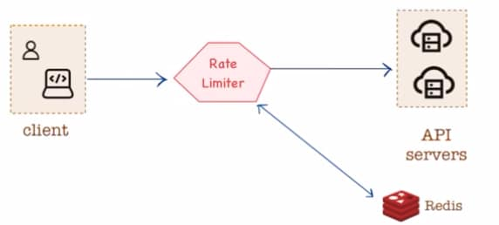
We should be able to query all of the rules that determines rate limiting, these rules they can be stored in a db, and we do not want to query our db again and again, so I have my rules db, before this rules db we can add caching layer and this caching layer will frequently try to update all of the rules and then instead of querying all of our rules db again and again we can ask rate limiter to query the cache instead, so this takes care of all of the rules based upon which we might have to perform rate limiting.
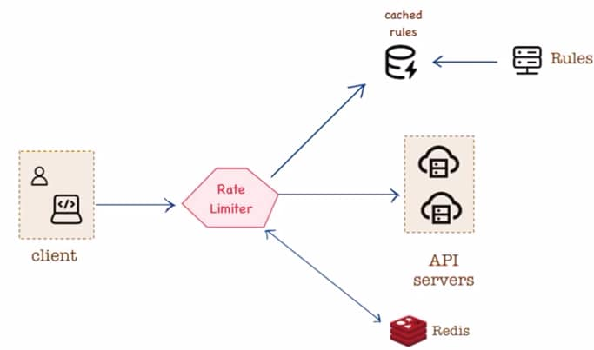
Now what about all of the requests that are getting denied?
In that case rate limiter will inform the client about all of the rate limited requests and we’ve more options, for every rate limited request we can drop this request completely or we can take this request and it to a Message Queue the purpose of MQ is if we want to retry we can look in our MQ and again try to make the request, it is optional based upon the requirement, this is how design of rate limiter looks like.
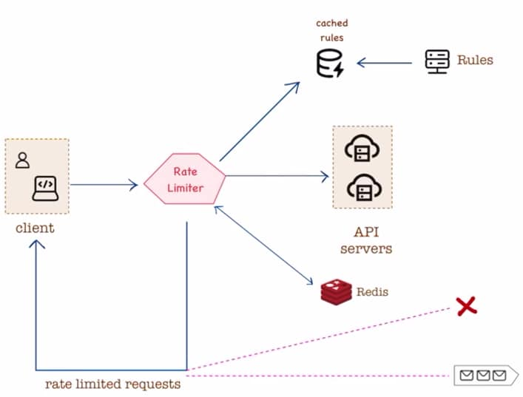

Handling a Distributed System (DS):
In a DS we’ll have diff rate limiters, one could be in a diff region and rate limiter could be in a diff region, it could be possible that client1 connect to the rate limiter1 and client2 connect to the rate limiter2 but whenever new requests are made then client1 connect to the rate limiter2 and client2 , connect to the rate limiter1 in such a case it may be possible that rate limiter2 does not know anything about client1, how many requests has the client1 made and similarly for client2 at rate limiter1, so we maintain a common redis store we do not have individual redis store for each of our rate limiter rather connect all of our rate limiter with a single redis store and this we’re able to maintain a DS b/s now rate limiter2 knows everything about all of the requests that client1 made and this redis store is giving us all of that info.
