FROM SIMPLILEARN------------(45 interview questions)
- What is SQL?
SQL is a structured query language, it is the language used to talk to databases. Like giving instructions to a computer system that store and organizes data Eg. I want to find out all the customers who ordered a specific product then SQL can help you do that with a simple command.
We can also use SQL to add new data like entering a new customer details into db, if you want to update someone’s phone number then SQL has got you covered, or maybe you want to delete old records that are no longer needed, SQL can handle that too.
Eg. To find all the customers in New York:
select * from customers where city = “New York” ;
Eg. To add new customers:
insert into customers(name,city) values(‘John’,’Los Angeles’);
With SQL, you can query, update, insert and delete data.
- What are different type of SQL commands?
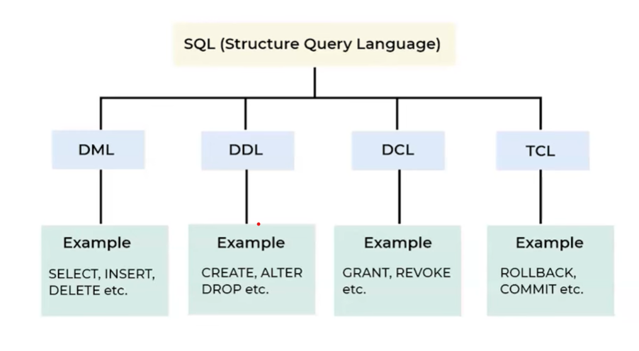
DDL- Data Definition Language
It defines structure of a database, Eg. If you want to create/alter/drop a table
DML- Data Manipulation Language
It deals with the actual data in the db. Eg. SELECT, INSERT, UPDATE, DELETE
DCL- Data Control Language
It will manage permission and access control Eg. GRANT, REVOKE
Grant will provide access rights and revoke is used to remove the access rights.
TCL- Transaction Control Language
It will manage transactions in the db Eg. COMMIT – it is used to save changes
ROLLBACK – it is used to undo the changes
SAVE POINT – it is used to create intermediate points in a transaction
For instance, in a schema with customers and order table, DDL commands are used to define the table whereas DML commands, it is used to update customer or order data, DCL is used to control access and TCL is used to manage transactions.
3. What is primary key in SQL?
A primary key in SQL is like a unique id for each record in a table. No two rows in a table have the same value. Primary key column can’t have empty or null value.
Eg. In table customers, I have a column called customer ID as the primary key, then each customer have a unique customer ID, this makes easy to identify and retrieve specific customers from db.

Eg. If we have orders table, we can use customer id as a reference to connect each order to a specific customer, this help maintain data integrity across the db.
4. What is foreign key in SQL?
A FK in SQL is like a connection/link b/w 2 tables. It is a field in one table that refers to the PK in another table. This creates a relationship b/w the tables and ensures that the data stays consistent.
Eg. You have 2 tables, a customer table with a PK c/d customer ID and a sales table with a field c/d customer ID which is a FK linking back to the customer ID in the customers table.
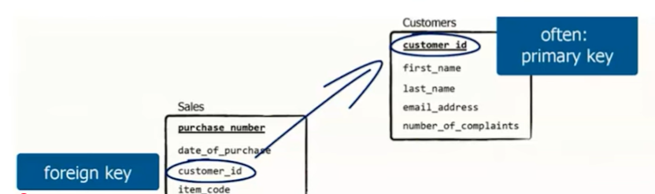
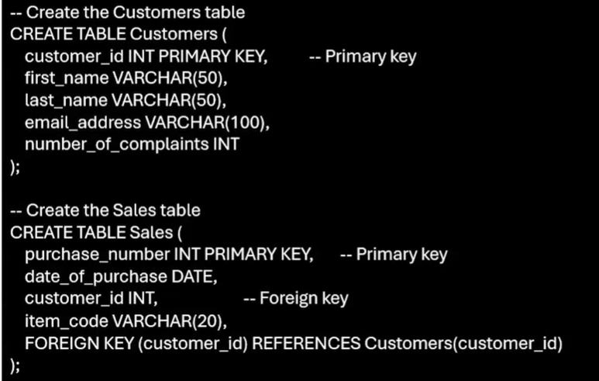
5. DELETE and TRUNCATE commands
DELETE and TRUNCATE commands in SQL both remove data from a table, but they work in different ways.
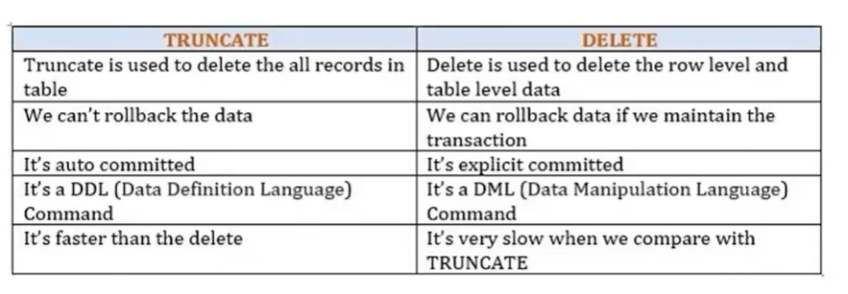
DELETE command is used when you want to remove specific rows from a table based on a condition.
Eg you want to delete all the customers based on the specific city, then we can use DELETE command. It will allow you to be selective but it is slower b/s it logs each row deletion which also make it possible to rollback the changes if needed, if you are using transactions.
TRUNCATE will remove all the rows from a table at once without allowing any condition. Eg. Simply write it as truncate table tablename. It is much faster b/s it doesn’t log individual row deletion, and it simply clears the entire table in one go. You can’t rollback a truncate operation in most db’s once it’s done.
DELETE is for specific rows & TRUNCATE is for clearing the entire table.

6. What is a JOIN in SQL, and what are its types?
A JOIN in sql is used to combine a data from 2 or more tables based on related column, like a common key that links them together. Its just like connecting pieces of puzzles join help you see the picture by merging related data.
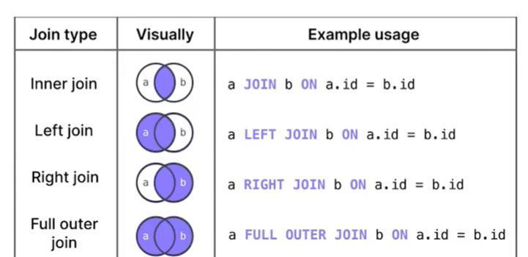
Eg. If you’ve a customer & a orders table, you can use the join to see which customer place which order by linking them through a common column such as customer id.
Type of JOINS-
Inner join: It’ll combine rows from both tables where there is a match in the common column, like we can see overlapping section in the venn diagram, only rows that exist and both the table are included.
Left join: Or left outer join, it will retrieve all the rows from the left table and the matching rows from the right table, if there is no match then result includes null values for the right tables column.
Right join: Or right outer join, it is similar to left join but it’ll retrieve all the rows from the right table and matching rows from the left table, if there is no match null values are included for the left table column.
Full join: Or full outer join will combine rows when there is a match in the either table if no match is found it includes null/ missing values from the either table. When combining both the circles in the venn diagram and everything from both the tables are included.
7. What do you mean by null value in SQL?
A NULL value in SQL means that a column has no data – it’s missing or unknown. Its not the same as an empty string or the number zero, those represent actual value whereas null represents no value at all. Eg. You’ve a table of customers and one of the row doesn’t have a phone number, then the phone no.column for that row will be null.
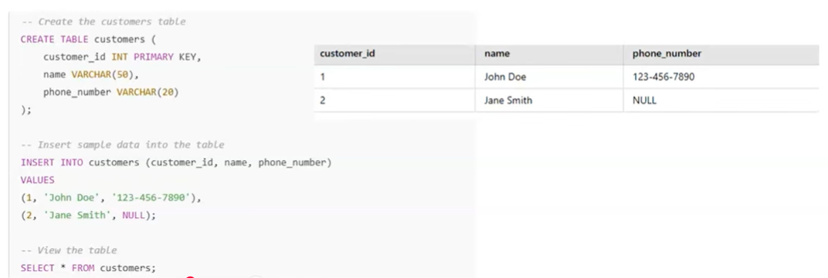
8. Define a unique key in SQL?
A unique key in SQL ensures that all values in a column (or a combination of columns) are unique – no duplicates are allowed. It is like having a rule to make sure that no two rows in a table must have the same value in that column. Eg. In a user table the email column can have a unique key to ensure that no two users can register with the same email address.
Unlike a primary key, a table can have more than one unique key. Unique keys allows null values, while primary keys do not.
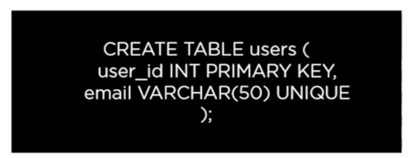
9. What is a database?
A db is an organized way to store and manage data.
In this the information is neatly arranged in tables with rows and column. Each row represents record (like a single entry) and each column represents specific detail about that record (like a name or date)
Eg. A db for a library must have a table for books, then the rows represents individual books and the columns include book title, author and publication year.
Db’s are used in everything from apps to websites to banking system and ecommerce platform.
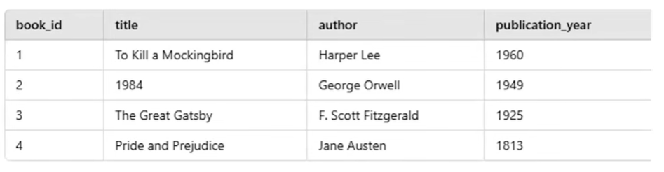

10. D/f b/w SQL and NoSQL databases?
SQL db’s are structured which means they can store the tables with rows and column like spreadsheet they follow predefined schema meaning structure of data is fixed and you need to define it before adding any data, these db’s are great when you need consistent and reliable data like banking system Eg, MySQL, Oracle, PostgreSQL etc. SQL db’s are also known as Rdms which is relational db management system.
NoSQL db’s are flexible and do not use table instead they can handle unstructured or semi structured data, NoSQL db is dynamic where data is primarily stored in JSON objects like key pair
They don’t have a specific structure, such db’s are mostly not preferred for performing complex query operations. Eg MongoDB, DynamoDB, Elastic search etc.
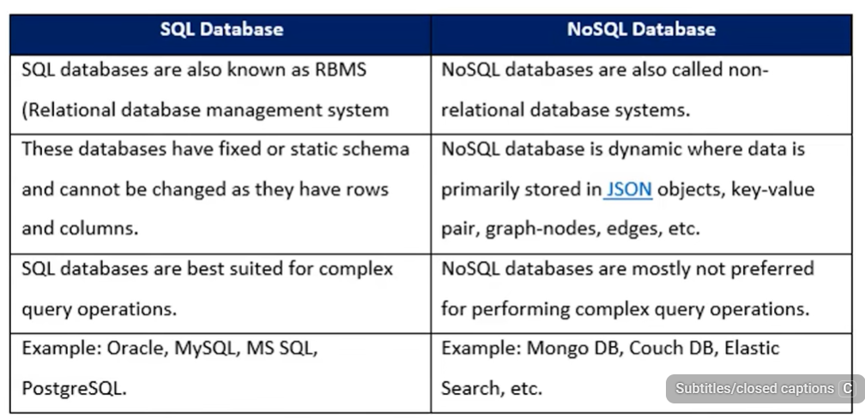
11. What is a table and a field in SQL?
A table is like a spreadsheet that stores data in organized way using rows and columns. Each table contains rows (records) and their details (columns). Eg Employee table stores information about employees in a company
A field is a column in a table which represents specific attribute or property of the data. Eg, In the employees table fields/column could be employee id, name and department
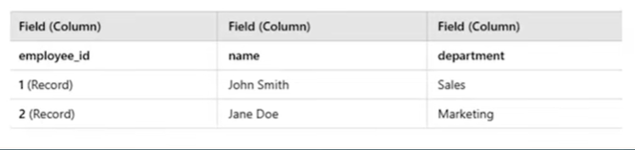
12. Describe the SELECT statement?
It is used to retrieve data from a table (or multiple tables), like asking db to show me specific information. You can specify which column you want to see.
Eg, To retrieve all customer names from a customer table:
SELECT name FROM customers;
Eg. If you want to retrieve all the data of customers table:
SELECT * FROM customers;
We can also apply filters we can use where clause to filter the results
SELECT name FROM customers where city=’New York’;
We can also sort the results using order by to sort the data, for instance to sort the customers by the name:
SELECT name FROM customers order by name ASC;
13. What is a constraint in a SQL? Name a few?
A constraint in SQL is a rule applied to a table that ensures that the data stored is accurate and consistent. It helps maintaining data integrity by restricting what values can be added/modified in a table. Some of them are:
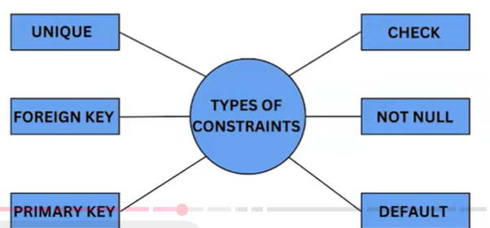
CHECK ensures that data meets specific condition before being inserted or updated.
NOT NULL ensures that a column cannot have null values
14. What is normalization in SQL?
Normalization in SQL is a process used to organize the data in a db to make it more efficient and reliable. The goal is to reduce redundancy (duplicate data) and ensures data consistency.
This is done by splitting a large table into smaller related tables and then linking them using relationship like PK and FK
Eg. Imagine a single table that stores customer details and orders, if the same customer places multiple orders then their info like name and address will be repeated for each order, now using normalization you would seperate this into 2 tables, first we’ll have customer table which will store customer details like customer id, name etc and then we’ve order table which will store order details like order id, customer id and the order date. Now by linking these tables using customer id you can also reduce duplication and ensure that any changes to customer details are updated in just one place.
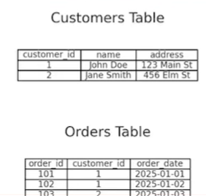

15. How do you use the WHERE clause?
WHERE clause serves the purpose of selectively fitering rows according to specified conditions, by enabling you to fetch exclusively those rows that align with the criteria you define.
Eg. SELECT * FROM employees WHERE department=’HR’;
16. D/f b/w UNION and Union ALL?
Union merges the contents of two structurally compatible tables into a single combined table. The d/f b/w UNION and Union ALL is that Union will omit duplicate records whereas Union ALL will include duplicate records.
Performance of Union ALL is better than Union, since Union requires the server to do the additional work of removing any duplicates. So in cases, where is certain that there will not be any duplicates, or where having duplicates is not a problem, use of Union ALL would be recommended for performance.

17. What will be the result of the query?
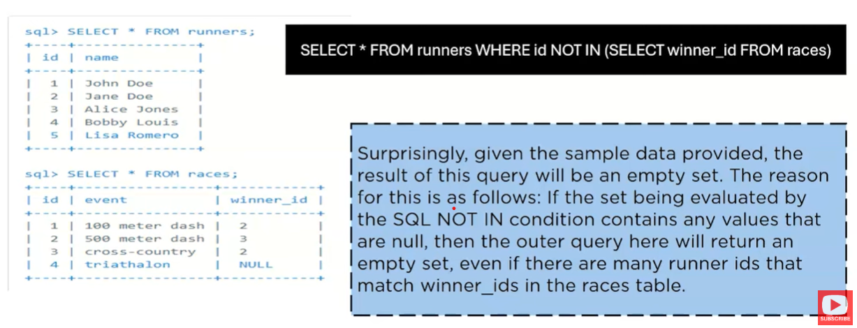
18. What are indexes in SQL?
Indexes in SQL are like a shortcut to quickly find data in a table. Instead of searching through every row one by one, an index creates a sorted structure based on one or more columns, making data retrieval much faster.
Eg. We can think of an index in a book, and if you’re looking for a specific topic you can go to the index at the back and find the page no. and stop flipping through every page similarly in db an index help the system quickly locate the rows you need.
So, if you often search customers by the name creating an index will speed up those queries:
CREATE INDEX idx_customer_name ON customers(name);
The db uses the index to find the row so you just have to run a query which is:
SELECT * from customers where name=’John’, and then you can use the index to find the row with name equals to John much faster
19. Explain GROUP BY in SQL?
GROUP BY clause in SQL groups rows with the same values in a column allowing you to apply functions like SUM, COUNT, or AVG to each group.
Eg. In a sales table to find total sales by region we write it as:
SELECT region, SUM(amount) AS total_sales FROM sales GROUP BY region;
So we group the sales by region and calculates the total for each.
20. What is an SQL alias?
A SQL alias is a temporary name you give it to a table or a column in a query to make it easier to read or work with. It’s like giving a nickname to something for clarity.
Eg SELECT first_name AS “FIRST_NAME”, last_name AS “LAST_NAME” FROM employees;
for first_name column, you can use an alias to rename it as FIRST_NAME
Here the as keyword assigns the alias and the output will show the column as FIRST_NAME and LAST_NAME
Aliases are also useful for tables:

This shortens table name for easier referencing. Alias are not permanent, they only exist while the query is running.
21. Explain ORDER BY in SQL?
ORDER BY clause is used to sort the result set of query based on one or more columns. You can specify each column’s sorting order (ascending or descending)
Eg, SELECT * FROM products ORDER BY price DESC;

22. D/f b/w WHERE and HAVING in SQL?
WHERE clause is employed to restrict individual rows before they are grouped such as when filtering rows prior to a GROUP BY operation
The HAVING clause is utlilized to filter groups of rows after they have been grouped,like filtering groups based on aggregate value.
HAVING clause cannot be used without a GROUP clause whereas the WHERE clause specifies the criteria of which individual records must be in selected query it can be used with the GROUP BY clause.
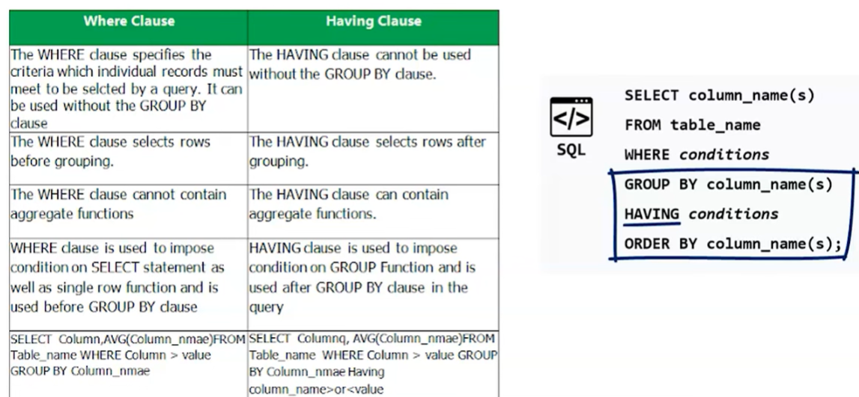
23. What is a view in SQL?
- SQL view is a virtual table that derives its data from the outcome of a SELECT query.
- Views serve multiple purposes, including simplifying intricate queries, enhancing data security through an added layer, and enabling the presentation of target data subsets to users.
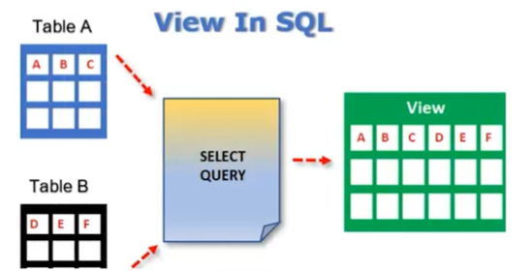
24. What is a stored procedure?
A SQL stored procedure comprises of pre compiled SQL statements that can be executed together as a unified entity. These procedure are commonly used to encapsulate business logic, improve performance, and ensure consistent data manipulation practices.
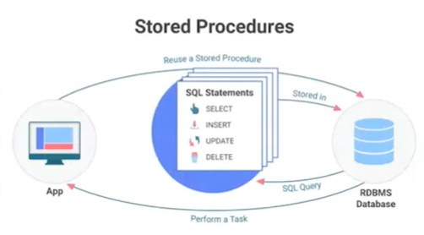
25. What is a trigger in SQL?
A SQL trigger consists of a predefined sequence of actions that are executed automatically when a particular event occurs, such as when an INSERT or DELETE operation is performed on table.
Triggers are employed to ensure data consistency, conduct auditing and streamline various tasks. You can use INSERT TRIGGER, UPDATE TRIGGER, DELETE TRIGGER accordingly.
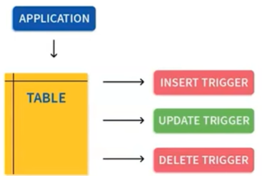
26. What are the aggregate functions? Can you name a few?
AGGREAGATE functions perform calculation on a set of values and returns a single result
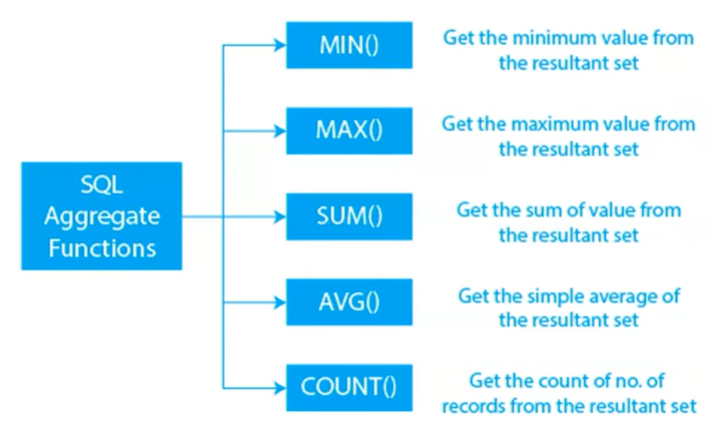
27. How do you update a value in SQL?
UPDATE statement serves the purpose of altering pre existing records within a table. It involves specifying the target table for the update, the specific columns to be modified, and the desired new values to be applied.
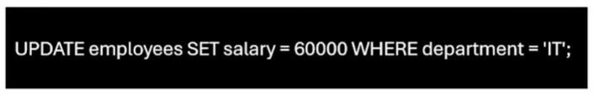
28. What is a SELF JOIN, and how do we use it?
A self-join is a type of join where a table is joined with itself. It is useful for comparing rows within the same table or exploring hierarchical relationship, such as finding employees and the manager in the same organization.
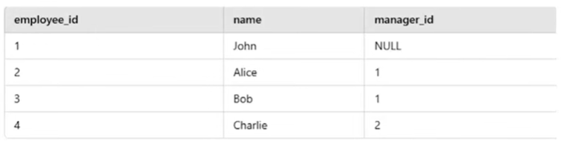
If you have an employee table, where you have employee_id, name and manager_id, so if you want to find each employee and the manager you can use SELF JOIN
You can write a query as:
SELECT e.name AS Employee, m.name as Manager from employees e LEFT JOIN employees m ON e.manager_id = m.employee_id;

29. Explain different type of JOINS with example?
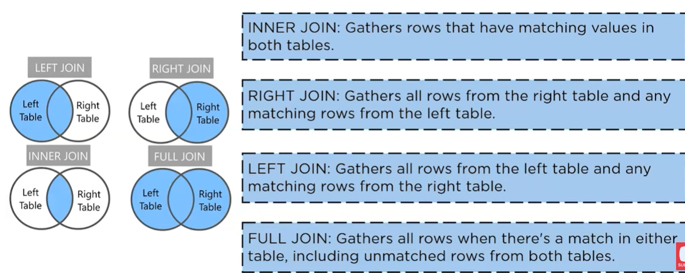
30. What is a subquery? Provide an example
A subquery refers to a query that is embedded with another query, serving the purpose of fetching information that will subsequently be employed as a condition or value within the encompassing outer query.
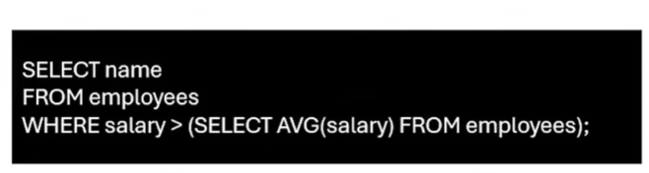
31. How do you optimize SQL queries?
- SQL query optimization involves improving the performance of SQL queries by reducing resource usage and execution time.
- Strategies include using appropriate indexes, optimizing query structure, and avoiding costly operations like full table scans.
32. What are correlated subqueries?
- It is a type of subquery that makes reference to columns from the surrounding outer queries.
- This subquery is executed repeatedly, once for each row being processed by the outer query, and its execution depends on the outcomes of the outer query.
33. What is a transaction in SQL?
A transaction in SQL is a group of one or more SQL commands that are treated as a single unit. It ensures that all the operations in the group either succeed completely or fail entirely. This guarantees the integrity of the database.
Eg. Transferring money from my bank account to friend’s account, so the bank first deducts the amount from my account and then it adds the same amount to your friend’s account, these two steps together form a transaction if one of these steps fails like the system crashes after deducting money from my account but before adding to friends account then the entire transaction is rolled back meaning no money is transferred and the db returns to its original state.
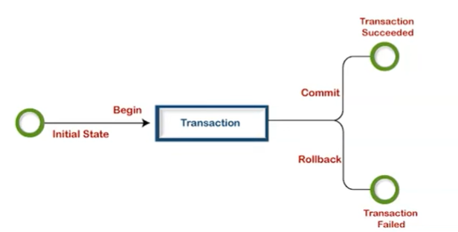
34. Explain ACID properties in SQL?
ACID stands for atomicity, consistency, isolation, and durability. These are key properties that ensures database transactions are reliable and maintain data integrity.
Atomicity you can think of it as all or nothing. A transaction is a single unit of work, if any part of the transaction fails then the entire transaction is rolled back and no changes are made to the db.
Eg. If you’re transferring money b/w two accounts either both the debit and credit operations happen or neither does.
Consistency The db must always be in balanced state. A transaction takes a db from one valid state to another following all the rules and constraints.
Eg. If a transaction adds a record that violates a rule like a duplicate PK, then the transaction fails keeping the db consistent.
Isolation Isolation and transactions don’t interfere with each other, even if multiple transactions are running at the same time each transaction works as if it’s the only one happening.
Eg. If two people are updating the same record then one transaction will wait until the other is complete.
Durability Once a transaction is committed it’s permanent even if there is a power outage or system failure the data is saved and it won’t be lost.
After you complete an online purchase the transaction is stored securely even if the server crashes immediately after.
35. How do you implement error handling in SQL?
Error handling in SQL is a process to manage and respond to the error that occur during query execution. Different database systems have specific ways to handle errors.
In SQL server the try catch block is commonly used, the try block contains the main operation while the catch block handles errors if they occur.
For instance, in a transaction you can use rollback in a catch block to undo changes if something goes wrong
Similarly, in oracle the exception block within PLSQL is used to handle errors. If an error arises, the exception block executes rolling back the transaction and looging the error message.
By implementing error handling you ensure that operations fail gracefully without corrupting data making the db operation more reliable and secure.
36. Describe the data types in SQL?
SQL supports various types of data types, which define the kind of data a column can hold. These are broadly categorized into numeric, character, date/time, and binary types.
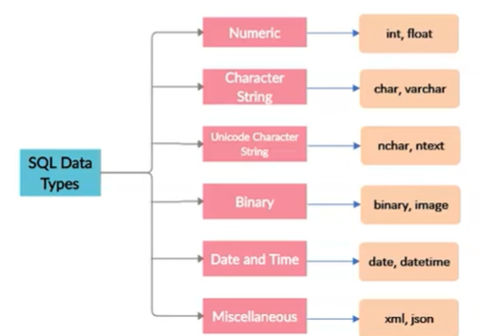
37. Explain normalization and denormalization?
Normalization is breaking the tables into smaller ones to remove duplicate data and improve accuracy. Eg. Instead of repeating customer details in every order, you can create one table for customer and another for orders linking them with the key.
Denormalization is when you combine or duplicate data to make it faster to retrieve. For instance you might add customer details directly to the orders table so that you don’t need to join tables during a query.
Normalization help you space and maintain consistency while denormalization make data retrieval quicker depending on what the db needs.
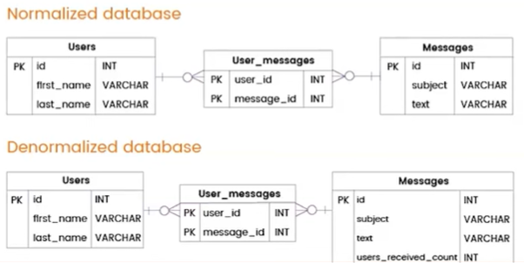
38. What is a clustered index?
A clustered index in SQL determines the physical order of the data rows in the table. Each table can have only one clustered index, which impacts the table’s storage structure.
Rows in a table are physically stored in the same order as the clustered index key.
39. How do you prevent SQL injection?
SQL injection is a security risk where attackers insert harmful code into SQL queries, potentially accessing or tampering with your db.
To prevent this you can use parameterized queries or repair statements to handle user inputs safely.
You can validate inputs to allow only expected values, use stored procedures to separate logic from data, limit database permissions, and escape special characters.
These steps help you secure that your db is free from SQL injection.
40. Explain the concept of db schema?
A db schema functions as a conceptual container for housing various db elements such as tables, views and indexes and procedures.
It’s primary purpose is to facilitate the organization and segregation of these db elements while specifying their structure and interconnections.
41. How is data integrity ensured in SQL?
It is ensured through various means, including constraints (Eg. PK, FK, CHECK constraints), normalization, transactions, and referential integrity constraints. These mechanism prevent invalid or inconsistent data from being stored in the db.
42. What is a SQL injection?
SQL injection is a cybersecurity attack method that involves insertion of malicious SQL code into application’s input fields or parameters. This unauthorized access enables attackers to access a db, extract confidential information, or manipulate the data.

