What is Docker?
- Docker is a software development platform to deploy apps
- Apps are packaged in containers that can be run on any 0S
- Apps run the same way, regardless of where they run it could be
  - Any machines
  - No compatibility issues
  - Predictable behavior
  - Less work to do
  - Easier to maintain and deploy
  - Works with any kind of language, any OS, any technology
- Use cases: microservices architecture, lift and shift apps from on premises to AWS Cloud
Docker on an OS
We have a server (like EC2 instance), then we can start docker containers, like 1st docker container may contain JAVA app, 2nd docker container may contain nodejs app, and we can have multiple docker containers of the same JAVA application, and we can also run db's within Docker
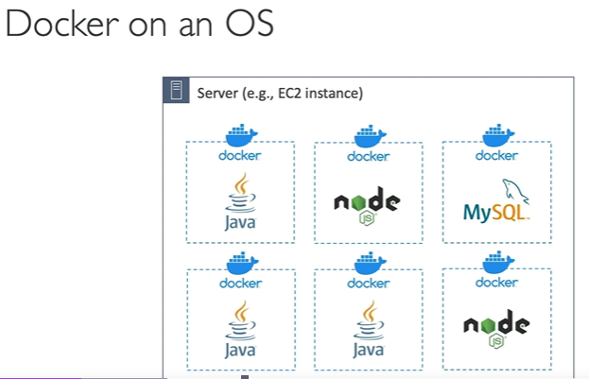
Where are docker images stored?
- Docker images are stored in docker repositories
- Docker Hub
  - It is a public repository
  - We can find base images for many technologies or OS (like Ubuntu, MySQL etc)
- ECR (Elastic Container Registry)
  - It is a private repository
  - There is also public repo available on ECR (from ECR public gallery)
Docker vs Virtual Machine
- Docker is sort of virtualization technology, but not exactly
- Resources are shared with the host, that is many containers on one server
- In the architecture of VM, we have infrastructure, host OS, hypervisor, and then we have apps which has VM, this is how EC2 works, Amazon provides many EC2 instances to many type of customers, all these VM are separated, they are not going to share resources and it is isolated.
- But in docker container, we have infrastructure, host OS (ec2 instance), docker daemon, and on the top of it there are lot of containers running on top of docker daemon, these containers share networking, share some data, it allows to run more containers on a single servers

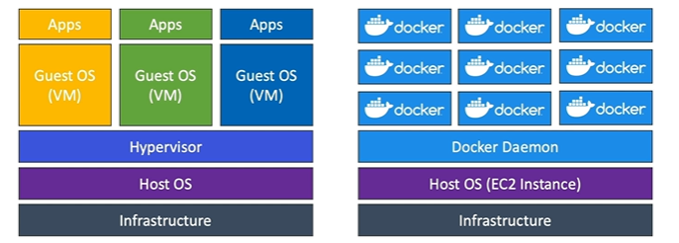

Getting started with Docker:

- First we have to write a docker file, which is defining how the docker container will look like, so in this we have base docker image and we add some files, and then we build the docker image, then that docker image we can store it in docker repository, push the docker image inside docker hub (public repo) or ECR , then we pull back these images from the repositories, and then we run the docker image which becomes a container, which runs a code which we have built from the docker build.
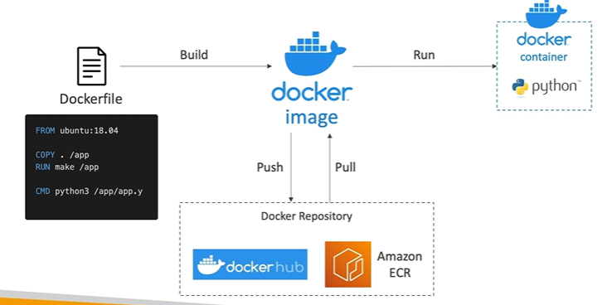

Docker container management on AWS
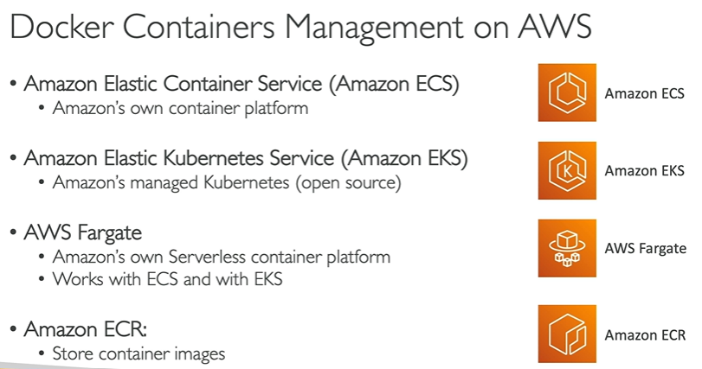

Amazon ECS
Amazon ECS- EC2 Launch Type
- When we launch docker containers on AWS, we are launching ECS Tasks on ECS Clusters
- EC2 launch type, in this we maintain the infrastructure of EC2 instances
- So, ECS cluster is going to be composed of multiple EC2 instances, these instances must run the ECS agent, these ECS agent register each ec2 instance into the ECS service, and the specified ECS Cluster
- When we start ECS tasks, then AWS is going to be starting or stopping the containers.
Whenever we have a new docker container, it is going to be placed accordingly on each EC2 instance overtime. We can start/stop the ECS tasks.

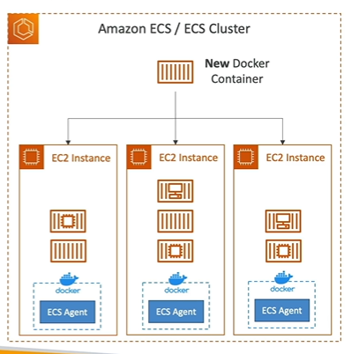

Amazon ECS- Fargate Launch Type
- We can launch docker containers on AWS
- We do not provision the infrastructure (no EC2 instances to manage)
- Its all serverless, no need to manage the servers
- In this, if we have ECS Cluster, we just create task definition to define our ECS task
Then AWS runs ECS tasks based on CPU/RAM you need
- To scale just increase the no. of tasks – no more EC2 instances

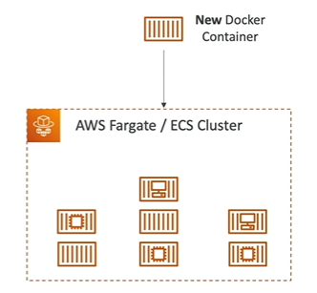

Frequently Asked Docker Interview Questions | Edureka

- What is Hypervisor?

It is a software that makes virtualization possible, it is also c/d virtual machine monitor. It divides the host system and allocates the resources to each of the divided virtual env

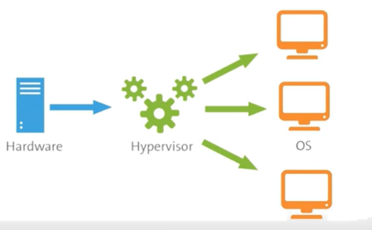

- What is virtualization?

Virtualization is the process of creating a software based, virtual version of something (compute storage, servers, application etc). It lets you split one system into many diff sections which acts like diff individual systems.

Virtual env created by hyper visor is c/d as Virtual Machine

- What is containerization?

An application that is being developed and deployed is bundled and wrapped together with all its configuration files and dependencies. This bundle is called a container.

So, when we wish to run the application on another system, so the container is deployed which gives bug free environment as all the dependencies and libraries are wrapped together, most famous containerization env includes docker and kubernetes.

- What is docker compose?

Docker compose is a YAML file which contains details about the services, networks, and volumes for setting up the docker application.

- What is docker swarm?

Docker swarm is native clustering for docker. It turns a pool of docker hosts into a single, virtual docker host.

- What is docker namespace?

A namespace is one of the linux features and an imp concept of containers. Namespace adds a layer of isolation in containers. Some of them are mount, ipc, user, network etc.

- What is the lifecycle of docker container?

First you create a container then you run the container, then you can pause/unpause the container depending upon the requirement, after that you can stop the container also you can restart the container, and when you are done using containers, after that you can kill the container and then destroy it.

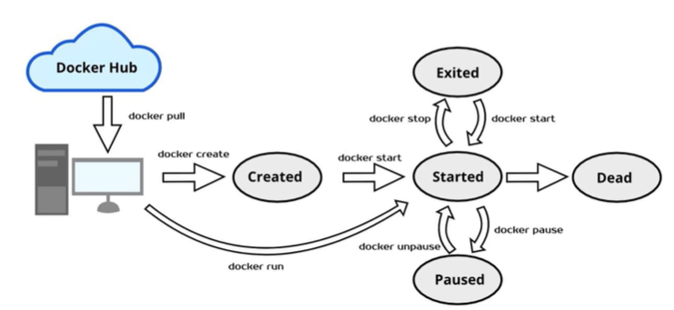
- What is docker machine?

Docker machine is a tool that lets you install Docker Engine on virtual hosts. Docker machine also lets you provision docker swarm clusters.

- How to check docker client and docker server version?

Just type docker version in the terminal

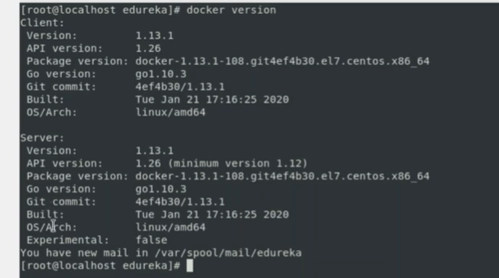

- How do you get the number of containers running, paused and stopped?

Type docker info in the terminal, we can see total images as well

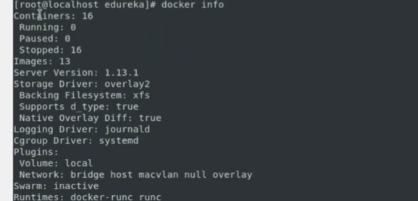

- If you vaguely remember the command and you’d like to confirm it, how will you get help on that particular command?

Type docker –help

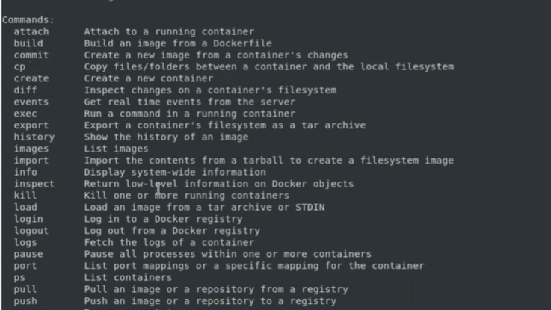

- How to login into docker repository?

docker login (to push and pull docker images from docker hub), then we have to enter the username and password, then we’ll able to login successfully

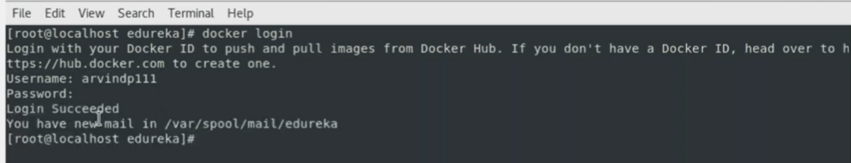

- If you wish to use a base image and make modifications or personalize it, how do you do that?

For that we use, docker pull <image_name>

Go to docker hub website to pull the base image, you can pull any image that you want. Suppose we are pulling postgres image from the dockerhub

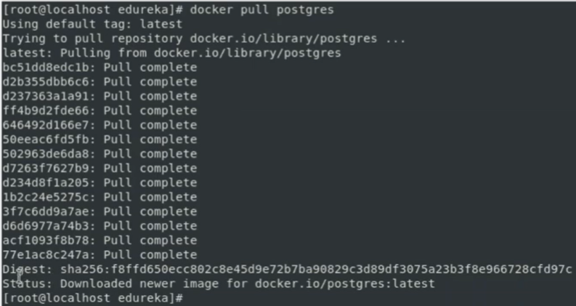
- How do you create a docker container from an image?

Command is: docker run -it -d <image_name>

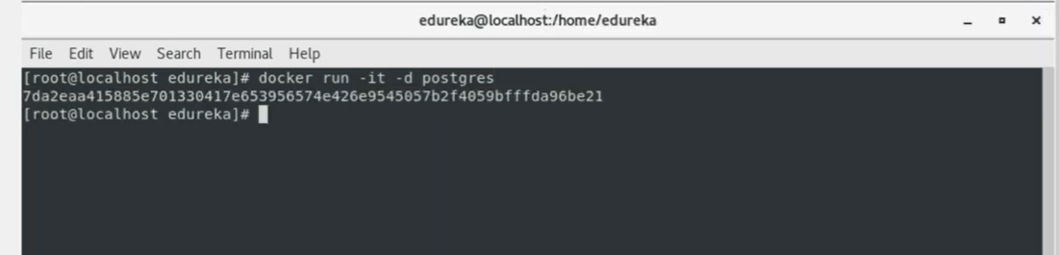

- How do you list all the running containers?

docker ps

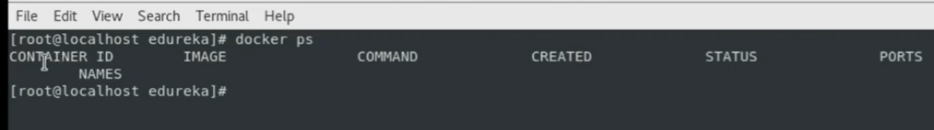

Right now there are no containers

- How do you access a running container?

docker exec -it <container id> bash

After running this command, we are inside container and we can do whatever operations that we want

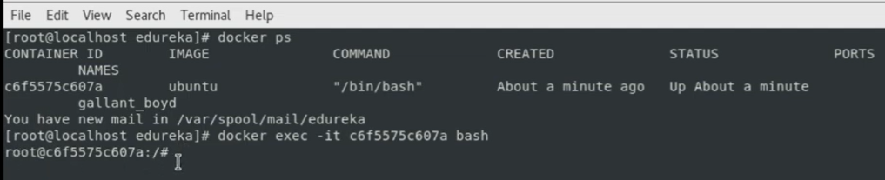

- How to start, stop and kill a container?

docker start <container id>

docker stop <container id>

docker kill <container id>

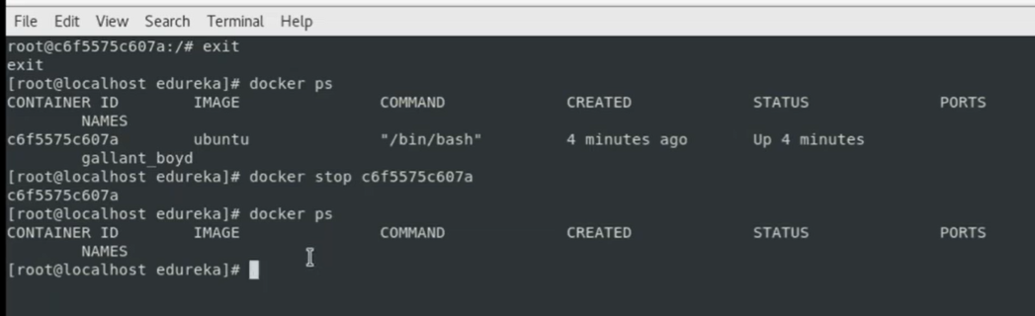

- Can you use a container, edit it and update it?

docker commit <container id> <username/imagename>

in this the image name is ubuntu

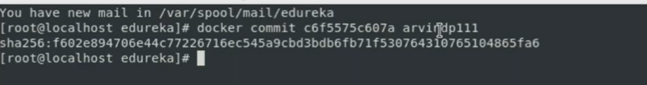

- Once you’ve worked with an image, how do you push it to the docker hub?

docker push <username/imagename>

- How to delete a stopped container?

First stop the container using command: docker start <container id> and then use:

docker rm <container id>

- How to delete an image from the local storage system?

docker rmi <image-id>

- How to build a Dockerfile?

Once you’ve written a dockerfile, you need to build it to create an image with those specifications. Use the followring command to build a dockerfile:

docker build <path to docker file>

- Do you know why docker system prune is used? What does it do?

Command is: docker system prune

This command is used to remove all the stopped containers, all the networks that are not used, all the dangling images and all built caches. This is one of the most useful commands in docker.

- Will you lose your data, when a docker container exits?

No, we won’t lose any data when a docker container exits. Any data that our application writes to the container gets preserved, until you explicitly deletes the container.

- Where all do you think docker is being used?

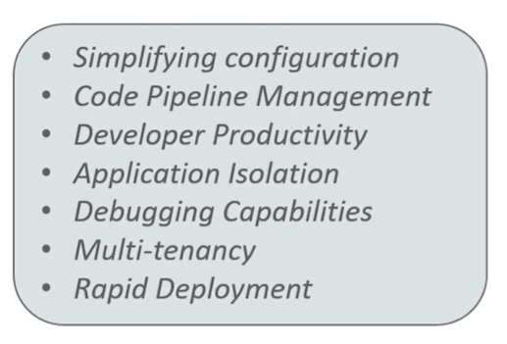

- How is docker different from other containerization methods?

Docker containers are very easy to deploy in any cloud platform. It can get more applications running on the same hardware when compared to other technologies. It makes it easy for the developers to quickly create ready to run containerized applications and it makes managing and deploying applications much easier.

- Can I use JSON instead of YAML for my compose file?

Yes

- How far do containers scale? Are there any specific requirement for the same?

Large web developments like Google and Twitter and platform providers such as dotCloud, all run on container technology. Containers can scale to 100’s or 1000’s or even millions of them running in parallel. Containers require the memory, and OS, and use the memory efficiently when scaled.

- What platforms does docker run on?

Ubuntu, linux, EC2, ECS, Azure etc.

- Is there a way to identify the status of a docker container?

There are 6 possible states a container can be at any give point of time – created, running, paused, restarting, exited, dead

- Can you remove a paused container from docker?

No, you cannot. The container has to be in stopped state before it can be removed.

- Can a container restart by itself?

No. By default the restart flag is set to false

- Is it better to directly remove the container using the rm command or stop the container followed by remove container?

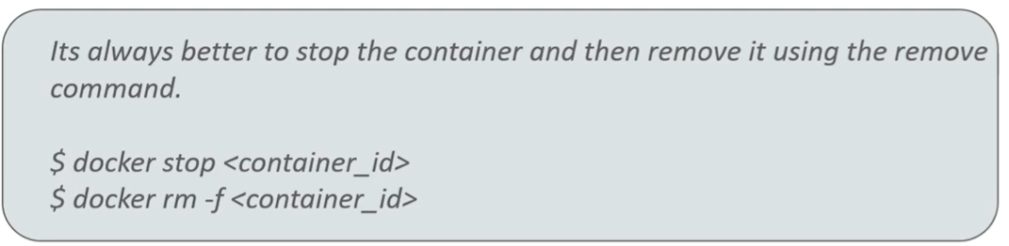

This is better b/s all the containers have enough time to clean up there tasks. This avoids unwanted errors and a good practice.

- Will cloud overtake the use of containerization?

Using cloud service with containerization will hype up the game. Docker + Cloud is good.

- How many containers can run per host?

There can be as many containers as you wish per host. Docker does not put any restrictions on it. But you need to consider every container needs a storage space, CPU, and memory which the hardware needs to support. Also we have to consider application size, containers considered to be light weight but very dependent on the host OS.

- Is it a good practice to run stateful applications on docker?

Stateful applications store their data onto the local file system. You need to decide to move the app to another machine by retrieving the data. It is not preferred to run stateful app on docker.

- Will docker compose wait for the current container to be ready to move to the running of the next service?

Yes, docker compose always runs in the dependency order. These dependencies are specifications like depends on, links, volumes from etc.

- How will you monitor docker in production?

Docker provides functionalities like docker stats and docker events to monitor docker in prod. Docker stats provides cpu and memory usage of container. Docker events provide info about the activities taking place in the docker daemon.

- Is it a good practice to run docker compose in production?

Yes, using docker compose in prod is the best practical application of docker compose. We can use it in staging, testing etc.

- What changes are expected in your docker compose file while moving it into production?

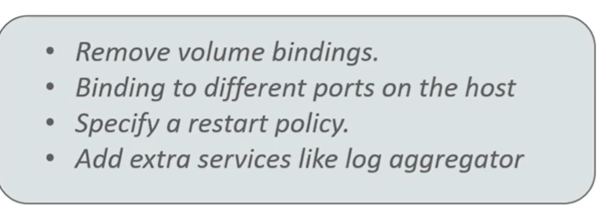

- Are you aware of load balancing across containers and host? How does it work?

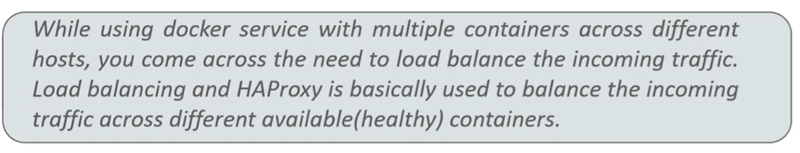

If one container crashes then another container automatically starts running, and the traffic routed to the new container.

