RAG (Retrieval Augmented Generation) – Krish Naik
RAG is the process of optimizing the output of a large language model, so it references an authorative knowledge base outside of its training data sources before generating a response.
LLMs are trained on vast volumes of data and use billions of parameters to generate original output of tasks like answering questions, translating languages and completing sentences.
RAG extends the already powerful capabilities of LLMs to specific domains or an organization’s internal knowledge base, all without the need to retrain the model.
It is a cost effective approach to improving LLM output so it remains relevant, accurate, and useful in various contexts.
Suppose we have an LLM, and a user is asking for a query, and before the query sent to the LLM we add a prompt, and this prompt is just like an instruction to the LLM , like how the LLM should work and based on which we’ll get an output. This is a simple GenAI application where the LLM is used to generate the content
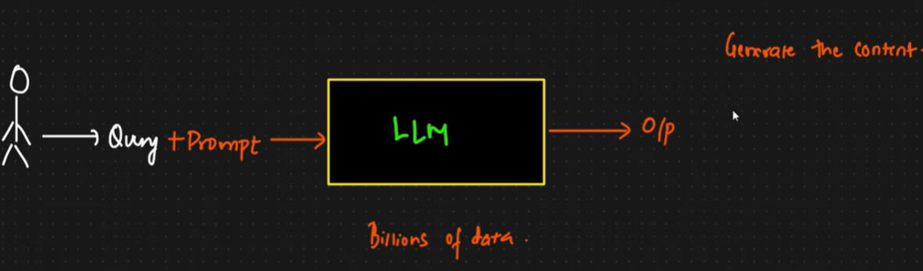
One of the disadvantage of this particular approach is, every LLM is trained for a specific set of data, so suppose today is 31st August, and we’ve an LLM model GPT5 from OpenAI, when the model was launched, so this model is trained with data till 1st August. So this LLM will not have any idea what has basically happened in the current world b/w 1st to 31st August. If I go ahead and ask a specific question to the LLM b/w these specific dates, the LLM will start hallucinating.
So, one of the major disadvantage of only using LLM is that it will hallucinate. Hallucination means that even though it doesn’t have knowledge about what has happened b/w 1st to 31st Aug, even though we ask any question, so the LLM try to generate its own answer, and it’ll show you answer that you may also have to believe it. This condition is c/d as Hallucinating.
2nd disadvantage is suppose I’m using this LLM and we know that this LLM has been trained for huge amount of data. Suppose I am running a startup, and in that startup I am solving a specific usecase and I have data, and I want to use this particular data along with LLM. Like I have data like policies of my company / HR policies of company / finance policies and this policies will not be available publicly as the data is protected. But I also want to use this data and create a chatbot.
One of the way is to take this data and we can fine tune the model, but fine tuning model is a very expensive process very tedious process b/s LLM has billions of parameters and tweaking this billions of parameters takes a lot of time.So this is a expensive solution.And everyday we can’t fine tune, as the policies data can change.
The solution to prevent this is with the help of RAG. So, instead of fine tuning we’ll implement the RAG.
So, we have LLM and user give a query, now 2 pipelines gets created, as LLM is already trained with huge amount of data and along with this we’ve an external database c/d as Vector database. As LLM is trained with some amount of data and any additional data like startup data/policies data, with this data we’ll try to create a data ingestion pipeline.
Data Ingestion Pipeline: Lets say I have my data and from this data we will do some parsing and from this parsing we will do embeddings and then we finally store it into vector store.
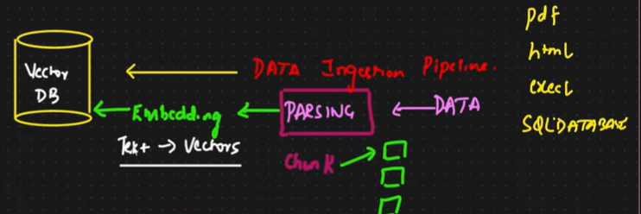
This data can be in any format like pdf/html/excel/sql db format, any type of format. So initially we will take this data, and do data parsing. Data Parsing is all about how do you read the unstructured/structured data that is present inside this and how do you divide specific data into chunks. Chunking is very important as we need to save the data into some kind of vector store/vector db.
Vector store/vector db will help us to save vectors. So once you do the chunking and after doing the chunking you pass it to embedding models. In the embedding models you convert text to vectors. Vectors are just numerical representation for text, so that we will able to apply algorithms like similarity search, cosine similarity techninques that are already available wherein similar kind of results based on specific query can be retrieved from this particular databases
Embedding will be applied to every chunks. We can use different different embeddings like Google Germany Embedding models, OpenAI embedding models, Huggingface embedding models and each and every embedding models exist with different costs and there are opensource embedding models as well which will help you convert the text into vectors. So, this is one specific pipeline which is Data Ingestion Pipeline. At the end of data ingestion pipeline, we’re able to store text into vectors inside vector db. This data is specifically for statup like for policies/finance data . So now vector db is our knowledge base. Knowledge base can be either internal/external.
This Knowledge base does not exist with LLM, some amount of information may be available but not the entire part.
Now, when user gives a query , now this query instead of directly going to LLM will go to this vector db, and before going we need to apply embeddings, b/s the user’s query will be converted into vectors, and we need to convert into vectors so that when we are hitting this query to the vector db, then similarity search is basically applied and based on this we get some kind of context, we get some information from the vector db.
Now whatever query I am asking like: what is the policy of my company, so first it goes to the vector store and it will gather all the relative information which is available and when it is sending it to the llm it is called as context . Now we use this context and along with that we write a specific prompt, now this prompt is an instruction to LLM and says that you can use this context to answer the question and finally you get the output
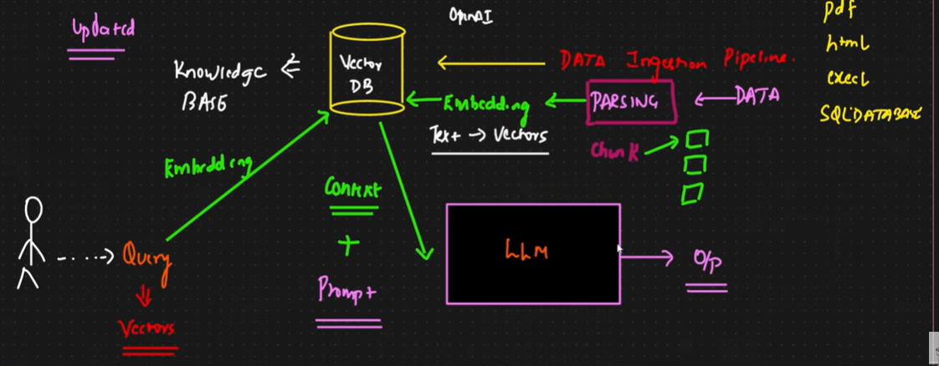
This is the entire pipeline and it is basically called as Retrieval Pipeline. It is very good example of traditional RAG.
It removes some amount of hallucination. If any query is asked related to the data present in the vector db so I definitely get some kind of context, and my LLM will give me the output, if the data is not present in the vector db then LLM can hallucinate
Eg. Perplexity: It is based on RAG applications. In perplexity, it is connected to various retrievers, tools, web search and then it summarizes the o/p and give it to LLM
2 Pipelines are there: is Data Ingestion Pipeline and Retrieval Pipeline.
In Data Ingestion Pipeline, we will be performing data injection, then data parsing then we perform embeddings then we store everything to the vector store, then we create retriever for this, and when user ask any query, it will be able to give context to the LLM and then we’ll be finally generating the output.
So the Data Ingestion Pipeline is Retrieval and when retriever connects to LLM through vector store this is Augmentation. Augmentation is giving context to the LLM along with the prompt to generate the o/p. And when output is generated it is c/d as Generation
