FASTAPI – A python framework (4 hrs- bitfumes)
FASTAPI is a super fast python web framework. It has feature of asynchronous programming. It provides automated documentations, bydefault fastapi provide swagger ui, where we can simply check what routes we’ve created or what are the endpoints you’ve created, and we can also try the apis inside swagger, and see the response.
FASTAPI also provides ReDoc UI, it has minimal design for the documentation.
Pydantic library:
From Pydantic library, fastapi provides typing system i.e. you can type variable and other things, like in this user_id should be string or id should be int.
Fastapi also has auto complete feature, which is also achieved through typing system using pydantic library.
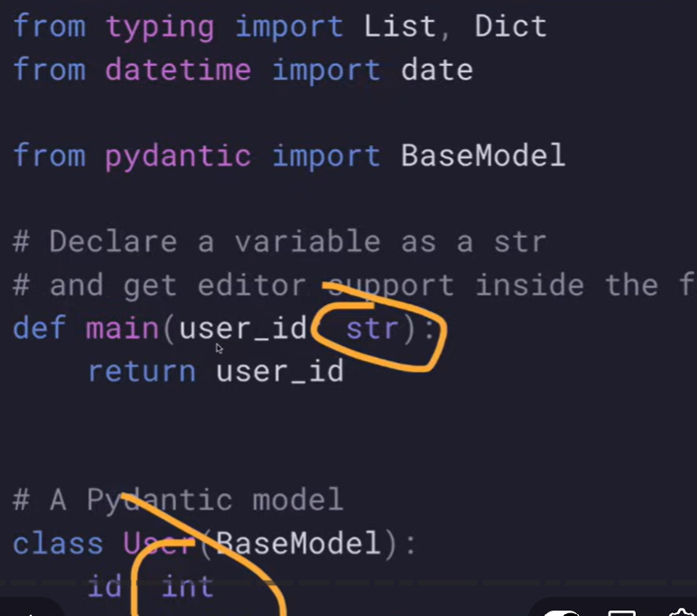
FASTApi is totally based on open api and json schema, open api is a linux foundation and it defines how you create your API, so that you’ll create a standardized API. It also has JSON schema i.e. it by default returns JSON which every modern API need.
FASTAPI security and authentication:
- HTTP Basic
- Oauth2 with JWT token
You can send API token in the header, query, cookies etc.
You can test fastapi application using pytest.
FASTAPI uses Starlette features-
Starlette is another framework of python, fastapi built over starlette. Stralette provides websocket support, graphql support, inprocess background tasks, startup and shutdown events, session and cookie support, CORS, Streaming responses.
Other supports-
SQL db’s, NoSQL db’s, and GraphQL
localhost:8000/docs for swagger & localhost:8000/redoc for redoc
To create virtual environment (folder) we use: python -m venv venv
Then activate the virtual environment: venv\Scripts\activate
Then we install the dependencies needed (requirements.txt)
To upgrade pip version: python -m pip install –upgrade pip
If you are not using venv so it will be available globally.
app = FastAPI() …..in this way instance of fastapi is created
then index() is created which will return hello
@app.get(‘/’)………..in this @ is the decorator, where app is the fastapi and / means the base url like localhost:8000
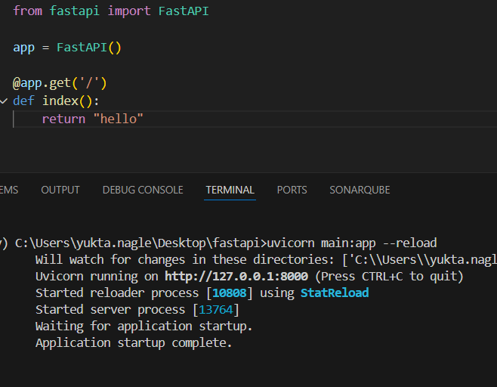
o/p on localhost:8000 is “hello”
import, instance, function, decorate these 4 things needed
We are returning a simple string, generally now api needs JSON, so we can return it as {}
(like dictionary), which is having ‘data’ and another dictionary which is going to have name and it’s value. So, we have JSON returned
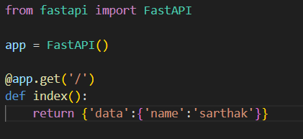
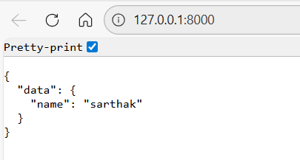
- To create the about router we use it like:
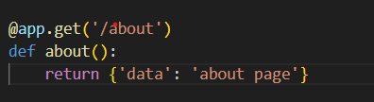

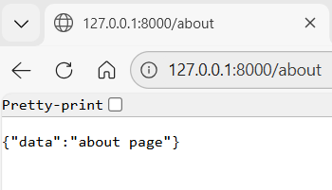

We start the server with uvicorn main:app --reload…in this main is the main.py file, and app b/s we have created instance of fastapi as app
And - - reload restarts the server whenever any new changes is done.

What if we change the name of instance as myapp and not app?
So now the server run as: uvicorn main:myapp, so it totally depends on the naming. Similarly we can create function of any name
Similary we can change the name of main.py file as well and run the server according to that.

I can create same functions as well, if the routers are not same. We’ll get the same output.

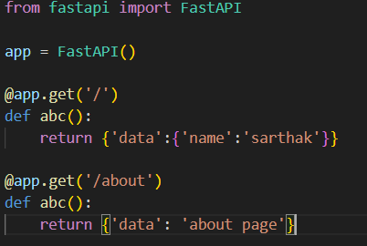

In this ‘/’ is the base path and ‘/about’ is the about path
Like get method we have post,put,delete methods
get is the operation on the path

And the function above which we are defining the operation and the path using app decorator is c/d path operation function i.e. abc() , b/s we are performing the operation on the path through function only

@app is the path operation decorator

- To fetch all the blogs:

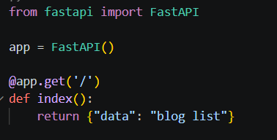

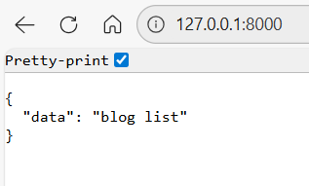

- To fetch or show a single blog:

In FastAPI, whenever you need dynamic routing then just use parenthesis and inside that give the name Eg. {id}, and we have to accept variable i.e. id inside the function as well
Here, {id} is the path parameter and we are passing path parameter to the function.

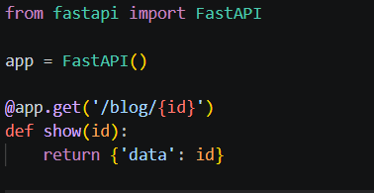

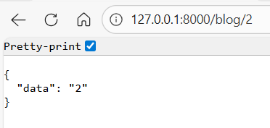

- But in this id is a string, and I want number not string, so we need to provide the type of the parameter we need, so inside function we will define type for the parameter

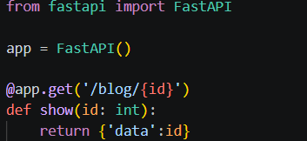

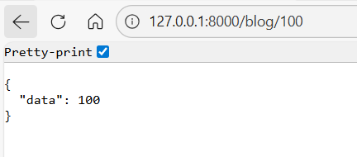

id is now int and not a string

If instead of int 100 we will pass a string like my-first-blog, while doing this we’ll get:, so we need a valid int value

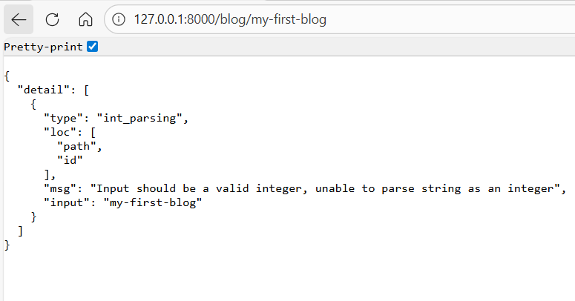

- Another router of unpublished blog: List of all the unpublished blogs I want

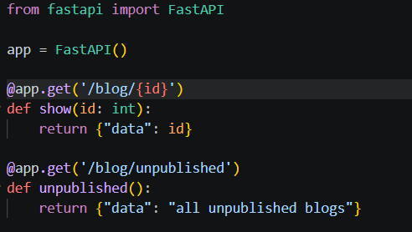

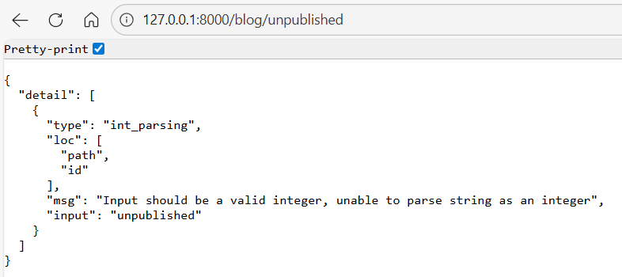

We are getting this error, value is not a valid int, but this error is for show() or the path of /blog/{id}, it is not reaching to /blog/unpublished b/s fastapi reads the file line by line, so it first matches blog/{id}, and {id} is something and this something matches unpublished, but then unpublished is a string and not an int that’s why we are getting error. So it’s never going to reach the /blog/unpublished api, b/s of dynamic routing of /blog/{id}

If we want to make it work so we’ve to move this router: /blog/unpublished above this: /blog/{id}

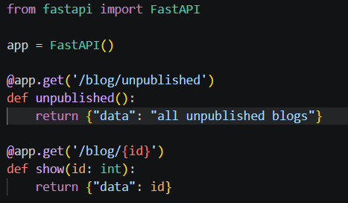

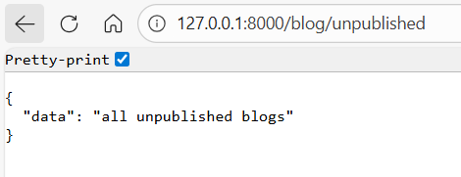
We are having this type system and data conversion, all these things are done with the use of pydantic. Pydantic is a library which is going to hold all the data validation. We can use str, float, bool and many other complex data types.

- Another routing we can create of comments:

Fetching the comments of blog with id = id

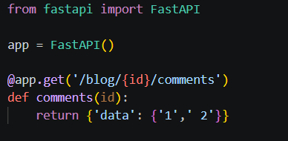

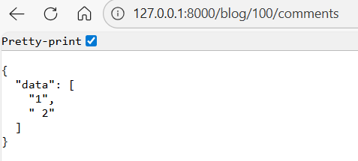

- Swagger UI:

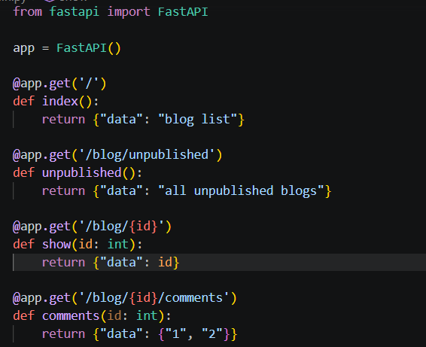

In swagger it looks like this and also we can try it out inside the swagger:

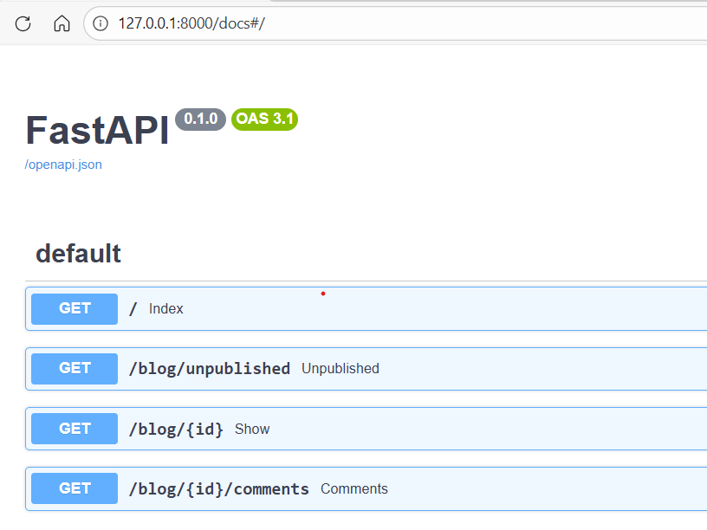
When we try to get all the blogs using @app.get(‘/blog’) , it is super inefficient, suppose if there are 10000 of blogs in the db, and if we try to fetch all the 10000 then it is super inefficient, you have to limit or if I just want the published blogs and not all the blogs so we can do like:
Query parameters are like ? and then name and = with a value
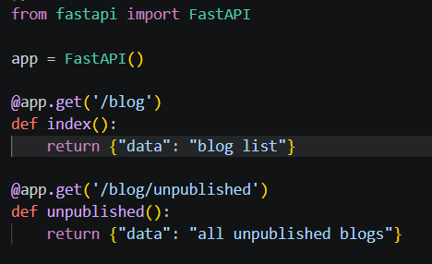
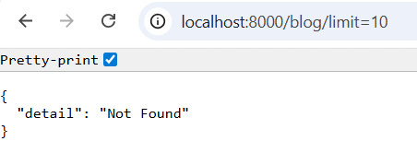
It is not changing, b/s query parameter are not going to change query. So we need to accept the query parameter just like we accepted path parameter id inside the function. So we have to use limit parameter inside the function then we can use them.
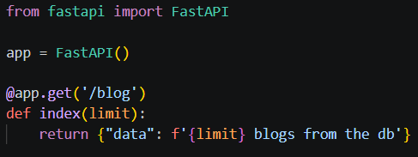
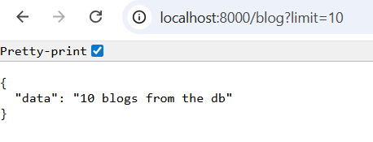
And for published blogs, we need to provide second query param with & sign..&published=true
And we need to accept published inside index function. Also we need validation on the query parameters also as: published : bool
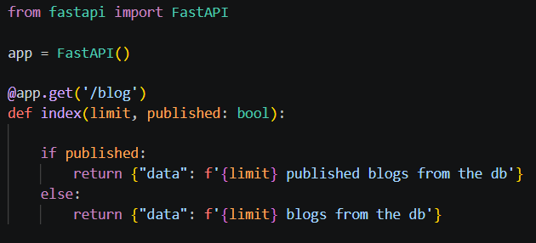
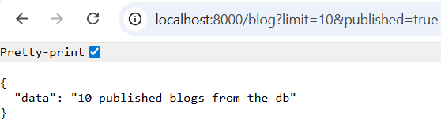
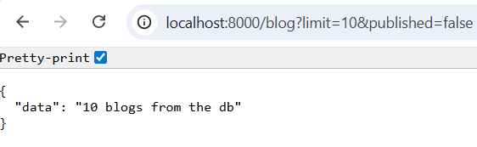
If there is no validation then the value of published will never be bool and it will be string.

- If we do not provide published then it will give me:

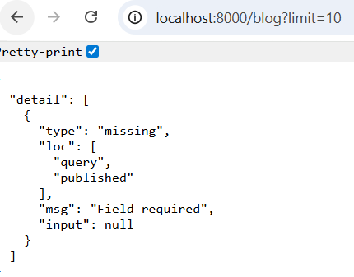
So, published is required, and if we remove the limit part also then it also says that limit is required

- I want to give limit= 10 as a default value if no one is giving limit value, and if we are giving limit’s default value then we have to give default value to published as well.

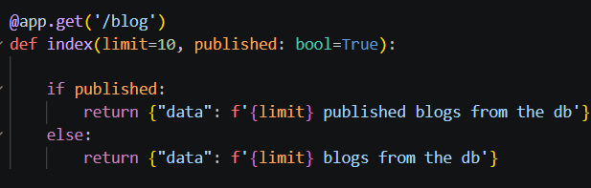

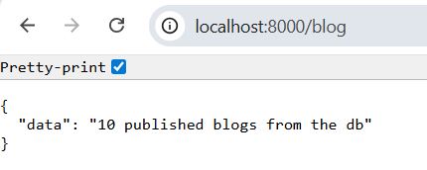
- Now I want sort as optional, so for that we’ll use Optional and type will be string, and since it is optional we can provide default value as none. And we need to import the optional.

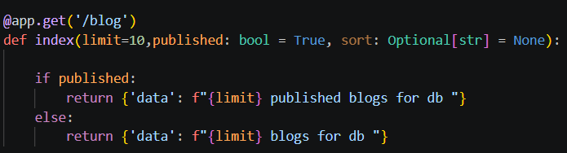

It is necessary to give optional a default value

- Now for the comments api, how fastapi know if it is query parameter or path parameter. So suppose I want to limit the comment to 10.Fastapi is smart enough to know that if identify that if there is anything given in the path and that is accepted inside function, otherwise it is query parameter.

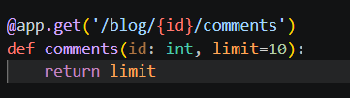

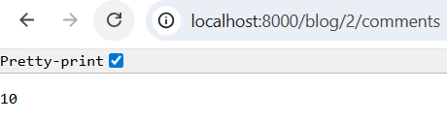
- POST is used to create something, so we’ll use POST to create blog. When you want to create a blog, you need to send the new blog information. When we need to send data from a client/browser to your API, you send it as a request body.
To declare the request body we use pydantic models (using from pydanitc import BaseModel), so we create the class and extends the BaseModel (so class becomes a pydantic model), then we simply define the parameters we need in the class.
We will extend the class Blog with the base model, inside the function create_blog, the request body is of type Blog model.
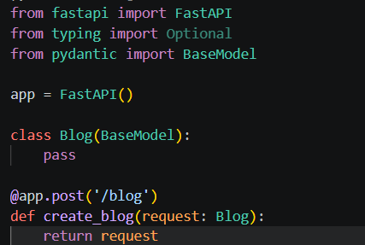
Now in swagger we can see that this api has a request body, which is required, and the schema is empty i.e. {} , and it returns {} b/s we haven’t send anything
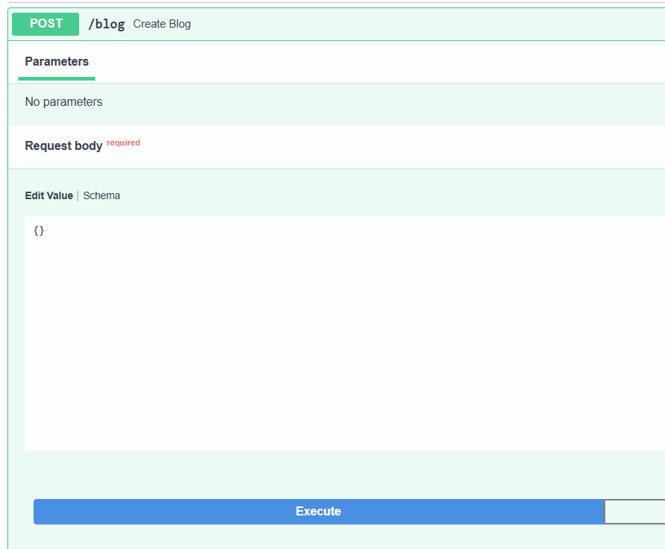
- Now let’s define some fields for the blog and change the return statement:

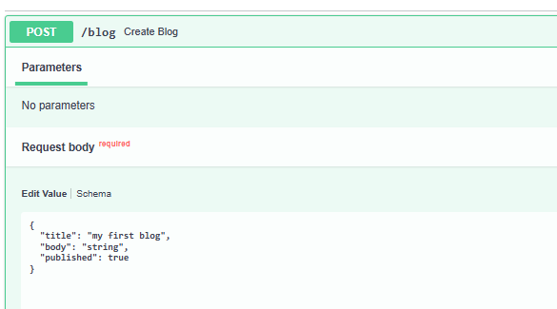
When we define the fields and reload the swagger, now we have the schema, schema needs three things title, body (which are required) and published (not required), and we are returning the request only.
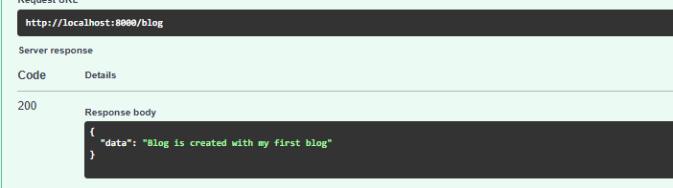
You can replace request with blog as well:
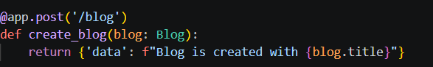

- How to debug FastAPI application?
Suppose I want to see what are the things I have in my blog, blog is a request body. So, the point at which you want to check the status of your application, click on that line, a red dot will appear which is a breakpoint.
Whenever you try to debug your application then at this breakpoint your application is going to stop and you’ll get all the information about your application at that particular moment
After defining the breakpoint, press ctrl+shift+p and then simply say debug restart, and choose fastapi framework, now we are inside debug console:
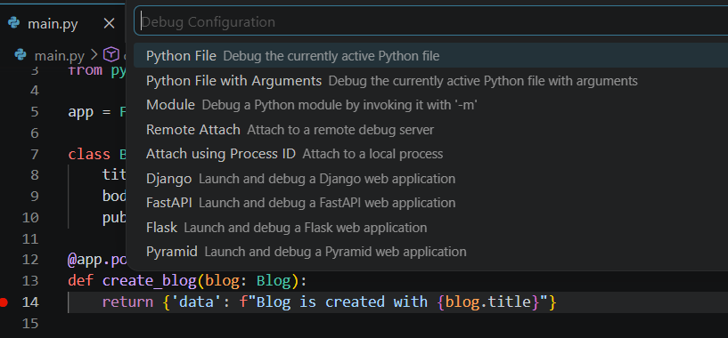
Remember to terminate the 8000 port so that debugger will run correctly.
Now, once we click on execute in the swagger api, now this red dot has some kind of arrow, and it is actually describing that we are paused at this point.
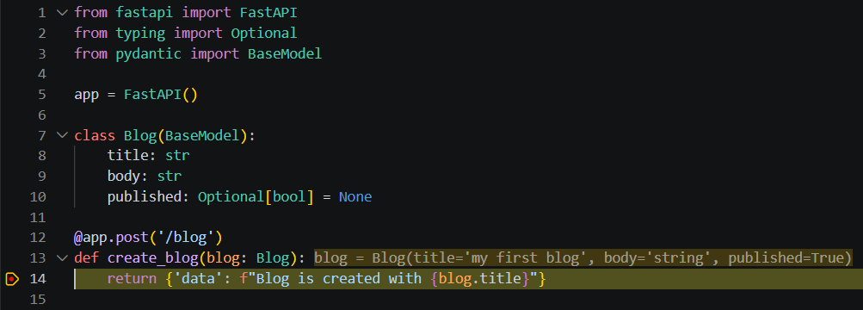
Then you can go to the debug icon, where we can see all the local variables we have passed the body as string, and published as True etc, so in this way we can debug application.
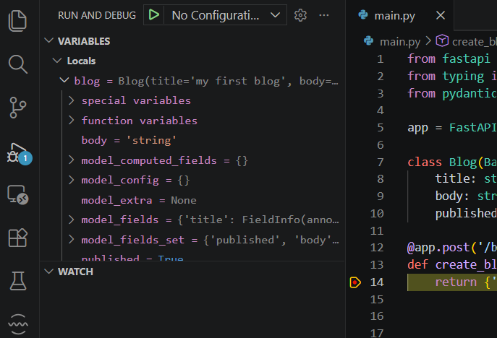
I can move the breakpoint forward as well, and then restart debugging, so now we have all those things at that moment:
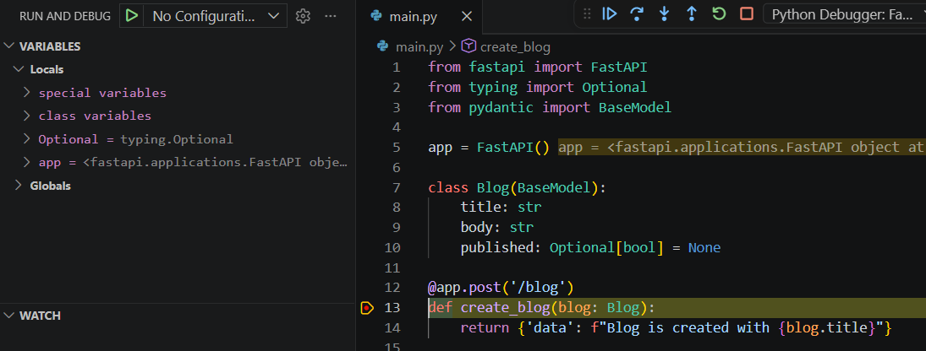
You can change the port as well:
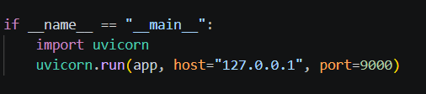
- Pydantic Schema

We will create a new directory c/d blog, inside this directory we will create __init__.py file, main.py file then we create virtual env and requirements.txt file as well, fill the requirements.txt, and run pip install -r requirements.txt

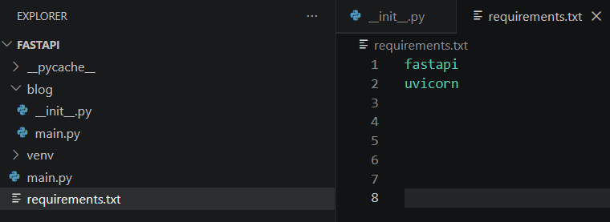

- In the main.py file, first we create the blog, for that we need post request.
We can start the server with uvicorn blog.main:app

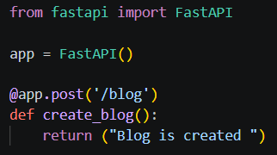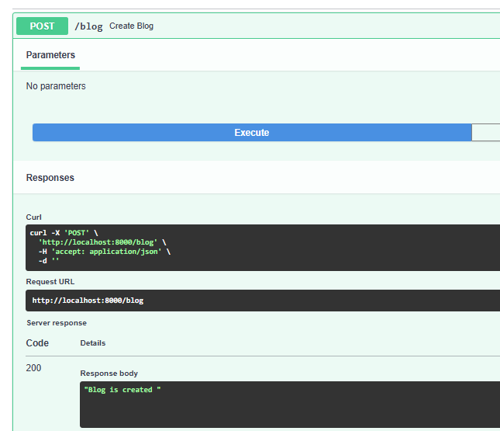

- Since, there are no parameters we’ll give the parameters

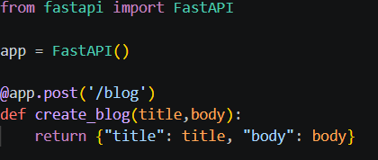
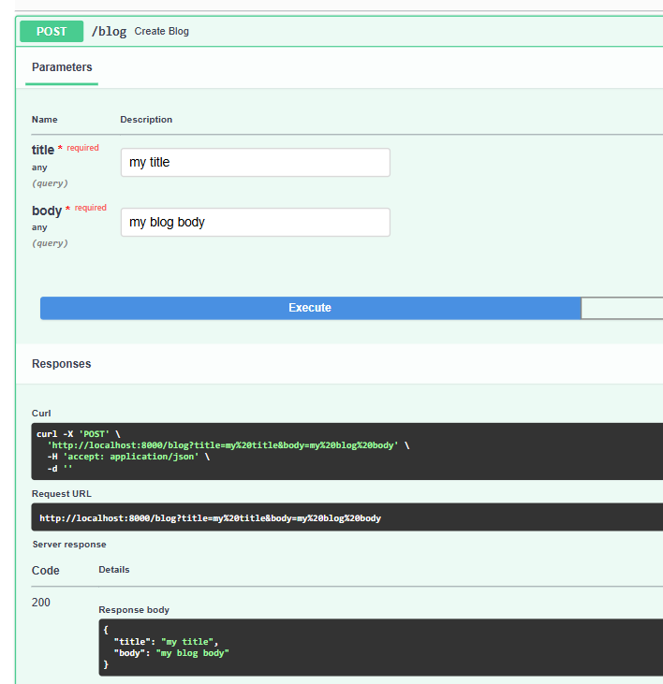

- But we don’t pass these parameters directly, we need pydantic model, so we create the class, and since we are going to create a pydantic model, we need a colon to define the type

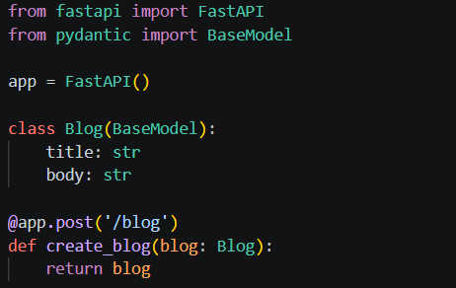

Now, instead of getting simple fields, now we are having request body
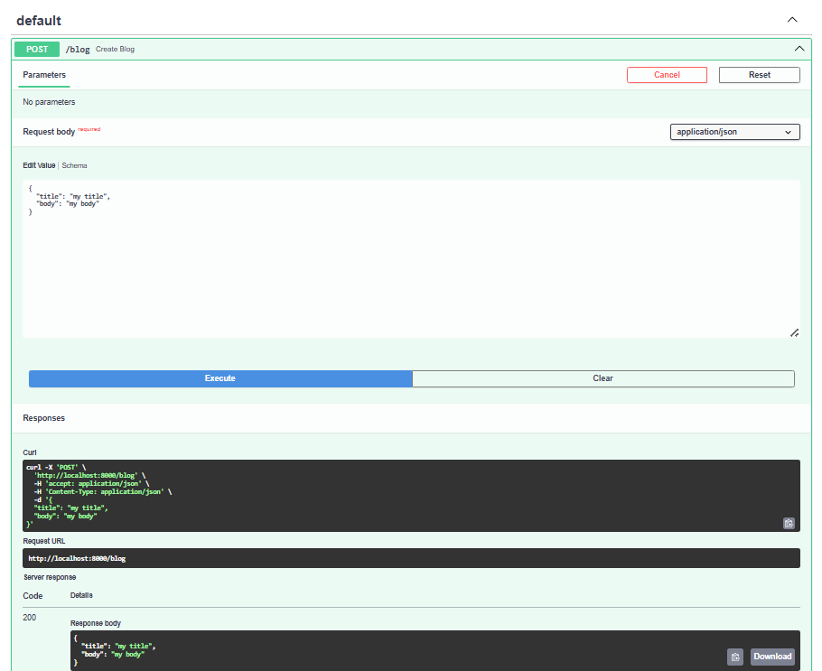
- Instead of creating class directly in the main file, we’ll use schemas file (schemas.py), inside the blog directory, and we move the class to schemas file

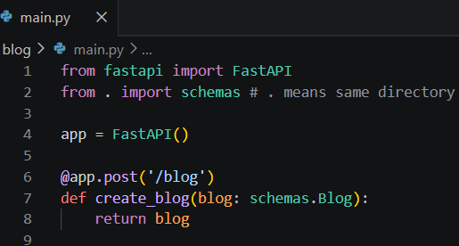

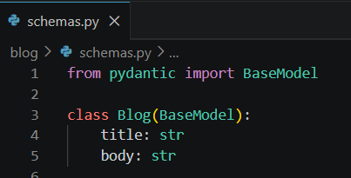

- Now we need to store all the information we got from the request body into the db. For that we need to first connect to the database

FastAPI needs SQLAlchemy
ORM: Object Relational Mapper, it maps the objects in code into db tables.
Eg. class Pet represents SQL table pets, so SQLAlchemy maps Pet class with the db (pets table)
How to create db connection?
First, we need to create the engine, so it uses in-memory SQLite database, and we need create_engine from SQLAlchemy.
We create the database file in blog folder, then import the create_engine, then we need to create the engine by giving the db connection url and connection args as false., so we will create blog.db as well (db that is created).
We’ll create constant for the url as: SQLALCHEMY_DATABASE_URL
After creating the engine, we need to declare a mapping, for that we need to import declarative base, and then we need the Base (Base = declalartive_base())
Then we need to create a session, for that we need to import sessionmaker, then we create the session (SessionLocal). We bind the engine into session maker. And autocommit, autoflush as false. In this way, db connection is set up.
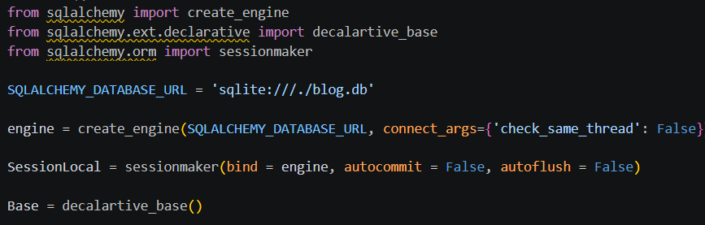

While creating the db connection in dbeaver or some other platform, we need to locate the db path (blog.db) inside dbeaver of blog.db file that we have created

- Model & Table
After creating db connection, we need to create the tables, so we need to create a model which is going to define all the fields and the table name. So inside blog directory, we create models.py file inside which we’ll create a class Blog, and we need to extend model Blog with a Base, and this Base is from the db connection (inside database.py), everything is imported from sqlalchemy. This Blog class needs id, title, body. And we have to define table name as blogs

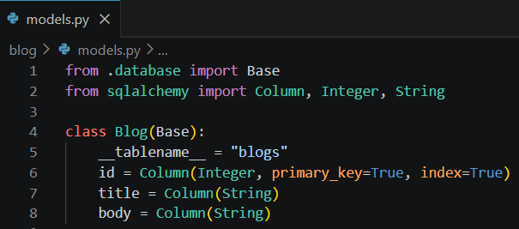

How we can use this model?
models.Base.metadata.create_all(bind=engine)
This line is going to create table into our database, so in main.py we need to import the models,engine and write this line models.Base.metadata.create_all(bind=engine). If the table is there, it’s not going to do anything, but if table is not there, it’s going to create it.

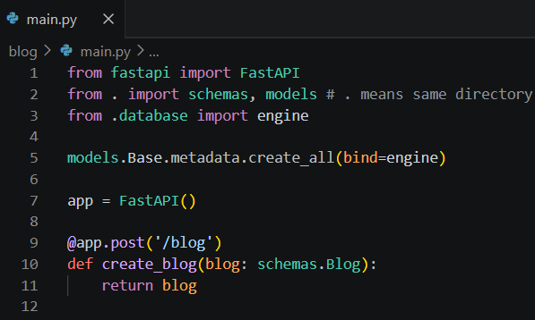

After this process, the table is created into the db.

Now in the post request, to create the blog, we can actually store the blog information into our db, to have the instance of db, in the create function we pass the 2nd argument as db, and if we return db, but db is now creating as a query parameter

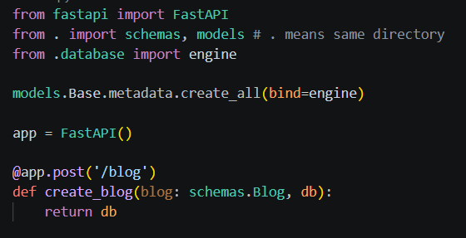

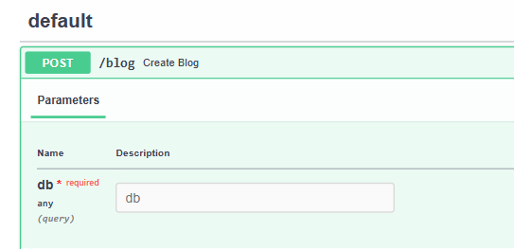

But we don’t want it to be query parameter, so db is of type Session, Session from SQLAlchemy.orm…but it gives error session is not a pydantic thing

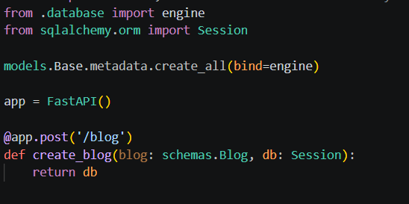

So the default value is going to be Depends, on a db (get_db is a function that we’ll create), we need to import Depends from fastapi, this is going to convert session into a pydantic thing, and we need to create get_db function, inside there is SessionLocal and SessionLocal is from database (so we need to import that as well), then try yield and finally close the db, so if everything is done then close the db connection.

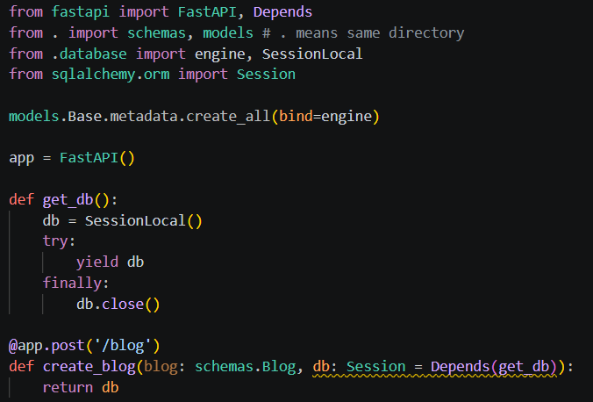

Now, it is not recognizing db as a query parameter, and it is returning db, so the response is right now {}

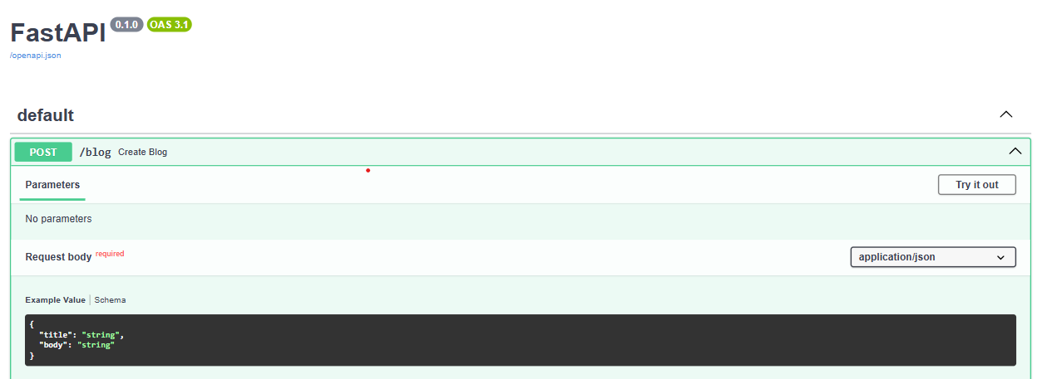

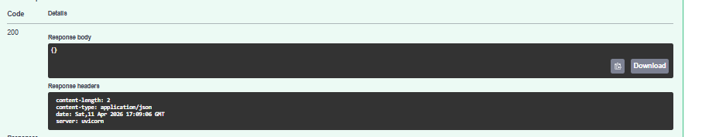

So, we have to create a new blog, and we have to use models, then we have to add that new model in db, and then commit and then refresh the new blog so that we can easily return the new blog.

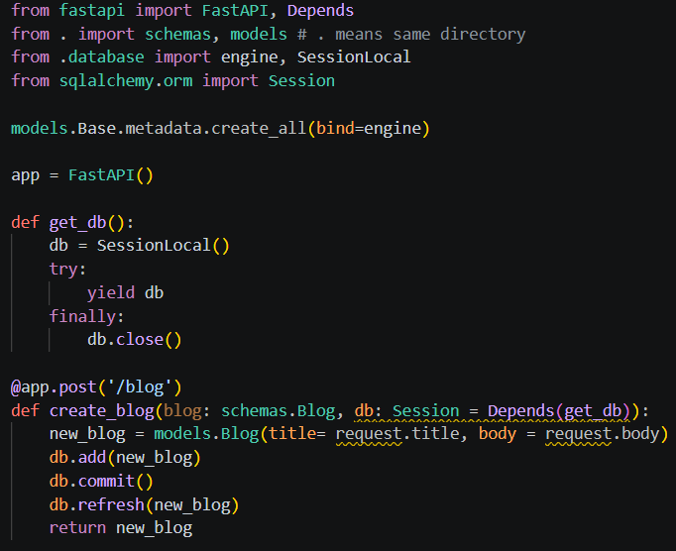

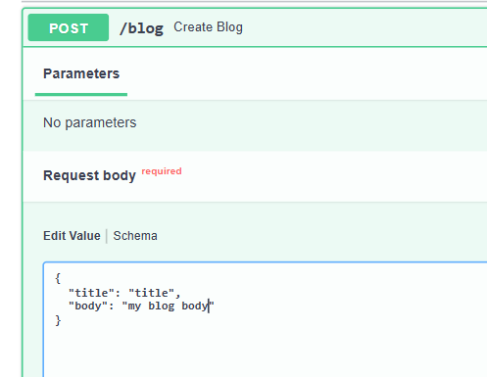

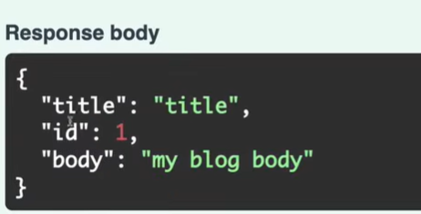

Not only the title and body, we are also getting id from the db, in the db we have 1 entry.

GET blogs from the database

For that we use @app.get, and we need db instance that is db session with depends, then we’ll querying on model and for all the blogs we use .all(), then return the blog we get from query, so db.query(model.Blog).all() creates an SQL query and then we’ll get the blogs.

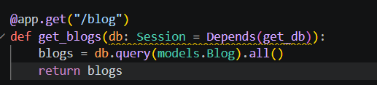

Now, we’ve list of blogs:

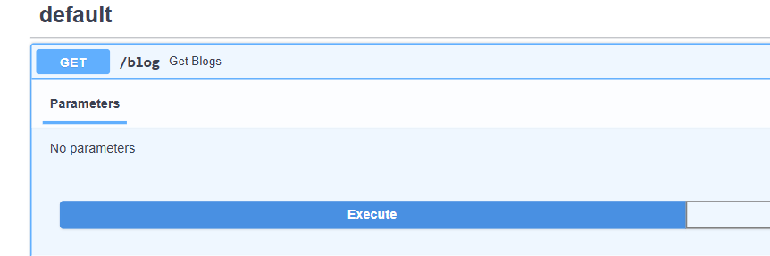

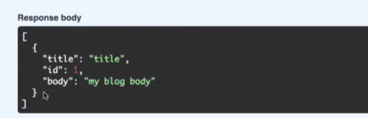

GET a blog with an id

It needs db instance and id inside the function parameters, but now after db query we need filtering condition having model.field name with a value, but here we’ll not use all(), b/s it always going to give at least one or none, so I need the first(), which only gives me the first result.

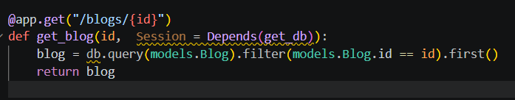

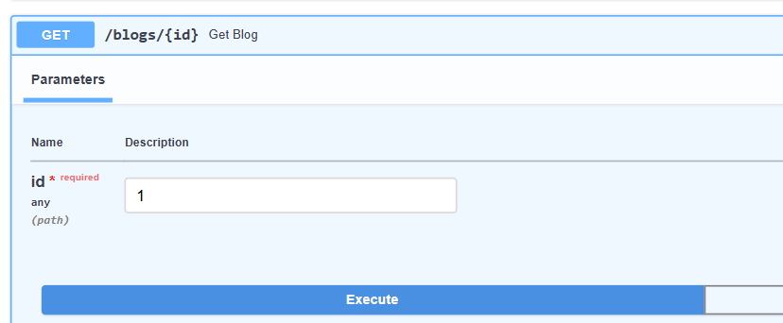

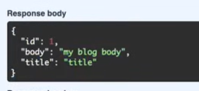

If we say id as 3 so the response will be null, b/s it does not exist in db

Exception and Status code:
For the success response of creating and getting, the status code is always 200. But when we create something, the response code should be 201 that’s the original response code for created thing.
So now we’ll add the real response code.
Inside a parameter of the decorator method (get, post etc), we need to say status_code and then the real code
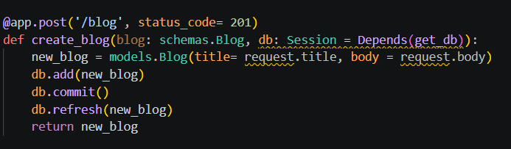
Now when we hit post api we’ll get status code as 201 and not 200
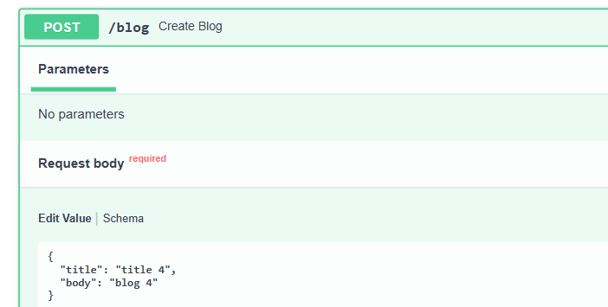
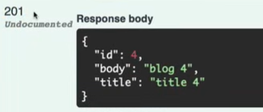
But how do we know the code of which response type?
We have python documentation for http status code, like:
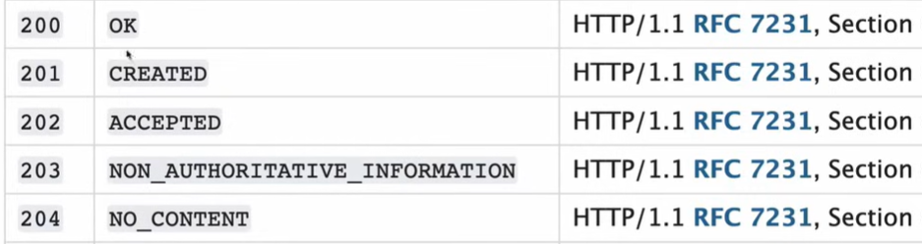
But suppose we forgot the status code, so fastapi gives us all the status codes through autocompletion.
We can import status from the fastapi and then use it.
Instead of status_code = 201 we will write as status.HTTP_201_CREATED
After hitting status. All the lists are there then we just write create and autocomplete will do our task

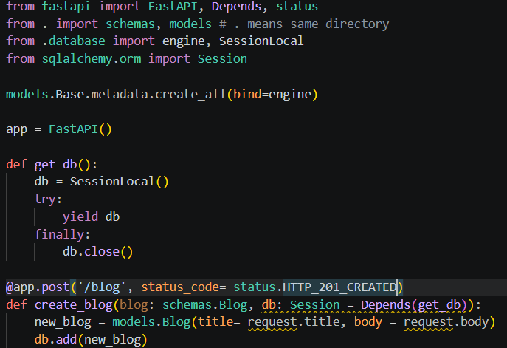

Now in a GET API, If I had given a value which doesn’t exist in db, so in response we will get null, but still we are getting 200, which is wrong

How do we give proper response code and message?

We can return custom status code like: response.status_code = status.HTTP_201_CREATED, if we have applied custom status code then the status code applied on the decorator (get,post etc) will not work.
For this we need to import Response from fastapi, and we need to add Response in the function as well.

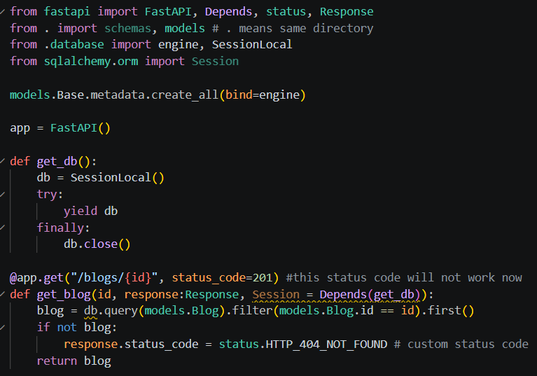

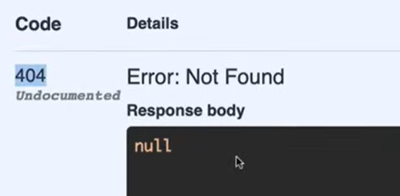

We can also provide the detail and f-string having message
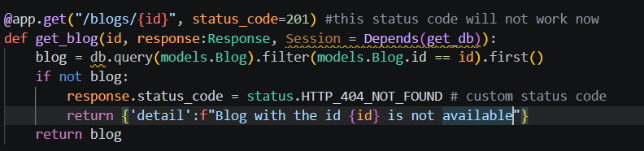
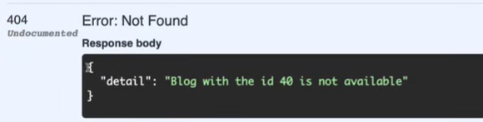
If the blog id is correct then we’ll get a correct response having status code as 200

But fastapi will help us for wrong response as well, which is HTTPException, so when you want to raise new exception, then use HTTPException and this HTTPException should be imported from the fastapi, then provide the status code and the detail
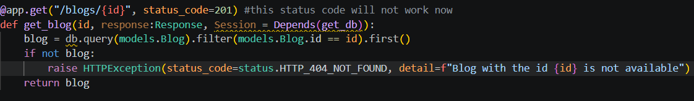

Delete a blog:
For deleting a particular blog, we use {id}, and no content status code
Instead of using .first() we will use delete()
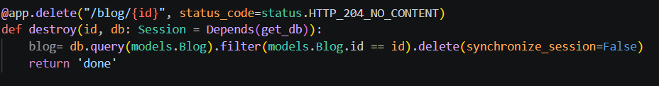
While deleting 5th blog I am getting:
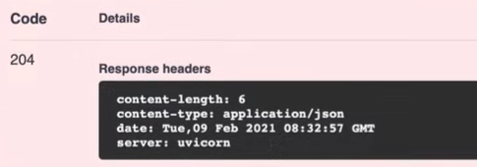
But when we try to get blog 5 it is still returning response, so whenever we do something in db, so we need to commit the changes after that
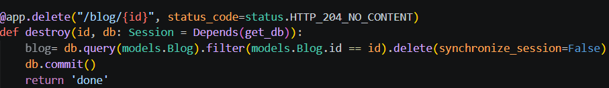
Now, if we try to get 5th blog, so it says Blog with the id 5 is not available
Update a blog:
In this we need id, request, and db session inside the function
request:schemas.Blog – like we’ve done while creating blog , request is whatever we pass from the swagger. The schema is:
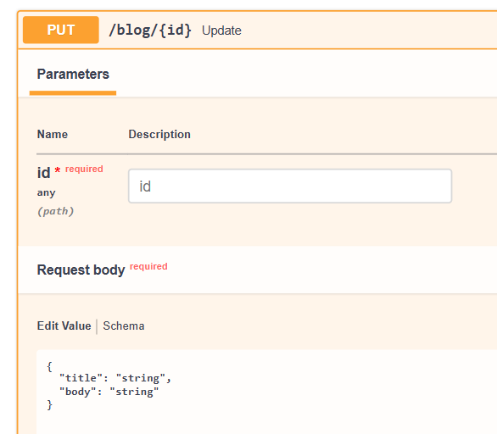

How do we update it?
We’ll query on a model, then filter and then update with fields that you want, then we can use synchronize session= false or synchronize session= false, then we return something
Query.update() method is a bulk operation, so suppose we have 2 users having same emails, so it’s going to be updated on both of the user, so this is a bulk update, so like delete() we don’t need .first() or .all() in update()
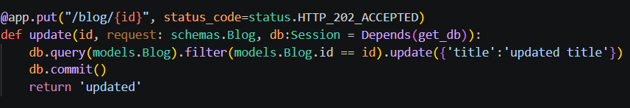
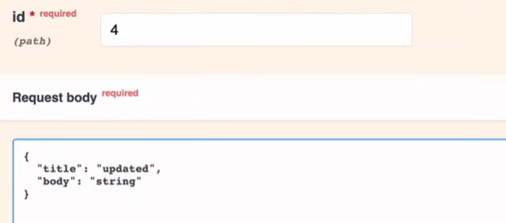
This will give 202 status code and in response : updated, now when we get blog id 4 it will get updated value

Since, we are already passing json in the request body of swagger, so we can directly pass the request body in the update function, i.e. full request
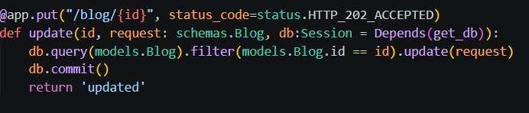
Now we can update anything (both title and body):
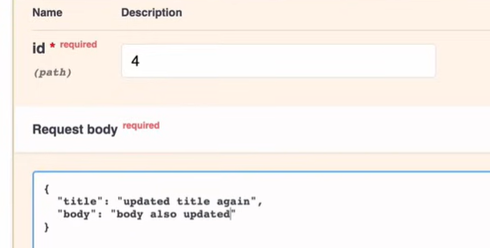
But if we try to update a blog which is not available inside the db, still it gives me “updated” 202
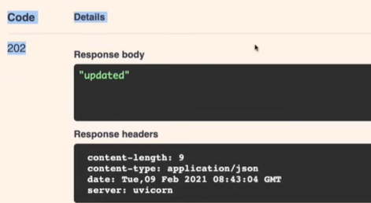
So, first we need to check if blog is there, if there is a blog then update otherwise raise the exception. So we will put the update query in blog variable , and will write if condition
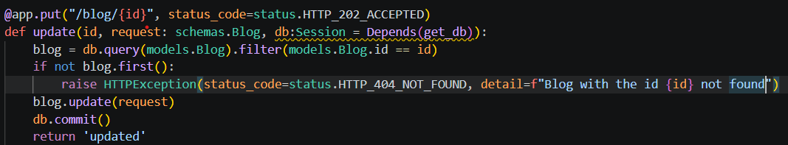
Now for that id which does not exist, we get this:
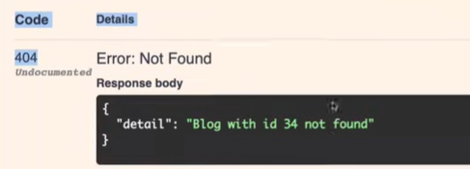
Similarly, for delete we can apply the same if condition, if the id does not exist
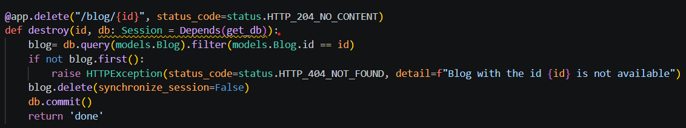
Response Model:
For that we’ll use response_model = model_name, which we are calling inside decorator, and this is going to be pydantic model, and in fastapi we call pydantic model not as model, we call it as a schema.
So for the SQLAlchemy model (i.e. models.py), we call it model, but for the pydantic model (i.e. schemas.py), we call it schemas, so response_model is the response schema
Now, suppose in this GET response:
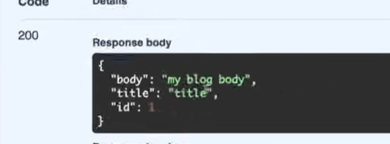
I don’t want to show the id and I just want to show body and title, so in that case we need to create a model and that model is going to be pydantic model i.e. we’re going to create a schema (ShowBlog schema), and we will extend Blog for that, and we will pass, b/s Blog already has body and title
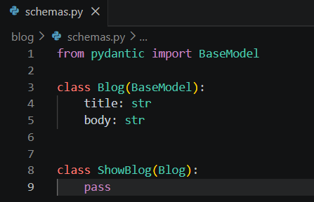
Now in main.py, wherever we are getting blog with the id, we need to define the response model as well, and this is pydantic model and pydantic models are schemas, so after importing the schemas we can use schemas.ShowBlog. Now after this:
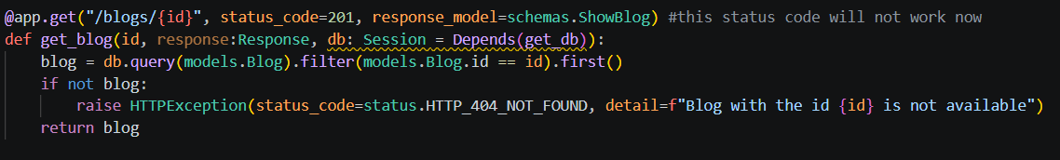
We get Internal Server Error
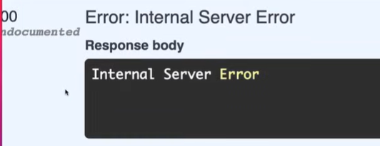
Error: value is not a valid dict
We need to define the orm mode when we define our model, so whenever there is a model, and then we need to create Config class inside the model class, and then we need to just say orm_mode = True, b/s we are using db query that means we are using orm (SQLAlchemy orm) so we need to define class Config and orm_mode = True
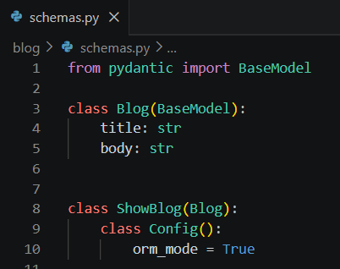
Now the response of GET API is:
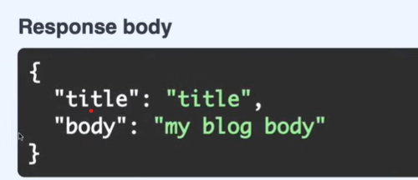

Now instead of extending Blog model, lets extend BaseModel and I just want title now:
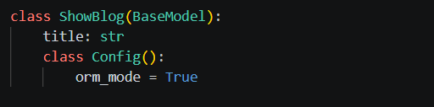
Now we are just getting the title, b/s we have defined the response_model, we need a response which is exactly similar to ShowBlog schema
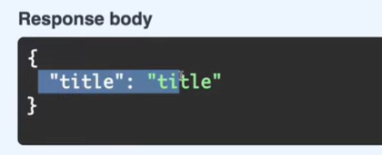
Now we have another api of getting all the blogs from the db, and in this as well we are getting id for each of the blog, so one more time we need response_model
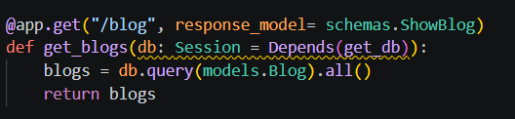
Again getting Internal Server Error
Error: field required (type= value_error.missing)
B/s we are not getting 1 blog, we are getting the collection of blogs, so we need list of schemas, and import the List from typing
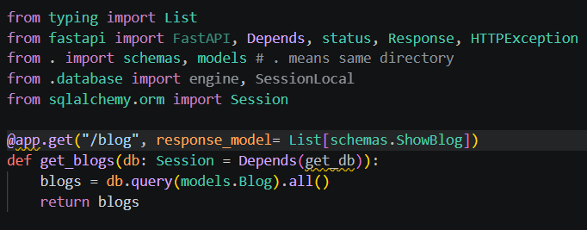
Now we just get the title for every blog:
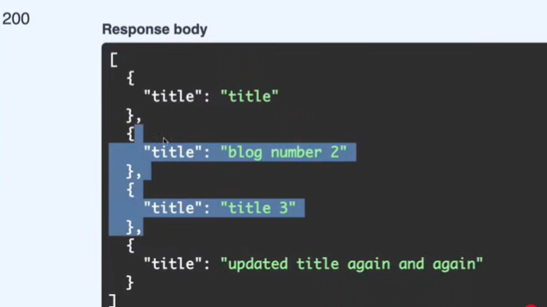

Create User
For this new api of user, we need to create new schema for the user. In this schema of User, we have name, email, and password
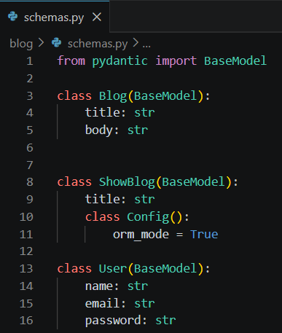
In this api, we just return the request for now:
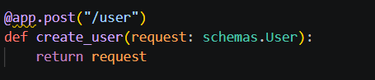
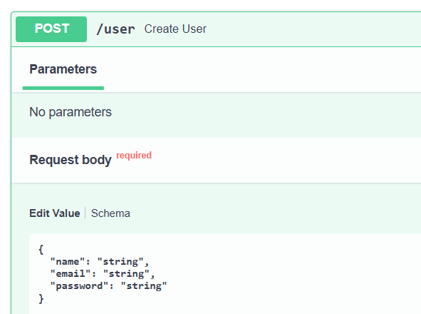
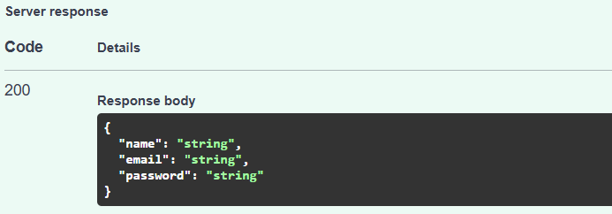
But we need db connection in this create user api, so we add db session, and when we create we need SQLAlchemy model, where in models file we define the table structure
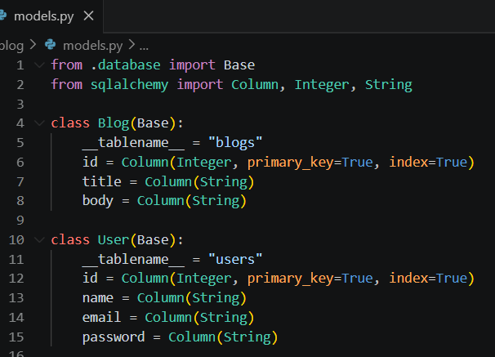

Now we use this SQLAlchemy model in our api
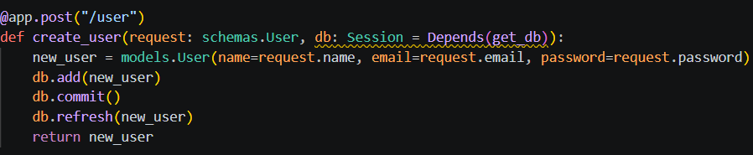
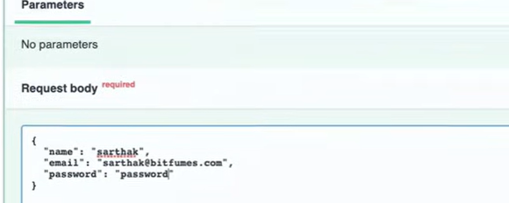
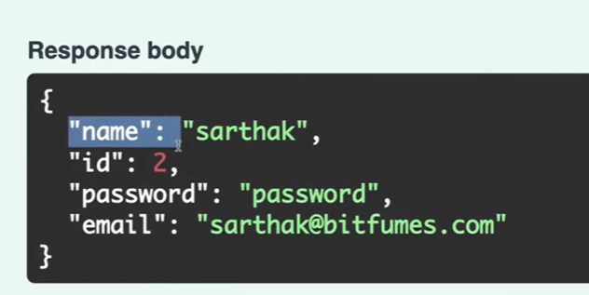
Now the users table, and one user is created inside the db.
But in this the password is not encrypted
Hash the Password (Encryption of password)
We’ll use passlib library to create hashing of password. For that first we need to import the CryptContext, then we need to create password context by defining schema that we’re going to use, then using the password context we can say pwd_context.hash(password)
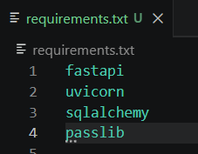
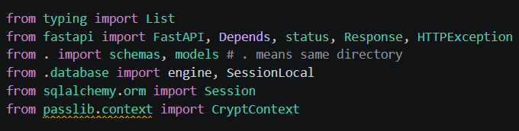
Create the password_context, then when we create the user, just before that we have to define hashedPassword, and instead of passing request.password, we’ll used hashedPassword
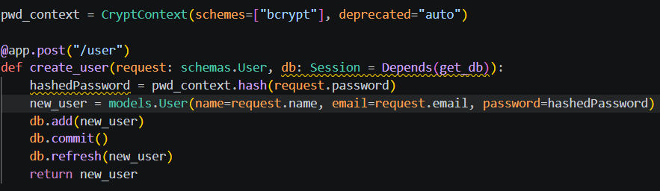
We have to install bcrypt as well along with passlib.
Now when we create the user again, now we have encrypted password
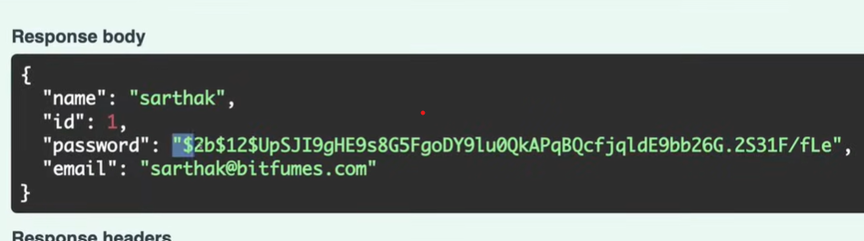
If you don’t want to do something like defining hashedPassword, so we can create a file like hashing.py, inside which we create a class called Hash(), in which we create a function like bcrypt
And bcrypt needs password which is string, and then we can use pwd_context, also we will define pwd_context and import CryptContext in hashing.py file.
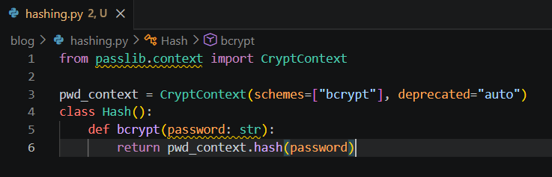
Also we’ve to call bcrypt function in main.py as well:
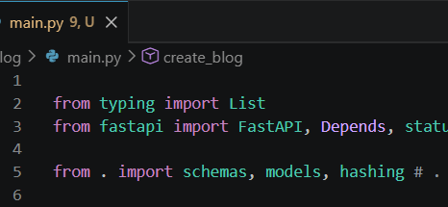
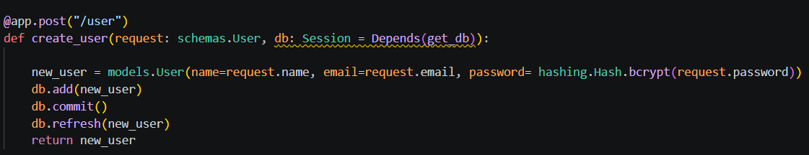
Now, when we create another user so in that as well encryption of password will work.
We can also directly import Hash
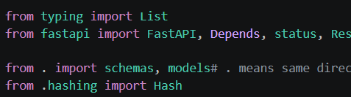
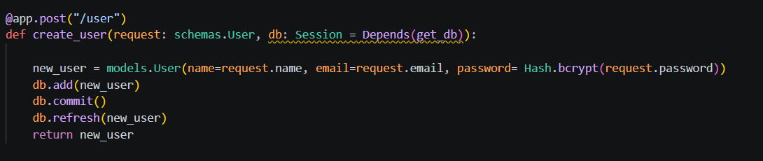
This will work as well
Now, I want to get the user, but we don’t want to get the password.
Show a User
Whenever we create a password, we don’t want the id, password to be returned, we only want name and email, so for that we have to create user response model i.e. schema (pydantic model), so we’ll create ShowUser class, which is having BaseModel, and it just need name and email, and in the create user api, we define the response model for show user
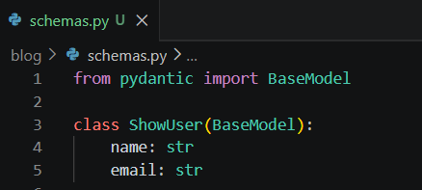
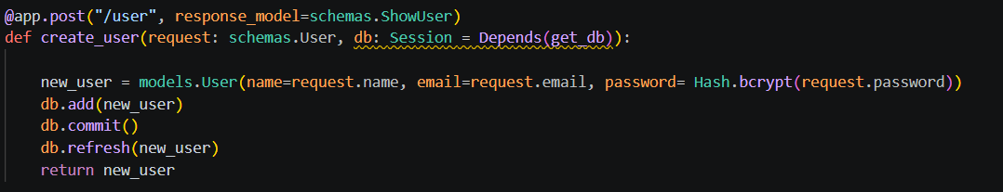
Now when we create a user, then we get Internal server error, b/s we have to create class Config as well, while creating class ShowUser
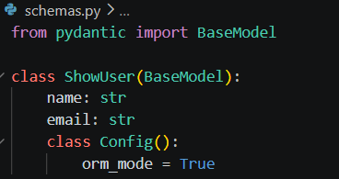
Now when we try, we get the name and email in the response:
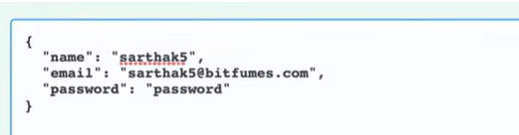
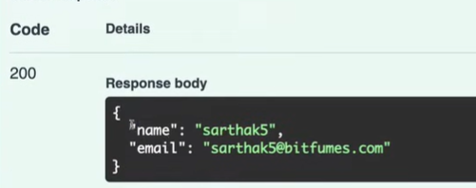
Lets create another path to get the User
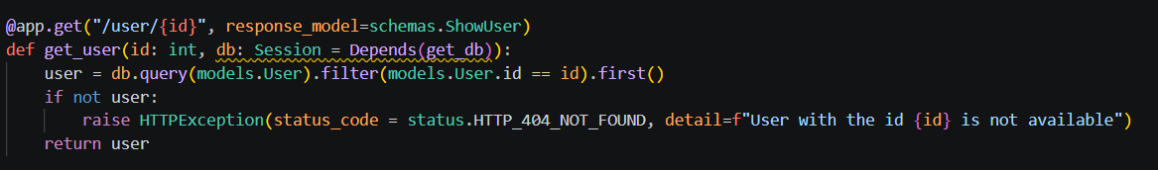
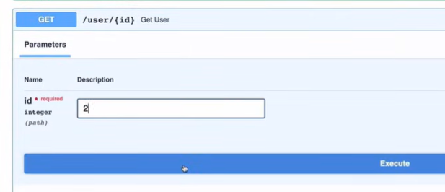
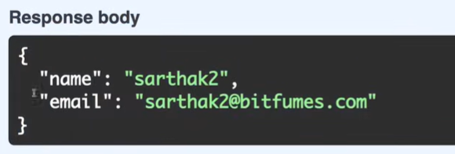
And if that id does not exist then:
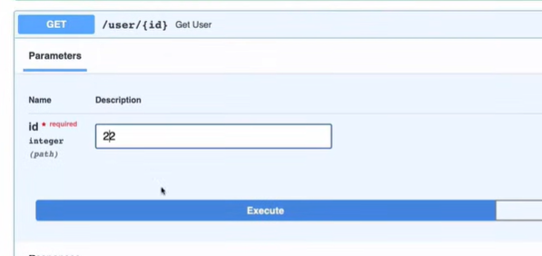
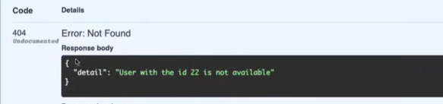
One more problem in the documentation we can see is every route is c/d as default route
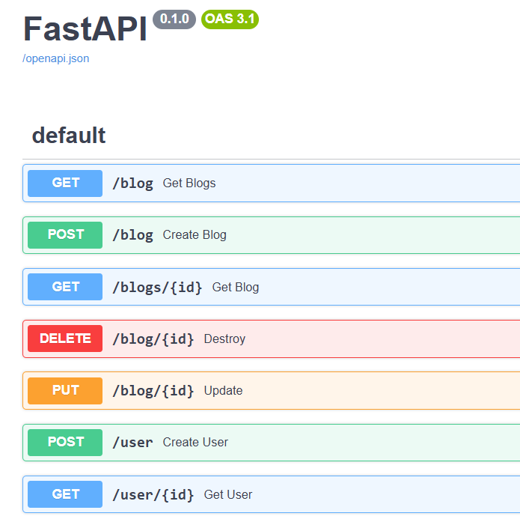

We can show these endpoints in proper manner using doc tags
For this we’ve metadata and docs url, so wherever we’re defining the path, we need to say tags and then tag name inside the array. Eg in all blog related apis we use this: tags = [‘Blogs’]
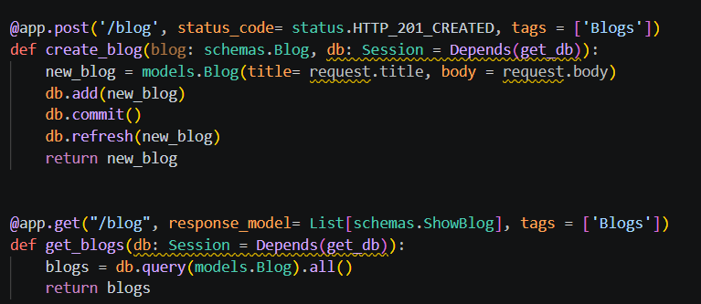
Now in swagger documentation, it is like:
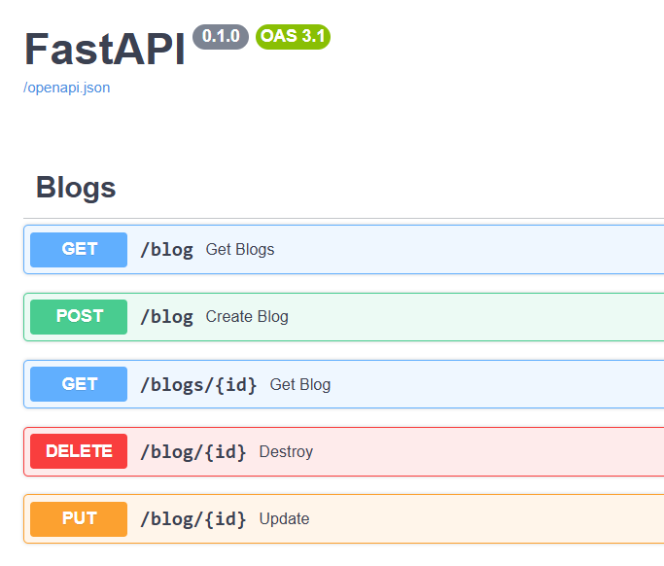
And for user route apis, we use this: tags = [‘Users]
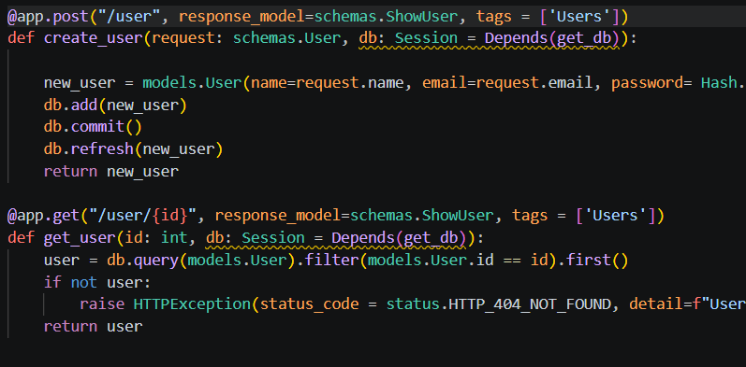
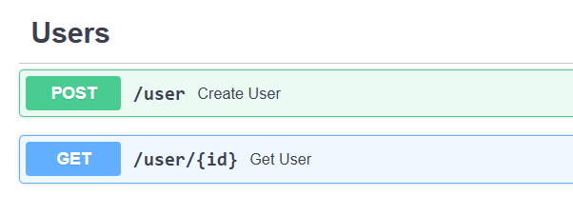
Relationship
We’ve the blogs, every blog should belongs to a user, so we need FK inside the blogs so that when we fetch the blog, we also fetch the user of the blog, or when we fetch the user, we should also fetch the related blogs
To create the relationships, we need to import relationship from sqlalchemy.orm. So when we define sqlalchemy model, then we need to define relationship as well, but we also need to define the FK (which FK from which table we’re going to use)
In models.py, we import relationship, For Blog class, create the relationship as creator, having model name which back populates as table name blogs, so back_populates means we need the relationship in User table as well, User table back_populates to creator, and we need one more column in Blog table for the FK.
We need to import FK as well from sqlalchemy. This is how relationship is defined.
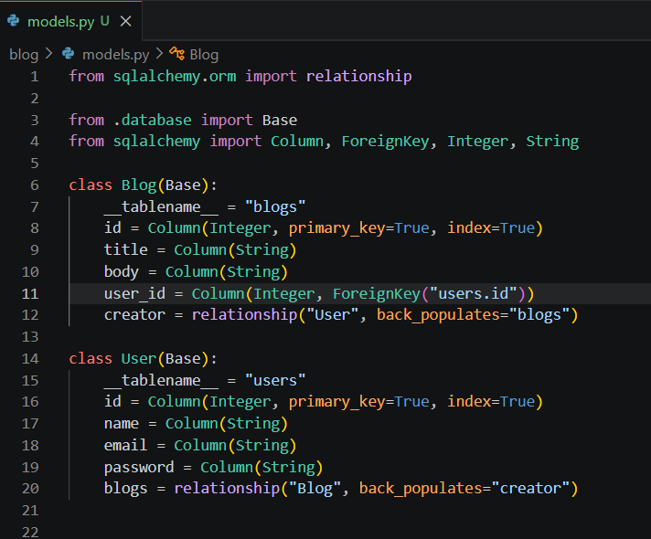
Now, when we create a blog
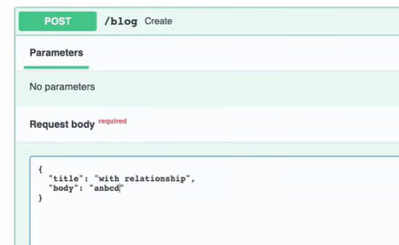
This will give Internal Server Error, b/s the tables users, blogs are already created, we have to delete these tables, then it will not show Internal Server Error

Now we’ve user_id column in the blogs table, and user_id is FK as well, now when we try again:
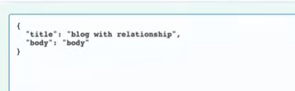
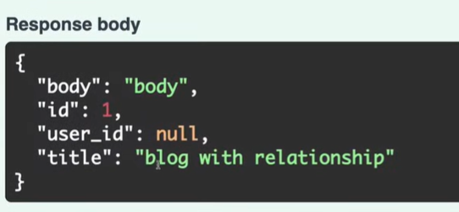
It is created, but in this user id is null, so in main.py when we are creating the blog, then we are passing title and the body, and we hard code user_id as 1, and now when we execute once again, this we’ll get user_id as 1 in the response
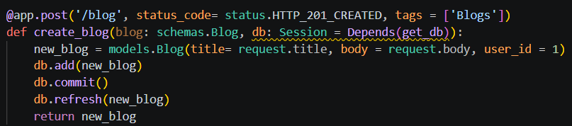
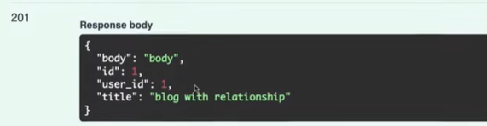
Since we have a blog with the id of 1, let’s try to get that blog
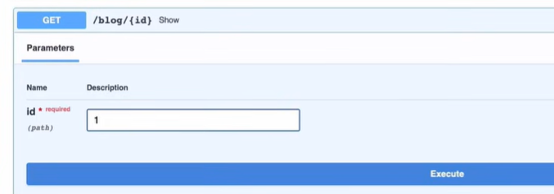
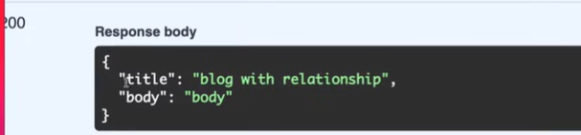
But we also need creator in the response, so we’ve to transform the response model i.e. schemas.showBlog for this api: @app.get("/blogs/{id}",
On the ShowBlog, I also want to load the relationship, for that we’ve to say creator which is having ShowUser schema
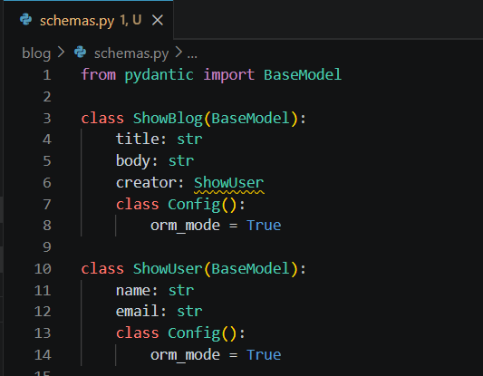
But in this, ShowUser is not defined, but we already we have it, so let’s move ShowBlog below ShowUser
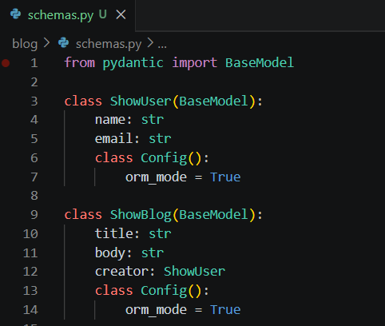
But still we’re getting Internal server error
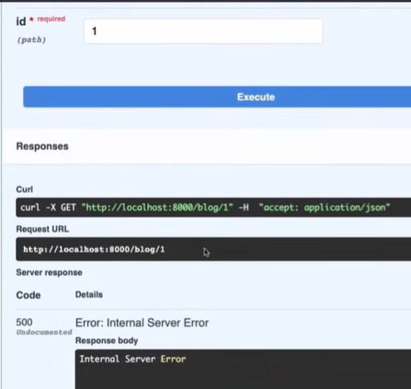
B/s we don’t have any user in our db, so we’ve to first create a user
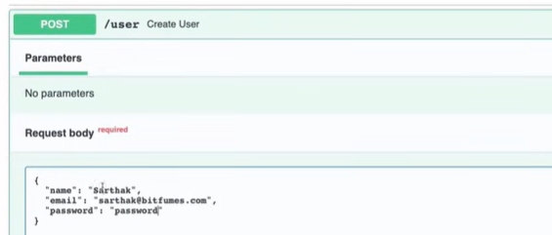
Then we create a blog and the response is:
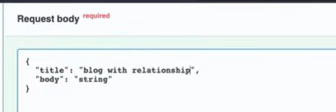
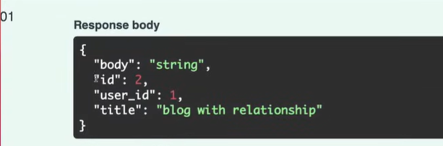
Now when we show blog 2, we having creator now having name and email:
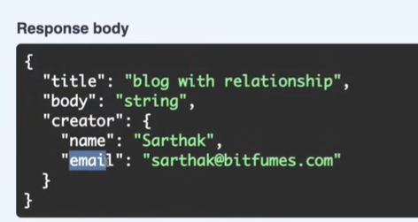
Now, we get the User with all the blogs, so in ShowUser we need blog having list of ShowBlog
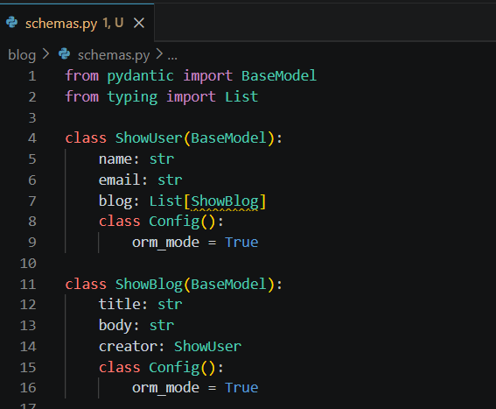
But, again we get that ShowBlog is not defined, so instead of using ShowBlog we use List
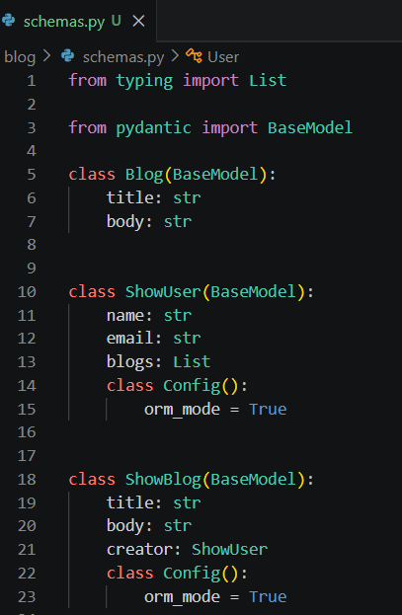
Now the response is:
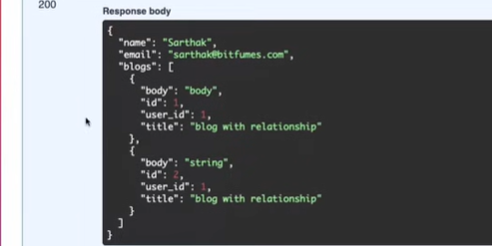
But we’re getting everything from the Blog table, we don’t want that, we’re having issue when we are using schema Blog i.e. blogs: List[Blog]= [], b/s in the Blog class we’re defining title and body, but we don’t have config class with orm_mode = True, so we’ve to define config class in Blog class as well
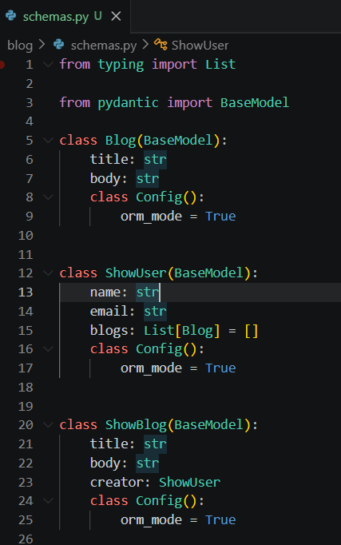
Now, when we execute it we get:
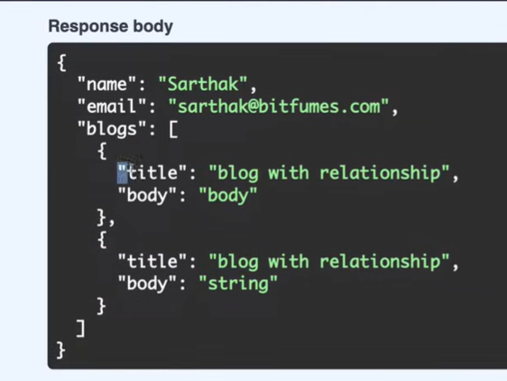
Instead of writing config in the Blog class, we’ll call Blog class as BlogBase class, then we create one more class Blog which is going to extend BlogBase, and that in that class Base, we need to define class config. This will work as well.
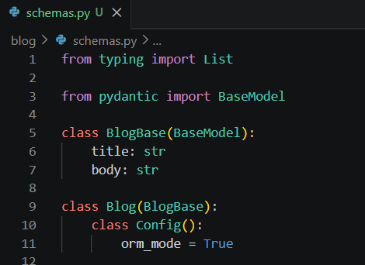
API Router:
We’ve 2 different kind of routes, one is for blogs and one is for users, so first we need to create a directory of routers, and inside that directory we’ll create __init__.py, user.py and blog.py file
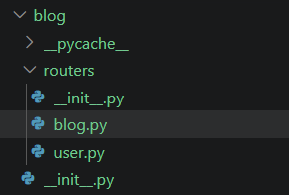
For these files, we need to import APIRouter from the fastapi, and how we’ve created app instance, in this we’ve to create router instance
In blog.py, I put every route one by one which is related to blog, and instead of @app.get now we’ll write @router.get, then we need to import schema (.. b/s we need to move double directory up), and others imports as well, and get_db function instead of main.py we paste it to database.py, and instead of get_db we use database.get_db
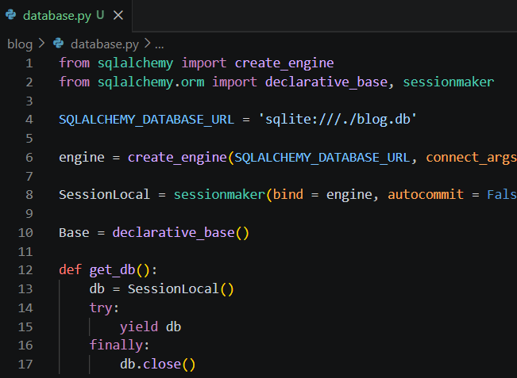
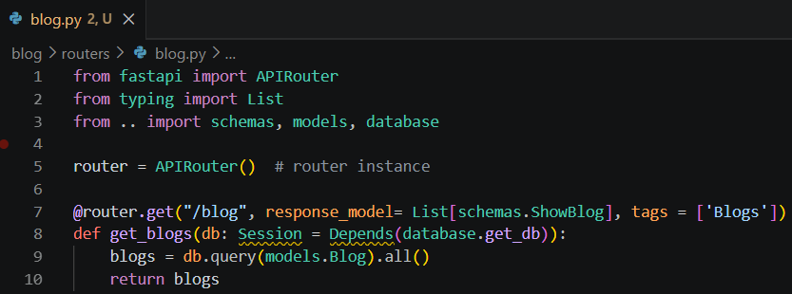
Now we’ve to register this route that we’ve created in main.py file:
For that, we’ve to use app.include_router, and define whatever router we want to give
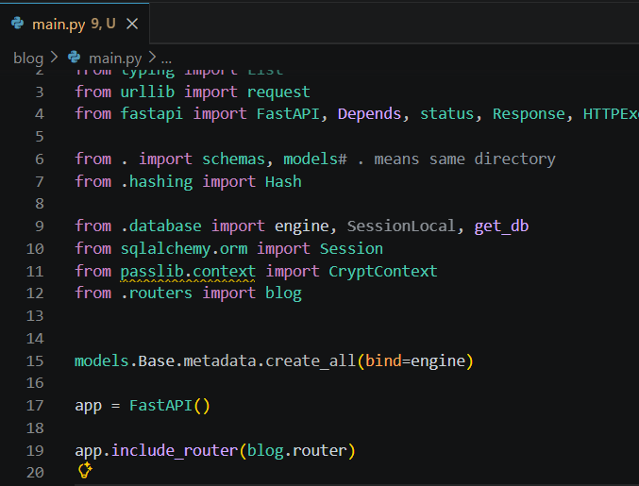
Now, we can see the api of get all blogs is created
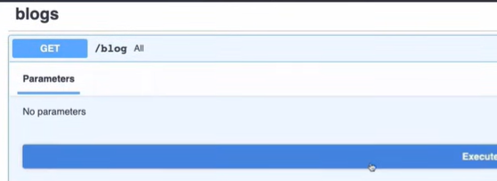
We’re getting all the blogs from this.
Now, we will add all the blog related apis inside this blog router
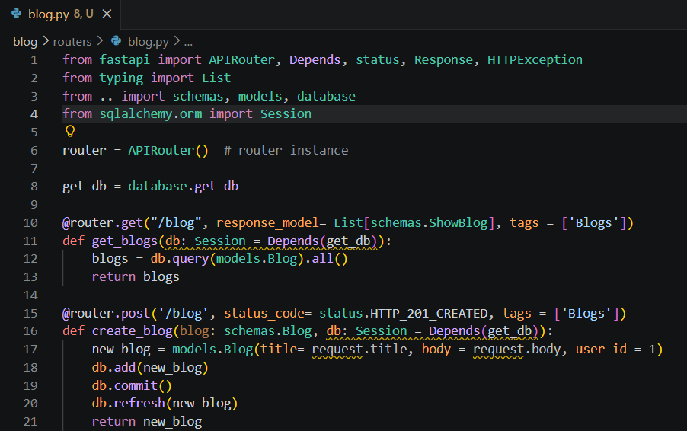
Similarly for user router we’ll do the same:
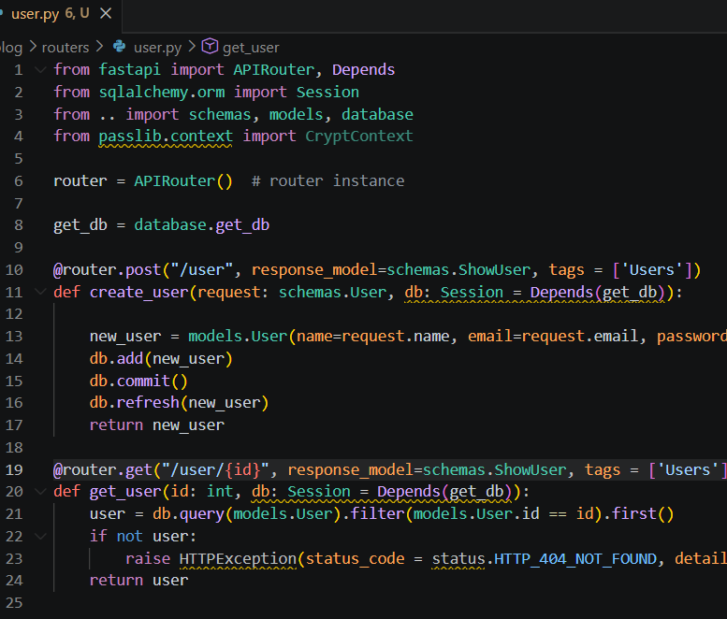
And in main.py:
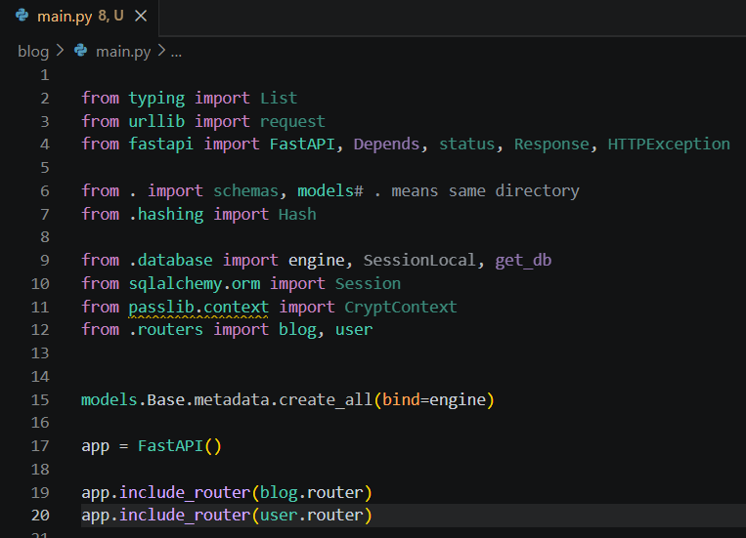
API Router operators:
In every routes, we’re defining tags, instead of defining tags everywhere we can define this tag inside the APIRouter when when initialize this router, similarly we’ll do it for user
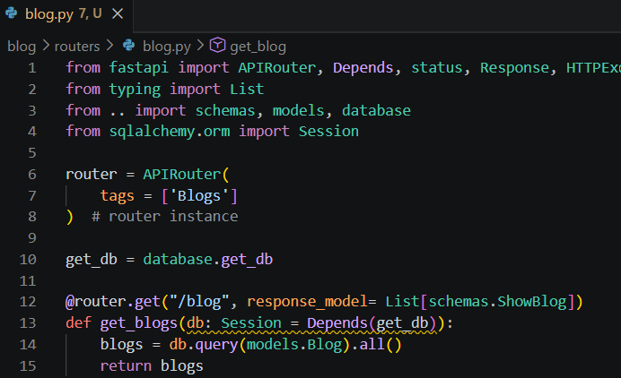
Next refactoring we can do is prefixing, we can prefix all the routes with some name, since all the blog routes starts with /blog, so we can define prefix as /blog, and every api where we’ve used /blog, in place of that we use ‘/’, similarly in user.py we’ll create prefix of: /user
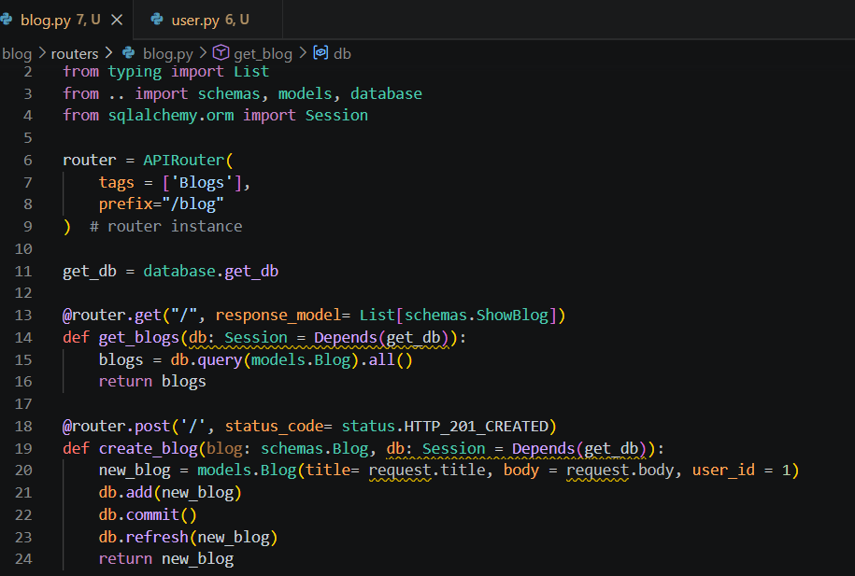
Blog and User Repositories:
In the routes that we’ve created, we’re doing so much things like db.add, db.commit, db.refresh, we can extract these things in a dedicated file, so we’ll create repository directory inside which we will create blog.py, for get all blogs the things that we’ve performed we will put that in the blog repository file
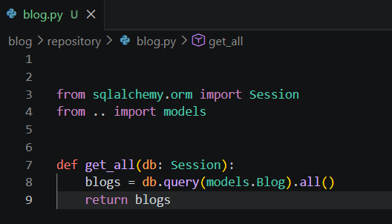
Now, we have to use this in our router file
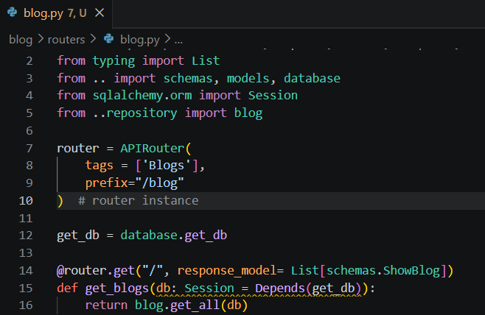
Similarly, we can do this in create blog as as well
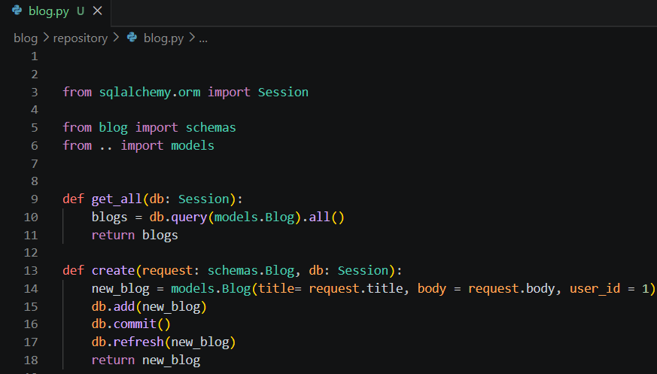
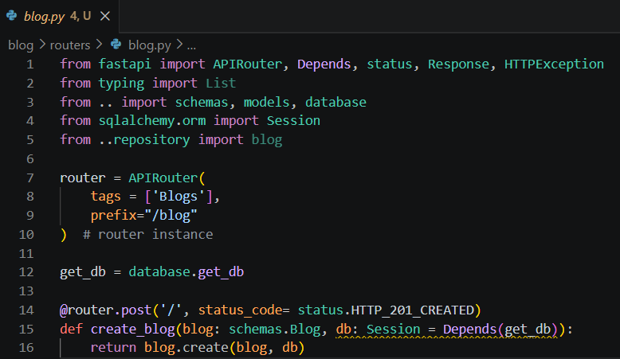
And for delete, update, get blog by id, we’ll do the same
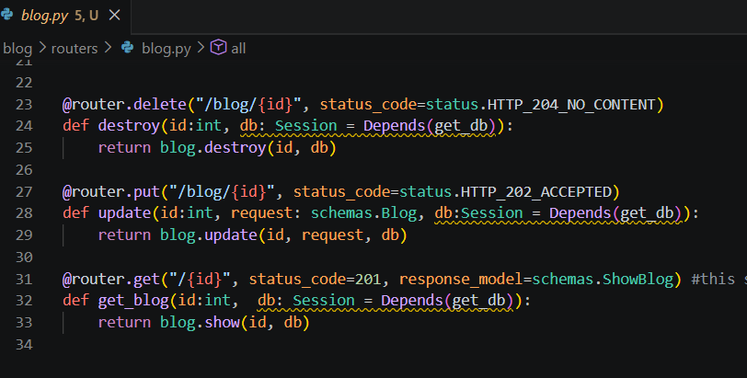
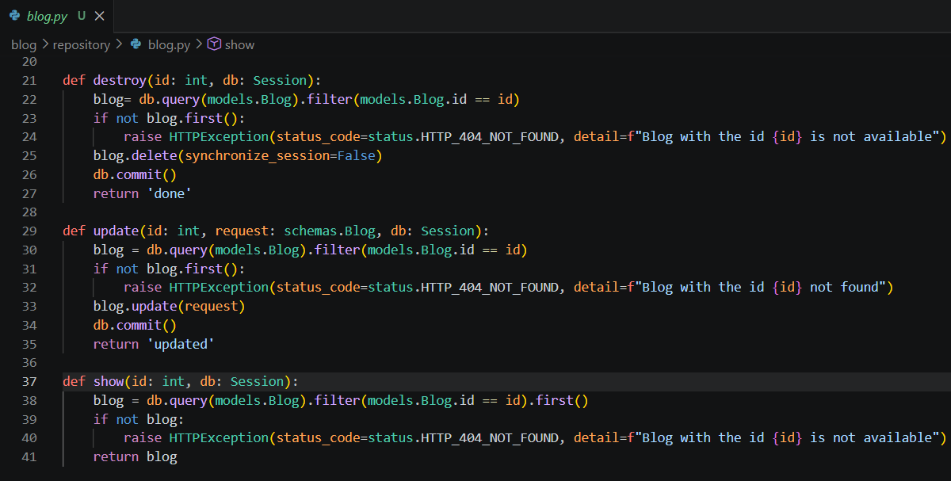
Similarly for user router as well, we’ll create the repository
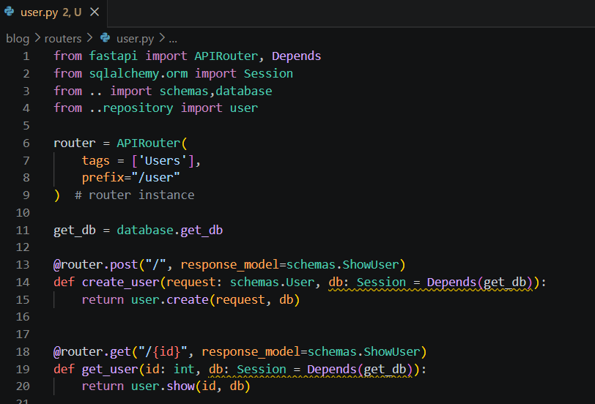
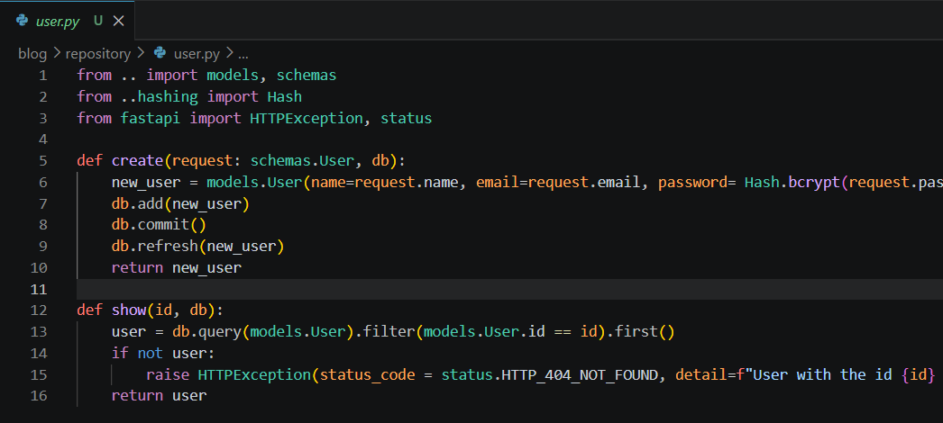
Login and Verify Password
Let’s create the route to login the user with email and password, so in routers folder we’ll create authentication.py and create the tags as well., and make changes in main.py as well
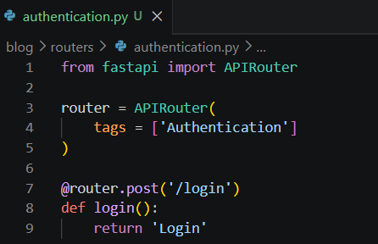
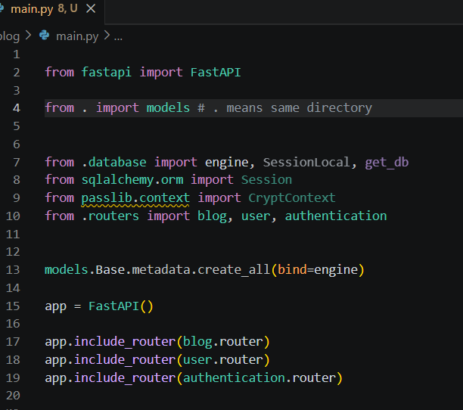
Since it is a post request so we need 2 things username and password, so we’ll create schema of Login for the request body, in this username is the email b/s in JWT , Oauth2PasswordRequestForm need username as identifier
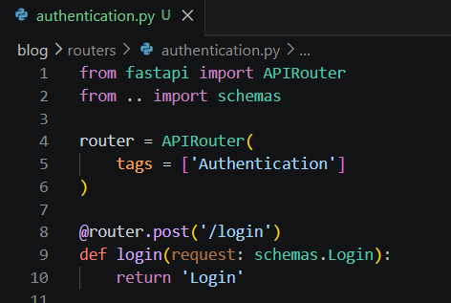
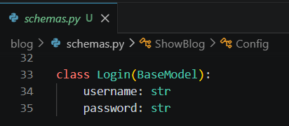
Then we’ve to find the user, for that we need db, so we’ll import database and use database.get_db, and we’ll create db session as well, then we are going to find the user through db.query and return the user
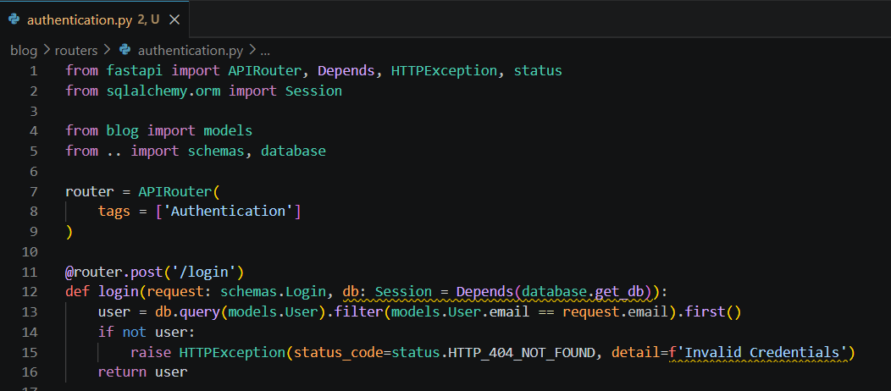
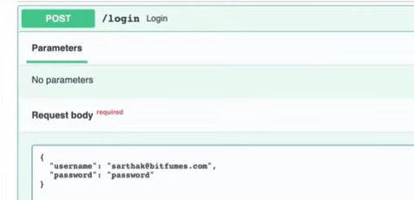
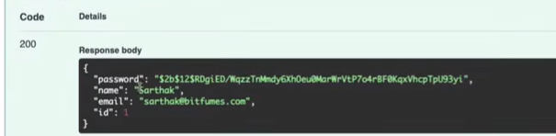
But we don’t need the user, we need access token, for that we need to implement JWT thing. Before that we need to verify the password as well, so we use Hash.verify(user.password, request.password) for that, and raise the exception for unsuccessful verification.
And we’ve to define verify function in hashing file which is having hashed password (user one)and plain password (requested one), then with the help of pwd_cxt we’ll verify plain and hashed password
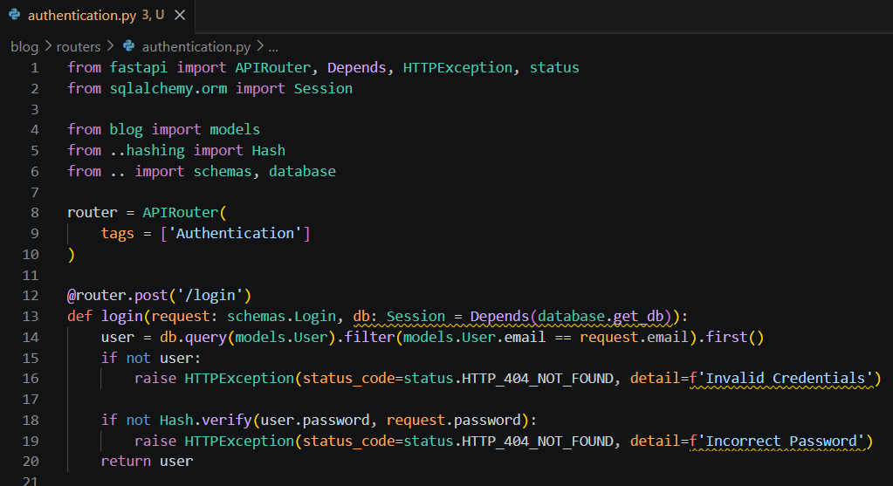
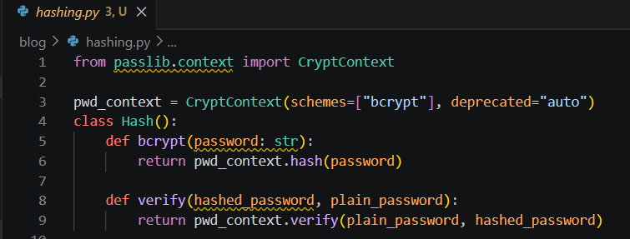
Now let’s try with incorrect password:
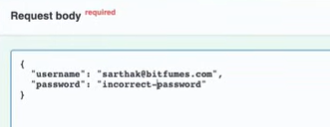
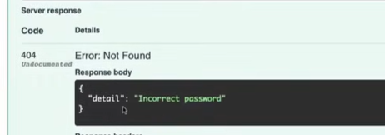
And, if I provide correct password:
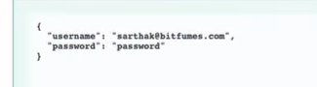
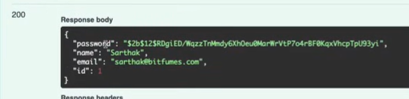
JWT Access Token
Now, instead of getting user details we need JWT. For that we need to install library: python-jose, then we need SECRET_KEY and ALGORITHM and ACCESS_TOKEN_EXPIRE_MINUTES (to encode JWT), and we’ll create another file in blog folder for jwt which is: token.py and all these 3 things there, and we need 2 pydantic models (i.e. schemas) which is Token, TokenData, and to generate jwt we create create_access_token function in token.py file
In create_access_token function, it needs data which we’re going to pass, then we’ll import jwt, JWTError from python-jose library, so in this we have to_encode, SECRET_KEY, and ALGORITHM, and it returns encoded_jwt. In create_access_token we are getting data and through to_encode.update, we’re going to add expiration to the data dict we’re having, and then finally encode it.
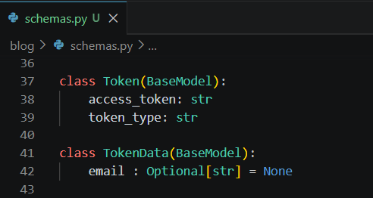
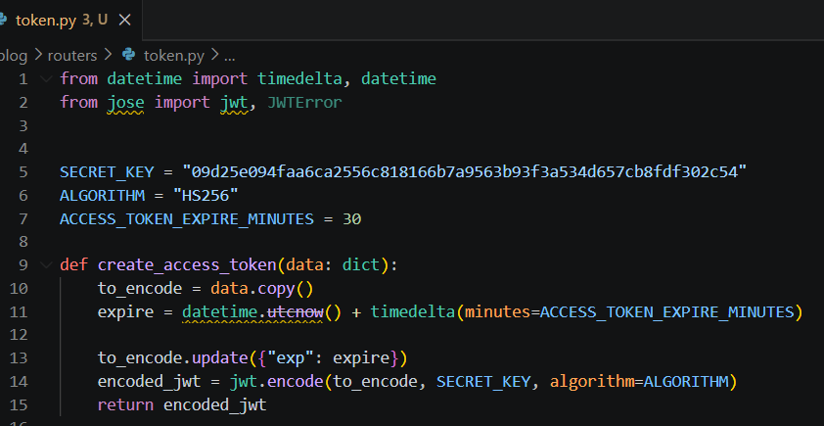
Now we’ll use create_access_token in our authentication file, after verifying the password we’re going to paste 2 lines access_token, and return access_token
Create access token providing data as user.user_email
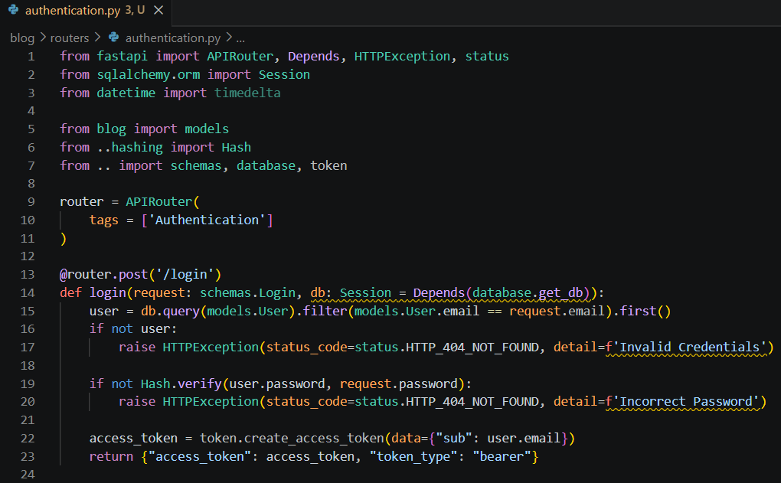
Now when we try it out:
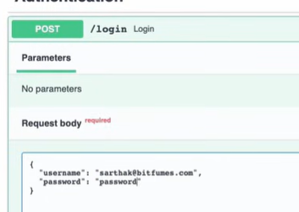

Now we’re getting access_token & token type
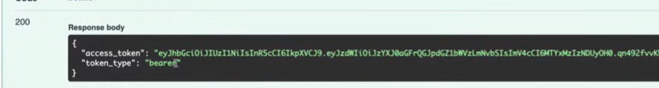
Now, we’ve to protect all the routes through this access token, we can access these routes only when the user is authenticated, otherwise user is un-authenticated
Routes behind Authentication
For this we’ll use OAuth2PasswordBearer, for this we’ll create file in blog folder c/d oauth2.py. Inside this file we’ll create a dependency get_current_user, which is going to check that the token is valid or not (by decoding and getting the user details), get_current_user needs token and ouath2 scheme, ouath2 scheme define the token url through OAuth2PasswordBearer
tokenUrl is where you want to fetch the token, so I want in login route, so from login route we are going to fetch the token
Then, in get_current_user, HTTPException is created.
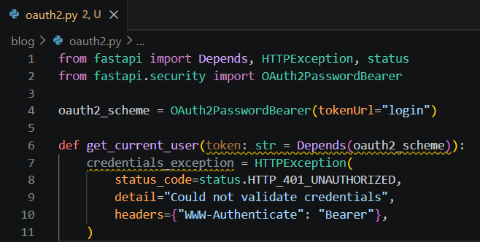
Then we try to decode the token that we’re having, which we’re going to do through token.py file, so we’ll create verify_token function in token.py, this function helps us to verify the token. In verify_token we’ll pass the token and credentials_exception as well

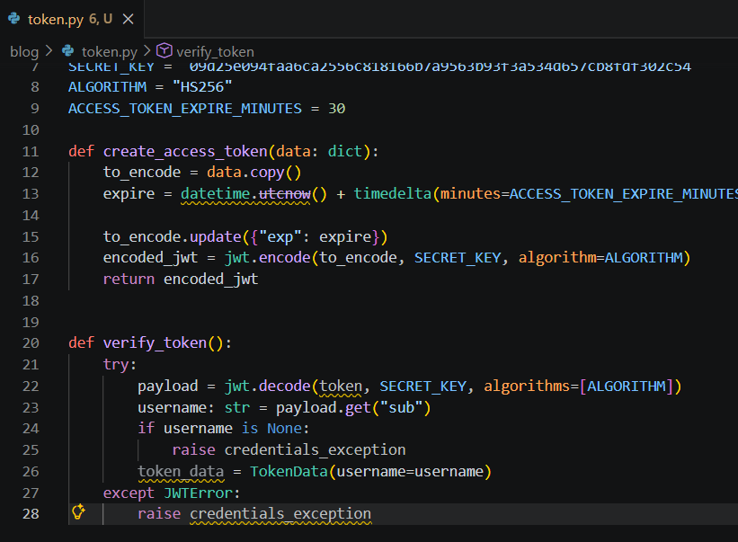
Then we use verify_token function into oauth2.py file

