Project Design Phase

Solution Architecture

Date | 15 July 2026
Team ID
Project Name | DarshanEase
Maximum Marks | 4 Marks

Solution Architecture:
Solution architecture is a complex process – with many sub-processes – that bridges the gap between business problems and technology solutions. Its goals are to:
- Find the best tech solution to solve existing business problems.
- Describe the structure, characteristics, behavior, and other aspects of the software to project stakeholders.
- Define features, development phases, and solution requirements.
- Provide specifications according to which the solution is defined, managed, and delivered.

DarshanEase Solution Architecture Overview:
DarshanEase follows a modular MERN stack architecture. Devotees access the platform through a React.js single-page application, which communicates with a Node.js/Express.js REST API over HTTPS. All requests pass through a JWT-based authentication and role-based authorization middleware before reaching the Controllers/Services layer, which handles Users, Temples, Darshan Slots, Bookings, and Donations. Data is persisted in MongoDB Atlas via Mongoose. Supporting services include a payment gateway for ticket and donation payments, an email/SMS service for booking notifications and reminders, and a QR code service that generates the digital darshan pass for confirmed bookings.

Example - Solution Architecture Diagram:

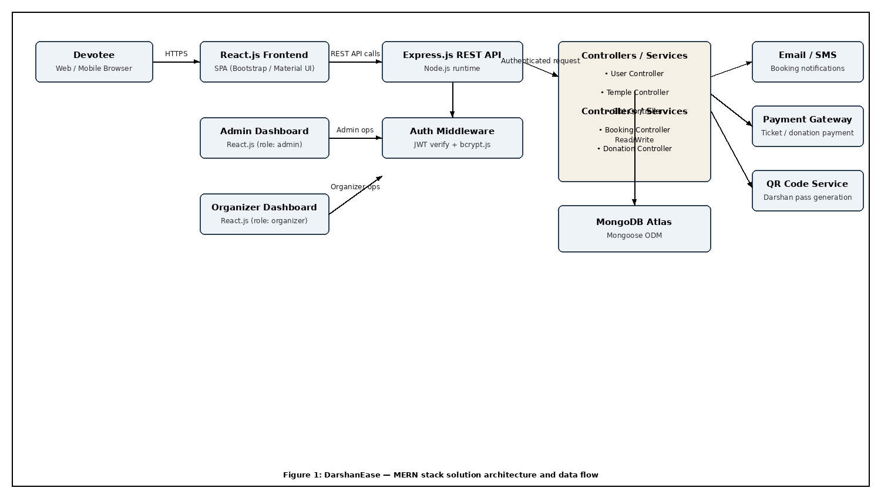

Figure 1: Architecture and data flow of the DarshanEase temple darshan booking application

Reference: https://aws.amazon.com/blogs/industries/voice-applications-in-clinical-research-powered-by-ai-on-aws-part-1-architecture-and-design-considerations/

