Project Design Phase-II
Data Flow Diagram & User Stories
Date | 15 July 2026
Team ID
Project Name | DarshanEase – Temple Darshan Ticket Booking System
Maximum Marks | 4 Marks
Data Flow Diagrams:
A Data Flow Diagram (DFD) is a visual representation of the information flows within the DarshanEase system. It shows how data enters and leaves the system, what processes transform the data, and where the data is stored (Users, Temples, Slots and Bookings collections in MongoDB Atlas).
Level 0 – Context Diagram
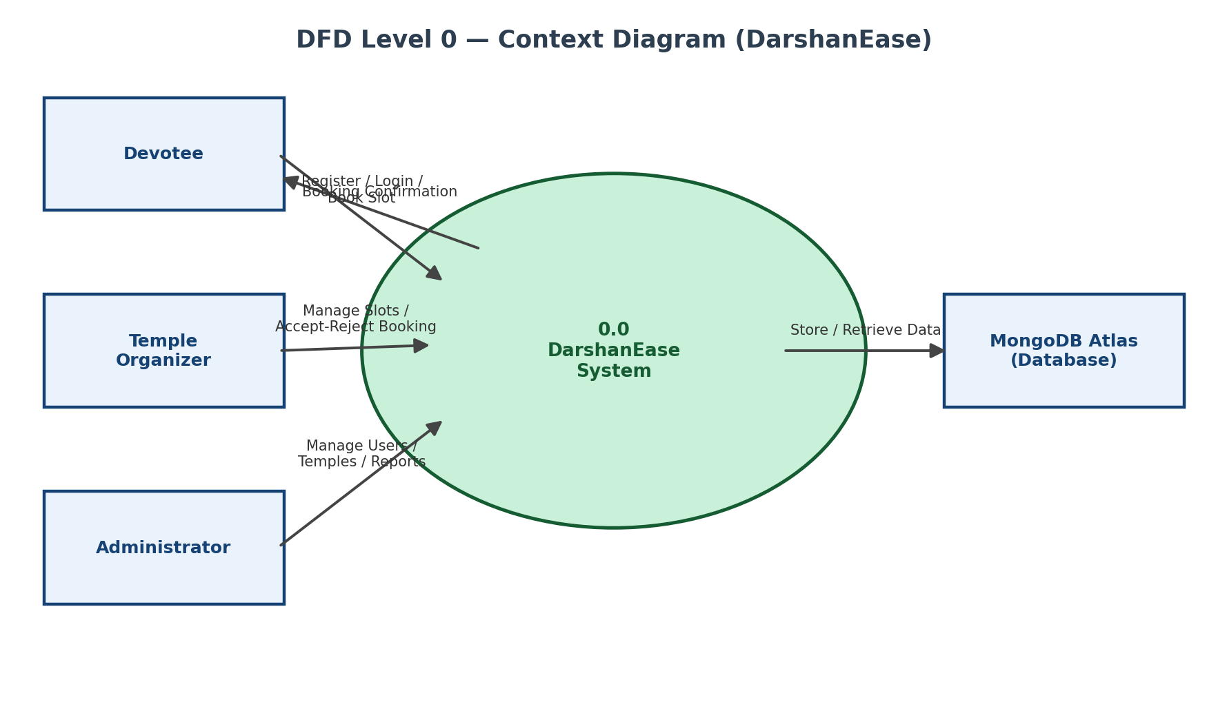
Level 1 – Process Breakdown
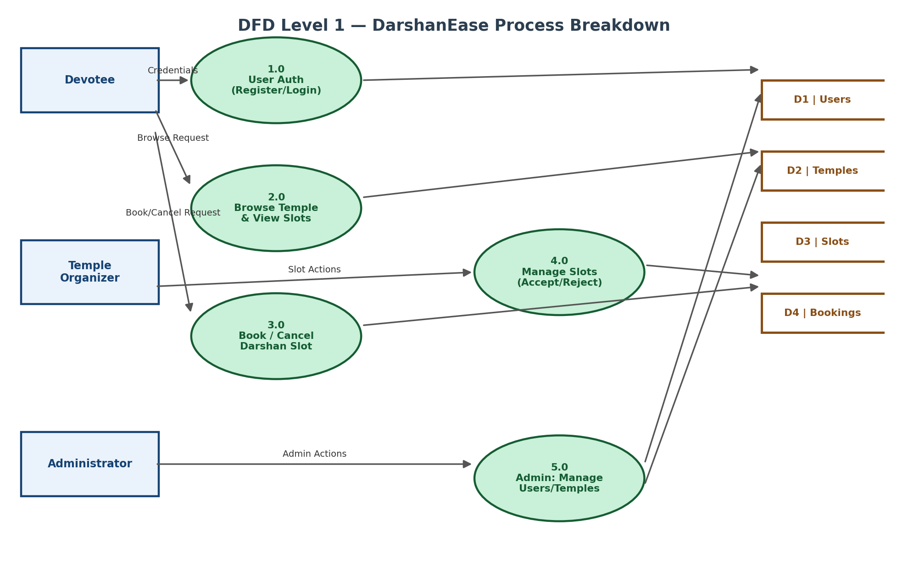
User Stories
The table below lists the user stories for DarshanEase, grouped by user type and functional requirement (epic).
User Type | Functional Requirement (Epic) | User Story Number | User Story / Task | Acceptance Criteria | Priority | Release
Devotee (End User) | Registration | USN-1 | As a devotee, I can register for the application by entering my name, email, and password. | I can access my account/dashboard after successful registration. | High | Sprint-1
 |  | USN-2 | As a devotee, I want my password to be stored securely so that my account remains safe. | Password is hashed (bcrypt) before being stored in the database. | High | Sprint-1
 | Login | USN-3 | As a devotee, I can log in using my registered email and password to access my dashboard. | I receive a JWT token and can access protected pages. | High | Sprint-1
 | Browse Temples | USN-4 | As a devotee, I can view a list of available temples so that I can choose where to book a darshan slot. | Temple list loads with name, location and description. | High | Sprint-1
 |  | USN-5 | As a devotee, I can view available darshan slots for a selected temple by date and time. | Available slots are displayed along with capacity. | High | Sprint-1
 | Slot Booking | USN-6 | As a devotee, I can book a darshan slot for my preferred date and time. | A booking record is created with status “Pending”. | High | Sprint-2
 |  | USN-7 | As a devotee, I can view my booking history to track my past and upcoming bookings. | “My Bookings” page lists all bookings with current status. | Medium | Sprint-2
 |  | USN-8 | As a devotee, I can cancel a booking if my plans change. | Booking status changes to “Cancelled”. | Medium | Sprint-2
Temple Organizer | Slot Management | USN-9 | As an organizer, I can view all booking requests made for my temple's slots. | Organizer dashboard lists pending bookings for the temple. | High | Sprint-2
 |  | USN-10 | As an organizer, I can accept a devotee's booking request. | Booking status changes to “Accepted”. | High | Sprint-2
 |  | USN-11 | As an organizer, I can reject a devotee's booking request. | Booking status changes to “Rejected”. | High | Sprint-2
Administrator | User & Temple Management | USN-12 | As an administrator, I can view and manage all registered users. | Admin dashboard lists all users along with their role. | Medium | Sprint-3
 |  | USN-13 | As an administrator, I can add, update, or remove temple records in the system. | Temple records reflect the changes made by the admin. | Medium | Sprint-3
 | Reporting | USN-14 | As an administrator, I can view booking reports across all temples. | Reports page displays booking statistics by temple/status. | Low | Sprint-3

