Project Design Phase-II
Technology Stack (Architecture & Stack)
Date | 15 July 2026
Team ID
Project Name | DarshanEase – Temple Darshan Ticket Booking System
Maximum Marks | 4 Marks
Technical Architecture:
The DarshanEase platform follows a three-tier architecture consisting of a Presentation Layer (React.js), an Application Layer (Node.js/Express.js REST APIs with JWT authentication), and a Database Layer (MongoDB Atlas). Devotees, organizers, and administrators each interact with the same presentation layer through role-based views, and all requests flow through secured REST APIs to the database.
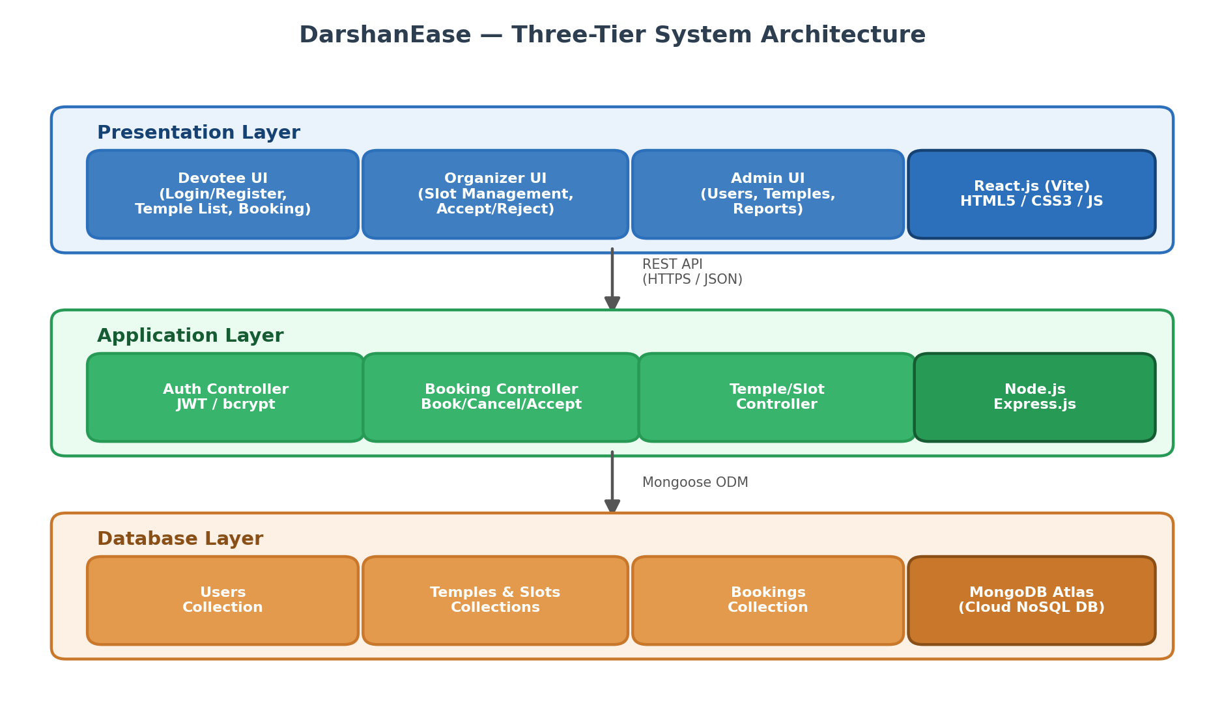
Table-1 : Components & Technologies:
S.No | Component | Description | Technology
1. | User Interface | Web UI through which devotees, organizers, and admins interact with the system | React.js (Vite), HTML5, CSS3, JavaScript
2. | Application Logic-1 | User registration, login, and authentication logic | Node.js, Express.js, JWT, bcrypt.js
3. | Application Logic-2 | Darshan slot booking, cancellation, and booking-status logic | Node.js, Express.js, Mongoose
4. | Application Logic-3 | Organizer slot management and admin user/temple/report management logic | Node.js, Express.js
5. | Database | Stores users, temples, slots, and booking data as documents | MongoDB (NoSQL, document-based)
6. | Cloud Database | Cloud-hosted database service for the application | MongoDB Atlas
7. | File Storage | Storage for static assets and (future) temple images | Local Filesystem / Cloud Storage (future scope)
8. | External API-1 | Online payment processing (future scope) | Razorpay / Stripe API (planned)
9. | External API-2 | Booking confirmation notifications (future scope) | Nodemailer (Email) / Twilio (SMS) (planned)
10. | Machine Learning Model | Not used in the current scope of the project | N/A
11. | Infrastructure (Server / Cloud) | Local Server Configuration: Node.js/Express server on localhost with MongoDB Atlas cloud DB. Cloud Server Configuration: Deployable on Render/Vercel/Netlify (planned). | Local: Node.js Server; Cloud: Render / Vercel / Netlify
Table-2: Application Characteristics:
S.No | Characteristics | Description | Technology
1. | Open-Source Frameworks | React.js, Express.js, Node.js and Mongoose form the complete open-source MERN stack used to build the application | MERN Stack
2. | Security Implementations | JWT-based authentication, bcrypt password hashing, protected routes via middleware, and role-based access control for Devotee / Organizer / Admin | JWT, bcrypt.js
3. | Scalable Architecture | Three-tier architecture (Presentation, Application, Database) allows each layer to be scaled independently as load increases | 3-Tier Architecture
4. | Availability | MongoDB Atlas provides a managed, redundant cloud database; stateless REST APIs allow the backend to be replicated across servers | MongoDB Atlas, REST APIs
5. | Performance | Lightweight Vite-built React front end, indexed MongoDB queries, and minimal JSON payloads keep API response times low | Vite, MongoDB Indexing
References:
MongoDB Atlas Documentation — https://www.mongodb.com/atlas
Express.js Documentation — https://expressjs.com/
React.js Documentation — https://react.dev/
JWT Introduction — https://jwt.io/introduction

