**SCHOOL OF COMPUTER SCIENCES**

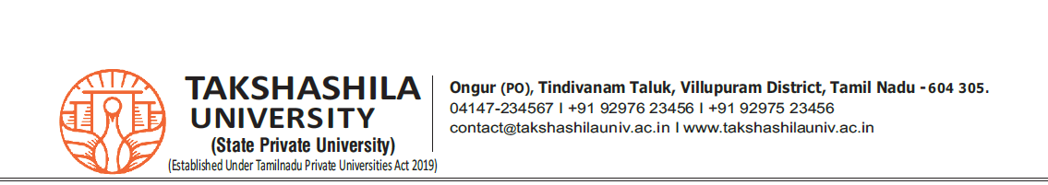**PROJECT TITLE SUBMISSION**

**Date :**

|  |  |
| --- | --- |
| **Name of the Student** |  |
| **Register No.** |  |
| **Class** |  |
| **Title of the Project** |  |
| **Frontend** |  |
| **Backend** |  |
| **Name of the Company with Address** |  |
| **Signature of the Student** |  |
| **Signature of the Internal Guide** |  |
| **Signature of the School Incharge** |  |

**ABSTRACT**

WordBridge is an AI-powered language translation web application that enables users to translate text, speech, and images into multiple languages instantly. It uses Natural Language Processing (NLP), Machine Learning (ML), and Optical Character Recognition (OCR) to provide accurate and efficient translations. The platform offers key features like text translation, speech-to-text, text-to-speech, and image-based translation, making it a versatile tool for breaking language barriers. With an intuitive and user-friendly interface, WordBridge also includes real-time language detection, translation history, and saved translations to enhance the user experience.

Built using Python (Django), JavaScript, HTML, CSS, and MySQL, WordBridge integrates APIs like Google Translate API, DeepL API, SpeechRecognition, and gTTS to improve translation accuracy. It is designed to be fast, accessible, and efficient, catering to a wide range of users, including travelers, students, businesses, and content creators. The project aims to simplify global communication by providing a smart and reliable translation solution that adapts to the needs of the modern world.