HEART DISEASE PREDICTION SYSTEM
USING MACHINE LEARNING
Machine Learning Internship - Week 4 Capstone Project Report
Project Report
Submitted as part of the Machine Learning Internship Program

Abstract
Cardiovascular disease remains one of the leading causes of death globally, and early, low-cost risk assessment from routine clinical measurements can support timely medical attention. This report documents the design, implementation and evaluation of a Heart Disease Prediction System built during a four-week Machine Learning internship. Using the publicly available UCI Heart Disease dataset (920 patient records collected across four clinical sites), a complete supervised-learning pipeline was built: data cleaning, exploratory data analysis, leakage-free preprocessing, model training, evaluation and model selection. Two classification algorithms - Logistic Regression and a Decision Tree Classifier - were trained and objectively compared using Accuracy, Precision, Recall, F1-score and ROC-AUC on a held-out, stratified test set. Logistic Regression was selected as the final model based on its higher ROC-AUC and Recall. The trained pipeline was deployed through an interactive Streamlit web application that allows a user to enter patient details in plain, meaningful terms and receive a risk prediction with an associated probability, alongside a clear disclaimer that the tool is for educational purposes only and does not constitute medical advice.

1. Introduction
Machine Learning has increasingly been applied to healthcare-related decision support, where models trained on historical patient data can help surface patterns that assist - but do not replace - clinical judgement. This project uses the well-known UCI Heart Disease dataset to build and evaluate a binary classification system that estimates whether a patient is likely to have heart disease, based on demographic information and standard, non-invasive diagnostic measurements. Beyond model development, the project emphasises the complete software lifecycle expected of an applied ML engineer: reproducible data processing, rigorous evaluation, model packaging, and delivery through a usable web interface.

2. Problem Statement
Given a set of clinical attributes for a patient - such as age, sex, resting blood pressure, cholesterol level, chest pain type, maximum heart rate achieved, and results of exercise-based diagnostic tests - the goal is to predict whether the patient is likely to have heart disease (a binary outcome: disease present or absent). The original dataset records disease severity on a 0-4 scale; for this project the problem is framed as binary classification, since the primary decision-support question is whether disease is present at all.

3. Objectives
- Clean and prepare the UCI Heart Disease dataset without discarding large portions of the data.
- Perform exploratory data analysis to understand feature distributions and their relationship to the target.
- Build a reproducible, leakage-free preprocessing pipeline using scikit-learn.
- Train and fairly compare two classification models: Logistic Regression and a Decision Tree.
- Evaluate both models using multiple complementary metrics, with particular attention to Recall.
- Select and persist the best-performing model as a single deployable artifact.
- Deploy the model through an interactive, professional web application.

4. Dataset Description
The dataset used is the UCI Heart Disease dataset (heart_disease_uci.csv), containing 920 patient records and 16 columns, aggregated from four clinical sites: Cleveland, Hungary, Switzerland and VA Long Beach. Because the data was collected at different sites with different testing protocols, several columns have missing values - most notably ca (number of major vessels, missing in the majority of records), thal (thalassemia result) and slope (slope of the peak exercise ST segment).

4.1 Key Columns
- age, sex - patient demographics
- cp - chest pain type (typical angina, atypical angina, non-anginal, asymptomatic)
- trestbps - resting blood pressure (mm Hg)
- chol - serum cholesterol (mg/dl)
- fbs - fasting blood sugar > 120 mg/dl (boolean)
- restecg - resting electrocardiographic result
- thalch - maximum heart rate achieved
- exang - exercise-induced angina (boolean)
- oldpeak - ST depression induced by exercise relative to rest
- slope - slope of the peak exercise ST segment
- ca - number of major vessels coloured by fluoroscopy
- thal - thalassemia test result
- num - original target (0-4 severity), converted to the binary heart_disease column used for modelling

5. Technologies Used
- Python 3 - primary programming language
- pandas, NumPy - data loading, cleaning and manipulation
- Matplotlib, Seaborn - exploratory data visualization
- scikit-learn - preprocessing (ColumnTransformer, Pipeline), model training and evaluation
- joblib - persisting the trained pipeline to disk
- Streamlit - interactive web application

6. Methodology
The project follows a standard supervised-learning workflow: data acquisition, cleaning, exploratory analysis, preprocessing, model training, evaluation, model selection, and deployment. Each stage is implemented as a reusable Python module (src/preprocessing.py, src/train_model.py, src/eda.py, src/predict.py) so that the entire pipeline is reproducible with random_state=42 fixed throughout.

7. Data Preprocessing
The id column was dropped as a non-predictive row identifier. Boolean columns (fbs, exang) were cast to string categories so they are handled consistently with the other categorical features. Two duplicate records were removed. Rather than dropping columns or rows with high missingness (ca, thal, slope), missing values are handled inside the modelling pipeline: numerical features are median-imputed and standard-scaled, and categorical features are most-frequent-imputed and one-hot encoded, both within a scikit-learn ColumnTransformer wrapped in a Pipeline. Because this pipeline is fit only on the training split and re-applied unchanged to the test split and to new patient input, the design avoids data leakage and ensures the web application receives exactly the same transformations used during training.
The dataset was split 80% training / 20% testing, using random_state=42 and stratification on the target. Stratified splitting preserves the original class balance (roughly 55% disease-positive, 45% disease-negative) in both splits, which keeps evaluation metrics - especially Recall and ROC-AUC - reliable on the smaller test set.

8. Exploratory Data Analysis
Exploratory analysis examined the distribution of the target variable, numerical features (age, resting blood pressure, cholesterol, maximum heart rate, oldpeak) and categorical features (sex, chest pain type, fasting blood sugar, resting ECG, exercise-induced angina, slope, thalassemia), each in relation to the diagnosis outcome. Selected visualizations are shown below; the full set is available in outputs/eda/.
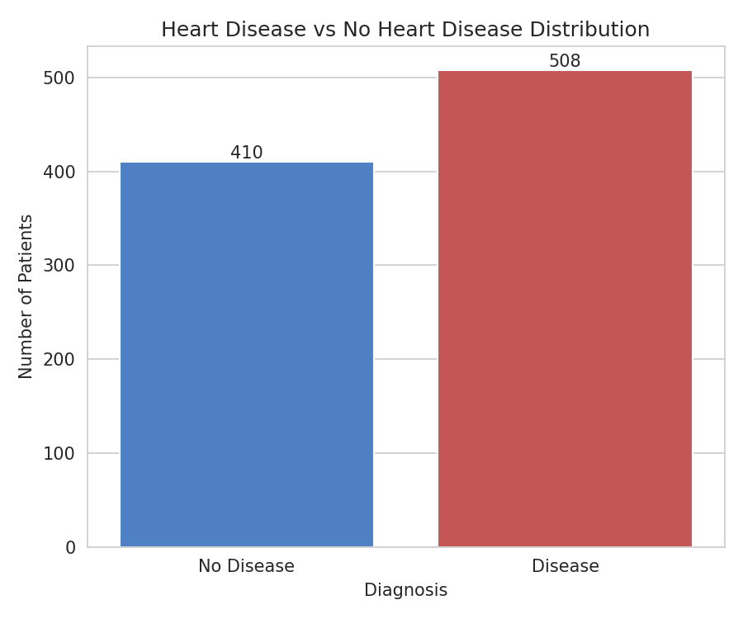
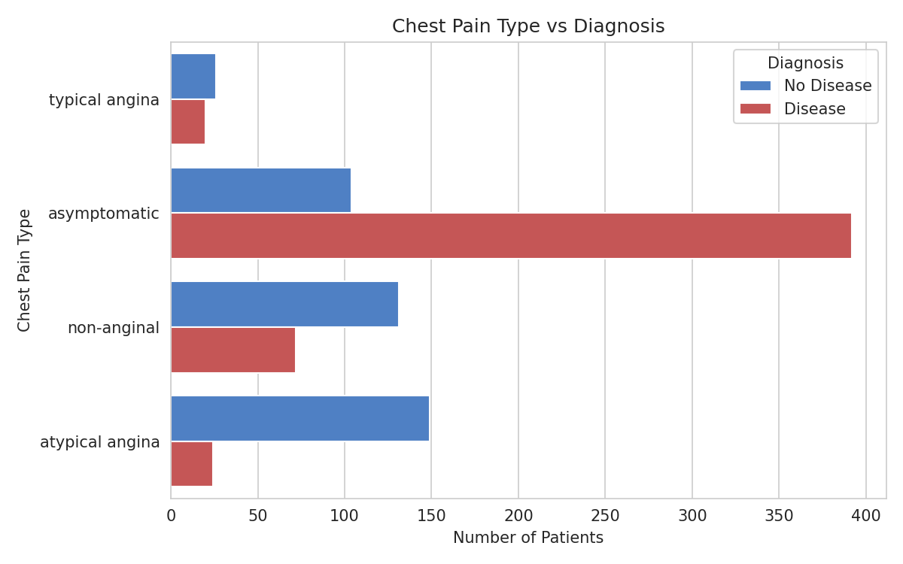
The target distribution shows a moderate class imbalance (508 disease-positive vs. 410 disease-negative records after cleaning), which motivated the use of stratified splitting and Recall as a key evaluation metric. Chest pain type shows a strong relationship with diagnosis: asymptomatic chest pain is associated with a notably higher proportion of heart-disease-positive cases than the other categories, consistent with clinical literature suggesting that silent presentations can be a marker of more advanced disease.

9. Machine Learning Models
Two models were trained and compared under identical preprocessing:
- Logistic Regression (max_iter=1000, random_state=42) - a linear baseline model, chosen for its interpretability and strong performance on well-behaved tabular clinical data.
- Decision Tree Classifier (max_depth=5, min_samples_leaf=10, random_state=42) - a non-linear model capable of capturing feature interactions; depth and leaf-size were constrained to reduce overfitting.

10. Model Evaluation
Both models were evaluated on the same held-out, stratified 20% test set (184 patients), using Accuracy, Precision, Recall, F1-score, ROC-AUC, a full classification report, and confusion matrix and ROC curve visualizations.

10.1 Metric Definitions
- Accuracy - overall proportion of correct predictions.
- Precision - of patients predicted disease-positive, the proportion who actually are.
- Recall (Sensitivity) - of patients who actually have heart disease, the proportion correctly identified; prioritised here because missing a true positive case is the more costly error in a screening context.
- F1-score - harmonic mean of Precision and Recall.
- ROC-AUC - the model's ability to discriminate between the two classes across all thresholds (1.0 = perfect, 0.5 = random).

10.2 Confusion Matrices and ROC Curve
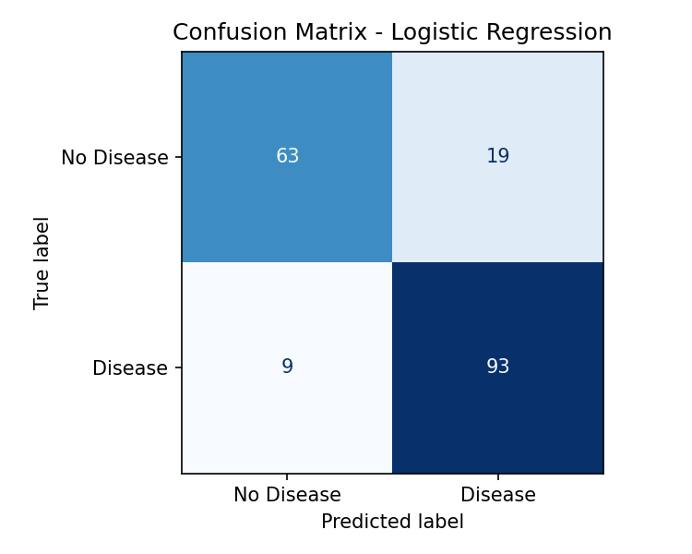
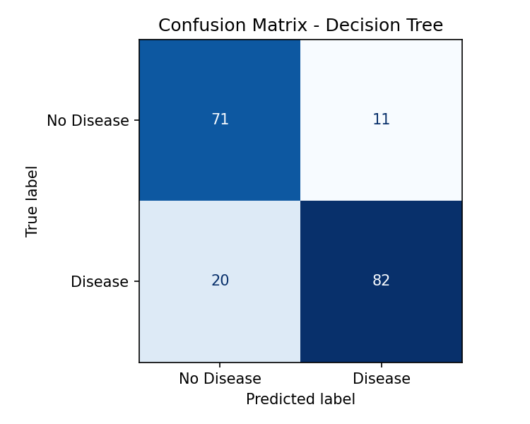
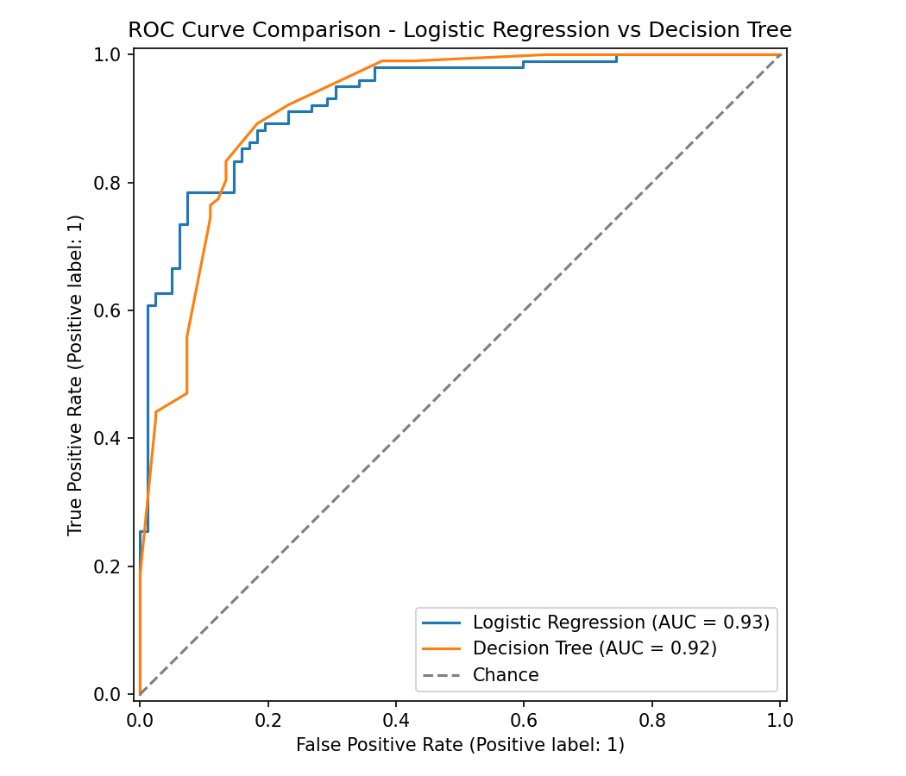

11. Results and Discussion
The table below reports actual test-set results produced by running src/train_model.py; no values are hard-coded or assumed.
Model | Accuracy | Precision | Recall | F1-Score | ROC-AUC
Logistic Regression | 0.8478 | 0.8304 | 0.9118 | 0.8692 | 0.9284
Decision Tree | 0.8315 | 0.8817 | 0.8039 | 0.8410 | 0.9193

Logistic Regression achieved the higher ROC-AUC (0.9284 vs. 0.9193) and substantially higher Recall (0.9118 vs. 0.8039), meaning it correctly identifies a larger share of patients who actually have heart disease. The Decision Tree achieved slightly higher Precision (0.8817 vs. 0.8304), meaning fewer of its positive predictions are false alarms, but at the cost of missing more true positive cases. Given that under-detecting heart disease is the more clinically consequential error in a screening tool, Logistic Regression was selected as the final model, using ROC-AUC as the primary selection criterion and Recall as the tie-breaker.

11.1 Feature Importance / Interpretation
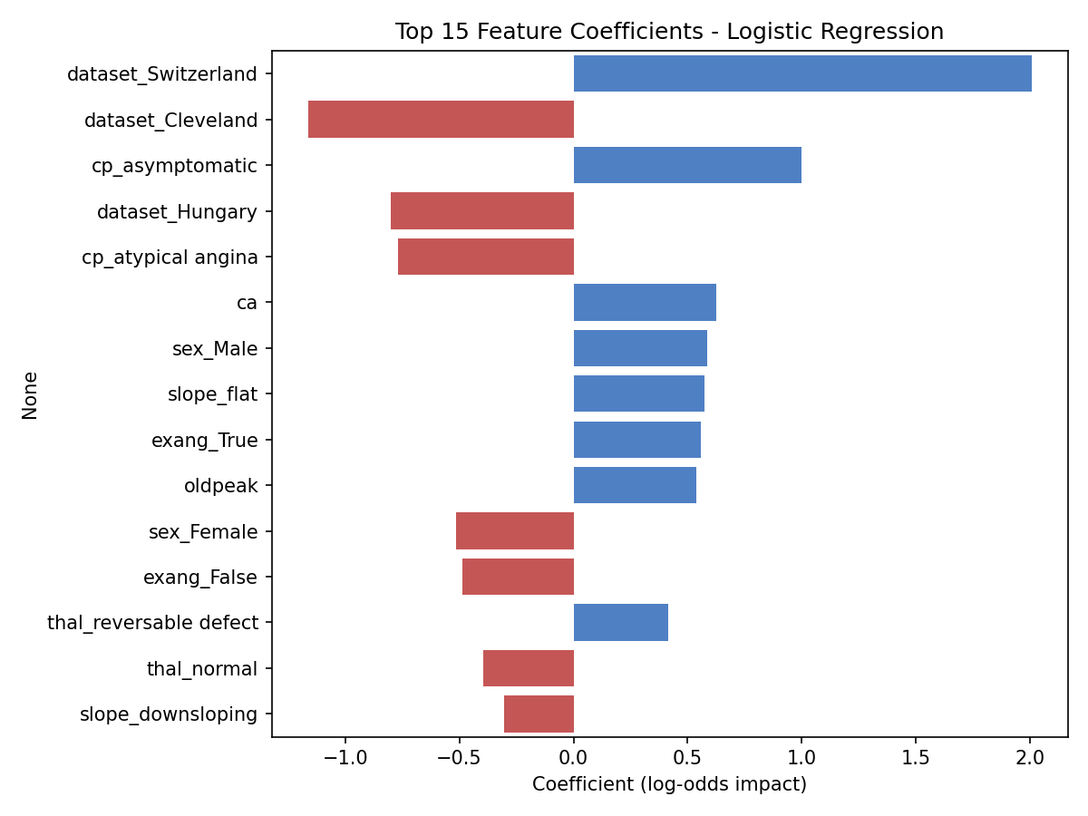
For the selected Logistic Regression model, the coefficients indicate the direction and relative strength of each feature's association with the predicted log-odds of heart disease. Features such as chest pain type, exercise-induced angina, thalassemia result and the number of major vessels show the strongest associations. These are statistical associations learned from this dataset and should be interpreted as such - not as medical causation.

12. Web Application
The final model pipeline was deployed through a four-page Streamlit web application with a clean, healthcare-inspired interface:
- Home - project introduction, objective, technologies used, and the required medical disclaimer.
- Predict - an interactive form using meaningful labels (e.g. 'Asymptomatic' rather than a raw code 0-3) for chest pain type, thalassemia and other categorical fields; sliders and number inputs for continuous values; a Predict button that returns a clear positive/negative result plus a predicted probability.
- Model Performance - the metrics table above, confusion matrices, the ROC curve comparison, and feature importance, all generated from the actual trained models.
- Dataset Insights - key EDA visualizations for anyone reviewing the project to explore the underlying data.
The saved pipeline (models/heart_disease_model.pkl) bundles preprocessing and the trained classifier together, so the app can accept raw, human-readable patient input directly without any separate encoding step, eliminating a common source of train/serve skew.

13. Conclusion
This project successfully implemented a complete, reproducible Machine Learning pipeline for heart disease risk prediction, from raw multi-site clinical data through to a deployed, interactive web application. Logistic Regression was identified as the stronger of the two evaluated models on this dataset, achieving approximately 85% accuracy, 91% recall and 93% ROC-AUC on unseen test data. The project demonstrates practical skills across data cleaning, exploratory analysis, leakage-aware preprocessing, model evaluation and selection, and software delivery - the core competencies expected of an applied Machine Learning engineer.

14. Future Scope
- Testing additional algorithms such as Random Forest, Gradient Boosting, or SVM.
- Hyperparameter tuning (e.g. grid/randomised search) and k-fold cross-validation for more robust model selection.
- Deeper model interpretability using tools such as SHAP values.
- Training on larger and more diverse patient populations.
- Model monitoring and periodic retraining after deployment.
- Deployment on a cloud platform for wider accessibility.
- Integration with healthcare information systems, subject to appropriate privacy, validation and regulatory requirements.
This system has not undergone clinical validation and is not intended for real-world diagnostic use.

15. References
1. Dua, D. and Graff, C. (2019). UCI Machine Learning Repository - Heart Disease Data Set. University of California, Irvine, School of Information and Computer Sciences.
2. Pedregosa, F. et al. (2011). Scikit-learn: Machine Learning in Python. Journal of Machine Learning Research, 12, 2825-2830.
3. Streamlit Documentation - https://docs.streamlit.io/
4. McKinney, W. (2010). Data Structures for Statistical Computing in Python (pandas).

