PROJECT-3
Problem Statement:
Design a 4-bit wide single-port RAM with synchronous read/write and asynchronous reset.

Introduction:
Single port RAM is a type of memory that uses only one set of address, data, and control lines for both reading and writing operations. This means the memory will store data where each location holds 4 bits, and there is only one port used for both reading and writing operations. The RAM should work with synchronous read and write, which means both operations happen according to the clock signal. Additionally, it should have an asynchronous reset feature, so that the memory can be cleared or reset immediately without waiting for the clock. The goal is to design this memory in a way that it properly stores, reads, and resets data based on the given control signals.
Objectives
- To design a 4-bit wide single-port RAM.
- To implement synchronous read and write operations using a clock signal.
- To understand memory design fundamentals and address-based data access.
- To verify the design using a testbench and basic verification techniques.

Features:
- Each memory location stores 4 bits of data
- Uses a single port for both read and write operations
- Synchronous read/write controlled by a clock signal
- Includes asynchronous reset to clear memory instantly
- Accesses data using a common address line
- Simple design with low hardware complexity

Module Design:

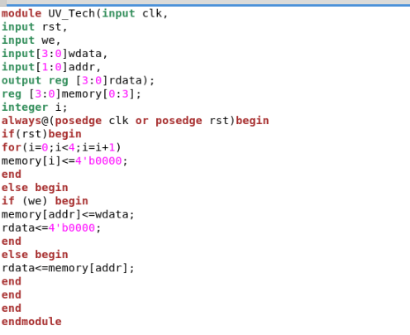

Testbench:

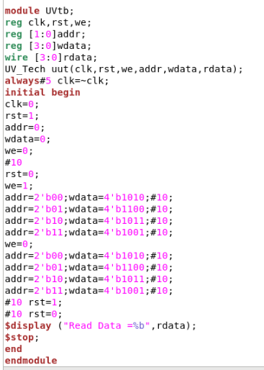

Block Diagram:

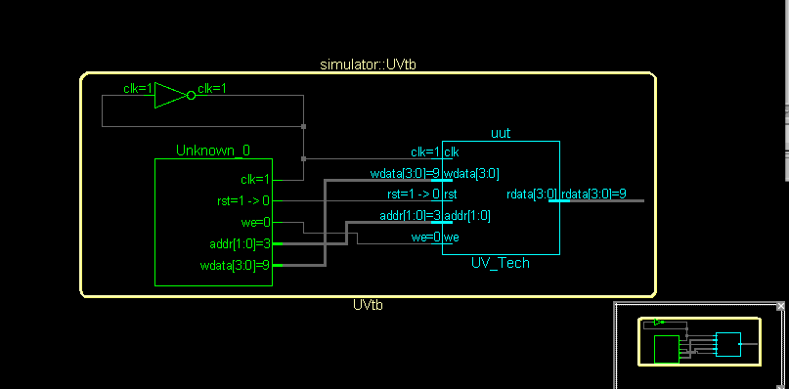

Waveform:

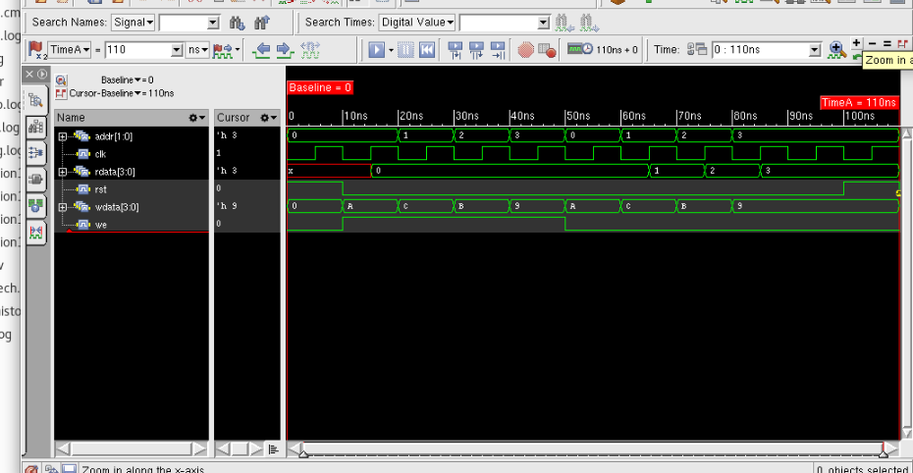

Approach/Logic Used:
- Storage Capacity: It creates 4 memory locations where each location can store a 4-bit value.
- Asynchronous Reset: The always block triggers on the posedge clk or posedge rst. If rst is high, a for loop initializes all 4 memory locations to zero (4'b0000). Because rst is in the sensitivity list, the memory wipes as soon as the reset button is pressed.

- Write Mode (we = 1):

- The data present on wdata is saved into the memory array at the index specified by addr.
- While writing, the output rdata is forced to 0. This is a specific design choice in this code to "blank" the output during a write operation.

- Read Mode (we = 0):
- The module looks up the value stored in memory[addr].
- This value is then assigned to the output register rdata
Repository Link:
https://github.com/Yukti847/RTL-design

