Lab 9th February

***Yukti19csu366***

# Experiment 1:

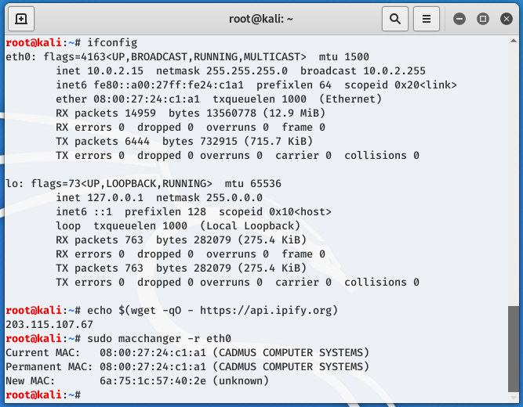

# Experiment 2:

Private IP:



Public IP:

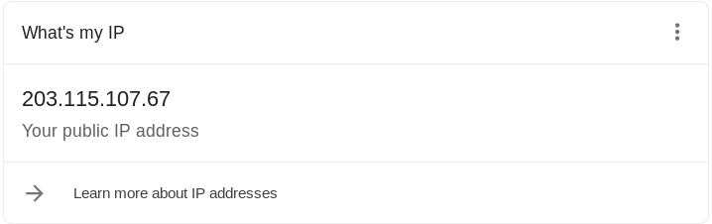

# Experiment 3:

Before proxy:

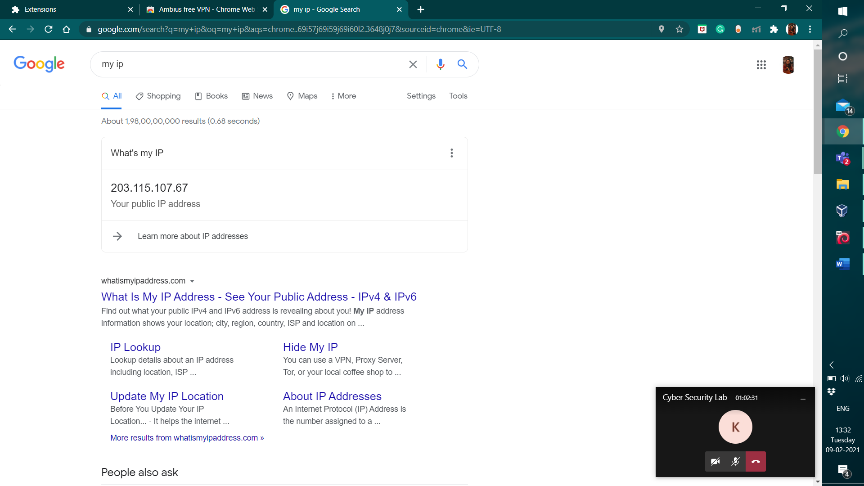

After proxy:

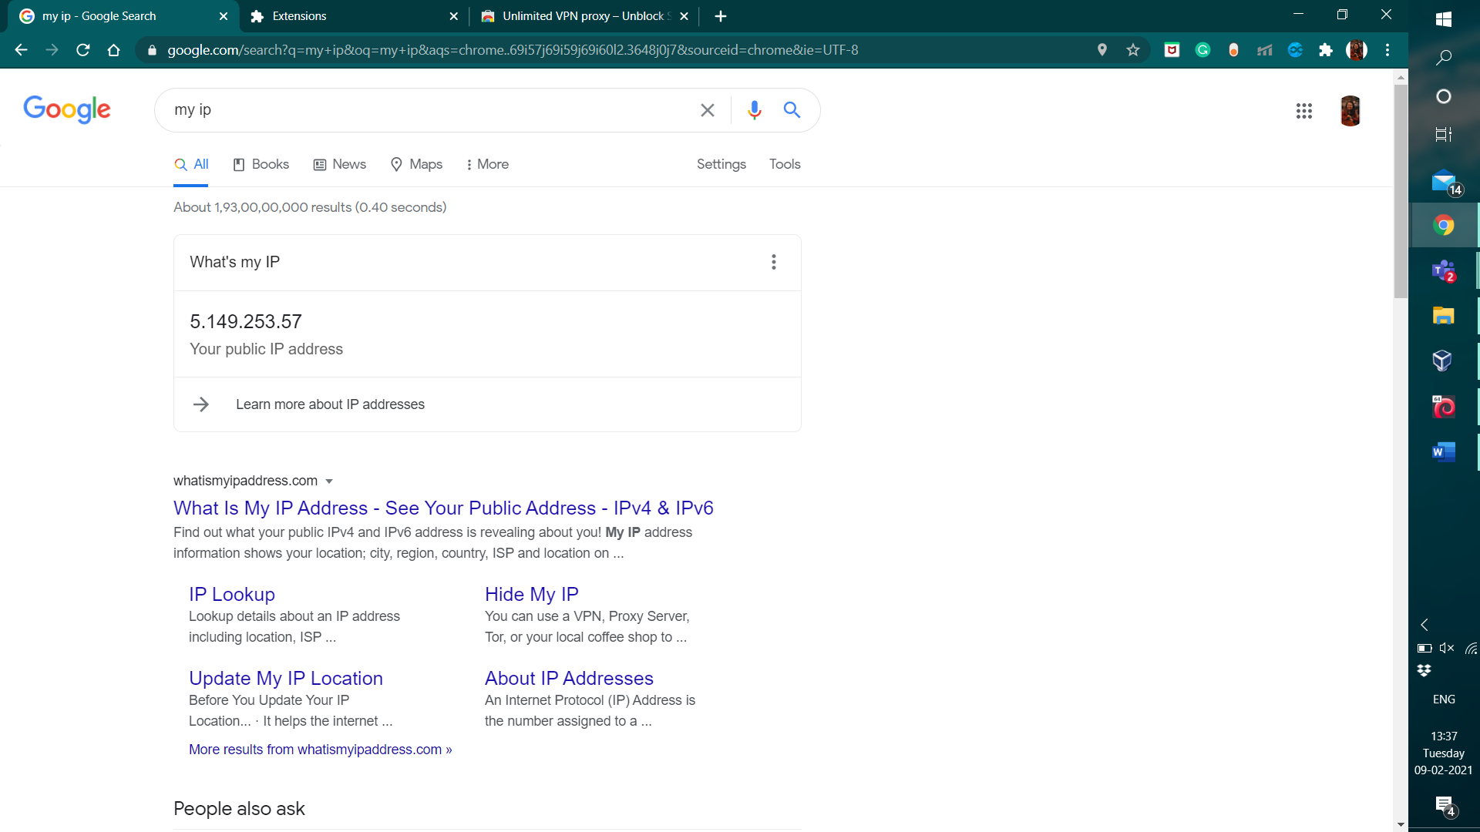

# Experiment 4:

Before VPN:

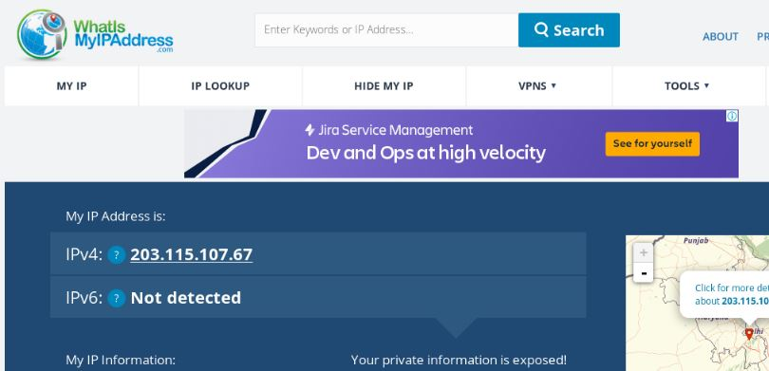

After VPN:

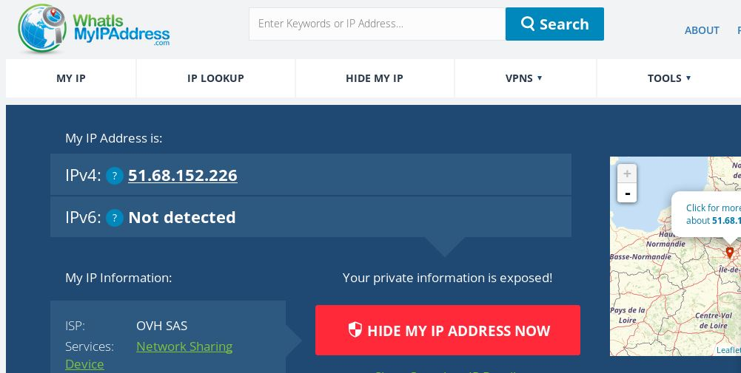

After remove of VPN:

