Scanning

[https://www.microsoft.com/en-in and 192.168.1.1](https://www.microsoft.com/en-in%20and%20192.168.1.1)

Yukti Agarwal

19csu366

**nmap** [**https://www.microsoft.com/en-in**](https://www.microsoft.com/en-in)

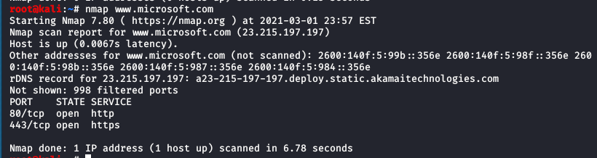

**Nmap 192.168.195.1-255**

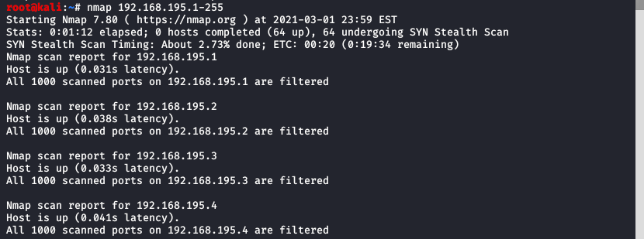

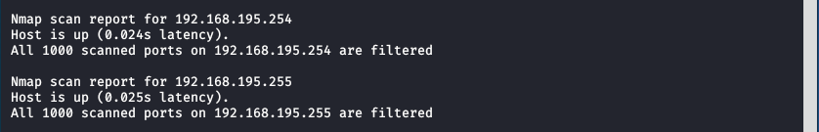

**Nmap --top-ports 5 23.215.197.197**

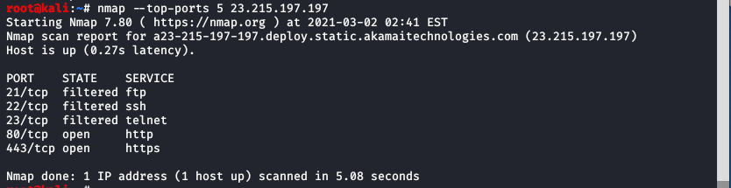

**Nmap -v -O --osscan-guess 23.215.197.197**

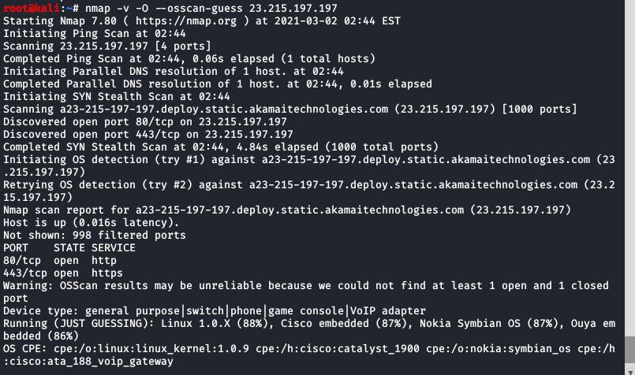

**Nmap -F 23.215.197.197**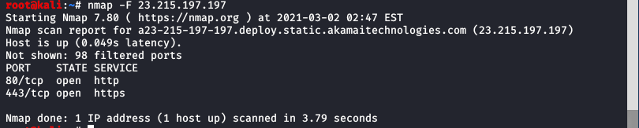

**Nmap –sV 23.215.197.197**

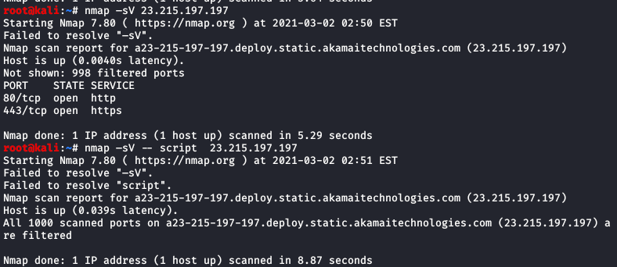

**Nmap –sV –script 23.215.197.197**



**Nmap –sA 23.215.197.197**

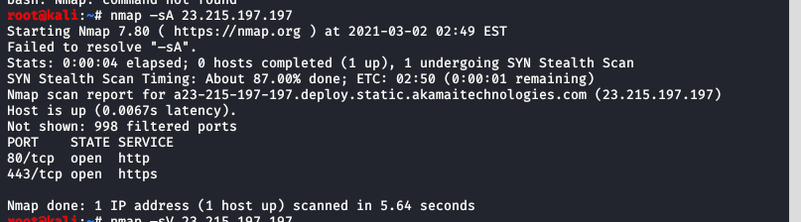

**nmap -sO 23.215.197.197**

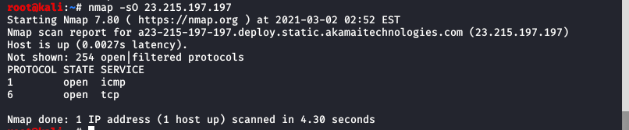

**Nmap --script vuln 23.215.197.197**

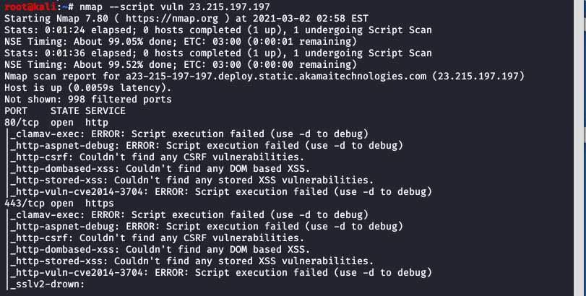

**nmap -sT 192.168.1.1**

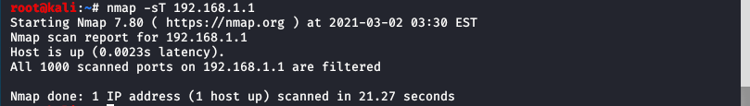

**nmap -sU 192.168.1.1**

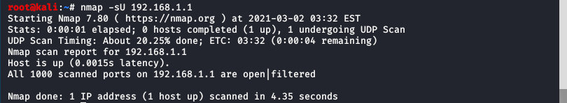

**nmap -sW 192.168.1.1**

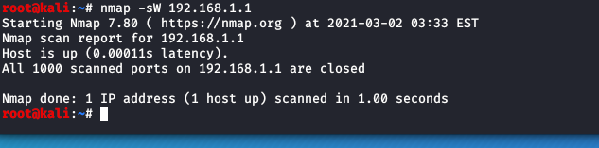

**nmap -Pn --script=http-sitemap-generator 192.168.1.1**



**nmap -sS 192.168.1.1**

