Zenmap (192.168.1.1)

Yukti_19csu366

Regular scan

nmap 192.168.1.1

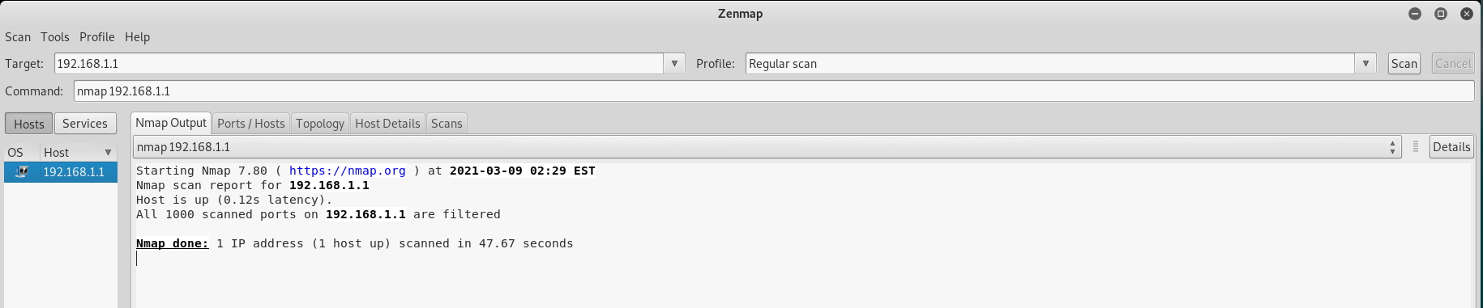

Intense scan

nmap -T4 -A -v 192.168.1.1

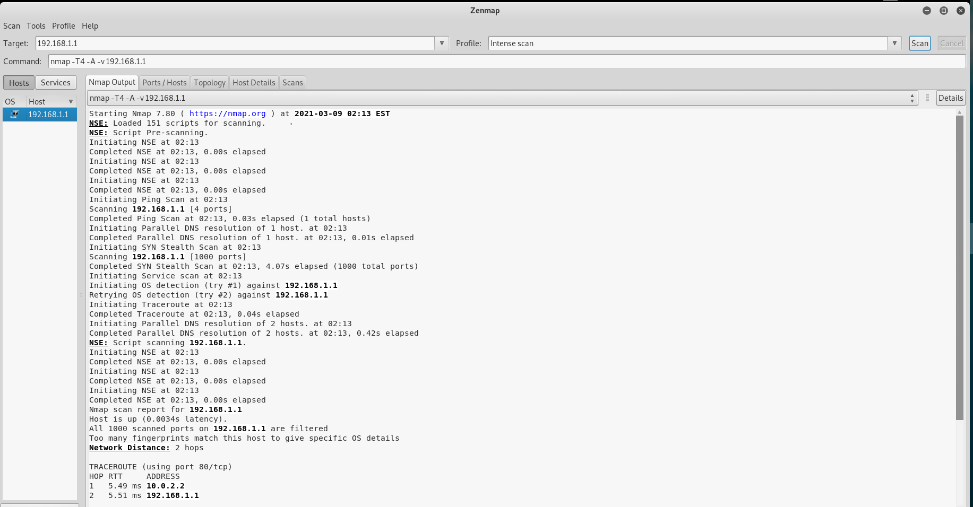

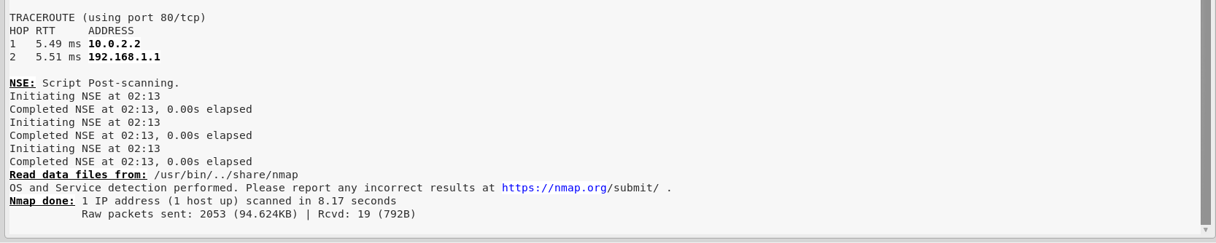

Intense scan plus UDP

nmap -sS -sU -T4 -A -v 192.168.1.1

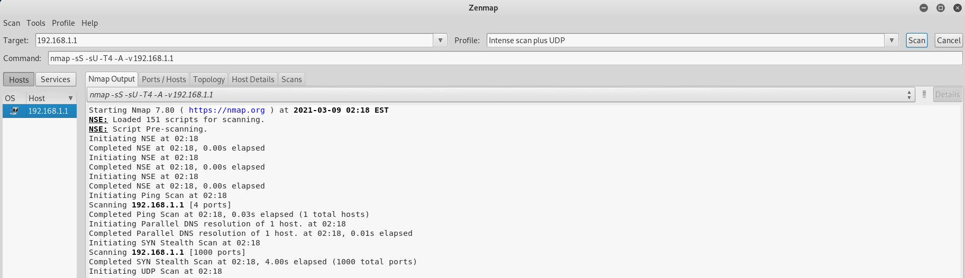

nmap -p 1-65535 -T4 -A -v 192.168.1.1

Intense scan, all TCP ports

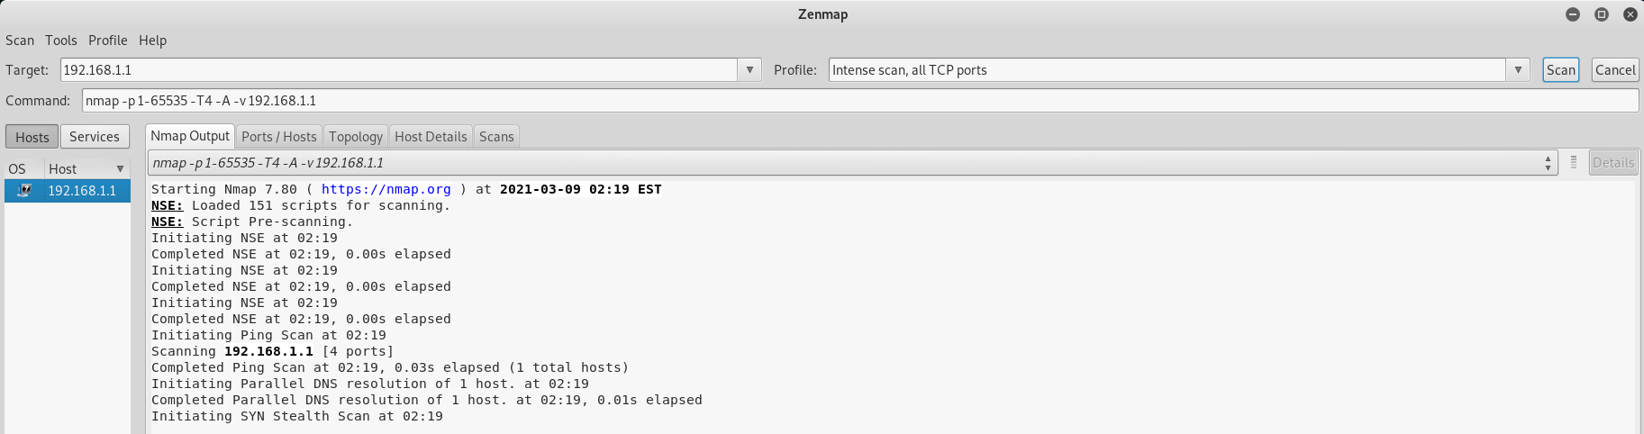

Intense scan, no ping

nmap -T4 -A -v -Pn 192.168.1.1

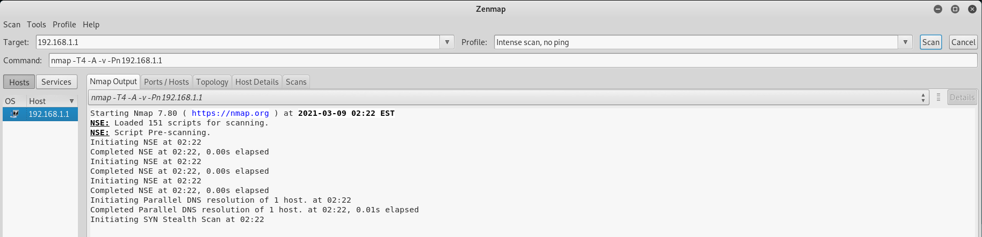

Ping scan

nmap -sn 192.168.1.1

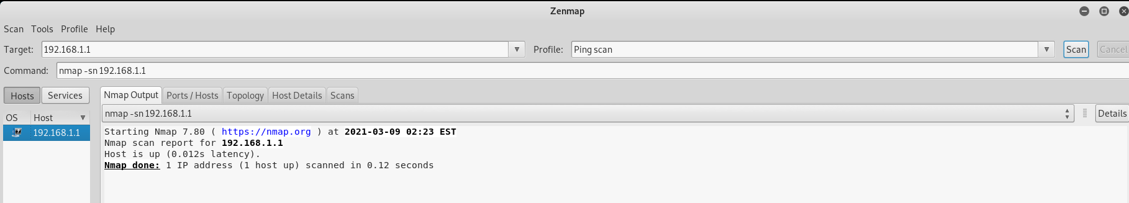

Quick scan

nmap -T4 -F 192.168.1.1

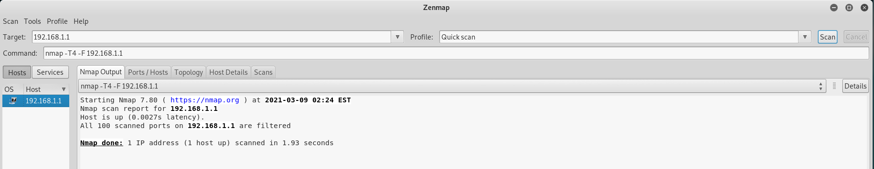

Quick scan plus

nmap -sV -T4 -O -F --version-light 192.168.1.1

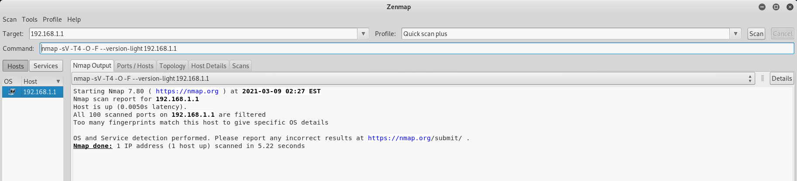

Quick traceroute

nmap -sn --traceroute 192.168.1.1

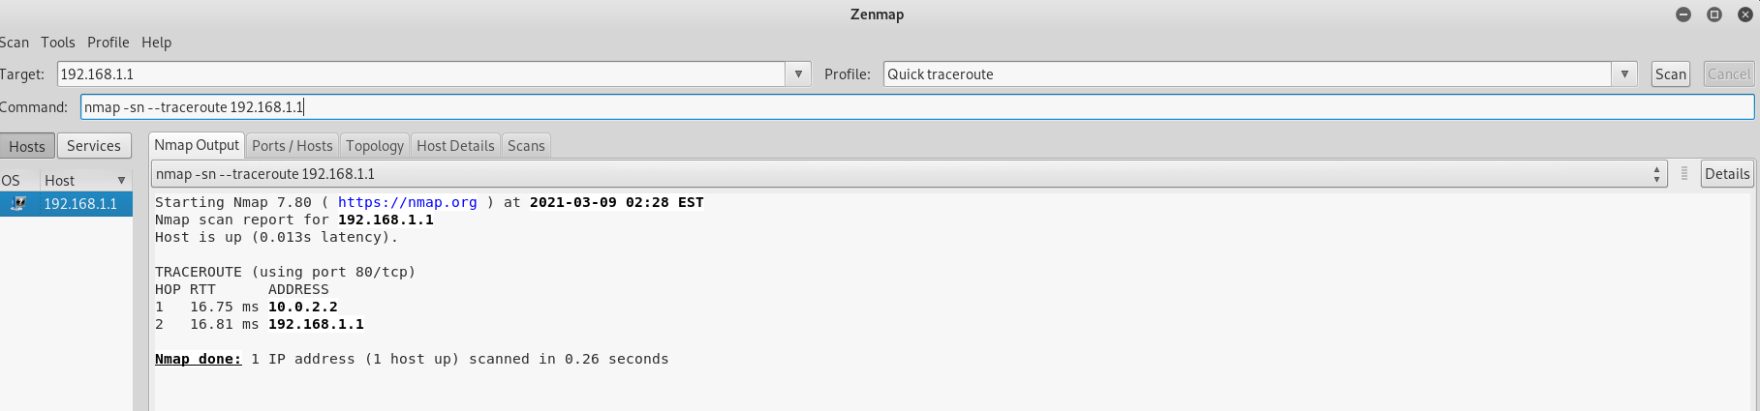

Slow comprehensive scan

nmap -sS -sU -T4 -A -v -PE -PP -PS80,443 -PA3389 -PU40125 -PY -g 53 --script "default or (discovery and safe)" 192.168.1.1

