Wireshark

Yukti_19csu366

HTTP and HTTPS

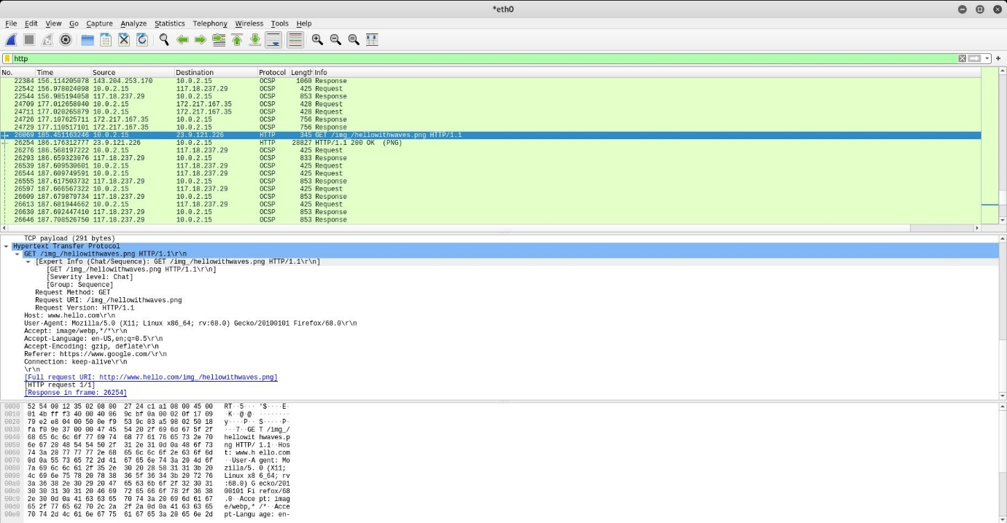

UDP

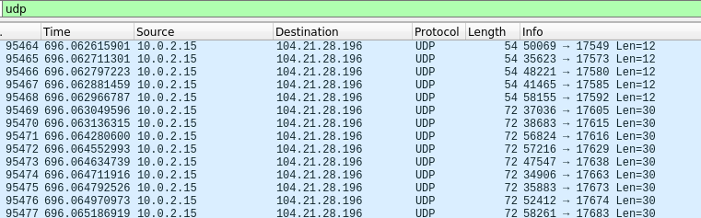

TCP Analysis

TCP ALive

GET

REST

User and pass

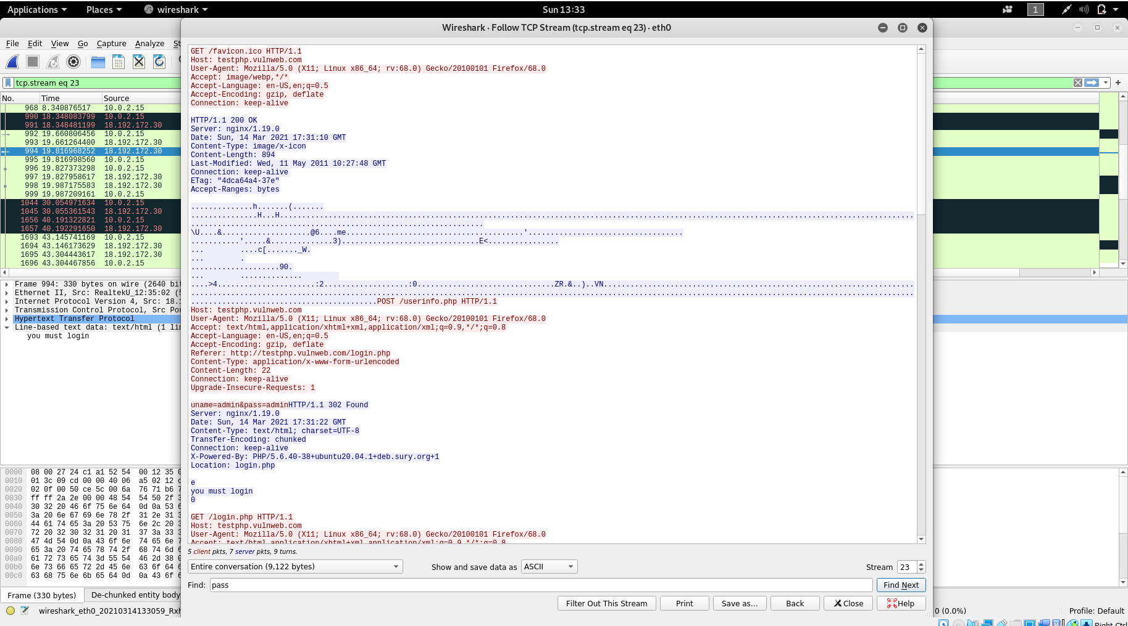

Image capture



Timeout (ACK not received)

