**Problem Statement**

Consider the COMPANY database in Basic_SQL_Queries_Company_DB document and execute the following queries:

1. Find the sum of the salaries of all employees, the maximum salary, the minimum salary, and the average salary.
2. Find the sum of the salaries of all employees of the ‘Research’department, as well as the maximum salary, the minimum salary, and the average salary in this department.
3. Retrieve the total number of employees in the company.
4. Retrieve the number of employees in the ‘Research’ department.
5. Count the number of distinct salary values in the database
6. For each department, retrieve the department number, the number of employees in the department, and their average salary.
7. For each project, retrieve the project number, the project name, and the number of employees who work on that project.
8. For each project *on which more than two employees work,* retrieve the project number, the project name, and the number of employees who work on the project
9. For each project, retrieve the project number, the project name, and the number of employees from department 5 who work on the project.
10. For each department that has more than five employees, retrieve the department number and the number of its employees who are making more than $40,000.

**Output: Screenshots**

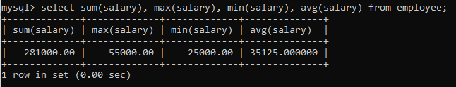

2.

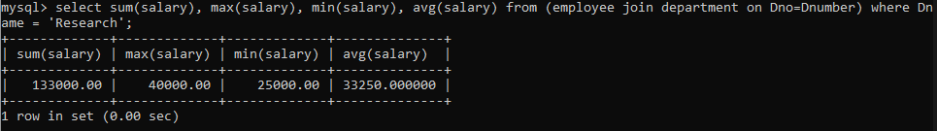

3.

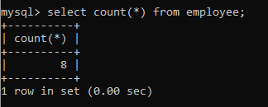

4.

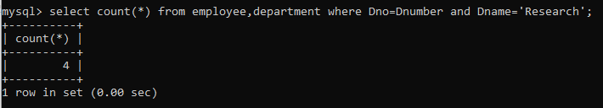

5.

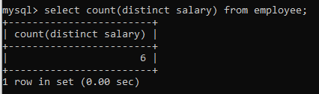

6.

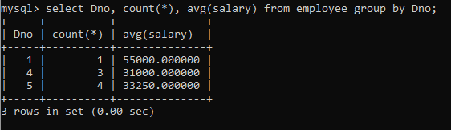

7.

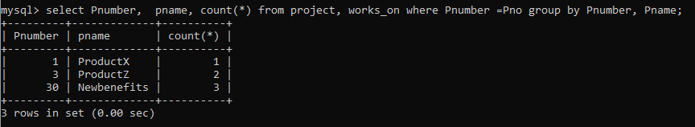

8.

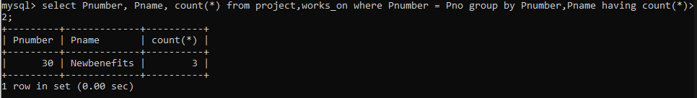

9.

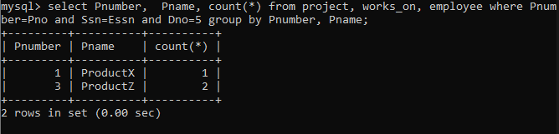

10.

