**VOICEITT**

**Mission**

We will utilize advancing technology to provide a quick, content-secure method of input, review, and sharing of patient information.

**Vision**

Developing a “voice-created” medical records package that will provide printed patient records while capturing the information for the eventual “paperless” record.

**Executive Summary**

VOICEITT was created to provide a solution to orthopedic surgeons. Specifically, the solution deals with the input of patient data into a medical records database.

The solution utilizes an increasingly popular and accurate speech recognition component known as “telephony.” This solution will allow the orthopedic surgeons to input patient data as they give the actual exam. This will fill a major gap not available in the current competitive product offerings.

The value proposition to the physician is the ability to see more patients and decrease their operating costs. This provides higher revenue and greater operating margins.

The company will be differentiated from its competitors as a result of offering the first turnkey solution for electronic medical records utilizing telephony.

Market research demonstrated that less than 10% of the industry currently utilizes electronic medical records. Further, 89% of the market plans to purchase electronic medical records within the next five years. Of that, 42% within 18 months, 36% within three years, and 11% within five years.

Currently, most physicians collect patient information on paper. That information will include patient demographics, patient examinations, lab reports, and referral physician information. Electronic medical records represent all patient information is stored in a database creating the potential for a paperless office.

**Market Analysis Summary**

Our initial target market will be the orthopedist in the medical industry, (see definition of orthopedist below.) This market has been chosen due to:

The expertise of our management team in this industry.

The expressed interest for this product by orthopedics at trade shows for the past two years.

A member of our management team is considered an industry expert in providing speech recognition solutions to orthopedics.

We will concentrate our speech recognition solutions on subspecialty orthopedists. These orthopedists are required to dictate extensive referral letters. These physicians have reported transcription costs ranging from $5,000 to $20,000 per year. The savings in these transcription costs, as well as our current visibility in this market, make this an integral part of our overall strategy.

Definition – The orthopedic industry is served by two specialties.

Orthopedist

Orthopedic surgeons

**Market Trends**

Reduced physician reimbursement from government and insurance companies (Medicaid/Medicare).

With an increased aging population, “baby boomers” reached age 60 in 2002, thus increasing demand for medical care.

Legislation in Congress to eliminate handwritten records. This impacts all physician’s patient documentation.

Deaths from medical errors due to misreading handwritten clinical data.

**Products and Services**

We sell products that create a paperless medical practice and improve operational efficiencies along with traditional orthopedic screening products.

These products include:

Electronic medical records.

Dictation/transcription solutions using speech recognition software.

Software for the management of scanned paper documents and digital files, (early conversion to the paperless office).

Orthopedic products.

Our strategy is to license the telephony module of our electronic medical record software to our competitors. We believe this will help protect price erosion, and provide high-margin, low-maintenance revenue.

**Business Model**

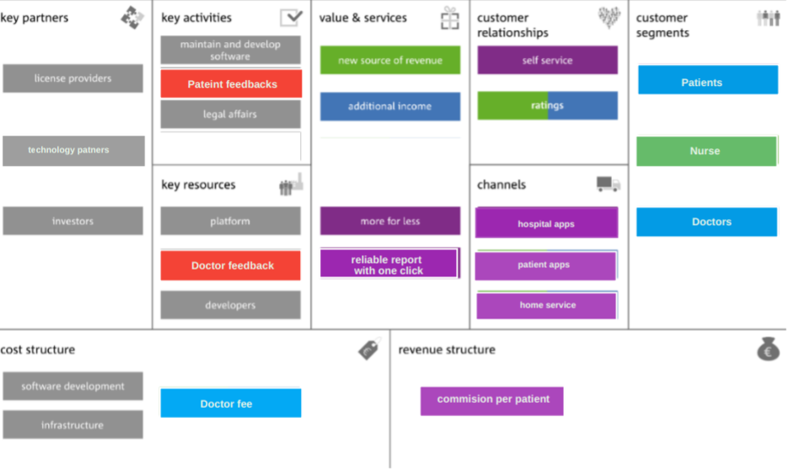

**Who Uses Voice Recognition Software?**

Hospitals and clinics will use voice recognition software to quickly collect patient information and record clinical documentation. Medical transcription can be offered as either a software or a service and can save hospitals countless hours and capital on record keeping.

But our scope can increase as typing and transcribing can take up a lot of a person’s day, both at work and at home. Most professionals type countless emails a day at face value, but that doesn’t count all the time spent typing up personal text messages or using search engines. Voice recognition software allows users to do all or at least some of these tasks using just their voice, taking some of the load off our poor wrists and hands. It can expand to:

Law — Many law firms will employ a voice recognition tool for the extensive bookkeeping and data entry that comes with running a practice. These products can assist with other activities such as task management and client communications as well.

**SWOT Analysis**

Strength

Acceptance of speech recognition software as an alternative process to current methods of dictation/transcription. Establishing our market leadership position by providing a “custom” solution to individual, end-users ’ dictation/transcription needs. Developing a “voice-created” medical records package that will provide printed patient records while capturing the information for the eventual “paperless” record. Profitably managing the explosive growth opportunities in this emerging market.

Weakness

Technology sometimes cannot be reliable. Some Companies can face difficulties in the beginning in installing this kind of exclusive technology.

Opportunities

Penetrate 13% of the electronic medical records business in the orthopedic dictation market by year five. Prepare a business model that can be successfully launched in additional vertical medical markets by year five. Penetrate 7% of the orthopedic dictation market with speech recognition by year five.

Threats

Intense competition will reduce profitability – only a few rivals have considerably higher capital and capability

**Financial Plan**

Substantial funding is required to execute this business plan. The tables shown in the sections to follow, and in the appendix, detail the investment and use of capital.

Funding will be required to allow the company to begin operation, complete their acquisition, hire staff, develop technology, purchase additional computer equipment needs, and fund marketing campaigns.

Further funding will be required to allow the company to complete expansion of staff, complete beta testing, fund marketing campaigns and purchase computer equipment needs. An additional infusion will be required to satisfy our capital needs.

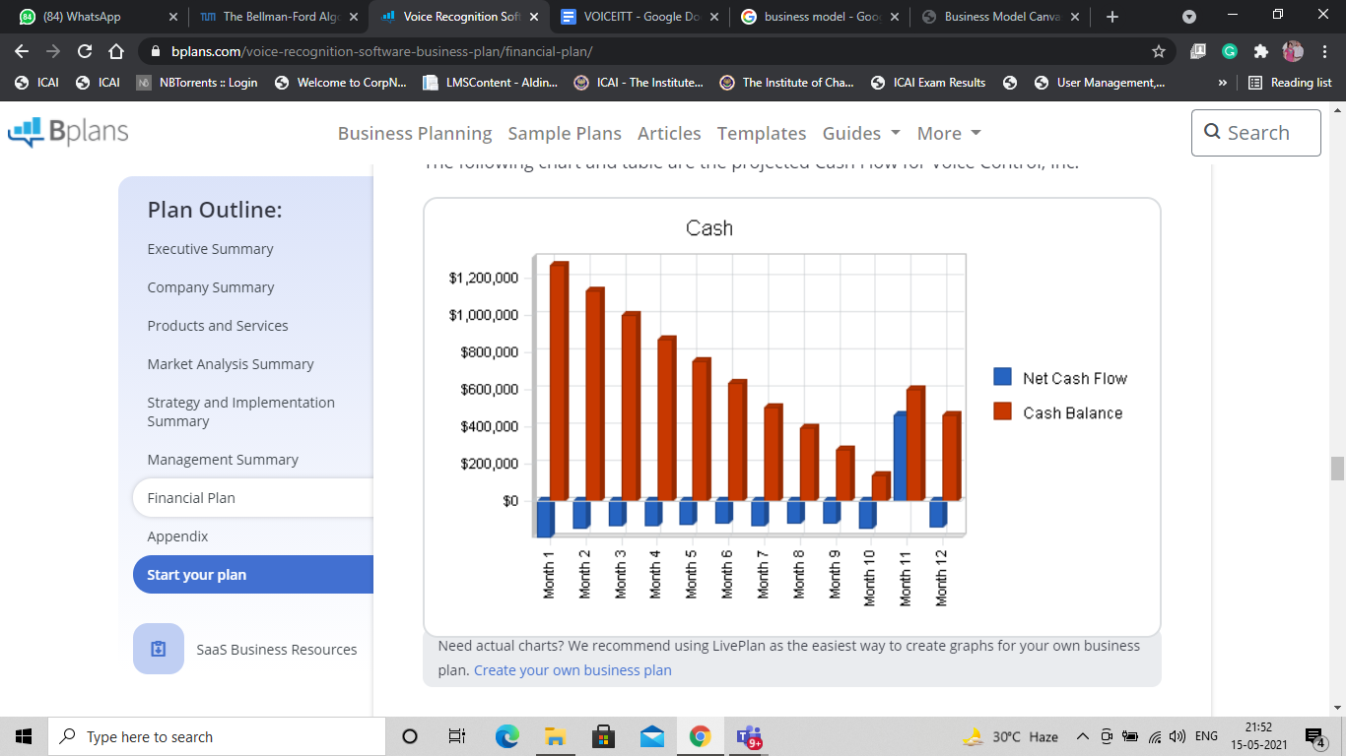

**Management Summary**

Our company will initially employ three people. They will all be principals of the company. These three people will fill the key management roles as the company moves forward. Specifically, those roles are president, vice president electronic medical records, and vice president voice recognition and imaging systems. Our technology partner will develop the software and provide support for our speech recognition, data-based products, and technology needs.

Our near-term needs will include a database coordinator and two sales representatives. We will have a human resource consultant to provide hiring assistance, routine human resource duties, and job descriptions. This will allow for our management team to remain focused on sales initiatives, profit initiatives, and product development.

Our management philosophy will be based on customer relationships. This single guiding philosophy will provide all team members an environment that encourages creativity, customer satisfaction, and business goal achievement.

**How will Voice Recognition Software be helpful today?**

As we know today’s situation due to COVID-19. The coronavirus spreads mainly from person to person. This can happen between people who are in close contact with one another. Droplets that are produced when an infected person coughs or sneezes may land in the mouths or noses of people who are nearby or possibly be inhaled into their lungs. Anyone who comes into close contact with someone who has COVID-19 is at increased risk of becoming infected themselves, and of potentially infecting others. So voice recognition will help people to maintain social distancing and prevent touching a surface contaminated or not. It will record patient reports and issues without any contact with anyone. This will prevent the spread of viruses that can be very helpful in this time of need.