Research

1. Experimental Setup and Implementation:

Our proposed approach is based on google search terms. The search terms reflect mental health concern of the public before and after epidemic of COVID-19 19and the impact it had on people around the world. The search terms cover "mental health", "depression", "anxiety", "ocd", "obsessive compulsive disorder", "insomnia", "panic attack", "counselling", "psychiatrist" which had been the major exploration of the pandemic in the areas of Canada, US, Italy, Iran, Japan, South Korea and UK. The data provided also include data of Canada for the past 4 years, from 2016 to 2019.

Search terms are shown by a number between and 100, where 100 implies the most prevalent point of the week whereas 1 implies the minimum. We have applied country wise analysis where different growth search terms is compared over time. A keyword analysis has also been implemented which compares each country’s trend rise along with comparison between Canada pre and post COVID-19.

1. Results and Discussion:
2. Analysis of Cases in United States:

We mapped fig (1) by combining all datasets for the region of US over the period of 50 weeks Fig (1) depicts how individuals had looked through terms, the most searched term being anxiety for that year. Mental health and psychiatrist were looked sooner or later in that year. Obsessive compulsive disorder had lowest trend in comparison.

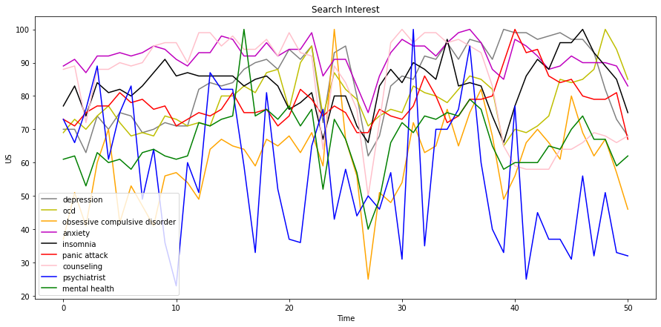

1. Analysis of Cases in United Kingdom:

UK comes on top with cases starting in early April. Fig (2) implementation gives data by consolidating all datasets for the area of UK over the time of 50 weeks. This figure portrays how people had peeked through the terms; the most looked through term was anxiety for that particular year. Depression and OCD were not that far behind while psychiatrist had minimal pattern in correlation.

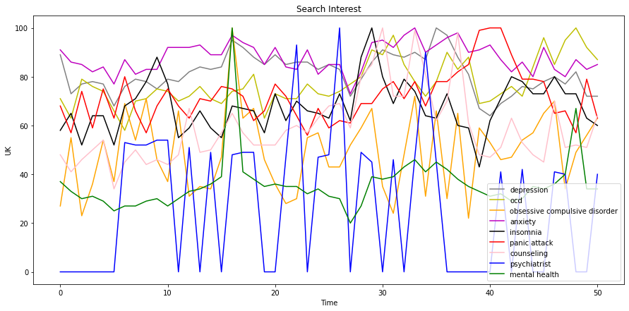

1. Analysis of Cases in Italy:

Fig (3) shows combination of all datasets for Italy for a duration of over an year. It also demonstrates how each search item reached its peak. Depression reached its peak in the starting of 2020 where as obsessive-compulsive disorder, panic attack, mental health and counselling were at their highest in end of 2019. Anxiety, ocd, insomnia and psychiatrist peaked after second month of 2020.

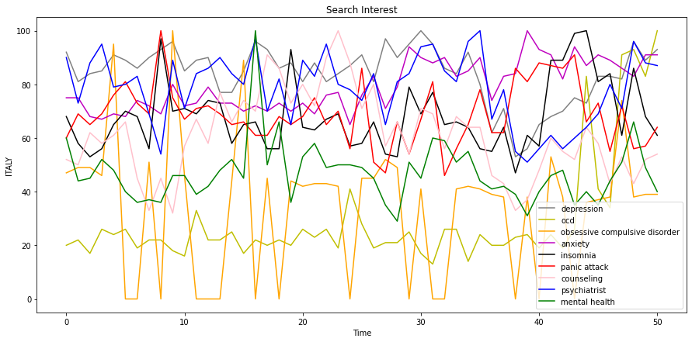

1. Analysis of Cases in Iran:

Fig (4) is deliberated by means of joining all datasets for the location of Iran. Fig (4) portrays how humans had studied via the search terms, the most appeared through time period being depression for that year. Anxiety and psychiatrist had appeared ultimately in the following year. In contrast, the curve for mental health was lowest.

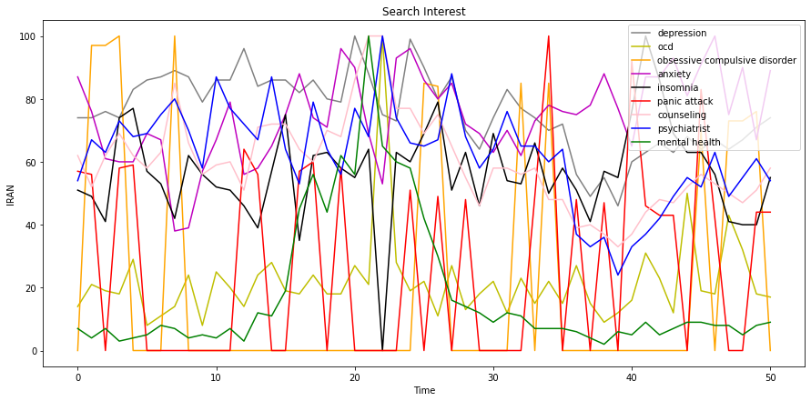

1. Analysis of Cases in Japan:

Fig (5) execution gives information by combining all datasets for the region of the Japan throughout the period of 50 weeks. This figure depicts how individuals had examined the terms. Insomnia made it to one of the top searched terms with a higher inclination in Japan. Insomnia is a sleep disorder in which you have trouble falling and/or staying asleep. Anxiety was not so a long way behind while obsessive compulsive disorder had a comparably less contribution.

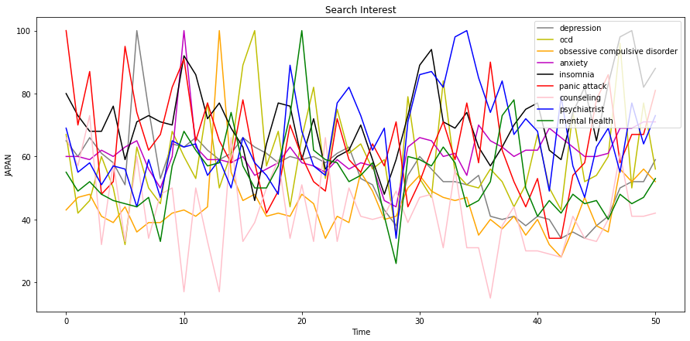

1. Analysis of Cases in South Korea:

Upon mapping out the dataset for South Korea as shown in fig (6) it exhibits how each search term arrived to it’s pinnacle. Panic attack arrived at the top in the beginning of covid-19 whilst depression, anxiety, obsessive compulsive disorder and ocd joined in as the cases of COVID-19 increased tragically. As the cases of insomnia increased with the start of 2020, psychiatrists’ term was also searched more often.

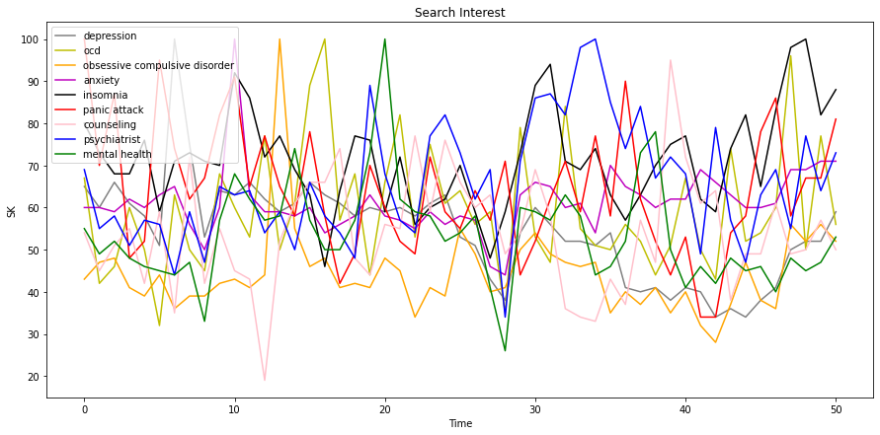

1. Post and Pre Canada in COVID-19:

Another implementation proposed in fig (7) is a distinction in trends for pre-COVID-19 times and post COVID-19 times in Canada. Analysis the graph it’s shown that there's a rise within the search terms in nearly each section whereas there's a decrease in counselling and psychiatrist. One of the main reason for this would be due to the lockdown within the country as there was a scare among people to go out and possibly catching the virus.

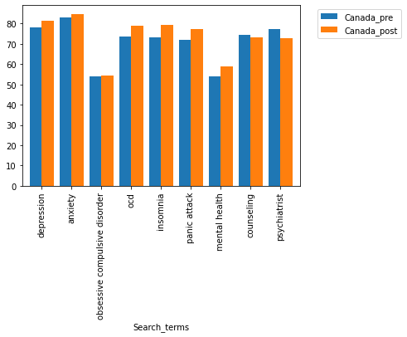

1. Conclusion:

In this paper we examined mental health search terms trend in various counties over during the time of a world-wide pandemic. These trends exhibited the mental crisis that dawned upon people across the globe over the course of 50 week.

Fig (8) conveys how anxiety and depression took the top spots followed by insomnia which is closely associated to the other two illnesses. The spikes in the graph portrays how different news or events caused a disrupt in the health of the general public.

We showcased country wise analysis in each search term and the changes between pre-covid era and the post-covid era. This researched demonstrated how people can not only be affected by fear of virus but also the cabin fear caused by it.

