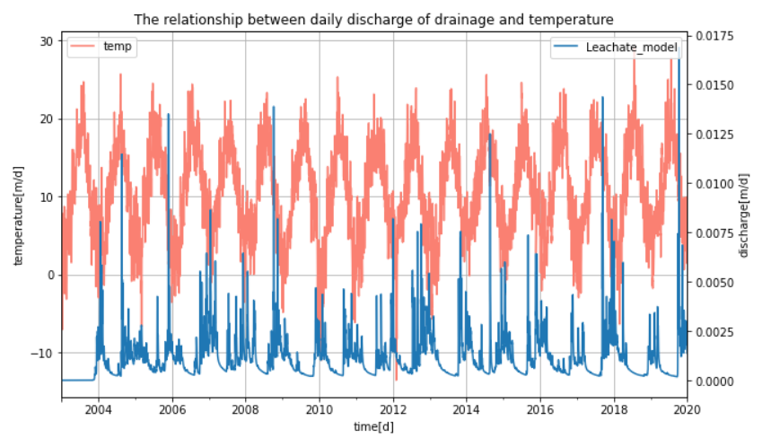**Figure 1.** The relationship between daily discharge of drainage and temperature

Climatic conditions, specifically rainfall and temperature, determines both the quantity and quality of the landfill leachate. High temperature not only leads to high evaporation and consequent high leachate concentrations, but also emit foul odors and even cause fires, this is particularly pronounced in water-scarce areas(Al-Yaqout & Hamoda, 2003). Reduced amount of leachate due to high temperature is observed in San Marcos Landfill(Camba et al., 2014). In Figure 1, the temperature and the quantity of the leachate shows clear inverse trend, which meets the expectation. The quantity of leachate reaches minimum every summer and maximum every winter. There are many burrs in the leachate line, which are caused by a combination of other factors such as will and, humidity, compaction, etc.

Al-Yaqout, A. F., & Hamoda, M. F. (2003). Evaluation of landfill leachate in arid climate—a case study. *Environment International, 29*(5), 593-600. doi:<https://doi.org/10.1016/S0160-4120(03)00018-7>

Camba, A., González-García, S., Bala, A., Fullana-i-Palmer, P., Moreira, M. T., & Feijoo, G. (2014). Modeling the leachate flow and aggregated emissions from municipal waste landfills under life cycle thinking in the Oceanic region of the Iberian Peninsula. *Journal of Cleaner Production, 67*, 98-106. doi:<https://doi.org/10.1016/j.jclepro.2013.12.013>