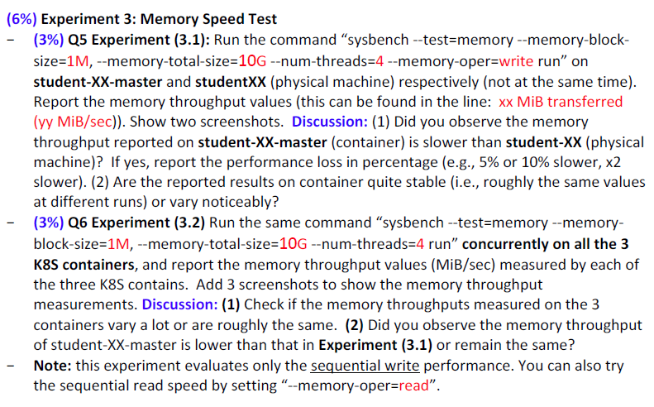

**Q3.1**

Physical machine:

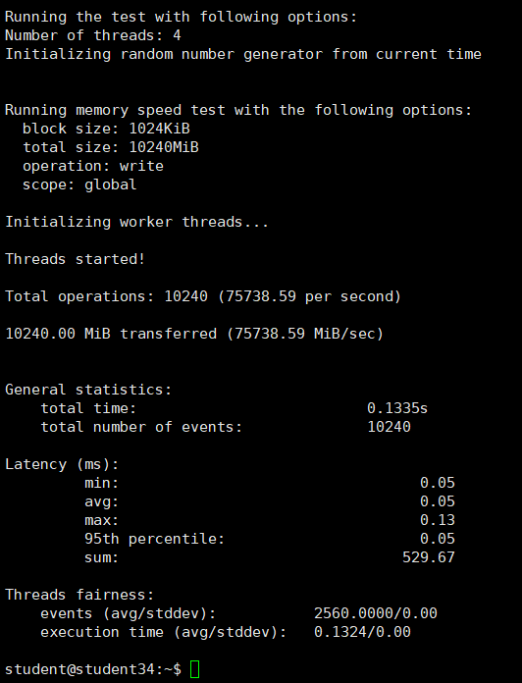

Container

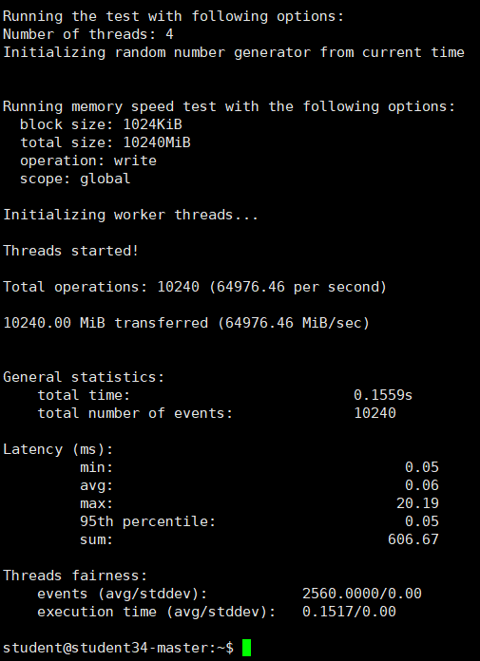

1. Yes. Performance loss in percentage is about 15% slower.
2. The reported results on container are vary noticeably.









**Q3.2**

Master

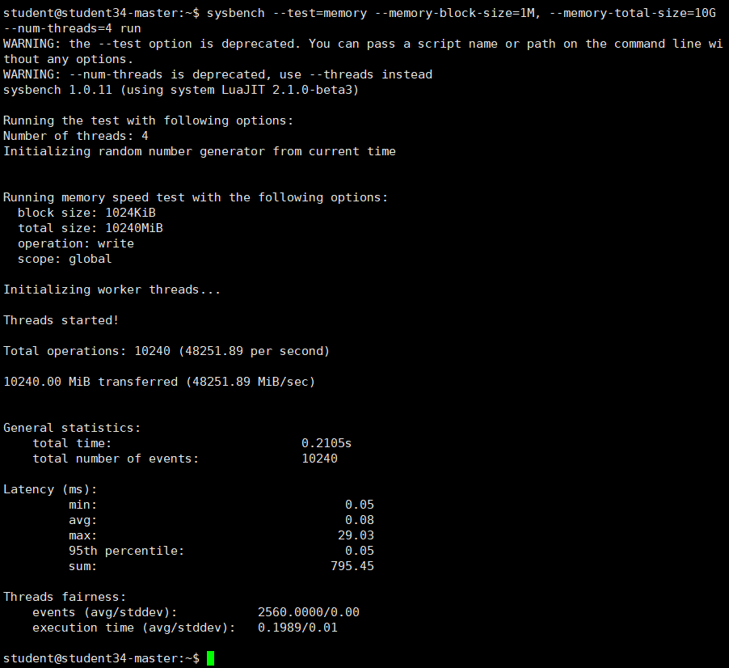

X1

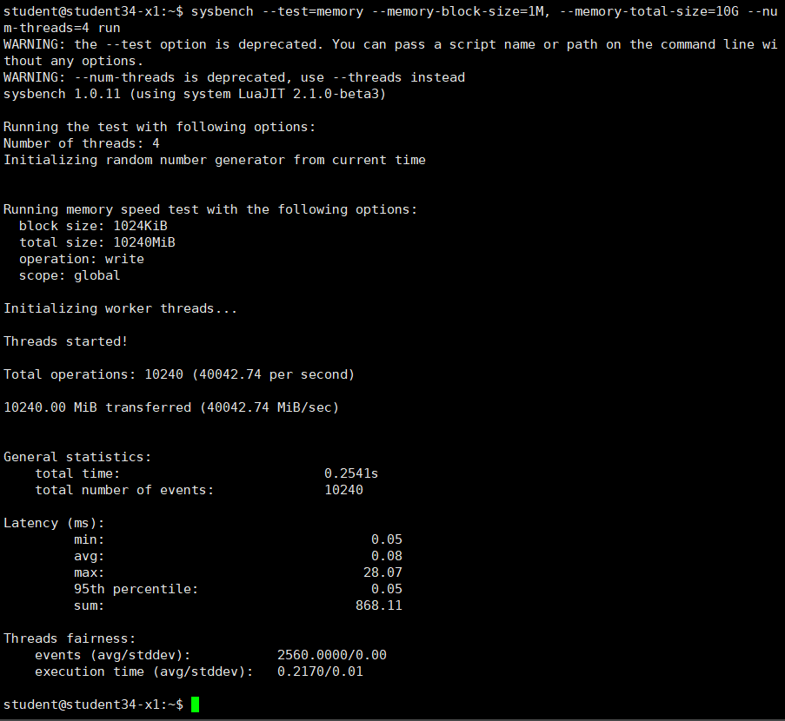

X2

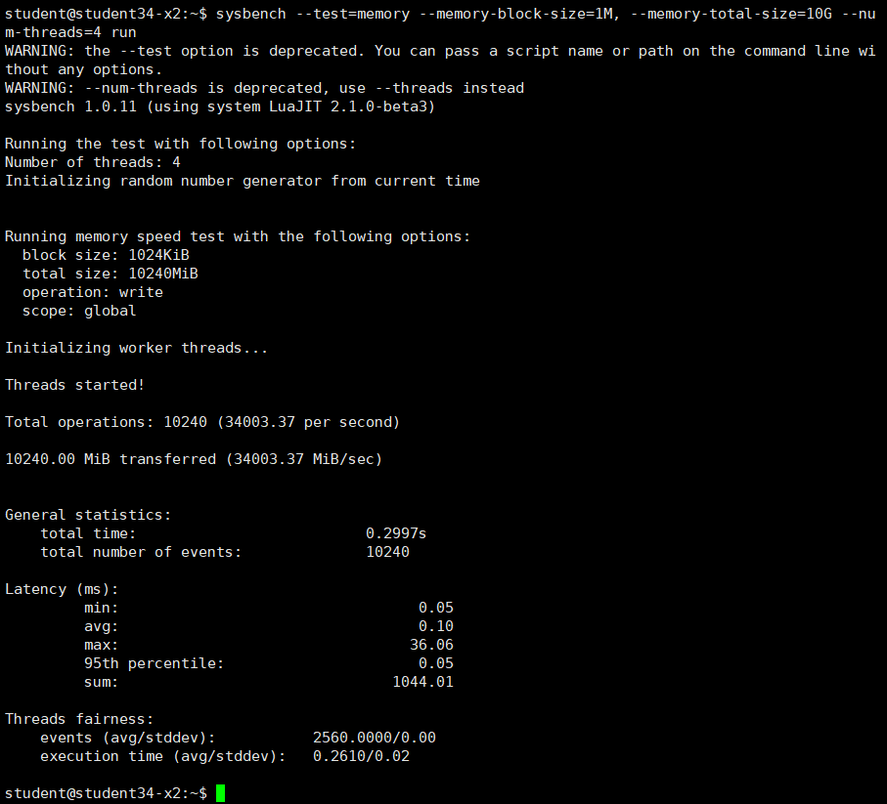

1. They are roughly the same
2. Yes, the memory throughput of studentXX-master is lower than that in Experiment (3.1)