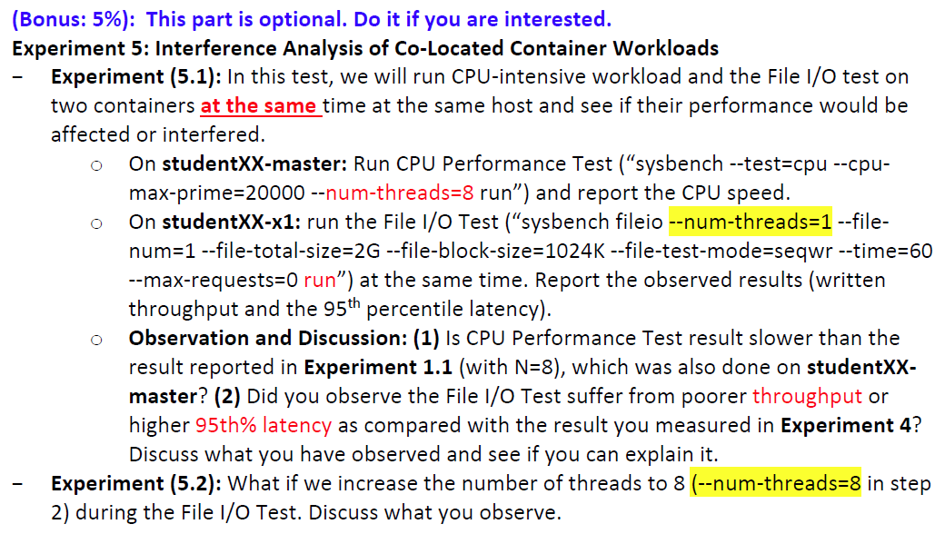

Q1

* 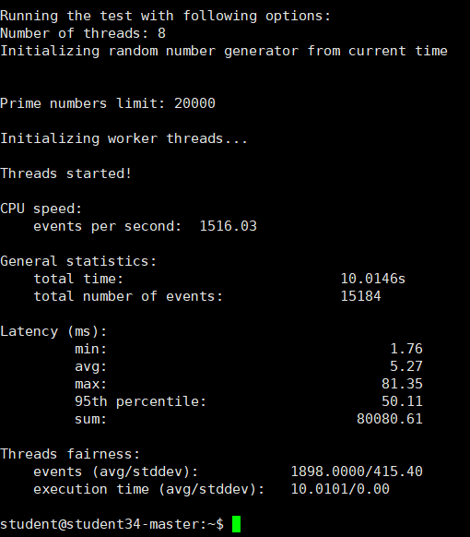
* 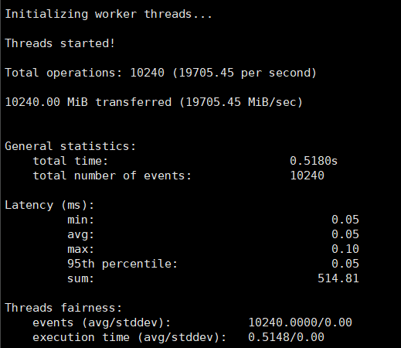
* Written throughput is 42370.17 MiB/sec. the 95th percentile latency is 0.05.

1. Yes. The CPU performance is showed in the image.

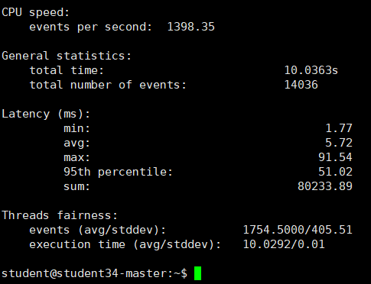

The events per second in 1.1 is around 3000, but here the events per second is around 1400.

(2) should do Exp4 first

Exp 5.2

Master:

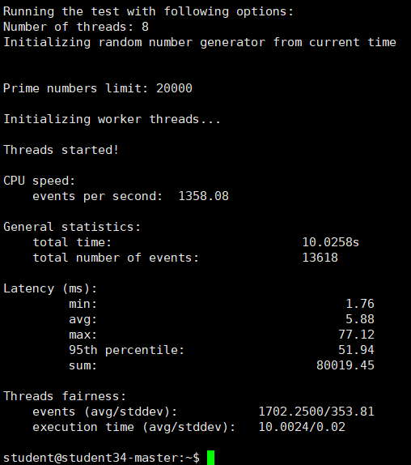

X1:

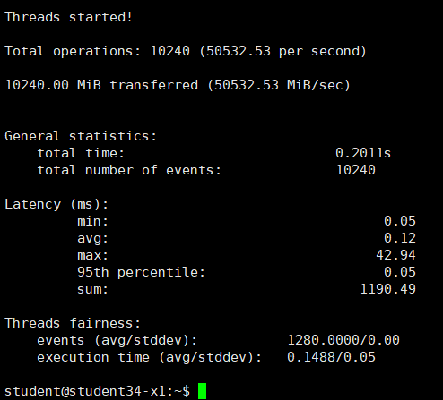

We observe that the memory speed improved, from 20000 to 50000. In the perspective of latency, with the increasing of num-threads, the average time and summation of time increased. Thirdly, in the threads fairness, the average events and average execution time decreased.