Untitled

25 July, 2025

Yukun Jiao^Linköping University^

Author note

Correspondence concerning this article should be addressed to Yukun Jiao, Campus Valla, 581 83 Linköping, Sweden. E-mail: [yukun@example.com](mailto:yukun@example.com)

Untitled

This manuscript uses the Workflow for Open Reproducible Code in Science (Van Lissa et al., 2021) to ensure reproducibility and transparency. All code are available at .

This is an example of a non-essential citation (Van Lissa et al., 2021). If you change the rendering function to worcs::cite_essential, it will be removed.

## GitHub Documents

This is an R Markdown format used for publishing markdown documents to GitHub. When you click the **Knit** button all R code chunks are run and a markdown file (.md) suitable for publishing to GitHub is generated.

## Including Code

You can include R code in the document as follows:

library(ggplot2)  
df_plot <- study_results  
df_plot$beta <- ordered(df_plot$beta)  
ggplot(df_plot, aes(x = n, y = power, color = beta, shape = beta)) +  
 geom_point() +  
 geom_line() +  
 theme_bw()

## Warning: Using shapes for an ordinal variable is not advised

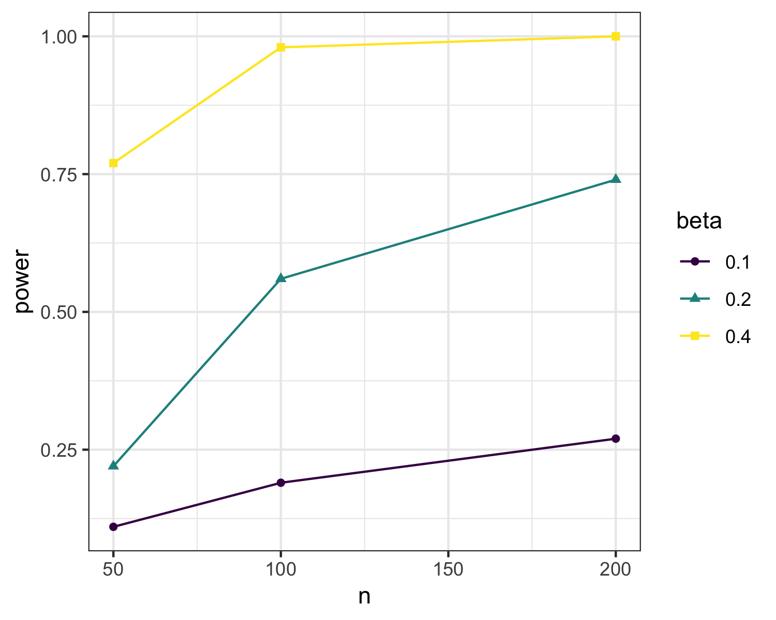

## Including Plots

You can also embed plots, for example:

## Warning: Using shapes for an ordinal variable is not advised



Note that the echo = FALSE parameter was added to the code chunk to prevent printing of the R code that generated the plot.

sdt <- dagitty::dagitty(paste(readLines("../theory/sdt.txt"), collapse = "\n"))  
sdt

## dag {  
## external_event  
## healthy_development  
## integration  
## intrinsic_motivation  
## locus_of_causality  
## needs  
## wellbeing  
## external_event -> intrinsic_motivation  
## external_event -> locus_of_causality  
## external_event -> needs  
## integration -> healthy_development  
## integration -> wellbeing  
## intrinsic_motivation -> healthy_development  
## intrinsic_motivation -> wellbeing  
## locus_of_causality -> intrinsic_motivation  
## needs -> integration  
## needs -> intrinsic_motivation  
## needs -> wellbeing  
## }

tidySEM::graph_sem(sdt)

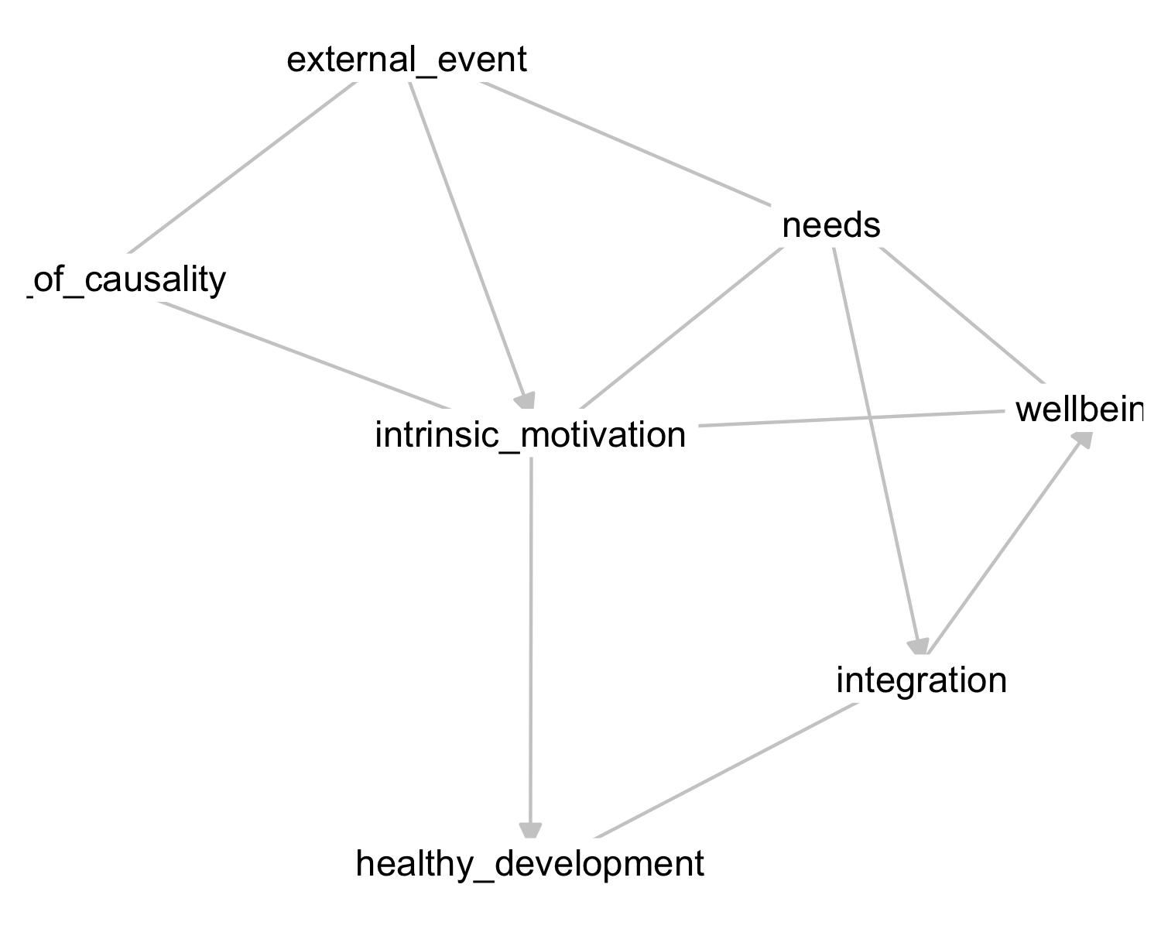

test

Van Lissa, C. J., Brandmaier, A. M., Brinkman, L., Lamprecht, A.-L., Peikert, A., Struiksma, M. E., & Vreede, B. M. I. (2021). WORCS: A workflow for open reproducible code in science. *Data Science*, *4*(1), 29–49. <https://doi.org/10.3233/DS-210031>