2. mongoimport --db usdata --collection cityinfo --file zips.json

3. 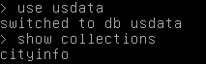

4. 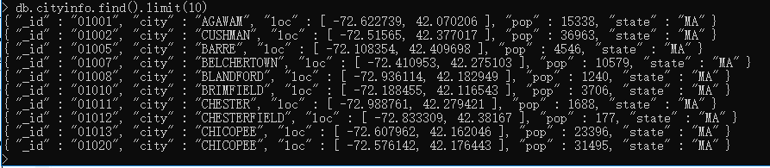

5.

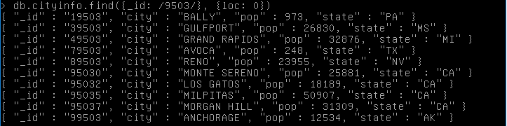

6.

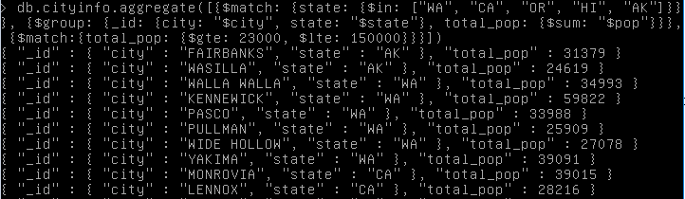

7.

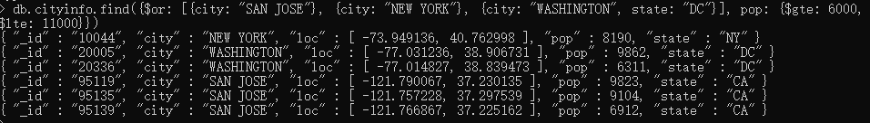

8.

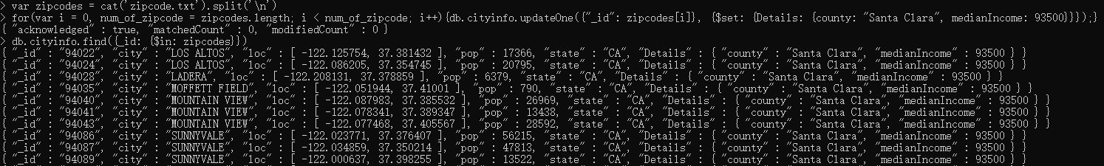

9.

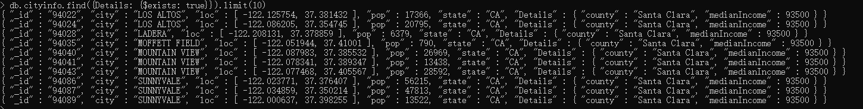

10.

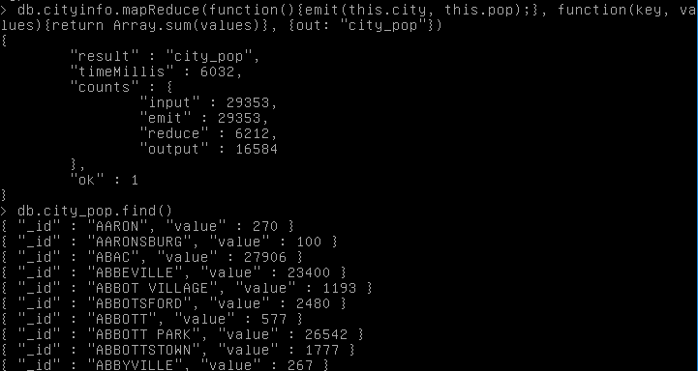

11.

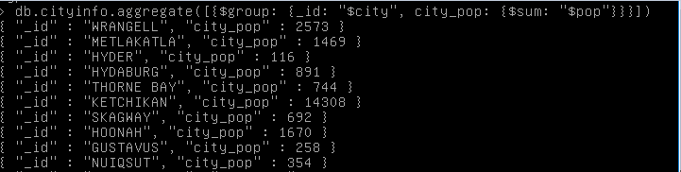

12.

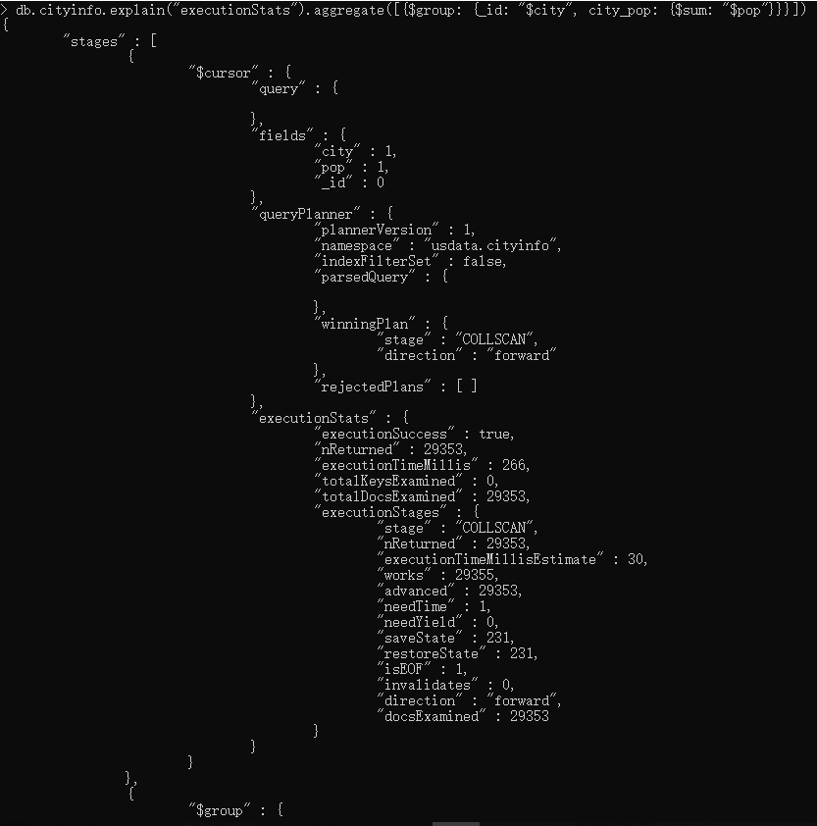

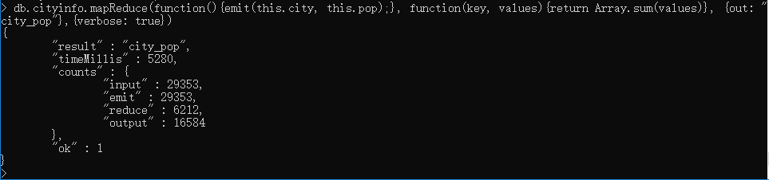

MapReduce uses 5280 timeMillis. Aggregation uses 266 executionTimeMillis. Aggregation is much faster than MapReduce.