CS 149 HW1: Q1:

Assume the original process is process 1.

Process 4

I = 2

Process 5

I = 3

Process 2

I = 3

Process 6

I = 2

Process 4

I = 2

Process 2

I = 3

Process 3

I = 6

Process 1

I = 5

Process 1

I = 5

Process 2

i = 1

Process 1

i = 0

Process 1 has children: process 2, process 3. Process 4 has child process 6.

Process 2 has children: process 4, process 5.

There are 6 total processes.

I value:

P1: 5

P2: 3

P3: 6

P4: 2

P5: 3

P6: 2

Q2:

When user inputs sleep 300 &, the parent process doesn’t wait for the child process to terminate.

The parent process terminates first, and the child process becomes orphan.

Operating System assigns a system process as the new parent.

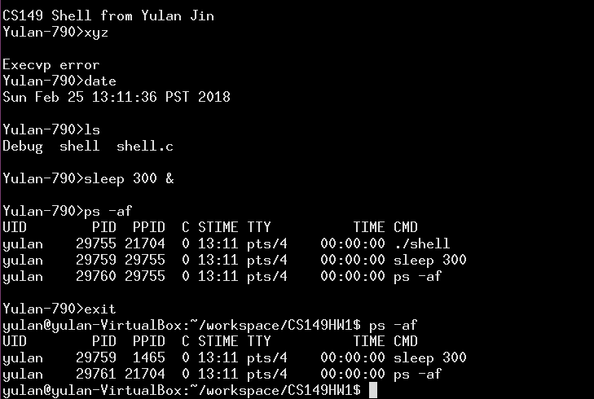

The sleep 300 process is still running, so it has the same pid.

In this case, pid of the original parent process is 29755, which is terminated after user types in exit.

The pid for the new parent process is 1465.