МДК 01.04 «Системное программирование»

Практическая работа №1

Учебная группа **32\1 ИСД-21К**

Студент **Юлдашев Иброхим Камалидинович**

# Код программного приложения

Таблица 1

|  |
| --- |
| using System.Management;  ManagementObjectSearcher searcher = new ManagementObjectSearcher("select * from Win32_Registry");  foreach (ManagementObject obj in searcher.Get())  {  Console.WriteLine(String.Format("|{0,25}|{1,10}||{2,10}| |{3,10}| |{4,10}| ", obj.GetPropertyValue("Caption"), obj.GetPropertyValue("Description"), obj.GetPropertyValue("InstallDate"),obj.GetPropertyValue("Status"),obj.GetPropertyValue("CurrentSize")));  } |

Демонстрация работы приложения

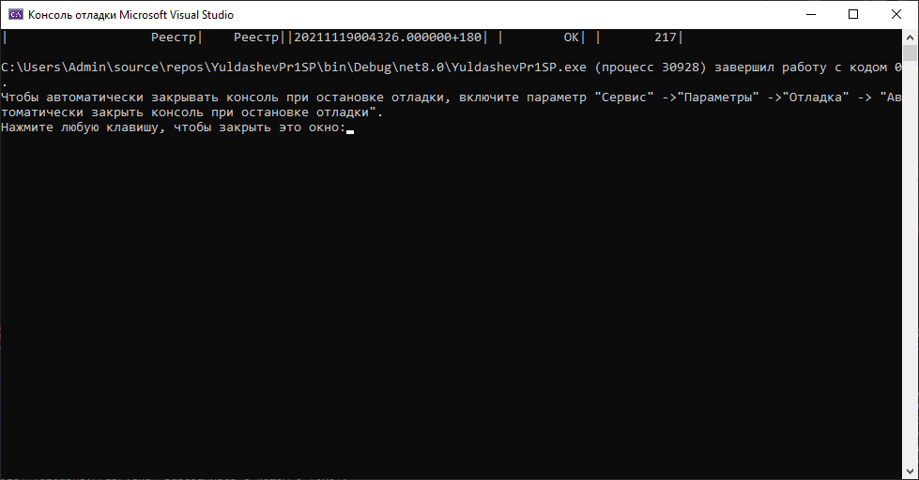

Таблица 2

|  |
| --- |
| ManagementObjectSearcher searcher2 = new ManagementObjectSearcher("select * from Win32_CodecFile");  foreach (ManagementObject obj in searcher2.Get())  {  Console.WriteLine(String.Format("|{0,25}|{1,10}||{2,10}| |{3,10}| |{4,10}| ", obj.GetPropertyValue("AccessMask"), obj.GetPropertyValue("Archive"), obj.GetPropertyValue("Compressed"), obj.GetPropertyValue("CreationDate"), obj.GetPropertyValue("EightDotThreeFileName")));  }  Console.ReadLine();  Console.Clear(); |

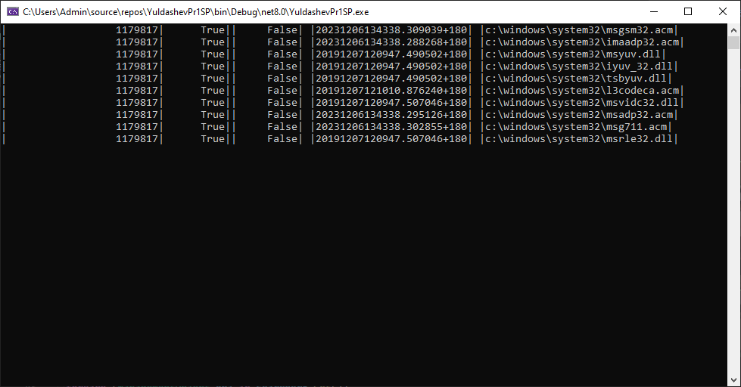

Таблица 3

|  |
| --- |
| ManagementObjectSearcher searcher3 = new ManagementObjectSearcher("select * from Win32_Session");  foreach (ManagementObject obj in searcher3.Get())  {  Console.WriteLine(String.Format("|{0,25}|{1,10}||{2,10}| |{3,10}| |{4,10}| ", obj.GetPropertyValue("Caption"), obj.GetPropertyValue("Description"), obj.GetPropertyValue("InstallDate"), obj.GetPropertyValue("Status"), obj.GetPropertyValue("StartTime")));  }  Console.ReadLine();  Console.Clear(); |

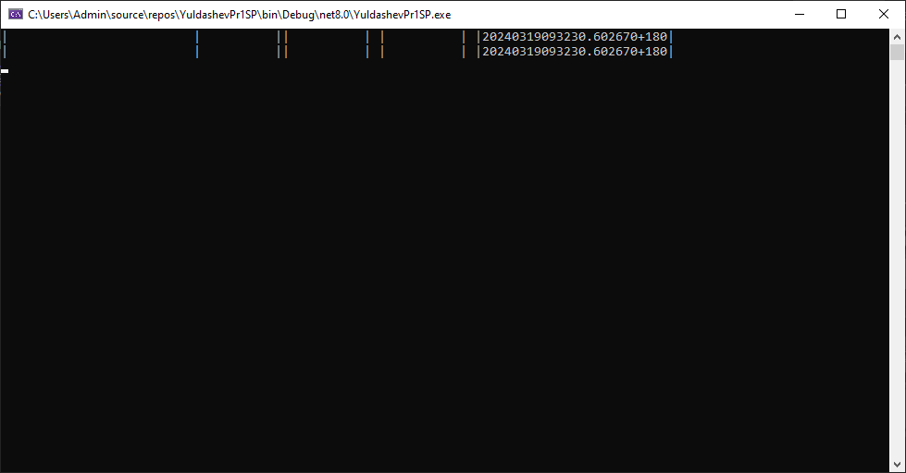

Таблица 4

|  |
| --- |
| ManagementObjectSearcher searcher4 = new ManagementObjectSearcher("select * from Win32_SystemAccount");  foreach (ManagementObject obj in searcher4.Get())  {  Console.WriteLine(String.Format("|{0,25}|{1,10}||{2,10}| |{3,10}| |{4,10}| ", obj.GetPropertyValue("Caption"), obj.GetPropertyValue("Description"), obj.GetPropertyValue("InstallDate"), obj.GetPropertyValue("Status"), obj.GetPropertyValue("SID")));  }  Console.ReadLine();  Console.Clear(); |

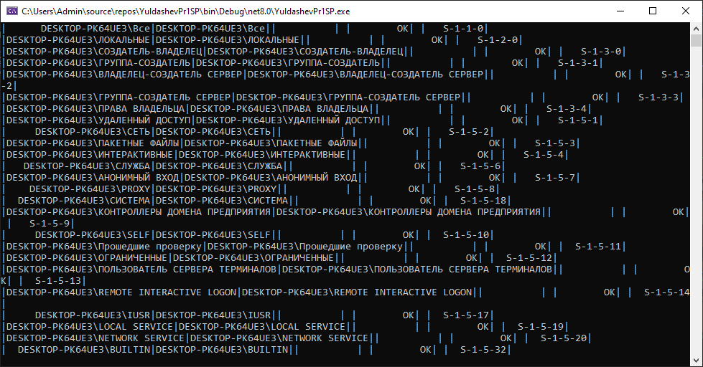

Таблица 5

|  |
| --- |
| ManagementObjectSearcher searcher5 = new ManagementObjectSearcher("select * from Win32_Service");  foreach (ManagementObject obj in searcher5.Get())  {  Console.WriteLine(String.Format("|{0,25}|{1,10}||{2,10}| |{3,10}| ", obj.GetPropertyValue("Name"), obj.GetPropertyValue("PathName"), obj.GetPropertyValue("DisplayName"), obj.GetPropertyValue("DesktopInteract")));  } |

