1. ABCD figurasining berilgan AB, AD va DC tomonlari bo‘ylab perimetrini toping (To‘g‘ri burchakli uchburchakning gipotenuzasini uning katetlari orqali hisoblash funksiyasini aniqlang).

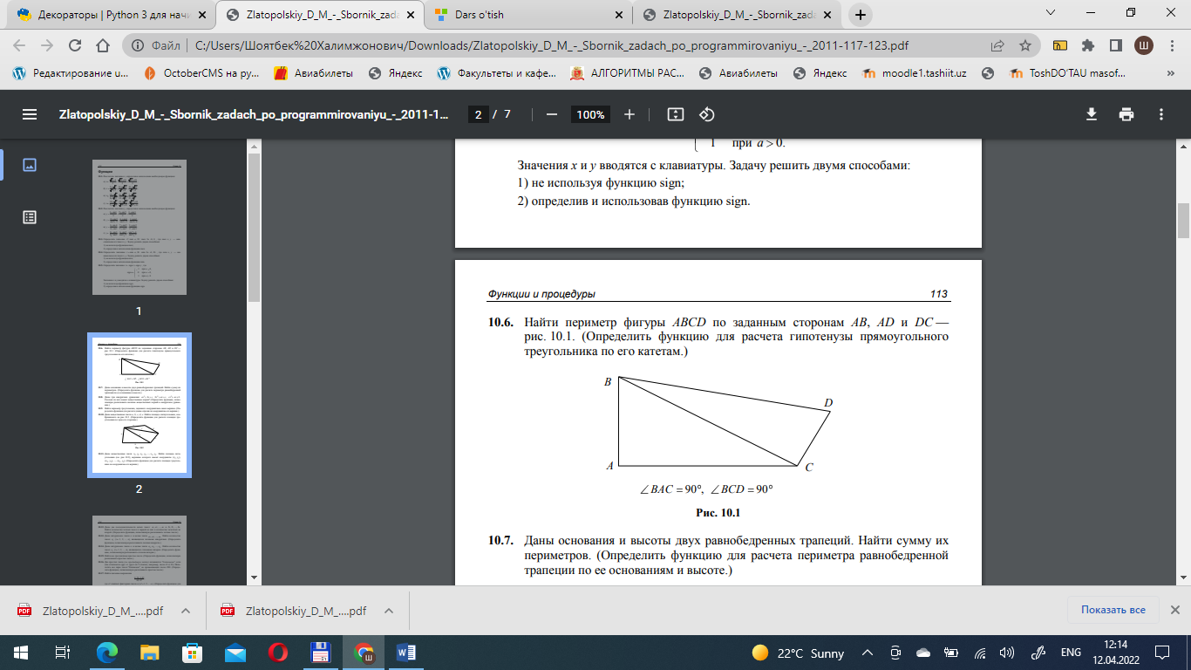

AB = 6  
BC = 7  
DC = 4  
  
  
P = AB + DC + (BC ** 2 - AB ** 2) ** 0.5 + (BC ** 2 - DC ** 2) ** 0.5  
print(P)



**def** f(a, b):  
 **return** (a ** 2 + b ** 2) ** 0.5

**4.** Ikki natural son berilgan. Ulardan kamida bittasi palindrom ("o'zgaruvchan"), ya'ni o'nli yozuvi chapdan o'ngga va o'ngdan chapga bir xil tarzda o'qiladigan bunday raqam ekanligini aniqlang. (Palindrom sonlarini tanib olish funksiyasini aniqlang.)

a = 12344321  
b = 43562  
  
**def** f(n):  
 **if** str(n) == str(n)[::-1]:  
 **return True  
 return False**print(f(a))



1. Natural n sonining faktorialini hisoblash uchun rekursiv funksiya yozing
2. **def** f(n, S=1):  
    **if** n == 1:  
    **return** S  
    S *= n  
    **return** f(n - 1, S)  
     
   print(f(5))

